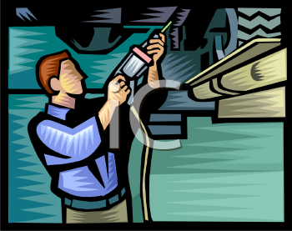

**Applications of pneumatics**

Introduction:

Pneumatische Steuerungen sind heute Kernelemente der modernen Technik. Pneumatische Zylinder bewegen Türen, öffnen Behälter, verschieben Lasten, positionieren Komponenten, vereinzeln oder verschieben Werkstücke, verschrauben PKW-Räder, falten Kartons, heben Blechtafeln an usw. Im Bereich der Fördertechnik, der Handhabungstechnik, der Fertigungstechnik, der Montagetechnik, allgemein in der Automatisierung von Anlagen sind sie überall anzutreffen.

Learning objectives:

By the end of this learning sequence you will …

* … be able to name different types of pneumatic actuators.
* … understand the functions of different pneumatic actuators in a handling device.
* … know the most important symbols of pneumatic actuators.

**Homework**

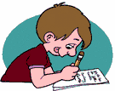

Create your own vocab cards and learn the new vocabulary!

Tasks:

1. 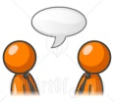You will watch a video to get an impression about pneumatic actuators and their applications. After watching the video sequence match the images to the devices and their applications in the table below. Work in pairs.

|  |  |  |
| --- | --- | --- |
| Device | Application | Image |
| Zylinder | Werkstücke spannen | **5** |
| Schwenkantrieb | Werkstücke/Klappen umdrehen | **9** |
| Zylinder | Türe öffnen/schliessen | **7** |
| Lineareinheit | Werkstücke befördern | **4** |
| Zylinder | Werkstücke verschieben | **1** |
| Druckluftmotor | Radmuttern anziehen | **6** |
| Greifer | Werkstücke greifen | **3** |
| pneumatischer Drehtisch | Baueinheit drehen | **8** |
| pneumatischer Sauger | Bleche anheben | **2** |

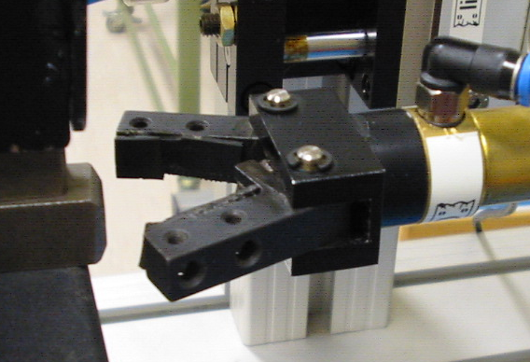

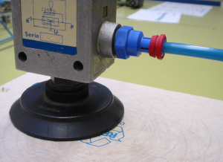

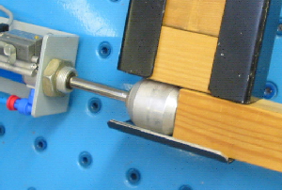

**3**

**2**

**1**

**4**

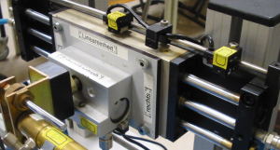

**6**

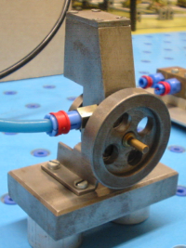

**5**

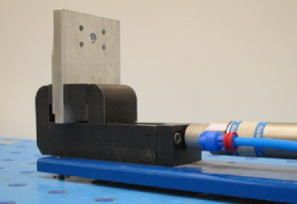

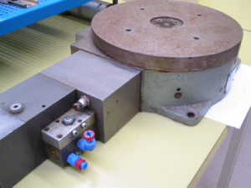

**7**

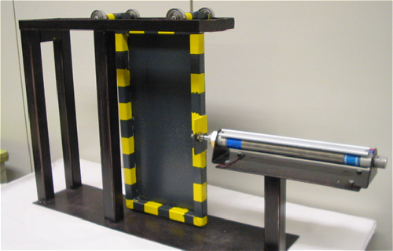

**8**

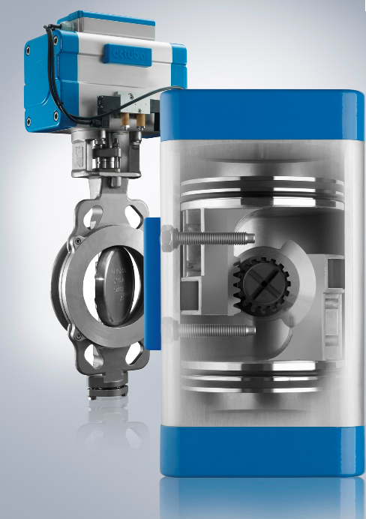

**9**

1. You will see a demonstration of a handling device. Match the components 1 to 8 with the German expression. Find out the English equivalent using the online dictionaries listed below. Work on your own.

<http://www.dict.cc/>

<http://www.festo-didactic.com/de-de/service/online-woerterbuch/>

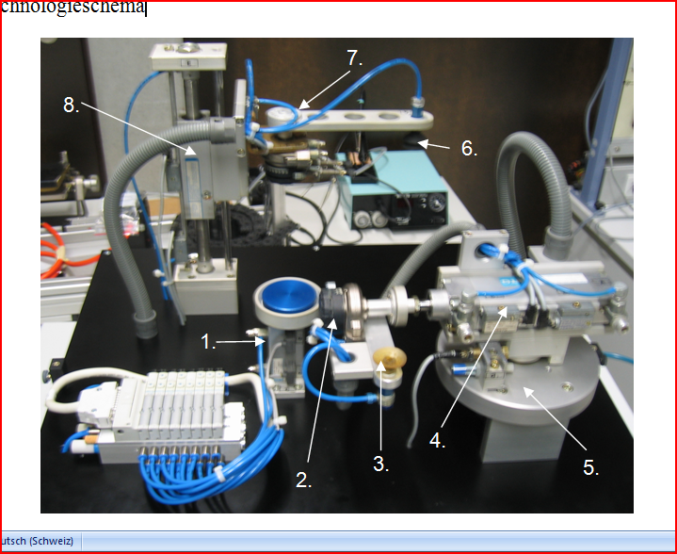



|  |  |  |
| --- | --- | --- |
| Device | German | English |
| 3 | Sauger | Vacuum suction cup |
| 8 | Linearantrieb | Linear drive |
| 1 | Zylinder | Cylinder |
| 6 | Sauger | Vacuum suction cup |
| 5 | Drehtisch | rotary table |
| 2 | Schwenkantrieb | Semi-rotary table |
| 4 | Zylinder | Cylinder |
| 6 | Schwenkantrieb | Semi-rotary table |

1. Complete the table using vocabulary word bank given below. Work on your own.

|  |  |  |
| --- | --- | --- |
| Schwenkantrieb |  | vacuum suction cup |
| Sauger |  | pneumatic motor |
| Zylinder |  | semi-rotary drive |
| Druckluftmotor |  | cylinder |



|  |  |  |
| --- | --- | --- |
| German | English | Symbol |
| Zylinder | Cylinder |  |
| Schwenkantrieb | Semi-rotary table |  |
| Druckluftmotor | Pneumatic mototr |  |
| Sauger | vacuum suction cup |  |

1. Compare your results of b) and c) with those of your colleagues and make corrections if necessary.