**Structure and signal flow of pneumatic systems**

Introduction:

Pneumatic systems consist of an interconnection of different groups of elements. This group of elements forms a control path for signal flow, starting from the signal input through to the actuating section (output). Control elements control the actuating elements in accordance with the signals received from the processing elements.

Signalfluss

Signal flow

Signalverarbeitung

Signaleingabe

Befehlsausführung

Signalausgabe

Command execution

Signal output

Signal processing

Signal input

**Tasks:**

1. Complete the flow chart on the right with the German equivalents.
2. Wie wird dieses Prinzip der Datenverarbeitung genannt?

EVA-Prinzip (Eingabe-Verarbeitung-Ausgabe)

Learning objectives:

By the end of this learning sequence you will …

* … understand the signal flow of a control system more clearly.
* … be able to sketch the structure of a pneumatic control system.
* … understand the structure of a pneumatic circuit diagram.

**Homework**



Make your own vocab cards and learn the new vocabulary!

Pneumatic control system

The primary levels in a pneumatic system are:

* supply elements
* input elements (sensors)
* processing elements (processors)
* control elements
* power components (actuators)

The elements in the system are represented by symbols which indicate the function of the element.

Power components

COMMAND EXECUTION





* pneumatic cylinders
* motors
* visual indicators



Control elements

SIGNAL OUTPUT

* directional control valves



Processing elements

SIGNAL PROCESSING



* directional control valves
* non-return valves
* time delay valves

Input elements

SIGNAL INPUT



* pushbutton valves
* roller lever valves
* proximity switches

Supply elements

ENERGY SUPPLY



* compressor
* pressure regulating valve
* air service unit



**Tasks:**

1. Complete the above chart using the following expressions:

supply elements input elements processing elements control elements power components

1. Complete the table using the expressions of c).

|  |  |
| --- | --- |
| English | German |
| Supply elemnts | Versorgungsglieder |
| Input elements | Signalglieder |
| processing elments | Steuerglieder |
| control elemnts | Stellglieder |
| Power components | Antriebsglieder |

Circuit diagram and pneumatic elements

A directional control valve can be used as an input, processing or control element. The distinguishing feature for the allocation of the individual components to the respective groups of elements is the configuration within a pneumatic system.

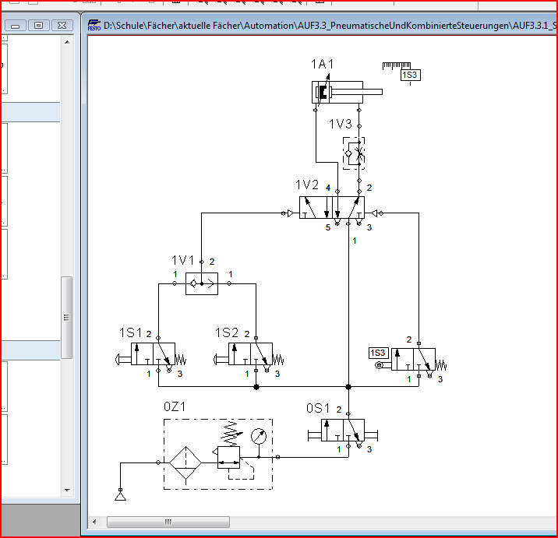

Control elements

Power components

Input elemnts

Supply elements

Processing elemnts

** Tasks:**

1. Complete the circuit diagram using the expressions of c).
2. Complete the table using the device designations in the circuit diagram.

|  |  |  |
| --- | --- | --- |
| Device designation | English | German |
| 0Z1 | air service unit | Wartungseinheit |
| 0S1 | start-up valve | Einschaltventil |
| 1S1 /1S2 | 3/2-way valve with pushbutton actuator | 3/2-Wegeventil, Betätigung durch Druckknopf |
| 1S3 | 3/2-way roller lever valve | 3/2-Wege Rollenhebelventil |
| 1V1 | shuttle valve | Wechselventil |
| 1V2 | 5/2-way double pilot valve, pneumatically actuated, both sides | 5/2-Wegeventil, beidseitig druckluftbetätigt |
| 1V3 | one-way flow control valve | Drosselrückschlagventil |
| 1A1 | double-acting cylinder | doppeltwirkender Zylinder |