**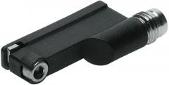*Magnetic Proximity Sensor***

**Task**

**W**ork through the paragraph ***Function of a magnetic proximity sensor*** [tasks f) to i)] in the document "Palletising roof tiles" and answer the following questions:

1. What do you call a magnetic proximity sensor in German?

Magnetischer Nährungsschalter/ Reed-Schalter

1. Write down the difference between a *limit switch with roller lever* and a

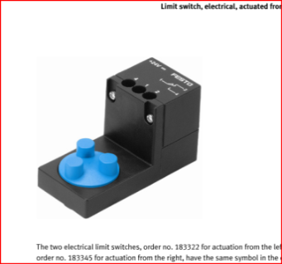proximity sensor!

Limit switch is activated with contact the sensor can be actvated without contact

Proximity Sensor is magnetically activated and the roller lever is mechanicly actvatited

1. Complete the following paragraph:

Function of a reed switch:

Reed switches are magneticlly actuated proximity switches. Proximity switch because you don’t need to touch the sensor for actuation. There is a magnet fixed on the piston of the cylinder. The field of the magnet causes the contact in the reed switch to close, and that allows the current to flow.