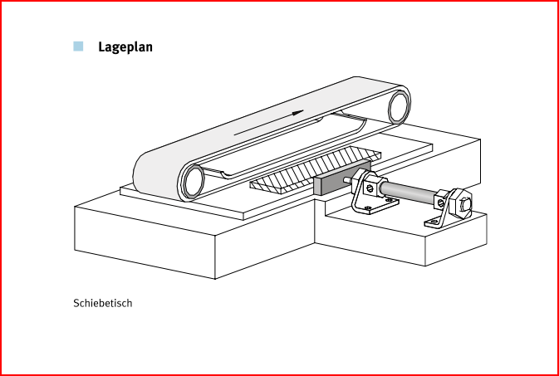***Actuation of a sliding platform***

**Introduction**

Wooden boards are manually placed onto a sliding platform. The boards are pushed under a belt sanding machine by means of a pneumatic drive.

**Tasks**

1. Read the introduction carefully and match the English to the German expressions in the table below. Work on your own and do it without the aid of a dictionary.

|  |  |  |  |  |
| --- | --- | --- | --- | --- |
| No. | English |  | Nr. | German |
| 1 | wooden board |  | 2 | Schiebetisch |
| 2 | sliding platform |  | 1 | Holzbrett |
| 3 | belt sanding machine |  | 3 | Bandschleifmaschine |

1. Work in pairs and translate the introduction into German. **Goal: You understand every detail of the text.**
2. Label the **positional sketch** using the following terms :

* *sanding belt*
* *double-acting cylinder*
* *wooden board*
* *sliding platform*

Sliding platform

Sanding belt

Double-acting cylinder

Wood board

Learning objectives:

By the end of this learning sequence you will be able …

* … to calculate electrical characteristic values.
* … to explain and design electrical latching circuits with dominant switch-off signal.

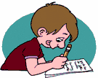

**Optional homework**

Create your own vocab cards and learn the new vocabulary.

**Method of operation**

A double-acting cylinder is used as a drive.

The piston rod advances and retracts only gradually (**exhaust air flow control!**)

The piston rod of the cylinder advances automatically as soon as pushbutton S1 is actuated. Actuation of pushbutton S2 causes the piston rod to retract.

**The piston rod of the cylinder also needs to be advanced when the pushbutton S1 is pressed only briefly. Therefore the activation of the pushbutton must be stored.**

1. Read the method of operation carefully. Work in pairs and translate the method of operation into German. **Goal: You understand every detail of the text.**

1. Tick the correct displacement-step diagram.

_

_

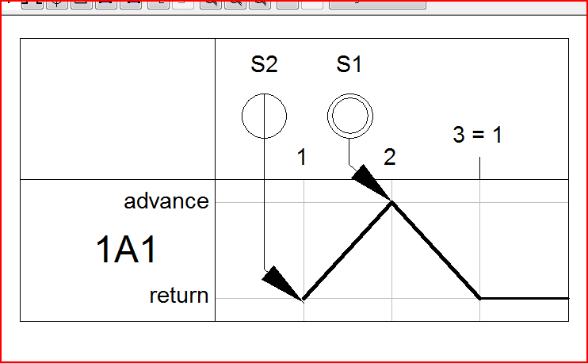 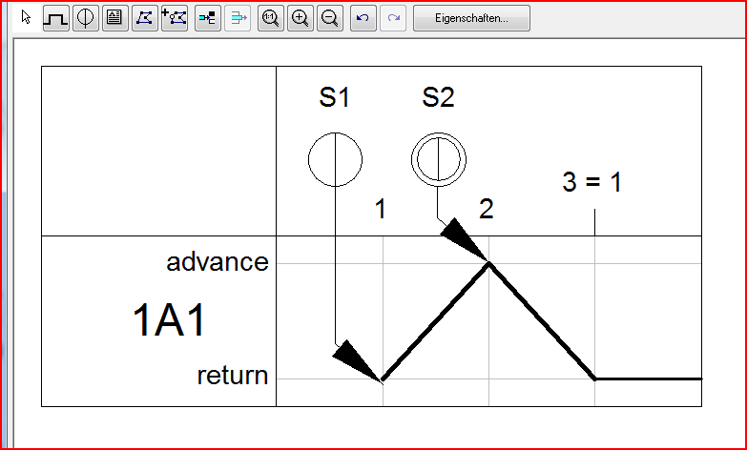

X

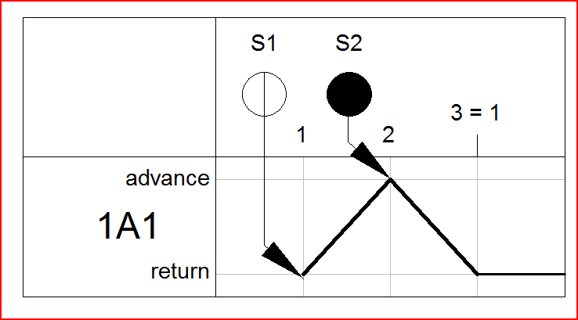 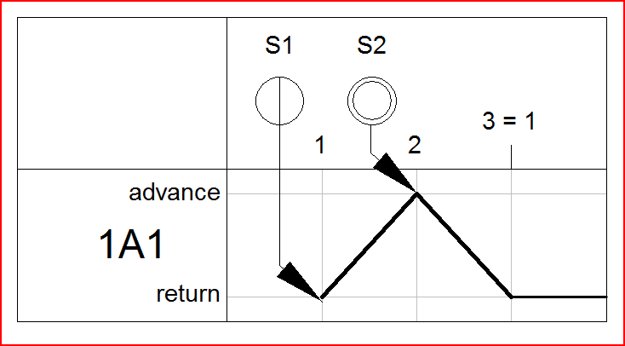

**Equipment list**

1. Complete the equipment list below.

|  |  |  |  |
| --- | --- | --- | --- |
| **Quantity** | **Picture** | **Description** | **Beschreibung** |
| 1 |  | double-acting cylinder | doppeltwirkender Zylinder |
| 1 |  | signal input plate, electrical | Signaleingabe, elektrisch |
| 1 |  | …3-off relay | Relais, 3-fach |
| 1 |  | 5/2-way single solenoid valve with LED | 5/2 Magnetventil mit LED |
| 2 |  | one-way flow control valve | Drosselrückschlagventil |
| 1 |  | manifold | Verteilerblock |
| 1 |  | start-up valve  with filter control valve | Einschaltventil  mit Filterregelventil |
| 1 | - | compressed air supply | Druckluftversorgung |
| 1 | - | power supply unit 24 VDC | Netzgerät 24 VDC |

**Calculating the current consumption of a valve coil**

A spring-return solenoid valve is actuated via pushbutton S1.

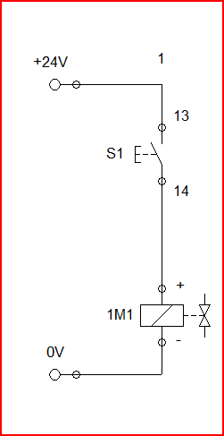

0 V

14

1. Calculate the current consumption *[=Stromverbrauch]* of the valve coil 1M1 at a voltage supply of 24 VDC and a coil resistance of 48 Ω.

$$I=\frac{U}{R}=\frac{24V}{48Ω}=0.5A$$

**5/2-way single solenoid valve**

1. Label the circuit symbol using the following terms:

* *manual override*
* *pilot control*
* *solenoid coil*

Manual override

solenoid control

Pilot control

**Design the pneumatic and electrical circuit diagrams**

1. Use *FluidSIM* and draw the **pneumatic circuit diagram**. Label all the **connections with the correct numbers** and mark the components with the appropriate **designation of elements**. Simulate your circuit and verify the accuracy of its function.

 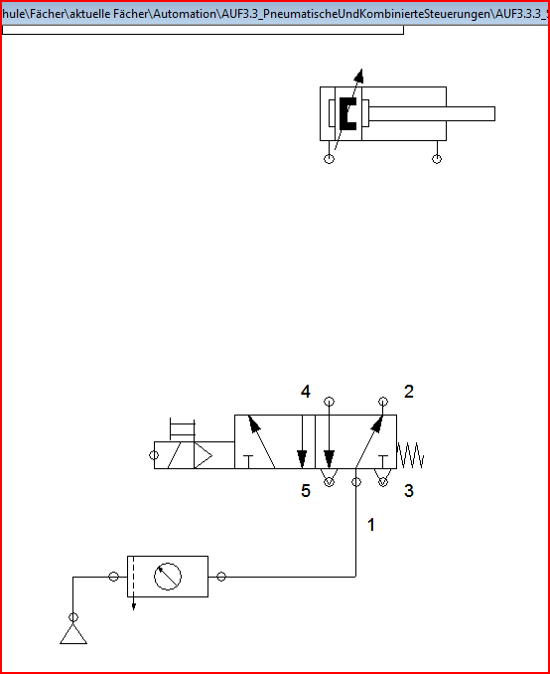

1. Use *FluidSIM* and draw the **detached circuit diagram** of the cylinder control. Label all the **connections with the correct numbers** and mark the components with the appropriate **code letter**. Simulate your circuit and verify the accuracy of its function.

 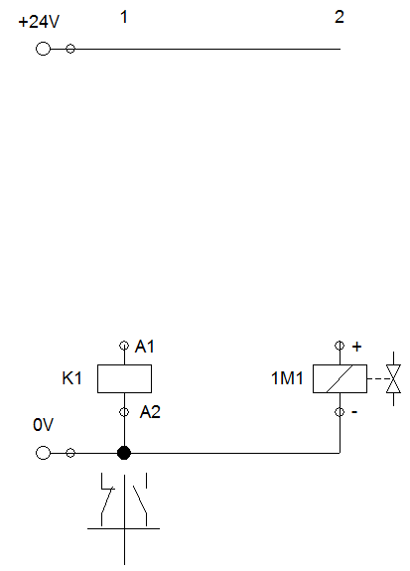

14

0 V

**Analysing circuits**

1. Describe the performance *[=Betriebsverhalten]* of the circuit in the event of an electrical power supply failure and/or pressure failure.

**Electrical power supply failure:**

If the electrical power supply fails the Cylinder will retract into the rear end position.

**Pressure failure :**

If the pressure fails the cylinder stops and will finish his action after the pressure is fixed.