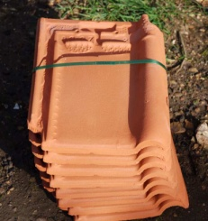***Palletising Roof Tiles***

**Introduction**

Stacks of roof tiles are strapped together.

The resulting sets are then transported to a

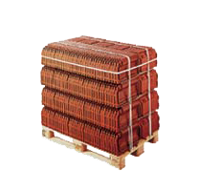pallet loading station where they are transfered

to Euro pallets.

**Tasks**

1. Read the introduction carefully and match the English expressions to the pictures in the table below. Work on your own and do it without the aid of a dictionary.

|  |  |  |  |  |
| --- | --- | --- | --- | --- |
| No. | English |  | Nr. | Picture |
| 1 | roof tile |  | 3 | http://imghost.indiamart.com/data/9/J/MY-284691/Euro_Pallets_250x250.jpg |
| 2 | pallet loading station |  | 1 | http://www.asia.ru/images/target/img/product/11/54/88/11548852.jpg |
| 3 | Euro pallets |  | 2 | http://www.cornpro.co.uk/products/pl441ms.jpg |

1. Work in pairs and translate the introduction into German. **Goal: You understand every detail of the text.**

Learning objectives:

By the end of this learning sequence you will be …

* … familiar with displacement-step diagrams.
* … able to realise a sequence control using two cylinders.
* … familiar with the design and mode of operation of magnetic proximity sensors (reed switch).

**Optional homework**

Create your own vocab cards and learn the new vocabulary.

**Method of operation**

Double-acting cylinder 1A1 advances when pushbutton S1 is pressed. A stack of roof tiles is transported to the loading station and sensor 1B2 is actuated. Single-acting cylinder 2A1 advances, pushes the package onto the pallet and actuates sensor 2B2. If sensor 2B2 is actuated and S1 is unactuated, cylinder 1A1 retracts. 1B2 is no longer actuated and single-acting cylinder 2A1 retracts.

The advanced end position of the double-acting cylinder and also the advanced end position of the single-acting cylinder will be detected with a magnetic proximity sensor (reed switch).

1. Read the method of operation carefully. Work in pairs and translate the method of operation into German. **Goal: You understand every detail of the text.**

1. Tick the correct design of the **displacement-step diagram**.

_

_

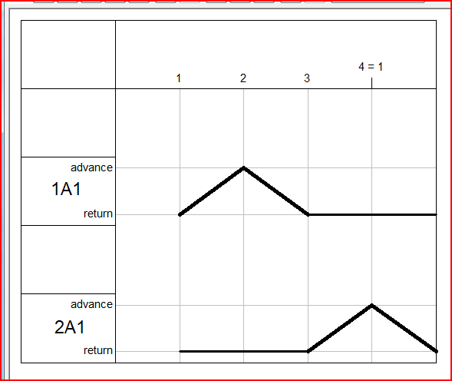 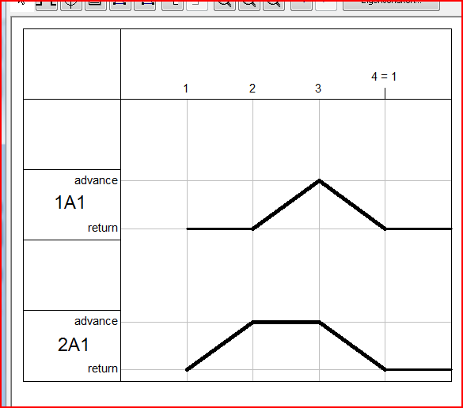

_

X

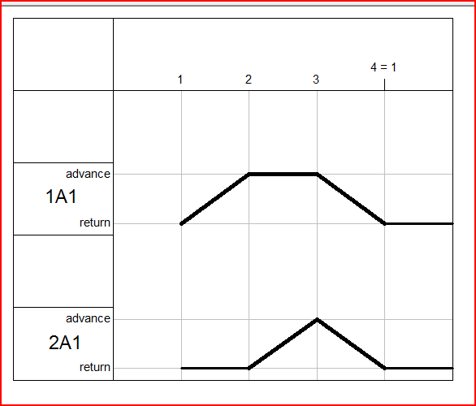 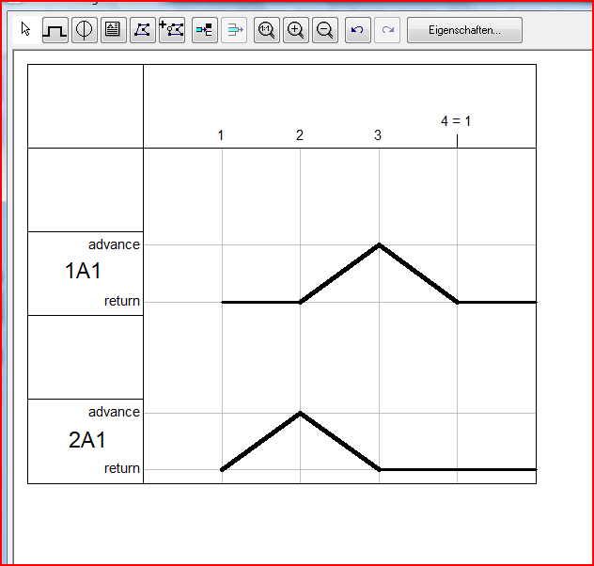

**Equipment list**

1. Complete the equipment list below.

|  |  |  |  |
| --- | --- | --- | --- |
| **Quantity** | **Picture** | **Description** | **Beschreibung** |
| 1 |  | Double acting Cylinder | doppeltwirkender Zylinder |
| 1 |  | Single acting Cylinder | einfachwirkender Zylinder |
| 1 |  | signal input plate, electrical | Signaleingabe, elektrisch |
| 2 | Näherungsschalter, elektronisch 540695 | Proximity switch | Näherungsschalter, elektronisch |
| 1 |  | Relais, -off | Relais, 3-fach |
| 1 |  | 5/2-way double solenoid valve with LED | 5/2-Wege-Magnet-Impulsventil mit LED |
| 1 |  | 2x 3/2-way single solenoid valve with LED, in | 2x 3/2-Wege-Magnetventil mit LED, in Ruhestellung gesperrt |
| 3 |  | one-way flow control valve | Drosselrückschlagventil |
| 1 |  | Manifold | Verteilerblock |
| 1 |  | start-up valve  with filter control valve | Einschaltventil  mit Filterregelventil |
| 1 | - | Compressed air supply | Druckluftversorgung |
| 1 | - | Power supply unit 24VDC | Netzgerät 24 VDC |

**Function of a magnetic proximity sensor (reed switch)**

In contrast with limit switches, proximity sensors are switched contactlessly and without any external mechanical actuating force.

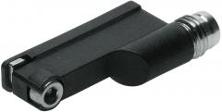 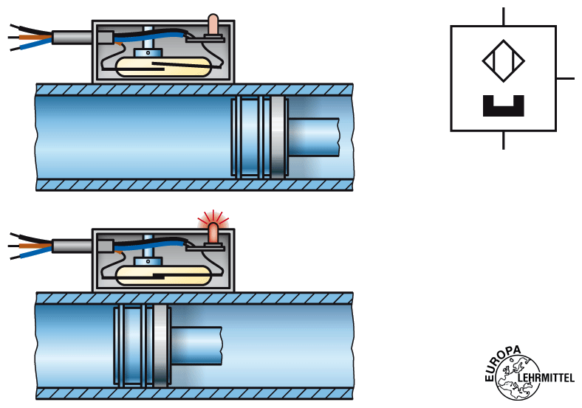

Fig.: Schematic representation of a magnetic proximity sensor (reed switch)

**Reedschalter** *[=reed switch]* sind **magnetisch betätigte Näherungsschalter**. Sie bestehen aus zwei Kontaktzungen, die sich in einem schutzgasgefüllten Glasröhrchen befinden. Durch Einwirkung eines Magneten wird der Kontakt zwischen den beiden Zungen geschlossen, so dass ein elektrischer Strom fliessen kann. Reedschalter weisen eine hohe Lebensdauer und eine geringe Schaltzeit auf.

Open the **datasheet** of the magnetic proximity sensor *(🡪* ***540695.pdf****)* and work through the tasks f), g), h) and i).

1. Tick the symbol of a magnetic proximity sensor.

_

_

X

_

_

**    **

1. Look up the **switching time** of the sensor.

ON: 0,5ms OFF: 0,5ms

1. Does the magnetic proximity sensor have **protection against polarity reversal** [=Verpolungsschutz]?

X

_

JA NEIN

1. Does the magnetic proximity sensor have **short-circuit protection** [=Kurzschlussschutz]?

_

X

JA NEIN

**Design the pneumatic and electrical circuit diagrams**

1. Use *FluidSIM* and draw the **pneumatic circuit diagram**. Label all the **connections with the correct numbers** and mark the components with the appropriate **designation of elements**. Simulate your circuit and verify the accuracy of its function.

 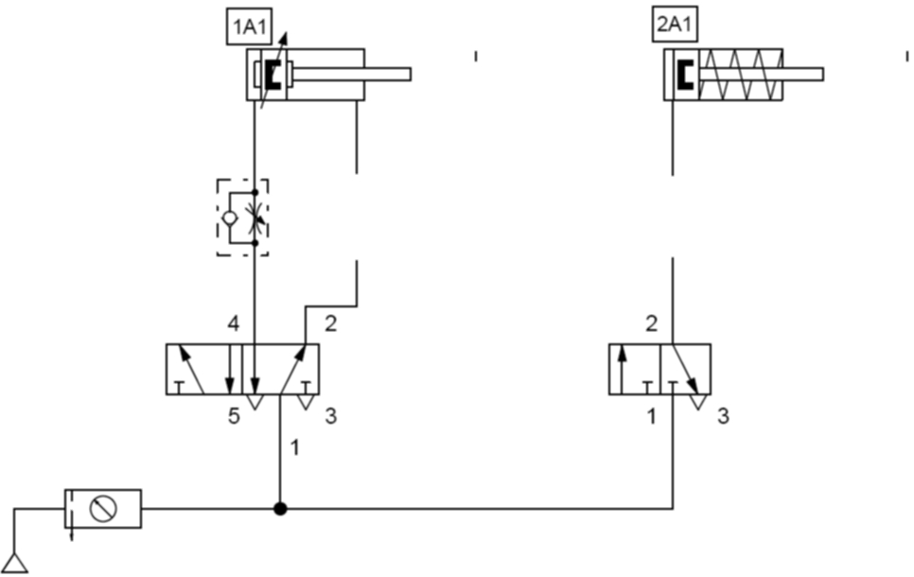

1. Use *FluidSIM* and draw the **detached circuit diagram** of the cylinder control. Label all the **connections with the correct numbers** and mark the components with the appropriate **code letter**. Simulate your circuit and verify the accuracy of its function.

 