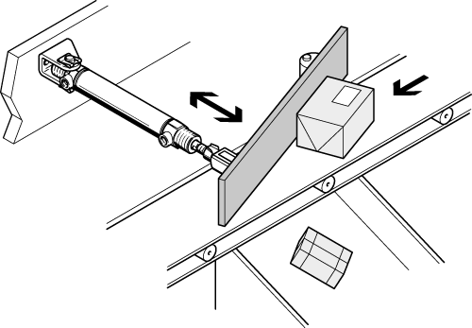***Sorting of packages***

**Introduction**

Packages are transported on a conveyor belt past workstations. The packages can be diverted by means of deflectors.

**Tasks**

1. Read the introduction carefully and match the English to the German expression in the table below. Work on your own and do it without the aid of a dictionary.

|  |  |  |  |  |
| --- | --- | --- | --- | --- |
| No. | English |  | Nr. | German |
| 1 | conveyor belt |  | 2 | Arbeitsplatz |
| 2 | workstation |  | 3 | Weiche |
| 3 | deflector |  | 1 | Transportband |

1. Work in pairs and translate the introduction into German. **Goal: You understand every detail of the text.**
2. Label the **positional sketch** using the following terms :

* *package*
* *double-acting cylinder*
* *deflector*
* *conveyor belt*

Conveyor belt

Double-acting Cylinder

Package

Deflector

Learning objectives:

By the end of this learning sequence you will be …

* … able to calculate piston forces according to specific values.
* … able to calculate electrical characteristic values.
* … able to explain and design an example of indirect actuation.



**Optional homework**

Create your own vocab cards and learn the new vocabulary.

**Method of operation**

A double-acting cylinder is used as a drive. The cylinder is monitored on both end-positions by **electromechanical limit switches** (1S1 and 1S2).

The piston rod advances and retracts only gradually (**exhaust air flow control!**)

The piston rod of the cylinder advances automatically as soon as pushbutton S1 is actuated. Please note: **Triggering of the advancing movement is only possible if the piston rod is in the retracted end position!**

In the front end-position, the cylinder actuates limit switch 1S2, which reverses final control element 1V1. Cylinder 1A1 is retracted.

1. Read the method of operation carefully. Work in pairs and translate the method of operation into German. **Goal: You understand every detail of the text.**

1. Tick the correct displacement-step diagram.

_

X

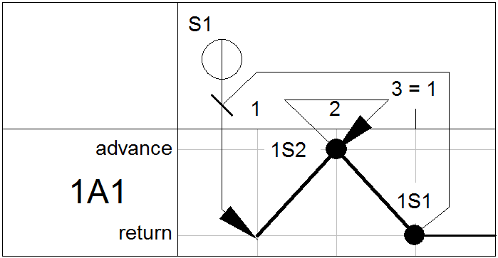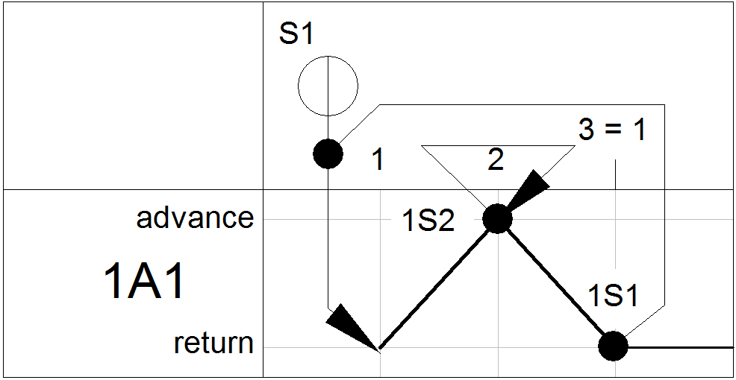

_

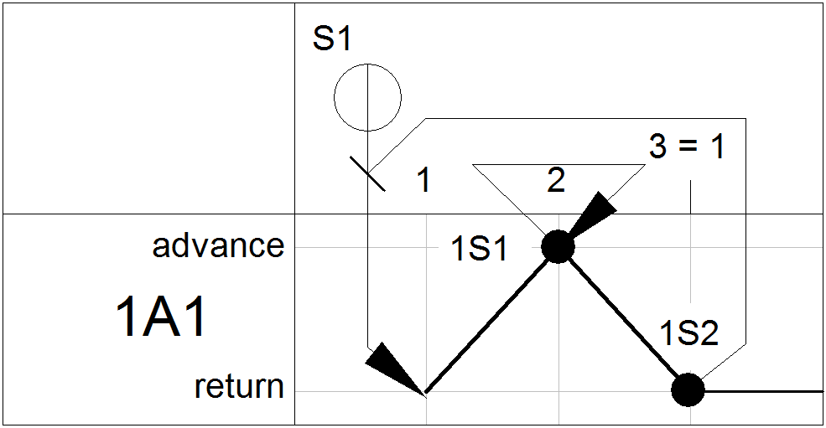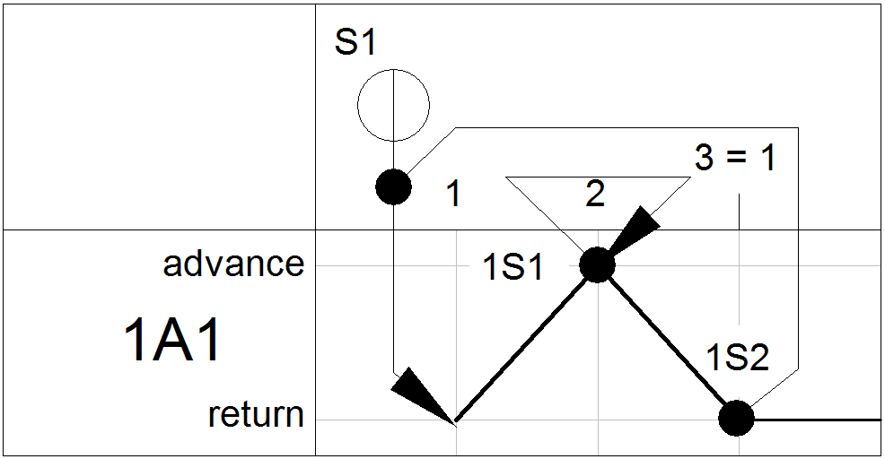

**Equipment list**

1. Complete the equipment list below.

|  |  |  |  |
| --- | --- | --- | --- |
| **Quantity** | **Picture** | **Description** | **Beschreibung** |
| 1 |  | double-acting cylinder | doppeltwirkender Zylinder |
| 1 |  | signal input plate, electrical | Signaleingabe, elektrisch |
| 1 |  | relay, 3-off | Relais 3 fach |
| 1 |  | limit switch, electrical, actuated from the left | Endschalter elekrisch von links betätigt |
| 1 |  | limit switch, electrical, actuated from the right | Endschalter elekrisch von rechts betätigt |
| 1 |  | 5/2-way double solenoid valve with LED | 5/2-Wege-Magnetimpulsventil mit LED |
| 2 |  | one-way flow control valve | Drosselrückschlagventil |
| 1 |  | manifold | Verteilerblock |
| 1 |  | start-up valve  with filter control valve | Einschaltventil  mit Filterregelventil |
| 1 | - | compressed air supply | Druckluftversorgung |
| 1 | - | power supply unit 24 VDC | Netzgerät 24 VDC |

**Calculation of piston force**

The piston of a double-acting cylinder has a diameter of 20 mm and the piston rod a diameter of 8 mm. The frictional losses *[=Reibungsverluste]* within the cylinder are 10 %.

1. Calculate the effective piston force of the advance stroke and the effective piston force of the return stroke at an operating pressure of 6 bar.

**Note:**

**1 bar = 100‘000 Pa = 100‘000 N/m2 = 0,1 N/mm2**

**Advance stroke:**

$$F=p_{e}∙A∙η=$$

$$0.6\frac{N}{mm^{2}}∙0.9∙\left({\left(10mm\right)}^{2}∙π\right)=169.6N$$

**Return stroke:**

$$F=p_{e}∙A∙η=6\frac{N}{mm^{2}}∙0.9∙({\left(10mm\right)}^{2}∙π-{\left(4mm\right)}^{2}∙π))=142.5N$$

**Calculation of electrical characteristic values**

A relay in an electropneumatic circuit is designated as follows: 580 Ω , 1 W.

1. Calculate the permissible *[=zulässige]* operating voltage which ensures that no overload occurs on the relay.

$$U_{max}=\sqrt{P∙R}=\sqrt{580Ω∙1W}=24V$$

**5/2-way double solenoid valve**

1. Label the circuit symbol using the following terms :

* *Vorsteuerung - pilot control*
* *Handbetätigung - manual override*

Pilot control

Solenoid coil

Manual override

* *Magnetspule - solenoid coil*

Handbetätigung

Magnetspule

Vorsteuerung

**Design the pneumatic and electrical circuit diagrams**

1. Use *FluidSIM* and draw the **pneumatic circuit diagram**. Label all the **connections with the correct numbers** and mark the components with the appropriate **designation of elements**. Simulate your circuit and verify the accuracy of its function.

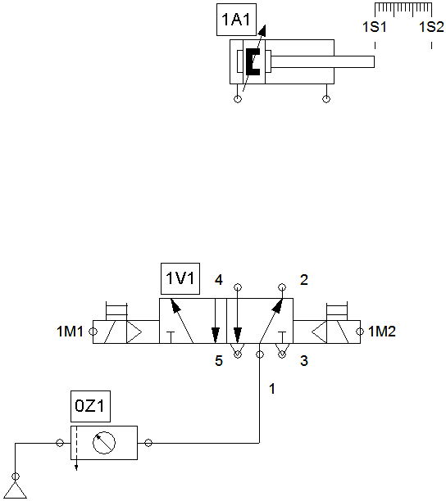

1. Use *FluidSIM* and draw the **detached circuit diagram** of the cylinder control. Label all the **connections with the correct numbers** and mark the components with the appropriate **code letter**. Simulate your circuit and verify the accuracy of its function.

