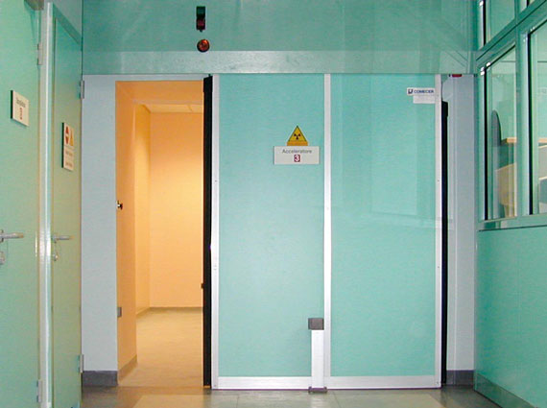***Actuation of a sliding door***

**Introduction**

A sliding door is opened and closed from both sides by means of a pushbutton. Only one pushbutton is located on each side of the door in order to eliminate incorrect operation in cases of emergency.

**Tasks**

1. Read the introduction carefully and complete the table below. Work on your own and do it without the aid of a dictionary.

|  |  |
| --- | --- |
| English | German |
| sliding door | Schiebetür |
| (to) locate | Platzieren |
| (to) eliminate | Beseitigen |
| incorrect operation | Fehlbedinung |
| cases of emergency | Im falle eines norfalls |



1. Work in pairs and translate the introduction into German. **Goal: You understand every detail of the text.**

1. Which statement is correct? Tick the correct meaning.

* Zur Bedienung der Schiebetüre werden vier Drucktaster benötigt.

_

* Zur Bedienung der Schiebetüre werden zwei Drucktaster benötigt.

X

Learning objectives:

By the end of this learning sequence you will be …

* … able to explain and realise logic AND/OR operations.
* … able to combine logic operations.
* … familiar with the design and mode of operation of a magnetic proximity switch.

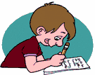**Optional homework**

Create your own vocab cards and learn the new vocabulary.

**Method of operation**

Provided that the sliding door is in a defined end position, it can be moved into the opposite end position by means of pressing a pushbutton. The sliding door can thus be opened and closed. It is not possible to start the opening or closing function as long as the door is not in an end position.



1. Work in pairs and translate the method of operation into German. **Goal: You understand every detail of the text.**
2. Complete the „Funktionsbeschreibung“ below.

Befindet sich die Schiebetüre in einer definierten Endlage, kann es durch den drücken des Drucktasters in die andere Endlage gebracht werden . Dadurch kann sie geöffnet oder geschlossen werden. Solange sich die Tür nicht in der Endlage befindet kann der Schliess oder Öffnen Vorgang nicht gestartet werden.

**Function of a pneumatic proximity sensor**

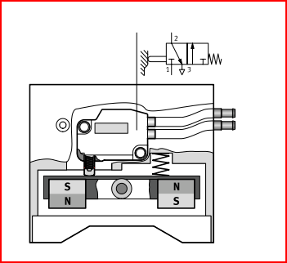

Fig. : Schematic representation of a pneumatic proximity sensor

Der **pneumatische Näherungsschalter** besteht aus einem 3/2-Wege-Stösselventil, in Ruhestellung geöffnet, und einer Wippe mit 2 Permanentmagneten. Durch eine Druckfeder wird über die Wippe der Stössel des Ventils betätigt. Durch das Magnetfeld des Magneten auf dem Kolben eines Zylinders kippt die Wippe. Das Ventil ist nicht mehr betätigt und am Ausgang des Ventils steht ein Druckluftsignal an.

1. Tick the symbol of a pneumatic proximity sensor.

X

_

_

_

_



**Equipment list** *[=Materialliste]*

1. Complete the equipment list below.

|  |  |  |  |
| --- | --- | --- | --- |
| **Quantity** | **Picture** | **Description** | **Beschreibung** |
| 1 |  | double-acting cylinder | doppeltwirkender Zylinder |
| 2 |  | 3/2-way valve with pushbutton actuator, normally closed | 3/2-Wegeventil mit Drucktaster, in Ruhestellung gesperrt |
| 2 |  | proximity switch, pneumatic, with cylinder attachment | pneumatischer Näherungsschalter, mit Zylinderbefestigung |
| 1 |  | 5/2 double piolet valve pneumatic actuated | 5/2-Wege-Pneumatik-Impulsventil |
| 2 |  | one-way flow control valve | Drosselrückschlagventil |
| 2 |  | Dual pressure valve | Zweidruckventil (UND) |
| 1 |  | Shutle valve | Wechselventil (ODER) |
| 1 |  | manifold | Verteilerblock |
| 1 |  | start-up valve  with filter control valve | Einschaltventil  mit Filterregelventil |
| 1 | - | compressed air supply | Druckluftversorgung |

**Design the pneumatic circuit diagram**

1. Use *FluidSIM* and draw the circuit diagram. Label all the **connections with the correct numbers** and mark the components with the appropriate **designation of elements**. Simulate your circuit and verify the accuracy of its function.

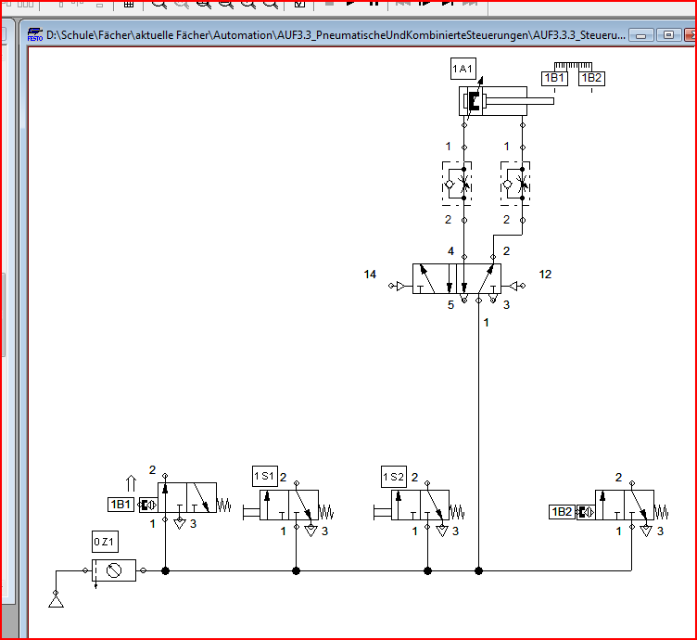

1. What happens if the compressed air supply fails during the advance or return movement?

It stops.

1. How can the circuit be re-started and what needs to be done for this?

If the compressed air supply restarts the cylinder finished the last action.