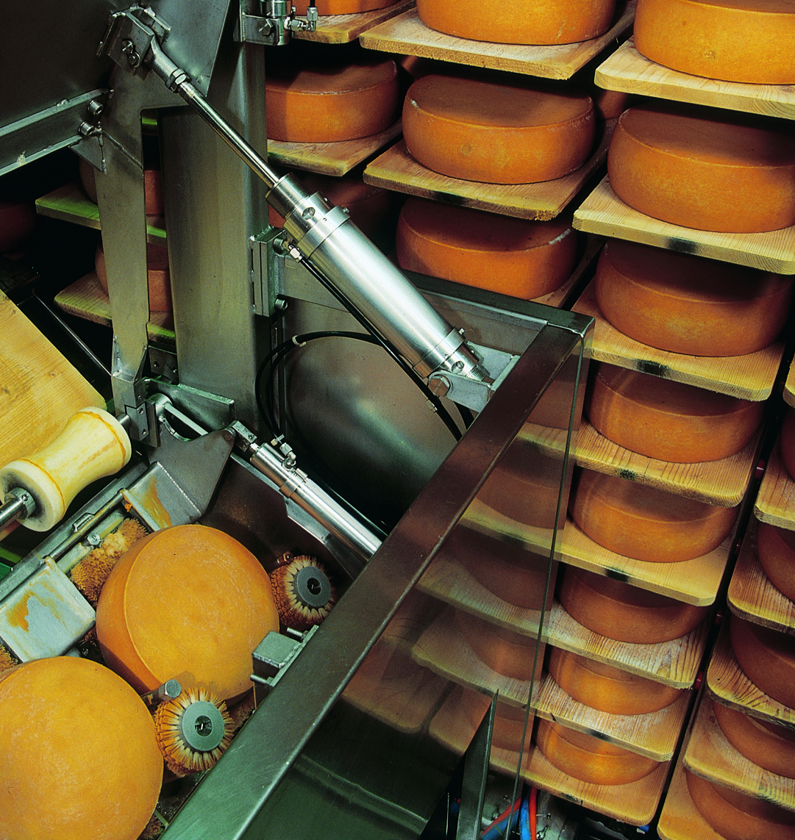***Brushing of cheese wheels***

**Introduction**

Cheese wheels are brushed during the production. The loading of the brushing device is controlled manually. The cheese wheels are supplied via a conveyor belt. Material flow is stopped by means of a slide if the device is filled.

**Tasks**

1. Read the introduction carefully and match the English to the German expressions in the table below. Work on your own and do it without the aid of a dictionary.

|  |  |  |  |  |
| --- | --- | --- | --- | --- |
| No. | English |  | Nr. | German |
| 1 | cheese wheels |  | 4 | anliefern |
| 2 | (to) brush |  | 1 | Käselaibe |
| 3 | brushing device |  | 2 | bürsten |
| 4 | (to) supply |  | 3 | Bürstvorrichtung |



1. Work in pairs and translate the introduction into German. **Goal: You understand every detail of the text.**
2. Which statement is correct? Tick the correct meaning.

* Ist die Bürstvorrichtung gefüllt, wird der Materialfluss durch einen Schieber angehalten.

X

* Ist die Bürstvorrichtung gefüllt, wird der Materialfluss durch einen Schieber freigegeben.

_

Learning objectives:

By the end of this learning sequence you will be …

* … able to explain and realise a logic OR operation.
* … able to explain and configure an indirect actuation.

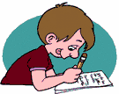**Optional homework**

Create your own vocab cards and learn the new vocabulary.

1. Read the method of operation carefully. Then complete the „Funktionsbeschreibung“ using the vocabulary word bank given below. Work on your own.

**Method of operation**

Actuation of the pushbutton causes the cylinder to advance and push the slide into the material flow. The cylinder retains this position even after the pushbutton is released and material flow remains interrupted. Actuation of the second pushbutton causes the cylinder to return into the retracted position and releases material flow again. It remains there until the first pushbutton is actuated again.

**Funktionsbeschreibung**

Durch Betätigung des Drucktasters fährt der Zylinder aus und drückt den Schieber in den Materialstrom. Der Zylinder bleibt auch nach Loslassen des Drucktasters in dieser Stellung und der Materialfluss bleibt unterbrochen. Durch Betätigung des zweiten Drucktasters fährt der Zylinder in die hintere Endlage und gibt den Materialfluss wieder frei. Er bleibt dort, bis der erste Drucktaster erneut betätigt wird.

|  |
| --- |
| Schieber |
| Zylinder |
| Materialfluss |
| Drucktaster |

|  |  |
| --- | --- |
| German | English |
| loslassen | (to) release |
| unterbrechen | (to) interrupt |
| beibehalten | (to) retain |
| freigeben | (to) release |
| bleiben | (to) remain |
| drücken | (to) push |
| betätigen | (to) actuate |

1. Complete the vocabulary word bank using the method of operation and the „Funktionsbeschreibung“ of task d). Work in pairs.

**Function of a shuttle valve**

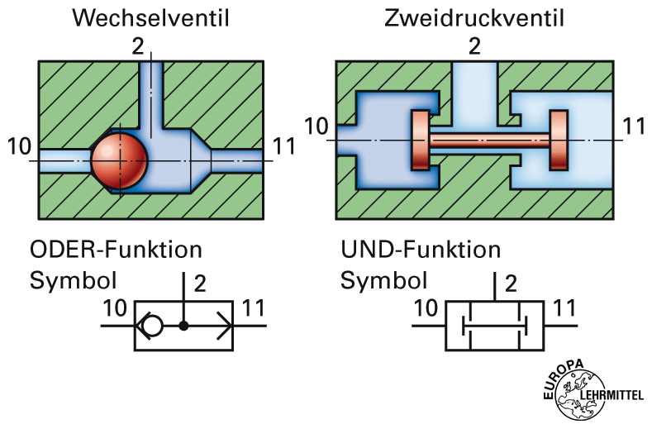

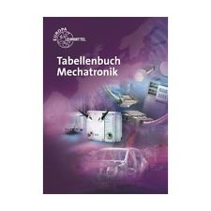 Fig. : Schematic representation of a shuttle valve

1. Open your „Tabellenbuch Mechatronik“ to page 271 and read the description of „Wechselventil“. Then read the German description below and complete the sentences.

Das Wechselventil wird zur logischen ODER-Verknüpfung eingesetzt. Druckluftsignale am Eingang 10, am Eingang 11 oder an beiden Eingängen bewirken ein Signal am Ausgang 2 . Kein Eingangssignal liefert auch kein Ausgangssignal. Stehen an beiden Eingängen Signale an, gelangt das Signal mit dem grösseren Druck zum Ausgang.

1. Tick the symbol of a shuttle valve.

_

X

_

_

_

**    **

**Equipment list** *[=Materialliste]*

1. Complete the equipment list below.

|  |  |  |  |
| --- | --- | --- | --- |
| **Quantity** | **Picture** | **Description** | **Beschreibung** |
| 1 |  | Double-acting Cylinder | doppeltwirkender Zylinder |
| 1 |  | 3/2-way valve with pushbutton actuator, normally closed | 3/2-Wegeventil mit Drucktaster, in Ruhestellung gesperrt |
| 1 |  | 3/2-way valve with pushbutton actuator, normally open | 3/2 Wgeventil mit Drucktaster schliesser |
| 1 |  | 3/2-way valve, pneumatically actuated, one side | 3/2-Wege-Pneumatikventil |
| 1 |  | 5/2-way valve, pneumatically actuated, one side | 5/2-Wege-Pneumatikventil |
| 2 |  | one-way flow control valve | Drosselrückschlagventil |
| 1 |  | shuttle valve (OR) | Wechselventil |
| 1 |  | Manifolder | Verteilerblock |
| 1 |  | start-up valve  with filter control valve | Einschaltventil  mit Filterregelventil |
| 1 | - | compressednair supply | Druckluftversorgung |

**Design the pneumatic circuit diagram**

1. Use *FluidSIM* and draw the required self-holding control circuit. Label all the **connections with the correct numbers** and mark the components with the appropriate **designation of elements**. Simulate your circuit and verify the accuracy of its function.

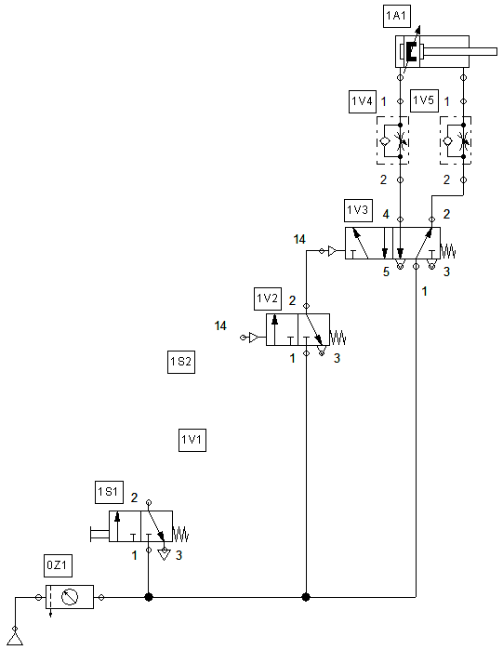

1. Complete the mode of operation of the self-holding control using the designation of elements (1S1, 1V3, …).

Actuation of the pushbutton at valve 1S1 causes the ball in the shuttle valve (OR) 1V1 to release compressed air flow. Since the valve 1S2 is switched through in the normal condition, the compressed air is able to actuate the 3/2-way valve 1V2. This causes the 5/2-way valve 1V3 to reverse and the cylinder piston to advance. The condition simultaneously becomes true via the return line to the shuttle valve (OR) 1V1. The pressure in the lines remains stored and maintains the valve 1V2 actuated. If the pushbutton at valve 1S2 is actuated, the pressure in the lines is exhausted, the valve 1V2 as well as the 5/2-way valve 1V3 are de-energized. The cylinder piston retracts again.