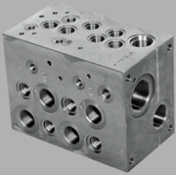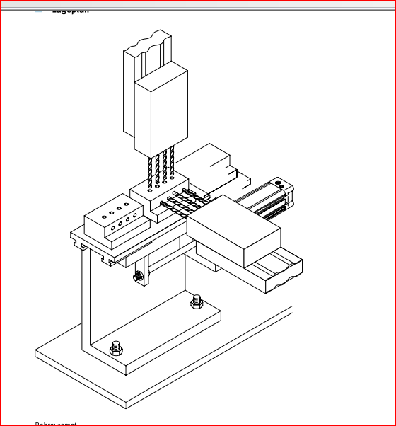***Drilling manifold blocks***

**Introduction**

Manifold blocks are drilled from the top and from the side with two pneumatic feed units. As the two drilling axes intersect, make sure that the first drilling operation has been completed before the second one is started.

**Tasks**

1. Read the introduction carefully and complete the table below. Work on your own and use an online dictionary if necessary.

|  |  |
| --- | --- |
| English | German |
| (to) drill | bohren |
| (to) intersect | kreuzen |



1. Work in pairs and translate the introduction into German. **Goal: You understand every detail of the text.**

1. Label the layout using the following terms:

* *vertical feed unit*

Vertical feed unit

Horizontal feed unit

Manifold block

Drill bit

* *horizontal feed unit*
* *manifold block*
* *drill bit*

Learning objectives:

By the end of this learning sequence you will be …

* … able to set up indirect actuation of cylinders.
* … familiar with the design and mode of operation of various sensors for monitoring the end-positions of a cylinder.

**Optional homework**

Create your own vocab cards and learn the new vocabulary.

**Method of operation**

Double-acting cylinders 1A1 (=vertical feed unit) and 2A1 (=horizontal feed unit) are monitored in the rear end-position by roller lever valve with idle return 1S2 and pneumatic proximity switch 2B1.

The process is started by means of a 3/2-way valve with pushbutton 1S1.

Cylinder 1A1 advances and simulates the first drilling operation. In the front end-position, the cylinder actuates roller lever valve 1S3, which reverses final control element 1V1. Cylinder 1A1 is retracted.

After cylinder 1A1 has returned to its rear end-position, roller lever valve with idle return 1S2 is switched to the free-flow direction and actuates final control element 2V1.

Cylinder 2A1 advances and simulates the second drilling operation. After reaching its front end-position, the cylinder actuates roller lever valve 2S1. Final control element 2V1 is reversed and cylinder 2A1 returns to its rear end-position where it actuates pneumatic proximity switch 2B1.

1. Read the method of operation carefully and complete the table below. Work on your own.

|  |  |
| --- | --- |
| English | German |
| rear end-position | Hintere Endlage |
| front end-position | Fordere Endlage |



1. Work in pairs and translate the method of operation into German. **Goal: You understand every detail of the text.**
2. The end-positions of the double-acting cylinders will be monitored by three different sensors. Enter the sensors in the table below.

|  |  |  |  |
| --- | --- | --- | --- |
|  | | **English** | **German** |
| double-acting cylinder 1A1 | rear end-position | 3/2-way roller lever valve with idle return | 3/2-Wege-Kipprollenventil |
| front end-position | 3/2-way roller lever valve | 3/2-Wege-Rollenhebelventil |
| double-acting cylinder 2A1 | rear end-position | 3/2-way pneumatic proximity switch | 3/2-Wege pneumatischer Näherungsschalter |
| front end-position | 3/2-way roller lever valve | 3/2-Wege-Rollenhebelventil |

**Displacement-step diagram (=Weg-Schritt-Diagramm)**

1. Complete the displacement-step diagram using the appropriate **designation of elements** (1S1/1S2/1S3/2B1/2S1).

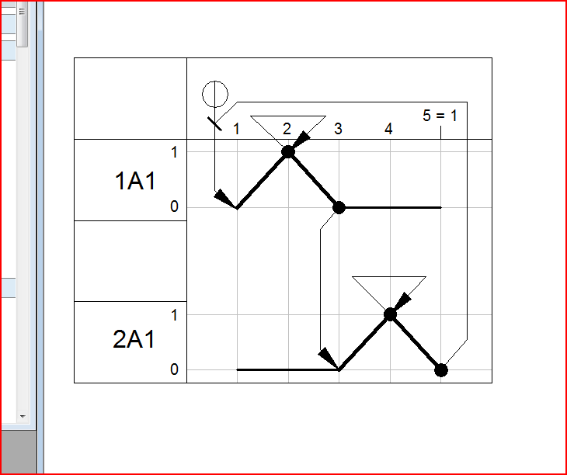

1S1

1S3

2B1

1S2

2S1

Die Zylinderbewegung ist

in Kurzschreibweise:

**1A1+ 1A1– 2A1+ 2A1-**

1. What does the dash stand for?

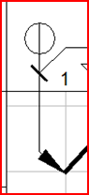

Logic function AND

**Function of a roller lever valve with idle return**

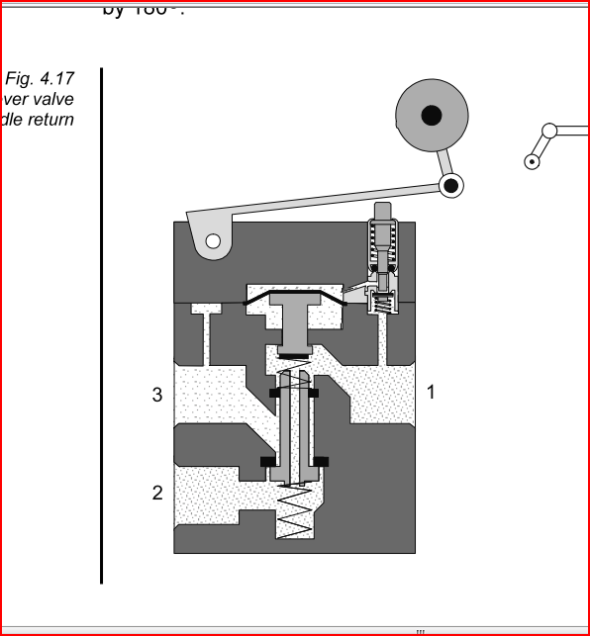

Fig. : Schematic representation of a roller lever valve with idle return

Das **Kipprollenventil mit Leerrücklauf** schaltet nur, wenn die Bewegung des Schaltnockens an der Kipprolle aus einer bestimmten Richtung erfolgt. Das Ventil wird als Grenztaster für die Positionsabfrage der ein- und ausgefahrenen Kolbenstange eingesetzt. Es ist darauf zu achten, dass das Ventil ordnungsgemäss in Bewegungsrichtung angebracht ist.

1. Tick the symbol of a roller lever valve with idle return.

_

X

_

_

_

** **

**Equipment list** *[=Materialliste]*

1. Complete the equipment list below.

|  |  |  |  |
| --- | --- | --- | --- |
| **Quantity** | **Picture** | **Description** | **Beschreibung** |
| 2 |  | double-acting cylinder | doppeltwirkender Zylinder |
| 1 |  | 3/2-way valve with pushbutton actuator, normally closed | 3/2-Wegeventil mit Drucktaster, in Ruhestellung gesperrt |
| 1 |  | proximity switch, pneumatic, with cylinder attachment | pneumatischer Näherungsschalter, mit Zylinderbefestigung |
| 2 |  | 3/2-way roller lever valve, normally closed | 3/2-Wege-Rollenhebelventil, in Ruhestellung gesperrt |
| 1 | Moser 014.JPG | 3/2-way roller lever valve with idle return, normally closed | 3/2-Wege-Kipprollenventil, in Ruhestellung gesperrt |
| 2 |  | 5/2-way double pilot valve, pneumatically actuated, both sides | 5/2-Wege-Pneumatik-Impulsventil |
| 2 |  | one-way flow control valve | Drosselrückschlagventil |
| 1 |  | manifold | Verteilerblock |
| 1 |  | start-up valve  with filter control valve | Einschaltventil  mit Filterregelventil |
| 1 | - | compressed air supply | Druckluftversorgung |

**Design the pneumatic circuit diagram**

1. Use *FluidSIM* and draw the circuit diagram. Label all the **connections with the correct numbers** and mark the components with the appropriate **designation of elements**. Simulate your circuit and verify the accuracy of its function.

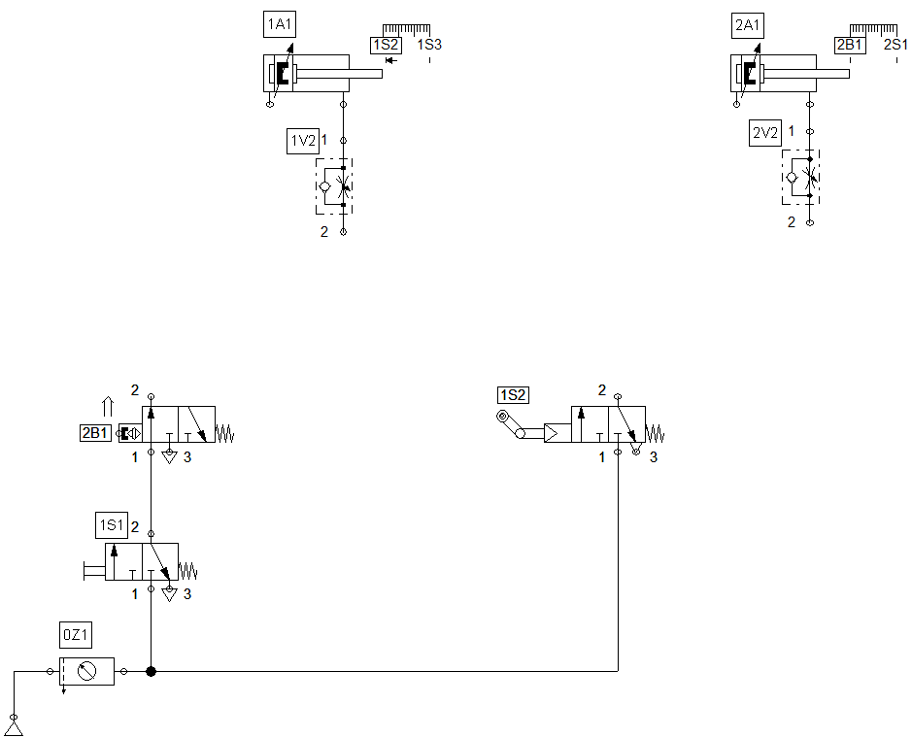

1. How does the controller respond when the roller lever valve 2S1 is shifted in the direction of the cylinder?

…