***Sorting of packages***

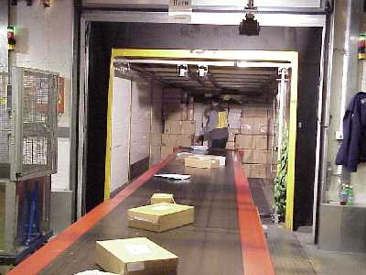**Introduction**

Packages are sorted manually by moving along a conveyor belt into large containers at a sorting station. When the containers are full, these are removed and new containers are made available. During this time material flow is stopped although the conveyer belt continues to run. The stopping action is realised by means of a mechanical blocking device (slide). This blocking device is operated from the sorting position.

**Tasks**

1. Read the introduction carefully and match the English to the German expression in the table below. Work on your own and do it without the aid of a dictionary.

|  |  |  |  |  |
| --- | --- | --- | --- | --- |
| No. | English |  | Nr. | German |
| 1 | conveyor belt |  | 5 | Sortierstation |
| 2 | mechanical blocking device |  | 4 | Sortierplatz |
| 3 | slide |  | 1 | Transportband |
| 4 | sorting position |  | 6 | Transportbehälter |
| 5 | sorting station |  | 3 | Schieber |
| 6 | containers |  | 2 | mechanische Sperre |

1. Work in pairs and translate the method of operation into German. **Goal: You understand every detail of the text.**
2. Which statement is correct? Tick the correct meaning.

* Während dem der volle Transportbehälter durch einen leeren Behälter ausgetauscht wird, läuft das Transportband weiter.

X

* Während dem der volle Transportbehälter durch einen leeren Behälter ausgetauscht wird, steht das Transportband still.

_

Learning objectives:

By the end of this learning sequence you will be …

* … familiar with the design and mode of operation of a double-acting cylinder.
* … familiar with the design and mode of operation of a 5/2-way valve.
* … able to explain and design an example of direct actuation.



**Optional homework**

Create your own vocab cards and learn the new vocabulary.

1. Read the method of operation carefully. Then complete the „Funktions-beschreibung“ using the vocabulary word bank given below. Work on your own.

**Method of operation**

Actuation of the selector switch causes the cylinder to advance and push the slide into the material flow. The cylinder remains in this position even after the selector switch is released and the material flow remains interrupted. Resetting of the selector switch causes the cylinder to return to the retracted end position and release the material flow again. The cylinder remains in this position until the selector switch is actuated again.

|  |  |
| --- | --- |
| selector switch | Wahlschalter |
| (to) advance [piston] | ausfahren [Kolben] |
| slide | Schieber |
| (to) remain | bleiben |
| retracted end position | hintere Endlage |
| (to) release | freigeben |

**Funktionsbeschreibung**

Durch Betätigung des Wahlschalters rückt der Zylinder vor und drückt den Schieber in den Materialstrom. Der Zylinder bleibt auch nach Loslassen des Wahlschalters in dieser Stellung und der Materialfluss bleibt unterbrochen. Durch Rückstellen des Wahlschalters fährt der Zylinder in die hintere Endlage und gibt den Materialfluss wieder frei . Er bleibt dort, bis der Wahlschalter erneut betätigt wird.

**Equipment list** *[=Materialliste]*

1. Complete the equipment list below.

|  |  |  |  |
| --- | --- | --- | --- |
| **Quantity** | **Picture** | **Description** | **Beschreibung** |
| 1 |  | double-acting cylinder | Doppeltwirkender Zylinder |
| 1 |  | 5/2-way valve  with selector switch | 5/2 Wgeventil mit Wahlschalter |
| 1 |  | manifold | Verteiler |
| 1 |  | start-up valve  with filter control valve | Wartungseinheit mit einschalt ventil |
| 1 | - | compressed air supply | Druckluftversorgung |

**Design and mode of operation of a double-acting cylinder**

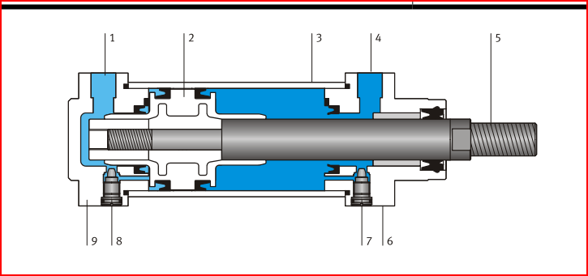

Fig. : Schematic representation of a double-acting cylinder

1. Match the designations to the individual components.

|  |  |  |  |  |
| --- | --- | --- | --- | --- |
| **No.** | **Designation** |  | **Nr.** | **Bezeichnung** |
| 3 | cylinder barrel |  | 5 | Kolbenstange |
| 5 | piston rod |  | 6 | Lagerdeckel |
| 2 | piston |  | 3 | Zylinderrohr |
| 4 | supply port of piston rod chamber |  | 7,8 | Einstellschrauben Endlagendämpfung |
| 1 | supply port of piston chamber |  | 2 | Kolben |
| 7,8 | adjusting screws of end position cushioning |  | 4 | Druckluftanschluss Kolbenstangenraum |
| 6 | bearing cap |  | 9 | Abschlussdeckel |
| 9 | end cap |  | 1 | Druckluftanschluss Kolbenraum |



1. What does the arrow in the symbol of a double-acting cylinder stand for?

The Cylinder has an adjustable end position cushioning

**Mode of operation of a 5/2-way valve**

1. Tick the symbol of a 5/2-way valve, manually operated, with spring return.

_

X

_

_



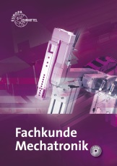

1. Open your „Fachbuch Mechatronik“ to page 434 and read the description of „Schieberventile“. Complete the mode of operation of the 5/2-way valve using the number of the ports!

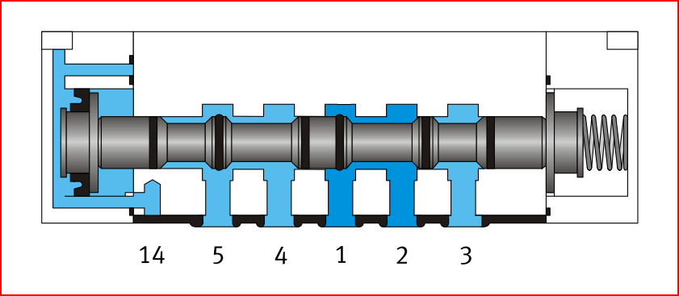

Fig.: Schematic representation of a 5/2-way valve

Beim abgebildeten Schieberventil wird der Steuerkolben durch Druckbeaufschlagung auf die Steuerleitung 14 verschoben. Dadurch strömt die Arbeitsluft von Anschluss 1 nach Anschluss 4 und die Abluft von Anschluss 2 nach Anschluss 3. Bei Abfall der Steuerluft am Anschluss 14 wird der Steuerkolben durch die Rückstellfeder in die Ausgangsstellung verschoben. Dadurch strömt die Arbeitsluft von Anschluss 1 nach Anschluss 2 und die Abluft von Anschluss 4 nach Anschluss 5 .

**Design the pneumatic circuit diagram**

1. Use *FluidSIM* and draw the circuit diagram. Label all the **connections with the correct numbers** and mark the components with the appropriate **designation of elements**. Simulate your circuit and verify the accuracy of its function.
2. Give the reason why a selector switch has been chosen instead of a pushbutton to design the actuating function.

Because we have a 5/3 way valve with a resetspring so you don’t have to designe a self-lalching function in the circiut .