***Terms from computer science***

**Introduction**

In connection with programmable logic controllers, terms from data and information processing such as **bit**, **byte**, **word** and **double word** are frequently used.

Learning objectives

By the end of this learning sequence you will …

* … be able to distinguish between bit, byte, word and double word.
* … understand the systematics of bit, byte, word and double word addressing.



**Optional homework**

Create your own vocab cards and learn the new vocabulary.

**Bit**

Bit is the abbreviation for binary digit. A bit is the smallest binary (bivalent) information unit which can have a signal status of "1" or "0".



Now work through task a).

**Task**

1. How many different conditions can be coded with a single bit?

Two conditions 0 or 1

**Byte**

The term byte is used for a unit of 8 binary characters.

Image1

Now work through task b).

**Task**

1. How many bits does a byte contain?

8

**Word**

A word is a sequence of binary characters, which is regarded as a unit in a specific connection. The word length corresponds to the number of the 16 binary characters. With words, the following can be represented:

 

Binary numbers

Letters

Control commands

Now work through task c).

**Task**

1. Complete the following sentence.

A word has the size of 2 bytes or 16 bits.

**Double word**

A double word corresponds to the word length of 32 binary characters. Further units are kilobit (kb) or kilobyte (kB), which stand for 210 or 1024 bits respectively 1024 bytes and the megabit (Mb) or megabyte (MB), which stands for 1024 kilobits respectively 1024 kilobytes.

Now work through tasks d) to f).

**Tasks**

1. Complete the following sentence.

A double word has the size of 2 words, 4 bytes or 32 bits.

1. A kilobyte corresponds to …

* 1024 bytes

x

* 1024 bit

* 512 bytes

_

_

* 1000 bit

1. 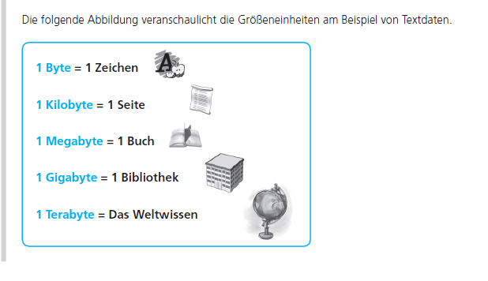 Put the sizes in the correct order, from the smallest to the biggest unit.

* bit, byte, kilobyte, terabyte, megabyte

* bit, megabyte, gigabyte, terabyte

x

* kilobyte, gigabyte, megabyte, terabyte

_

_

* byte, bit, kilobyte, megabyte

**Bit address**

Bits and bytes must be addressed, so that their data can be processed. Within each byte a number between 0 and 7 is assigned to each bit, the so-called bit address. The individual bits in a program are recognized through this bit address. The graphical representation of this 8-bit addressing is done from the right to the left. The rightmost bit is **bit 0** (the least significant bit) and the leftmost bit is **bit 7** (the most significant bit).

Image1

**Byte address**

The individual bytes also receive numbers called byte addresses. Additionally, the operand is still marked so that, for example, IB3 stands for input byte 3 and QB7 stands for output byte 7. Individual bits are clearly addressed by the combination of bit and byte addresses. The bit address is separated from the byte address by a point. The bit address is on the right of the point, whereas the byte address is on the left. Below you can see the schematic representation of input byte 0 with the inputs 0 to 7.

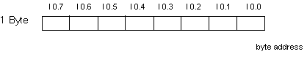

Now work through tasks g) and h).

**Tasks**

1. Label the following representation using the terms **bit**, **byte** and **flag**.

M20.4

flag

byte 20

bit 4

1. Which of the three terms in task g) is called operand?

The flag (M)

**Word address**

The numbering of words results in a word address. The word address is always the smallest address of the two pertinent bytes when using words, e.g. input word (IW), output word (QW), flag word (MW), etc. For example, for a word that is formed out of IB2 and IB3, the address is IW2.

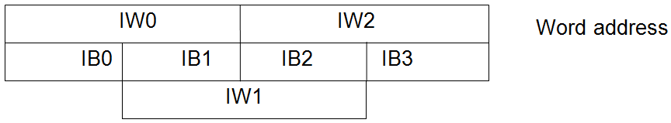

During word processing it is to be noted that, for example, the input word 0 and the input word 1 are in a „byte overlap“, and in addition, when counting bits, one begins at the rightmost bit. For example, bit 0 from IW1 gets the address I2.0, bit 7 gets the address I 2.7, and bit 8 receives the address I1.0. As you can see, there is a „jump“ between the bits 7 and 8.

**Double word address**

The numbering of double words results in a double word address. When using double words, e.g. ID, QD, MD etc., the double word address is the smaller word address of the two pertinent words.

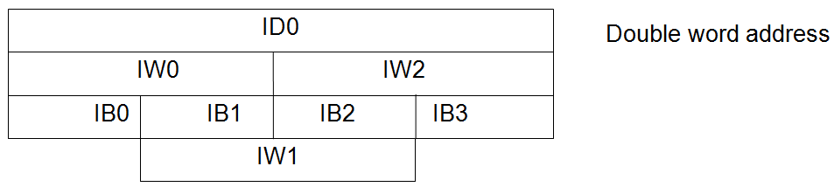

Now work through tasks i) to n).

**Tasks**

1. What is the address for bit 3 in IW1?

I2.3

1. What is the address for bit 14 in IW1?

I1.6

1. What is the address for bit 9 in IW2?

I2.1

1. What is the address for bit 12 in IW0?

I0.4

1. What is the word address for input bytes 5 and 6?

IW5

1. What is the double word address for input words 8 and 10?

ID8

**Vocabulary**

Complete the wordlist using just this document. **All the missing vocabulary is used within this worksheet.**

|  |  |
| --- | --- |
| English: | German: |
| Informatic | Informatik |
| bit | Bit |
| byte | Byte |
| Word | Wort |
| Doubleword | Doppelwort |
| Binary digit | Binärziffer |
| character | zweiwertig |
| Signe | Zeichen |
| (to) assigne | zuordnen |
| operand | Operand |
| Inputbyte | Eingangsbyte |
| Outputbyte | Ausgangsbyte |
| Flag | Merker |
| Flagword | Merkerwort |
| pertinet | dazugehörig |
| Byte overlap | Byte-Überschneidung |
| … | … |
| … | … |
| … | … |
| … | … |
| … | … |
| … | … |
| … | … |
| … | … |
| … | … |
| … | … |
| … | … |
| … | … |
| … | … |
| … | … |
| … | … |
| … | … |
| … | … |
| … | … |
| … | … |
| … | … |
| … | … |
| … | … |