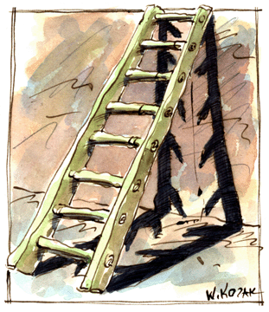***Ladder and Functional Block Programming***

**Introduction**

Ladder programming (LAD) and functional block programming (FBD) are methods of programming a PLC. This worksheet is an introduction to programming a PLC using ladder diagrams and functional block diagrams.

**Tasks**

1. Read the introduction carefully and match the English to the German expressions in the table below. Work on your own and do it without the aid of a dictionary.

|  |  |  |  |  |
| --- | --- | --- | --- | --- |
| No. | English |  | Nr. | German |
| 1 | LAD |  | 4 | Kontaktplan |
| 2 | FBD |  | 3 | SPS |
| 3 | PLC |  | 2 | FUP |
| 4 | ladder diagram |  | 5 | Funktionsplan |
| 5 | functional block diagram |  | 1 | KOP |

1. Work in pairs and translate the introduction into German. **Goal: You understand every detail of the text.**

Learning objectives:

By the end of this learning sequence you will be …

* … familiar with the basics about ladder and functional block programming.
* … able to match different ladder programs to functional block diagrams.

**Optional homework**

Create your own vocab cards and learn the new vocabulary.

**Ladder Diagrams**

As an introduction to ladder diagrams, consider the simple wiring diagram for an electrical circuit in figure a). The diagram shows the circuit for switching on or off an electric motor. We can redraw this diagram in a different way, using two vertical lines to represent the input power rails and stringing the rest of the circuit between them. Figure b) shows the result. Both circuits have the switch in series with the motor and are supplied with electrical power when the switch is closed. The circuit shown in figure b) is termed a ladder diagram.

+ 24 VDC

0 VDC

M1

M

Fig. a)

S1

0 VDC

+ 24 VDC

Fig. b)

M1

M

S1

With such a diagram, the power supply for the circuits is always shown as two vertical lines, with the rest of the circuit as horizontal lines. The power lines, or power rails, as they are often called, are like the vertical sides of a ladder, with the horizontal circuit lines similar to the rungs of the ladder. The horizontal rungs show only the control portion of the circuit; in the case of figure b) it is just the switch in series with the motor. Circuit diagrams often show the relative physical location of the circuit components and how they are actually wired. With ladder diagrams, no attempt is made to show the actual physical locations, and the emphasis is on clearly showing how the control is exercised.

Rung

1. 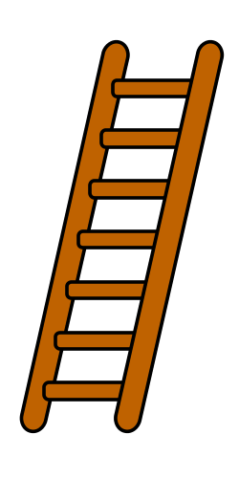Refer to the text above about ladder diagrams and label the different parts of a ladder using the correct technical term.

Rail

1. Tick the correct design of the ladder diagramaccording figure b).

M1

S1

S1

M1

( )

_

x

( )

1. Give the reason for your answer in d).

Because the Motor starts when s1 is closed so in other words if the input form s1 has a signal and same thing in the ladder diagram on the left if s1 has a signal the motor M1 starts. In the ladder diagram on the right side the input is inverted so motor m1 would be activated if s1 is not activated

1. Complete the table with the correct technical terms. Refer to the text about ladder diagrams.

S1

M1

( )

**1**

**2**

**3**

**4**

|  |  |  |
| --- | --- | --- |
| No. | Technical term | Technischer Begriff |
| 2 | Normaly opened contact | Schliesser |
| 4 | ladder rung | Programmzeile (Strompfad) |
| 3 | Output coil | Ausgang (Spule) |
| 1 | Power rail or power lines | Stromschiene |

**Functional Block Diagrams**

The term functional block diagram is used for PLC programs described in terms of graphical blocks. It is described as a graphical language for depicting signal and data flows through blocks, which are reusable software elements. A function block is a program instruction unit that, when executed, yields one or more output values. Thus a block is represented in the manner shown in figure c) with the function name written in the box.

Fig. c): Function block

Inputs

Output

Function

**Tasks**

1. Read the text about functional block diagrams carefully and match the English to the German expression in the table below. Work on your own and do it without the aid of a dictionary.

|  |  |  |  |  |
| --- | --- | --- | --- | --- |
| No. | English |  | Nr. | German |
| 1 | (for) depicting |  | 2 | wiederverwendbar |
| 2 | reusable |  | 3 | ausgeführt |
| 3 | executed |  | 4 | liefern/ergeben |
| 4 | sth. yields sth. |  | 1 | Darstellung |

1. Which types of function blocks do you know? Write down the names of 5 different types.

AND, OR, NOT, NANDT, NOR, XOR, timer, counter, SR memory box, RS memory box

1. Match the functional block diagrams to the ladder diagrams.

|  |  |  |  |  |  |  |  |  |
| --- | --- | --- | --- | --- | --- | --- | --- | --- |
| FBD | 1 | 2 | 3 | 4 | 5 | 6 | 7 | 8 |
| LAD | F | D | E | H | A | G | C | B |

**3**

**2**

**1**

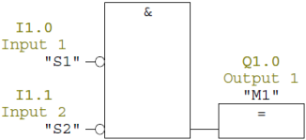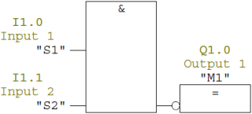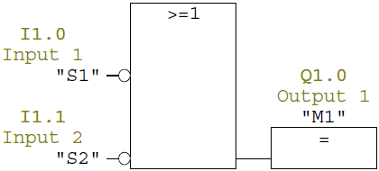

**6**

**5**

**4**

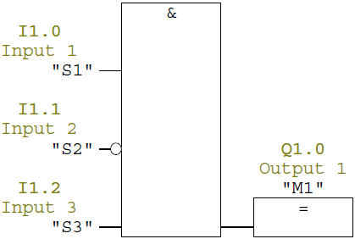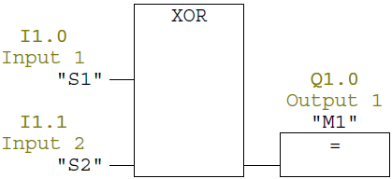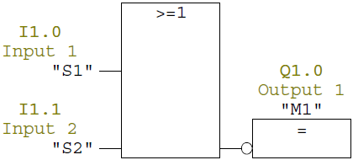

**8**

**7**

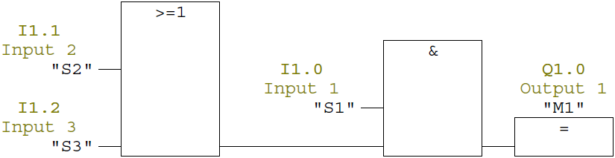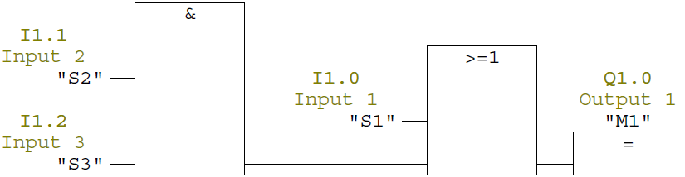

**A**

**B**

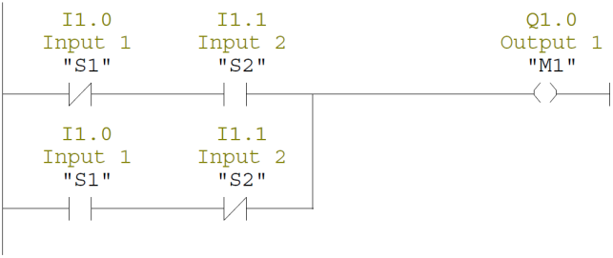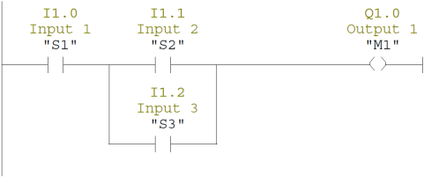

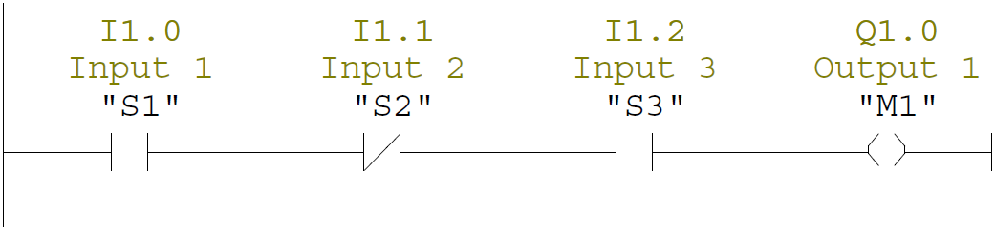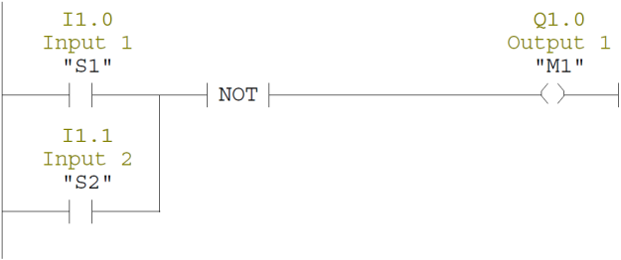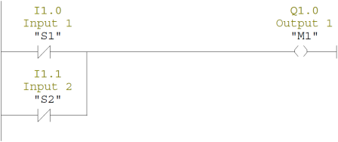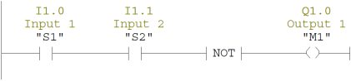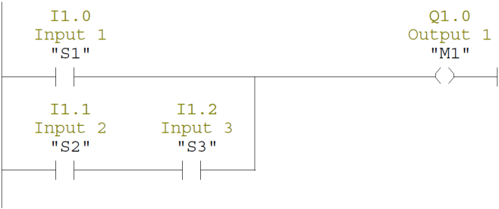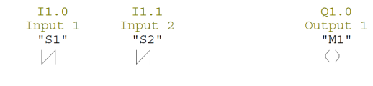

**G**

**H**

**F**

**D**

**C**

**E**