***Conveyor system*** *(Version 1)*

**Introduction**

Three conveyor belts need to be switched on separately and switched off commonly by means of pushbuttons. Each conveyor is engine-driven (by a three-phase induction motor) and each motor is protected against overload by using an overload relay. The PLC system S7-300 from Siemens is used to operate the control function.

Technology diagram

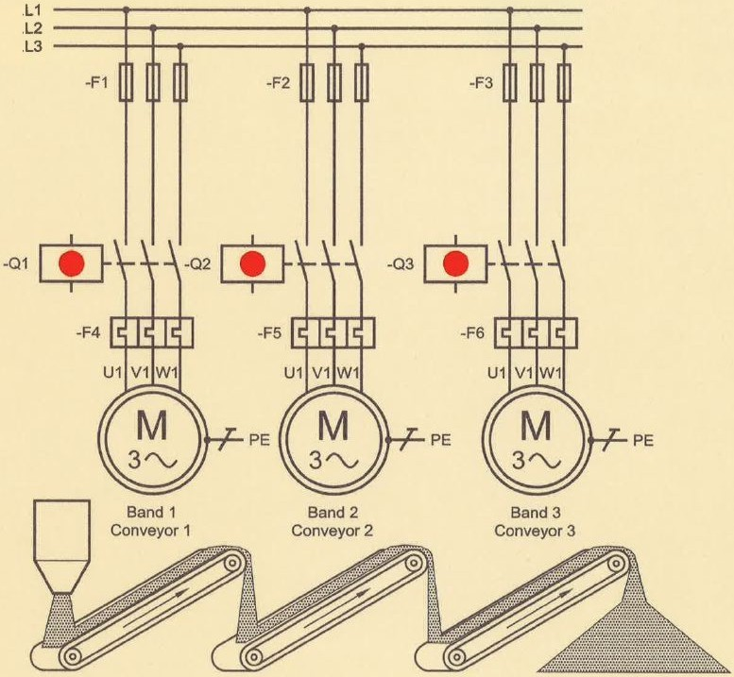 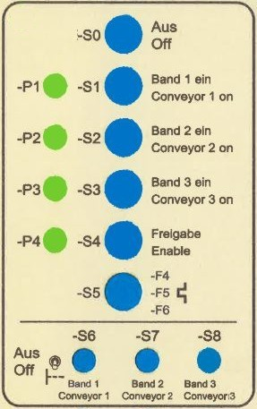

*Fig.1: Main circuit of the conveyor system Fig.2: Control panel*

Learning objectives

By the end of this learning sequence you will …

* … have successfully applied your knowledge of PLC in a practical example.
* … have worked out a structured PLC-program in the programming language FBD.
* … be able to create and work out all the required documents to record a PLC control task such as function diagram, connection diagram of PLC or symbol table.

**Optional homework**

Create your own vocab cards and learn the new vocabulary.

**Functional description**

The conveyor belts need to be switched on separately (S1, S2, S3) and switched off commonly (S0) by means of pushbuttons. One can start the system by the actuation of enable-pushbutton S4. To avoid filling up the conveyor system, one can switch on the conveyor belts only in the following starting sequence: Conveyor 3 followed by conveyor 2 and finally conveyor 1. The activated conveyors can be switched off at any time by pressing pushbutton S0. Actuation of pushbutton S0 also resets the enable signal. The auxiliary contacts of the overload relays F4, F5 and F6 are connected in series. In the event of an overload of one or more motors, normally closed contacts 95-96 on overload relays F4, F5 or F6 effects de-energization of the contactors Q1, Q2 and Q3 and as a result all conveyor belts stop. The response of overload relays F4, F5 and F6 can be simulated by pressing pushbutton S5.

Signal lamp P4 flashes with a clock frequency of 1.25 Hz while the enable status is active and it turns off when conveyor 3 is started. The on-status of the conveyors is indicated by means of the corresponding signal lamps P1, P2 and P3.

**Task**

Read the functional description carefully and discuss the following three questions in groups of three or four people. **Goals: You understand every detail of the text.**

* *In which order should the conveyor belts be started and why?*
* *How can you switch off the conveyor belts?*
* *What does P4 indicate?*

**Symbol table**

|  |  |  |
| --- | --- | --- |
| **Symbol** | **PLC-address** | **Comment** |
| S0 | I 124.0 | OFF (NC) |
| S1 | I 124.1 | Start conveyor 1 |
| S2 | I 124.2 | Start conveyor 2 |
| S3 | I 124.3 | Start conveyor 3 |
| S4 | I 124.4 | Enable |
| F4/F5/F6 (S5) | I 124.5 | Overload relay (NC) |
| Q1 (P1) | Q 124.0 | Conveyor 1 on |
| Q2 (P2) | Q 124.1 | Conveyor 2 on |
| Q3 (P3) | Q 124.2 | Conveyor 3 on |
| P4 | Q 124.3 | Enable activated |

**Tasks**

1. Work out the function diagram (Grafcet acc. EN60848) in accordance with the functional description.
2. Work out the connection diagram of PLC. Take the rules on wire breakage into account! The motor control must be fail-safe!
3. Create an S7-project and call it ***Convey_1***.
4. Work out the hardware configuration.
5. Create the symbol table using SIMATIC MANAGER.
6. Work out the PLC program in the programming language **FBD**.
7. Simulate your PLC program using PLCSIM.
8. Assemble and commission the conveyor system in the laboratory.
9. Present your solution to the teacher.

**Required documentations**

After finishing this control task, you are expected to file the following documents as hard copy:

* Function diagram (Grafcet)
* Connection diagram of PLC

After finishing this control task, you are expected to file the following documents as soft copy on „moodle“:

* S7-project *Convey_1.zap13*
* **Individual** conclusive comment on the control task *CC-Convey_1.docx*.

**Timetable**

Timetable according your teacher’s directions.

**Vocabulary**

Complete the wordlist using just this document! All the terms are used within this worksheet!

|  |  |
| --- | --- |
| English: | German: |
| … | Funktionsplan FUP |
| … | Förderanlage |
| … | Förderband |
| … | Einschaltreihenfolge |
| … | Freigabesignal |
| … | Taktfrequenz |
| … | Drahtbruch |
| … | drahtbruchsicher, fehlersicher, ausfallsicher |