***Conveyor system*** *(Version 2)*

**Introduction**

Three conveyor belts need to be switched on separately and switched off commonly by means of pushbuttons or switch off separately by means of toggle switches. Each conveyor is engine-driven (by a three-phase induction motor) and each motor is protected against overload by using an overload relay. The PLC system S7-300 from Siemens is used to operate the control function.

Technology diagram

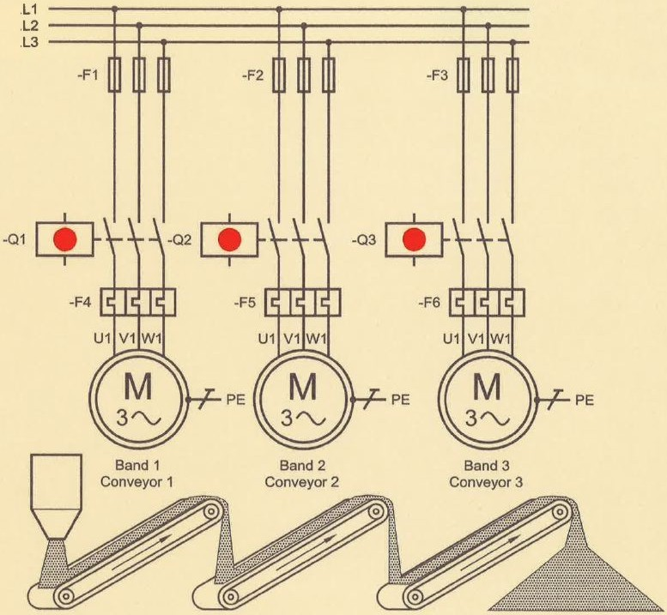 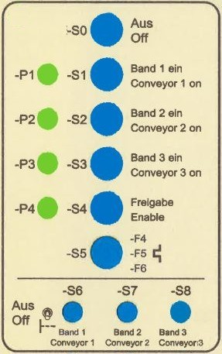

*Fig.1: Main circuit of the conveyor system Fig.2: Control panel*

Learning objectives

By the end of this learning sequence you will …

* … have successfully applied your knowledge of PLC in a practical example.
* … have worked out a structured PLC-program in the programming language LAD.
* … be able to create and work out all the required documents to record a PLC control task such as function diagram, connection diagram of PLC or symbol table.

**Optional homework**

Create your own vocab cards and learn the new vocabulary.

**Functional description** (version 1)

The basic control function of the conveyor system is given in the following electrical circuit diagram.

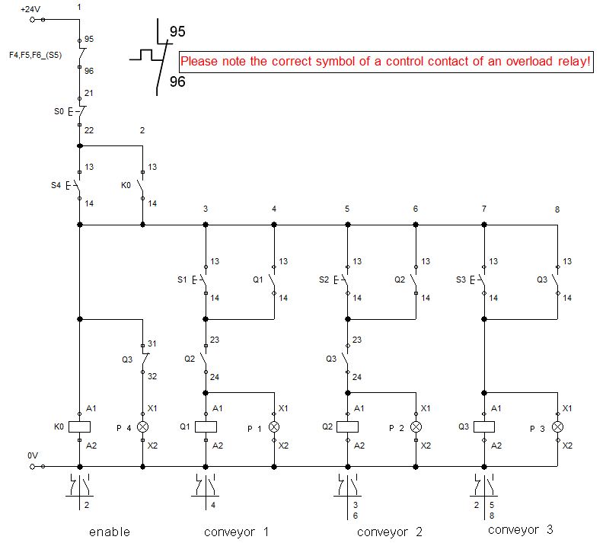

**Task**

Have a look at the electrical circuit diagram above and discuss the following three questions in groups of three or four people. **Goal: You understand how it works.**

* *In which order can one start the conveyor belts?*
* *How can you switch off the conveyor belt 3?*
* *What does P4 signalise?*

**Functional description** (version 2)

In addition, the three conveyor belts need to be switched off separately by means of toggle switches S6, S7 and S8. To avoid filling up the conveyor system, one can switch off the conveyor belts only in the following order: Conveyor 1 followed by conveyor 2 and finally conveyor 3.

**Symbol table**

|  |  |  |
| --- | --- | --- |
| **Symbol** | **PLC-address** | **Comment** |
| S0 | I 124.0 | OFF (NC) |
| S1 | I 124.1 | Start conveyor 1 |
| S2 | I 124.2 | Start conveyor 2 |
| S3 | I 124.3 | Start conveyor 3 |
| S4 | I 124.4 | Enable |
| F4/F5/F6 (S5) | I 124.5 | Overload relay (NC) |
| S6 | I 124.6 | Stop conveyor 1 (NC) |
| S7 | I 124.7 | Stop conveyor 2 (NC) |
| S8 | I 125.0 | Stop conveyor 3 (NC) |
| Q1 (P1) | Q 124.0 | Conveyor 1 on |
| Q2 (P2) | Q 124.1 | Conveyor 2 on |
| Q3 (P3) | Q 124.2 | Conveyor 3 on |
| P4 | Q 124.3 | Enable activated |

**Tasks**

1. Modify the electrical circuit diagram given according to the functional description (version 2) using FluidSIM. Call your FluidSIM file ***Convey_2***.
2. Complete the connection diagram of PLC. Take the rules on wire breakage into account! The motor control must be fail-safe!
3. Create an S7-project and call it ***Convey_2***.
4. Work out the hardware configuration.
5. Create the symbol table using SIMATIC MANAGER.
6. Work out the PLC program in the programming language **LAD**.
7. Simulate your PLC program using PLCSIM.
8. Assemble and commission the conveyor system in the laboratory.
9. Present your solution to the teacher.

**Extra Tasks**

1. Work out the function diagram (Grafcet acc. EN60848) in accordance with the functional description (version 2).
2. Create an S7-project and call it ***Convey_3***.
3. Work out the hardware configuration.
4. Create the symbol table using SIMATIC MANAGER.
5. Work out the PLC program in the programming language **FBD**.
6. Simulate your PLC program using PLCSIM.
7. Assemble and commission the conveyor system in the laboratory.
8. Present your solution to the teacher.

**Required documentations**

After finishing this control task, you are expected to file the following documents as hard copy:

* Connection diagram of PLC
* Function diagram (Grafcet) *[Only if you did the extra tasks!]*

After finishing this control task, you are expected to file the following documents as soft copy on „moodle“:

* FluidSIM file *Convey_2.circ*
* S7-project *Convey_2.zap13*
* S7-project *Convey_3.zap13 [Only if you did the extra tasks!]*
* **Individual** conclusive comment on the control task *CC-Convey_2.docx*.

**Timetable**

Timetable according your teacher’s directions.

**Vocabulary**

Complete the wordlist using just this document. All the terms are used within this worksheet.

|  |  |
| --- | --- |
| English: | German: |
| … | Kontaktplan KOP |
| … | Förderanlage |
| … | Förderband |
| … | Einschaltreihenfolge |
| … | Freigabesignal |
| … | Taktfrequenz |
| … | Drahtbruch |
| … | drahtbruchsicher, fehlersicher, ausfallsicher |
| … | Kippschalter |
| … | … |
| … | … |
| … | … |
| … | … |
| … | … |
| … | … |
| … | … |