***Heating control system***

**Introduction**

The **performance of the heating installation** in a storage area is to be controlled through power on/off of radiators. The PLC system S7-300 from Siemens is used to design the control function.

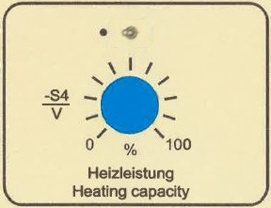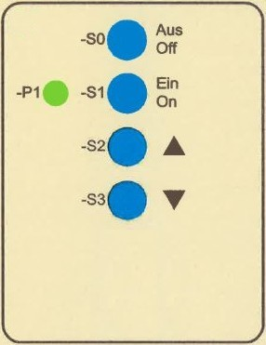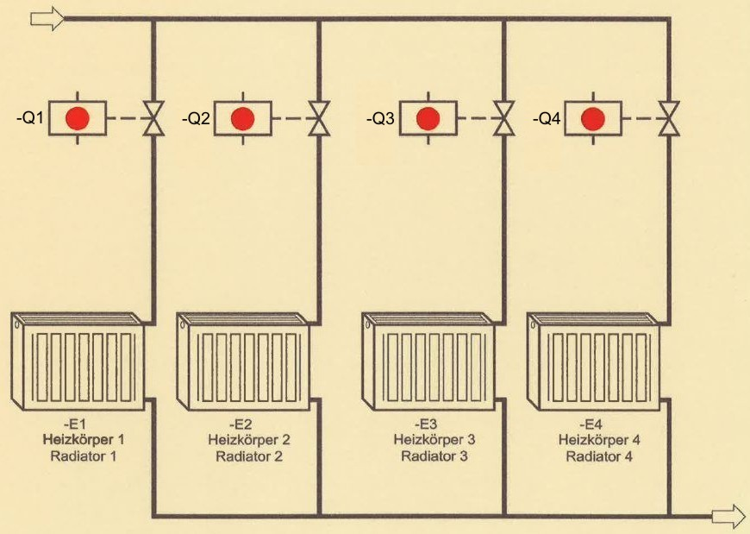

*Abb.1: Technology diagram of the heating control system Abb.2: Control panel*

The status of the four radiators must be indicated in the **control room** as follows:



|  |  |  |
| --- | --- | --- |
|  | **signal lamp** | **clock frequency [s]** |
| radiator 1 switched on | P10 flashes | 0,8 |
| radiator 2 switched on | P20 flashes | 1 |
| radiator 3 switched on | P30 flashes | 1,6 |
| radiator 4 switched on | P40 flashes | 2 |

Learning objectives

By the end of this learning sequence you will …

* … have successfully applied your knowledge of PLC in a practical example.
* … have understood the basics of analog value processing with PLC and you will have applied it in a practical example.
* … have worked out a structured PLC-program in the programming language FBD.
* ****… be able to create and work out all the required documents to record a PLC control task such as function diagram, connection diagram of PLC or symbol table.

**Homework**

Make your own vocab cards and learn the new vocabulary!

The following functions, 1 to 5, should be implemented **in sequence**. If a circuit function is designed on a previously designed circuit function, this is to be developed by amending or supplementing the previous circuit function. For this purpose use the function diagram (GRAFCET) or the parts of the program of the previous circuit function.

**Functional description 1**

The heating system is switched over to readiness with pushbutton S1 "on". Signal lamp P1 indicates the stand-by mode of the heating installation. By pressing pushbuttons S2 and S3, one can switch on or off the radiators in the sequence 1 to 4 and 4 to 1 via the valves Q1 to Q4. With the pushbutton S0 "off", the heating system can be switched off at any time.

**Functional description 2**

After assuming that all radiators have the same heating power, a different heating power of the radiators is now taken into account. So the following heat outputs can be switched with the valves Q1 to Q4:

|  |  |  |  |
| --- | --- | --- | --- |
| Q1: 1 KW | Q2: 2 kW | Q3: 4 kW | Q4: 8 kW |

As a result, the heating power can now be varied from 0 kW to 15 kW in increments of 1 kW.

**Functional description 3**

|  |  |
| --- | --- |
| 0 V | 0 % |
| 1 V | 10 % |
| … | … |
| 10 V | 100 % |

In accordance with functional description 1, the radiators

should now be switched on or off by setting the potentiometer S4. The linear setting range of the

potentiometer is given in the table beside.

**Functional description 4**

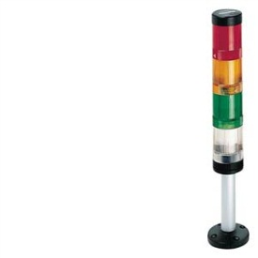In accordance with functional description 2, the radiators should now be switched on or off by setting the potentiometer S4.

**Functional description 5**

The heating control system (acc. to functional description 4) has to be extended with a signalling column which is able to communicate. The status of the four radiators must be indicated additionally in the **storage area** using a signalling column. The lamps of the column need to flash as follows:

|  |  |  |
| --- | --- | --- |
|  | **signal lamp** | **PLC-address** |
| radiator 1 switched on | http://www.mercateo.com/images/products/927_tgiautotech/8wd4400-1ab.jpg | **?** |
| radiator 2 switched on | http://www.insystems-shop.de/media/images/thumb/signalsule_gelb.jpg |
| radiator 3 switched on | http://www.mercateo.com/images/products/927_tgiautotech/8wd4400-1ac.jpg |
| radiator 4 switched on | http://support.automation.siemens.com/BE/llisapi.dll/csfetch/23218609/P_NSC0_XX_00179i.jpg |

**Symbol table**

|  |  |  |
| --- | --- | --- |
| **Symbol** | **PLC-address** | **Comment** |
| S0 | I 124.0 | Heating system off (NC) |
| S1 | I 124.1 | Heating system on (stand-by mode) |
| S2 | I 124.2 | Switch on any of the radiators |
| S3 | I 124.3 | Switch off any of the radiators |
| S4 | PIW 752 | Switch on/off any of the radiators |
| Q1 | Q 124.0 | Positioning valve Q1, feed radiator 1 |
| Q2 | Q 124.1 | Positioning valve Q2, feed radiator 2 |
| Q3 | Q 124.2 | Positioning valve Q3, feed radiator 3 |
| Q4 | Q 124.3 | Positioning valve Q4, feed radiator 4 |
| P1 | Q 125.0 | Heating system in stand-by mode |
| P10 | Q 125.4 | Radiator 1 is active |
| P20 | Q 125.5 | Radiator 2 is active |
| P30 | Q 125.6 | Radiator 3 is active |
| P40 | Q 125.7 | Radiator 4 is active |

**Tasks**

1. Work out the function diagram (Grafcet acc. EN60848) in accordance with the functional description.
2. Work out the connection diagram of PLC. Take the rules on wire breakage into account! The heating control must be fail-safe!
3. Create an S7-project and call it ***HeatCt1*** (resp. ***HeatCt2****/****HeatCt3****/****HeatCt4****/* ***HeatCt5***).
4. Work out the hardware configuration.
5. Create the symbol table using SIMATIC MANAGER.
6. Work out the PLC program in the programming language **FBD**.
7. Simulate your PLC program using PLCSIM.
8. Assemble and commission the heating control system in the laboratory.
9. Present your solution to the teacher.

**Required documentations**

After finishing this control task, you are expected to file the following documents as hard copy:

* Function diagram (Grafcet)
* Connection diagram of PLC

After finishing this control task, you are expected to file the following documents as soft copy on „moodle“:

* S7-project *HeatCt1.zip/ HeatCt2.zip/ HeatCt3.zip/ HeatCt4.zip/ HeatCt5.zip*
* **Individual** conclusive comment on the control task *HeatCt.docx*.

**Timetable**

According your teacher’s directions.

**Vocabulary**

Complete the wordlist **using just this document**! All the terms are used within this worksheet!

|  |  |
| --- | --- |
| English: | German: |
| … | Heizungssteuerung |
| … | Heizungsanlage |
| … | Lagerraum |
| … | Heizkörper |
| … | Kommandoraum |
| … | Analogwertverarbeitung |
| … | der Reihe nach |
| … | Abänderung |
| … | Ergänzung |
| … | Heizleistung |
| … | Einstellbereich |
| … | Signalsäule |
| … | Stellventil |
| to … | einspeisen |
| … | Drahtbruch |
| … | drahtbruchsicher, fehlersicher, ausfallsicher |
| … | Schlussbetrachtung |
| … | Zeitplan |
| … | … |
| … | … |
| … | … |
| … | … |
| … | … |
| … | … |
| … | … |
| … | … |
| … | … |
| … | … |
| … | … |
| … | … |