***Ventilation system***

**Introduction**

|  |  |
| --- | --- |
| Ampel - Set of Three  Stockfoto - 7151247 | If less than two fans are in operation, then no sufficient ventilation is ensured. |
| Ampel - Set of Three  Stockfoto - 7151247 | There are only two fans in operation, so that only just sufficient ventilation is guaranteed. |
| Ampel - Set of Three  Stockfoto - 7151247 | At least three of the four fans are in operation, so that good ventilation is ensured. |

The ventilation of an underground parking has to take place with four fans. A traffic light is attached over the entry, so that the underground parking can be used only if there is sufficient ventilation. Signalling has to be done as follows:

Technology diagram

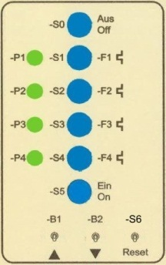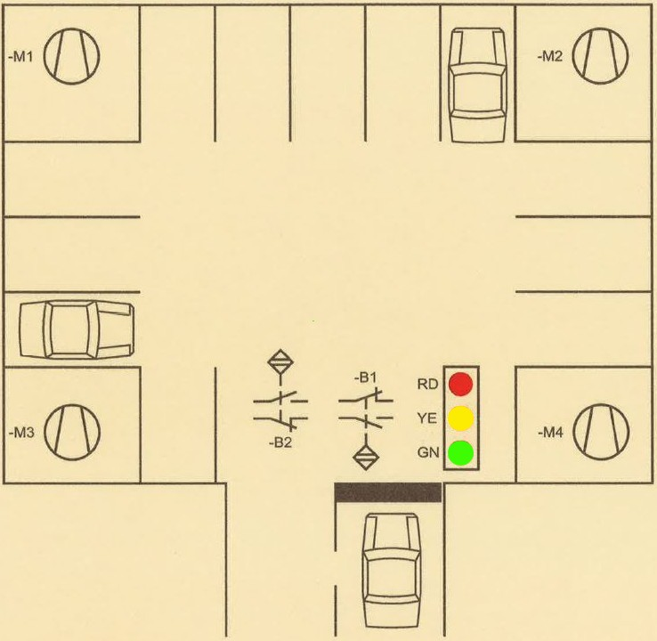

*Fig.1: Underground parking Fig.2: Control panel*

Learning objectives

By the end of this learning sequence you will …

* … have successfully analysed the logic function of the traffic light, and designed the logic circuit using Karnaugh as well as Boolean algebra.
* … have successfully applied your knowledge of PLC in a practical example.
* … have worked out a structured PLC-program in the programming language FBD.
* … be able to create and work out all the required documents to record a PLC control task such as function diagram, connection diagram of PLC or symbol table.



**Optional homework**

Create your own vocab cards and learn the new vocabulary.

**Functional description**

All the fans are switched on at once via a corresponding main contactor by means of the pushbutton S5. The activated fans can be switched off together at any time by pressing the pushbutton S0. The status of the fans is indicated by means of the corresponding signal lamps P1, P2, P3 and P4.

In the event of an overload of a fan motor, e.g. due to blocking the fan, the corresponding normally closed contact 95-96 on overload relay F*x* effects de-energization of the main contactor Q*x* and as a result the fan stops. The response of overload relays F1, F2, F3 and F4 can be simulated by pressing the related pushbuttons S1, S2, S3 and S4. Thus, switched off engines can be restarted by renewed operation of the pushbutton S5.

Additionally, when the underground parking is completely occupied (12 vehicles), the traffic light has to be set to red. The incoming vehicles cause an impulse of the sensor B1, whereas the outgoing vehicles cause an impulse of the sensor B2. Regardless of the current count value, the vehicle counter can be reset to the value 0 by means of the toggle switch S6 (reset).

**Task**

Read the functional description carefully and discuss the following three questions in groups of three or four people. **Goals: You understand every detail of the text.**

* *How can you switch on or switch off the fan motor no. 2?*
* *What does P3 indicate?*
* *What happens if there is no parking space left?*

**Symbol table**

|  |  |  |
| --- | --- | --- |
| **Symbol** | **PLC-address** | **Comment** |
| S0 | I 124.0 | Fan motors M1 to M4 off (NC) |
| F1 (S1) | I 124.1 | Overload relay F1, motor 1 (NC) |
| F2 (S2) | I 124.2 | Overload relay F2, motor 2 (NC) |
| F3 (S3) | I 124.3 | Overload relay F3, motor 3 (NC) |
| F4 (S4) | I 124.4 | Overload relay F4, motor 4 (NC) |
| S5 | I 124.5 | Fan motors M1 to M4 on |
| B1 | I 124.6 | Sensor to detect incoming vehicles |
| B2 | I 124.7 | Sensor to detect outgoing vehicles |
| S6 (Reset) | I 125.0 | Reset vehicle counter |
| P_RD | Q 124.0 | Traffic light red |
| P_YE | Q 124.1 | Traffic light yellow |
| P_GN | Q 124.2 | Traffic light green |
| Q1 (P1) | Q 125.0 | Fan motor 1 (main contactor and signal lamp) |
| Q2 (P2) | Q 125.1 | Fan motor 2 (main contactor and signal lamp) |
| Q3 (P3) | Q 125.2 | Fan motor 3 (main contactor and signal lamp) |
| Q4 (P4) | Q 125.3 | Fan motor 4 (main contactor and signal lamp) |

**Development of the logic function for the traffic light device**

1. Work out the truth table.

|  |  |  |  |  |  |  |
| --- | --- | --- | --- | --- | --- | --- |
| Fan 1 | Fan 2 | Fan 3 | Fan 4 | Traffic light red | Traffic light yellow | Traffic light green |
| **Q1** | **Q2** | **Q3** | **Q4** | **P_RD** | **P_YE** | **P_GN** |
| 0 | 0 | 0 | 0 | **1** | **0** | **0** |
| 0 | 0 | 0 | 1 | **1** | **0** | **0** |
| 0 | 0 | 1 | 0 | **1** | **0** | **0** |
| 0 | 0 | 1 | 1 | **0** | **1** | **0** |
| 0 | 1 | 0 | 0 | **1** | **0** | **0** |
| 0 | 1 | 0 | 1 | **0** | **1** | **0** |
| 0 | 1 | 1 | 0 | **0** | **1** | **0** |
| 0 | 1 | 1 | 1 | **0** | **0** | **1** |
| 1 | 0 | 0 | 0 | **1** | **0** | **0** |
| 1 | 0 | 0 | 1 | **0** | **1** | **0** |
| 1 | 0 | 1 | 0 | **0** | **1** | **0** |
| 1 | 0 | 1 | 1 | **0** | **0** | **1** |
| 1 | 1 | 0 | 0 | **0** | **1** | **0** |
| 1 | 1 | 0 | 1 | **0** | **1** | **0** |
| 1 | 1 | 1 | 0 | **0** | **0** | **1** |
| 1 | 1 | 1 | 1 | **0** | **0** | **1** |

Complete the truth table for

the control of the traffic light

at the entry to the underground parking in accordance with the description

in the introduction at the very beginning of this worksheet!

1. Minimise the function of **„traffic light red“** using Karnaugh and Boolean algebra.

Karnaugh mapping: **Rules on looping**

1. All 1s must be enclosed by a loop.
2. Loops can only encircle 1, 2, 4 or 8 1s.
3. A 1 may be included in several loops.
4. Loops should be as big as possible.
5. There should be as few loops as possible.
6. You can loop corners and opposite sides.

|  |  |  |  |  |  |
| --- | --- | --- | --- | --- | --- |
| http://photos1.fotosearch.com/bthumb/TBZ/TBZ122/lb01p021.jpg**Traffic light red** | | Fan 1 / Fan2 | | | |
| 00 | 01 | 11 | 10 |
| Fan 3 / Fan 4 | 00 | **1** | **1** |  | **1** |
| 01 | **1** |  |  |  |
| 11 |  |  |  |  |
| 10 | **1** |  |  | *Fig.: A four-variable map* |

$$P_{RD}=\underset{\overline{Q1}∧\overline{Q2}∧\left(\overline{Q3}∨\overline{Q4}\right)}{\underbrace{\left(\overline{Q1}∧\overline{Q2}∧\overline{Q3}\right)∨\left(\overline{Q1}∧\overline{Q2}∧\overline{Q4}\right)}}∨\underset{\overline{Q3}∧\overline{Q4}∧\left(\overline{Q1}∨\overline{Q2}\right)}{\underbrace{\left(\overline{Q1}∧\overline{Q3}∧\overline{Q4}\right)∨\left(\overline{Q2}∧\overline{Q3}∧\overline{Q4}\right)}}$$

$$P_{RD}=\left[\overline{Q1}∧\overline{Q2}∧\left(\overline{Q3}∨\overline{Q4}\right)\right]∨\left[\overline{Q3}∧\overline{Q4}∧\left(\overline{Q1}∨\overline{Q2}\right)\right]$$

1. Minimise the function of **„traffic light yellow“** using Karnaugh and Boolean algebra.

|  |  |  |  |  |  |
| --- | --- | --- | --- | --- | --- |
| **Traffic light yellow** | | Fan 1 / Fan 2 | | | |
| 00 | 01 | 11 | 10 |
| Fan 3 / Fan 4 | 00 |  |  | **1** |  |
| 01 |  | **1** |  | **1** |
| 11 | **1** |  |  |  |
| 10 |  | **1** |  | **1**  *Fig.: A four-variable map* |



A simplification using Karnaugh is not possible due to the fact that loops can encircle only one of the 1s. A simplification using Boolean algebra would be too complicated and time-consuming.

$$P_{YE}=\overline{P_{RD}}∧\overline{P_{GN}}=\overline{P_{RD}∨P_{GN}}$$

1. Minimise the function of **„traffic light green“** using Karnaugh and Boolean algebra.

**Task**

Complete the Karnaugh map for the „traffic light green“ and „read out“ the logic function. Then simplify what you get using Boolean algebra!



|  |  |  |  |  |  |
| --- | --- | --- | --- | --- | --- |
| **Traffic light green** | | Fan 1 / Fan 2 | | | |
| 00 | 01 | 11 | 10 |
| Fan 3 / Fan 4 | 00 | … | … | … | … |
| 01 | … | … | 1 | … |
| 11 | … | 1 | 1 | 1 |
| 10 | … | … | 1 | … |

*Fig.: A four-variable map*

$$P_{GN}=\left(Q1∧Q2∧Q3\right)∨\left(Q1∧Q2∧Q4\right)∨\left(Q1∧Q3∧Q4\right)∨\left(Q2∧Q3∧Q4\right)$$

$$\underset{Q1∧Q2∧\left(Q3∨Q4\right)}{\underbrace{(Q1∧Q2∧Q3)∨\left(Q1∧Q2∧Q4\right)}}∨\underset{Q3∧Q4∧\left(Q1∨Q2\right)}{\underbrace{\left(Q1∧Q3∧Q4\right)∨(Q2∧Q3∧Q4)}}$$

$$P_{GN}=\left[Q1∧Q2∧\left(Q3∨Q4\right)\right]∨\left[Q3∧Q4∧\left(Q1∨Q2\right)\right]$$

**How does a PLC up/down counter work?**

**Task**

Examine the function of an up/down counter from Siemens. Complete the following table as well as the statement right below the table using the help function in the software tool SIMATIC Manager!

|  |  |
| --- | --- |
|  | Description: |
| **C no.** | Ip-Adress of the countere (DBx) |
| **CU** | Counting up |
| **CD** | Counting down |
| **S** | Set Pv to as counting value |
| **PV** | Parameter for the counting value |
| **R** | Resett the counting value |
| **CV** | Counting value dezimal code |
| **CV_BCD** | Counting value bcd code |

The status of the counter **Q** gets „TRUE“ (logic 1) when the count value equals PV.

**Tasks**

1. Work out the function diagram (Grafcet acc. EN60848) in accordance with the functional description.
2. Work out the connection diagram of PLC. Take the rules on wire breakage into account! The motor control must be fail-safe!
3. Create an S7-project and call it ***VtSys***.
4. Work out the hardware configuration.
5. Create the symbol table using TIA-Portal.
6. Work out the PLC program in the programming language **FBD**.
7. Simulate your PLC program using PLCSIM.
8. Assemble and commission the ventilation system in the laboratory.
9. Present your solution to the teacher.

**Required documentations**

After finishing this control task, you are expected to file the following documents as hard copy:

* Function diagram (Grafcet)
* Connection diagram of PLC

After finishing this control task, you are expected to file the following documents as soft copy on „moodle“:

* S7-project *VtSys.zap13*
* **Individual** conclusive comment on the control task *VtSys.docx*.

**Timetable**

Timetable according your teacher’s directions.

**Vocabulary**

Complete the wordlist using just this document! All the terms are used within this worksheet!

|  |  |
| --- | --- |
| English: | German: |
| … | Funktionsplan FUP |
| … | Lüftungsanlage |
| … | Tiefgarage |
| … | Ampel |
| … | Lüfter |
| … | Kippschalter |
| … | Motorschutzrelais |
| … | Hauptschütz |
| … | Karnaugh Diagramm |
| … | Vorwärtszähler |
| … | Rückwärtszähler |
| … | Zählwert |
| … | Drahtbruch |
| … | drahtbruchsicher, fehlersicher, ausfallsicher |
| … | Schlussbetrachtung |
| flag | Merker |
| flag byte | Merkerbyte |
| flag word | Merkerwort |
| flag area | Merkerbereich |
| … | … |
| … | … |
| … | … |
| … | … |
| … | … |
| … | … |
| … | … |
| … | … |