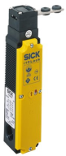***Safety switch with safety locking device***

**Introduction**

**Safety locking devices are used to monitor the positions of safety-related components, such as doors and flaps, and to control access in combination with the machine controls. They consist of a safety switch and a locking device. The safety switch includes an actuator which transfers motion directly to the switching element. Safety contacts are always forced NC contacts. This means that the contacts are opened in the event of movement.**

**Tasks**

1. Read the introduction carefully and match the English to the German expressions in the table below. Work on your own and do it without the aid of a dictionary.

|  |  |  |  |  |
| --- | --- | --- | --- | --- |
| No. | English |  | Nr. | German |
| 1 | safety locking device |  | 6 | Sicherheitsschalter |
| 2 | (to) monitor |  | 4 | Zugang |
| 3 | safety-related |  | 5 | Maschinensteuerung |
| 4 | access |  | 3 | sicherheitsrelevant |
| 5 | machine control |  | 8 | Zwangsöffnungskontakt |
| 6 | safety switch |  | 1 | Sicherheitszuhaltung |
| 7 | safety contact |  | 2 | überwachen |
| 8 | forced NC contact |  | 7 | Sicherheitskontakt |

1. Work in pairs and translate the introduction into German. **Goal: You understand every detail of the text.**

Learning objectives

By the end of this learning sequence you will be …

* … more familiar with safety locking devices.
* … able to understand an application of a safety switch with safety locking device.



**Optional homework**

Create your own vocab cards and learn the new vocabulary.

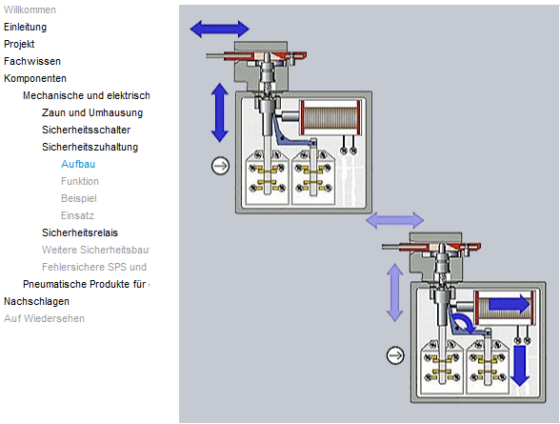Log on to the moodle-course **AutomatikerIn_09: Programmierbare Steuerungen (SPS)**, chapter **Funktionale Sicherheit von Maschinensteuerungen** and open the learning module ***Sicherheitstechnik***. Work carefully through the highlighted topics and then answer the tasks c) to f).

**Tasks**

1. Complete the table below.

|  |  |  |  |  |
| --- | --- | --- | --- | --- |
| No. | English |  | Nr. | German |
| 4 | safety switch |  | 3 | Schliesskontakt |
| 2 | forced NC contact |  | 6 | Magnetspule |
| 5 | locking device |  | 1 | Betätigungselement |
| 1 | actuating element |  | 2 | Zwangsöffnungskontakt |
| 6 | solenoid coil |  | 5 | Zuhaltung |
| 3 | NO contact |  | 4 | Sicherheitsschalter |

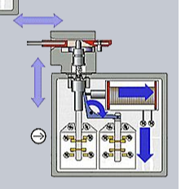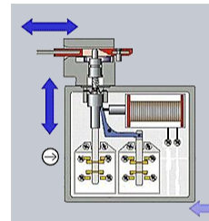

3

2

1

6

5

4

2

3

1. Complete the following sentence about the function of the safety switch with a safety locking device:

The locking device ensures that, for example, a safety door cannot be opened randomly. The door can only be opened after it has been unlocked. Only then can the safety switch carry out its task.

1. A safety locking device is used to monitor and control a safety door. Tick all the advantages of an application like this.

* Accessibility to the working area in order to insert or remove parts.

X

_

* Controlled access to the machine is possible.
* Production stoppages and hazards caused by machine over-travel are prevented.

X

* Protection against parts which are thrown out of the machine.

1. Complete the table below. Refer to an online dictionary if necessary.

|  |  |
| --- | --- |
| English | German |
| production stoppage = production break | Produktionsunterbruch |
| over-travel | Nachlauf |

**Datasheet**

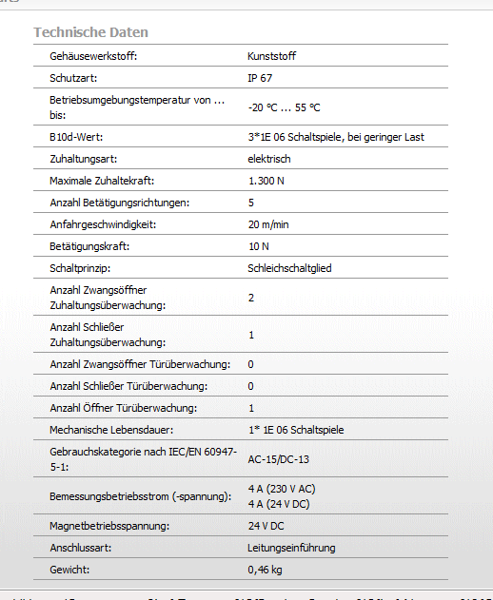Have a look at the datasheet of Sick‘s safety switch with turning lever on the right. Work through tasks g) to k).

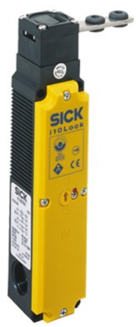

1. *Datasheet:* How many Newtons is the maximum locking force?

* 10 N

X

_

* 1’300 N

1. *Datasheet:* What is the locking type of the safety switch?

Electrical

1. 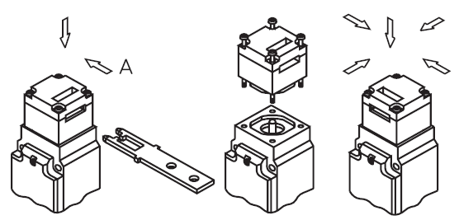*Datasheet:* What is the number of possible actuation directions?

5

1. 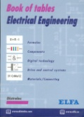Explain the **protection class** of the safety switch. Refer to your book of tables and your „Tabellenbuch Mechatronik“.

|  |  |  |  |
| --- | --- | --- | --- |
|  | | Description | Beschreibung |
| code letters | **IP** | International Protection | Internationaler Schutz |
| first code digit | **6** | Dustproof | Staubdicht |
| second code digit | **7** | Waterproof for 30min 1m deep | Wasserdicht für 30min  1m tief |

1. Tick the **symbols** for **waterproof** and **dustproof** below. Refer to your book of tables and your „Tabellenbuch Mechatronik“ if necessary.

X

_

X

_

_

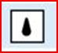 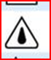 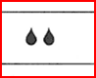  

**Application of a safety switch with safety locking device**

Have a look at the following application of a safety switch with safety locking device. Read carefully all paragraphs and then work through tasks l) to v).

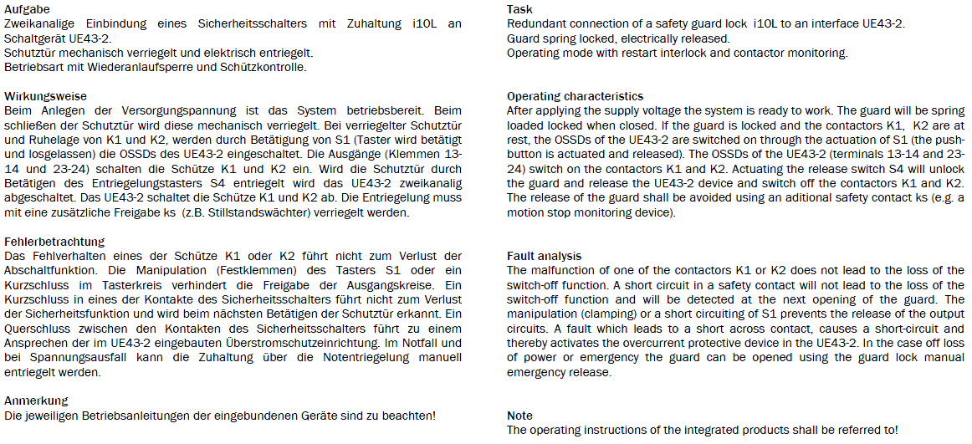

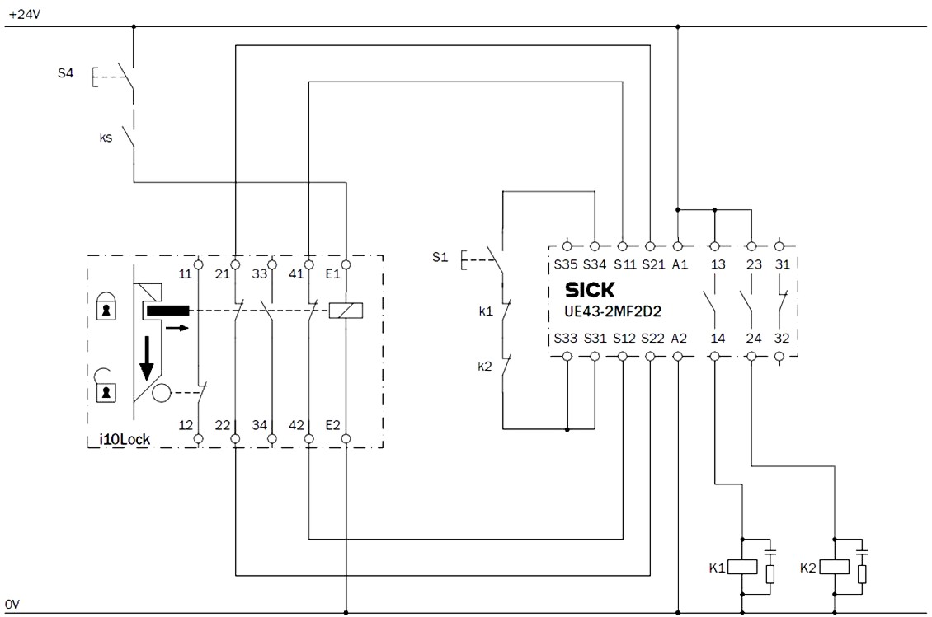

D

F

Please note: Correct code letter for contactors isQ!

E

C

B

A

*Fig.: Circuit arrangement for a locked guard.*

1. What do you call the device which is labelled F?

Safety Relay

1. What is the function of the **RC damping element (=surge suppression circuit)** connected in parallel with contactors K1 (Q1) and K2 (Q2)?

Complete the following description:

Surge suppressors are devices that respond to sudden increases in voltage by redirecting current away from protected devices. Surge suppressors contain a component, often a RC damping element, which allows a certain amount of flow based on voltage. At normal voltages, little current flows through the component, but as voltage increase, more current flows through the component and away from the protected device.

1. Which pushbutton is the “lock release pushbutton”?

_

* S1

X

* S4

1. Which contact confirms that the lock tongue of the safety switch is in place?

X

* A

_

* B
* C

_

* D

_

* E

1. Which contact can be used for external signalling to show if the lock is ON or OFF (= lock status indication)?

_

* A

X

* B
* C

_

_

* D
* E

_

1. Decide whether the following statement is true or not:

“Guard-locking switches generally operate on the principle of “energize to release”.”

* True

_

X

* False

1. Decide whether the following statement is true or not:

“No power can be applied to release the lock until safe conditions have been reached even if the machine has a rundown period.”

* True

X

* False

1. [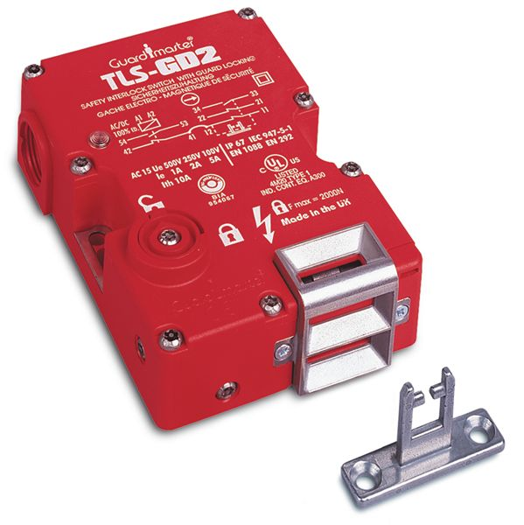](http://epub1.rockwellautomation.com/images/web-proof-large/GL/6303.jpg)The picture shows a tongue operated guard locking interlock switch. Decide whether the following statement is true or not:

“The picture shows a typical guard-locking switch with choice of entry ports and internal solenoid-operated lock.”

X

* True

_

* False

1. What type of sensor can we use to monitor the motion of a machine?

* Ultrasonic sensor

_

* Speed sensor

_

X

* Capacitive proximity sensor
* Strain gauge

_

_

* PT 1000

Rockwell Automation offers two different types of guard locking switches:

**Power to lock:** *When power is applied to the solenoid, the tongue is locked in the switch. When power is removed, the lock is released allowing the tongue to be extracted from the switch.*

**Power to release:** *When power is applied to the solenoid, the lock is released allowing the tongue to be extracted from the switch. When power is removed, the tongue is locked in the switch.*

When to use “power to lock” and when to use “power to release”?

See the pros and cons of the two types below.

Complete the following table.

|  |  |  |
| --- | --- | --- |
|  | Power to release | Power to lock |
| …advantage | Power is not applied to the switch all the time, but only when the door needs to be opened. Sudden loss of power does not compromise safety of maintenance workers, as the doors stay closed. | When the power is removed after a “controlled stop”, the doors unlock allowing maintenance workers to go inside the work cell easily. |
| Disadvantage | Loss of power will not unlock the door and maintenance workers will not be able to go inside the work cell. | Sudden loss of power will unlock the door allowing maintenance workers to go into the hazardous area and the machine may not be stopped. |

1. Complete the table below. Refer to the description of the application.

|  |  |
| --- | --- |
| English | German |
| motion stop monitoring device | Stillstandwächter |
| (to) unlock | Entriegeln |
| loss of power | Spannugnsausfall |
| operating instruction | Betreibsanleitung |
| operating mode | Betreibsart |
| restart interlock | Wiederanlaufsperre |
| malfunction | Fehlverhalten |
| (to) release | Entriegeln |
| maintenance worker | Wartungspersonal |

1. Work in pairs and translate the following paragraph into German. **Goal: You understand every detail of the text.**

[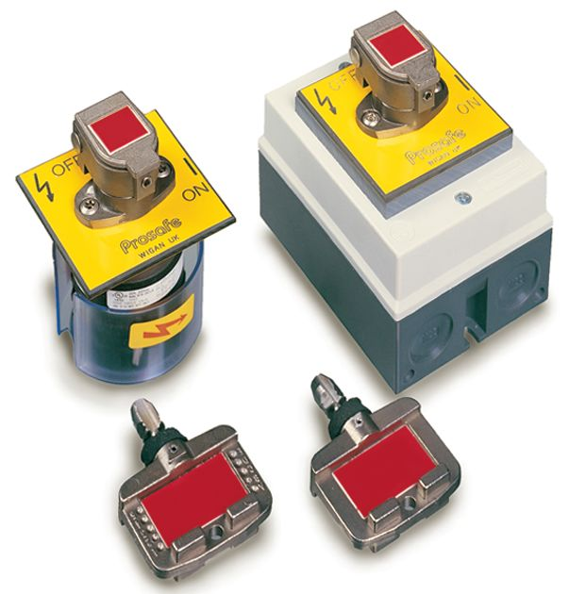](http://epub1.rockwellautomation.com/images/web-proof-large/GL/12301.jpg)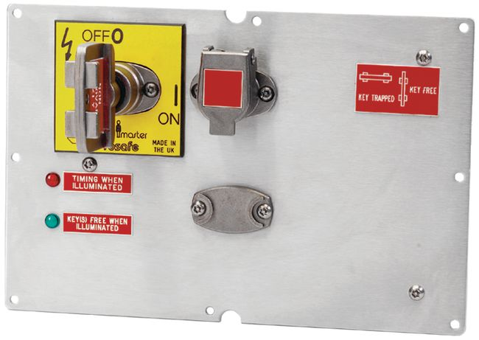Versions of guard locks are available with a trapped key facility. It is a mechanical system and is therefore widely used in applications including those where the location of plant, environment or explosive atmospheres make the use of electrical interlock systems unsuitable or expensive to install. When in operation (machine running), the key is trapped in the lock until a signal is applied to the internal solenoid coil. When the solenoid coil is energized, the guard door can be opened and the key can be removed locking the switch in an open state. This, of course, gives security to the person holding the key who is now also free to enter the area protected by the guard.

Trapped key facility = Schlüsselverrieglungsmechanismus

Auch bekannt unter dem Begriff “Schlüsseltransfersystem”