***Opto-electronic protective devices***

**Introduction**

Light curtains, light grids/barriers, laser scanners and 3D camera systems are additional safety components which are designed to detect anyone (e.g. the operator) reaching into the machine’s hazardous area and then trigger a safety function.

**Tasks**

1. Read the introduction carefully and complete the table below. Look up the German expressions in an online dictionary.

|  |  |  |
| --- | --- | --- |
| Application | English | German |
| http://www.automation.com/images/other/sti111.jpg | light curtain | Lichtschranke |
| Einfache Errichtung einer Zugangssicherung mit integrierter Laserausrichthilfe | light grid/barrier | Lichtgitter |
| http://www.leuze.de/press/data/rs4-6/rs4_ehb-bereichsabsicherung.jpg | laser scanner | Laser Scanner |
| http://www.drives.co.uk/news/images/SafetyEye%20diagram.jpg | 3D camera system | 3D Kamera System |

Learning objectives

By the end of this learning sequence you will be …

* … more familiar with opto-electronic protective devices.
* … able to look up the main features of opto-electronic protective devices on the internet.

**Homework**

Create your own vocab cards and learn the new vocabulary.

**Tasks**

1. Beschreibung: imagesCAB909B1In order to get more information about the functions of the different types of opto-electronic protective devices, visit YouTube. Plenty of video sequences are available there.
   * + - Click [here](https://www.youtube.com/watch?v=ZO003lCfebE) to see the function of a 3D camera system.
       - Click [here](https://www.youtube.com/watch?v=FLDPR28tl08) to see the function of a saw safety camera system.
       - Click [here](https://www.youtube.com/watch?v=-zQaEF9oRaI) to see the safety solution for a can palletizer.
       - Click [here](https://www.youtube.com/watch?v=cn-tQGYAz_U) to see the function of a light curtain.

Write down some notes about the different opto-electronic protective devices which are shown in the YouTube sequences.

3D Camera: create a project with danger zones, automatic restart.

Saw safety camera: detects red objects and stops when the red object enters a

danger zone

safety solution: controller received signal form safety device, such as safety laser,

safety strips, gate safety interlock. In case of an entering of the danger zone the

machine return into a safe state.

Light curtain:

1. 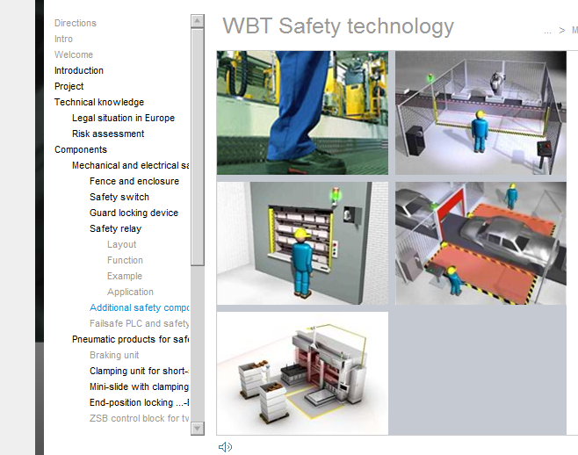Beschreibung: imagesCAB909B1Log on to the Moodle-course **AutomatikerIn_09: Programmierbare Steuerungen (SPS)**, chapter **Funktionale Sicherheit von Maschinensteuerungen** and open the [learning module Sicherheitstechnik](https://moodle.bbbaden.ch/course/view.php?id=555&section=6). Work carefully through the chapter ***additional safety components*** and complete the general description of opto-electronic protective devices in task d).
2. [](http://www.google.ch/imgres?q=internet&hl=de&biw=1301&bih=641&gbv=2&tbm=isch&tbnid=juX2FFBKKCkBkM:&imgrefurl=http://russiansphinx.blogspot.com/2010/03/geography-of-russian-internet.html&docid=W448o_-c3KJFEM&w=300&h=228&ei=prw2TvG6A8fOsgbL3JG5Ag&zoom=1)Complete the table below. Refer to the internet in order to find the leading manufacturers of opto-electronic protective devices.

|  |  |  |
| --- | --- | --- |
|  | General description | Leading manufacturers |
| http://www.automation.com/images/other/sti111.jpg | The light curtain consists of an entire series of interconnected light barriers and that is the reason why it is capable of monitoring a large area. | * SICK * ABB * Eaton * CEDES * Pilz |
| Einfache Errichtung einer Zugangssicherung mit integrierter Laserausrichthilfe | Light barriers generate a signal when the operator steps into the machine’s danger zone. A combination of light grids/barriers is also often used. | * ABB * Sick * Eaton * CEDES * Pilz |
| http://www.leuze.de/press/data/rs4-6/rs4_ehb-bereichsabsicherung.jpg | The laser scanner monitors its surroundings with a specified scanning angle and indicates when people or objects penetrate the danger zone. | * SICK * Pilz * … * … |
| http://www.drives.co.uk/news/images/SafetyEye%20diagram.jpg | The 3D camera monitors freely definable three-dimensional danger zones and can be used instead of mechanical and optoelectronic safety devices. | * PILZ * Sick * … * … |

1. Complete the table below. Refer to the internet and google the different types of devices.

|  |  |  |  |  |  |
| --- | --- | --- | --- | --- | --- |
|  | manufacturer | device-type | scanning range | protective field height | number of beams |
| http://www.automation.com/images/other/sti111.jpg | Sick | C2000 Eco |  | 600 mm | 20 |
| Einfache Errichtung einer Zugangssicherung mit integrierter Laserausrichthilfe | ABB | FII-4-K2-500 | 0.5m - 40m | 500mm | 2 |
|  | manufacturer | device-type | protective field range | scan angle | number of switchable field sets |
| http://www.leuze.de/press/data/rs4-6/rs4_ehb-bereichsabsicherung.jpg | Sick | S30B-2011CA | 2m | 270° | 4 |
|  | manufacturer | device-type | scanning range | max. visible range | min. light intensity |
| http://www.drives.co.uk/news/images/SafetyEye%20diagram.jpg | Pilz | SafetyEYE | 7.5m | Ca. 72 m2 | 300 lux *1) |

*1) Lighting of 300 lux required, depending on the background and environment.