***Safeguarding of robots***

You are going to see a video about safeguarding of robots created by the National Institute for Occupational Safety and Health (NIOSH), USA. (<http://www.youtube.com/watch?v=9TEjRhw6KGQ&feature=related>)



Watch the video sequence carefully and work through the following tasks!

**Tasks**

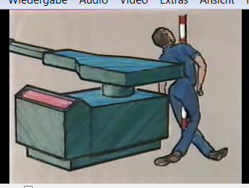

1. The narrator says that industrial robots have injured people. In one case in 1984 a worker was killed. Complete the following sentence using the key words:

The worker entered the working range of the robot and the robot control did not sense his presence. As a result, the worker was pinched between the back end of the robot and the steel safety pole.

1. The narrator says that no matter how automated a manufacturing line is, there are often workers around who must be protected. Complete the table below with the English equivalents of the German words!

|  |  |  |
| --- | --- | --- |
| English |  | German |
| Line operators |  | Bedienungspersonal |
| Maintenance workers |  | Wartungspersonal |
| Programmers |  | Programmierer |
| Managers |  | Geschäftsführer |
| visitors |  | Besucher |

1. Fill in the gaps using the key word:

Safeguarding robots is more complex than safeguarding other types of machines. Their range of movement is much greater than that of the other machines.

1. What does the speaker call this part of a machine?

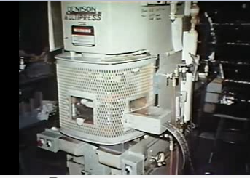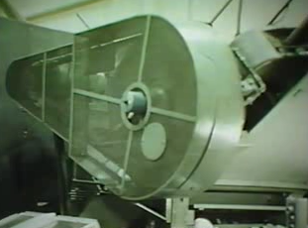

Machine guard

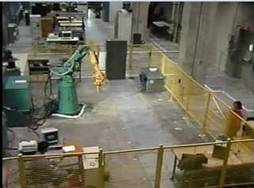

1. Complete the following sentence about guarding of a robotic working cell:

Robot guarding has to be flexible to adapt to the variety of tasks a single robot may perform.

1. „Preventive engineering“ highlights some of the ways to protect people in robotics environments. Which are the critical stages of the engineering job? Write down the correct expressions!

Implementation

Designe

Research

1. Before a workstation design begins, it is important to know the following information about the robot:
   * the precise Track of the movement
   * the range of velocities
   * the payload limits
   * the tooling actions that are required for the job
2. What does the speaker call this device of a robot? Complete the sentence!

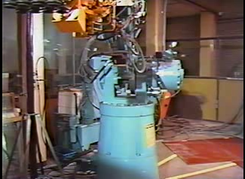

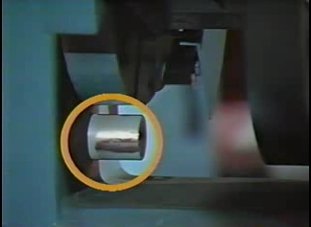Robots have emergency stop buttons to provide total shut down and interruption features to stop arm motion. Interruption circuitry in a robot should be supplemented by Hardware stops that will stop the arm even at its full payload and speed.

1. Safe design solutions often involve **barriers** which must not only keep the people out of the workcell but also keep the machine within! There are several different kinds of **perimeter guards** to design the isolation of the workcell.

Match the following terms of **safety guarding systems** to the pictures:

*safety fence safety glass/transparent barrier*

*panic pull cord interlocked door*

*warning light pressure sensitive mats*

*light curtain*

|  |  |  |
| --- | --- | --- |
| Panic pull cord | Safety glass/ transparent barrier | Pressure sensitive mats |
|  |  |  |

|  |  |  |
| --- | --- | --- |
| Safety fence | Light curtain | Warning light |
|  |  |  |

|  |
| --- |
| Interlock Door |
|  |

1. Each **safety guard system** has its strengths and weaknesses. Match the **perimeter guards** A, B, C and D to the statements from the film!

*A safety fence*

*B safety glass/transparent barrier*

*C pressure sensitive mat*

*D light curtain*

|  |  |
| --- | --- |
| **Type of barrier** | **„strength“/„weakness“** |
| A | „should be tall enough to discourage workers from climbing“ |
| C | „the amount of floor space which they take up“ |
| B | „cost more than fencing“ |
| D | „can be selectively blanked to provide access to the working cell for specific pieces of equipment or products while still sensing and interrupting the robot cycle for humans“ |
| B | „no vision obstruction problem“ |
| D | „available in many sizes“ |
| A | „difficult to move“ |
| C | „possibility of unintended interruption of the robot cycle“ |
| A | „obstructs the vision of workers“ |
| A | „inexpensive“ |

1. Fill in the gap using the key word:

Access gates (e.g. doors) should be interlocked with the robot controller to interrupt the robot cycle if opened .

1. Don Millard, Robot Safety Project Director, is talking about a **prototype safety system**, where they use different sensors which are capable of detecting the human motion within the workspace in order to be able to differentiate the human movements from the machine movements. Match the sensors A, B, C and D to their function!

*A capacitance sensor*

*B infrared sensor*

*C ultrasonic sensor*

*D microwave sensor*

|  |  |
| --- | --- |
| **Type of sensor** | **function** |
| B | The … is used to detect the change of temperature. |
| D | The … detects any motion. |
| C | The … is used to measure the distance from the robot to the objects that appear. |
| A | The … is used to detect human movement. |

1. 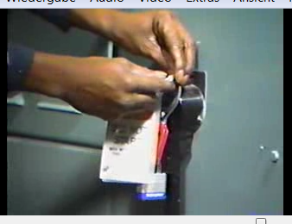What does the speaker call the procedure shown in the picture?

Lockout and Tagout [=lock and tag]

Lockout= you lock it

Tagout = you put a tag there.

**Extra task: Vocabulary**

Match the English to the German expressions in the table below. Work in pairs and without the aid of a dictionary.

|  |  |  |  |  |
| --- | --- | --- | --- | --- |
| No. | English |  | Nr. | German |
| 1 | (to) interlock |  | 7 | Absicherung |
| 2 | lockout |  | … | Schutzabdeckung |
| 3 | velocity |  | … | Nutzlast |
| 4 | (perimeter) guard |  | 12 | Zutrittsbereich |
| 5 | (to) blank |  | … | Schaltkreis |
| 6 | safety fence |  | … | verriegeln |
| 7 | safeguarding |  | … | Geschwindigkeit |
| 8 | track |  | … | Wartungssicherung durch Kennzeichnung |
| 9 | light curtain |  | 11 | Schaltmatte |
| 10 | tagout |  | 12 | Wartungssicherung z.B. mit einem Schloss |
| 11 | pressure-sensitive mat |  | 9 | Lichtvorhang |
| 12 | access gate |  | … | ausblenden |
| 13 | payload |  | 8 | Bahn, Weg |
| 14 | circuitry |  | 6 | Sicherheitszaun |
| … | … |  | … | … |
| … | … |  | … | … |
| … | … |  | … | … |
| … | … |  | … | … |
| … | … |  | … | … |
| … | … |  | … | … |
| … | … |  | … | … |