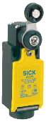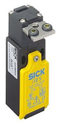***Safety switches (mechanical limit switches)***

**Introduction**

**Safety switches are used to monitor the positions of safety-related components, such as doors and flaps. They consist of an actuator which transmits motion directly to the switching element. Safety contacts are always forced NC contacts. This means that the contacts are opened in the event of movement.**

**Tasks**

1. Read the introduction carefully and match the English to the German expressions in the table below. Work on your own and do it without the aid of a dictionary.

|  |  |  |  |  |
| --- | --- | --- | --- | --- |
| No. | English |  | Nr. | German |
| 1 | safety switch |  | 3 | sicherheitsrelevant |
| 2 | (to) monitor |  | 4 | Sicherheitskontakt |
| 3 | safety-related |  | 1 | Sicherheitsschalter = Positionsschalter mit Sicherheitsfunktion |
| 4 | safety contact |  | 5 | Zwangsöffnungskontakt |
| 5 | forced NC contact |  | 2 | überwachen |

1. Work in pairs and translate the introduction into German. **Goal: You understand every detail of the text.**

Learning objectives

By the end of this learning sequence you will be …

* … more familiar with safety switches.
* … able to understand an application where a safety switch is used to monitor a protective door.



**Optional homework**

Create your own vocab cards and learn the new vocabulary.

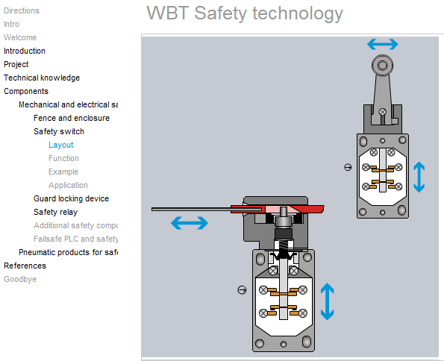Log on to the moodle-course **AutomatikerIn_09: Programmierbare Steuerungen (SPS)**, chapter **Funktionale Sicherheit von Maschinensteuerungen** and open the learning module ***Sicherheitstechnik***. Work carefully through the highlighted topics and then answer the tasks c) to o).

**Tasks**

1. Tick the **symbol** of a **forced NC contact** below.

X

_

_

_

_

1. Tick the **actuator** of the **mechanical limit switch**.

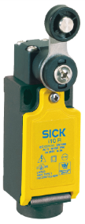

_

_

x

1. Tick the **actuator** of the **mechanical limit switch**.

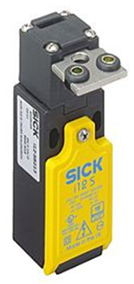

_

X

_

1. What is the main difference, in terms of the actuating element, between the safety switches below?

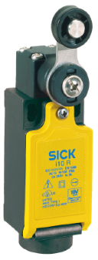

The safety switch on the right is a safety switch with a separate /external actuator whereas the safety switch on the left is a safety switch with an integrated actuator

1. Complete the following sentence:

Safety switches with separate/external actuators are suitable for sliding and particularly removable safety guards, which need to be closed to ensure the necessary operational security.

1. Complete the table below. Refer to an online dictionary if necessary.

|  |  |
| --- | --- |
| English | German |
| safety guard | Schutzeinrichtung |
| operational security | Betriebssicherheit |

1. Tick the **forced NC contact** of the safety switch below.

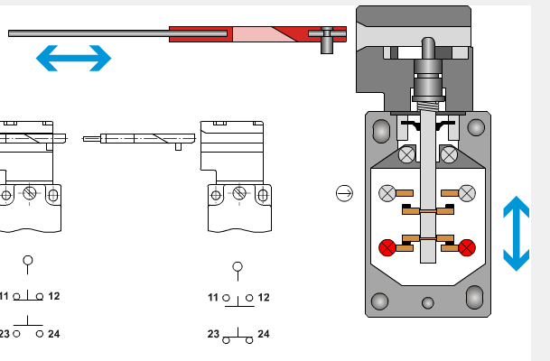

_

x



1. Why is the **use of forced NC contacts to stop a machine important?**

So it is made a forced NC contact that you can be sure that the contact opens when it’s triggered and if the wired breaks the machine also stops.

To make it a failsafe circuit

1. **Why would a broken reset spring in this type of safety switch not be critical?**

**Because the Switch would remain open**



1. 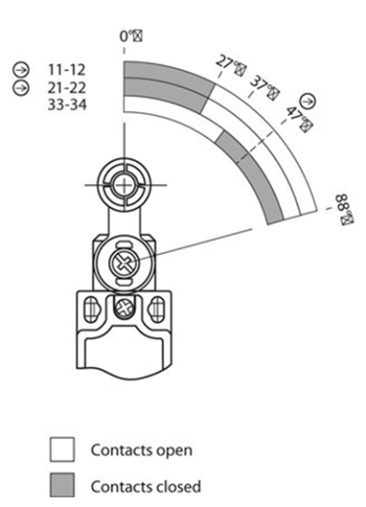Have a look at the **actuator travel diagram** *[=Schaltwegdiagramm]* of the safety switch with turning lever. How many forced NC contacts does this electromechanical safety switch have?

**2 (11-12 and 21-22)**

**Datasheet**

Have a look at the datasheet of Sick‘s safety switch with turning lever below. Work through tasks m), n), o) and p).

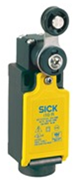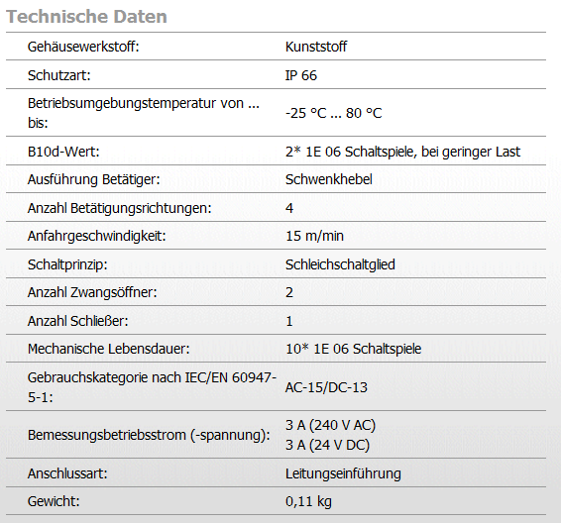

1. *Datasheet:* The housing material of the sensor is plastic. True or false?

* True

_

X

* False

1. *Datasheet:* What is the maximum number of **switching cycles** for the safety position switch?

_

* 100’000
* 200’000

_

_

* 1’000’000

X

* 2’000’000

_

* 10’000’000

* 20’000’000

1. 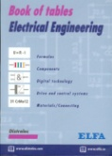Explain the **protection class** of the safety switch. Refer to your book of tables and your „Tabellenbuch Mechatronik“.

|  |  |  |  |
| --- | --- | --- | --- |
|  | | Description | Beschreibung |
| code letters | **IP** | International Protection | Internationale Schutzart |
| first code digit | **6** | Dust proof | staubdicht |
| second code digit | **6** | Almost waterproof | Fast wasserdicht |

1. Tick the **symbols** for **”jet waterprotected”** and **”dustproof”** below. Refer to your book of tables and your „Tabellenbuch Mechatronik“ if necessary.

X

_

X _

_

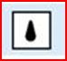 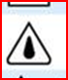 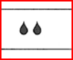  

**Applications of mechanical limit switches**

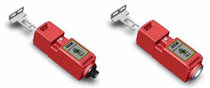With these devices the guard door is linked mechanically to the contacts of the switch. There are two main types of mechanical actuation: tongue-operated and cam/plunger-operated.

*Tongue-operated limit switch*

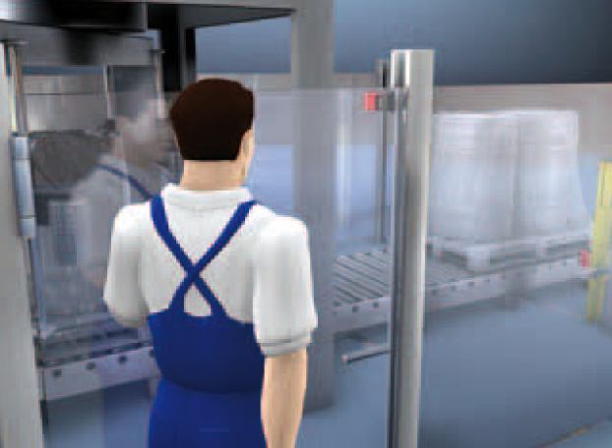These switches are destined for guarding machines and systems in which process or production interruptions are possible or may be necessary.

*Fig.: Safety switch on the door of a plastic film wrapping station.*

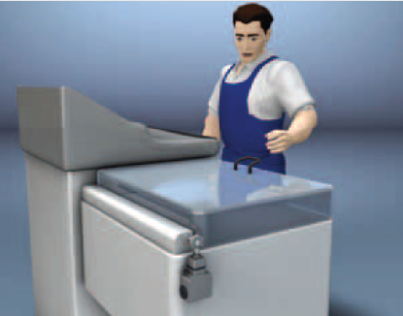*Safety position switch*

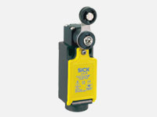The safety position switch’s design allows it to be mounted as an alternative to hinge switches, for example on flaps – always requiring appropriate actuation tappets or notches that can actuate the switch when friction is closed (=frictional connection).

*Fig.: Safety position switch on a machine with flap as protective device.*

**Tasks**

1. Read through the applications of mechanical limit switches and match the English to the German expressions in the table below. Work on your own and do it without the aid of a dictionary.

|  |  |  |  |  |
| --- | --- | --- | --- | --- |
| No. | English |  | Nr. | German |
| 1 | tongue operated |  | 5 | Betätigungsstössel |
| 2 | cam operated |  | 2 | mit Nocken betätigt |
| 3 | plunger operated |  | 7 | kraftschlüssige Verbindung |
| 4 | hinge switch |  | 3 | mit Stössel betätigt |
| 5 | actuation tappet |  | 6 | Betätigungsfalz |
| 6 | actuation notch |  | 1 | mit Lasche betätigt |
| 7 | frictional connection |  | 4 | Scharnierschalter |

1. Have a look at the three different **types of guards** below, where a tongue-operated limit switch is used. Match the technical terms given below to the guards. Discuss it with your partner.

* *sliding guard*
* *lift off guard*
* *hinged guard*

|  |  |  |  |
| --- | --- | --- | --- |
| Technical term | Hinged guard | Sliding guard | Lift off guard |
| Type of guard | Safety Interlock Tongue Switch from IDEM | Safety Interlock Tongue Switch from IDEM | Safety Interlock Tongue Switch from IDEM |

1. Have a look at the **contact block** of a tongue-operated limit switch below. Label the schematic diagram using the vocabulary given! Discuss it with your partner.

*cam tongue open closed safety contact auxiliary contact*

tongue switch closed

tongue switch opened

tongue

Cam

Safety contact

Auxiliary contact

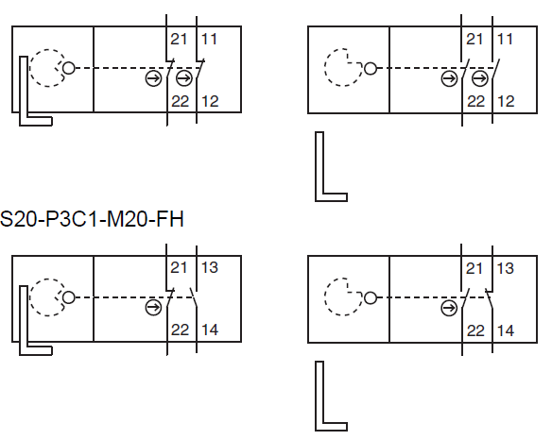

1. What can you use the auxiliary contact of a tongue-operated limit switch for?

You can use the auxiliary contact to signalize whether the guard is open or close