***Two-hand control***

**Introduction**

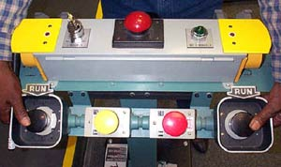A two-hand tripping device is commonly used to protect the hands of the operators working with dangerous machines. The machine starts only when both activate buttons are pressed almost simultaneously (e.g. within 0,2 seconds). This has to be done with the left and right hands. The machine stops immediately if one of the buttons is released.

**Tasks**

1. Read the introduction carefully and match the English to the German expressions in the table below. Work on your own and do it without the aid of a dictionary.

|  |  |  |  |  |
| --- | --- | --- | --- | --- |
| No. | English |  | Nr. | German |
| 1 | two-hand control |  | 3 | schützen |
| 2 | two-hand tripping device |  | 4 | gleichzeitig |
| 3 | (to) protect |  | 6 | loslassen |
| 4 | simultaneously |  | 1 | Zweihand-Steuerung |
| 5 | immediately |  | 5 | sofort |
| 6 | (to) release |  | 2 | Zweihand-Bediengerät |

1. Work in pairs and translate the introduction into German. **Goal: You understand every detail of the text.**

Learning objectives

By the end of this learning sequence you will be …

* … more familiar with two-hand tripping devices.
* … able to understand the function of a safety relay in combination with a two-hand tripping device.



**Homework**

Make your own vocab cards and learn the new vocabulary!

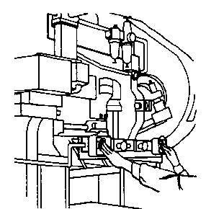**Applications**

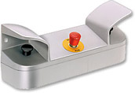Beschreibung: imagesCAB909B1Whether on presses, punching machines, cutting machines or paper processing machines, wherever it is important to keep the operator's hands away from hazardous areas to prevent the risk of injury, a two-hand operating console is certainly a good choice.

*Fig.: Two-hand operating console*

1. Match the applications mentioned above to the pictures in the table below. After that, translate the English terms using an online dictionary.

|  |  |  |
| --- | --- | --- |
|  | English | German |
| http://www.zelly.ch/Bilder/Betrieb/Schneidmaschine.jpg | cutting machines | Schneidemaschine |
| http://www.engineerlive.com/media/images/large/large_Press_release_01354SHEAR_-_MIB_Hydro_hydraulic_press.jpg | Presses | Presse |
| http://www.vonarb-ag.ch/images/Stanzmaschine.jpg | punching machines | Stanzmaschine |
| Papierverarbeitungsmaschine | paper processing machines | Papierverarbeitungs maschine |

1. [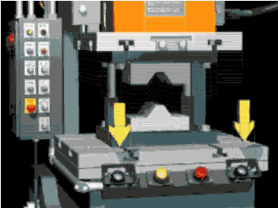](http://www.osha.gov/SLTC/etools/machineguarding/animations/buta.html)Click on the picture and watch carefully the animation of a two-hand control operation. Then complete the following sentences:

The press starts only when both operating pushbuttons are activated almost at the same time. The pressing process stops immediately if one of the operating pushbuttons is released!

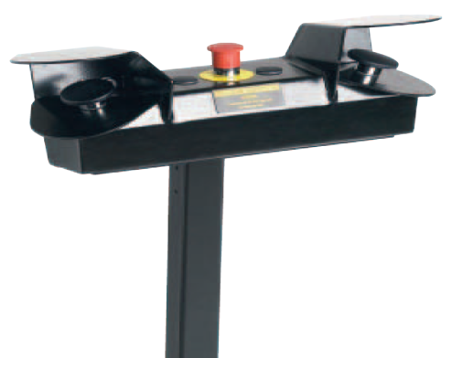



**Two-hand device JSTD20**

Have a look at the information sheet of Jokab Safety’s two-hand device “JSTD20” (*TwoHandDevice_JSTD20.pdf*).

Work through tasks e) to j).

1. Within how many seconds must both operating pushbuttons be activated in order to start a machine?

0.5 seconds

1. What happens if one or both operating pushbuttons are released?

A stop signal is given to the machine, and all contacts must return to their deactivated positions before a new start is allowed.

1. Tick the correct statement!

* Nach Loslassen einer Drucktaste ist ein erneuter Anlauf der Maschine durch erneute Betätigung derselben Drucktaste möglich.

_

* Nach Loslassen einer Drucktaste ist ein erneuter Anlauf der Maschine erst möglich, wenn alle Kontakte in ihre unbetätigte Position zurückkehrt sind.

X

1. Complete the table below!

|  |  |
| --- | --- |
| English | German |
| Emergency Pushbutton | NOT-HALT-Taster |
| Operating pushbutton | Betätigungstaster |
| Safety relay | Sicherheitsrelais |

1. Label the circuit diagram below using the English terms from the table in h).

Operating pushbutton

Emergency pushbutton

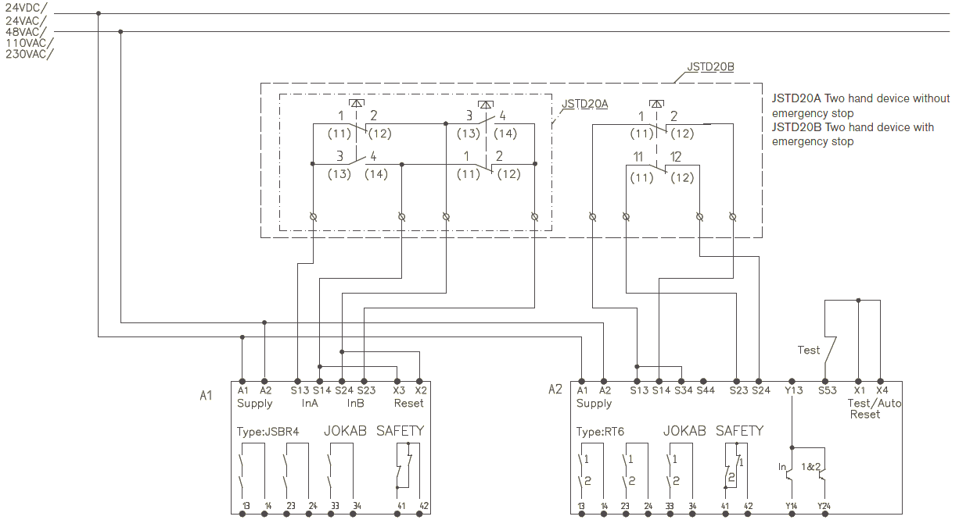

Safety relay

1. What exactly is the function of the safety relay *JSBR4*, which is used to monitor the two-hand tripping device?

* Ensure both operating pushbuttons are pressed to start and stops if one or both of the operating pushbuttons are released
* Ensure both operating pushbuttons are pressed simultaneously for 0.5 seconds
* Ensure that all contact return to their deactivated position before a new start