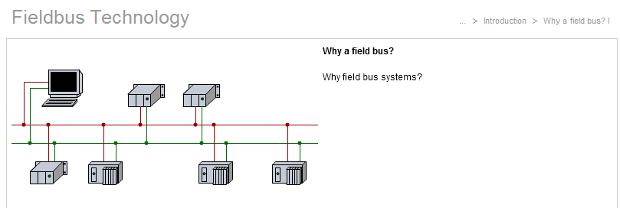***Fieldbus technology***

**Introduction**

Fieldbus is an industrial network system for real-time distributed control. It is a way to connect instruments in a manufacturing plant. A complex automated industrial system - such as a manufacturing assembly line - usually needs an organised hierarchy of controller systems to function. In this hierarchy there is usually a Human Machine Interface (HMI) at the top where an operator can monitor or operate the system. This is typically linked to a middle layer of programmable logic controllers (PLC) via a non-time-critical communication system (e.g. Industrial Ethernet). At the bottom of the **control chain** is the fieldbus that links the PLCs to the components that actually do the work such as sensors, actuators, electric motors, console lights, switches, valves and contactors. Fieldbus works on a network structure which typically allows line, star, ring and tree network topologies.

**Tasks**

1. Read the introduction carefully and label the illustration below using the correct terms. All the terms are used within the introduction.

Human Machine Interface (HMI)

Electric motor

PLC

Sensors

Fieldbus

non-time-critical communication system (e.g. Industrial Ethernet)

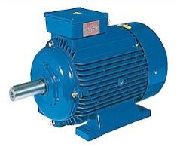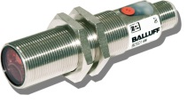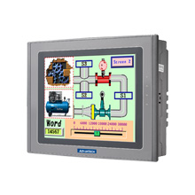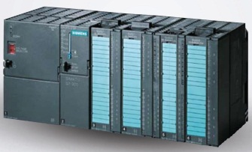

1. Work in pairs and translate the introduction into German. **Goal: You understand every detail of the text.**

Learning objectives

By the end of this learning sequence you will be …

* … more familiar with the use of fieldbus systems in a factory.
* … able to list the advantages of a bus system in contrast to the traditional parallel data transmission.
* ****… able to differentiate between the topologies which are used for fieldbus systems.

**Homework**

Make your own vocab cards and learn the new vocabulary!

Open the learning module “fieldbus technology” on moodle and work through the chapter “**introduction**”. Answer tasks c) to e) in the given order!

**Tasks**

1. What are **fieldbus systems** used for? Complete the following sentence.

Fieldbus systems replace the traditional parallel data transmission with serial data transmission.

1. What are the **advantages of fieldbus systems** compared to conventional wiring? Complete the two statements below.

* Further maintenance and modifications are easier to realise.
* Fieldbus systems have tremendous cost saving implication on cables and labor.

1. Label the following illustration of a **fieldbus application**. All the terms needed are used within the learning module.

Actuator, machine, application

Terminal box on the machine

PLC

Fieldbus cable

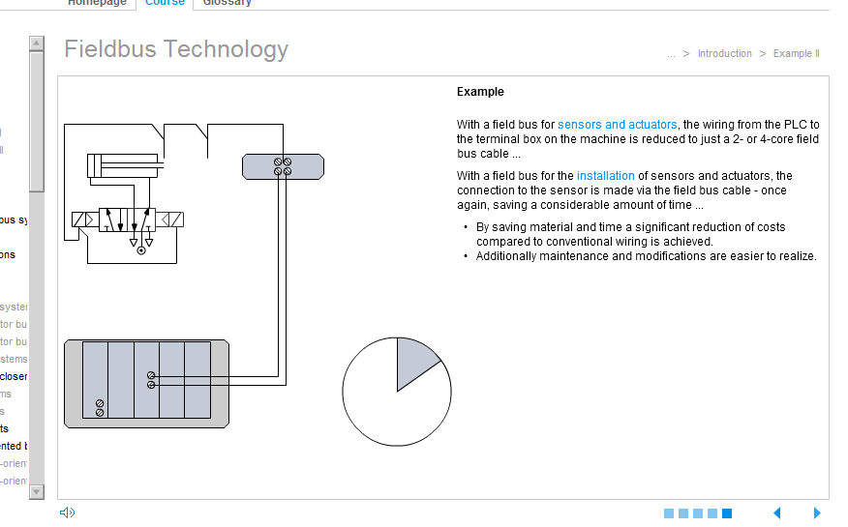

Fieldbus Modul in the plc

Open the learning module “fieldbus technology” on moodle and work through the chapter “**classification of fieldbus systems**”. Answer tasks f) to l) in the given order!

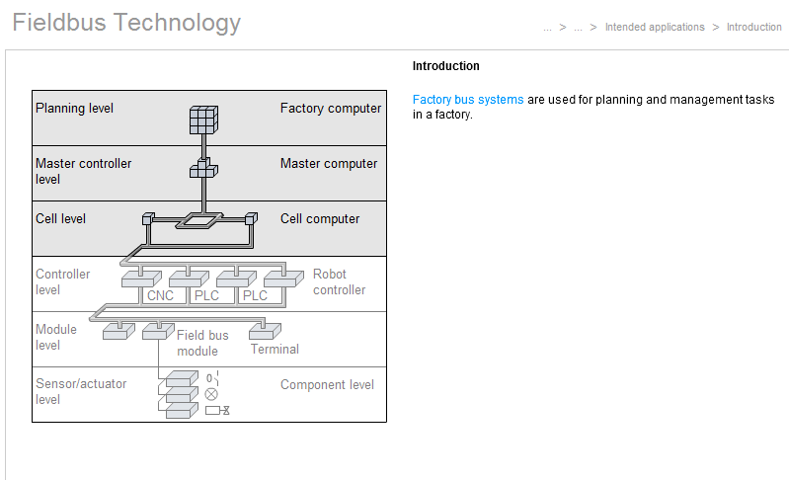**Tasks**

1. What are **factory bus systems** used for?

They are used for planning and management task in a factory

1. In which area of a factory are **fieldbus systems** used? Refer to the illustration and complete the following sentence.

A fieldbus is a system for serial data transmission in the **fieldbus area**, which consists of the Sensor/actuator level, the Module level, the Controller level and partly up to the Cell level.

1. Various fieldbus systems have been developed for different tasks in the fieldbus area. **Process bus (1)** and **sensor/actuator bus (installation systems) (2)** are two different types of fieldbus systems. Match the types of bus (1 or 2) to the characteristics!

|  |  |
| --- | --- |
| **Type of bus** | **Characteristics** |
| 1 | Does not need to operate at a particularly high speed. |
| 2 | Allows a cyclical exchange of I/O data between a controller and distributed I/O modules. |
| 1 | It is used for communication between PLCs. |
| 2 | Must be able to transport short data messages between a PLC and a fieldbus module. |
| 1 | It is used to exchange data which has already been pre-processed. |
| 1 | Transmission of data like *“Cell computer to PLC: Please produce 240 units of Type B!”*. |
| 2 | Need to operate at high speed. |
| 1 | Transmission of data like *“Message from PLC to robot: Workpiece ready, please take it away!”*. |
| 1 | Transmission of data like *“CNC machine to PLC: Tool breakage! Please wait!”*. |
| 2 | “Real-time operation”, for example, an installation can be halted by pressing a stop pushbutton. |
| 1 | Event-controlled communication (=send a message when an event has taken place, e.g. tool breakage). |
| 1 | Must transmit data messages of different lengths. |
| 2 | Cycle communication (=transmits data at regular intervals, no matter whether the data content is new or not). |

1. Definition of the terms “**Master**” and “**Slave**” regarding fieldbus technology: Complete the sentences below using the two terms!

A Master is a station which is able to initiate the transport of data via the bus. In contrast to this, the Slave can transmit data only in response to a request from the Master.

1. Explain the difference between **open** and **closed bus systems**. Use the following illustrations and complete the text below!

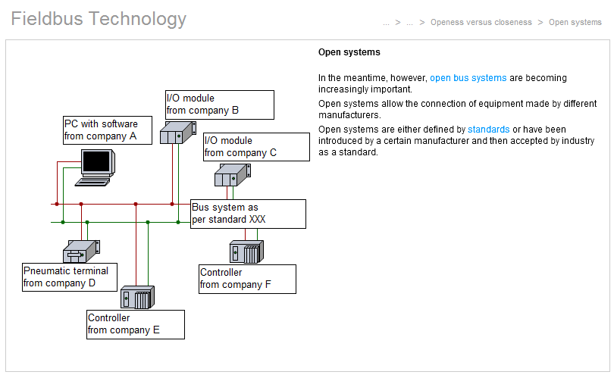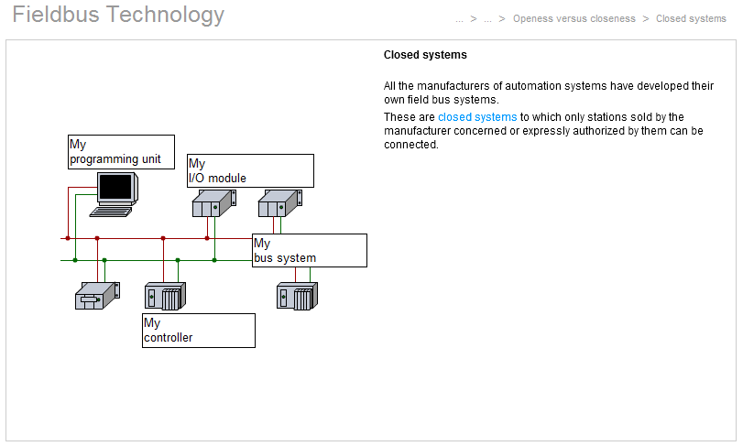

*Fig.: Closed bus system*

*Fig.: Open bus system*

All the manufacturers of automation systems have developed their own fieldbus systems. These are closed systems to which only stations sold by the manufacturer or expressly authorized by them can be connected. Open systems allow the connection of equipment made by different manufacturers. Opened systems are either defined by standards or have been introduced by a certain manufacturer and then accepted by industries as a standard.

1. Regarding **data transmission** one distinguishes between …

* … **message-oriented** bus systems,
* … **station-oriented** bus systems,
* … **multi-master** concepts and
* … **installation** concepts.

Write down a short description of the different types of data transmission!

|  |  |  |
| --- | --- | --- |
| **Type of data transmission** | **Description** | **Field bus (e.g.)** |
| **message-oriented** | One station calls another station and request a connection, if the other station is ready a logic channel is set up via which data can be transmitted, all messages contain the sender and receiver addresses. | Profibus |
| **station-oriented** | Within the ring, every station-starting with the master station – has a clear and unambiguous address. The complete message which is pushed through the ring by the master includes a checksum*1) at the beginning and all the input and output data. Each station within the ring must pass on all the data not intended for this particular station. | Interbus |
| **multi-master c.** | A station says something at the precise moment at which it has something new to say. Each of the other stations decides for itself whether the message is relevant and how it should react. | CAN |
| **installation c.** | An installation system for the connection of components must offer the benefit of a further drastic simplification of installation and maintenance work. Systems such as AS-i bus transport both data and power via a common two-core cable. The connection of a simple sensor, therefore, requires only two conductor wires. | AS-i |

*1) In der Informatik ist eine **Prüfsumme** (englisch ***checksum***) eine einfache Massnahme zur Gewährleistung von Datenintegrität bei der Datenübermittlung oder -speicherung. Sie wird hauptsächlich bei der Datensicherung und bei der Datenübertragung verwendet. Es gibt verschiedene Prüfsummenverfahren. Die einfachen Verfahren laufen stets nach einem gleichen Schema ab: Es werden Bits, Bytes oder eine andere grundlegende Komponente von Daten einer Nachricht mit einem bestimmten Faktor multipliziert und anschliessend der Reihenfolge nach aufsummiert. Der sich ergebende Wert wird dann als Prüfsumme mitgespeichert oder mitübertragen. Der Empfänger der Nachricht kann aus den Daten ebenfalls eine Prüfsumme berechnen und diese mit der mitübertragenen Prüfsumme des Senders vergleichen. Sind die beiden Prüfsummen unterschiedlich, liegt ein Übertragungsfehler vor und die Nachricht muss wiederholt werden. Sind die beiden Prüfsummen identisch, ist die Nachricht mit hoher Wahrscheinlichkeit korrekt übertragen worden.

1. What are the main advantages of installation concepts such as AS-interface? Complete the sentences below using the correct terms!

* Installation concepts for the connection of individual sensors/actuators have the upside of offering a further drastic reduction of installation costs.
* Installation concepts are fast, since they are confined to small systems and therefore have only a small volume of data to transmit.
* Installation concepts have real-time capability, because they are generally master/slave systems.

Open the learning module “fieldbus technology” on moodle and work through the chapter “**topology**”. Answer tasks m) to w) in the given order!

**Tasks**

1. Explain the term “**topology**” in one sentence!

Topology is the graphical representation of the structure or  wiring of a bus system.

1. List the three **basic topologies**?

line, ring, star

1. Which topology fits best to the description?

* tree

… topology consists of a continuous bus cable to which stations are connected without interruption. A cable used as a transmission line must be terminated electrically at each end in a defined manner, generally by means of a bus terminating resistor.

_

* line

X

* network

_

* star

_

* ring

_

1. Which topology fits best to the description?

* tree

… topology is a mixture of the line and the star topology. A line is connected to a central station. From the lines connected to this station, further lines branch out, creating – figuratively speaking – a structure like that of a tree. This type of topology is found in particular in sensor/actuator bus systems which extend down to the component level.

X

* line

_

* network

_

* star

_

* ring

_

1. Which topology fits best to the description?

* tree

… topology means that all stations are connected to a central station by a separate cable in each case. The advantage of … topology is the great ease with which maintenance can be carried out. If a cable fails, for example, only one connected station stops operating, making the fault simple to find. The disadvantage of this topology is the high cost of installing cables. This type of topology is very rarely used in field bus systems.

_

* line

_

* network

_

* star

X

* ring

_

1. Which topology fits best to the description?

* tree

The … topology is a type of topology in which essentially a point-to-point connection is established from one station to the next. This means that each station within the … must pass on all the data not intended for this particular station without modification.

_

* line

_

* network

_

* star

_

* ring

x

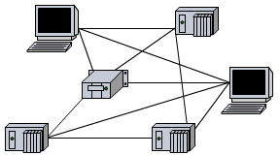

1. What do we call the topology shown in the figure on the right?

Network topology

1. Which topologies are used for **fieldbus systems**?

Line, ring, tree

1. Complete the main characteristics of a **line topology**!

* The **Profibus**, for example uses line topology.
* The line consists of an uninterrupted cable .
* The line is fitted at its ends with bus terminating resistors.
* As a rule, individual stations can be switched on or off while the system is in operation.
* The line can be extended or expanded using repeaters .

1. Complete the main characteristics of a **ring topology**!

* The **Interbus**, for example uses ring topology.
* The ring is interrupted by each station .
* Each station within the ring acts like a repeater , which amplifies the signal and extends the overall distance which can be covered.
* Within the ring, every station – starting with the master station – has a clear and unambiguous address .

1. Complete the main characteristics of a **tree topology**!

* The **AS-i bus**, for example uses tree topology.
* Tree topology is used in particular for the type of bus systems which branch down towards the component level.
* The tree must never be turned into a ring or network topology.

Open the “**glossary**” in the learning module “fieldbus technology” on moodle and work through the following task!

**Task**

Which technical term fits to the description? Refer to the glossary if necessary!

|  |  |
| --- | --- |
| **Technical term** | **description** |
| Shield | The … of a fieldbus cable is a metallic sleeve around the conductor cores, which are generally of twisted-pair type. With field bus systems, both ends of the … are connected to earth. |
| Topology | The structure of a communication system. |
| Real-time | The term "… operation" indicates that an automation system is guaranteed to respond within a given time frame. There is no specification of how large this time frame is or needs to be. The size of the time frame is stated by defining how long the maximum permissible reaction time is or needs to be for a specific application. An automation system must always have … capability, since it is essential, for example, that an installation can be halted by pressing a "Stop" button. |
| Master/slave system | Within a … system, only one station, the master, has control over the bus. All other stations must monitor the bus constantly but are allowed to transmit data via the bus only when requested by the master. |
| Fibre optic cable | … are the most interference-immune data transmission systems which have yet been devised. They are usually somewhat more expensive than copper cable systems, require a somewhat more complex installation technique and - when used in a fieldbus context - form a ring. |
| Bus terminator | A … is always required with a line. A line in this case is an uninterrupted cable fitted at both ends with a … resistor, generally of around 150 ohms. The … resistors prevent the reflection or echo of the data signal. |