# Shower – Manual control of the water temperature (example of a feedback control)

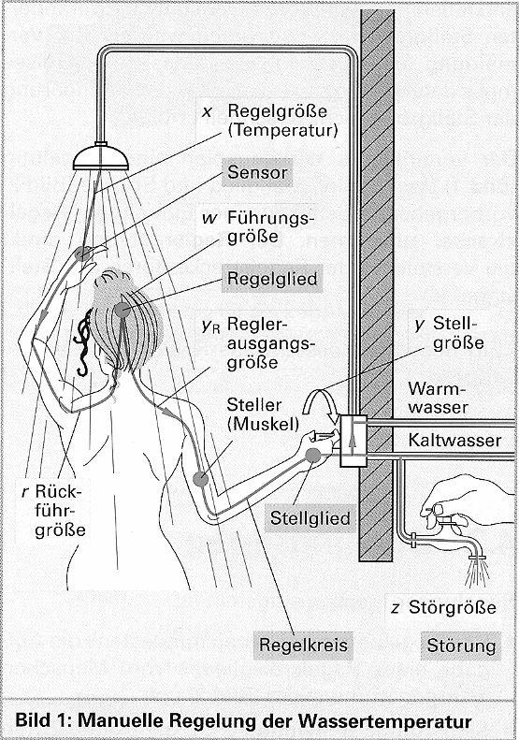Technical illustration of a shower:

|  |  |
| --- | --- |
| Führungsgrösse w | Set value SCV |
| Reglerausgangs-grösse yR | Contolled output variable |
| Stellgrösse y | Manipulated variable |
| Regelgrösse x | Controlled variable |
| Störgrösse z | Disturbance variable |
| Rückführgrösse r | Process value PV |
| Steller | contollelement |
| Stellglied | Final control element |
| Regelkreis | Closed loop contorl |
| Störung | Disturbance |

**Tasks**

1. Complete the table above using the correct English terms. Refer to the document „Steuerungen und Regelungen“ if necessary!
2. Complete the closed-loop control circuit below for the manual control of the water temperature (shower). What stands for the **controller**? What is the **control element**? What corresponds to the **final control element**? What is the **actuator**? What stands for the **controlled process** and what is used as **measuring device**?

automatic control device

controller output variable

yC

z

disturbance variable

manipulated variable

y

error

(control deviation)

e

Human

x

controlled variable

servo unit

Brain

Muscles

Shower cabine

SV

set value

Summing

point

Hand

+

PV

process value

-

Skin

1. Is the **signal flow path** of the shower example open or closed?

_

* open

closed

X _

1. Is the **process of action** of the shower example open or closed?

* open

_

closed

X

1. Have a look at the general structure of the control loop above and match the values of the shower example to the terms listed in the table below!

|  |  |
| --- | --- |
| set value SV | Desired temperature |
| manipulated variable y | Position of the mixed water tab [°] or [mm] |
| disturbance variable z | Drop in water temperature [°C] |
| controlled variable x | Actual temperature in the cabine |
| process value PV | Signal t o the human brain [mA] |



**Homework**

Make your own vocab cards and learn the new vocabulary!