# Rotational speed control of a steam turbine (example of a feedback control)

The technology diagram of a speed control for a steam turbine is given below. It is a classic **fixed command control** *[=Festwertregelung]*.

valve

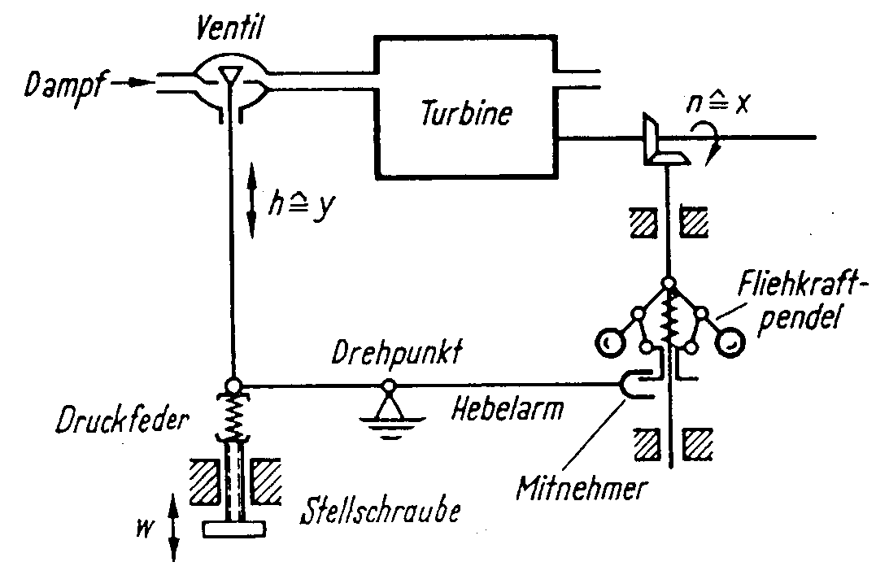

Gear box

Driver shaft

Centrifual pendulum

Driver

Contorl screw

Preassure spring

Center of rotation

steam

Lever arm

**Tasks**

1. Complete the labelling of the technology diagram above using the following expressions:
   * *driver - pressure spring - gear box*
   * *control screw - drive shaft - valve*
   * *centrifugal pendulum - lever arm - center of rotation*
2. Describe the function of the rotational speed control in your own words! Write down complete sentences in English!

You can set a speed, an then the control spring is pressed. The spring is opening the valve so that the steam can enter the turbine. Through the turbine the driver shaft is driven, the gearbox takes the rotation to the centrifugal pendulum. The pendulum corrects the control spring with the lever arm over the center of rotation.

1. Structure of a closed-loop control circuit (=control loop):

controller

x

controlled variable

automatic control device

servo unit

control element

final control element

controlled process

z

disturbance variable

y

manipulated variable

SV

set value

measuring device

PV

process value

summing

point

+

-

actuator

controller output variable

yC

error

(control deviation)

e

Have a look at the general structure of the control loop above and match the devices and values of the rotational speed control to the terms listed in the table below!

|  |  |
| --- | --- |
| controlled process | Turbine |
| actuator | Valve |
| set point setting device | Contorl screw |
| automatic control device | Center of rotation / lever arm / driver |
| measuring device | Centrifugal pendulum |
| controlled variable x | Acutal rotion speed [min-1] |
| set value SV | Preassure of the spirng [n/mm |
| manipulated variable y | stroke h [mm] of the valve cone |
| disturbance variable z | Lack of steam [l], load [kg], steam preassure [N/mm] |

1. Why is this type of a closed-loop control (=feedback control) called a fixed command control? Write down a brief explanation in English!

You just have to set the set value one time and don’t have to change it

1. Is the **signal flow path** of the rotational speed control open or closed?

_

* open

closed

X

1. Is the **process of action** of the rotational speed control open or closed?

* open

_

closed

X



**Optional homework**

Create your own vocab cards and learn the new vocabulary.