**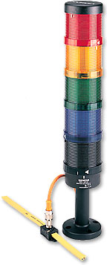*Ventilation system - Extension AS-i-bus!***

**Introduction**

Signalling columns at machines or in automated processes are important optical devices to monitor complex sequences. They are used as visual alarm devices when emergency situations occur.

The signalling columns at the vocational school BBB are communication-capable and can be directly connected to the yellow AS-i cable. They can combine a maximum of four different optical signalling elements that can be easily mounted.

Technology diagram

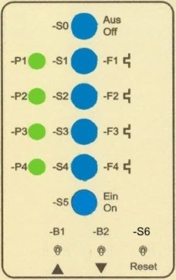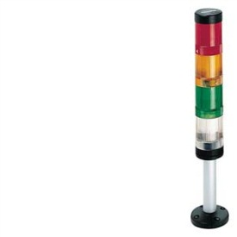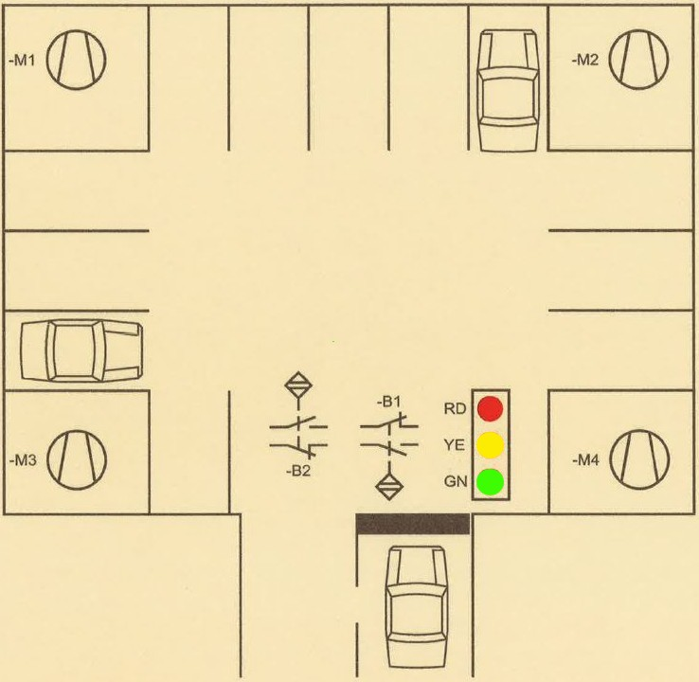

*Fig.1: Underground parking Fig.2: Control panel*

Learning objectives

By the end of this learning sequence you will …

* … understand the systematics of AS-i addressing.
* … have successfully extended an existing PLC-program with a communication-capable signalling column. *[without the* „*extra extension*“*!]*
* … have successfully extended an existing PLC-program with a communication-capable signalling column and a LOGO! control unit as an AS-i slave. *[inclusive the* „*extra extension*“*!]*
* … be able to create and work out all the required documents to record a PLC control task such as function diagram, connection diagram of PLC or symbol table.



**Homework**

Make your own vocab cards and learn the new vocabulary!

**Which AS-i signalling column occupies which addresses?**

Read carefully through the document „Aktuator-Sensor-Interface (AS-i)“ (AUF3.4.7_AS-i.docx) and complete the following table with the correct addresses for the AS-i signalling columns at the vocational school BBB!

|  |  |  |  |  |
| --- | --- | --- | --- | --- |
|  | | **Slave-address** | **Lamp** | **PLC-address** |
| **collateral** | **no. 1** | **20** | http://www.mercateo.com/images/products/927_tgiautotech/8wd4400-1ab.jpg | Q86.7 |
| http://www.insystems-shop.de/media/images/thumb/signalsule_gelb.jpg | Q86.6 |
| http://www.mercateo.com/images/products/927_tgiautotech/8wd4400-1ac.jpg | Q86.5 |
| http://support.automation.siemens.com/BE/llisapi.dll/csfetch/23218609/P_NSC0_XX_00179i.jpg | Q86.4 |
| **collateral** | **no. 2** | **21** | http://www.mercateo.com/images/products/927_tgiautotech/8wd4400-1ab.jpg | Q86.3 |
| http://www.insystems-shop.de/media/images/thumb/signalsule_gelb.jpg | Q86.2 |
| http://www.mercateo.com/images/products/927_tgiautotech/8wd4400-1ac.jpg | Q86.1 |
| http://support.automation.siemens.com/BE/llisapi.dll/csfetch/23218609/P_NSC0_XX_00179i.jpg | Q86.0 |
| http://photos1.fotosearch.com/bthumb/TBZ/TBZ122/lb01p021.jpg**collateral** | **no. 3** | **22** | http://www.mercateo.com/images/products/927_tgiautotech/8wd4400-1ab.jpg | Q 87.7 |
| http://www.insystems-shop.de/media/images/thumb/signalsule_gelb.jpg | Q 87.6 |
| http://www.mercateo.com/images/products/927_tgiautotech/8wd4400-1ac.jpg | Q 87.5 |
| http://support.automation.siemens.com/BE/llisapi.dll/csfetch/23218609/P_NSC0_XX_00179i.jpg | Q 87.4 |
| **collateral** | **no. 4** | **23** | http://www.mercateo.com/images/products/927_tgiautotech/8wd4400-1ab.jpg | Q88.3 |
| http://www.insystems-shop.de/media/images/thumb/signalsule_gelb.jpg | Q88.2 |
| http://www.mercateo.com/images/products/927_tgiautotech/8wd4400-1ac.jpg | Q88.1 |
| http://support.automation.siemens.com/BE/llisapi.dll/csfetch/23218609/P_NSC0_XX_00179i.jpg | Q88.0 |
| **collateral** | **no. 5** | **24** | http://www.mercateo.com/images/products/927_tgiautotech/8wd4400-1ab.jpg | Q88.7 |
| http://www.insystems-shop.de/media/images/thumb/signalsule_gelb.jpg | Q88.6 |
| http://www.mercateo.com/images/products/927_tgiautotech/8wd4400-1ac.jpg | Q88.5 |
| http://support.automation.siemens.com/BE/llisapi.dll/csfetch/23218609/P_NSC0_XX_00179i.jpg | Q88.4 |
| **collateral** | **no. 6** | **25** | http://www.mercateo.com/images/products/927_tgiautotech/8wd4400-1ab.jpg | Q88.3 |
| http://www.insystems-shop.de/media/images/thumb/signalsule_gelb.jpg | Q88.2 |
| http://www.mercateo.com/images/products/927_tgiautotech/8wd4400-1ac.jpg | Q88.1 |
| http://support.automation.siemens.com/BE/llisapi.dll/csfetch/23218609/P_NSC0_XX_00179i.jpg | Q88.0 |

**Functional description**

The existing control of the ventilation system has to be extended with a signalling column which is able to communicate.

The state of the traffic light at the underground parking entry must be indicated additionally in the switching center using a signalling column. The lamps of the column need to flash as follows:

* The red signal lamp flashes with a clock frequency of 0.5 Hz.
* The yellow signal lamp flashes with a clock frequency of 0.625 Hz.
* The green signal lamp flashes with a clock frequency of 1.0 Hz.

**Symbol table**

Complete the following symbol table in accordance with the signalling column that you will use in the laboratory:

|  |  |  |
| --- | --- | --- |
| http://www.schuenemann.name/studium/leittext/denken.jpg**Symbol** | **PLC-address** | **Comment** |
| SC-P_RD | Q88.7 | Signalling column, red lamp |
| SC-P_YE | Q88.6 | Signalling column, yellow lamp |
| SC-P_GN | Q88.5 | Signalling column, green lamp |

**Tasks**

1. Complete the function diagram (Grafcet acc. EN60848) in accordance with the functional description.
2. Save your S7-project *VtSys*as ***VtSys_E1***.
3. Extend the symbol table using SIMATIC MANAGER.
4. Extend the PLC program in the programming language **FBD**.
5. Simulate your PLC program using PLCSIM.
6. Assemble and commission the ventilation system in combination with the signalling column in the laboratory.
7. Present your solution to the teacher.

**Required documentations**

After finishing this control task, you are expected to file the following documents as hard copy:

* Function diagram (Grafcet)
* Connection diagram of PLC *[Only if you did the “extra extension”!]*

After finishing this control task, you are expected to file the following documents as soft copy on „moodle“:

* S7-project *VtSys_E1.zip*
* S7-project *VtSys_E2.zip [Only if you did the “extra extension”!]*
* LOGO! program *VtSys_E2.lsc [Only if you did the “extra extension”!]*
* **Individual** conclusive comment on the control task *VtSys_E.docx*.

**Timetable**

Timetable according your teacher’s directions.

**Vocabulary**

Complete the wordlist using just this document! All the terms are used within this worksheet!

|  |  |
| --- | --- |
| English: | German: |
| … | Signalsäule |
| … | kommunikationsfähig |
| … | Schaltzentrale |
| (to) … | blinken |
| … | Taktfrequenz |
| … | Zuordnungsliste |
| … | SPS-Anschlussplan |
| … (Grafcet) | Funktionplan (Grafcet) |
| … | Zeitplan |

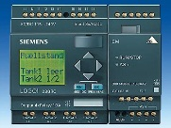***Extra extension***

The existing control of the ventilation system has to be extended as follows: Additionally one can switch off the ventilation system by means of the pushbutton S01, which is directly wired to the LOGO! control unit. S01 has exactly the same function as S0! In addition, the status of the fans needs to be indicated by means of four signal lamps (P01, P02, P03 and P04), which are also directly wired to the LOGO! control unit. The communication between the LOGO! control unit and the S7-300 PLC is made by AS-i-bus!

**Tasks**

1. Complete the function diagram (Grafcet acc. EN60848) in accordance with the functional description.
2. Work out the connection diagram of PLC for the LOGO! control unit. Take the rules on wire breakage into account! The motor control must be fail-safe!
3. Save your S7-project *VtSys_E1*as ***VtSys_E2***.
4. Extend the PLC program in the programming language **FBD**.
5. Create a LOGO!-project and call it ***VtSys_E2***.
6. Work out the LOGO! program in the programming language **FBD**.
7. Assemble and commission the ventilation system in combination with the signalling column in the laboratory.
8. Present your solution to the teacher.

**Required documentations**

See further above (page 3)!