
Final Report
Database System Project
Department of Software Engineering
Program : Data Science
SMIU
Database Project
Student Name : Akbar Ali
Student ID: BDA-25S-028
Student Name: Wasif Ahmed Siddiqui
Student ID: BDA-25S-029

Assigned by: Sir Asif Irshad

Motivation
The motivation of this project is to apply logical thinking in designing real-life database systems. Hospital, University, and E-Commerce databases were selected after analyzing their requirements and data flow. For this project, ERDs were created using the draw.io website to clearly understand entities, attributes, and relationships.
This project served as a bridge between theoretical concepts and practical implementation. While we studied database theories like Normalization and Relational Algebra in books, applying them to these three diverse scenarios helped me understand their real value. For instance, converting complex many-to-many relationships into bridge tables was a direct practical application of the mapping rules we learned in theory.
After designing the ERDs, relational models were developed to convert those diagrams into proper database tables. This process required significant logical effort to identify Primary Keys, Foreign Keys, and ensure Referential Integrity. Moving from a visual diagram to a structured schema taught me how to maintain data consistency and avoid redundancy in a real-world environment.
By working on ERDs and relational models, I improved my understanding of database structure and design concepts. This journey from theory to practice helped me develop critical problem-solving skills and provided me with practical knowledge of database management systems used in different professional fields.
Overview
Significance / Importance of the Project
The motivation for this project is to gain practical experience in database design and management. These systems are important because they are widely used and handle large and critical data. The project is useful for learning ERD design, relational models, and SQL in a real context. Although the area requires logical thinking and careful planning, a successful design can reduce data errors, improve data management, and provide strong academic and practical value.
Description of the Project
This project is about designing database systems for Hospital, University, and E-Commerce domains. The main problem addressed is how to store and manage large amounts of data in a proper and organized way. Poor data management can cause errors, duplication, and data loss, which can be critical in fields like healthcare or finance.
To solve these issues, the scope of this project includes creating ERDs (Entity Relationship Diagrams), converting them into Relational Models, and finally implementing the databases using SQL Server.
A key part of this project was the transition from theoretical rules to practical execution. I applied the theory of Normalization (1NF, 2NF, 3NF) to ensure that the data is not redundant and remains consistent. For example, while the theory explains how to remove data duplication, implementing it in SQL Server using Primary Keys and Unique Constraints showed me how to practically enforce these rules.
The approach used is general and can be applied to other similar systems. By using SQL Server for implementation, I was able to write DDL (Data Definition Language) queries to transform my logical designs into physical tables. This process helped me understand how theoretical constraints (like Referential Integrity) actually work to protect data in a live environment.
Related Work and Literature Review
I studied textbooks, lecture notes, and online resources to understand database design, ERD, normalization, and SQL. Tools like draw.io were used for ERD creation. For generating transaction data, I used Python scripts to create realistic sample data. When I did not understand some concepts, I also referred to YouTube videos for guidance.
References:
- Draw.io – Online ERD Tool.
- Python – Used for generating sample transaction data.
- YouTube videos and tutorials.
- Course lecture slides and notes.
Salient Features
- Organized Data Management
The project stores data in structured tables with clear relationships, making it easy to retrieve and update information for hospitals, universities, and e-commerce systems.
- ERD and Relational Model Design
ERDs were created using draw.io, and relational models were developed to ensure proper database structure, relationships, and data integrity.
- Transaction Data Generation
Sample transaction data was generated using Python scripts to simulate real-world operations like patient visits, student records, and customer orders.
- Error-Free and Accurate Data
By using proper primary and foreign keys, the database avoids duplicate and inconsistent records, ensuring data accuracy.
- Practical Learning Experience
The project helps improve SQL, database design, and logical thinking skills, providing hands-on experience that is useful academically and professionally.
- Generalized Approach
The database design approach can be applied to other similar systems, not just the three domains used in this project.
- User-Friendly and Easy to Understand
The structure is simple enough to be understood by non-specialists, making it easier to use and explain.
Project Planning
The project is planned in simple steps to complete it successfully.
- Requirement Analysis Study project needs and decide what data is needed.
- ERD Design Draw ERDs using draw.io to show entities and relationships.
- Relational Model Convert ERDs into database tables with keys.
- Data Generation Use Python scripts to create sample transaction data.
- Database Implementation Create tables and insert data using SQL.
- Testing & Validation Check the database for errors, accuracy, and relationships.
- Report & Documentation Write project report and prepare submission.
Responsibility
- Student 1 Requirement analysis and ERD design
- Student 2 Data generation and testing and SQL implementaion
- Student 1 Transform ERD into Relational Model
- Student 2 Report writing and documentation
Timeline :
- Week 1: ERD Design Relational Model And Data Generation
- Week 2: Database Implementation ,Testing & Validation ,And Report
Required Hardware and Software
Hardware Requirements
- Computer / Laptop – To design and implement the databases.
- Internet Connection – For research, online tutorials, and software download.
Software Requirements
- Database Software SQL Server for creating and testing databases.
- ERD Tool – draw.io (online free tool) for designing ERDs.
- Programming Language – Python (for generating sample transaction data).
- Libraries – Python libraries like random, datetime, pandas (for data generation).
- Documentation Tools – MS Word for report writing.
Libraries / Modules Used in Project
Third-party APIs are not used. Only standard Python libraries are applied.
- random
  - Version: Standard Python library
  - Purpose: To generate random numbers and data values for sample transactions (like patient IDs, order amounts, etc.)
  - Reference: Python official documentation: https://docs.python.org/3/library/random.html
- datetime
  - Version: Standard Python library
  - Purpose: To generate dates for transactions, appointments, orders, and other time-based data
  - Reference: Python official documentation: https://docs.python.org/3/library/datetime.html
References
1 SQL Server 2012
3 Python (Generate for data)
4 draw.io Online Tool,
5 Course Lecture Slides and My Notes
6 YouTube Tutorials (for database and Python help),

University Database System
ERD:
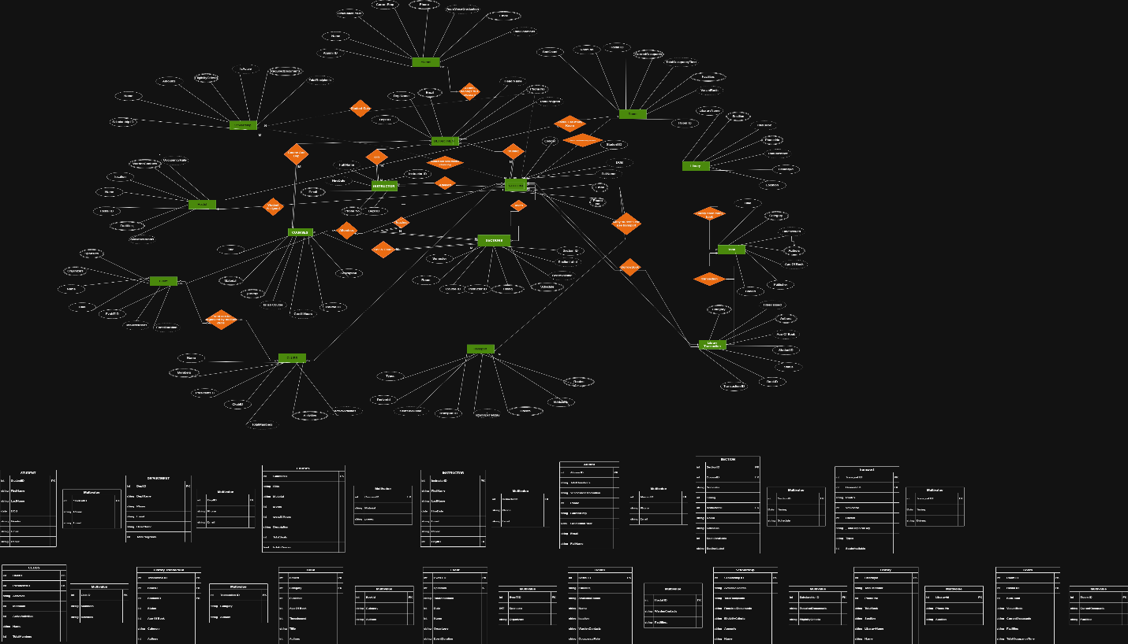
Table Queries
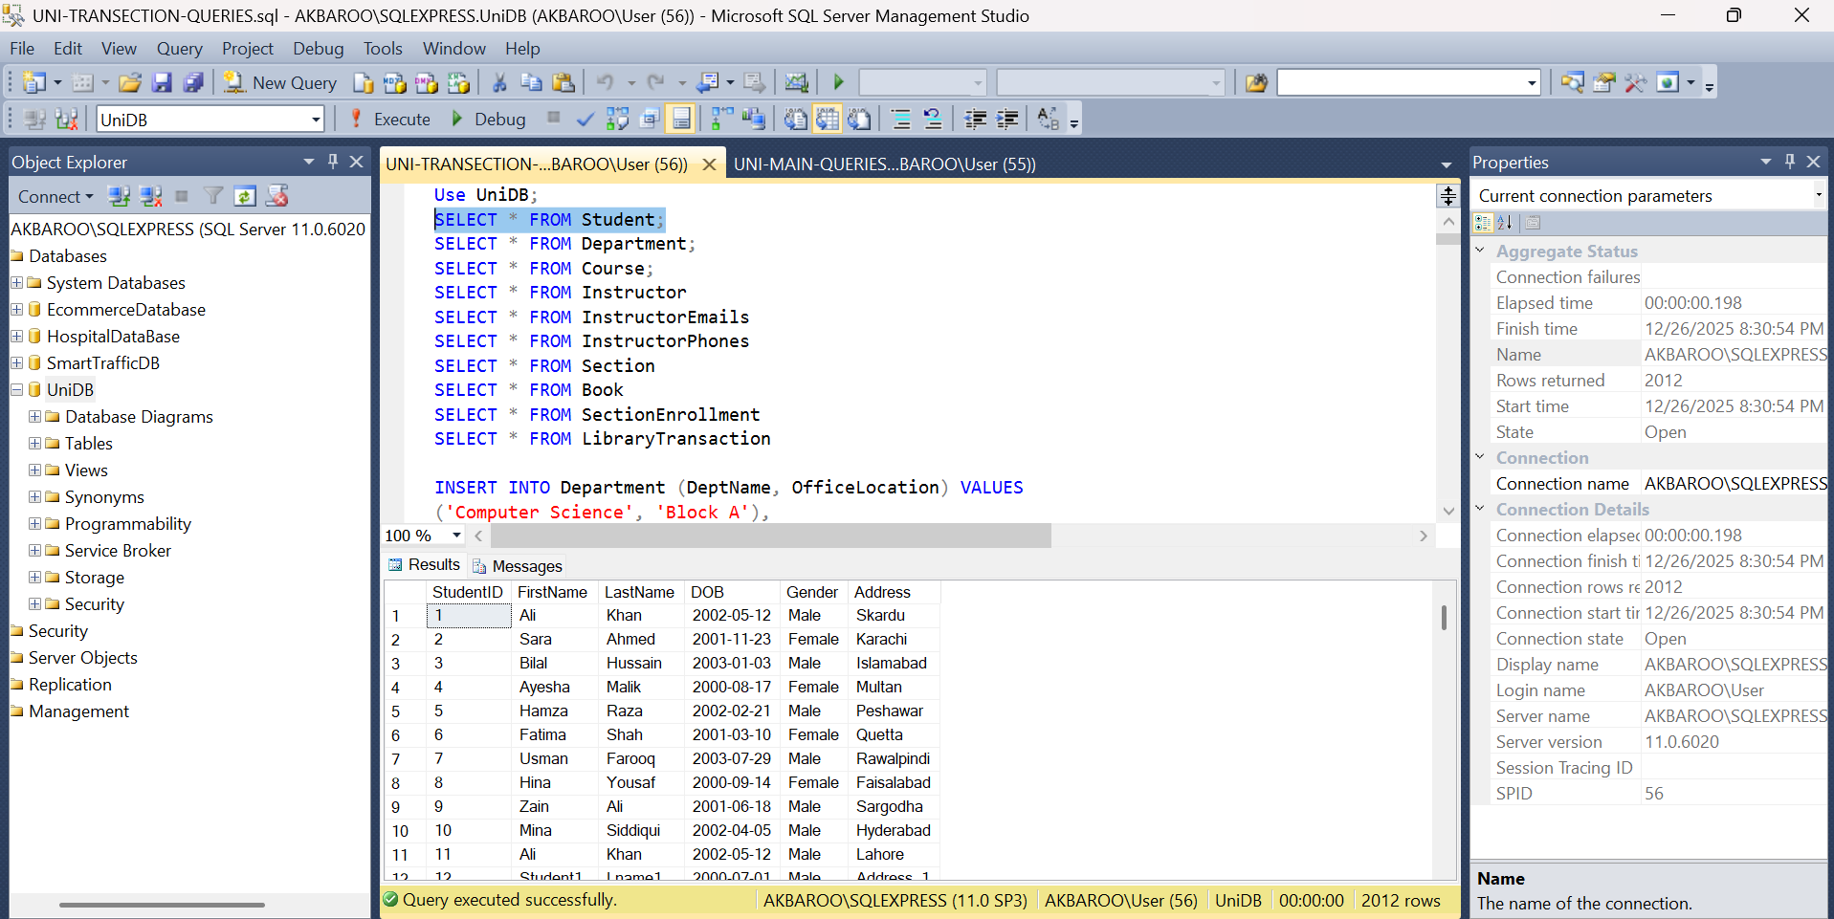
Update Queries(Hospital & E-commerce also same queries but different data)
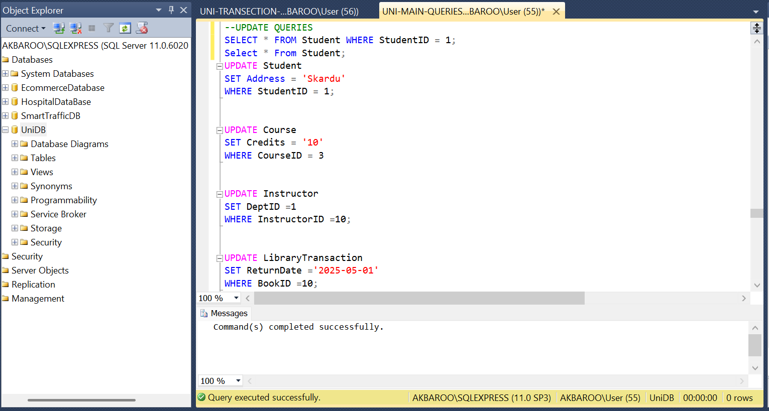
Indexing And View Queries (hospital & E-commerce also same queries but different data)
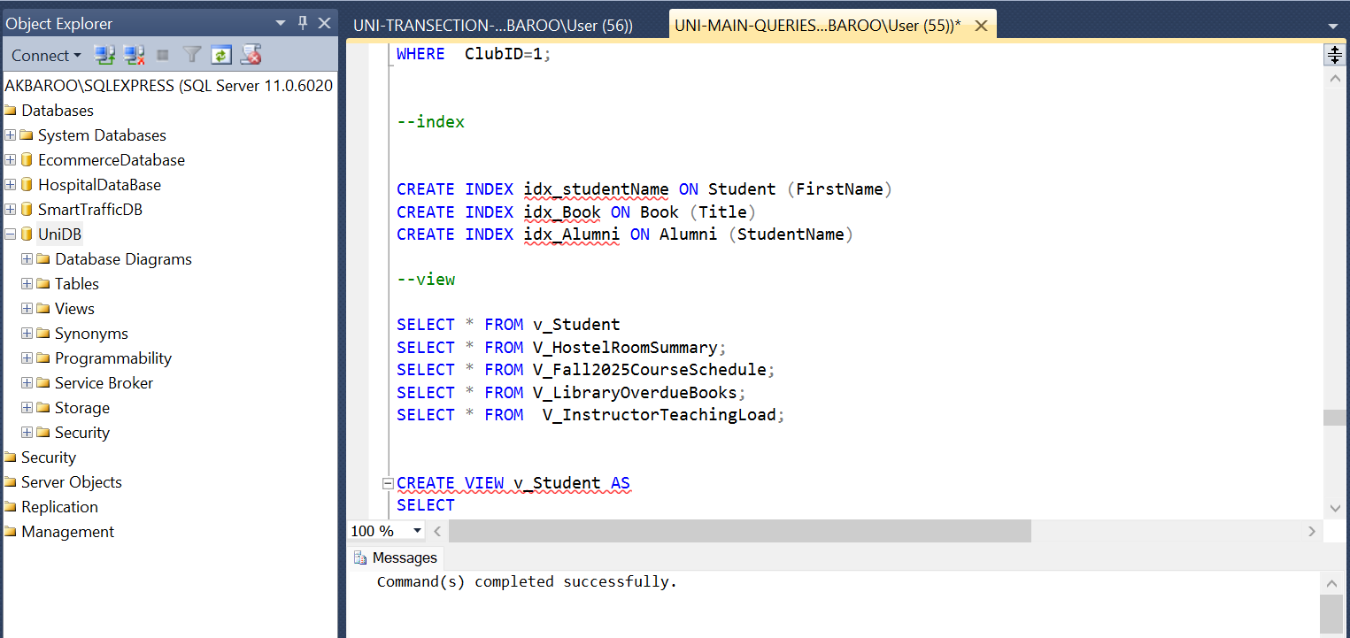
Python script for generate simple data
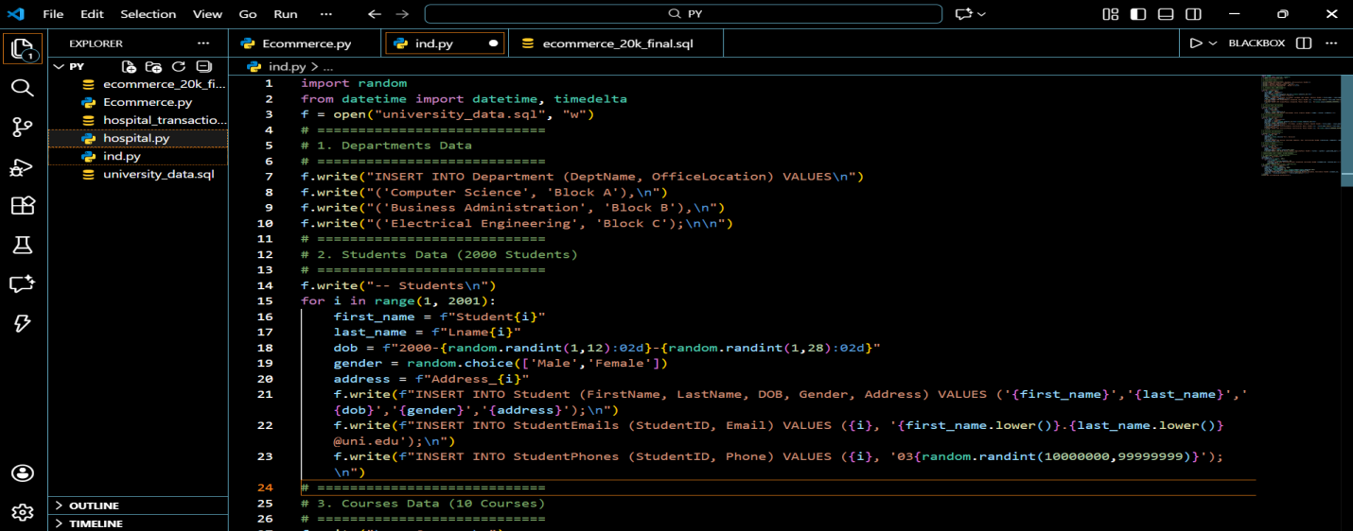
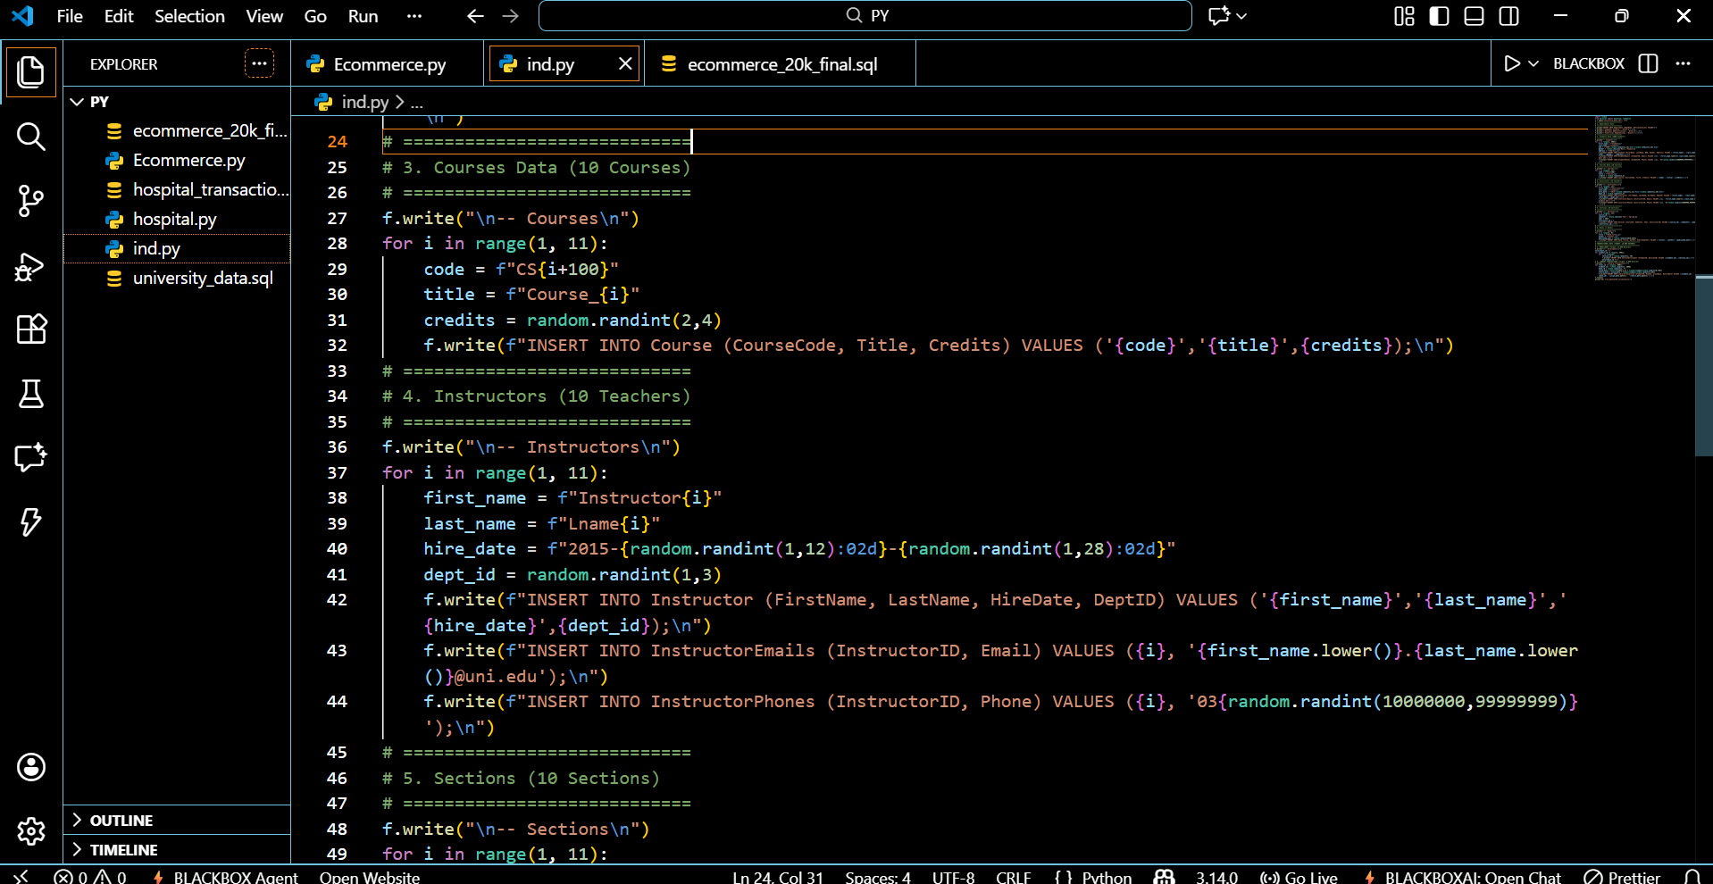
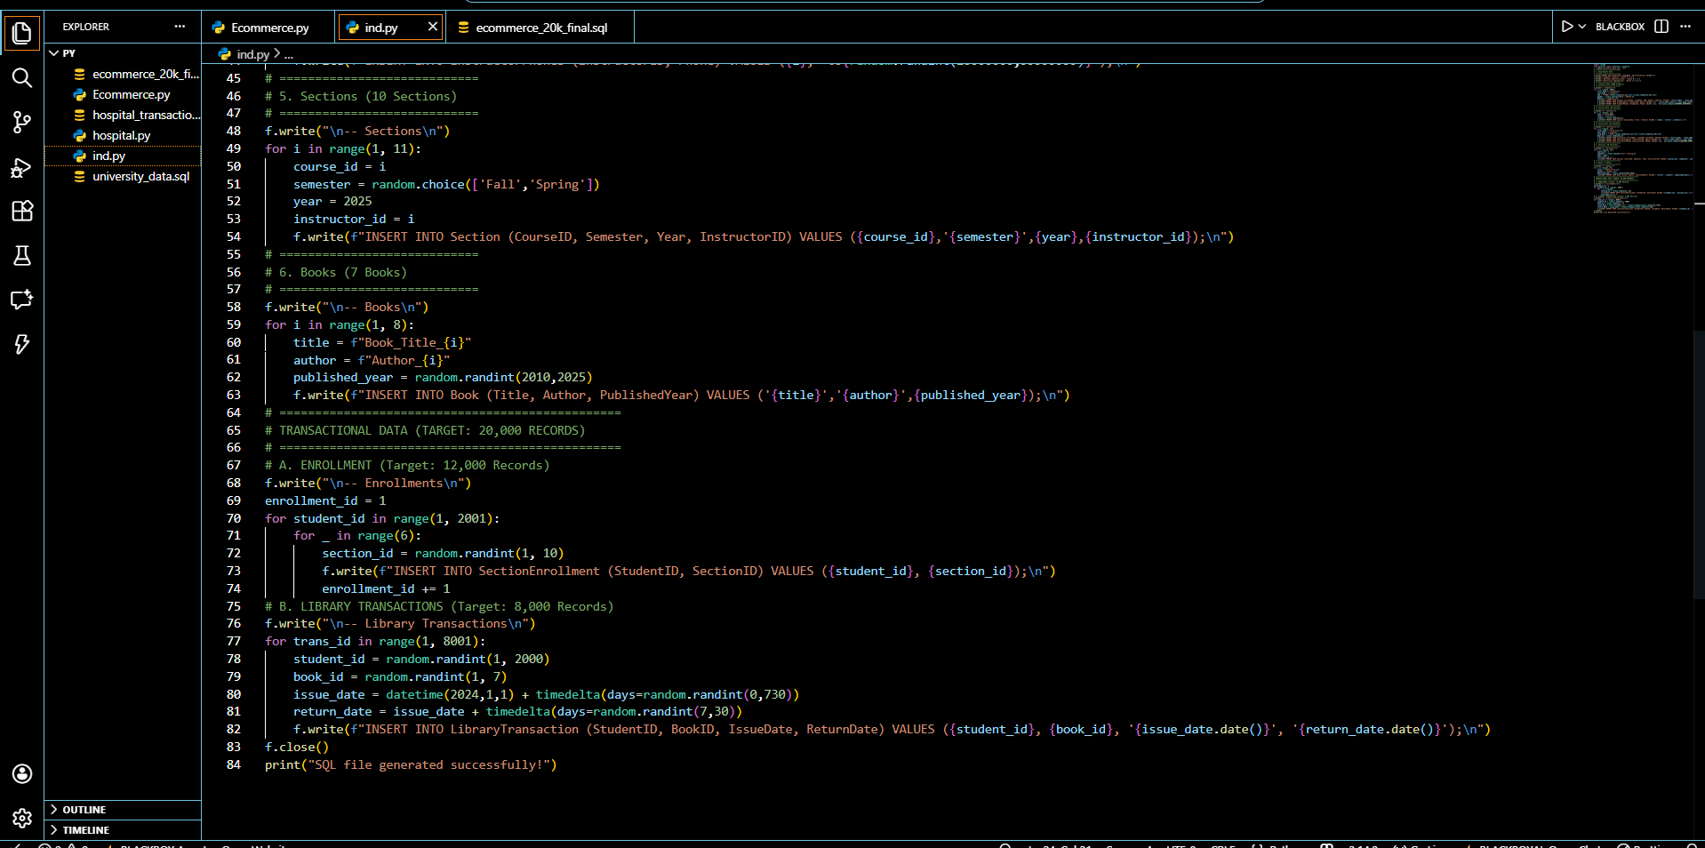
Hospital Database System (ERD)
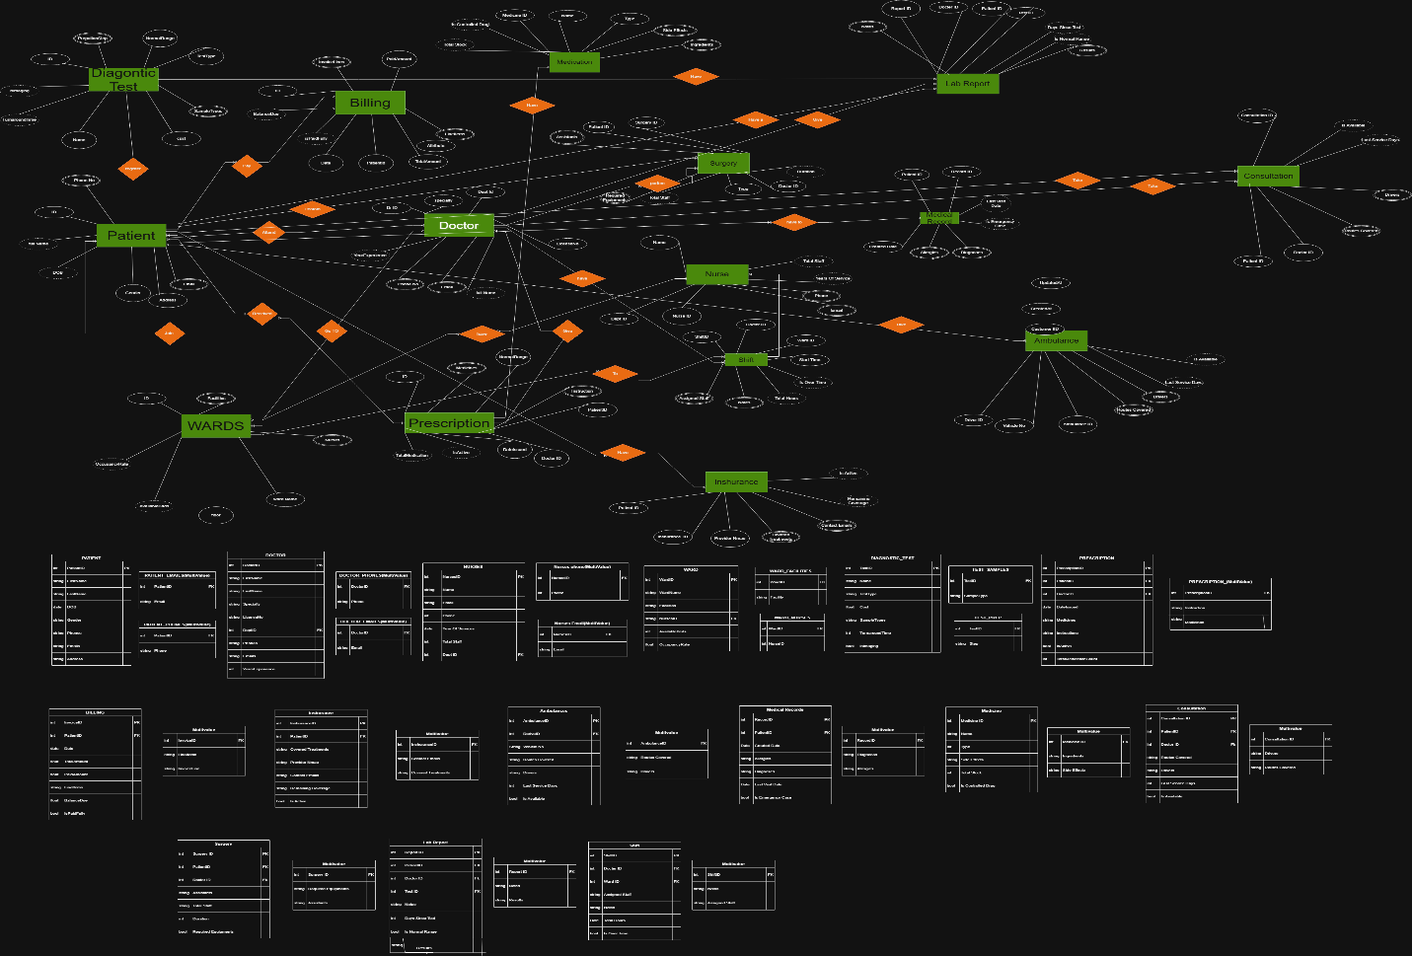
Table Queries
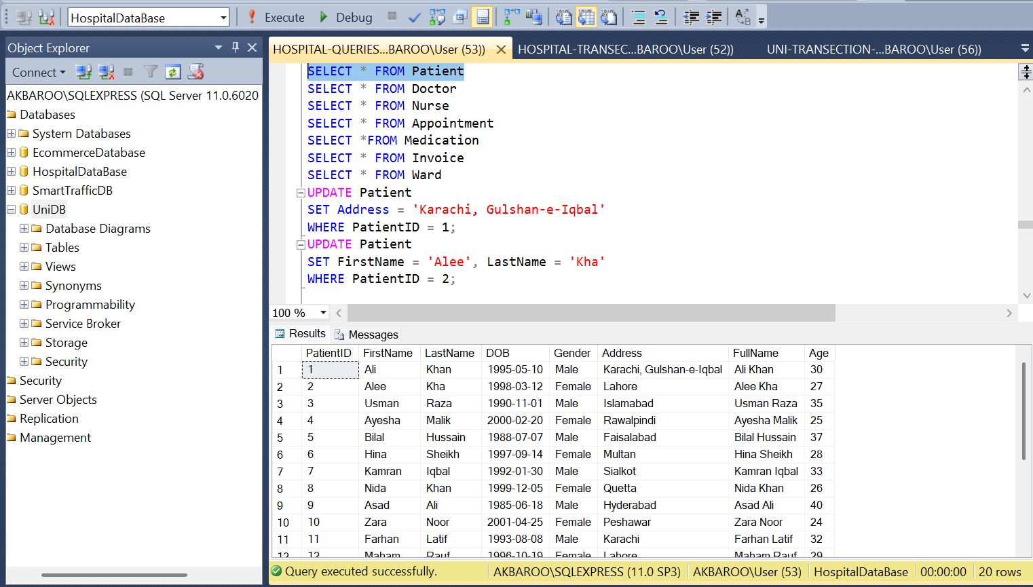
Python script for generate simple data
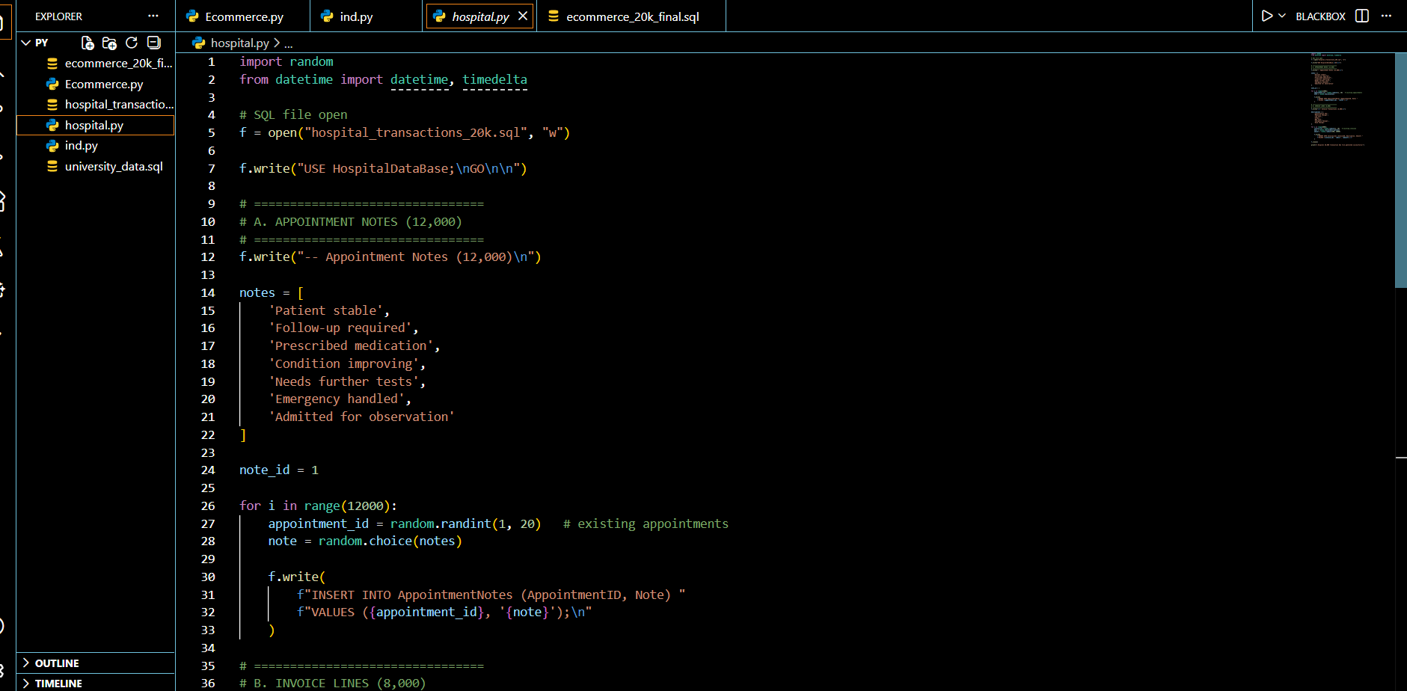
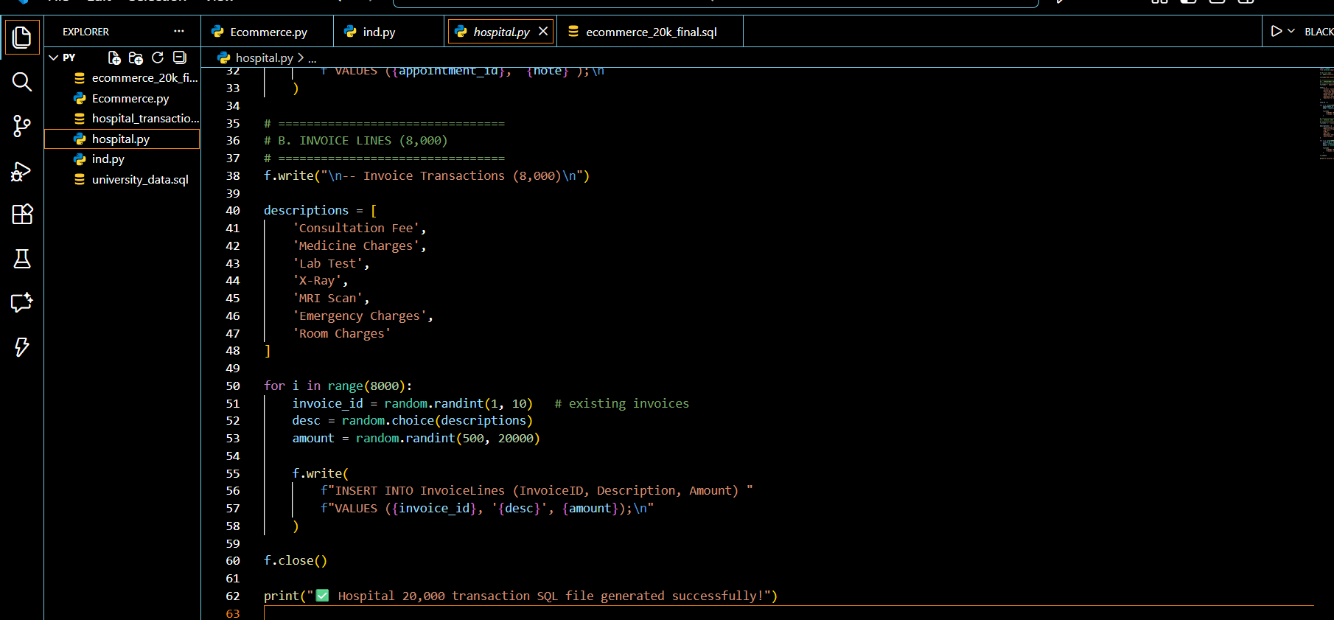

E-Commerce Database System ERD
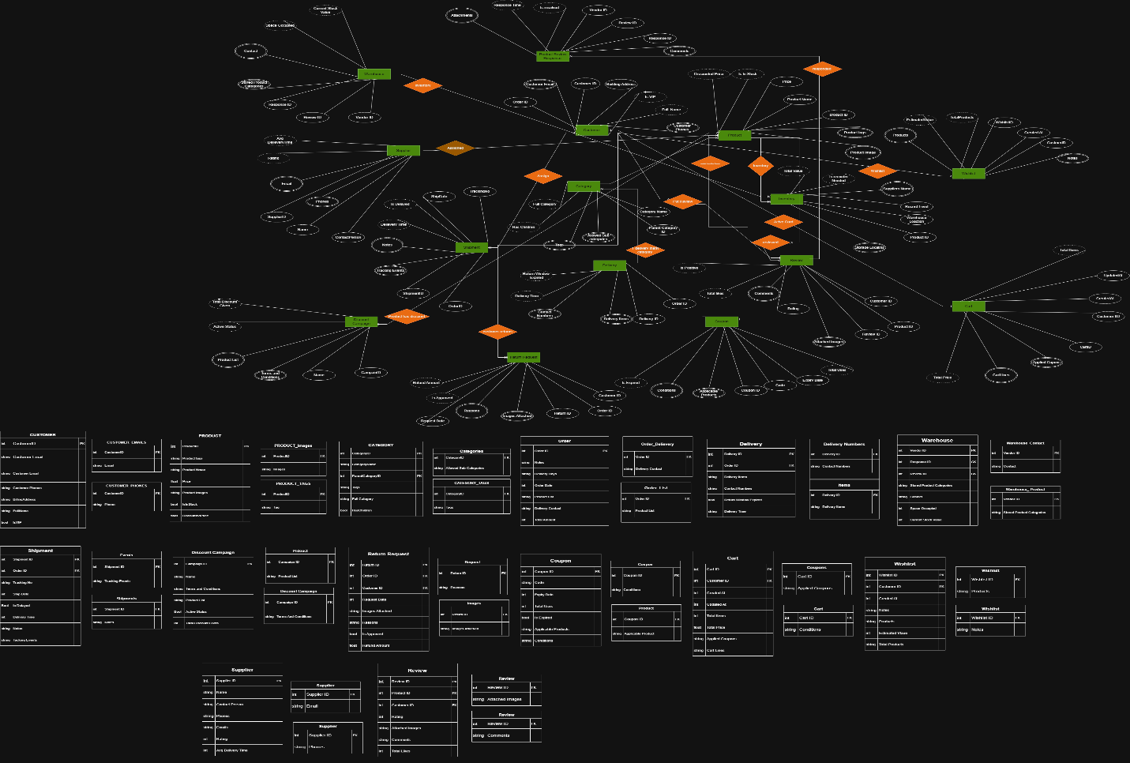
Table Queries
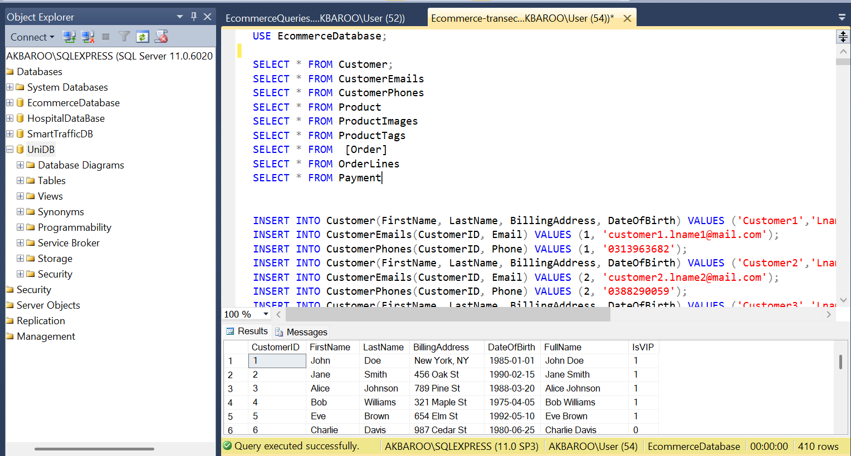
Python script for generate simple data
