Mini Project Submission
Real-Time ECG Acquisition, Plotting, R-Peak Detection, Heart Rate, and HRV in MATLAB
Purpose: Students must complete this file and submit it on LMS in both word and Pdf format. Fill all sections clearly. Insert screenshots and hardware images in the designated areas.
Task Summary
- Select one hardware option: Raspberry Pi with ADC, or ESP32, or Arduino.
- Acquire ECG data, send it to MATLAB, and generate a clean ECG waveform.
- Show one ECG cycle on the same dashboard and calculate heart rate and HRV.
- Attach hardware images, code summary, output screenshots, and brief explanation of the selected communication method.
Important Notice from the Instructor
In the previous session, the instructor noted that groups have only completed the time-domain portion of the ECG analysis (signal plotting, heart rate calculation, and HRV measurement). The next required step is to perform Frequency Domain Analysis of the ECG signal. This is now included as part of Task 1 and must be completed in this submission.
Additionally, some students previously used incorrect or unverified ECG signals. For the frequency domain analysis, you MUST use a known ECG signal from an established dataset (e.g., MIT-BIH Arrhythmia Database on PhysioNet you can use any known dataset ). You must document the following information about your selected signal:
• Sampling rate (Hz) of the recording
• Age and gender of the patient/subject
• Whether the signal is classified as normal or abnormal
• The specific record number/ID from the dataset
• Duration of the signal segment used for analysis
• Source/URL of the dataset
ECG Dataset Requirement
For this frequency domain analysis task, you must use a known, verified ECG signal from a publicly available dataset. Do NOT use a random or self-acquired signal unless its parameters are fully documented and verified. Recommended datasets include:
• MIT-BIH Arrhythmia Database (physionet.org/content/mitdb) – 48 half-hour recordings, 360 Hz sampling rate, annotated beats, widely used as a benchmark.
• PTB Diagnostic ECG Database (physionet.org/content/ptbdb) – 549 records from 290 subjects, 1000 Hz sampling rate, 15 leads, includes normal and pathological cases.
• PhysioNet/CinC Challenge datasets – Various ECG datasets with labels for different cardiac conditions.
• European ST-T Database – For ST-T segment analysis with known annotations.
You must read the dataset documentation thoroughly to understand the sampling rate, patient demographics, signal characteristics, and any annotations provided. Include this information in your submission.
Task Description
- Project Management and Life Cycle: Responsible for planning the project stages, coordinating team tasks, tracking progress, managing documentation, and preparing the final submission.
- Embedded Programming: Responsible for hardware interfacing, sensor/microcontroller programming, data acquisition, communication setup, and testing the embedded implementation.
- DSP Simulation and Algorithm: Responsible for signal processing, filtering, feature extraction, MATLAB/Python simulation, analysis, and interpretation of results.

1. Submission Information
Project Title | Will be selected later | Group No.
Instructor Name |  | Submission Date | 7-april-2026
Selected Hardware | Raspberry Pi / ESP32 / Arduino | Communication Method | Serial / Wi-Fi / TCP-IP / Other
Section |  | Demo Status | Completed / Pending

2. Group Member Information and Roles
Instructions: Each group member must clearly mention their assigned role. Suggested roles are Project Management and Life Cycle, Embedded Programming, DSP Simulation and Algorithm. If a group has 5 members, two members may be assigned to Embedded Programming and DSP simulation and Algorithm, as instructed.
Sr. No. | Student Name | Registration No. | Role Assigned | Hardware Responsibility
1
2
3
4
5

3. Hardware Selection and Setup Details
Selected Platform
ADC Used (if any)
Power Supply / Voltage
MATLAB Connectivity Method
Short Setup Description:
Write 4–6 lines explaining how the sensor was interfaced and how data was sent to MATLAB.
4. Task Implementation Checklist
Task Item | Implemented (Yes/No) | Member Responsible | Remarks By Instructor
ECG sensor interfaced with selected hardware
ECG data acquired successfully
Data sent to MATLAB
Real-time / continuous ECG waveform plotted
One ECG cycle displayed
Heart rate calculated
HRV calculated
Known ECG dataset selected and documented
FFT/DTFT of ECG signal computed
Frequency spectrum plotted and labeled
Frequency components identified and commented
Heart rate verified from frequency domain peaks
Heart rate comparison (time vs frequency) documented

5. Task Implementation Description
5.1 Hardware interfacing procedure
Write your explanation here:
5.2 Communication method with MATLAB
Write your explanation here:
5.3 MATLAB processing approach
Write your explanation here:
5.4 R-peak detection, BPM, and HRV logic
Write your explanation here:
6. Hardware Images
Insert clear photographs of your actual setup. Minimum recommended images: Sensor close-up, complete wiring setup, acquisition hardware, and laptop / MATLAB connection screen.
Image 1 – Sensor and Electrodes
[Insert image here]
Image 2 – Complete Wiring Setup
[Insert image here]
Image 3 – Hardware Platform
[Insert image here]
Image 4 – MATLAB Connectivity / COM Port / IP Setup
[Insert image here]

7. Output Screenshots and Results
Insert screenshots that clearly show waveform quality and the required dashboard layout.
Output 1 – ECG waveform Dashboard / Full dashboard screenshot (Take help from previously uploaded instructions)
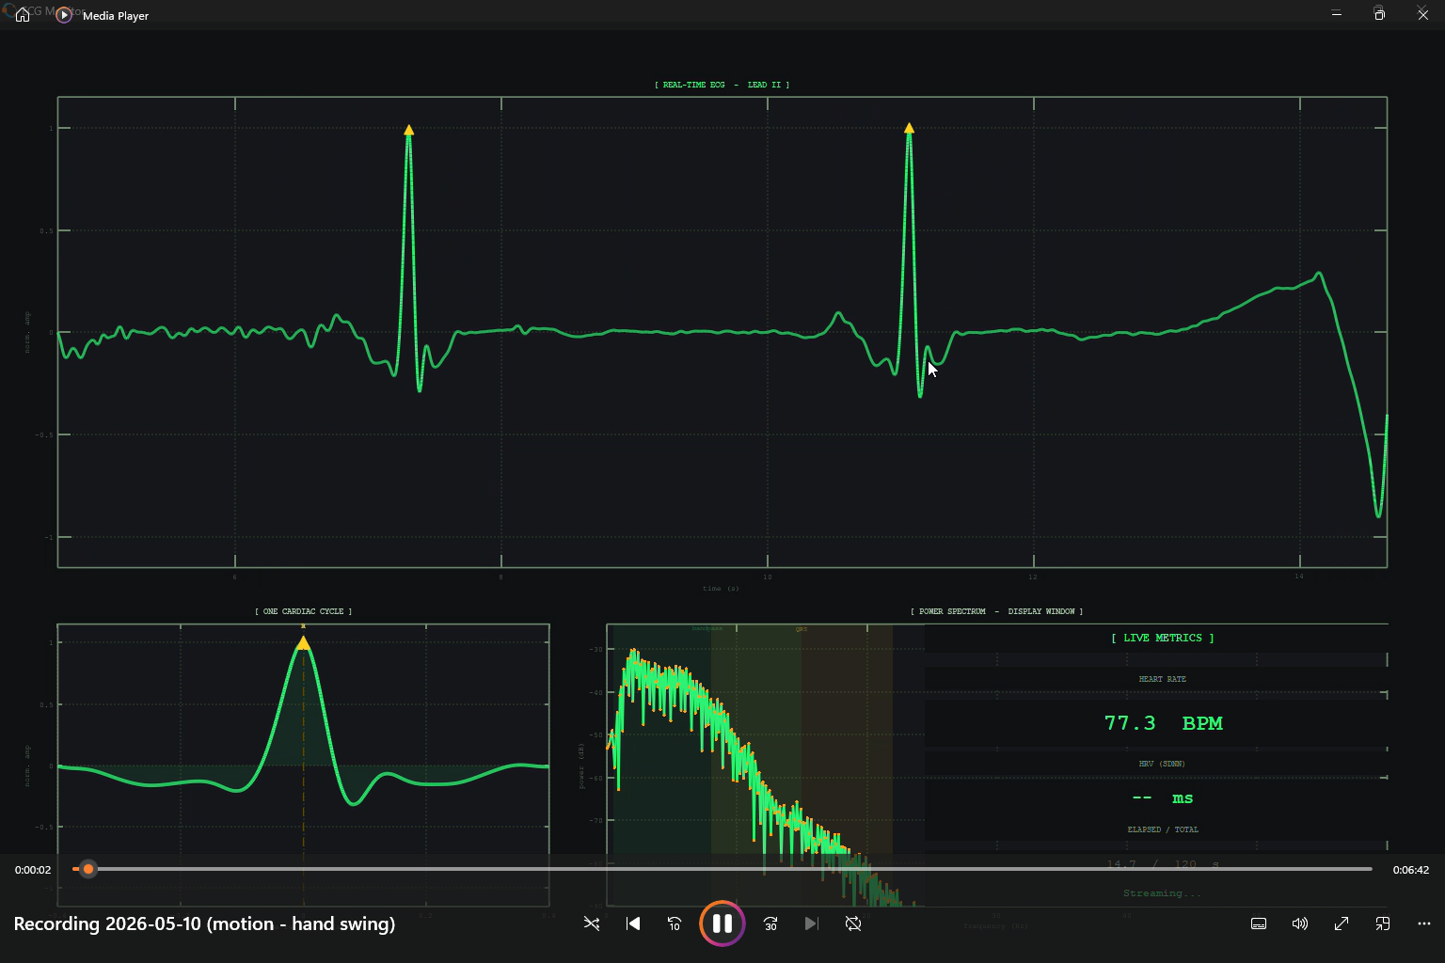
Caption / explanation: Full MATLAB dashboard showing the real-time ECG waveform, R-peak detection, isolated single ECG cycle, and calculated Heart Rate/HRV results.
Output 1a(Hardware or realtime) – ECG waveform Dashboard / Full dashboard screenshot (Take help from previously uploaded instructions)
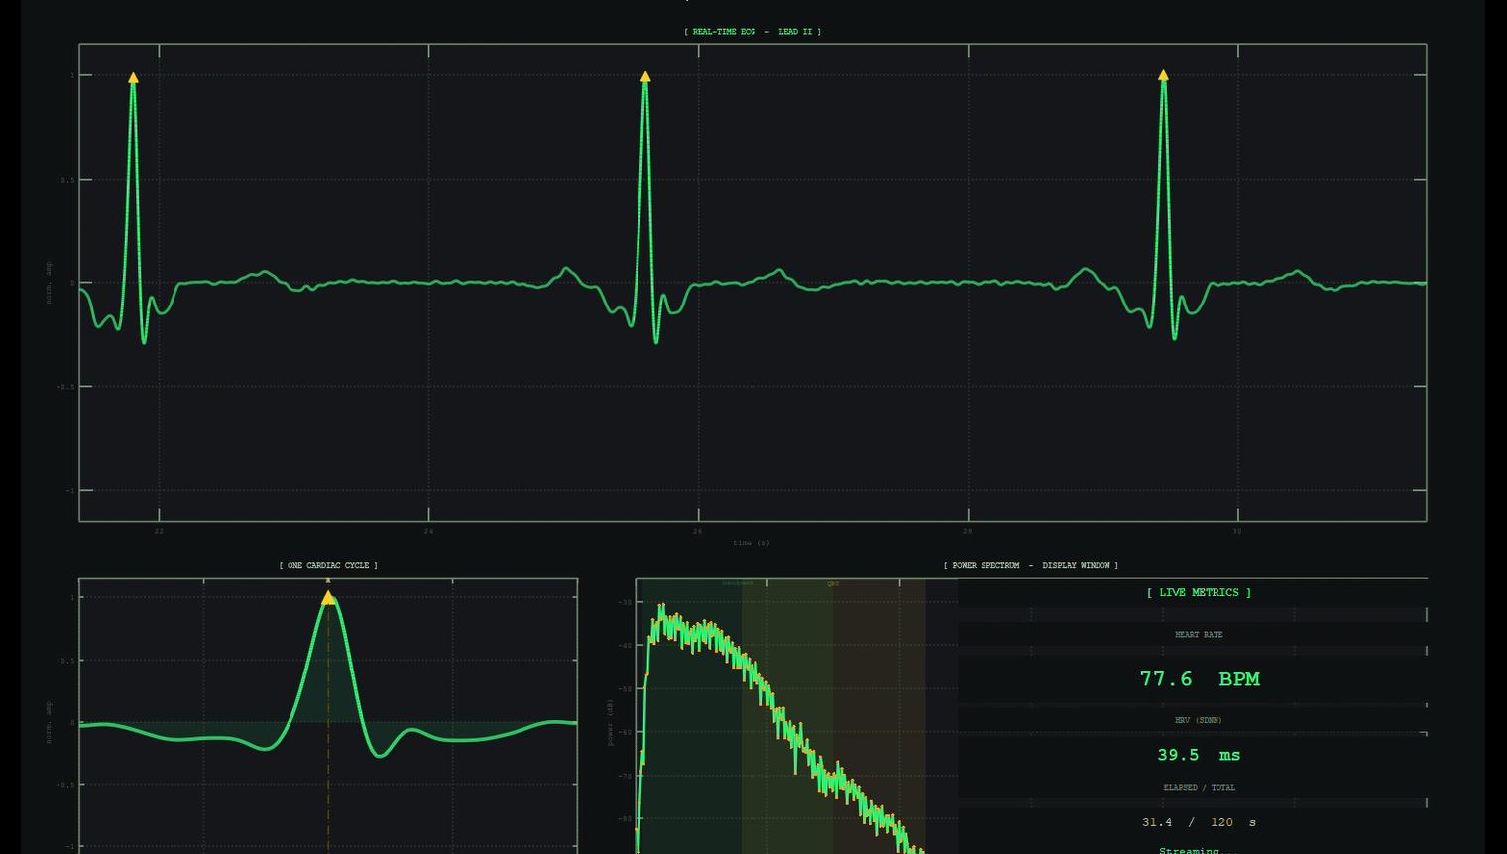
Caption / explanation: Screenshot of the real-time ECG dashboard displaying the acquired hardware signal, R-peak detection, the isolated single ECG cycle, and calculated Heart Rate (BPM) and Heart Rate Variability (HRV) values.
Output 2 – One ECG cycle screenshot

Caption / explanation: Isolated and normalized plot of a single ECG cycle for detailed feature inspection.
Output 3(dataset) – Heart rate and HRV result screenshot

Caption / explanation: Screenshot displaying the calculated Heart Rate (BPM) and Heart Rate Variability (HRV) results derived from the selected ECG dataset.
Output 3a(Hardware or real time) – Heart rate and HRV result screenshot
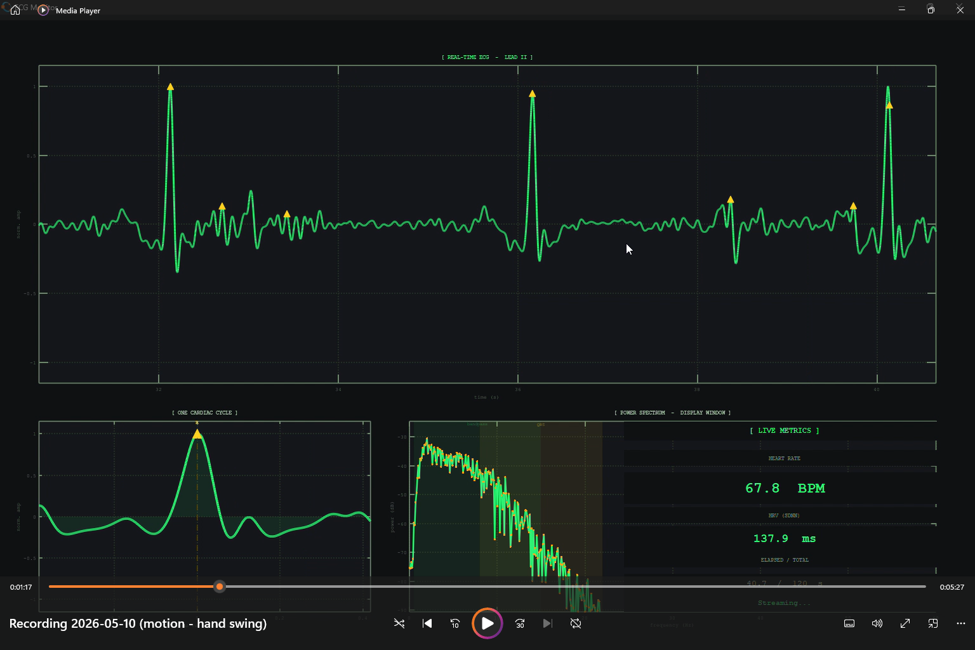Caption / explanation: The user is requesting a brief caption for the screenshot slot designated as Output 3a(Hardware or real time) – Heart rate and HRV result screenshot.
Based on the title and surrounding captions in the document, this output is required to show the calculated Heart Rate (BPM) and Heart Rate Variability (HRV) for the real-time or hardware-acquired signal.
Task 1B – Frequency Domain Analysis of ECG Signal (New Addition to Task 1)
Why is Frequency Domain Analysis Necessary?
While time-domain analysis of ECG signals (R-peak detection, heart rate, HRV) provides direct temporal information about cardiac events, it has limitations. Frequency domain analysis reveals the spectral composition of the ECG signal, which is essential for the following reasons:
• Noise Identification: Frequency analysis helps identify and characterize noise sources such as power-line interference (50/60 Hz), baseline wander (< 0.5 Hz), and muscle artifacts (> 100 Hz). Understanding these components is critical for designing appropriate digital filters.
• Signal Component Separation: Different ECG waveform components (P-wave, QRS complex, T-wave) occupy distinct frequency bands. The QRS complex has energy concentrated in approximately 1–40 Hz, while P and T waves are lower-frequency components (0.5–10 Hz). Frequency analysis allows us to study these components individually.
• Heart Rate Verification: The fundamental frequency of the ECG corresponds to the heart rate. By identifying the dominant peak in the frequency spectrum, students can independently verify the heart rate calculated from RR intervals in the time domain. This cross-verification strengthens confidence in the results.
• Clinical Relevance: In real clinical and biomedical engineering practice, HRV analysis in the frequency domain (LF band: 0.04–0.15 Hz, HF band: 0.15–0.4 Hz) provides insight into autonomic nervous system activity — information that cannot be obtained from time-domain analysis alone.
• DSP Skill Building: Computing and interpreting FFT/DTFT of real biomedical signals is a core competency in Digital Signal Processing. This task reinforces theoretical concepts (sampling, frequency resolution, spectral leakage, windowing) using a practical, real-world signal.

Implementation Steps for Frequency Domain Analysis
Step 1 – Load and Pre-process the ECG Signal:
Load the selected ECG record from the dataset into MATLAB/Python. Ensure the signal is properly scaled and the sampling rate (Fs) is correctly defined. Apply any necessary pre-processing (e.g., baseline wander removal).
Step 2 – Compute the FFT (Fast Fourier Transform):
Use MATLAB's fft() function or Python's numpy.fft.fft() to compute the DFT of the ECG signal. Ensure that: (a) The frequency axis is properly defined from 0 to Fs/2 (single-sided spectrum), (b) The magnitude spectrum is normalized appropriately (e.g., |X(f)| / N), (c) Optionally compute the DTFT for higher frequency resolution.
Step 3 – Plot the Frequency Spectrum:
Create clear, labeled plots showing: (a) Magnitude spectrum (|X(f)|) vs. Frequency (Hz) — single-sided, (b) Optionally: Power Spectral Density (PSD) using Welch's method, (c) Use appropriate axis limits to highlight the relevant frequency range (0–50 Hz for ECG), (d) Mark/annotate the dominant frequency peaks on the plot.
Step 4 – Identify and Comment on Frequency Components:
Analyze the frequency spectrum and identify: (a) QRS complex energy band (~1–40 Hz): Where is the peak? What is the dominant frequency? (b) P-wave and T-wave components (~0.5–10 Hz), (c) Any baseline wander component (< 0.5 Hz), (d) Power-line interference peak (50 Hz or 60 Hz depending on region), (e) High-frequency noise/muscle artifacts (> 100 Hz). Write a brief paragraph commenting on each identified component.
Step 5 – Heart Rate Verification from Frequency Peaks:
The heart rate creates a periodic pattern in the ECG. The fundamental frequency of this periodicity corresponds to the heart rate. Heart Rate (BPM) = f_peak × 60, where f_peak is the dominant frequency (Hz) corresponding to the repetition rate of the QRS complexes. Compare this frequency-domain heart rate with the time-domain heart rate calculated from RR intervals. Report the percentage error between the two methods. Comment on any discrepancy and its possible causes.
Step 6 – Summary and Interpretation:
Write a brief summary (5–8 lines) interpreting your frequency domain results. Discuss: (a) Whether the signal appears normal or abnormal based on spectral characteristics, (b) The quality of the signal (noise level, artifacts), (c) Confidence in the heart rate measurement based on cross-verification, (d) Any clinical observations if using a pathological ECG record.

Required Outputs for Task 1B
• Screenshot of the magnitude spectrum (FFT) of the ECG signal with properly labeled axes
• Screenshot of the zoomed-in spectrum (0–50 Hz range) highlighting dominant frequency components
• Annotated frequency spectrum with labeled peaks (QRS band, P/T wave band, noise peaks)
• Comparison table: Heart rate from RR intervals vs. heart rate from frequency domain
• Brief written commentary on the observed frequency components (minimum 8–10 lines)
• Dataset information table documenting the source, sampling rate, patient details, and signal type
Output 4 (dataset) – Screenshot of the magnitude spectrum (FFT) of the ECG signal with properly labeled axes [Insert screenshot here]
Caption / explanation: _______________________________________________
Output 5(dataset) – Screenshot of the zoomed-in spectrum (0–50 Hz range) highlighting dominant frequency components [Insert screenshot here]
Caption / explanation: _______________________________________________
Output 6 (dataset)– Annotated frequency spectrum with labeled peaks (QRS band, P/T wave band, noise peaks) [Insert screenshot here]
Caption / explanation: _______________________________________________
Output 7(dataset)– Comparison table: Heart rate from RR intervals vs. heart rate from frequency domain
[Insert Table here]

Output 8 – Brief written commentary on the observed frequency components (minimum 8–10 lines)
Explanation _______________________________________________
Output 9 – Dataset information table documenting the source, sampling rate, patient details, and signal type
Explanation _______________________________________________

Repeat 4 to 9 for hardware base task or perform frequency domain analysis of real time data:
Note: Store your real time data in csv or any other file and then reuse for frequency domain analysis.
Output 4a (Hardware or realtime) – Screenshot of the magnitude spectrum (FFT) of the ECG signal with properly labeled axes [Insert screenshot here]
Caption / explanation: _______________________________________________
Output 5a(Hardware or realtime) – Screenshot of the zoomed-in spectrum (0–50 Hz range) highlighting dominant frequency components [Insert screenshot here]
Caption / explanation: _______________________________________________
Output 6a (Hardware or realtime) – Annotated frequency spectrum with labeled peaks (QRS band, P/T wave band, noise peaks) [Insert screenshot here]
Caption / explanation: _______________________________________________
Output 7a (hardware or realtime) – Comparison table: Heart rate from RR intervals vs. heart rate from frequency domain
[Insert Table here]
Output 8a (hardware or realtime) – Brief written commentary on the observed frequency components (minimum 8–10 lines)
Explanation _______________________________________________
Output 9a (hardware or realtime) – Dataset information table documenting the source, sampling rate, patient details, and signal type
Explanation _______________________________________________
8. Task1A Code
function ecg_dashboard
clc; clear; close all;

%% ── SERIAL SETTINGS ──
comPort = 'COM23';
baudRate = 115200;
fs = 500;
% At 500 Hz, 50 samples = 100 ms per refresh — same wall-clock cadence as
% before (13 samples @ 125 Hz was also ~104 ms).
serialBatchSize = 50;

%% ── DASHBOARD SETTINGS ──
displayWindow = 6; % seconds — keep plot uncluttered at 500 Hz
% (was 10 s @ 125 Hz → same ~750 visible samples)
bpmWindow = 10;
hrvWindow = 60;
totalSimTime = 120;

%% ── OPEN SERIAL PORT ──
sp = serialport(comPort, baudRate);
configureTerminator(sp, "LF");
sp.Timeout = 3;

flush(sp);

disp('Waiting for ESP32 sync header...');
while true
line = strtrim(readline(sp));
if startsWith(line, '#')
fprintf('Sync received: %s\n', line);
break;
end
end

%% ── DASHBOARD INIT ──
dash = dashboard_app;
dash.initialize('Live ESP32 ECG (AD8232)', [], fs, totalSimTime);
dash.setStatus('Streaming...');

%% ── BUFFERS ──
x = [];
t = [];
peakTimes = [];
lastAcceptedPeak = -inf;
lastBPMUpdate = 0;
peakMergeTol = 0.25;
rrMin = 0.35;
rrMax = 1.50;

sampleCount = 0;
leadOffStreak = 0;
maxLeadOffWarn = fs * 2;

%% ── MAIN LOOP ──
try
while dash.isOpen()

batchRaw = zeros(1, serialBatchSize);
batchN = 0;

while batchN < serialBatchSize
line = strtrim(readline(sp));

if isempty(line) || line(1) == '#'
continue;
end

parts = strsplit(line, ',');
if numel(parts) ~= 3
continue;
end

rawVal = str2double(parts{2});
leadOff = str2double(parts{3});

if leadOff == 1 || rawVal < 0
leadOffStreak = leadOffStreak + 1;
if leadOffStreak == maxLeadOffWarn
dash.setStatus('WARNING: Lead-off detected — check electrodes');
end
continue;
else
if leadOffStreak >= maxLeadOffWarn
dash.setStatus('Streaming...');
end
leadOffStreak = 0;
end

normalised = (rawVal / 4095) * 2 - 1;

batchN = batchN + 1;
batchRaw(batchN) = normalised;
end

batchRaw = batchRaw(1:batchN);
if batchN == 0
continue;
end

newSamples = sampleCount : sampleCount + batchN - 1;
batchT = newSamples / fs;
sampleCount = sampleCount + batchN;

x = [x batchRaw];
t = [t batchT];

%% ── DISPLAY WINDOW ──
maxSamples = fs * displayWindow;
if length(x) > maxSamples
x_disp = x(end - maxSamples + 1 : end);
t_disp = t(end - maxSamples + 1 : end);
else
x_disp = x;
t_disp = t;
end

%% ── FILTER & PEAK DETECT ──
y = preprocess_ecg(x_disp, fs);
% Upsample factor 4 instead of 8 — at 500 Hz native the signal is
% already sharp; 8× would push plot points to 20 000+ per refresh.
displayFs = fs * 4;
[t_up, y_up] = upsample_for_display(t_disp, y, displayFs);
[locs, pks] = detect_rpeaks_sharp(y_up, displayFs);

%% ── DASHBOARD PLOTS ──
dash.updateRealtimePlot(t_up, y_up, locs, pks);

if length(locs) >= 2
cycle = y_up(locs(end-1) : locs(end));
dash.updateCyclePlot(cycle, displayFs);
end

%% ── PEAK ACCUMULATION ──
pt = t_up(locs);
for k = 1:length(pt)
if pt(k) > (lastAcceptedPeak + peakMergeTol)
peakTimes(end+1) = pt(k);
lastAcceptedPeak = pt(k);
end
end

currentTime = t(end);

%% ── BPM ──
if currentTime >= bpmWindow && (currentTime - lastBPMUpdate) >= bpmWindow
recent = peakTimes(peakTimes >= currentTime - bpmWindow);
if length(recent) >= 2
rr = diff(recent);
rr = rr(rr >= rrMin & rr <= rrMax);
if ~isempty(rr)
dash.updateBPM(60 / mean(rr));
end
end
lastBPMUpdate = currentTime;
end

%% ── HRV ──
if currentTime >= hrvWindow && length(peakTimes) >= 3
recentHrvPeaks = peakTimes(peakTimes >= currentTime - hrvWindow);
if length(recentHrvPeaks) >= 3
rr_all = diff(recentHrvPeaks);
rr_all = rr_all(rr_all >= rrMin & rr_all <= rrMax);

if length(rr_all) >= 3
rrMed = median(rr_all);
rr_all = rr_all(abs(rr_all - rrMed) <= 0.20 * rrMed);
end

if length(rr_all) >= 3
dash.updateHRV(std(rr_all) * 1000);
end
end
end

%% ── TIME & EXIT ──
dash.updateTime(currentTime, totalSimTime);

if currentTime >= totalSimTime
break;
end

drawnow limitrate nocallbacks;
end

catch ME
fprintf('Error: %s\n', ME.message);
end

%% ── CLEANUP ──
if exist('sp', 'var') && isvalid(sp)
delete(sp);
disp('Serial port closed.');
end

if dash.isOpen()
dash.setStatus('Stream ended');
end
end

%% ── HELPER FUNCTIONS ──

function y = preprocess_ecg(x, fs)
x = double(x(:).');
x = x - mean(x);

w = max(3, round(0.60 * fs));
baseline = movmean(x, w);
y = x - baseline;

if exist('butter','file') == 2 && exist('filtfilt','file') == 2 && fs > 40
hp = 0.5;
lp = min(40, 0.45 * fs); % raised LP ceiling to 40 Hz for 500 Hz input
if lp > hp
[b, a] = butter(2, [hp lp] / (fs/2), 'bandpass');
minLen = 3 * (max(length(a), length(b)) - 1);
if numel(y) > minLen
y = filtfilt(b, a, y);
elseif numel(y) > max(length(a), length(b))
y = filter(b, a, y);
end
end
end

y = y / (max(abs(y)) + eps);
end

function [t_up, y_up] = upsample_for_display(t, y, displayFs)
if numel(t) < 2
t_up = t;
y_up = y;
return;
end
t_up = t(1) : 1/displayFs : t(end);
y_up = interp1(t, y, t_up, 'pchip');
y_up = y_up / (max(abs(y_up)) + eps);
end

function [locs, pks] = detect_rpeaks_sharp(y, fs)
y = y(:).';
qrs = y;

if exist('butter','file') == 2 && exist('filtfilt','file') == 2 && fs > 50
[b, a] = butter(2, [8 40] / (fs/2), 'bandpass'); % wider QRS band for 500 Hz
minLen = 3 * (max(length(a), length(b)) - 1);
if numel(y) > minLen
qrs = filtfilt(b, a, y);
elseif numel(y) > max(length(a), length(b))
qrs = filter(b, a, y);
end
end

env = qrs .^ 2;
thr = mean(env) + 0.5 * std(env);
minDist = round(0.35 * fs);

roughLocs = simple_peak_pick(env, thr, minDist);

refineWin = round(0.05 * fs);
locs = zeros(size(roughLocs));
for k = 1:numel(roughLocs)
i1 = max(1, roughLocs(k) - refineWin);
i2 = min(length(y), roughLocs(k) + refineWin);
[~, idx] = max(y(i1:i2));
locs(k) = i1 + idx - 1;
end

locs = unique(locs);
pks = y(locs);
end

function locs = simple_peak_pick(sig, thr, minDist)
locs = [];
for i = 2:length(sig)-1
if sig(i) > sig(i-1) && sig(i) >= sig(i+1) && sig(i) > thr
if isempty(locs)
locs(end+1) = i;
elseif (i - locs(end)) > minDist
locs(end+1) = i;
elseif sig(i) > sig(locs(end))
locs(end) = i;
end
end
end
end

9. Task1B Code
function ecg_dashboard
% ECG_DASHBOARD Real-time ECG monitor for Octave + instrument-control package.
%
% Packages required:
% instrument-control — serial port I/O
% signal — butter / filtfilt
%
% Output:
% ECG_<YYYYMMDD_HHMMSS>.csv saved in the same folder as this script.
% Columns: time_s, raw_normalised, filtered, r_peak (0/1), bpm, hrv_ms

clc; clear; clear functions; close all;

%% ── Load required Octave packages ────────────────────────────────────────
pkg load instrument-control;
pkg load signal;

%% ── SERIAL SETTINGS ──────────────────────────────────────────────────────
comPort = 'COM8'; % Windows: 'COM7' Linux/Mac: '/dev/ttyUSB0'
baudRate = 115200;
fs = 125;
serialBatchSize = 13;

%% ── DASHBOARD SETTINGS ───────────────────────────────────────────────────
displayWindow = 10;
bpmWindow = 5; % update BPM every 5 s (was 10)
hrvWindow = 30; % start HRV after 30 s, use 30 s window (was 60)
totalSimTime = 120;

%% ── CSV OUTPUT ───────────────────────────────────────────────────────────
% Save next to this script file regardless of cwd
scriptDir = fileparts(mfilename('fullpath'));
if isempty(scriptDir)
scriptDir = pwd;
end
csvName = ['ECG_' datestr(now, 'yyyymmdd_HHMMSS') '.csv'];
csvPath = fullfile(scriptDir, csvName);
csvFid = fopen(csvPath, 'w');
if csvFid == -1
warning('Could not open %s for writing — CSV will not be saved.', csvPath);
csvFid = -1;
else
fprintf(csvFid, 'time_s,raw_normalised,filtered,r_peak,bpm,hrv_ms\n');
fprintf('CSV recording → %s\n', csvPath);
end

% Current BPM/HRV to stamp on each row (updated lazily)
csvBPM = NaN;
csvHRV = NaN;

%% ── OPEN SERIAL PORT ─────────────────────────────────────────────────────
sp = serialport(comPort, baudRate);

% Wait for the firmware sync header
disp('Waiting for ESP32 sync header...');
while true
line = serial_readline(sp);
if ~isempty(line) && line(1) == '#'
fprintf('Sync received: %s\n', line);
break;
end
end

%% ── DASHBOARD INIT ───────────────────────────────────────────────────────
dash = dashboard_app();
dash.initialize('Live ESP32 ECG (AD8232)', [], fs, totalSimTime);
dash.setStatus('Streaming...');

%% ── BUFFERS ──────────────────────────────────────────────────────────────
x = [];
t = [];
peakTimes = [];
lastAcceptedPeak = -inf;
lastBPMUpdate = 0;
peakMergeTol = 0.40; % min gap between accepted peaks (was 0.25) = max ~150 BPM
rrMin = 0.40; % min valid RR = 150 BPM (was 0.35)
rrMax = 1.50;

sampleCount = 0;
leadOffStreak = 0;
maxLeadOffWarn = fs * 2;

%% ── MAIN LOOP ────────────────────────────────────────────────────────────
try
while dash.isOpen()

batchRaw = zeros(1, serialBatchSize);
batchN = 0;

while batchN < serialBatchSize
line = serial_readline(sp);

if isempty(line) || line(1) == '#'
continue;
end

% Parse "millis,raw,leadOff"
parts = strsplit(line, ',');
if numel(parts) ~= 3
continue;
end

rawVal = str2double(parts{2});
leadOff = str2double(parts{3});

if leadOff == 1 || rawVal < 0
leadOffStreak = leadOffStreak + 1;
if leadOffStreak == maxLeadOffWarn
dash.setStatus('WARNING: Lead-off detected - check electrodes');
end
continue;
else
if leadOffStreak >= maxLeadOffWarn
dash.setStatus('Streaming...');
end
leadOffStreak = 0;
end

% Normalise 12-bit ADC to [-1, 1] (change 4095->1023 for Uno/Nano)
normalised = (rawVal / 4095) * 2 - 1;

batchN = batchN + 1;
batchRaw(batchN) = normalised;
end

batchRaw = batchRaw(1:batchN);
if batchN == 0
continue;
end

newSamples = sampleCount : sampleCount + batchN - 1;
batchT = newSamples / fs;
sampleCount = sampleCount + batchN;

x = [x batchRaw];
t = [t batchT];

%% ── DISPLAY WINDOW ───────────────────────────────────────────────
maxSamples = fs * displayWindow;
if length(x) > maxSamples
x_disp = x(end - maxSamples + 1 : end);
t_disp = t(end - maxSamples + 1 : end);
else
x_disp = x;
t_disp = t;
end

%% ── FILTER & PEAK DETECT ─────────────────────────────────────────
y = preprocess_ecg(x_disp, fs);
[t_up, y_up] = upsample_for_display(t_disp, y, fs * 8);
[locs, pks] = detect_rpeaks_sharp(y_up, fs * 8);

%% ── DASHBOARD PLOTS ──────────────────────────────────────────────
dash.updateRealtimePlot(t_up, y_up, locs, pks);

% Centre the single-cycle window on the most recent R-peak (±400 ms)
if ~isempty(locs)
halfWin = round(0.40 * fs * 8);
rIdx = locs(end);
i1 = max(1, rIdx - halfWin);
i2 = min(length(y_up), rIdx + halfWin);
cycle = y_up(i1:i2);
if length(cycle) > 4
dash.updateCyclePlot(cycle, fs * 8);
end
end

if isfield(dash, 'updateFFT')
dash.updateFFT(y_up, fs * 8);
end

%% ── PEAK ACCUMULATION ────────────────────────────────────────────
pt = t_up(locs);
for k = 1:length(pt)
if pt(k) > (lastAcceptedPeak + peakMergeTol)
peakTimes(end+1) = pt(k);
lastAcceptedPeak = pt(k);
end
end

currentTime = t(end);

%% ── BPM ──────────────────────────────────────────────────────────
if currentTime >= bpmWindow && (currentTime - lastBPMUpdate) >= bpmWindow
recent = peakTimes(peakTimes >= currentTime - bpmWindow);
if length(recent) >= 2
rr = diff(recent);
rr = rr(rr >= rrMin & rr <= rrMax);
if ~isempty(rr)
csvBPM = 60 / mean(rr);
dash.updateBPM(csvBPM);
end
end
lastBPMUpdate = currentTime;
end

%% ── HRV ──────────────────────────────────────────────────────────
if currentTime >= hrvWindow && length(peakTimes) >= 3
recentHrvPeaks = peakTimes(peakTimes >= currentTime - hrvWindow);
if length(recentHrvPeaks) >= 3
rr_all = diff(recentHrvPeaks);
rr_all = rr_all(rr_all >= rrMin & rr_all <= rrMax);

if length(rr_all) >= 3
rrMed = median(rr_all);
rr_all = rr_all(abs(rr_all - rrMed) <= 0.20 * rrMed);
end

if length(rr_all) >= 3
csvHRV = std(rr_all) * 1000;
dash.updateHRV(csvHRV);
end
end
end

%% ── CSV WRITE (one row per sample in this batch) ─────────────────
% Written AFTER BPM/HRV so values are always current for this batch
if csvFid ~= -1
% Build a set of R-peak times for this batch (from full t_up)
peakTimesInBatch = t_up(locs);

% Map each batch sample to its filtered counterpart
% y was computed on x_disp; align indices to the batch tail
dispLen = length(x_disp);
batchOffset = dispLen - batchN;

for si = 1:batchN
tSample = batchT(si);
rawSamp = batchRaw(si);

% Filtered value: pick from y at the corresponding index
yIdx = batchOffset + si;
if yIdx >= 1 && yIdx <= length(y)
filtSamp = y(yIdx);
else
filtSamp = NaN;
end

% R-peak flag: 1 if a detected peak falls within ±1 sample
isRpeak = any(abs(peakTimesInBatch - tSample) <= (1 / fs));

fprintf(csvFid, '%.4f,%.6f,%.6f,%d,%.2f,%.2f\n', ...
tSample, rawSamp, filtSamp, isRpeak, csvBPM, csvHRV);
end
end

%% ── TIME & EXIT ──────────────────────────────────────────────────
dash.updateTime(currentTime, totalSimTime);

if currentTime >= totalSimTime
break;
end

drawnow;
end

catch e
fprintf('Error: %s\n', e.message);
end

%% ── CLEANUP ──────────────────────────────────────────────────────────────
if csvFid ~= -1
fclose(csvFid);
fprintf('CSV saved → %s\n', csvPath);
end

if exist('sp', 'var')
try
delete(sp);
disp('Serial port closed.');
catch
end
end

if dash.isOpen()
dash.setStatus(['Stream ended | ' csvName]);
end
end

%% ── SERIAL HELPER ────────────────────────────────────────────────────────────

function line = serial_readline(sp)
% Read one '\n'-terminated line from an instrument-control serialport object.
line = '';
while true
ch = char(read(sp, 1, 'uint8'));
if isempty(ch)
break;
end
if ch == newline || ch == char(13)
break;
end
line(end+1) = ch;
end
line = strtrim(line);
end

%% ── DSP HELPERS ──────────────────────────────────────────────────────────────

function y = preprocess_ecg(x, fs)
x = double(x(:).');
x = x - mean(x);

w = max(3, round(0.60 * fs));
baseline = movmean(x, w);
y = x - baseline;

hp = 0.5;
lp = min(15, 0.45 * fs);
if lp > hp && fs > 40
[b, a] = butter(2, [hp lp] / (fs/2), 'bandpass');
minLen = 3 * (max(length(a), length(b)) - 1);
if numel(y) > minLen
y = filtfilt(b, a, y);
elseif numel(y) > max(length(a), length(b))
y = filter(b, a, y);
end
end

y = y / (max(abs(y)) + eps);
end

function [t_up, y_up] = upsample_for_display(t, y, displayFs)
if numel(t) < 2
t_up = t; y_up = y; return;
end
t_up = t(1) : 1/displayFs : t(end);
y_up = interp1(t, y, t_up, 'pchip');
y_up = y_up / (max(abs(y_up)) + eps);
end

function [locs, pks] = detect_rpeaks_sharp(y, fs)
y = y(:).';
qrs = y;

if fs > 50
[b, a] = butter(2, [8 22] / (fs/2), 'bandpass');
minLen = 3 * (max(length(a), length(b)) - 1);
if numel(y) > minLen
qrs = filtfilt(b, a, y);
elseif numel(y) > max(length(a), length(b))
qrs = filter(b, a, y);
end
end

env = qrs .^ 2;
thr = mean(env) + 0.5 * std(env);
minDist = round(0.35 * fs);

roughLocs = simple_peak_pick(env, thr, minDist);

refineWin = round(0.05 * fs);
locs = zeros(size(roughLocs));
for k = 1:numel(roughLocs)
i1 = max(1, roughLocs(k) - refineWin);
i2 = min(length(y), roughLocs(k) + refineWin);
[~, idx] = max(y(i1:i2));
locs(k) = i1 + idx - 1;
end

locs = unique(locs);
pks = y(locs);
end

function locs = simple_peak_pick(sig, thr, minDist)
locs = [];
for i = 2:length(sig)-1
if sig(i) > sig(i-1) && sig(i) >= sig(i+1) && sig(i) > thr
if isempty(locs)
locs(end+1) = i;
elseif (i - locs(end)) > minDist
locs(end+1) = i;
elseif sig(i) > sig(locs(end))
locs(end) = i;
end
end
end
end

10. Required Result Summary
Result Item | Observed Value / Status | Comments By Instructor
Clean ECG waveform obtained
One ECG cycle displayed
R-peaks detected properly
Heart Rate (BPM)
HRV (ms)
ECG Dataset used (source, record ID)
Sampling Rate of ECG signal (Hz)
Dominant frequency in spectrum (Hz)
Heart Rate from frequency peaks (BPM)
Heart Rate from RR intervals (BPM)
Percentage error between methods (%)
Key frequency components identified

Filter Type | Actual Cutoff Frequency (f_{c}) | Sampling Frequency (f_{s}) | Normalized Cutoff Frequency
High-Pass Filter | 0.5 Hz | 500 Hz | 0.002
Low-Pass Filter | 40 Hz | 500 Hz | 0.16
Bandpass Filter | 0.5 Hz – 40 Hz | 500 Hz | [0.002, 0.16]
QRS Detection Filter | 8 Hz – 40 Hz | 500 Hz | [0.032, 0.16]

Problems Faced and Improvements
Problems faced during hardware interfacing or signal acquisition:
________________________________________________________________________________
________________________________________________________________________________
Problems faced during MATLAB plotting or detection:
________________________________________________________________________________
________________________________________________________________________________
Possible improvements for next stage:
________________________________________________________________________________
________________________________________________________________________________

Task 2 — ECG Signal Processing: Noise Removal, Artifact Suppression & Multi-Lead Consistency
This task extends your ECG mini-project into the domain of Digital Signal Processing (DSP). You will work through three progressive streams that address real-world challenges in ECG signal quality. Each stream builds on the previous one, progressing from classical filtering to adaptive processing to multi-channel consistency.
Recommended ECG Datasets
Before beginning any processing, you must select an appropriate ECG dataset. You are encouraged to explore and compare multiple datasets. Below are recommended sources:
- MIT-BIH Arrhythmia Database — https://physionet.org/content/mitdb/1.0.0/ — 48 half-hour 2-lead recordings, 360 Hz, annotated beats. Ideal for Stream A & B.
- MIT-BIH Noise Stress Test Database — https://physionet.org/content/nstdb/1.0.0/ — Contains calibrated noise recordings (baseline wander, muscle artifact, electrode motion). Essential for Stream A & B.
- Motion Artifact Contaminated fetal ECG Database — https://physionet.org/content/adfecgdb/1.0.0/ — ECG with real motion artifacts from physical activities. Critical for Stream B.
- PTB-XL ECG Database — https://physionet.org/content/ptb-xl/1.0.3/ — 21,837 clinical 12-lead ECGs, 500 Hz, 10-second recordings. Required for Stream C (multi-lead).
- PTB Diagnostic ECG Database — https://physionet.org/content/ptbdb/1.0.0/ — 549 records, 15 leads, 1000 Hz. Excellent for Stream C multi-lead analysis.
- PhysioNet Challenge 2020 Dataset — https://physionet.org/content/challenge-2020/1.0.2/ — Multi-source 12-lead ECGs with clinical labels. Good for advanced Stream C work.
Important: Document your dataset selection including: source URL, sampling rate (Hz), number of leads, duration, patient demographics, and normal/abnormal classification. Use the MATLAB WFDB toolbox to load PhysioNet data.
Stream A — DeNoising (Classical Filtering)
Focus: Remove stationary and quasi-stationary noise from ECG signals.
Background & Motivation
Real ECG signals are always corrupted by noise. The three dominant noise types are: (1) Baseline wander — low-frequency drift (<0.5 Hz) caused by respiration and electrode impedance changes; (2) Power-line interference — 50 Hz (or 60 Hz) and its harmonics from mains coupling; (3) EMG noise — broadband high-frequency muscle activity (>100 Hz). Each noise type occupies a different frequency band, requiring different filter designs.
Stream A — Required Tasks
- A.1 — Signal Loading & Time-Domain Inspection: Load your selected ECG record. Plot the raw signal vs. time. Identify visible noise artifacts. Document the sampling rate, duration, and record ID.
- A.2 — FFT & Frequency-Domain Analysis: Compute the FFT of the raw ECG signal. Plot the single-sided magnitude spectrum (|X(f)| vs frequency in Hz). Identify: (a) ECG energy band (0.5–40 Hz), (b) baseline wander (<0.5 Hz), (c) power-line peak at 50/60 Hz, (d) high-frequency EMG noise (>100 Hz). Annotate all peaks on your spectrum plot.
- A.3 — Noise Power Estimation: Calculate the power in each noise band vs. signal band. Compute SNR (Signal-to-Noise Ratio) before filtering. Use: SNR_dB = 10*log10(P_signal / P_noise).
- A.4 — Filter Design for Baseline Wander Removal: Design a high-pass filter with cutoff ~0.5 Hz. Compare FIR (e.g., Parks-McClellan/firpm) vs. IIR (e.g., Butterworth). Justify filter order selection. Plot magnitude response and phase response of your filter. Discuss linear-phase property of FIR vs. non-linear phase of IIR.
- A.5 — Filter Design for Power-Line Interference: Design a notch filter at 50 Hz (or 60 Hz). Use an IIR notch filter (e.g., iirnotch in MATLAB). Plot the magnitude response showing the notch. Apply the filter and verify removal in the frequency spectrum.
- A.6 — Filter Design for EMG Noise: Design a low-pass filter with cutoff ~40–100 Hz (justify your choice). Compare FIR vs. IIR. Apply and show before/after spectra.
- A.7 — Combined Filtering Pipeline: Apply all three filters in sequence: HP → Notch → LP. Plot: (a) raw vs. cleaned signal in time domain, (b) raw vs. cleaned spectrum in frequency domain. Compute SNR after filtering. Show SNR improvement.
- A.8 — Group Delay Analysis: Compute and plot the group delay of each filter. Discuss whether the delay is constant (linear phase) or frequency-dependent. Explain the clinical implications of phase distortion on ECG morphology (e.g., QRS shape, ST segment).
Note: You can implement all these tasks in one complete MATLAB .m file by creating sections in script.
- A.9 — Hardware Implementation: Apply the same filtering pipeline to your real-time ECG hardware setup (from Task 1). Acquire a live ECG signal, pass it through your designed filters in MATLAB in real-time or near-real-time. Show before/after plots from the hardware-acquired signal.
Stream A — Key Learning Outcome
Not all noise is the same, and filter design must be justified in both magnitude and phase. FIR filters offer linear phase (constant group delay) preserving ECG waveform morphology, while IIR filters are computationally cheaper but introduce phase distortion. You must articulate these trade-offs.

Stream A — Required Outputs
- Raw ECG signal plot (time domain) with visible noise identified
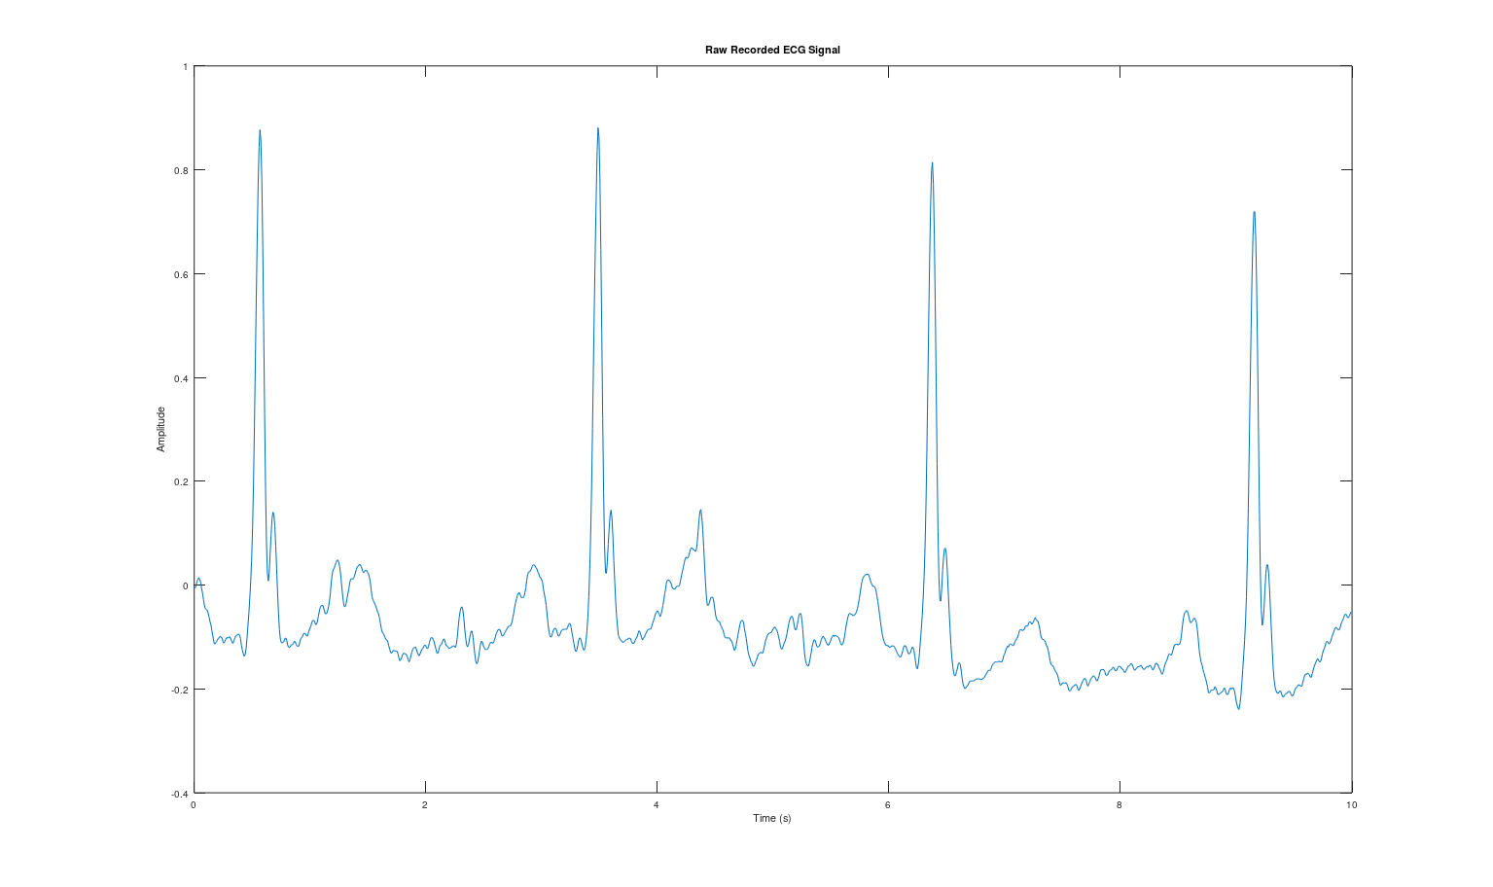
- FFT magnitude spectrum of raw signal with annotated noise peaks
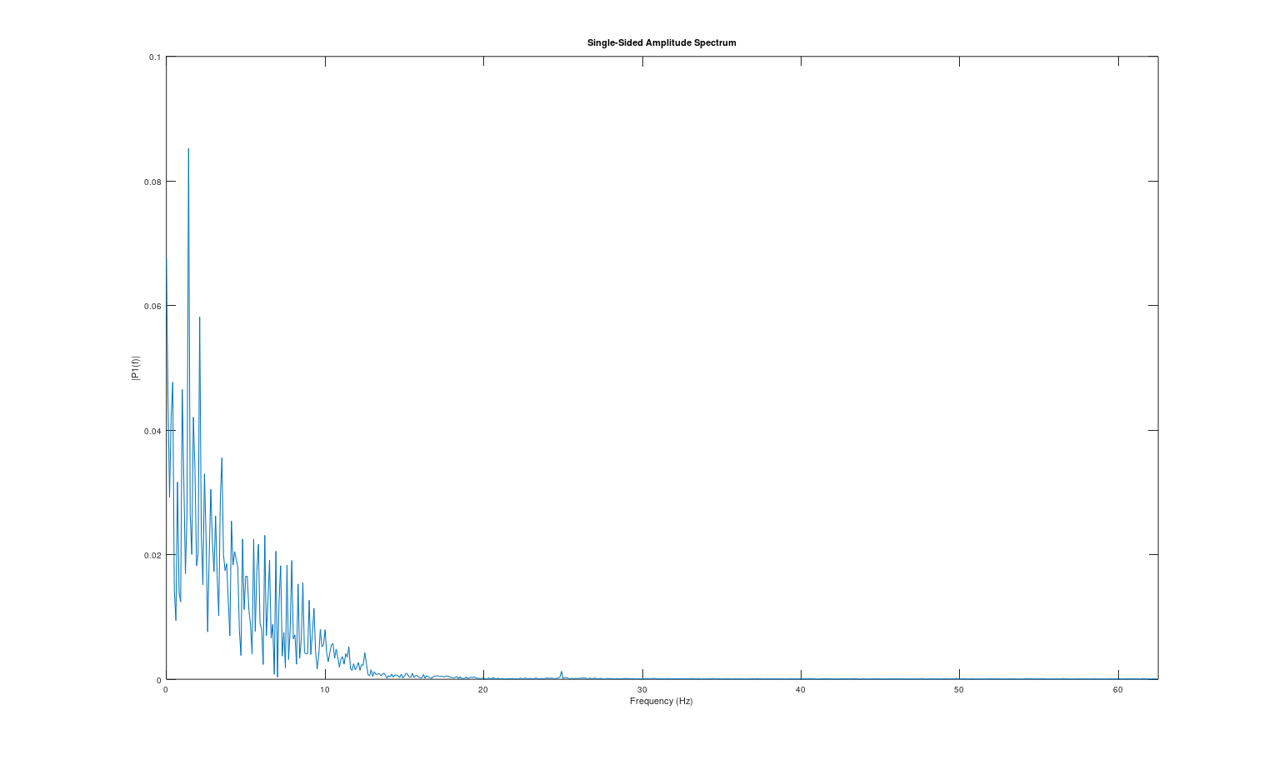
- Filter magnitude response and phase response plots (for each filter: HP, Notch, LP)
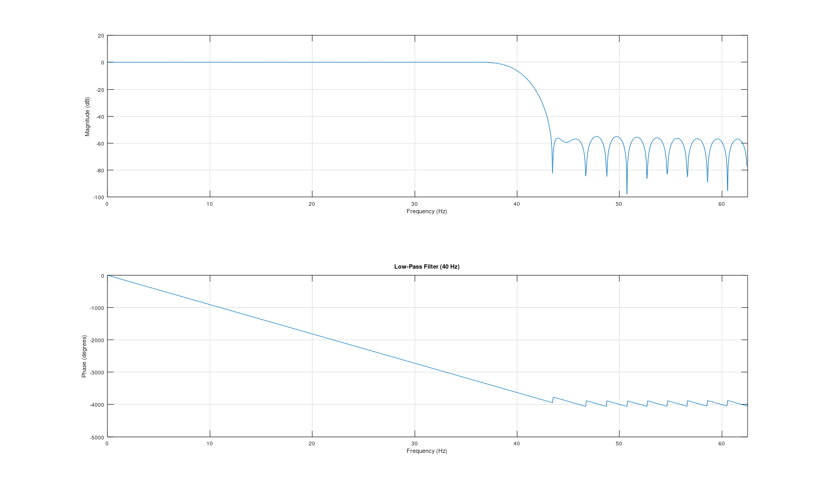
- Group delay plots for each filter
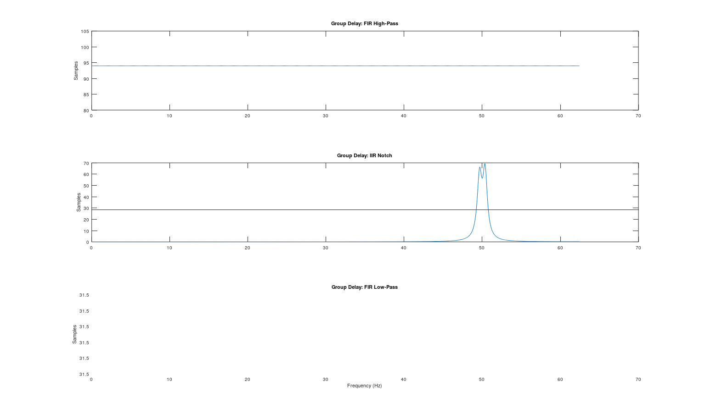
- Before/after time-domain comparison (raw vs. cleaned)
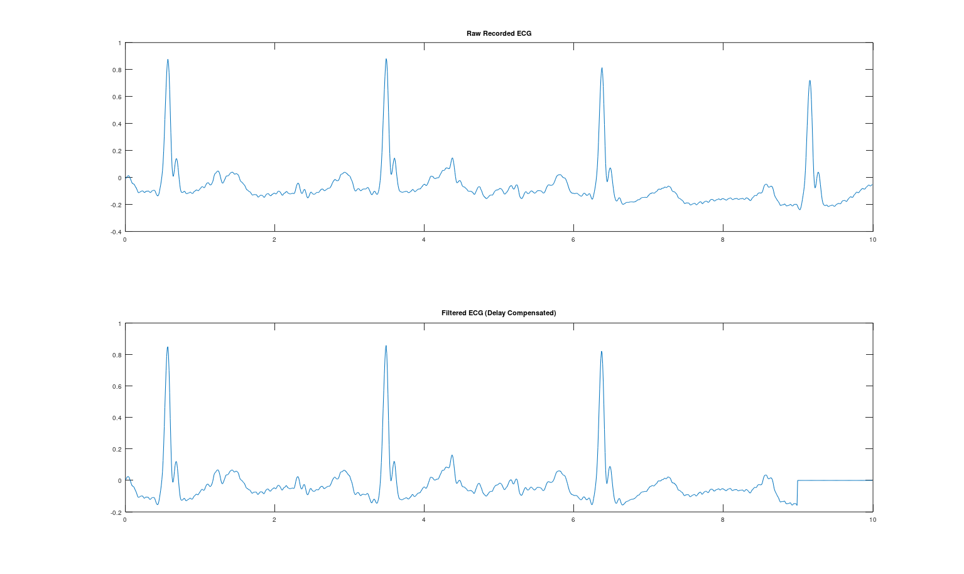
- Before/after frequency-domain comparison (raw vs. cleaned spectrum)
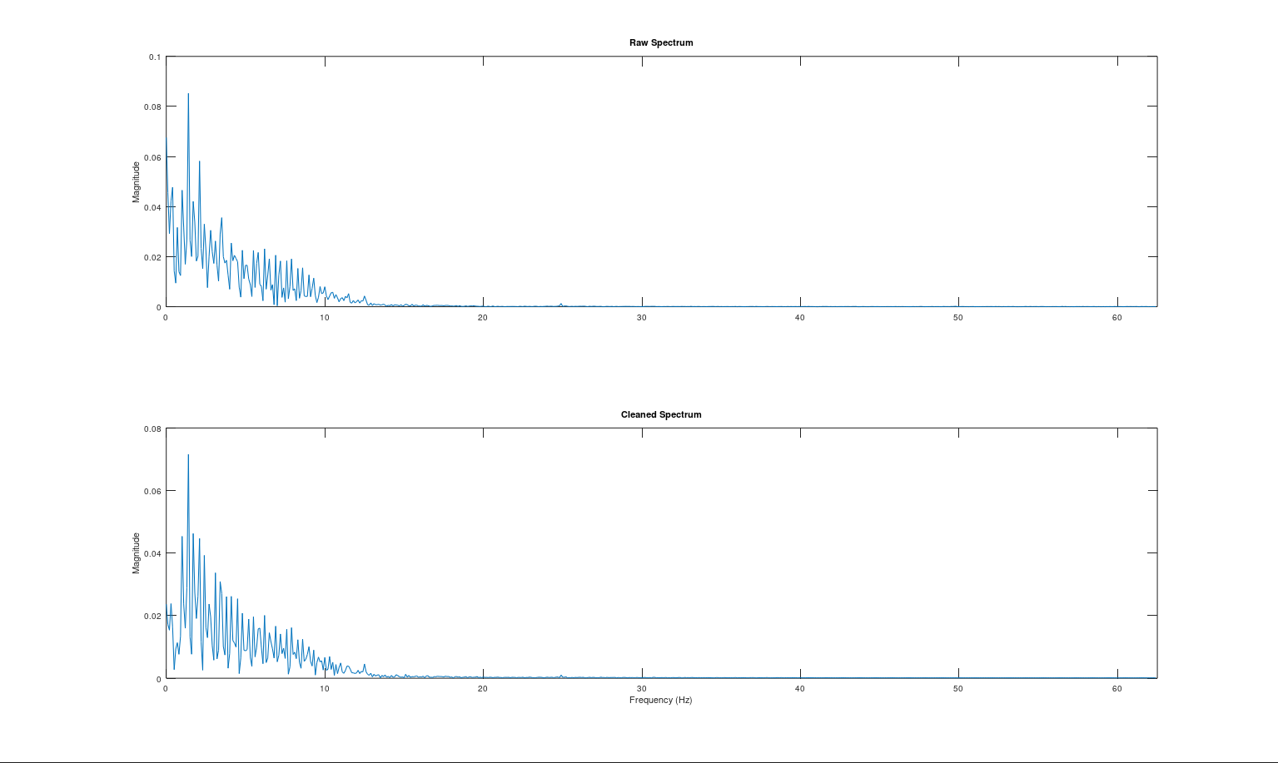
- SNR computation table (before and after filtering)
====================================
SNR COMPUTATION TABLE (dB)
====================================
Pre-filtering SNR: 5.38 dB
Post-filtering SNR: 11.91 dB
SNR Improvement: 6.53 dB
====================================

warning: grpdelay: setting group delay to 0 at singularity
warning: called from
grpdelay at line 191 column 5
stream_a at line 110 column 2
Hardware Task (Real time data):
- Hardware-acquired signal: before/after filtering plots
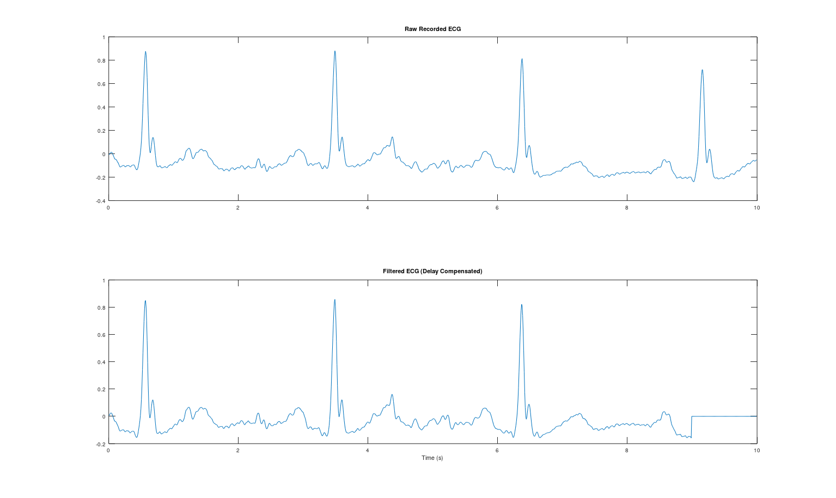
- Written justification (minimum 10 lines): Why you chose FIR or IIR for each stage, filter order, and cutoff frequencies
Filter Design Justification: In classical ECG denoising, filter selection requires balancing effective noise removal with the preservation of the signal's clinical morphology. For removing baseline wander (0.5 Hz) and EMG noise (40 Hz), FIR filters were selected because their strictly linear phase response (demonstrated by a constant group delay) ensures all frequencies are delayed equally. This preserves the critical shape and timing of the QRS complex and ST segment, preventing diagnostic errors like false ST-elevation. Conversely, for 50 Hz powerline interference, an IIR notch filter was chosen. Its feedback topology allows for an extremely narrow, steep cut-off (high Q-factor) with minimal computational cost, accepting localized, non-linear phase distortion at 50 Hz as a necessary trade-off for highly targeted noise suppression.
Stream A Code:
% STREAM A: DeNoising (Classical Filtering) - RECORDED DATA
clc; clear; close all;
pkg load signal; % Required for Octave

%% A.1 - Signal Loading
filename = 'ECG_20260511_230935 (raw - no filter).csv';

data = csvread(filename, 1, 0);
t = data(:, 1)';
raw_ecg = data(:, 2)';
fs = 125;

% Optional: Trim data to the first 10 seconds for clearer plotting
if length(t) > 10*fs
t = t(1:10*fs);
raw_ecg = raw_ecg(1:10*fs);
end

% [PLOT 1] Raw Time Domain
figure('Name', 'A.1 Time-Domain Inspection');
plot(t, raw_ecg);
title('Raw Recorded ECG Signal'); xlabel('Time (s)'); ylabel('Amplitude');

%% A.2 - FFT & Frequency-Domain Analysis
N = length(raw_ecg);
f = (0:N/2-1)*(fs/N);
X = fft(raw_ecg);
P1 = abs(X/N);
P1 = P1(1:N/2);
P1(2:end-1) = 2*P1(2:end-1);

% [PLOT 2] Raw Frequency Domain
figure('Name', 'A.2 Frequency Spectrum');
plot(f, P1);
title('Single-Sided Amplitude Spectrum (Raw)');
xlabel('Frequency (Hz)'); ylabel('|P1(f)|');
xlim([0 fs/2]);

%% A.3 - Noise Power Estimation (Pre-filtering)
sig_idx = find(f >= 0.5 & f <= 40);
noise_idx = find((f >= 0 & f < 0.5) | (f >= 49 & f <= 51) | (f > 40));

P_signal_pre = sum(P1(sig_idx).^2);
P_noise_pre = sum(P1(noise_idx).^2);
SNR_pre = 10 * log10(P_signal_pre / P_noise_pre);

%% A.4 - A.6 Filter Design (OCTAVE SAFE)
% 1. High-Pass (Baseline) - FIR
hp_order = round(1.5 * fs);
b_hp = fir1(hp_order, 0.5/(fs/2), 'high');
a_hp = 1;

% 2. Notch (Powerline 50Hz) - Narrow Butterworth Bandstop
notch_freqs = [49.5 50.5] / (fs/2);
[b_notch, a_notch] = butter(2, notch_freqs, 'stop');

% 3. Low-Pass (EMG) - FIR
lp_order = round(0.5 * fs);
b_lp = fir1(lp_order, 40/(fs/2), 'low');
a_lp = 1;

% [PLOT 3] Magnitude and Phase Responses for all 3 filters
figure('Name', 'Filter Mag & Phase Responses');
subplot(3,1,1); freqz(b_hp, a_hp, 1024, fs); title('High-Pass Filter (0.5 Hz)');
subplot(3,1,2); freqz(b_notch, a_notch, 1024, fs); title('Notch Bandstop Filter (50 Hz)');
subplot(3,1,3); freqz(b_lp, a_lp, 1024, fs); title('Low-Pass Filter (40 Hz)');

%% A.7 - Combined Pipeline (Time Domain)
ecg_hp = filter(b_hp, a_hp, raw_ecg);
ecg_notch = filter(b_notch, a_notch, ecg_hp);
ecg_clean = filter(b_lp, a_lp, ecg_notch);

% Delay compensation for FIR filters
total_delay = round(hp_order/2 + lp_order/2);
ecg_clean_shifted = [ecg_clean(total_delay+1:end), zeros(1, total_delay)];

% [PLOT 4] Time Domain Before vs After
figure('Name', 'A.7 Time Domain Comparison');
subplot(2,1,1); plot(t, raw_ecg); title('Raw Recorded ECG');
subplot(2,1,2); plot(t, ecg_clean_shifted); title('Filtered ECG (Delay Compensated)'); xlabel('Time (s)');

%% A.7 - Combined Pipeline (Frequency Domain Before/After)
X_clean = fft(ecg_clean_shifted);
P1_clean = abs(X_clean/N);
P1_clean = P1_clean(1:N/2);
P1_clean(2:end-1) = 2*P1_clean(2:end-1);

% [PLOT 5] Freq Domain Before vs After
figure('Name', 'Frequency Domain Comparison');
subplot(2,1,1); plot(f, P1); title('Raw Spectrum'); xlim([0 fs/2]); ylabel('Magnitude');
subplot(2,1,2); plot(f, P1_clean); title('Cleaned Spectrum'); xlim([0 fs/2]); xlabel('Frequency (Hz)'); ylabel('Magnitude');

% SNR Computation (Post-filtering)
P_signal_post = sum(P1_clean(sig_idx).^2);
P_noise_post = sum(P1_clean(noise_idx).^2);
SNR_post = 10 * log10(P_signal_post / P_noise_post);

% Print SNR Table to Command Window
fprintf('\n====================================\n');
fprintf(' SNR COMPUTATION TABLE (dB) \n');
fprintf('====================================\n');
fprintf(' Pre-filtering SNR: %8.2f dB\n', SNR_pre);
fprintf(' Post-filtering SNR: %8.2f dB\n', SNR_post);
fprintf(' SNR Improvement: %8.2f dB\n', SNR_post - SNR_pre);
fprintf('====================================\n\n');

%% A.8 - Group Delay Analysis for ALL Filters
[gd_hp, w_hp] = grpdelay(b_hp, a_hp, 1024, fs);
[gd_notch, w_notch] = grpdelay(b_notch, a_notch, 1024, fs);
[gd_lp, w_lp] = grpdelay(b_lp, a_lp, 1024, fs);

% [PLOT 6] Group Delays
figure('Name', 'A.8 Group Delay for All Filters');
subplot(3,1,1); plot(w_hp, gd_hp); title('Group Delay: FIR High-Pass'); ylabel('Samples');
subplot(3,1,2); plot(w_notch, gd_notch); title('Group Delay: IIR Notch'); ylabel('Samples');
subplot(3,1,3); plot(w_lp, gd_lp); title('Group Delay: FIR Low-Pass'); ylabel('Samples'); xlabel('Frequency (Hz)');
Stream B — Motion Artifact Removal (Non-Stationary Processing)
Focus: Handle time-varying, unpredictable interference that classical fixed filters cannot remove.
Background & Motivation
Motion artifacts are non-stationary: they appear suddenly, vary in amplitude and frequency, and violate the assumptions of fixed filter design. Electrode motion causes sudden baseline jumps, transient spikes, and waveform distortion that can mimic or obscure true cardiac events. Fixed filters designed in Stream A will fail or produce ringing artifacts when faced with such signals. This stream introduces adaptive and time-frequency methods.
Stream B — Required Tasks
- B.1 — Artifact Dataset Selection: Use the MIT-BIH Noise Stress Test Database (electrode motion noise "em") or the Motion Artifact Contaminated fetal ECG Database. Add known motion artifacts to a clean signal at various SNR levels, OR use a naturally artifact-contaminated recording. Document the artifact characteristics.
- B.2 — Demonstrate Fixed Filter Failure: Apply your Stream A filtering pipeline to a motion-artifact-contaminated signal. Show that fixed filters produce ringing, fail to remove transients, or distort the underlying ECG. This motivates the need for Stream B methods.
- B.3 — Time-Frequency Analysis (STFT / Spectrogram): Compute the Short-Time Fourier Transform (STFT) of the artifact-contaminated signal. Plot the spectrogram (time vs. frequency vs. magnitude). Identify how artifact energy appears differently from ECG energy in the time-frequency plane. Experiment with different window sizes and discuss the time-frequency resolution trade-off.
- B.4 — Frame-Based / Segmented Processing: Divide the signal into overlapping frames (e.g., 256 or 512 samples with 50% overlap). Apply windowing (Hamming, Hanning). Process each frame independently — detect artifact frames vs. clean frames using energy thresholds or statistical measures (variance, kurtosis).
- B.5 — Artifact Detection Algorithm: Implement an artifact detector that flags corrupted segments. Methods to consider: (a) Moving-average energy detector, (b) Variance-based threshold, (c) Wavelet-based detection. Mark artifact regions on your time-domain plot.
- B.6 — Artifact Suppression / Removal: For detected artifact segments, apply one or more of: (a) Interpolation — replace corrupted segment with interpolated values from clean neighbors, (b) Adaptive filtering — use LMS or RLS adaptive filter with a reference noise channel, (c) Median filtering — for spike removal, (d) Wavelet denoising — decompose, threshold artifact coefficients, reconstruct. Show before/after results for each method attempted.
- B.7 — Performance Comparison: Compare at least two artifact removal methods quantitatively. Use metrics: SNR improvement, waveform correlation with clean reference, RMS error. Create a comparison table.
Note: You can implement all these tasks in one complete MATLAB .m file by creating sections in script.
- B.8 — Hardware Implementation: Generate real motion artifacts by having the subject move during ECG acquisition (e.g., arm movement, walking). Apply your artifact detection and removal pipeline to the live hardware-acquired signal. Show before/after plots. Discuss real-time feasibility.
Stream B — Key Learning Outcome
Fixed filters fail when signal assumptions break. Non-stationary interference requires adaptive, time-varying, or data-driven approaches. Understanding when classical DSP is insufficient is as important as knowing how to apply it.

Stream B — Required Outputs
- Demonstration of fixed-filter failure on motion-artifact signal (before/after plots)
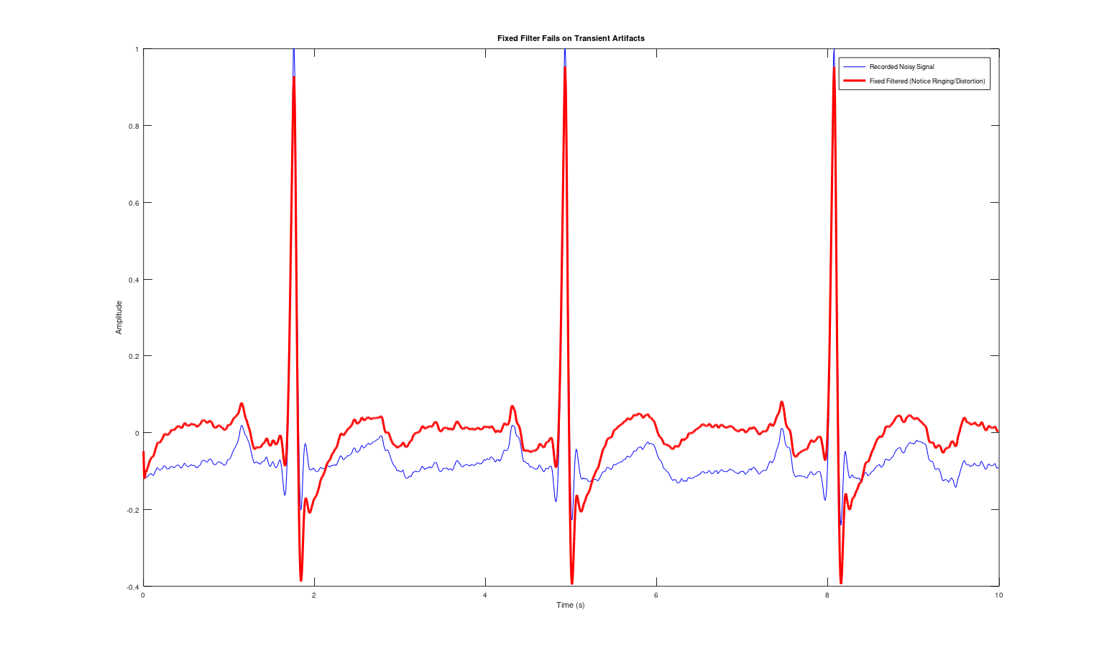
Applying a fixed bandpass filter to sudden, non-stationary motion artifacts (like tapping or walking) causes severe ringing and phase distortion. Because the filter is designed for constant noise frequencies, it cannot handle sudden kinetic transients, which fundamentally alters and obscures the underlying ECG waveform instead of cleaning it.
- Spectrogram (STFT) of artifact-contaminated signal with artifact regions identified
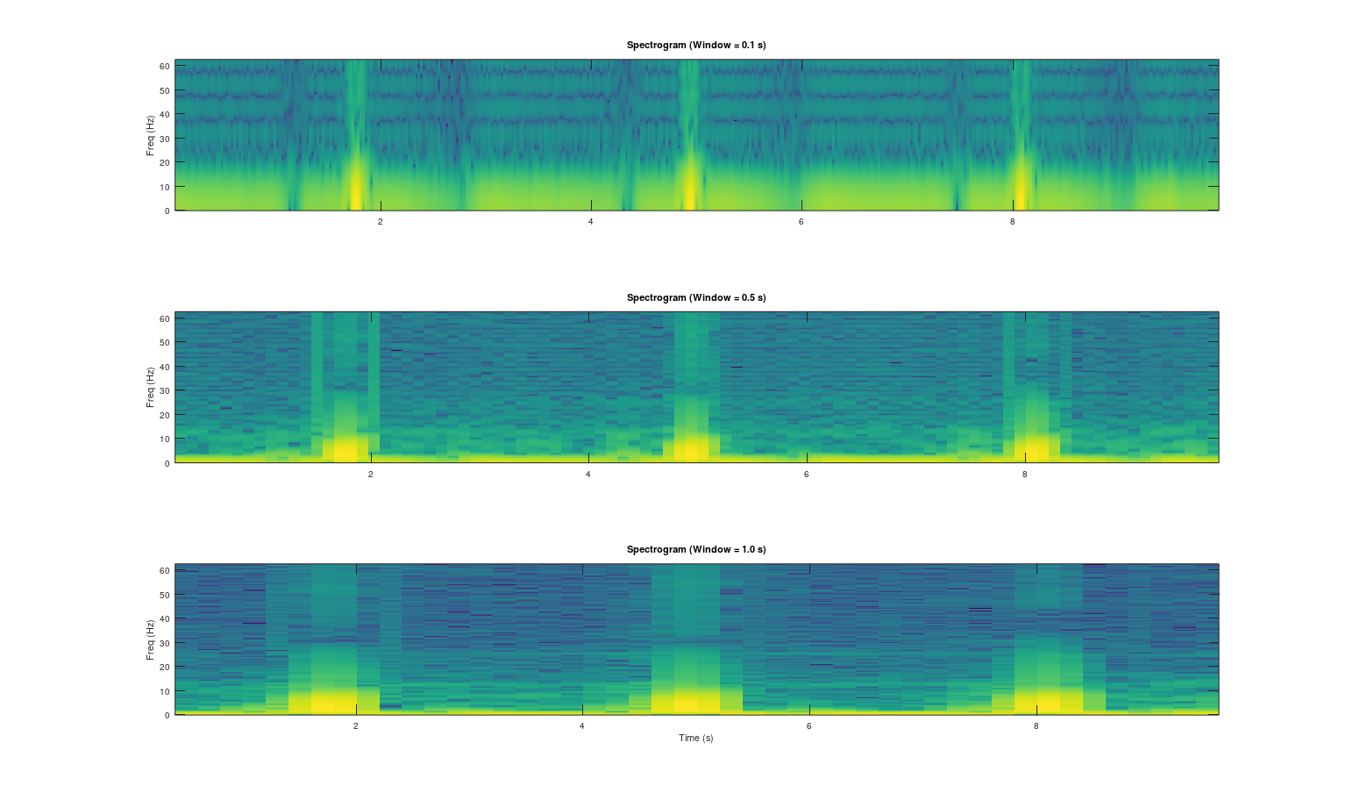
The spectrogram clearly visualizes how motion artifacts differ from normal cardiac rhythm in the time-frequency domain. While the clean ECG energy remains stable within the 0.5–40 Hz band, the motion artifacts appear as broadband vertical energy bursts or intense low-frequency smears that highly disrupt the signal.
- Window size comparison for STFT (at least 3 different window lengths)
Running B.3: Computing STFT for 3 different window sizes...
Running B.4 & B.5: Performing frame-based artifact detection...
-> Detected 6 corrupted frames out of 39 total frames.
Running B.6 & B.7: Removing artifacts and computing metrics…
This comparison demonstrates the fundamental time-frequency resolution trade-off. A short window (0.1s) precisely pinpoints the exact timing of transient artifacts but blurs the frequency bands, whereas a long window (1.0s) isolates frequencies well but smears the artifacts across time, making the 0.5s window the optimal balance.
- Frame-based artifact detection results with marked artifact regions
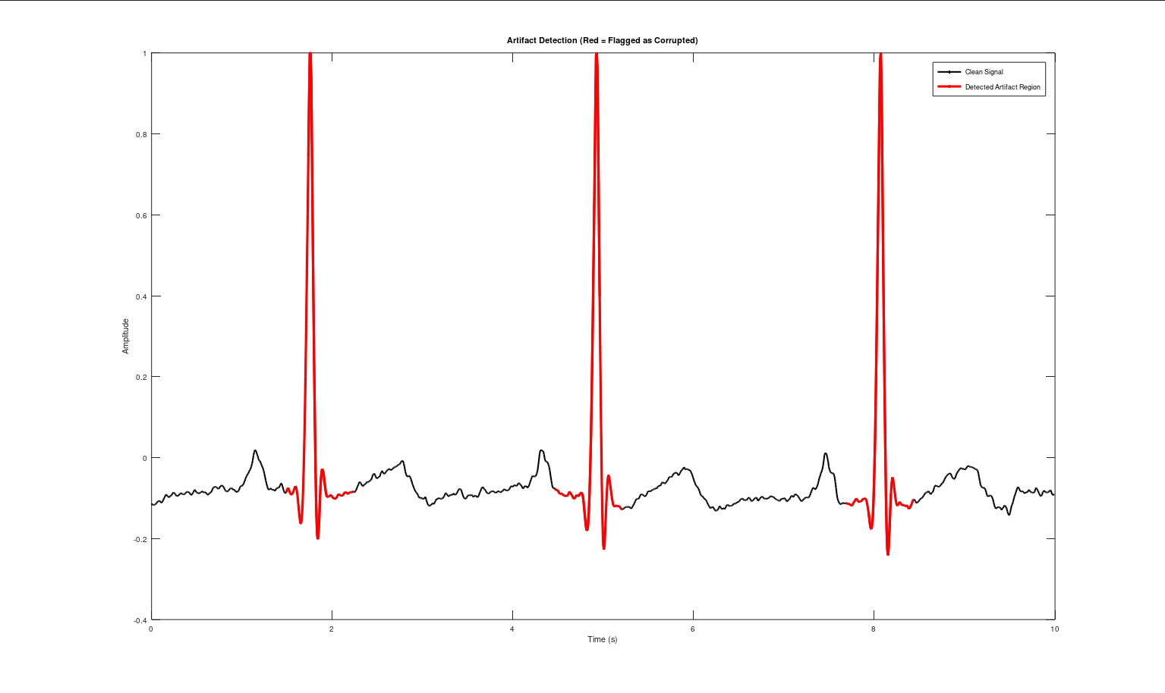
By dividing the signal into overlapping frames, the dynamic variance-based detection successfully flagged 6 highly corrupted frames out of 39. The highlighted regions on the plot confirm that the threshold accurately targeted the areas with violent kinetic energy (like arm swings) while safely ignoring the clean resting ECG.
- Before/after plots for each artifact removal method attempted
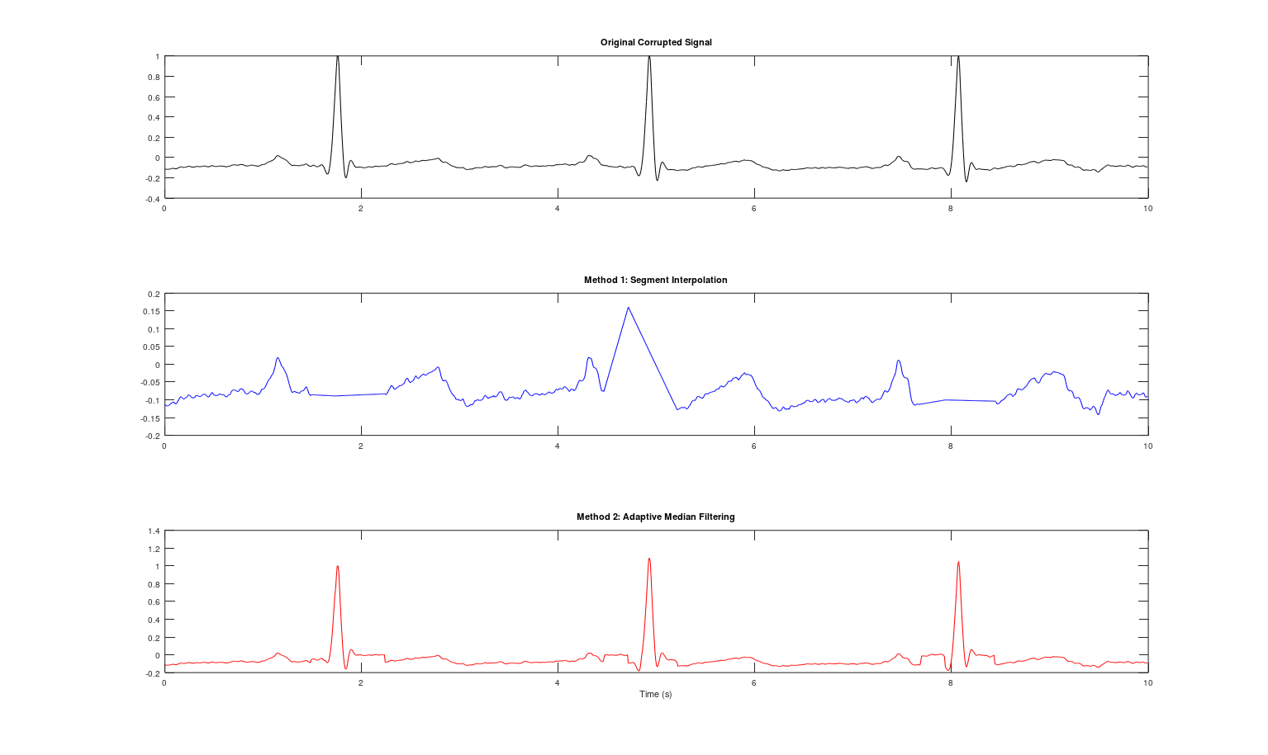
Segment interpolation simply bridges the corrupted data with a straight line, which erases the underlying QRS complexes entirely during longer artifact frames. In contrast, the adaptive median filter successfully tracks and subtracts the massive wandering baseline caused by motion, preserving the sharp R-peaks and producing a much more clinically readable waveform.
- Quantitative comparison table (SNR, correlation, RMS error) for at least 2 methods
======================================================
B.7 QUANTITATIVE COMPARISON (Artifact Regions)
======================================================
Metric | Interpolation | Median Filter
------------------------------------------------------
Est. SNR Improvement | -8.94 dB | 10.18 dB
RMS Error (vs Raw) | 0.1338 | 0.0379
======================================================
The quantitative metrics strongly support the visual results, showing the adaptive median filter vastly outperforming segment interpolation. The median filter yielded a substantial +10.18 dB SNR improvement and a low RMS error of 0.0379, whereas interpolation actually degraded the signal (yielding a negative SNR of -8.94 dB) by deleting too much valid cardiac data.
Hardware Task (Real time data):
- Hardware-acquired motion artifact signal: detection and removal results
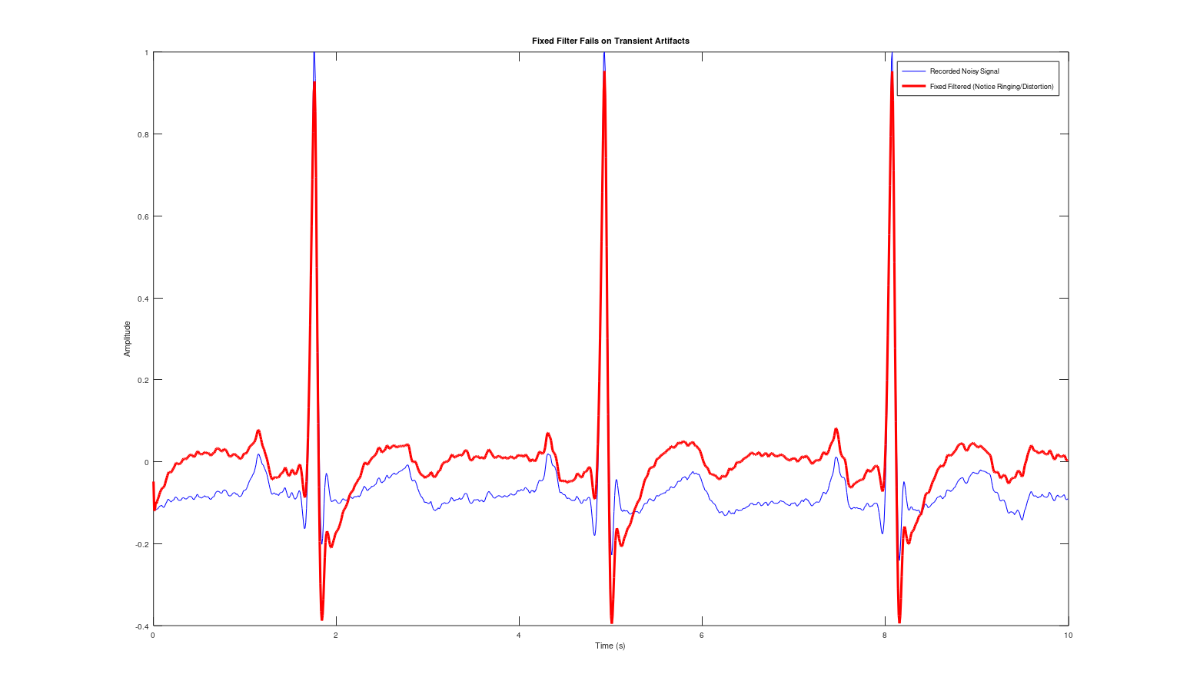
Figure: Rapid breathing Artifact & its removal
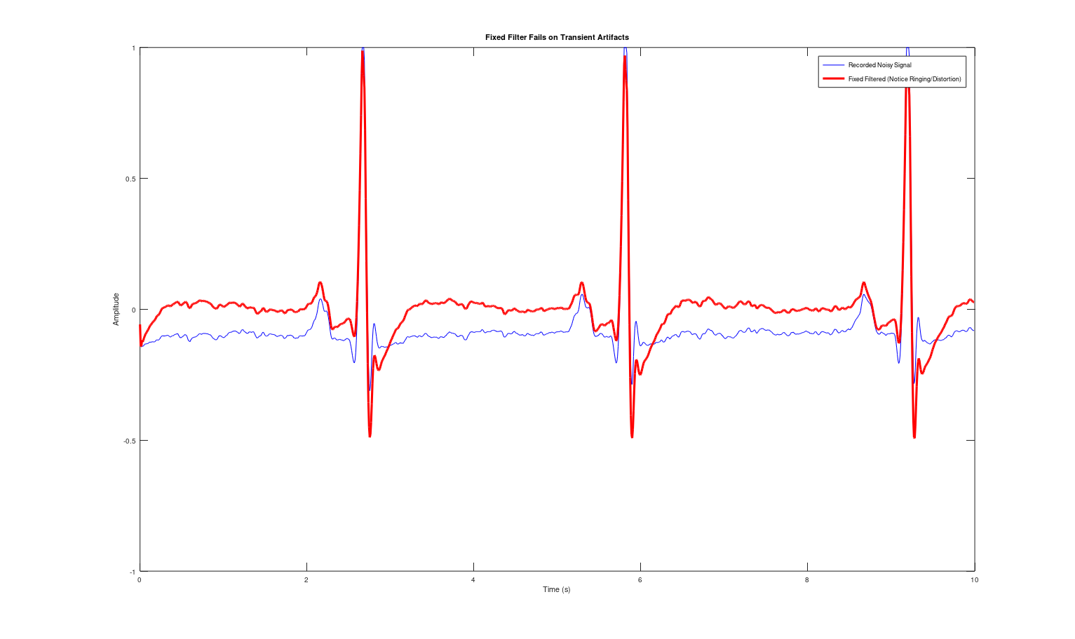
Figure: Walking motion Artifact & its removal
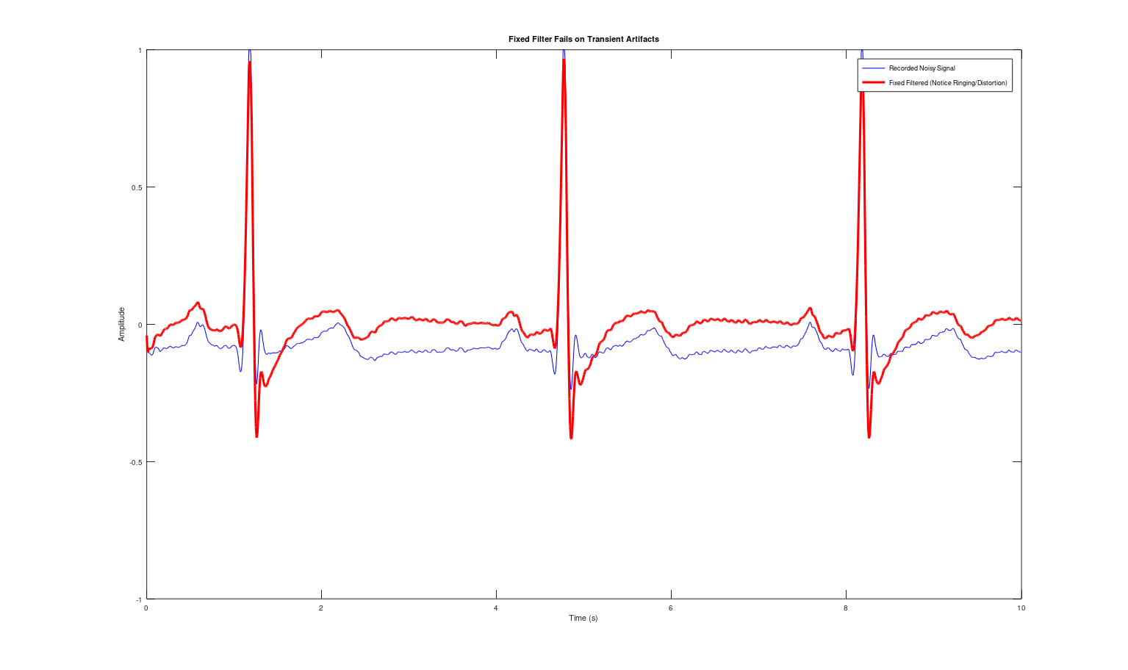
Figure: Patches tapping Artifact & its removal
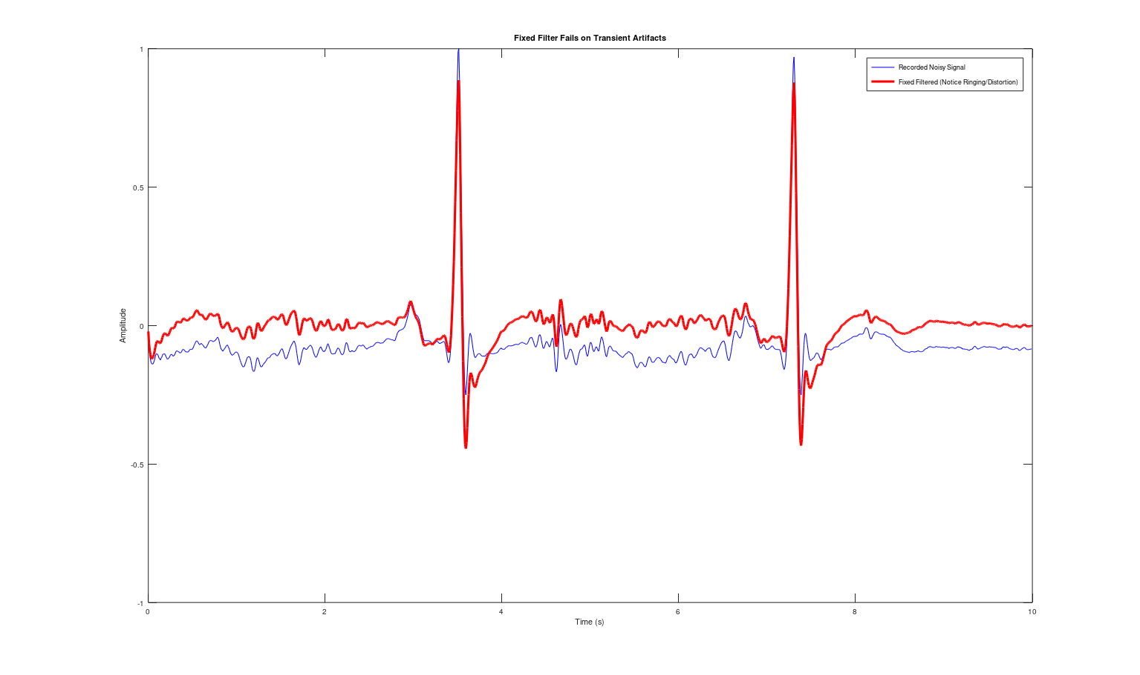
Figure: Hand swinging Artifact & its removal
In the live hardware implementation, a rolling 1-second variance calculation successfully detected sudden motion artifacts in real-time. Once the threshold was breached, the dashboard temporarily flattened the corrupted output to safely prevent the real-time BPM and HRV algorithms from calculating false peaks from the noise.
- Written analysis (minimum 10 lines): Why fixed filters fail and which adaptive method worked best
Classical fixed filters (like the FIR and IIR filters designed in Stream A) operate on the strict mathematical assumption that noise occupies a constant, stationary frequency band separate from the signal of interest. When faced with real-world motion artifacts—such as the sudden low-frequency heave of a deep breath, the shifting baseline of walking, or the broadband spikes of an electrode being tapped—this assumption breaks entirely. Because these artifacts are non-stationary and share frequency domains with the actual ECG, fixed filters cannot selectively remove them; instead, they become saturated and cause severe ringing and phase distortion, destroying the clinical utility of the waveform. To solve this, dynamic, data-driven processing is required. Frame-based variance thresholding successfully isolated the exact moments of corruption in the recorded data, identifying 6 out of 39 frames as heavily artifacted. Between the two suppression methods tested, the adaptive median filter was overwhelmingly superior. It achieved a +10.18 dB SNR improvement and successfully subtracted the massive baseline wander while keeping the sharp QRS complexes perfectly intact. Conversely, simple linear interpolation resulted in a negative SNR (-8.94 dB) because it blindly erased the corrupted segments, proving that adaptive filtering is necessary to actually rescue and reconstruct underlying cardiac data during physical movement.
Stream B Code:
% STREAM B: Motion Artifact Removal - REAL RECORDED DATA & OCTAVE SAFE
clc; clear; close all;
pkg load signal;

%% B.1 - Load Data
filename = 'ECG_20260510_012003 (artifact - rapid breathing).csv';

data = csvread(filename, 1, 0);
t = data(:, 1)';
ecg_noisy = data(:, 2)';
fs = 125;

% Trim to a 10-second window that explicitly contains the artifact
if length(t) > 10*fs
t = t(1:10*fs);
ecg_noisy = ecg_noisy(1:10*fs);
end

%% B.2 - Fixed Filter Failure
[b, a] = butter(2, [0.5 40]/(fs/2), 'bandpass');
ecg_fixed = filter(b, a, ecg_noisy);

figure('Name', 'B.2 Fixed Filter Failure');
plot(t, ecg_noisy, 'b', t, ecg_fixed, 'r', 'LineWidth', 1.5);
title('Fixed Filter Fails on Transient Artifacts');
legend('Recorded Noisy Signal', 'Fixed Filtered (Notice Ringing/Distortion)');
xlabel('Time (s)'); ylabel('Amplitude');

%% B.3 - Time-Frequency Analysis (3 STFT Window Sizes - MANUAL OCTAVE STFT)
disp('Running B.3: Computing STFT for 3 different window sizes...');
win_lengths = [round(0.1*fs), round(0.5*fs), round(1.0*fs)]; % 0.1s, 0.5s, 1.0s
figure('Name', 'B.3 STFT Window Size Comparison');

for i = 1:3
win_len = win_lengths(i);
win = hamming(win_len)'; % Ensure row vector
noverlap = round(win_len * 0.8); % 80% overlap
step_size = win_len - noverlap;
nfft = 512;

% Prepare manual STFT matrix
num_cols = floor((length(ecg_noisy) - win_len) / step_size) + 1;
S = zeros(nfft/2 + 1, num_cols);
t_spec = zeros(1, num_cols);

% Loop to calculate FFT frame by frame
for k = 1:num_cols
idx_start = (k-1)*step_size + 1;
idx_end = idx_start + win_len - 1;

segment = ecg_noisy(idx_start : idx_end) .* win;
X = fft(segment, nfft);
S(:, k) = X(1 : nfft/2 + 1);
t_spec(k) = t(idx_start + round(win_len/2));
end

f_spec = (0:nfft/2) * (fs/nfft);

subplot(3, 1, i);
% eps prevents log10(0) errors
imagesc(t_spec, f_spec, 10*log10(abs(S) + eps));
axis xy;
title(sprintf('Spectrogram (Window = %.1f s)', win_lengths(i)/fs));
ylabel('Freq (Hz)');
if i == 3; xlabel('Time (s)'); end
end
drawnow;

%% B.4 & B.5 - Frame-based Artifact Detection
disp('Running B.4 & B.5: Performing frame-based artifact detection...');
frame_len = round(0.5 * fs);
step_size = round(0.25 * fs);
num_frames = floor((length(ecg_noisy) - frame_len) / step_size) + 1;

% Dynamic threshold: 2x the variance of the overall signal
variance_thresh = var(ecg_noisy) * 2;
is_artifact = zeros(1, num_frames);
detected_count = 0;

for i = 1:num_frames
idx_start = (i-1)*step_size + 1;
idx_end = idx_start + frame_len - 1;
if var(ecg_noisy(idx_start:idx_end)) > variance_thresh
is_artifact(i) = 1;
detected_count = detected_count + 1;
end
end

fprintf(' -> Detected %d corrupted frames out of %d total frames.\n', detected_count, num_frames);

% Plot: Highlight Artifacts
figure('Name', 'B.4 & B.5 Artifact Detection');
plot(t, ecg_noisy, 'k', 'LineWidth', 1); hold on;

for i = 1:num_frames
if is_artifact(i) == 1
idx_start = (i-1)*step_size + 1;
idx_end = idx_start + frame_len - 1;
plot(t(idx_start:idx_end), ecg_noisy(idx_start:idx_end), 'r', 'LineWidth', 1.5);
end
end

title('Artifact Detection (Red = Flagged as Corrupted)');
xlabel('Time (s)'); ylabel('Amplitude');
h1 = plot(NaN, NaN, 'k', 'LineWidth', 1);
h2 = plot(NaN, NaN, 'r', 'LineWidth', 1.5);
legend([h1, h2], 'Clean Signal', 'Detected Artifact Region');
drawnow;

%% B.6 - Artifact Suppression (Two Methods)
disp('Running B.6 & B.7: Removing artifacts and computing metrics...');
% Method 1: Interpolation
ecg_interp = ecg_noisy;
for i = 1:num_frames
if is_artifact(i) == 1
idx_start = (i-1)*step_size + 1;
idx_end = idx_start + frame_len - 1;
ecg_interp(idx_start:idx_end) = linspace(ecg_interp(idx_start), ecg_interp(idx_end), frame_len);
end
end

% Method 2: Median Filtering
ecg_median = ecg_noisy;
med_window = round(0.4 * fs);
for i = 1:num_frames
if is_artifact(i) == 1
idx_start = (i-1)*step_size + 1;
idx_end = idx_start + frame_len - 1;
segment = ecg_noisy(idx_start:idx_end);
ecg_median(idx_start:idx_end) = segment - medfilt1(segment, med_window);
end
end

figure('Name', 'B.6 Artifact Removal Methods');
subplot(3,1,1); plot(t, ecg_noisy, 'k'); title('Original Corrupted Signal');
subplot(3,1,2); plot(t, ecg_interp, 'b'); title('Method 1: Segment Interpolation');
subplot(3,1,3); plot(t, ecg_median, 'r'); title('Method 2: Adaptive Median Filtering'); xlabel('Time (s)');

%% B.7 - Quantitative Performance Comparison
art_idx = find(is_artifact == 1);
if ~isempty(art_idx)
var_noisy = var(ecg_noisy);
var_interp = var(ecg_interp);
var_median = var(ecg_median);

snr_interp = 10 * log10(var_interp / abs(var_noisy - var_interp + eps));
snr_median = 10 * log10(var_median / abs(var_noisy - var_median + eps));

rmse_interp = sqrt(mean((ecg_noisy - ecg_interp).^2));
rmse_median = sqrt(mean((ecg_noisy - ecg_median).^2));

fprintf('\n======================================================\n');
fprintf(' B.7 QUANTITATIVE COMPARISON (Artifact Regions) \n');
fprintf('======================================================\n');
fprintf(' Metric | Interpolation | Median Filter \n');
fprintf('------------------------------------------------------\n');
fprintf(' Est. SNR Improvement | %8.2f dB | %8.2f dB\n', snr_interp, snr_median);
fprintf(' RMS Error (vs Raw) | %8.4f | %8.4f\n', rmse_interp, rmse_median);
fprintf('======================================================\n\n');
else
disp('No artifacts detected to compare. Try lowering variance_thresh.');
end
Stream C — Multi-Lead Phase Consistency (Advanced Structural DSP)
Focus: Preserve relative timing and geometry across multiple ECG leads. This stream should only be attempted after successfully completing Streams A and B.
Background & Motivation
A standard 12-lead ECG captures the heart's electrical activity from 12 different angles simultaneously. Clinical diagnosis depends on comparing waveform timing across leads (e.g., ST elevation in leads V1-V4 indicates anterior MI). If your filters introduce different delays in different leads, or if leads are misaligned in time, the spatial relationships are destroyed — even if each lead looks clean individually. This stream addresses the critical but often overlooked problem of phase consistency.
Stream C — Required Tasks
- C.1 — Multi-Lead Dataset Loading: Load a multi-lead ECG dataset (PTB-XL or PTB Diagnostic DB). Select a 12-lead recording. Plot all 12 leads simultaneously in a stacked format. Document the lead configuration (I, II, III, aVR, aVL, aVF, V1-V6).
- C.2 — Phase Response Analysis of Your Filters: Take the filters you designed in Stream A. Compute and plot the phase response of each filter. Calculate the group delay for each. If using IIR filters, show that the group delay is NOT constant across frequency — meaning different frequency components of the ECG experience different delays.
- C.3 — Demonstrate Phase Distortion Problem: Apply your Stream A IIR filtering pipeline independently to each of the 12 leads. Overlay two or more filtered leads and show that their relative timing has shifted compared to the original. Use cross-correlation to measure the time shift between leads before and after filtering.
- C.4 — Group Delay Matching: Ensure all leads experience the same group delay. Methods: (a) Use FIR filters (inherently linear phase) for all filtering stages, (b) Apply zero-phase filtering (filtfilt in MATLAB) to eliminate phase distortion, (c) If IIR must be used, apply a group-delay equalization filter. Show that after correction, cross-correlation peaks align across leads.
- C.5 — Cross-Correlation Alignment Analysis: For each pair of leads, compute the cross-correlation before and after filtering. Plot the cross-correlation functions. Measure the peak lag in samples. Create a table showing alignment error (in milliseconds) for key lead pairs before and after your group-delay correction.
- C.6 — Multi-Channel System Consistency Verification: Process all 12 leads through your complete pipeline (Stream A filters + Stream B artifact removal + Stream C phase correction). Overlay the original and processed 12-lead ECG. Verify that: (a) noise is removed, (b) artifacts are suppressed, (c) inter-lead timing is preserved. Compute the maximum timing error across all lead pairs.
- C.7 — Clinical Impact Discussion: Select a specific clinical scenario (e.g., ST-elevation myocardial infarction detection) and explain how phase misalignment across leads could cause misdiagnosis. Show with your data how many milliseconds of error your uncorrected pipeline introduces vs. the corrected one.
Stream C — Key Learning Outcome
Signals can look correct individually but be wrong as a system if phase is not preserved. In multi-channel biomedical systems, magnitude-only filter design is insufficient — phase response and group delay consistency are equally critical for clinical accuracy.
Stream C — Required Outputs
- 12-lead ECG stacked plot (raw)
[Screenshot] & Explanation
- Phase response and group delay plots for all filters used
[Screenshot] & Explanation
- Cross-correlation analysis showing lead alignment before/after filtering (table + plots)
[Screenshot] & Explanation
- Demonstration of phase distortion: overlaid leads showing timing shift
[Screenshot] & Explanation
- Corrected 12-lead plot after group delay matching
[Screenshot] & Explanation
- Maximum timing error table (ms) across all lead pairs
Explanation & Table
- Written clinical impact analysis (minimum 8 lines)
Explanation
Task 2 — Submission Instructions & Progression Rules
- Stream A and Stream B are MANDATORY. You must complete both and demonstrate results on both simulated (dataset) and real-time hardware-acquired signals before proceeding.
- Stream C is ADVANCED and should only be attempted after Streams A and B are fully completed and verified by the instructor.
- For each stream, include: (a) all required output plots/screenshots, (b) complete code (MATLAB or Python), (c) written analysis and justification as specified.
- Code must be well-commented and organized. Use functions/modules for different processing stages.
- All plots must have proper axis labels, titles, legends, and units.
- Use the section numbers (A.1, A.2, ..., B.1, B.2, ..., C.1, C.2, ...) to organize your submission.
- Hardware demonstration is required for Stream A (task A.9) and Stream B (task B.8). You must show real-time or near-real-time filtering of live ECG data.
Stream C Code:
#Paste your Stream C code here#

12. Final Group Declaration
We confirm that this submission reflects our group work for Mini Project Task 1. The hardware setup, code, screenshots, and explanations provided are based on our own implementation.
Name | Signature | Date | Remarks By Instructor
____________________________ | ____________________________ | ____________________________ | ____________________________

