DAY 03
Snap 1
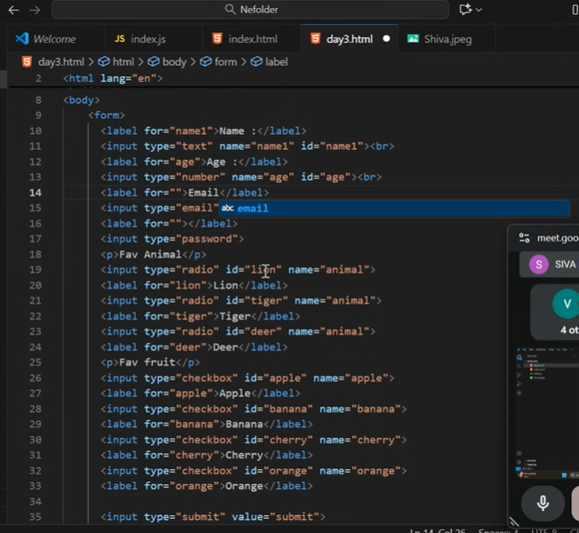
1.Js datatypes and explain?
2. Type of strings
1.string.charAt - camelCase
2. string.conCat
3. string.indexOf
4. string.lastIndexOf
5. string.slice
6. string.split
7. string.toLowerCase
8. string.toUpperCase

Javascript index starts at 0 ‘Hello’ console.log(b.charAt(4)) OP - 0

