Steps:

1. Start triplestore
2. Run Dummyservice
3. Run Executionservice
4. Create agents
   1. **Import** “*Lcc_Ex_1_Create_Agents_DifeAgentForLccTemplate*” collection to Postman from **AJAN_for_LCC/AdditionalData** folder
   2. Move mouse on top of the imported collection
   3. Click the 3 dots (near star) as described in picture



* 1. Click “Run Collection” from opening menu as describedi in picture

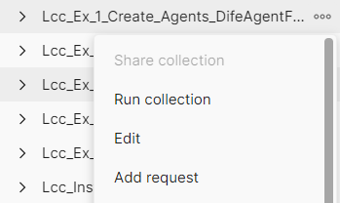

* 1. Click on “Deselect All” and then select 5 agents from the list

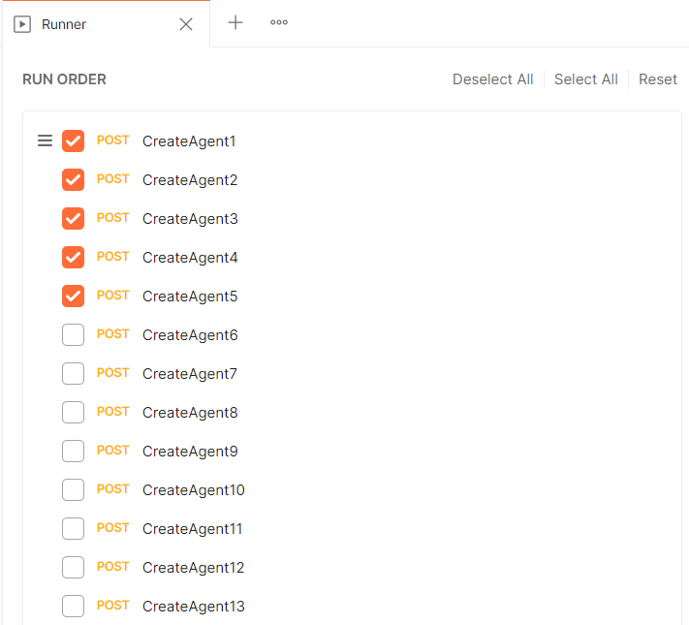

* 1. Then click on “Select File” on the right

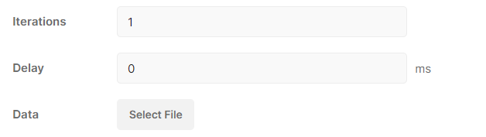

* 1. Select “**CreateAgents_port_8060.json**” file which is in **AJAN_for_LCC/AdditionalData** folder
  2. Then click Run Lcc_Ex_1 …. As in the picture:
  3. 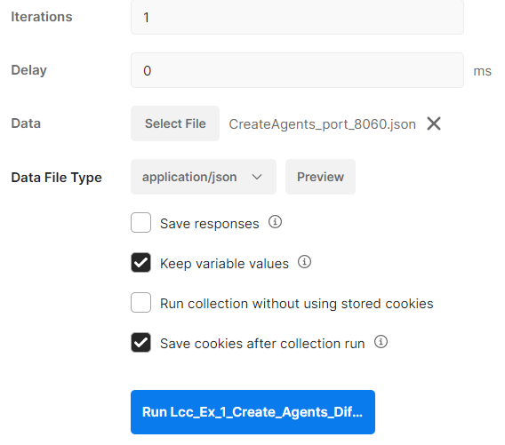
  4. Selected agents will be created one by one

1. Populate LAR
   1. Import “**Populate-LAR_Collection_DifeAgentForLcc**” collection to Postman from **AJAN_for_LCC/AdditionalData** folder
   2. Click the 3 dots (near star) as done in previous steps
   3. Click “Run Collection” from opening menu as done in previous steps
   4. Click on “Deselect All” and then select “**PopulateLar_5active**” option from the list
   5. Click on “Select File” as done in previous steps
   6. Select “Ip_Port_AgentId_Of_5_Agents.json” file which is in **AJAN_for_LCC/AdditionalData** folder
   7. Then click on the Run as done in previous steps.
   8. The 5 agents which were created in previous steps will populate their LAR since it is required for LCC such that agents can contact each other’s by using the info in their LAR.
2. Start LCC coordination process
   1. Import “Run_LCC_Collection_DifeAgentForLcc” collection to Postman from **AJAN_for_LCC/AdditionalData** folder
   2. Click the 3 dots (near star) as done in previous steps
   3. Click “Run Collection” from opening menu as done in previous steps
   4. Click on “Deselect All” and then select “Start-LCC-5-agents_1” ” option from the list
   5. Click on “Select File” as done in previous steps
   6. Select “Ip_Port_AgentId _Of_5_Agents.json” file which is in **AJAN_for_LCC/AdditionalData** folder
   7. Then click on the Run as done in previous steps.
   8. The 5 agents who are running will start LCC scenario. By default, “Agent1” is the dedicated agent and this can be modified in the corresponding Postman request.
   9. Agent logs can be viewed in Netbeans. In order to find the grouping results, search for “BOSS” keyword in Netbeans logs. Also the results can be viewed in the repositories of agents (LAKRs).
3. Run LCC Assessment phase
   1. Perform 5.b, 5.c steps
   2. Click on “Deselect All” and then select “Run_LCC_Assessment_Phase” option from the list
   3. Perform 5.e, 5.f, 5.g
   4. 5 Agents will receive the start assessment phase signal and they will inform applications
4. Submit LCC Assessment Scores phase
   1. Perform 5.b, 5.c
   2. Click on “Deselect All” and then select “Submit_LCC_Assessment_Scores_JSONLD” option from the list
   3. Perform 5.e
   4. Select “Ip_Port_AgentId_AssessmentScore_Of_5_Agents.json” file which is in **AJAN_for_LCC/AdditionalData** folder
   5. Perform 5.g
   6. 5 Agents will receive Assessment scores from applications and they will inform Teacher Panel
5. Submit LCC Final Result
   1. Perform 6.a
   2. Click on “Deselect All” and then select “Submit-LCC-Final-Result” option from the list
   3. Perform 6.c
   4. 5 agents will receive the final LCC result which is sent by Teacher Panel