Contents

**Constrained K-means algorithm – COP-Kmeans** (Wagstaff, Claire, Seth, & Stefan, 2001) 2

**COP-Kmeans algorithm pseudocode: (incomplete)** 3

**LCC_CKMeans Protocol** 4

**Boosted Constrained K-means Algorithm – BCKM** (Okabe & Yamada, 2018) 5

**Algorithm 2 - M-CKmeans** 6

**Algorithm 3 - BCKM** 7

SCOP-KMeans algorithm by Kiri Wagstaff 12

**References** 15

**LCC scenario as Constrained K-means clustering problem**

# **Constrained K-means algorithm – COP-Kmeans** (Wagstaff, Claire, Seth, & Stefan, 2001)

**COP-Kmeans** (agent **set** A, **must-link constraints ${Con}_{\text{=}}⊆A×A$** , **cannot-link constraints ${Con}_{\text{≠}}⊆A×A$** )

**INPUT:** Data set of agents, Must-link constraints and Cannot-link constraints

**OUTPUT**: A set of clusters or Empty set

1. Let ${tcn}_{min}$ and ${tcn}_{max}$ be the minimum and maximum number for the cardinality of each cluster as specified in the informal description.

${tcn}_{min}=2,{tcn}_{max}=5$

1. Let $k_{min}$ and $k_{max}$ be the lower and higher bound of **k** interval:
$$\begin{aligned}k_{min}=⌈{|A|}/{{tcn}_{max}}⌉ \\ k_{max}=⌈{|A|}/{{tcn}_{min}}⌉ \\ k=k_{min}\end{aligned}$$

2. Let $C_{1},...C_{k}$ be the initial cluster centers.
3. For each agent $a_{i}∈A$, assign it to the closest cluster $C_{j}$ such that $VIOLATE-CONSTRAINTS(a_{i},C_{j},{Con}_{\text{=}},{Con}_{\text{≠}})$ is **false**. If **no** such cluster **exist**, increment $k$ by one and check whether $k$ is not greater than $k_{max}$. If incremented $k$ is not greater than $k_{max}$, then **break** iteration and go to step 3. If it is greater, then **fail** (return {}).
4. For each cluster ${ C}_{i}$, update its center by **averaging** all of the points $a_{i}$ that have been assigned to it.
5. Iterate between **step 4** and **step 5** until **convergence**.
6. Return $\{C_{1},...,C_{k}\}$

$\begin{aligned}\text{VIOLATE-CONSTRAINTS}\text{(}\text{agent } a\text{, cluster }C\text{, must-link constraints }{Con}_{\text{=}}\text{,} \\ \text{cannot-link constraints }{Con}_{\text{≠}}\text{)}\end{aligned}$

For each $\left(a, a_{m}\right)∈Con_{=}:if a_{m}∉C$, return **true**

For each $\left(a, a_{c}\right)∈Con_{\text{≠}}:if a_{c}∈C$, return **true**

Otherwise, return **false**

$$COP-KMeans runtime compexity is O\left(Nkτ+{τN}^{2}\right) where N and k are the number of agents and$$ $clusters, respectively. τ is the number of iterations till convergence.$ (Wagstaff K. L., 2002)

$$k_{max}≅\frac{N}{2}. Therefore overall runtime=O\left(1,5N^{2}τ\right). \\ However, we extended the original algorithm such that the algorithm calculates a result for a k interval.$$ $Therefore, overall runtime decreases to O\left(Nkτ+τN^{2}\left(k_{max}-k_{min}\right)\right)=O\left(Nkτ+τN^{2}\left(\frac{3N}{10}\right)\right)=O(Nkτ+τN^{3})$

# **COP-Kmeans algorithm pseudocode: (incomplete)**

**INPUT**: TCN Data set D, Must-Link constraints ${Con}_{\text{=}}⊆D×D$, Cannot-link constraints ${Con}_{\text{≠}}⊆D×D$

1. Set the minimum and maximum number for the cardinality of each cluster. ${tcn}_{min}=2,{tcn}_{max}=5$
2. Calculate the minimum and maximum values for K. K represents the number of clusters.

$\begin{aligned}K_{min}=⌈{|D|}/{{tcn}_{max}}⌉ \\ K_{max}=⌈{|D|}/{{tcn}_{min}}⌉ \\ K=K_{min}\end{aligned}$

1. **WHILE** *K* is not greater than *Kmax*
2. Let $C_{1},...C_{k}$ be the initial cluster centers
3. **REPEAT**
4. **FOR** each data point in D
5. Assign it to the closest cluster center Cj such that no constraint is violated ($VIOLATE-CONSTRAINTS(d_{i},C_{j},{Con}_{\text{=}},{Con}_{\text{≠}})$ =false)
6. **IF** no such cluster exist **THEN**
7. Since there is no cluster to assign dj without violating a constraint for this k value and cluster centers, increment k by one and go to step 3.
8. **ENDIF**
9. **ENDFOR**
10. **ENDIF**
11. **FOR** each cluster Cj in $C_{1},...C_{k}$
12. Update its center by averaging all of the points that have been assigned to it
13. **ENDFOR**
14. **UNTIL** convergence of clustering
15. **IF** converged **THEN**
16. **OUTPUT** the set of clusters (return {$C_{1},...C_{k}$})
17. **ENDWHILE**
18. **OUTPUT** empty cluster set (return {})

$\text{VIOLATE-CONSTRAINTS}$

**INPUT**: $\text{data }\text{point }d\text{, cluster }C\text{, must-link constraints }{Con}_{\text{=}},\text{cannot-link constraints }{Con}_{\text{≠}}$

**OUTPUT:** true or false

1. **FOR** each pair $\left(d, d_{m}\right)$ in must-link constraints
2. **IF $d_{m}$** is not in cluster C **THEN**
3. **RETURN** true
4. **ENDIF**
5. **ENDFOR**
6. **FOR** each pair $\left(d, d_{c}\right)$ in cannot-link constraints
7. **IF $d_{c}$** is in cluster C **THEN**
8. **RETURN** true
9. **ENDIF**
10. **ENDFOR**
11. **RETURN** false

**===========================================================================**

# **LCC_CKMeans Protocol**

1. **Start**
2. Teacher selects a set of TCNs (or a classroom) and initiates the coordination
3. WPM sends a signal to the agents of selected TCNs. The signal contains information about the list of agents and a dedicated agent who is being selected by WPM (randomly or by considering the resources)
4. Dedicated agent collects **personal info** (no preference) from other coordinating agents, builds the complete personal info and **broadcasts** it to the coordinating agents.
5. Upon receiving the complete info, each agent creates 2 sets: **must-link** constraints and **cannot-link** constraints based on its own preferences
6. Dedicated agent collects these pair of sets from each agent, **merges** them appropriately into 2 **complete** **must-link** and **complete cannot-link** constraints sets.
7. (Optional) Dedicated agent broadcasts the complete must-link and complete cannot-link constraints to the agents such that any of them would be able to solve the problem in case anything happens to the dedicated agent.
8. Dedicated agent **runs COP-Kmeans(**D, must-link, cannot-link**)** algorithm and gives the complete info, must-link, cannot-link constraints as the **input**.
9. Upon finding a solution, dedicated agent sends the **result to WPM** and **other agents**.
10. (Optional) Upon receiving the result, WPM might decide **to kill or not kill** the agents who were involved in the coordination.
11. Teacher selects from **rank list**, **modifies** or **approves** the grouping proposal of agents and then either a grouping result or an “*approved*” message is sent to all involved agents by WPM.
12. Each agent informs the TCN by sending the name of the group which the TCN belongs to. Regardless of the login state of the TCN, agent proceeds to the next step. Because once an agent receives the approved grouping from teacher, it stores the info in LAKR such that the TCN can request it anytime via the Welcome app.
13. Each agent sends a signal to WPM informing that the coordination is **ended**.

**==========================================================================**

# **Boosted Constrained K-means Algorithm – BCKM** (Okabe & Yamada, 2018)

BCKM is an improved constrained k-means algorithm in terms of performance. It contains traditional COP-Kmeans and metric learning techniques. Although its computation time is worse than COP-Kmeans, it is fast enough according to the authors. In terms of performance, it is better than the most of the constrained clustering algorithms. BCKM algorithm is described in algorithm 3. It makes use of a modified constrained-kmeans algorithm which is described in algorithm 2. Both algorithms are taken from the paper.

**Modified Constrained K-means Algorithm – M-CKmeans** (Okabe & Yamada, 2018)

## **Algorithm 2 - M-CKmeans**

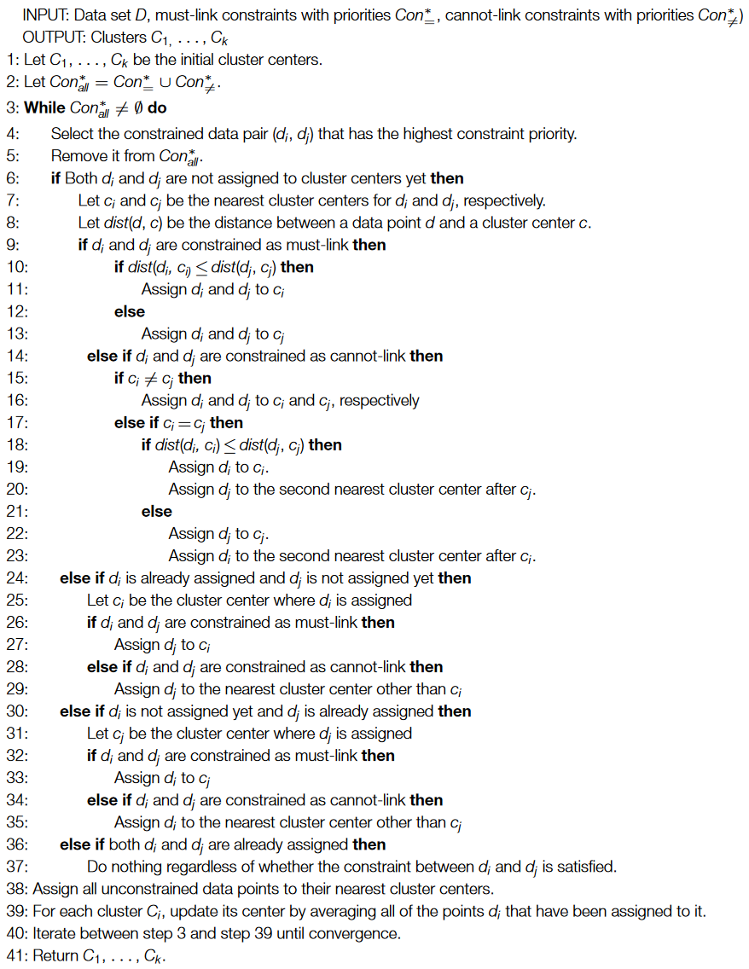

## **Algorithm 3 - BCKM**

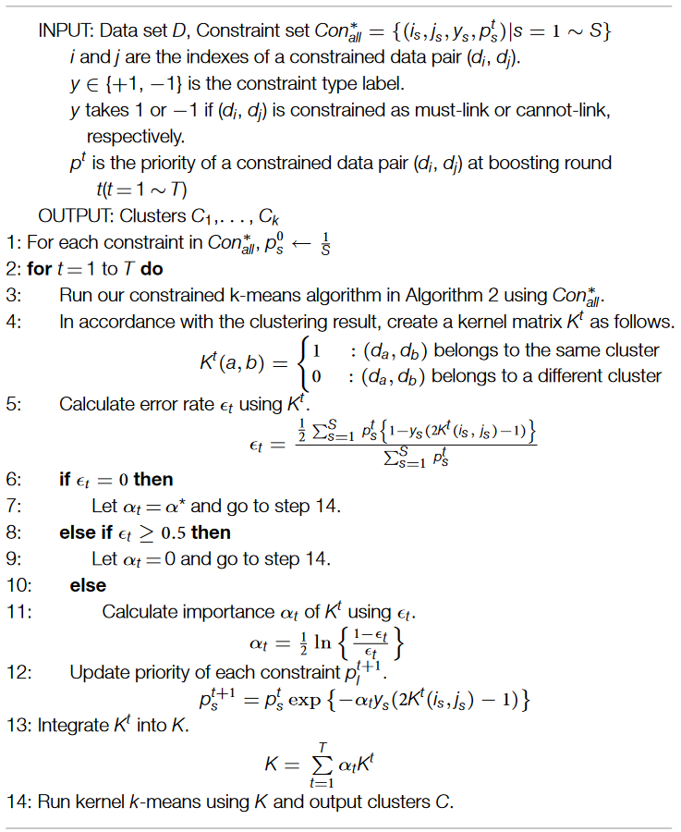

Implications:

COP-KMeans:

* Constraints are treated as hard and if any of them is not satisfied, the algorithm aborts.

BCOP-KMeans:

* Finds a solution even when some constraints are not satisfied.

Course constraints should be integrated into BCOP-KMeans.

What about the hard cons part of cop-kmeans?

LCC_BCOP-KMeans:



$BCOP-KMeans(A,CON_{all}^{*})$

$INPUT: agent set A,CON_{all}^{*}=\{(i_{s},j_{s},y_{s},p_{s}^{t})|s=1\sim S\})$

$i and j are the indexes of a constrained agent pair \left(a_{i},a_{j}\right) and S is the size of Con_{all}^{*}$

$y∈\left\{1,-1\right\} is the constrained type label. y takes 1 or-1 if \left(a_{i},a_{j}\right) is constrained as must-link or cannot-link , respectively.$

$p^{t} is the priority of a constrained agent pair \left(a_{i},a_{j}\right) at boosting round t (t=1\sim T)$

$OUTPUT:Kernel Matrix K$

$For each constraint in Con_{all}^{*}, p_{s}^{0}← \frac{1}{S}$

${tcn}_{min}=2,{tcn}_{max}=5. k_{min}=\left\lceil {\left|D\right|}/{{tcn}_{max}}\right\rceil , k_{max}=\left\lceil {\left|D\right|}/{{tcn}_{min}}\right\rceil$

$k=k_{min} and Clustering=∅$

$for t=1 to T do$

$while Clustering=∅ and k≤k_{max} do$

$C=OCOP-KMeans(k, A, Con_{all}^{*})$

$increment k by 1$

$If k>k_{max} then$

$fail, RETURN empty clusters C$

$Create a kernel matrix K^{t} from non-empty clusters C as follows:$

$$K^{t}\left(i,j\right)=\left\{\begin{aligned}1, :\left(a_{i},a_{j}\right) belongs to the same cluster \\ 0, &:\left(a_{i},a_{j}\right) belongs to a different cluster\end{aligned}\right.$$

$Calculate error rate ϵ_{t} using K^{t}$

$$ϵ_{t}=\frac{\frac{1}{2}\sum_{s=1}^{S}{p_{s}^{t}\{1-y_{s}(2K^{t}\left(i_{s},j_{s}\right)-1)\}}}{\sum_{s=1}^{S}{p_{s}^{t}}}$$

$if ϵ_{t}=0 then$

$Let α_{t}=α^{*} and go to step 20$

$else if ϵ_{t}≥0.5 then$

$Let α_{t}=0 and go to step 20$

$else$

$Calculate importance α_{t} of K^{t} using ϵ_{t}$

$$α_{t}=\frac{1}{2}ln⁡\{\frac{1-ϵ_{t}}{ϵ_{t}}\}$$

$Update priority of each constraint p_{l}^{t+1}$

$$p_{s}^{t+1}=p_{s}^{t}exp⁡\{-α_{t}y_{s}(2K^{t}\left(i_{s},j_{s}\right)-1)\}$$

$Integrate K^{t} into K$

$$K=\sum_{t=1}^{T}{α_{t}K^{t}}$$

$Output kernel matrix K and clusters C$

$BCOP-KMeans runtime complexity is O\left(T(\left(k_{max}-k_{min}\right)m+N^{2}-N)\right) where T is the rounds of$ $boosting process and m is the computation time of OCOP-KMeans algorithm.$

$k_{max}=\frac{N}{5}, k_{min}=\frac{N}{2}, k_{max}-k_{min}=\frac{3N}{10}$

$So the runtime is O(T(mN+N^{2}-N))$

Ordered Cop-Kmeans algorithm



$OCOP-KMeans(k, A, Con_{=}^{*}, Con_{≠}^{*})$

$INPUT: number of clusters k, agent set A,Con_{=}^{*}:must-link constraints with priorities, Con_{≠}^{*} :cannot-link constraints with priorities)$

$OUTPUT:Clusters C_{1}, . . C_{k}$

$Let C_{1}, . . , C_{k} be the initial cluster centers$

$Let Con_{all}^{*}=Con_{=}^{*}∪Con_{≠}^{*}$

$While Con_{all}^{*}≠∅ do$

$Select the constrained agent pair \left(a_{i},a_{j}\right) that has the highest priority.$

$Remove it from Con_{all}^{*}$

$If Both a_{i} and a_{j} are not assigned to cluster centers yet then$

$Let dist\left(a,C\right) be the distance between an agent and a cluster center.$

$If a_{i} and a_{j} are constraints as must-link then$

$Select c_{i} and c_{j} as the nearast cluster centers for a_{i} and a_{j} which don^{'}t violate$ $course constraints$

$If only 1 center \left(c_{i} or c_{j}\right) can be selected without violating course constraints then$

$Assign a_{i} and a_{j} to \left(c_{i} or c_{j}\right)$

$Else if no center can be selected without violating course constraints then$

$fail, RETURN ∅$

$if dist\left(a_{i},c_{i}\right)≤dist\left(a_{j},c_{j}\right) then$

$Assign a_{i} and a_{j} to c_{i}$

$else$

$Assign a_{i} and a_{j} to c_{j}$

$else if a_{i}and a_{j} are constrained as cannot-link then$

$Select c_{i} and c_{j} as the nearast cluster centers for a_{i} and a_{j} which don^{'}t violate$ $course constraints$

$If no center can be selected without violating couse constraints then$

$fail, RETURN ∅$

$if c_{i}≠c_{j} then$

$Assign a_{i} and a_{j} to c_{i} and c_{j}, respectively$

$else$

$if dist\left(a_{i},c_{i}\right)≤dist\left(a_{j},c_{j}\right) then$

$Assign a_{i} to c_{i}$

$Assign a_{j} to the next nearst cluster center after c_{j} which doesn^{'}t violate course$ $constraints$

$If no center exist which doesn^{'}t violate couse constraints then$

$fail, RETURN ∅$

$else$

$Assign a_{j} to c_{j}$

$Assign a_{i} to the next nearst cluster center after c_{i} which doesn^{'}t violate course$ $constraints$

$If no center exist which doesn^{'}t violate couse constraints then$

$fail, RETURN ∅$

$else if a_{i} is already assigned and a_{j} is not assigned yet then$

$Let c_{i} be the cluster center where a_{i} is assigned$

$if a_{i} and a_{j} are constrained as must-link then$

$if assigning a_{j} to c_{i} violates any course constraint then$

$fail, RETURN ∅$

$Assign a_{j} to c_{i}$

$else if a_{i} and a_{j} are constrained as cannot-link then$

$Assign a_{j} to the nearest cluster center other than c_{i} which doesn^{'}t violate course$ $constraints$

$if no such cluster exist then$

$fail, RETURN ∅$

$else if a_{i} is not assigned yet and a_{j} is already assigned then$

$Let c_{j} be the cluster center where a_{j} is assigned$

$if a_{i} and a_{j} are constrained as must-link then$

$if assigning a_{i} to c_{j} violates any course constraint then$

$fail, RETURN ∅$

$Assign a_{i} to c_{j}$

$else if a_{i} and a_{j} are constrained as cannot-link then$

$Assign a_{j} to the nearest cluster center other than c_{j} which doesn^{'}t violate course$ $constraints$

$if no such cluster exist then$

$fail, RETURN ∅$

$else if both a_{i} and a_{j} are already assigned then$

$Do nothing regardless of whether the constraint between a_{i} and a_{j} is satisfied$

$Assign all unconstrained data points to their nearest cluster centers without violating any course constraint$

$For each cluster C_{i}, update its center by averaging all of the points a_{i} that have been assigned to it$

$Iterate between step 3 and step 58 until convergence$

$Return C_{1}, . . . , C_{k}$

$OCOP-KMeans runtime complexity is O\left((5pS+p\right)τ) where p is runtime for a single calculation,$ $S is the number of constrained pairs and τ is the number of iterations till convergence.$

$S=\frac{N^{2}-N}{2}, therefore runtime is O(N^{2}τ)$

$Kernel-KMeans\left(kernel matrix K, cluster number k\right)$ (Likas & Tzortzis, 2008)

$INPUT:Kernel matrix K, Number of clusters k, Initial clusters C_{1}, . . C_{k}$

$OUTPUT:Final clusters C_{1},….C_{k}$

$For each point a_{n} and every cluster C_{i} compute {\left|\left|φ\left(a_{n}\right)-C_{i}\right|\right|}^{2} using \left(1\right)$

$Find c^{*}\left(a_{n}\right)=argmin_{i}({\left|\left|φ\left(a_{n}\right)-C_{i}\right|\right|}^{2})$

$Update clusters as C_{i}=\{a_{n}|c^{*}\left(a_{n}\right)=i\}$

$If not converged go to step 1 otherwise stop and return final clusters C_{1}, . . .,C_{k}$

$Kernel-KMeans runtime complexity is O\left(N^{2}τ\right) where N is the number ofdatapoints \left(agents\right)$ $and τ is the number of iterations till convergence.$ (Likas & Tzortzis, 2008)

$In total, the runtime complexity for BCOP-KMeans O\left(T\left(k_{max}-k_{min}\right)m\right)= O\left(T\left(k_{max}-k_{min}\right)(5pS+p)τ\right)$

$k_{max}=\frac{N}{2}, k_{min}=\frac{N}{5}→k_{max}-k_{min}=\frac{3N}{10}$

$In the worst case, S=\frac{N*\left(N-1\right)}{2} for N agents such that there is a constraint between each pair$ $of agents$

$$So O\left(T\left(k_{max}-k_{min}\right)(5pS+p)τ\right)=O\left(T*\frac{3N}{10}*\frac{N^{2}-N}{2}*τ\right)=O(TτN^{2}\left(N-1\right))$$

$Since kernel-Kmeans should be executed after BCOP-KMeans, we aggregate the runtime$ $complexities. O\left(TτN^{2}\left(N-1\right)+N^{2}τ\right)$

$BCOP-KMeans runtime= O\left(T\left(mN+N^{2}-N\right)\right)$

$OCOP-KMeans runtime=O(N^{2}τ)$

$Kernel-KMeans runtime=O\left(N^{2}τ\right)$

$So the overall runtime is O\left(T\left(\left(N^{2}τ\right)N+N^{2}-N\right) +N^{2}τ\right)=O\left(TN^{3}τ+TN^{2}-TN+N^{2}τ\right)$ $where N is the number of agents, τ is the iterations till convergence and T is the rounds of boosting.$

SCOP-KMeans algorithm by Kiri Wagstaff (Wagstaff K. L., 2002)

**SCOP-KMEANS** (number of clusters $k$, agent set $A$, preferences $Pref<a,b,s>$ where $(a,b)⊆AxA$ and $s∈[-1,1]$)

1. Let ${tcn}_{min}$ and ${tcn}_{max}$ be the minimum and maximum number for the cardinality of each cluster as specified in the informal description.
$${tcn}_{min}=2,{tcn}_{max}=5$$

2. Let $k_{min}$ and $k_{max}$ be the lower and higher bound of **k** interval:
$$\begin{aligned}k_{min}=⌈{|A|}/{{tcn}_{max}}⌉ \\ k_{max}=⌈{|A|}/{{tcn}_{min}}⌉ \\ k=k_{min}\end{aligned}$$

3. Let $C_{1},...C_{k}$ be the initial cluster centers.
4. For each agent $a_{i}$ in $A$, assign it to the closest and lowest in terms of preference constraints violation ( $PrefConstViol(a_{i},C_{a_{i}.cluster},Pref))$ such that no course constraint is violated ($CourseConstViol\left(a_{i},C_{a_{i}.cluster}\right)=0$). If **no** such cluster **exist**, increment $k$ by one and check whether $k$ is not greater than $k_{max}$. If so, then **break** iteration and go to step 3. If it is greater, then **fail** (return {}).

***Objective Function****:*

$$minimize\sum_{i=1}^{|A|}{ \frac{dist\left(a_{i},C_{a_{i}.cluster}\right)}{r}+ PrefConstVi{ol}_{ }(a_{i},C_{a_{i}.cluster},Pref)}$$

$$subject to \sum_{i=1}^{|A|}{CourseConstViol(a_{i},C_{a_{i}.cluster})}=0$$

$${where C}_{a_{i}.cluster }∈\left\{C_{1}, . . . C_{k}\right\}, r=100 and it is used to equalize the scales$$

The function $dist\left(a,C\right)$ ranges from0 (same course progress level) to 100 (maximum course progress level). $dist(a,C)∈[0,100]$

The function $PrefConstVi{ol}_{ }(a,C,Pref)$ ranges from 0 (no individual preference violated) to 1 (all individual preferences with strength 1.0 violated). $PrefConstViol(a,C,Pref)∈[0,1]$

The function $CourseConstViol(a,C)$ ranges from 0 (no course constraint violated) to 2 (both course constraints violated). $CourseConstViol(a,C)∈[0,2]$

1. Update each cluster center $C_{j}$ by **averaging** all of the points $a_{i}∈ C_{j}$ that have been assigned to it.
2. Iterate between **step 4** and **step 5** until convergence.
3. Return the partition $C_{1},...C_{k}$.

$PrefConstViol(agent a, cluster C, preferences Pref)$

1. Let $CV_{max}:=0, nConst≔0, nViol≔0$.
2. For each connection $<a,a^{'},s> ∈Pref$:

**If $\left|s\right|>CV_{max},$**

**If $s>0$** and $a'∉C$, then $CV_{max }≔\left|s\right|$ and $nConst≔nViol≔1$.

**Else** **if $s<0$** and $a'∈C$, then $CV_{max}≔|s|$ and $nConst≔nViol≔1$.

**Else** **if $\left|s\right|:=CV_{max}$** ,

Increment $CV_{max}$ by 1.

**If $s>0$** and $a^{'}∉C$, then increment $nViol$ by 1.

**Else** **if $s<0$** and $a'∈C$, then increment $nViol$ by 1.

1. Return $CV_{max}*\frac{nViol}{nConst}$

$CourseConstViol(agent a, cluster C)$

1. Let $nViol≔0$
2. Check cardinality constraint:

**If $\left|C\right|>5$** , then increment $nViol$ by 1.

1. In order to consider *missing previous lesson* constraint, let $M_{i}$ be a function which maps an agent to a value which represents whether he/she participated in the previous lesson:

**If** agent $a$ missed the previous lesson and $\sum_{i=1}^{|C|}{M_{i}}>0$, then increment $nViol$ by 1.

$M_{i}=\left\{\begin{aligned}1, &if agent i missed the previous lesson \\ 0, &otherwise\end{aligned}\right.$

1. Return $nViol$

$dist(agent a, cluster C)$

1. Let function $CPL$ be a function that maps an agent into its Course Progress Level.
2. Return $|CPL\left(a\right)-Ct(C)|$ where $Ct(C)$ is the cluster center of cluster C.

The $PrefConstViol$ function examines each constraint that applies to agent $a$. $CV_{max}$ is the maximum (absolute) strength of $a's$ violated constraints. $nConst$ counts the number of constraints at strength $CV_{max}$ and $nViol$ tracks how many of those are violated. The function then returns $CV_{max}$ times the fraction of maximum strength constraints that are violated. Constraints at a lower strength may or may not also be violated, but the maximum strength violations take precedence. The function ranges from 0 (no individual preference violated) to 1 (all individual preferences with strength 1.0 violated).

The $CourseConstViol$ function calculates the number of course constraints that would be violated if agent $a$ was assigned to cluster $C$. $nViol$ counts the number of violations. It is incremented by 1 each time a course constraint is violated. The function then returns the $nViol$. The function ranges from 0 (no course constraint violated) to 2 (both course constraints violated).

The $dist$ function given an agent and a cluster, calculates the distance between cluster center and agent course progress level. It ranges from0 (same course progress level) to 100 (maximum course progress level).

*Objective function:*

The minimization part of the objective function consists of similarity constraint (dist) and individual preferences (penalty for violation). The *Similarity* is described as a course constraint in the informal description of LCC scenario. Unlike other course constraints (e.g cardinality), it is not treated as a hard constraint. However, the objective function is designed in a way that the similarity constraint and individual preferences affect the result equally. To do so, distance value is divided by 100 to bring it to the same scale as the individual preferences violation penalty value.

**SCOP-KMeans** Runtime:

$$The runtime of COP-KMeans is O\left(Nkτ+τN^{3}\right). SCOP-KMeans algorithm is basically same as \\ COP-KMeans except it considers soft and hard constraints separately. However, both algorithms \\ do same amount of calculations for constraints. Therefore, SCOP-KMeans has the same runtime \\ complexity and it is O\left(Nkτ+τN^{3}\right)$$

Let $IPE(a)$ (Individual Preferences Evaluation) be a function that generates a set $IC (Individual Constraints)$ which consists of $<a,a^{'},s>$ relationships with an additional *strength* factor, $s$, that indicates how reliable the constraint is. The relationships that agent $a$ generates are in between agent $a$ and all other agents. Higher strength values indicate a stronger constraint. A constraint relationship $<a,a^{'},1>$ 
 corresponds to a must-link, $<a,a^{'},-1>$ corresponds to a cannot-link constraint. A constraint $<a,a^{'},0>$ 
 corresponds to “don’t care”.

$IPE\left(a\right)=IC=\bigcup_{i=1, a≠a_{i}}^{|A|}{\left(a,a_{i},s\right)}$ where $s∈[-1,1]$.

Each agent independently evaluates the relationship between itself and all other agents to decide the strength of the constraint based on its individual preferences.

For example, agent $a_{1}$ is free to generate $<a_{1}, a_{4}, 0.8>$ if it highly wants to be clustered with $a_{4}$. As well as, it can generate $<a_{1},a_{6},-0.7>$ if it highly prefers to be in a different cluster than the cluster of $a_{6}$.

Once all agents submit their individual constraints, there can be at most 2 relationship constraints which include same agents, one from each agent perspective. For example, $<a_{1},a_{2},0>$ (example.1) would be generated by $a_{1}$ and $<a_{2},a_{1},0.8>$ (example.2) would be generated by $a_{2}$ based on their individual preferences. Therefore, dedicated agent needs to combine double relationships such that there are only unique relationship constraints in terms of the constrained agents. To do so, dedicated agent can take the lower (0) or higher (0.8) value out of the two relationships in example.1 and example.2. However, to make the preferences of both agents $\left(a_{1}and a_{2}\right)$ are considered equally (fairly) in the final (unique) constraint relationship, dedicated agent calculates the average of two strength values. For *example.1* and *example.2*, $\frac{0+0.8}{2}=0.4$. Consequently, dedicated agent generates $<a_{1},a_{2},0.4>$ and removes other relationships which contain $a_{1}and a_{2}$.

As a result of refinement/recalculation process of constraint relationships, dedicated agent would have a set $Pref$ which consists of unique $<a_{i}, a_{j}, s>$.

Decentralized Clustering in Multi Agent Systems

Techniques from two papers:

1. A Method for Decentralized Clustering in Large Multi-Agent Systems (Ogston, Steen, Brazier, & Overeinder, 2003)
2. A Multi-Agent-Based algorithm for data clustering (Adamatti & Emmendorfer, 2020)

The first technique “…*agents are each given a two-dimensional point and seek to group themselves based on the* ***Euclidean distance*** *between their* ***points****. Initially agents are randomly assigned a small number (5) of neighbor agents. These neighbors are an agent’s only view of the system as a whole. Based on these local views, agents form clusters with the closest points they come across. Agents within a cluster coordinate, combining their local views to allow each member to search a broader range of neighbors for better matches. Clusters are limited in size by a user-defined parameter. Once clusters have grown to this size they spilt when better matches are found by their members, allowing stronger new clusters to form.*”. Preferences and personal information are not simple numbers or points which can be used by agents to calculate the **Euclidean distance.**

The second technique “…*Each agent* ***a*** *senses its own environment, within a limited vision scope of radius* ***α*** *around its own current coordinates. This resulting circumference is then divided into* ***s*** *sectors equally distributed. At each step, the agent evaluates all s sectors around it, searching for the sector with the* ***highest number******of agents****. Then the agent changes its cluster label, assuming the most frequent label in the agents inside the chosen sector, and finally moves towards the direction given by that sector. The movement step is set to the smallest distance among all original data points in D.*” The technique is based on the amount of agents (density). Personal information and preferences cannot be illustrated in this technique.

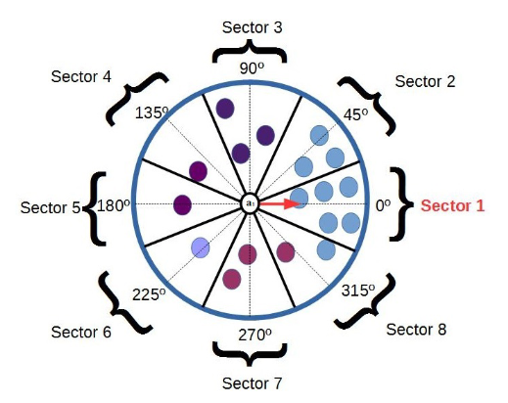

**Fig**. Illustration of an agent vision radius.

LCC_AVC algorithm

1. Each agent shares its personal info with Dedicated agent
2. Dedicated agent collects and broadcasts the complete personal info
3. Each agent constructs the info that there are n clusters for n agents and a_i is in C_i.
4. For each agent:
   1. It evaluates other clusters and selects the one it prefers most
   2. It informs other agents about its selection and other agents update their knowledge about the cluster membership

Each agent already has the complete personal info of others.

t=0

Repeat

t+=1

For each a in A:

Agent a evaluates the clusters and selects the one it prefers most for iteration t-1 (meaning that agent a must have info from all agents for the previous iteration)

Agent a broadcasts the cluster name for iteration t (or agent sends to a dedicated agent to prevent the broadcasting)

All agents update the cluster membership knowledge once they receive the complete info for iteration t (or dedicated agent collects the info for iteration t from all agents, updates the cluster membership and broadcasts)

Until no more changes in the cluster membership

Distributed clustering:

The idea is to prevent having a central dedicated agent as far as I know.

In AVC, each agent evaluates the sectors to select the most populated one at each step until there is no modification.

In LCC, each agent evaluates the existing clusters to select the most suitable one at each step until convergence.

ACS time complexity

$O(n^{2}×\frac{e^{π\sqrt{\frac{2n}{3}} }}{n})$

ACS solution quality

$solution quality=\frac{v\left(CS^{+}\right)*100}{v(CS^{*})}\%$

$CS^{+}:best coalition structure found by the algorithm$

$CS^{*}:optimal coalition structure found by ODP-IP$

Gain rate for ACS

$gain rate=\frac{\frac{v\left(CS\right)}{v(CS_{s})}}{max⁡(\frac{v(CS_{ACS}^{+})}{v(CS_{s})},\frac{v(CS_{CSG-UCT}^{+})}{v(CS_{s})})}$

$v\left(CS_{s}\right):the value of the CS that contains the singleton coalitions$

Gain rate indicates the extent to which an algorithm has improved the solution compared to that of the singleton coalitions.

ADC (Qiao & Brown, 2019)

ACS (Unknown, 2021)

**References**

Adamatti, D., & Emmendorfer, L. (2020). A Multi-Agent-Based algorithm for data clustering. *Progress in Artificial Intelligence*.

Likas, A., & Tzortzis, G. (2008). The Global Kernel k-Means Clustering Algorithm. *IEEE International Joint Conference on Neural Networks (IEEE World Congress on Computational Intelligence).* Hong Kong.

Ogston, E., Steen, M. v., Brazier, F., & Overeinder, B. (2003). A Method for Decentralized Clustering in Large Multi-Agent Systems. *Proceedings of the second international joint conference on Autonomous agents and multiagent systems*.

Okabe, M., & Yamada, S. (2018). Clustering Using Boosted Constrained k-Means Algorithm. *Frontiers in Robotics and AI*.

Qiao, C., & Brown, K. (2019). Asynchronous Distributed Clustering Algorithm for Wireless Sensor Networks. *the 2019 4th International Conference*.

Unknown, U. (2021). Code-based Algorithm for Coalition Structure Generation. *Unknown*.

Wagstaff, K. L. (2002). Intelligent Clustering with Instance-Level Constraints. *PhD thesis,Department of Computer Science, Cornell University*.

Wagstaff, K., Claire, C., Seth, R., & Stefan, S. (2001). Constrained K-means Clustering with Background Knowledge. *Proceedings of the Eighteenth International Conference on Machine Learning*, 577-584.