Contoh 1 :
sys=tf([1 2], [1 4 3]);
>> step(sys)
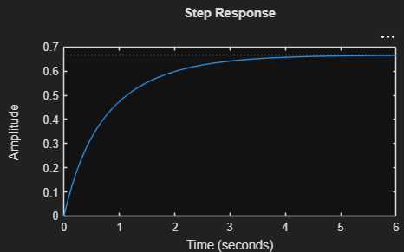
[y,t] = step(sys);
>> plot(t,y)
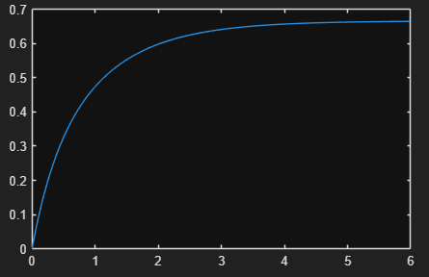
Step(sys, 8)
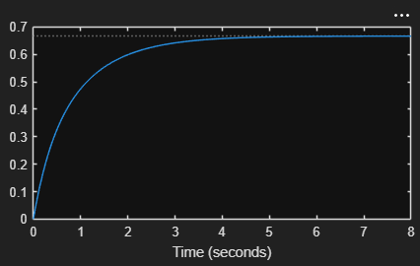
Step(sys, 8)
[y,t] = step(sys,8);
Plot (t,y)
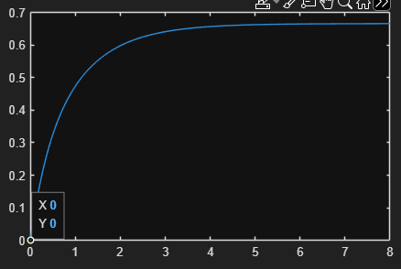

Contoh 2:
sys=tf(4, [1 2 10]);
>> t = 0:0.05:5;
>> step(sys,t)
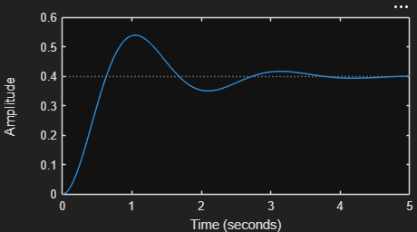

Contoh 3:
sys = zpk(-1,[-0.2 + 3j, -0.2 - 3j], 1) * tf([1 1],[1 0.05])
sys =
(s+1)^2
----------------------------
(s+0.05) (s^2 + 0.4s + 9.04)
Continuous-time zero/pole/gain model.
Model Properties
>> step(sys)
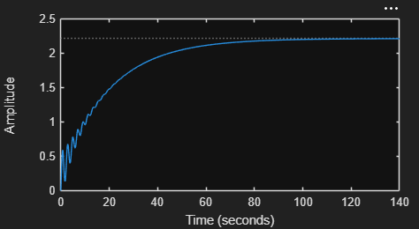

Contoh 4:
>> sys = zpk(-1,[-0.2 + 3j, -0.2 - 3j], 1) * tf([1 1],[1 0.05])
sys =
(s+1)^2
----------------------------
(s+0.05) (s^2 + 0.4s + 9.04)
Continuous-time zero/pole/gain model.
Model Properties

step(sys, 15)
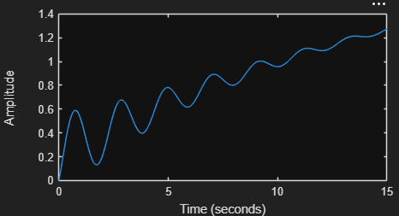
Contoh 5:
sys = zpk(-1,[-0.2 + 3j, -0.2 - 3j], 1) * tf([1 1],[1 0.05])
sys =
(s+1)^2
----------------------------
(s+0.05) (s^2 + 0.4s + 9.04)
Continuous-time zero/pole/gain model.
Model Properties
>> t = 20:0.2:120;
>> step(sys, t)
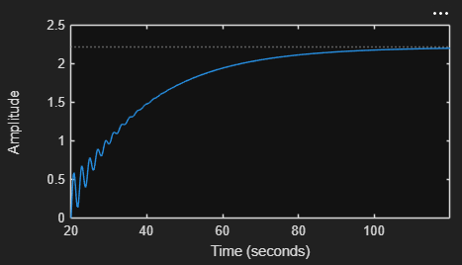

Contoh 7:
A = [-0.5572 -0.7814 ; 0.7814 0];
B = [1 -1 ; 0 2];
C = [1.9691 6.4493];
>> sys = ss(A, B, C, 0)
sys =
A =
x1 x2
x1 -0.5572 -0.7814
x2 0.7814 0
B =
u1 u2
x1 1 -1
x2 0 2
C =
x1 x2
y1 1.969 6.449
D =
u1 u2
y1 0 0
Continuous-time state-space model.
Model Properties
>> tf(sys)
ans =
From input 1 to output:
1.969 s + 5.039
-----------------------
s^2 + 0.5572 s + 0.6106
From input 2 to output:
10.93 s - 0.9297
-----------------------
s^2 + 0.5572 s + 0.6106
Continuous-time transfer function.
Model Properties

>> step(sys)
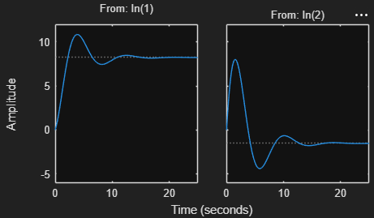
Contoh 8 :
>> A = [-1 -1 ; 6.5 0];
>> B = [1 1 ; 1 0];
>> C = [1 0 ; 0 1];
>> D = [0 0 ; 0 0];
>> step(A, B, C, D)
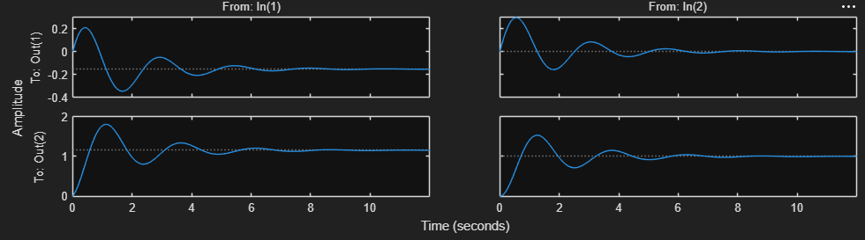

Contoh 8.1:
A = [-1 -1; 6.5 0]; B = [1 1;1 0]; C = [1 0; 0 1]; D=[0 0; 0 0];
step(A,B,C,D,1)
figure;
step(A,B,C,D,2)
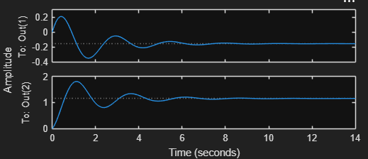
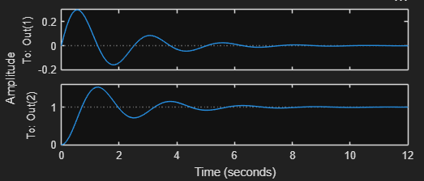

Contoh 9:
>> A = [1.6 -0.7; 1 0];
B = [0.5; 0];
C = [0.1 0.1];
D = 0;
sys = ss(A,B,C,D,0.2);
% 0.2 is the sampling
step(sys)
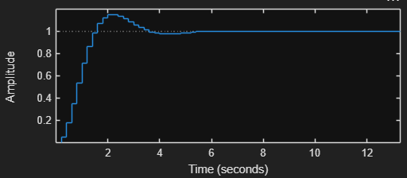

Contoh 10:
sys = tf([1 5 5],[1 1.65 5 6.5 2])
sys =
s^2 + 5 s + 5
----------------------------------
s^4 + 1.65 s^3 + 5 s^2 + 6.5 s + 2
Continuous-time transfer function.
Model Properties
>> step(sys)
>> S = stepinfo(sys)
S =
struct with fields:
RiseTime: 3.8456
TransientTime: 27.9762
SettlingTime: 27.9762
SettlingMin: 2.0689
SettlingMax: 2.6873
Overshoot: 7.4915
Undershoot: 0
Peak: 2.6873
PeakTime: 8.0530
