Laboratory work 10
- Create a stored procedure to insert a new flight into the flights table.
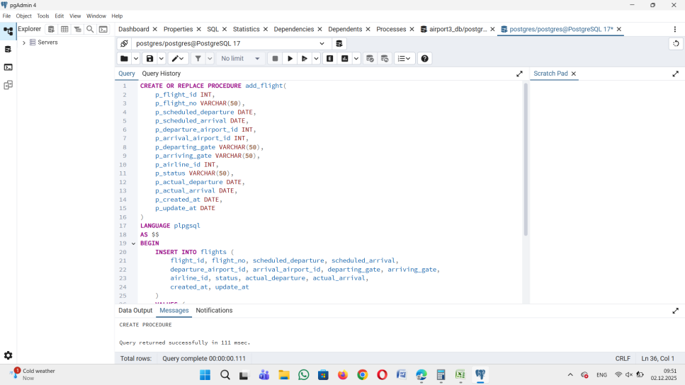
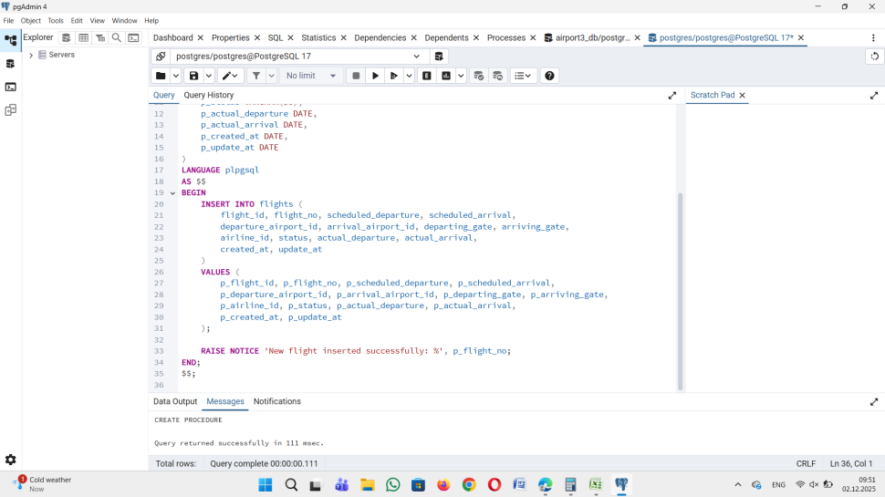
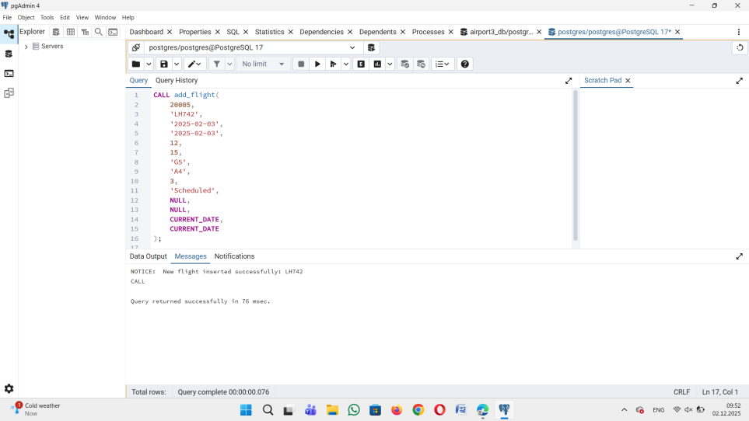

- Create a stored procedure to update the status of a flight.
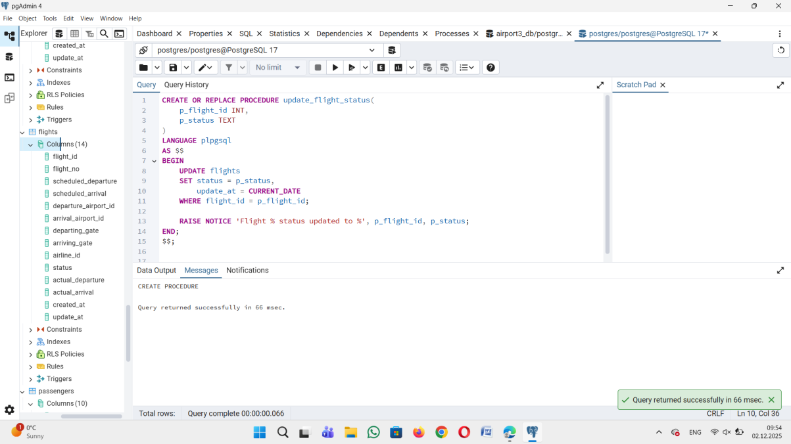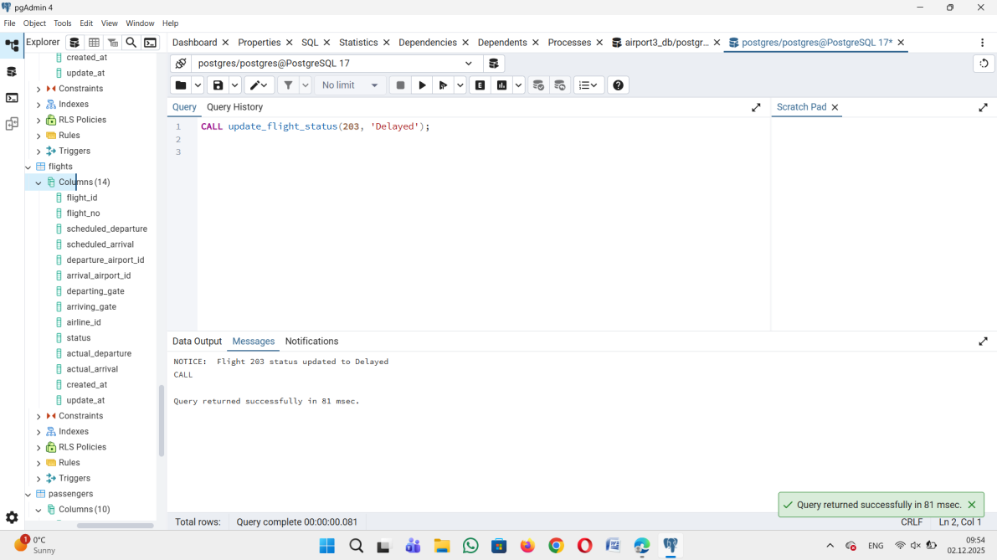
3.Create a stored procedure that returns a list of flights departing from a specific airport.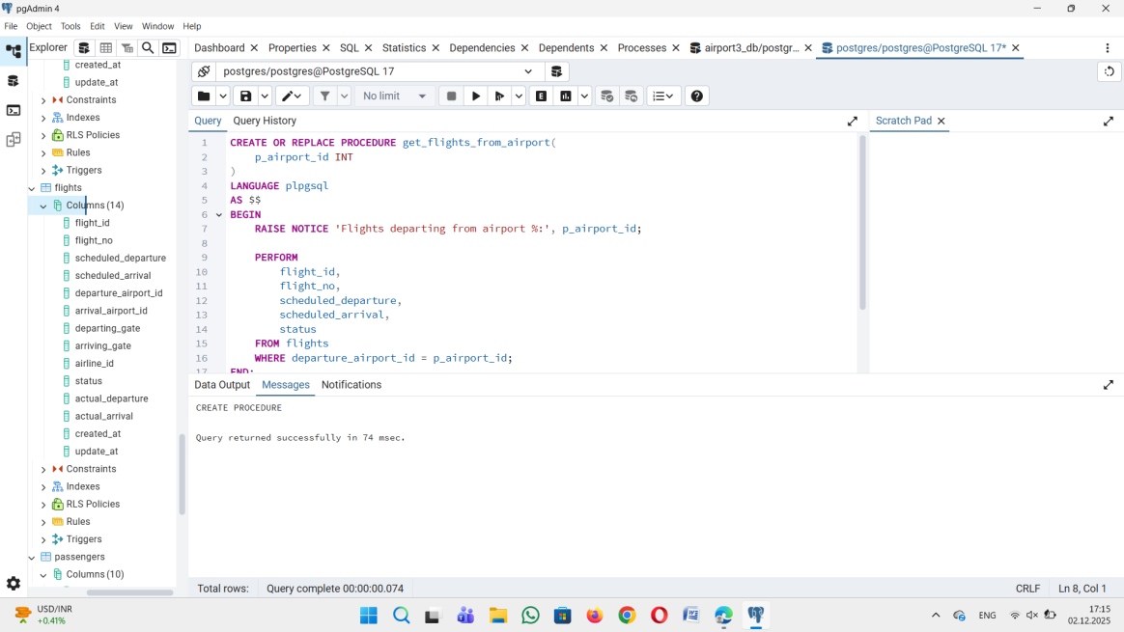
4. Create a function to calculate the average delay time of flights arriving at a specific airport.
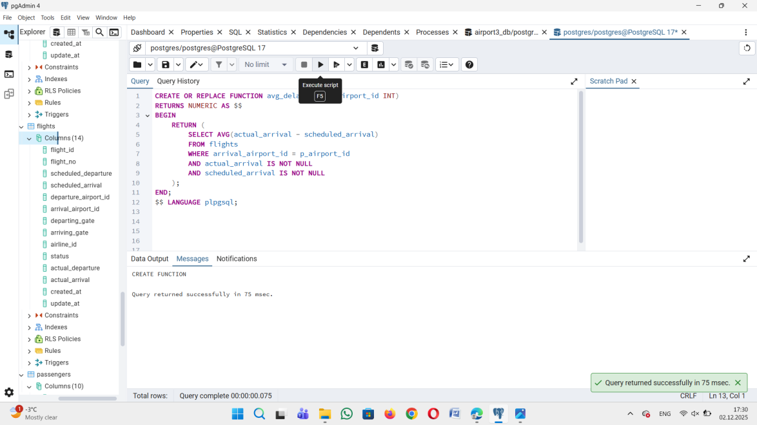
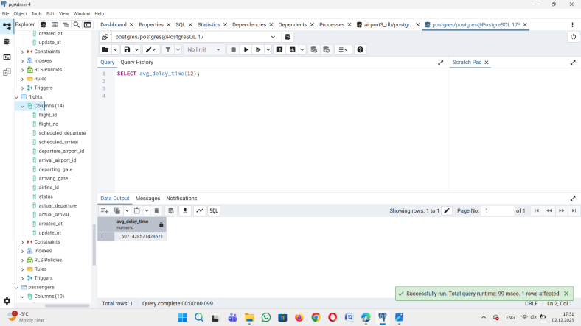
5. Create a stored procedure that lists all passengers for a given flight number.
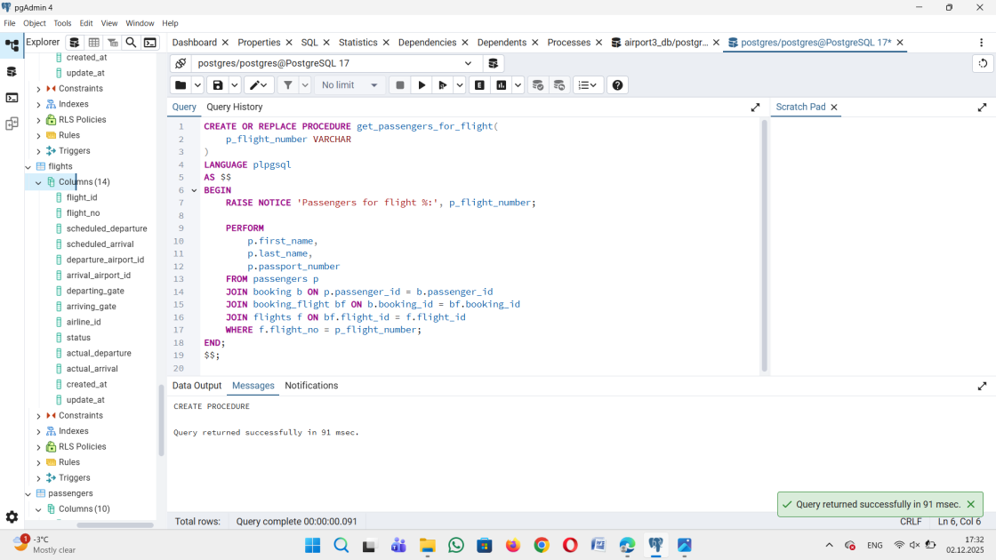
6. Create a stored procedure to find the passenger who has taken the greatest number of flights.
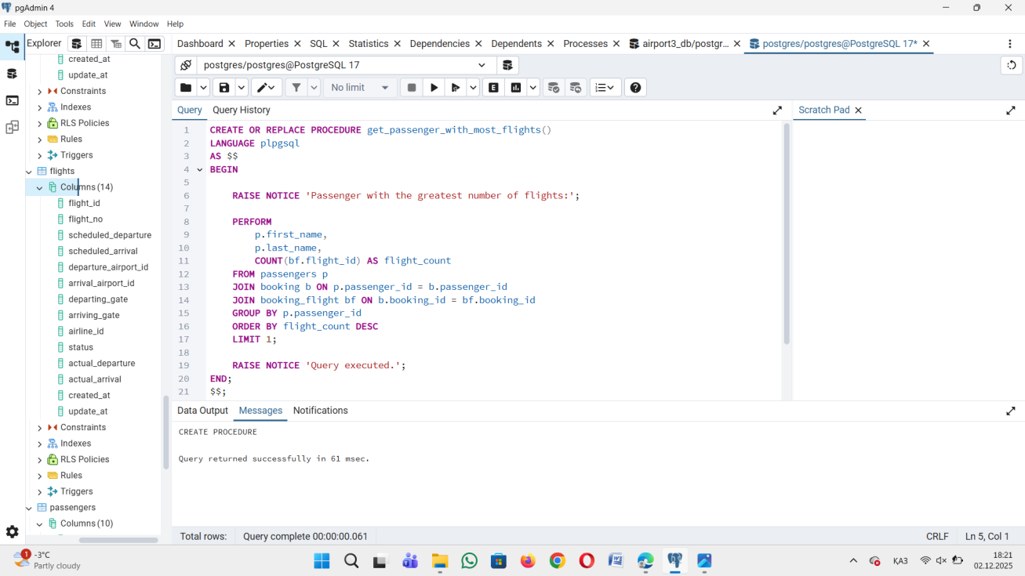
7. Create a stored procedure to find all flights that are delayed by more than 24 hours.
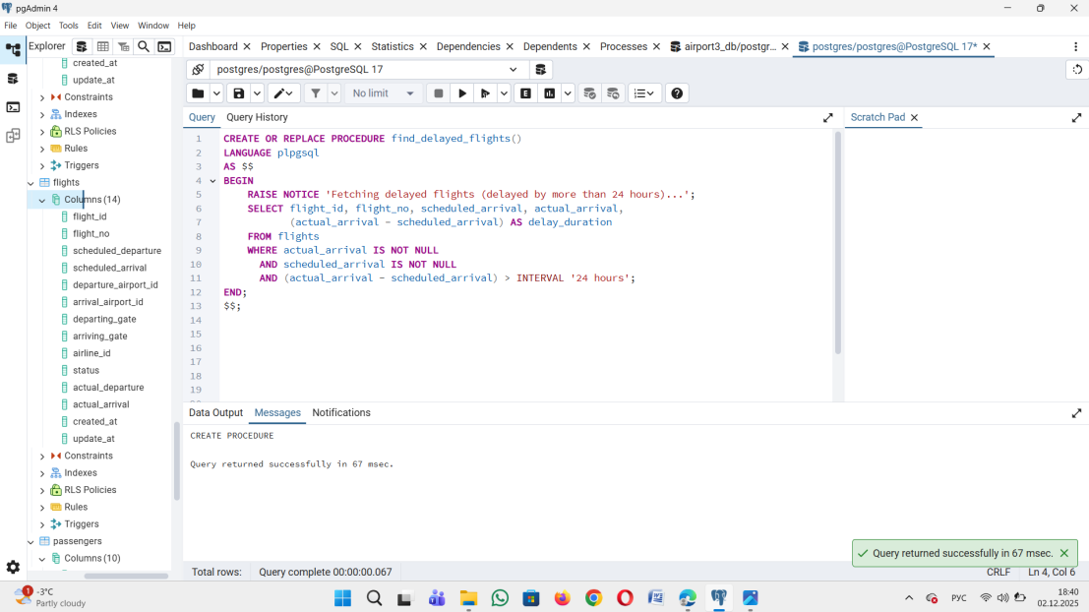
8. Create a function that counts the number of flights for each airline.
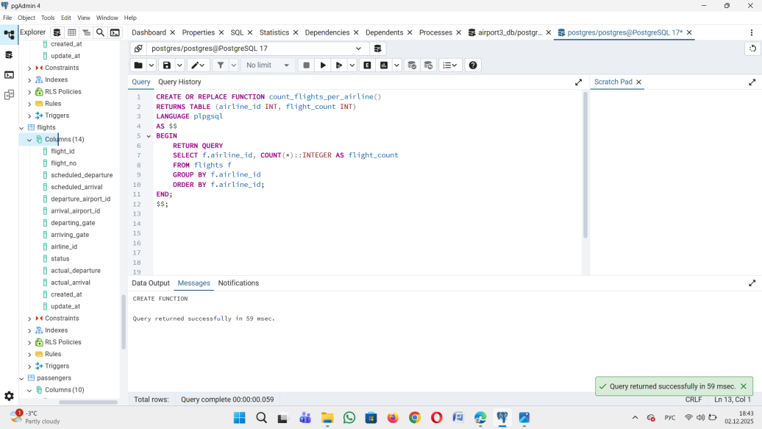
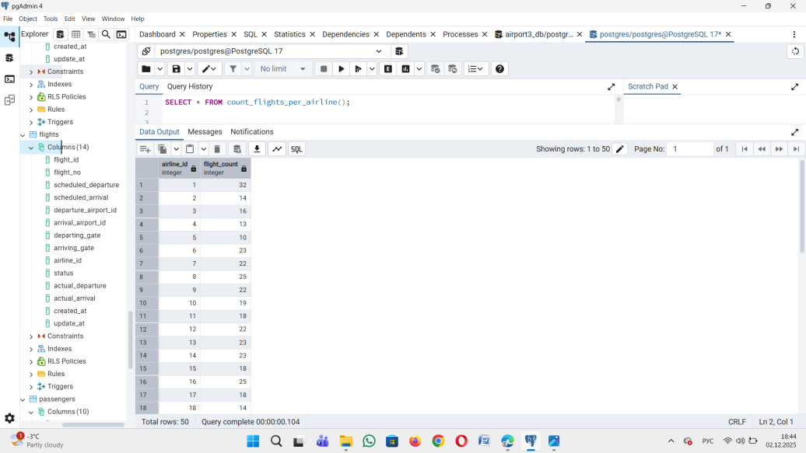

9. Create a stored procedure to calculate the average ticket price for a specific flight.
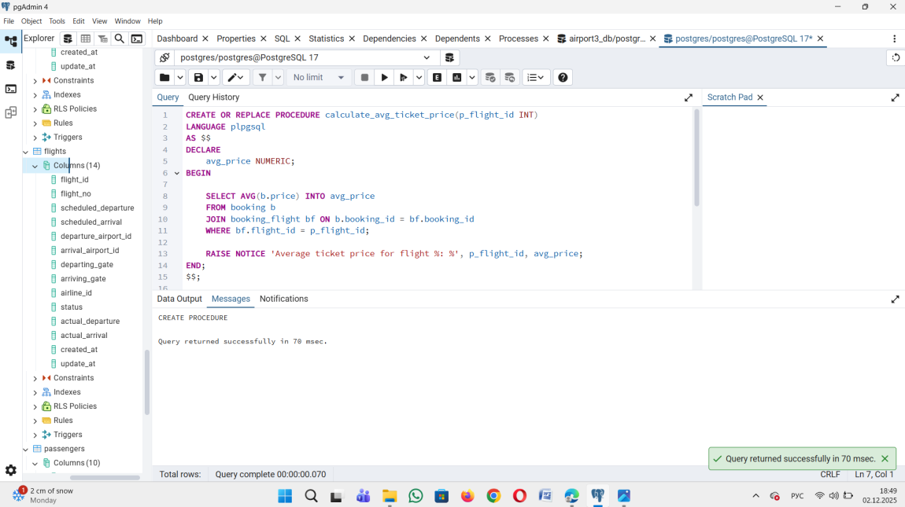
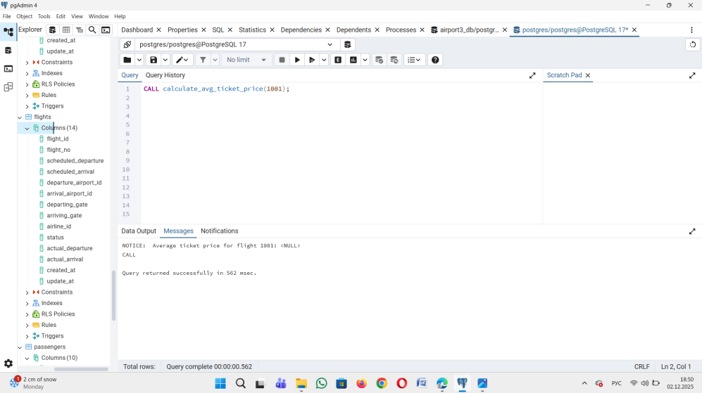
10. Create a stored procedure to find the flight with the highest ticket price. The procedure should return the flight number, the departure and arrival airports, and the ticket price for the most expensive flight
