Laboratory work 3
- Select all the data of passengers whose last name is same as first name.
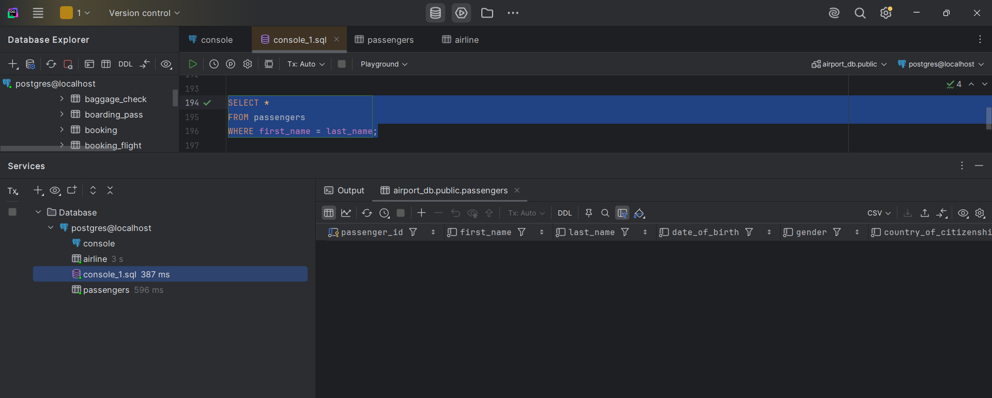
- Select the last name of all passangers without duplicates.
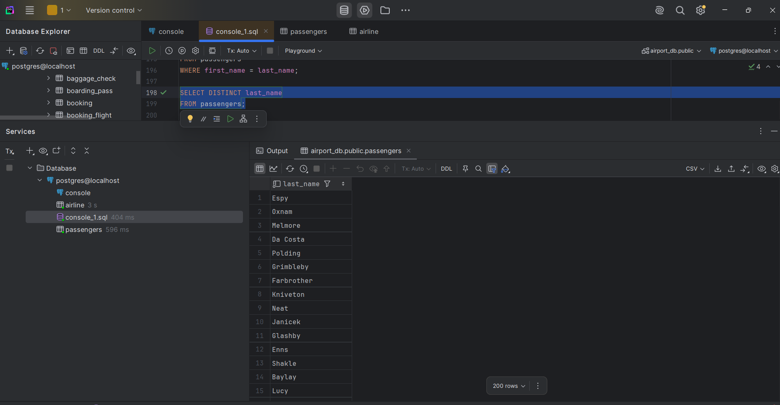
- Find all male passengers born between 1990 and 2000.
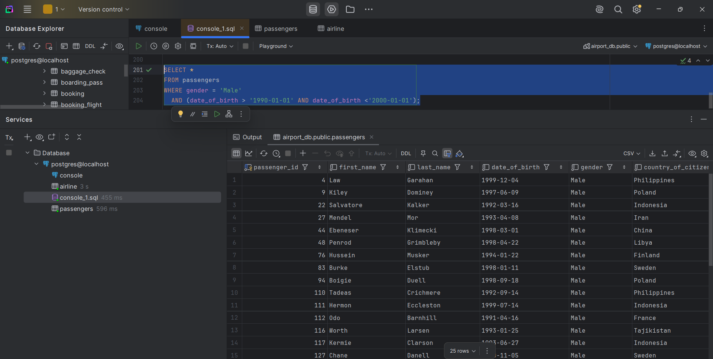

- Find price of tickets sold for each month in sorted way.
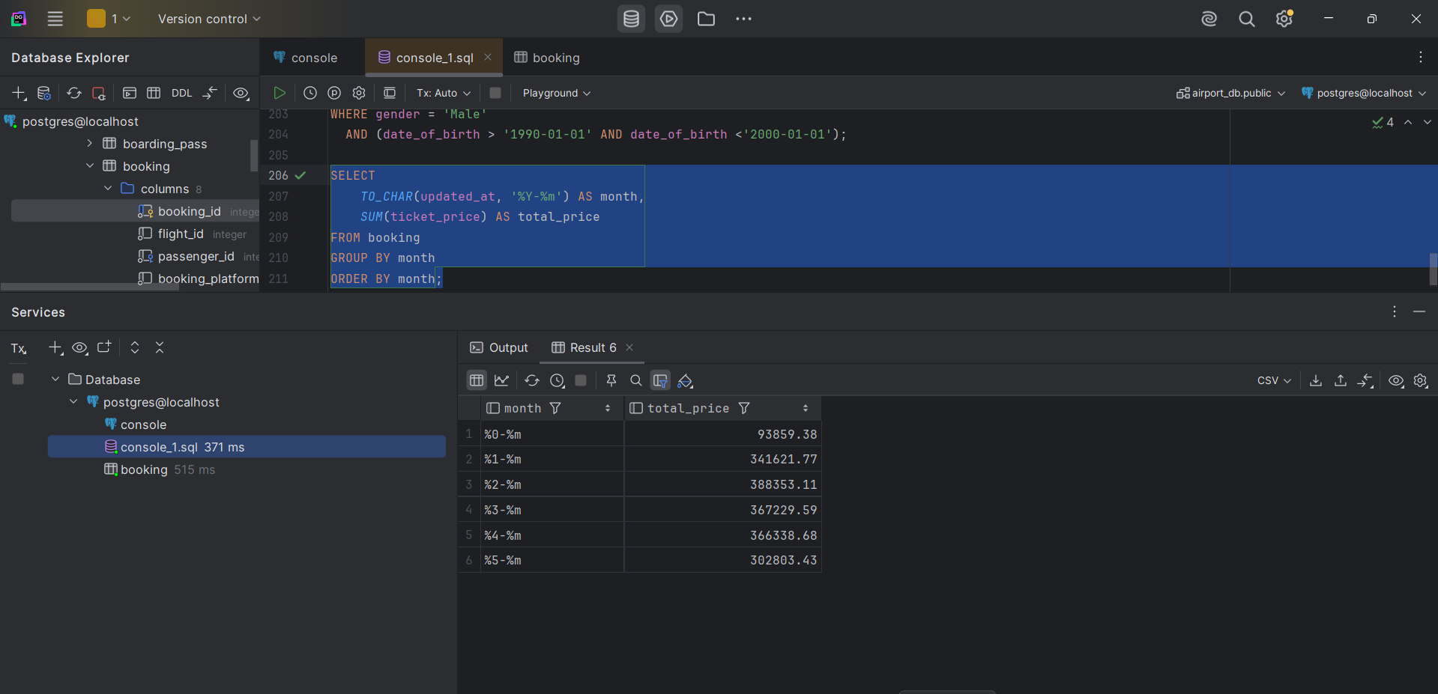
- Create a query that shows all flights flying to ‘China’.
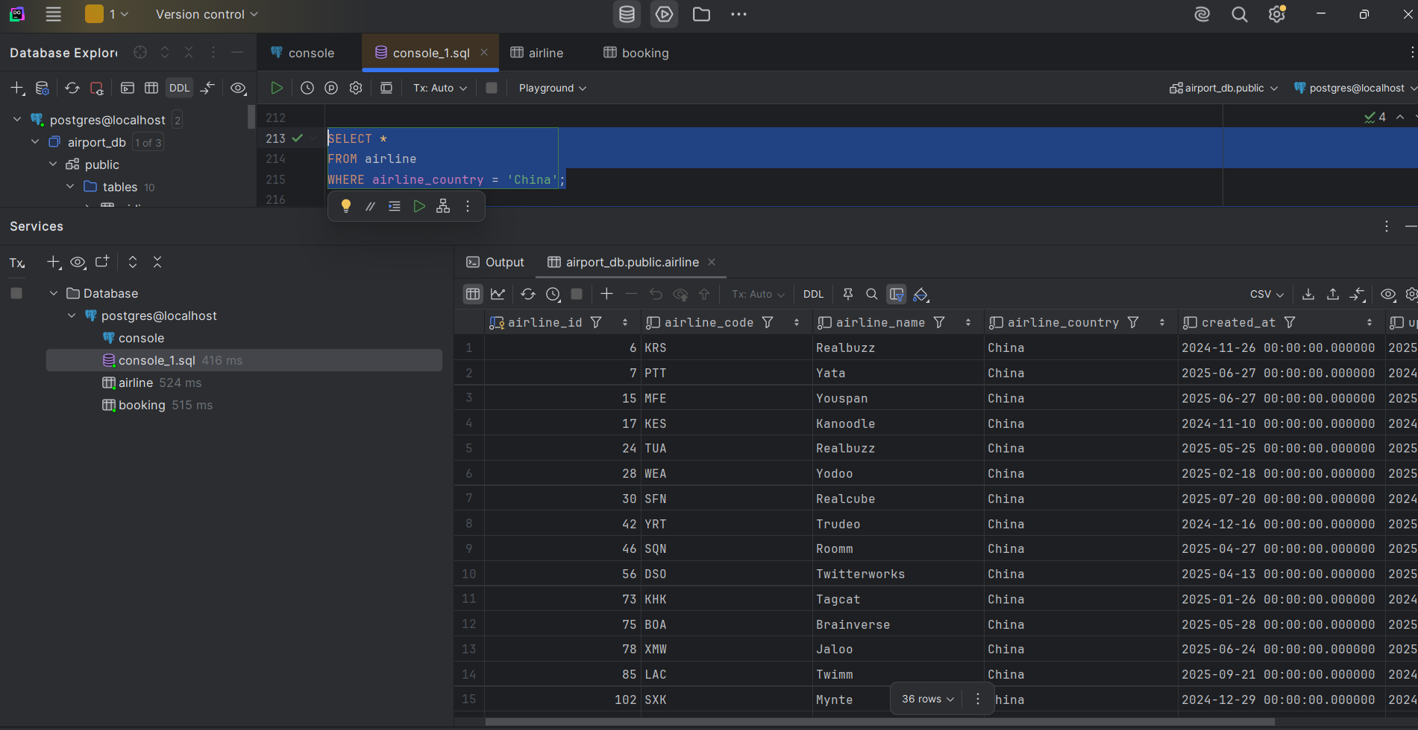
- Show airlines from any of: ('France','Portugal','Poland') created between '2023-11-01' and '2024-03-31'.
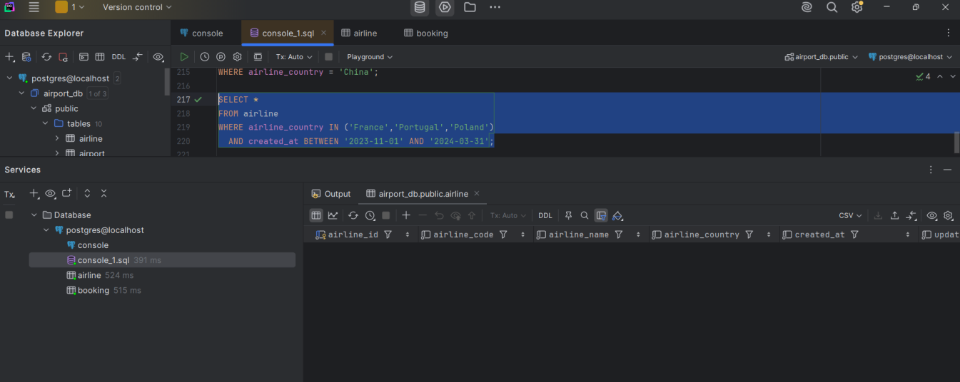

- Find all airline names based in Kazakhstan.
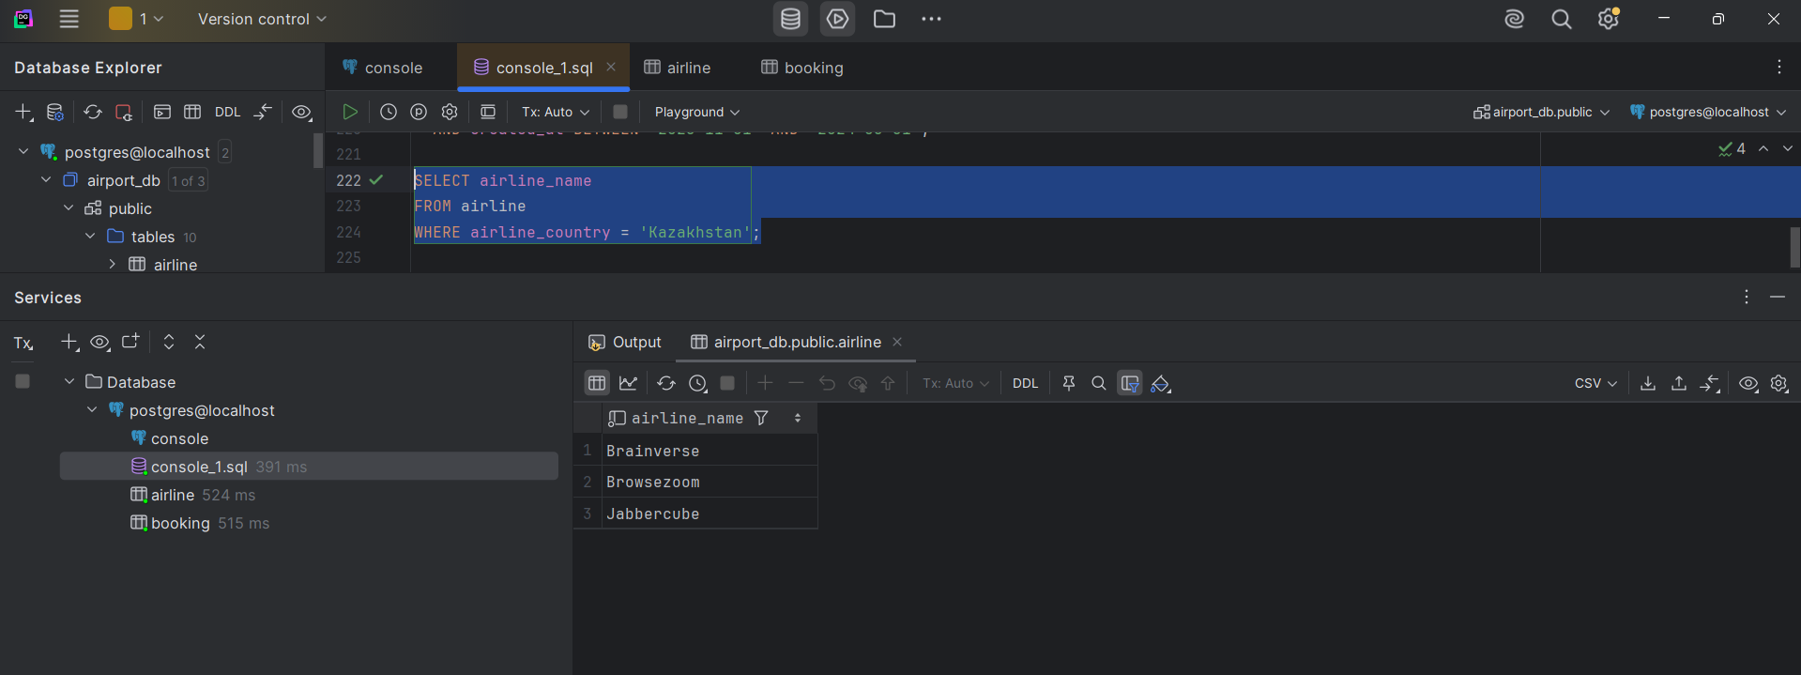
- Reduce the cost of booking price by 10% created before ’11-01-2023’.
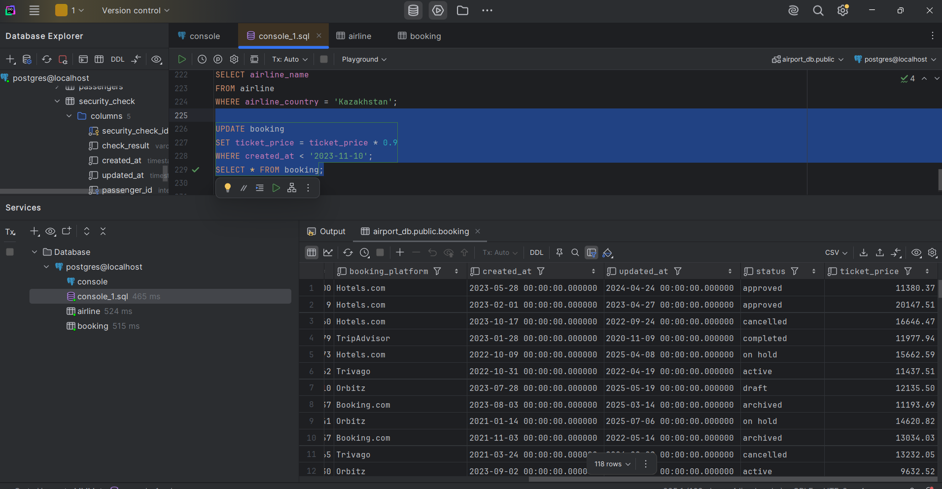
- Find top3 overweighted baggage with more than 25.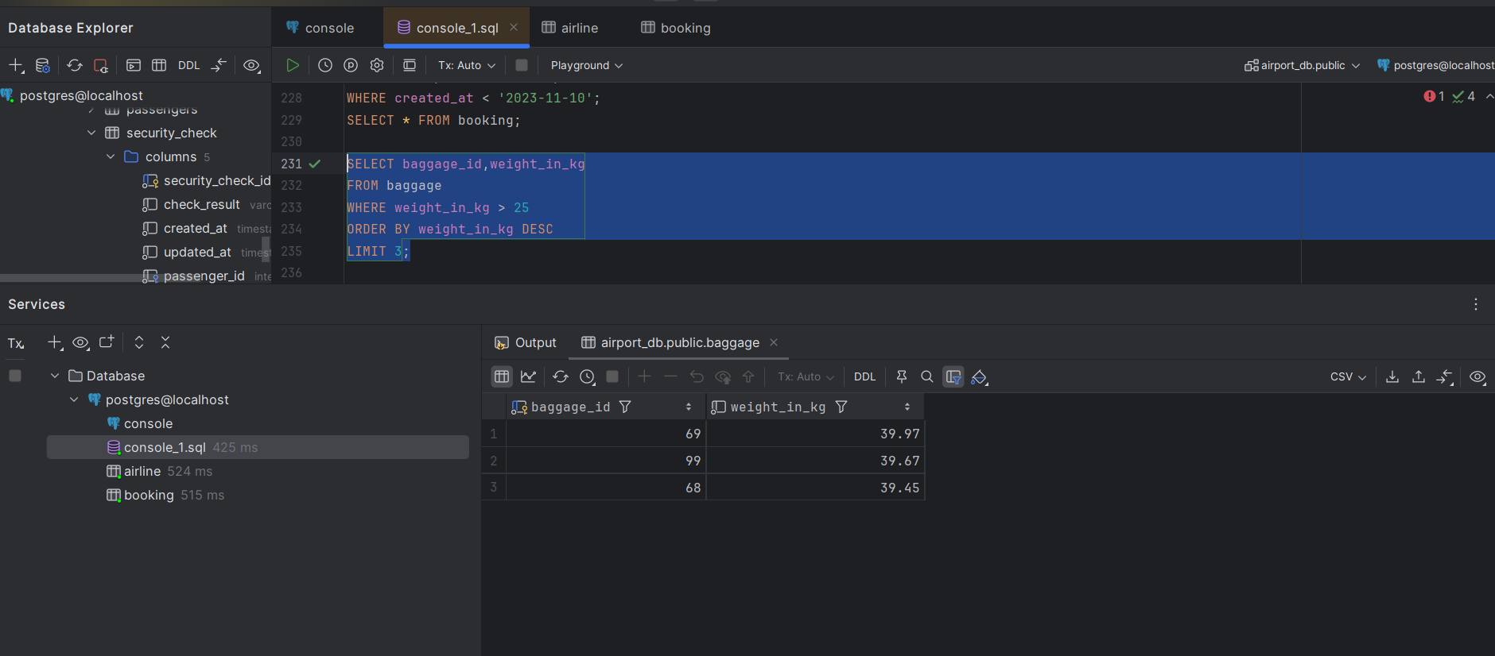

- Find the youngest passengers’ full name.
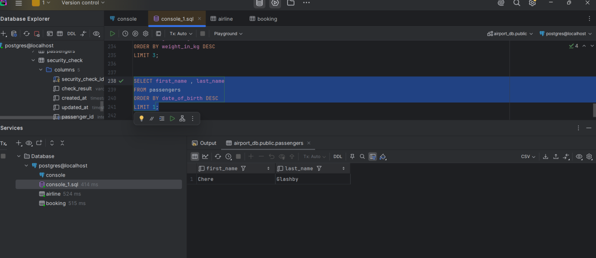
- Find the cheapest booking price on each booking platform.
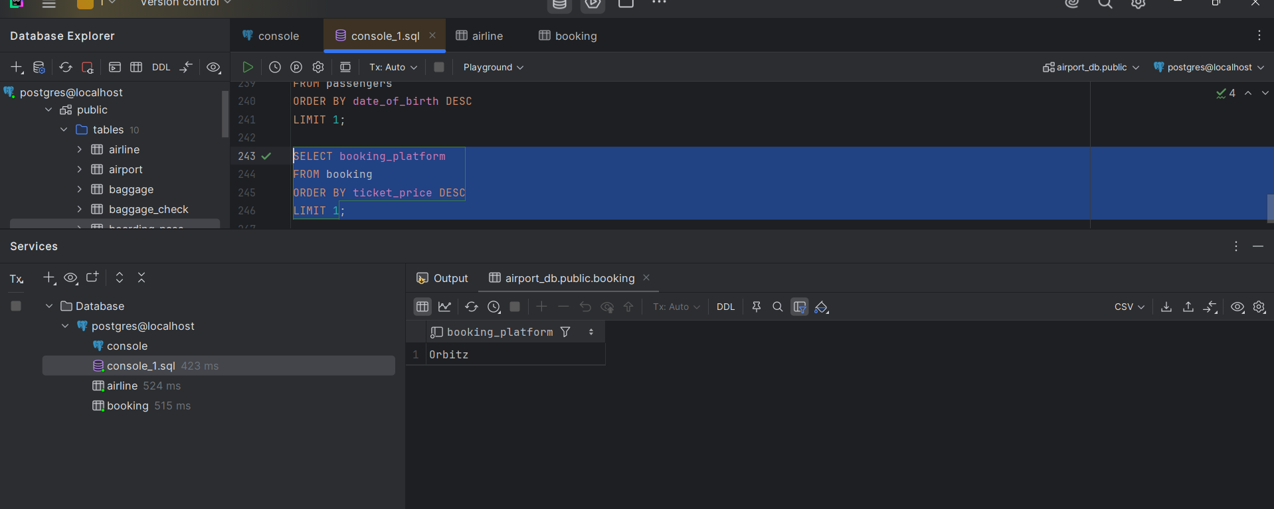
- Return airlines whose airline_code contains a digit.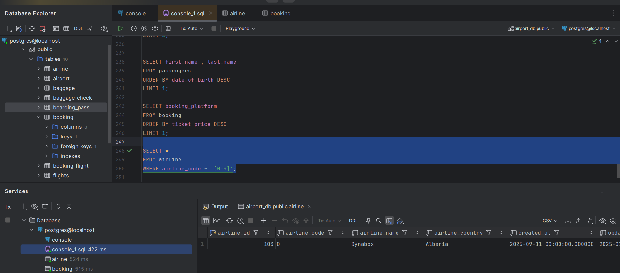
- List the top5 most recently created airlines.
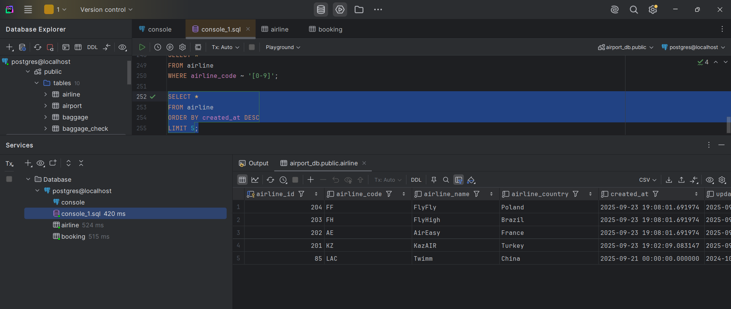
- Return all rows where booking_id is between 200 and 300 inclusive and check_result <> 'Checked'.
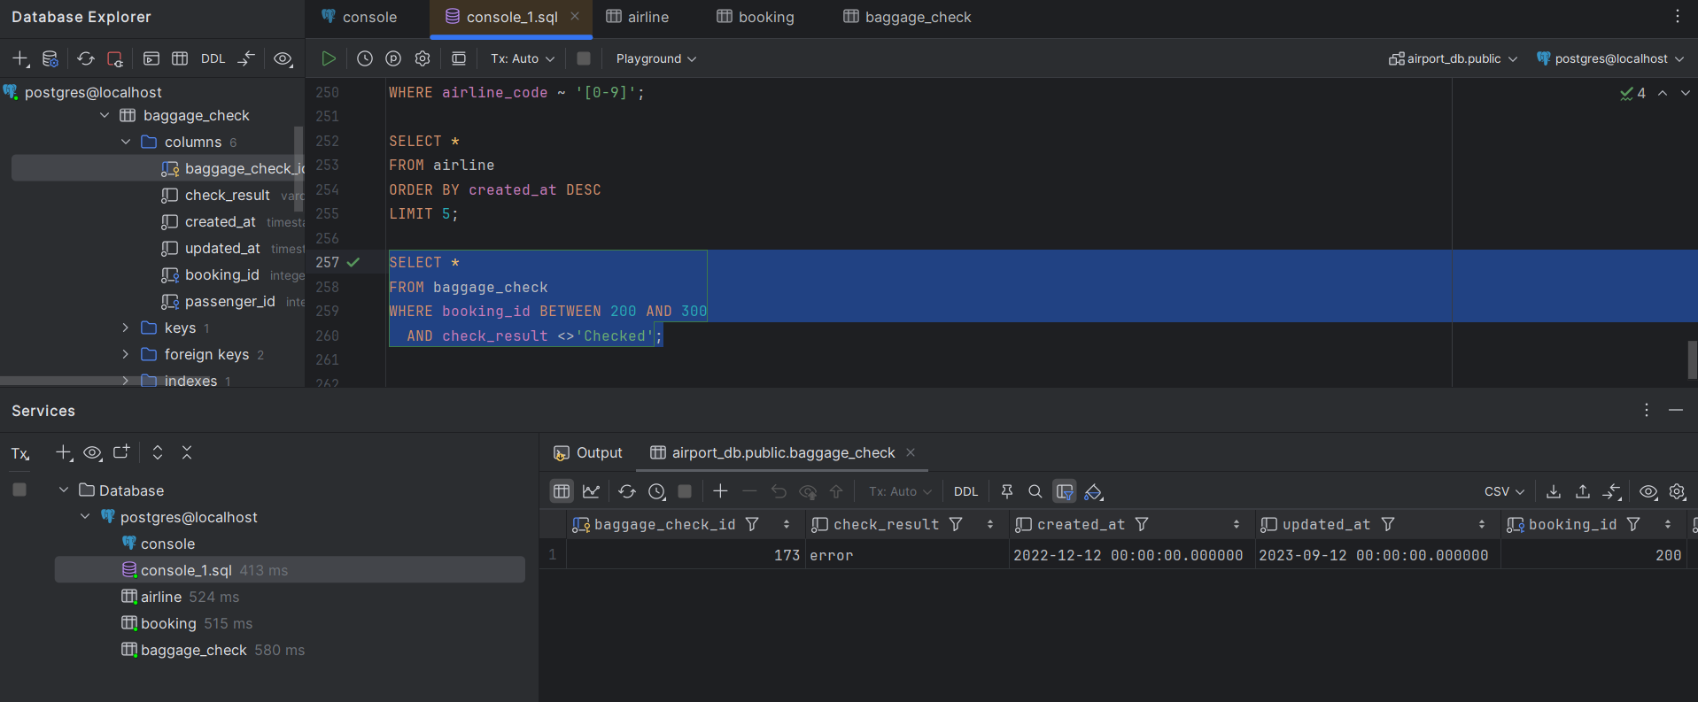
- Baggage checks where update_at is in the same month as created_at but occurs earlier than created_at.
