Project Design Documentation :
Last updated: Oct 13th, 2026

1. Project Title & Version Control
Project Title: Care Access Navigator | IAM + GRC Healthcare Cybersecurity Capstone
Version: v1.2
Date: 10/13/2026
Change Log: v1.2 (10/13/2026): integrated the Compliance 1 and Incident Response 1 course rubrics into the capstone (Sections 12–13); recorded the tools and frameworks actually implemented to date (Azure, Microsoft Entra ID OIDC federation, Defender for Cloud, Azure Policy, PCI DSS v4.0.1); added SAML federation, IAM automation (JML) and proof-of-detection / proof-of-prevention success criteria; added an implementation-status snapshot (Section 14). v1.1 (08/11/2026): revised tool stack and architecture diagram to use Tableau and practical 12-week simulation/equivalent components.
2. Project Summary (2-3 sentences)
- Care Access Navigator is a simulated healthcare cybersecurity environment that combines Identity and Access Management (IAM) with Governance, Risk and Compliance (GRC) to protect simulated electronic Protected Health Information (ePHI). The project demonstrates identity lifecycle management, RBAC, least privilege, access reviews, security monitoring, incident handling, risk assessment, control mapping, evidence collection, and reporting using synthetic data.

3. Problem Statement / Use Case
- Healthcare organizations need to ensure that workforce users receive only the access required for their job responsibilities, that access is removed when it is no longer needed, and that unusual access activity can be investigated. Care Access Navigator addresses this need through a simulated healthcare environment that demonstrates IAM governance, security monitoring, risk management, and control evidence without using real patient data or production healthcare systems.
- The intended users and stakeholders are IAM analysts, security analysts, GRC analysts, department managers, HR/workforce administrators, and other personnel responsible for requesting, approving, administering, reviewing, and monitoring access.

4. Goals and Objectives
Demonstrate role-based access control, least privilege, and identity governance for a simulated healthcare workforce using synthetic identities and applications.
- Implement and test joiner-mover-leaver (JML), access-request, approval, privileged-access, and periodic access-review workflows.
- Generate and investigate simulated authentication and access anomalies, document an end-to-end incident response, and connect findings to risks, controls, remediation, and management reporting.

5. Key Features / Functions
Synthetic healthcare workforce identities and events using non-production data only.
- RBAC and least-privilege model for Clinician, Nurse, Billing, HR, IT Support, Security Analyst, and Vendor roles.
- Joiner-Mover-Leaver lifecycle workflows covering provisioning, role changes, deprovisioning, and access verification.
- Access-request and approval workflow with business justification, manager approval, IAM/security validation, provisioning evidence, and access verification.
- Periodic access-review process that identifies excessive, stale, mismatched, privileged, or expired access and creates remediation actions.
- Security-event logging and simulated monitoring use cases including repeated failed logins, disabled-user activity, privilege escalation, excessive ePHI access, and expired vendor access.
- Risk register, control matrix, evidence index, gap assessment, exceptions, remediation tracking, and control testing.
- GRC dashboard/reporting combining IAM, incident, risk, control, access-review, and remediation metrics.
- Break-glass/emergency-access concept and governance controls for exceptional access scenarios.

6. Tech Stack and Tools
Identity provider: Keycloak — provides the primary identity-provider lab for users, groups, roles, authentication, and access workflows; Microsoft Entra ID concepts or lightweight lab integration may be demonstrated where feasible.
- Applications: Simulated Patient Portal, EHR Simulator, Billing App, and HR App — these may be shown as lightweight mock applications, simple interfaces, or sample datasets rather than fully built enterprise systems.
- Data: Synthetic identities, access records, application events, authentication logs, risk records, control evidence, and other non-production project data.
- Automation: Python is optional for simple data generation, log parsing, workflow support, and reporting automation; IAM workflows may also be implemented directly in the identity-provider lab.
- Data analysis and reporting: Excel/CSV analysis, Tableau dashboards, and optional Python/pandas for reviewing access, logs, risks, and reporting data.
- Security monitoring: Microsoft Sentinel lab or an equivalent lightweight SIEM/log-analysis simulation using sample or CSV logs, depending on feasibility within 12 weeks.
- Project/GRC tracking: Monday.com for tasks, evidence, status, risks, controls, and remediation tracking.
- Documentation: Microsoft Word and Excel for procedures, policies, risk register, control matrix, evidence index, test results, and reporting.
- Architecture and workflows: Lucidchart for IAM/GRC architecture, access lifecycle, incident, and data-flow diagrams.
- Version control: GitHub for portfolio versioning of sanitized documentation and configuration artifacts.
- Cloud platform (implemented, v1.2): Microsoft Azure (resource group rg-cloudsec1-can): VNet with NSG micro-segmentation and Bastion, Azure Container Registry/Instances, management groups + Azure Policy guardrails, Microsoft Defender for Cloud, Azure Monitor alert rules and an Azure Workbook security dashboard (Cloud Security 1).
- Federation (implemented + planned): Keycloak brokered to Microsoft Entra ID over OpenID Connect with Entra app-role → realm-role mappers (sync mode FORCE). SAML 2.0 federation (Keycloak SAML IdP → partner-realm service provider) is added in v1.2 so that both OIDC and SAML SSO are evidenced.
- IAM automation (v1.2): can_iam.py, a dependency-free Python tool that uses the Keycloak Admin REST API to run Joiner/Mover/Leaver, realm hardening (MFA, lockout, password policy), RBAC group migration, per-application access gates, quarterly access-review export and control verification, writing a hashed audit log as evidence.
- Incident response tooling (Incident Response 1): Wazuh custom rules (Wazuh XML syntax), Wireshark/tshark capture filters, Volatility 3, dd + SHA-256 disk imaging, iptables containment, chain-of-custody records. The course rubric names Parrot OS on VirtualBox; the evidence was produced in an equivalent Linux lab (see Section 13 for the substitution note).
- Compliance frameworks: HIPAA (Privacy, Security and Breach Notification Rules) as the primary regulation; PCI DSS v4.0.1 for the Billing App card-payment flow; NIST CSF 2.0 and NIST RMF (SP 800-37) / SP 800-53 control concepts for structure; ISO/IEC 27001:2022 Annex A as a secondary reference for audit readiness. No certification is claimed.

7. Architecture / Workflow Diagram
High-level architecture and process flow:
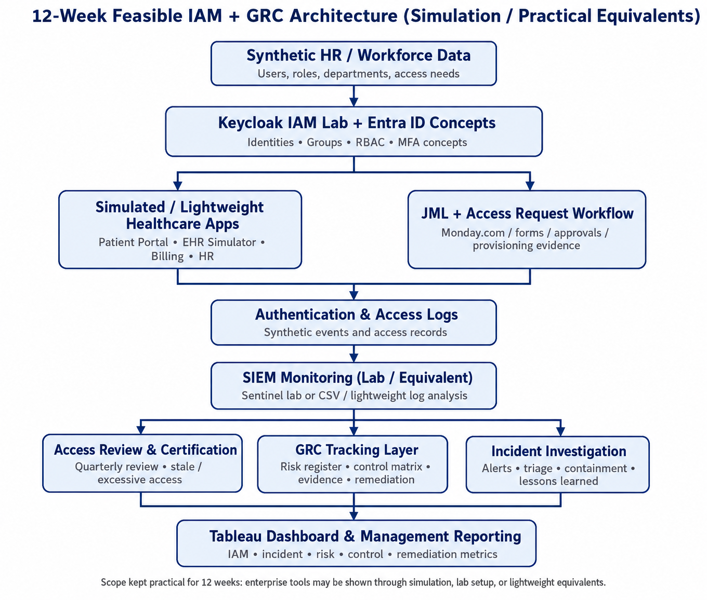
- Workforce identities → Keycloak / Entra ID concepts → Groups and RBAC roles → Simulated/lightweight healthcare applications and JML/access-request workflows → Authentication and access logs → SIEM monitoring and investigation → Access reviews, incident investigation, and GRC risk/control/evidence tracking → Tableau dashboard and management reporting.
- The design is intentionally simulated and uses synthetic identities, synthetic events, and non-production data. To keep the project achievable within 12 weeks, components that are impractical to build fully are represented through lab configurations, mock applications, sample datasets, screenshots, or lightweight equivalent tools.

8. Timeline / Weekly Milestones
Use this section to plan how your project will move through the software development life cycle (SDLC) over 12 weeks. Adjust the specific tasks to fit your project, while keeping the overall progression from planning through release.

Week | Project Outcome | SDLC Stage and What It Means
Week 1 | Define scenario, scope, stakeholders, requirements, assets, and success criteria for the simulated healthcare environment. | Planning / Healthcare Security Foundations: Establish the project vision, business problem, stakeholders, scope, assets, and success criteria.
Week 2 | Set up the project workspace and IAM lab; configure Keycloak, document Entra ID concepts, establish applications, users/groups, and the logging foundation. | Foundation Infrastructure & IAM Lab: Establish the identity, application, documentation, and logging foundation for the project.
Week 3 | Design IAM architecture and RBAC; define roles, permissions, least privilege, and the access-request/approval workflow; implement and test representative access. | IAM Architecture & RBAC: Translate business responsibilities into roles, permissions, least-privilege decisions, and tested access controls.
Week 4 | Implement joiner, mover, and leaver workflows and perform a sample periodic access review. | Identity Lifecycle: Demonstrate provisioning, role changes, deprovisioning, and access-review remediation.
Week 5 | Document authentication controls, MFA expectations, privileged roles, service/vendor identities, and test privileged-access scenarios. | Authentication & Privileged Access: Establish and test safeguards for authentication, elevated access, service accounts, and vendors.
Week 6 | Define SIEM monitoring use cases, generate/collect safe simulated events, create detections, and establish alert-triage procedures. | SIEM & Security Monitoring: Build monitoring use cases and demonstrate detection and triage of suspicious identity/access activity.
Week 7 | Simulate a suspicious ePHI-related access incident, investigate events, contain the simulated account, preserve evidence, and document lessons learned. | Incident Detection & Response: Demonstrate the complete analyst investigation and response workflow.
Week 8 | Define risk methodology, identify IAM/security risks, score risks, and create treatment plans. | GRC Risk Assessment: Establish the risk register, scoring model, risk owners, and remediation/treatment actions.
Week 9 | Create the control inventory and map relevant controls to HIPAA Security Rule concepts and NIST framework/control concepts; perform a gap assessment. | Controls & Compliance Mapping: Connect project controls to healthcare security expectations without claiming formal certification.
Week 10 | Organize evidence, perform sample control tests, document exceptions, and track corrective actions. | Evidence, Exceptions & Remediation: Demonstrate control testing, evidence management, exception handling, and remediation tracking.
Week 11 | Define and integrate IAM, incident, risk, control, access-review, and remediation metrics into a management dashboard/report. | GRC Dashboard & Reporting: Communicate security posture and governance status to management.
Week 12 | Execute end-to-end testing, finalize portfolio documentation and evidence, prepare the 5-minute demo, and present results and lessons learned. | Testing, Documentation & 5-Minute Demo: Validate the solution, finalize deliverables, and communicate the analyst story.

9. Risks and Risk Mitigation
Scope risk — Keep the project limited to the defined simulated healthcare environment, seven representative roles, controlled use cases, and the 12-week schedule.
- Tooling complexity — Use Keycloak as the primary IAM lab, Microsoft Sentinel or an equivalent lightweight monitoring approach, Tableau for final reporting, and simple documentation/tracking tools rather than attempting a full enterprise deployment.
- Synthetic data quality — Use repeatable templates and controlled synthetic identities/events; do not use real patient information or production data.
- Incomplete or weak evidence — Maintain an evidence index linking screenshots, logs, access reviews, tickets, approvals, test cases, and diagrams to controls and risks.
- Requirements or implementation gaps — Review scope and requirements during the project and track identified gaps through the risk register, exceptions, and remediation process.
- Lab drift and teardown: cloud resources (e.g., the Log Analytics workspace removed on 10/13/2026 to control cost) can disappear between courses. Mitigation: capture system-generated evidence with SHA-256 hashes at collection time, export the Keycloak realm before every change, and record any teardown as a documented exception.
- Rubric-tool substitution: when a rubric names a specific platform (e.g., Parrot OS/VirtualBox/Wazuh dashboard) and an equivalent was used, confirm acceptance with the instructor in writing and keep the substitution note in the deliverable.

10. Evaluation Criteria
IAM success: Demonstrate at least one complete JML workflow, an RBAC matrix, an access-request workflow, and a periodic access-review demonstration.
- Monitoring and incident success: Demonstrate at least three useful detection use cases with controlled test events and analyst investigation evidence, plus one end-to-end simulated access incident.
- GRC success: Complete a risk register, control matrix, evidence index, gap assessment, exceptions/remediation tracking, and a management dashboard or summary report.
- Portfolio success: Produce presentation-ready architecture, workflows, procedures, test cases, screenshots/evidence, reporting outputs, and a concise 5-minute demonstration within the 12-week project period.
- Compliance success (Compliance 1): two frameworks applied (HIPAA + PCI DSS v4.0.1); a compliance policy with approval workflow and version control; one detailed procedure; a training plan; an internal audit of three controls with hashed evidence, gap analysis and a prioritized remediation plan; a management status report, KPI monitor and record-retention schedule; a legal obligations matrix, ethical decision record and compliance incident scenario.
- Incident response success (Incident Response 1): three custom detection rules that fire on real test events; one suspicious-login investigation correlated across two hosts; three incidents classified with the severity matrix; containment playbook, chain of custody, one complete incident report, root cause analysis and a recovery validation checklist.
- Proof of detection / proof of prevention: for each priority attack (password brute force, unauthorized app access, privilege escalation, leaver re-use, firewall backdoor), show the alert that fired (detection) and a before/after test where the same action is blocked (prevention).

11. Future Considerations
Expand the simulated workforce, application set, and role coverage after the MVP is complete.
- Replace or supplement simulated/SIEM log analysis with a more advanced enterprise monitoring platform in a future version.
- Add additional incident simulations, deeper IAM automation, privileged-access controls, and broader compliance/control mappings.
- Build a self-service access-request portal and integrate additional identity governance capabilities in a future release.

12. Course Rubric Integration (Crosswalk)
Care Access Navigator is the single project used across every course in the program. Each course rubric is satisfied with evidence from the same HealthLine Regional Medical Center (HRMC) environment, and each course maps to one or more capstone weeks. The table records where each course lives in the 12-week plan and its status as of 10/13/2026.
Course | Capstone weeks | Key artifacts produced | Status (10/13/2026)
Cyber Threats & Vulnerabilities 1 | Wk 1, 3, 8 | Threat identification, AgentTesla malware analysis, SET phishing simulation, APT mapping, Nmap, OpenCTI, risk-register entries | Complete
Network Security 1 | Wk 2–3, 5–6 | Topology/subnetting, secure architecture, firewall/IDS/ACL design, tools live demo (tshark capture of token endpoint), monitoring plan | Complete (tasks 1–5 written as design; live demo on stand-in host)
Cloud Security 1 | Wk 2–3, 5–7, 9 | Shared responsibility; Bastion + NSG zero-trust; container scanning; Keycloak↔Entra ID IAM; Azure Policy/HIPAA checklist; Defender + alerts + IR playbook (INC-20261008-01) | Complete (6 criteria)
Risk Management 1 | Wk 8 | NIST RMF adoption, risk register R01–R05, inherent/residual scoring, treatment plan, communication, implementation (ISO/IEC 27001 references) | Complete (6 criteria)
Compliance 1 | Wk 8–11 | HIPAA + PCI DSS requirements analysis, program plan, policy CAN-POL-AC-001, procedure CAN-PRC-AC-002, training plan, audit CAN-IA-2026-01, tracker workbook | Complete (5 tasks); 6 audit findings in remediation
Incident Response 1 | Wk 6–7 | Wazuh rules, detection engine, suspicious-login investigation, containment, memory/disk forensics, chain of custody, IR report, RCA, recovery checklist | Delivered* (equivalent lab; confirm with instructor)

In plain terms: every course has been answered with work on the same hospital scenario, which is why the project tells one connected story (threat → network/cloud design → identity controls → risk → compliance → incident response). The remaining capstone work (Weeks 4, 5, 10–12) is mostly executing identity controls that the courses already designed, and turning the results into a dashboard and demo.

13. Compliance 1 and Incident Response 1: Rubric-to-Capstone Mapping
13.1 Compliance 1
Frameworks: HIPAA (45 CFR Part 164: Privacy, Security and Breach Notification Rules) for ePHI, and PCI DSS v4.0.1 for card payments taken by the Billing App. NIST CSF 2.0 / SP 800-53 and ISO/IEC 27001:2022 are used as supporting control vocabularies.
Rubric criterion | Capstone week / board item | Evidence (compliance_1/) | Status
1. Compliance Fundamentals: two frameworks, requirements analysis with process mapping, program plan (roles, timeline), two controls with procedures + tests | Wk 1 D3, Wk 9 D2–D3 | Task1_Compliance_Fundamentals.pdf | Complete
2. Compliance Program Development: governance model + org chart, communication plan, one policy with approval + version control, one detailed procedure, training plan | Wk 9 D1 (subitems: policy, training plan) | Task2_Compliance_Program_Development.pdf | Complete (update Monday subitems)
3. Compliance Auditing Basics: audit plan, evidence for three controls, assessment + gap analysis, prioritized remediation plan | Wk 9 D4, Wk 10 D1–D2 | Task3_Compliance_Auditing.pdf + audit-evidence/ (SHA-256 index) | Complete; findings F-01–F-06 open
4. Documentation & Reporting: document package with version/distribution control, management status report, records retention + access, KPI monitoring | Wk 10 D1, Wk 11 D1 | Task4_Documentation_Reporting.pdf + Compliance1_Tracker.xlsx | Complete
5. Legal & Ethical Implementation: obligations matrix with citations, ethical framework decision, compliance risk assessment, one compliance incident scenario | Wk 8, Wk 9 D1 (ethical-rationale subitem) | Task5_Legal_Ethical_Implementation.pdf | Complete

Carry-forward into the capstone: audit findings F-01 (MFA not enforced), F-02 (lockout disabled), F-04 (password standard) and F-05 (no completed access review) are closed by executing Weeks 4–5 with can_iam.py; F-03 (12-month log retention) and F-06 (IdP over HTTP) remain tracked exceptions with target dates in the Compliance 1 tracker.
13.2 Incident Response 1
Rubric criterion | Capstone week / board item | Evidence delivered | Status
1. IR Environment Setup: Wazuh on Parrot OS (VirtualBox), agent + log collection, 3 custom rules, Wireshark filters, Volatility, Parrot + macOS logs in Wazuh dashboard | Wk 6 D2–D3 | Section 1 package: wazuh_local_rules.xml (3 rules), detection engine, tshark filters, Volatility 3 install | Delivered* (equivalent lab, no Wazuh dashboard)
2. Incident Detection & Analysis: Parrot + macOS log analysis, one suspicious-login investigation (correlation, timeline, validation), 3 incidents classified | Wk 6 D4, Wk 7 D2 | Section 2 package: nurse_jsmith brute force → compromise timeline; High / Critical / High classification | Delivered* (macOS logs were a labeled sample)
3. Response & Containment: isolation, firewall rules, VirtualBox segmentation, evidence preservation, containment playbook | Wk 7 D3 | Section 3 package: veth isolation, iptables quarantine chain, gcore memory capture, SHA-256 manifest | Delivered* (no VirtualBox networking)
4. Digital Evidence Management: live collection, Volatility memory analysis, disk acquisition, chain of custody, macOS + Parrot timeline | Wk 7 D3 | Section 4 package: dd image with matching hashes, 8-row chain of custody, process-memory analysis | Delivered* (process core, not full-RAM Volatility)
5. IR Documentation & Reporting: IR playbook, incident tracking system, one full incident report, tool documentation | Wk 7 D3 | Section 5 package + Cloud IR-Playbook.md (Azure) | Complete
6. Post-Incident Procedures: recovery procedures, RCA, recovery validation checklist, improvement recommendations | Wk 7 D4 | Section 6 package: 5-Whys RCA, 7 validated recovery checks, 6 recommendations | Complete

*Substitution note: the IR 1 rubric names Parrot OS on VirtualBox with a Wazuh dashboard and live macOS log ingestion. The delivered evidence uses an equivalent Linux lab (real sshd/sudo/useradd events, Wazuh-syntax rules evaluated by a Python correlation engine, a labeled macOS sample, and process-level memory analysis). Before final grading, confirm in writing that the instructor accepts this substitution; if not, the companion Readiness Audit & Roadmap describes how to run a real Wazuh manager and agents.

14. Implementation Status Snapshot (10/13/2026)
Verified against system-generated evidence collected on 10/13/2026 (Keycloak kcadm extracts, Microsoft Graph, Azure Monitor) and the Monday.com board export. The companion document “Care Access Navigator: Capstone Readiness Audit & Roadmap” gives the full checklist, the step-by-step method for each gap and the plan to Week 12.
Capability | Current state | Status
Users / roles | Keycloak: 7 test users (one per role) + 3 Entra-federated; 7 realm roles. Entra ID: 3 users, 7 app roles, assignment required | Done
Groups / security groups | No Keycloak groups (roles assigned directly); Entra uses app roles instead of security groups (group-to-app assignment needs Entra ID P1) | Gap
Applications | 4 OIDC clients with fullScopeAllowed=false; no per-app sign-in gate, no running app front-end | Partial
RBAC / least privilege | Every user holds exactly one role; client scopes limit roles per app (audit AC-01 PASS) | Done
MFA | browser-mfa-privileged flow exists but bound to no client (finding F-01) | Gap
Lockout / password | bruteForceProtected=false; length 10, history 3 (F-02, F-04) | Gap
Federation | OIDC Keycloak↔Entra working; SAML not yet demonstrated | Partial
JML automation | Designed (Week 4 items), no script or executed scenario yet | Not started
Access review | Procedure CAN-PRC-AC-002 written; no completed review (F-05) | Gap
Monitoring / detection | Azure: 7 activity-log alerts + SSH brute-force query fired (50 alerts); Defender for Cloud. Keycloak events enabled but not sent to a SIEM | Partial
Log retention | Log Analytics workspace removed 10/13; 90-day native Activity Log only (F-03) | Gap
Incident playbook | Cloud IR playbook (tested INC-20261008-01) + IR 1 playbook | Done
Risk register / compliance | R01–R05 (RMF, scored); HIPAA checklist (CloudSec C5); audit + tracker (Compliance 1) | Done
Simulated attack + PoD/PoP | Done for cloud (backdoor NSG, key listing, SSH brute force, EICAR) and IR lab; not yet for the identity layer (Keycloak) | Partial
Dashboard | Azure Workbook + Excel compliance dashboard exist; Tableau GRC dashboard not started (Week 11) | Not started

