Project Design Documentation :
Last updated: Aug 3rd, 2026

1. Project Title & Version Control
Project Title: CareAccess Navigator — Healthcare IAM, ePHI Access Governance and Incident Monitoring.
Version: v0.2 (DRAFT)
Date: 08/03/2026
Change Log:
2. Project Summary (2-3 sentences)
- CareAccess Navigator is a simulated healthcare access-governance and monitoring project built for a small fictional organization. It demonstrates how access can be assigned, reviewed, and monitored using synthetic data, simple workflow controls, and spreadsheet-friendly analysis. The project is designed to be completed within 2–3 months and kept intentionally lightweight for an academic or portfolio setting.

3. Problem Statement / Use Case
- Healthcare organizations must control access to sensitive information, respond quickly when staff join or leave, and keep an audit trail of who approved access and when it was reviewed. Smaller organizations often need a simpler, lower-cost approach that does not require heavy enterprise tooling. CareAccess Navigator addresses this need by providing a streamlined access-monitoring simulation that uses a smaller workforce model, fewer role types, and CSV-based analysis.
- The intended users are an IAM analyst, a security analyst, and department managers who need to provision access, review access rights, and investigate unusual activity in a practical but simplified environment.

4. Goals and Objectives
Design and demonstrate a simplified role-based access control model for 30 synthetic healthcare workers across 5 job roles.
- Build a basic joiner-mover-leaver workflow, access-request workflow, and access-review process that can be completed and documented within 2–3 months.
- Generate three realistic incident simulations, analyze logs using CSV-based review, and produce a clear dashboard or summary report that shows access, review, and incident outcomes.

5. Key Features / Functions
Synthetic workforce dataset covering 30 identities across 5 job roles, with no real names or PHI.
- Simplified RBAC access matrix mapping each role to approved systems and data types.
- Joiner-Mover-Leaver automation or guided workflow that provisions, updates, and removes access records.
- Access-request and approval workflow with basic validation rules such as manager approval, justification, and contractor end date checks.
- Quarterly or periodic access-review report with risk flags such as dormant access, expired contractors, role mismatch, and privileged access.
- Security event log generator and three simulated incident scenarios, such as failed logins, unauthorized access, and excessive record access.
- CSV-based analysis for reviewing access, review results, and incident patterns.
- Dashboarding and reporting using Tableau where possible, with supporting CSV outputs and static summary tables if needed.
- Risk register and a break-glass or emergency-access procedure for a service outage scenario.

6. Tech Stack and Tools
Identity provider: Keycloak or Microsoft Entra ID — hosts synthetic identities, groups, and roles.
- Mock healthcare application: Python Flask — simulates the EHR / patient-record system.
- Database: SQLite or PostgreSQL — stores synthetic workforce and access data.
- Identity automation: Python or PowerShell — implements joiner-mover-leaver scripts.
- Data analysis: Python + pandas or spreadsheet analysis — processes access and log data.
- Log monitoring: CSV analysis — replaces Splunk for a simpler, lower-scope approach.
- Dashboarding: Tableau Public / Tableau Free edition if suitable — used for interactive visuals and summaries.
- Documentation: Word or Confluence — policies, SOPs, and project documentation.
- Diagrams: Draw.io or Lucidchart — architecture and workflow diagrams.
- Source control: GitHub — version control and portfolio README.

7. Architecture / Workflow Diagram
High-level data and process flow:
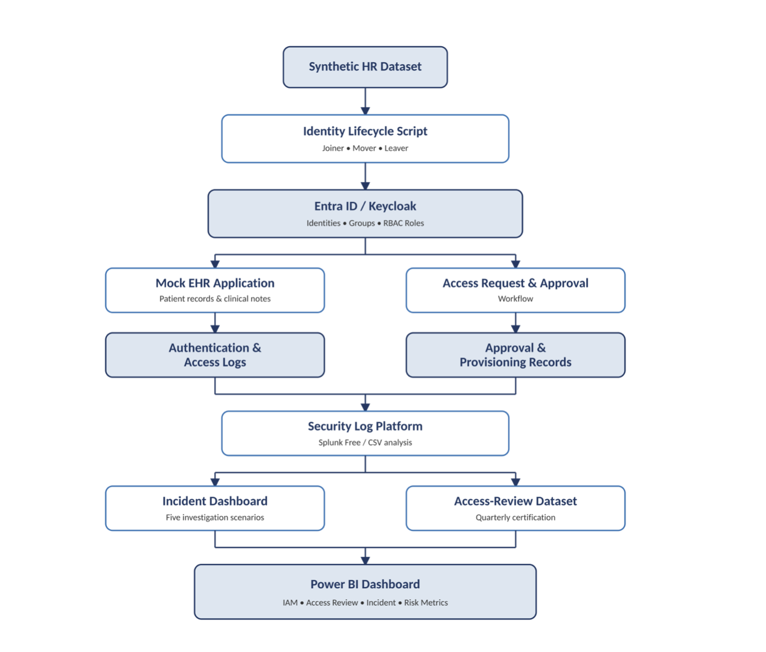
- Synthetic HR records and access requests → Identity provider / RBAC → Mock EHR system → Approval workflow → CSV log analysis → Access-review outputs and Tableau dashboard.
- This design keeps the workflow simple enough to complete in 2–3 months while still demonstrating access governance, review, and incident monitoring.

8. Timeline / Weekly Milestones
Use this section to plan how your project will move through the software development life cycle (SDLC) over 12 weeks. Adjust the specific tasks to fit your project, while keeping the overall progression from planning through release.

Week | Project Outcome | SDLC Stage and What It Means
Week 1 | Define project scope, objectives, healthcare IAM use case, project goals, success criteria, and identify 5 user roles (Physician, Nurse, Admin Staff, Lab Technician, IT Support). Create the initial list of 30 synthetic users. | Planning / Requirements Discovery: Define the project vision, business problem, stakeholders, scope, and expected outcomes. Establish what the IAM solution will address.
Week 2 | Document project requirements, constraints, MVP features, IAM workflows, data sources, and acceptance criteria. Create project repository, folder structure, and initial workflow diagrams. | Requirements Analysis: Define what the IAM solution must accomplish, including user lifecycle management, RBAC, access requests, approval workflows, access reviews, and reporting requirements.
Week 3 | Design IAM architecture, data models, synthetic healthcare datasets, user attributes, applications, roles, permissions, and access relationships. Configure required tools and technologies. | System Design: Define how different IAM components will interact. Design the mock EHR environment, data structure, RBAC model, and workflow before development begins.
Week 4 | Build synthetic datasets, finalize RBAC rules, create access control matrix, prepare mock EHR structure, and define access request and approval workflow. | System Design / Setup: Convert business requirements into technical designs. Establish security rules, access policies, and system workflows.
Week 5 | Set up development environment, repository, project structure, and create the initial IAM prototype. Load synthetic users, departments, roles, applications, and entitlement data. | Implementation Setup: Prepare the tools, environment, and foundation required for development. Establish the initial working structure of the project.
Week 6 | Implement Joiner-Mover-Leaver (JML) workflows for employee onboarding, role changes, and termination scenarios. Generate initial CSV outputs for user access records. | Implementation: Develop core IAM lifecycle management functions in small, testable components.
Week 7 | Develop access request workflow, approval process, entitlement assignment, role validation, and integrate IAM components into a complete workflow. | Implementation and Integration: Connect different IAM features together and verify that workflows operate as a complete solution.
Week 8 | Build access review/certification process, compliance checks, excessive privilege detection, risk flags, and governance reporting tables. | Testing and Quality Assurance: Validate IAM governance processes, identify access issues, and ensure the solution follows security requirements.
Week 9 | Generate IAM activity logs, simulate security incidents (terminated user access, excessive permissions, suspicious access activity), analyze results, and create dashboard visualizations using Tableau or alternatives. | Validation and Refinement: Confirm the IAM solution works in realistic scenarios. Improve monitoring, reporting, and detection capabilities.
Week 10 | Stabilize the project, fix defects, clean datasets, validate CSV reports, finalize dashboards, and complete technical and user documentation. | Release Preparation: Improve reliability, usability, and documentation quality before final release.
Week 11 | Package the completed IAM solution, prepare final dashboard outputs, screenshots, workflow diagrams, and demonstration materials. | Deployment: Deploy the final solution in the demonstration environment and verify that all components work correctly.
Week 12 | Conduct final acceptance testing, present project demonstration, review documentation, summarize lessons learned, and provide future enhancement recommendations. | Release and Maintenance Planning: Confirm project completion, communicate results, and define possible future improvements.

9. Risks and Risk Mitigation
Scope still exceeds the available time — Keep the MVP small and limit the project to 5 roles, 30 users, and 3 incident simulations.
- Tooling becomes too complex — Prefer CSV analysis, SQLite, and simple workflow tools over heavy enterprise platforms.
- Synthetic data quality is inconsistent — Use repeatable templates and fake-data generation.
- Tableau feature limits affect the final dashboard — Keep Tableau as a visualization layer and maintain CSV summary outputs as the source of truth.
- Missing requirements discovered mid-build — Revisit scope at the end of Week 2 and Week 6.

10. Evaluation Criteria
The project supports 30 synthetic identities across 5 roles with correct access rules.
- The access workflow, review process, and 3 incident simulations can all be demonstrated end to end.
- CSV analysis produces clear results for access review and incident review, and the final dashboard or report is understandable to a non-technical reviewer.
- The project is completed within 2–3 months and can be presented cleanly in a portfolio or academic setting.

11. Future Considerations
Expand the workforce model and role coverage in a future version.
- Replace CSV analysis with a more advanced monitoring platform later if needed.
- Add more incident simulations and deeper automation after the MVP is finished.
- Build a self-service request portal in a future release.

