Audit: Healthcare IAM - NIST CSF 2.0 Control Mapping
Version:

NIST CSF v2.0
Profile(s) :

04/11/2026

Auditors:
akchrao@gmail.com


Summary

Assessment scope:

Description:
Project controls mapped to NIST CSF 2.0 subcategories. Result per subcategory = weakest implementation of the mapped controls. Only mapped subcategories are assessed; the rest are out of the capstone scope.

Observations:

Number of requirements: 106
9 | 5 | 1 | 0 | 91
Compliant | Partially compliant | Non-compliant | Not applicable | Not assessed

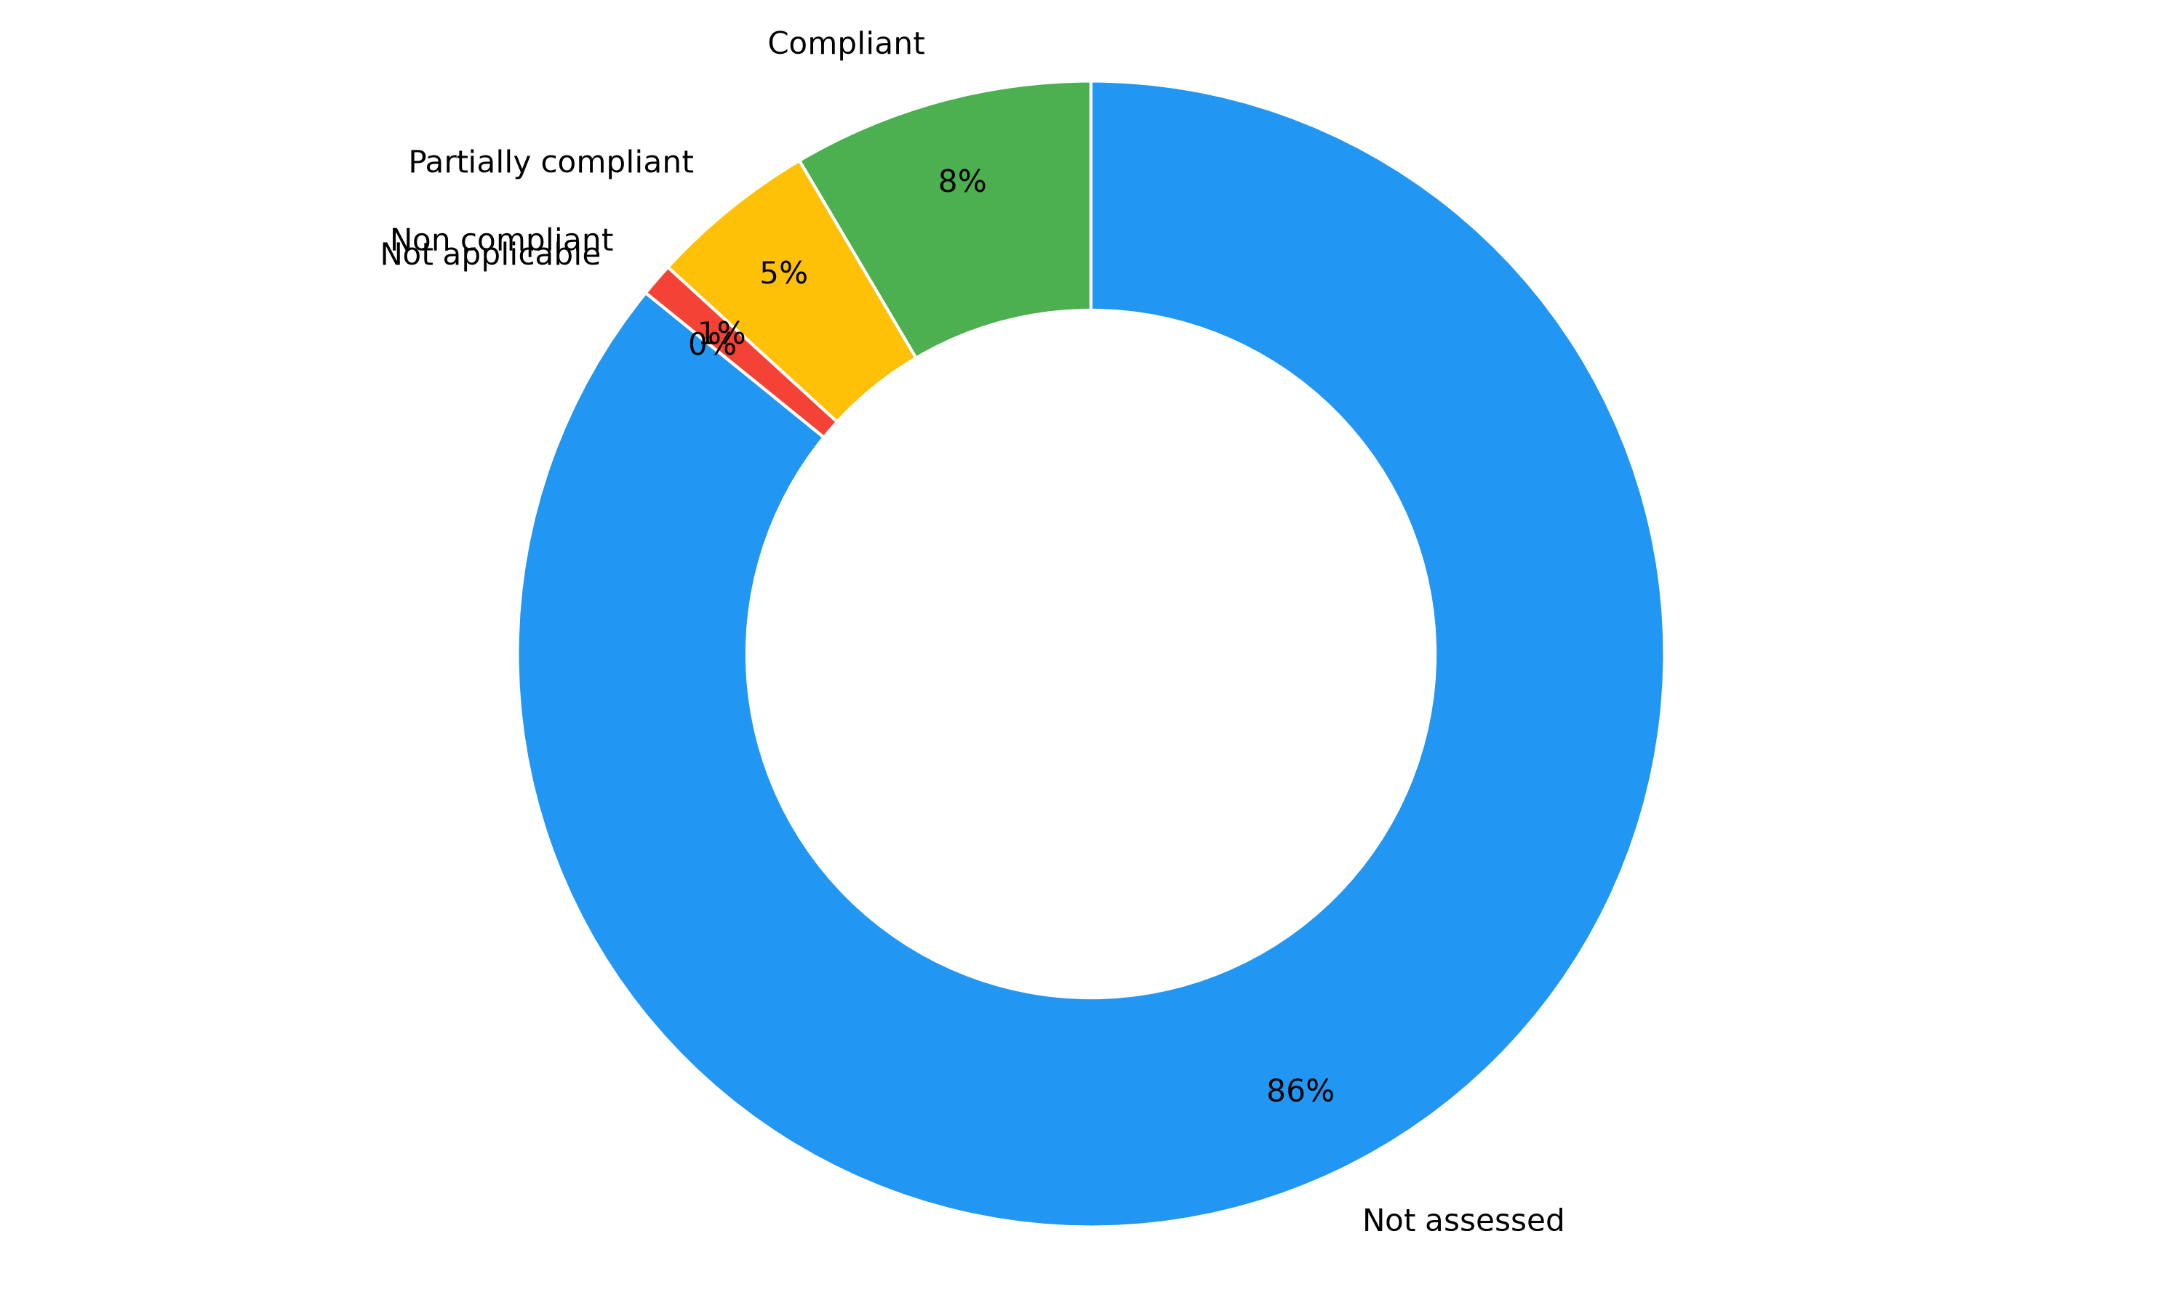

<Comments>


Audited scopes

Overview
The percentage indicates the completion of each section based on the items marked as compliant or non-applicable.

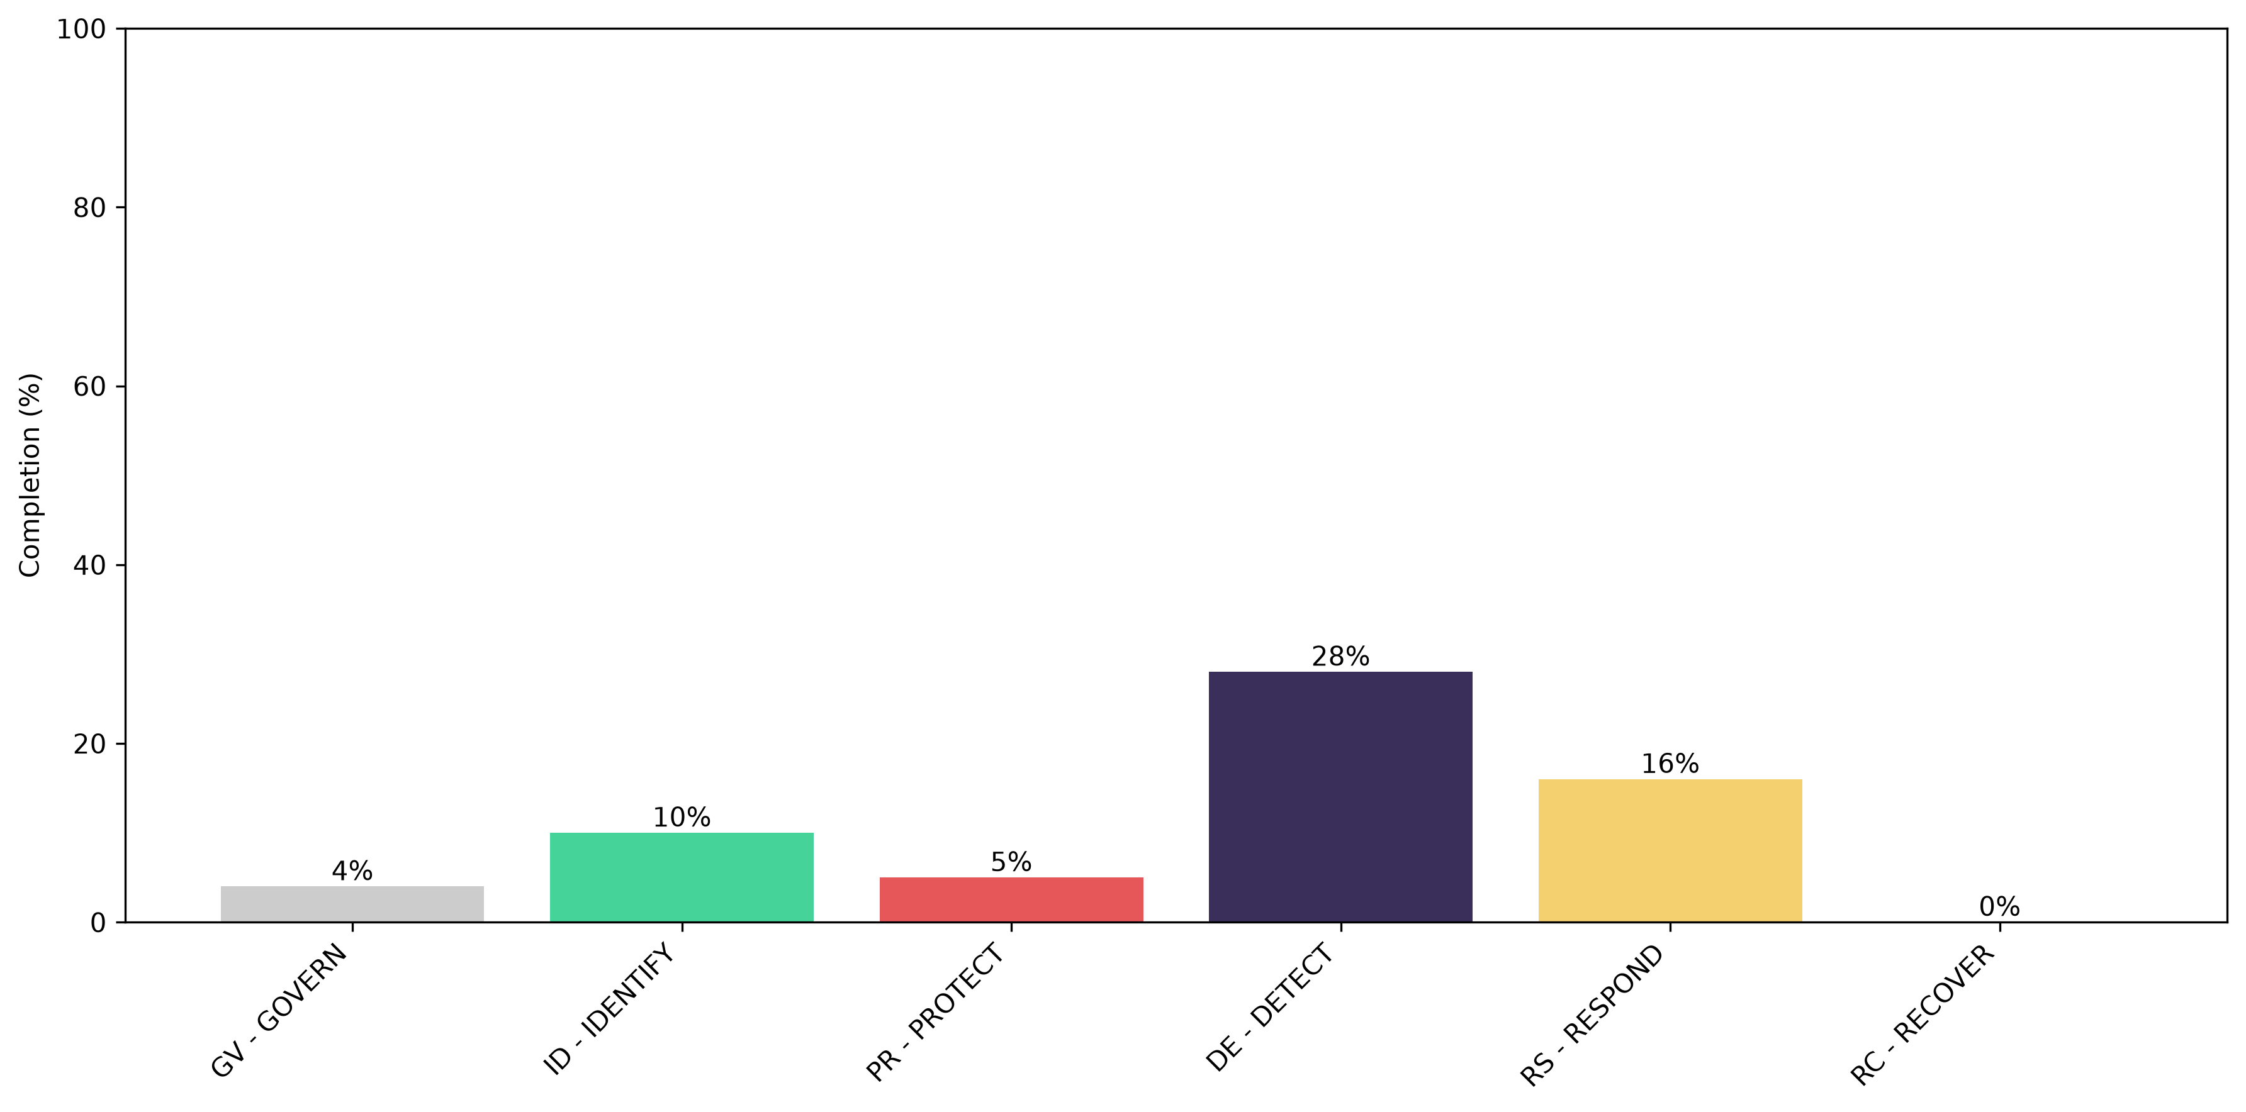
<comments>

Additionally, the following chart illustrates the maturity assessed by the auditor in each section:
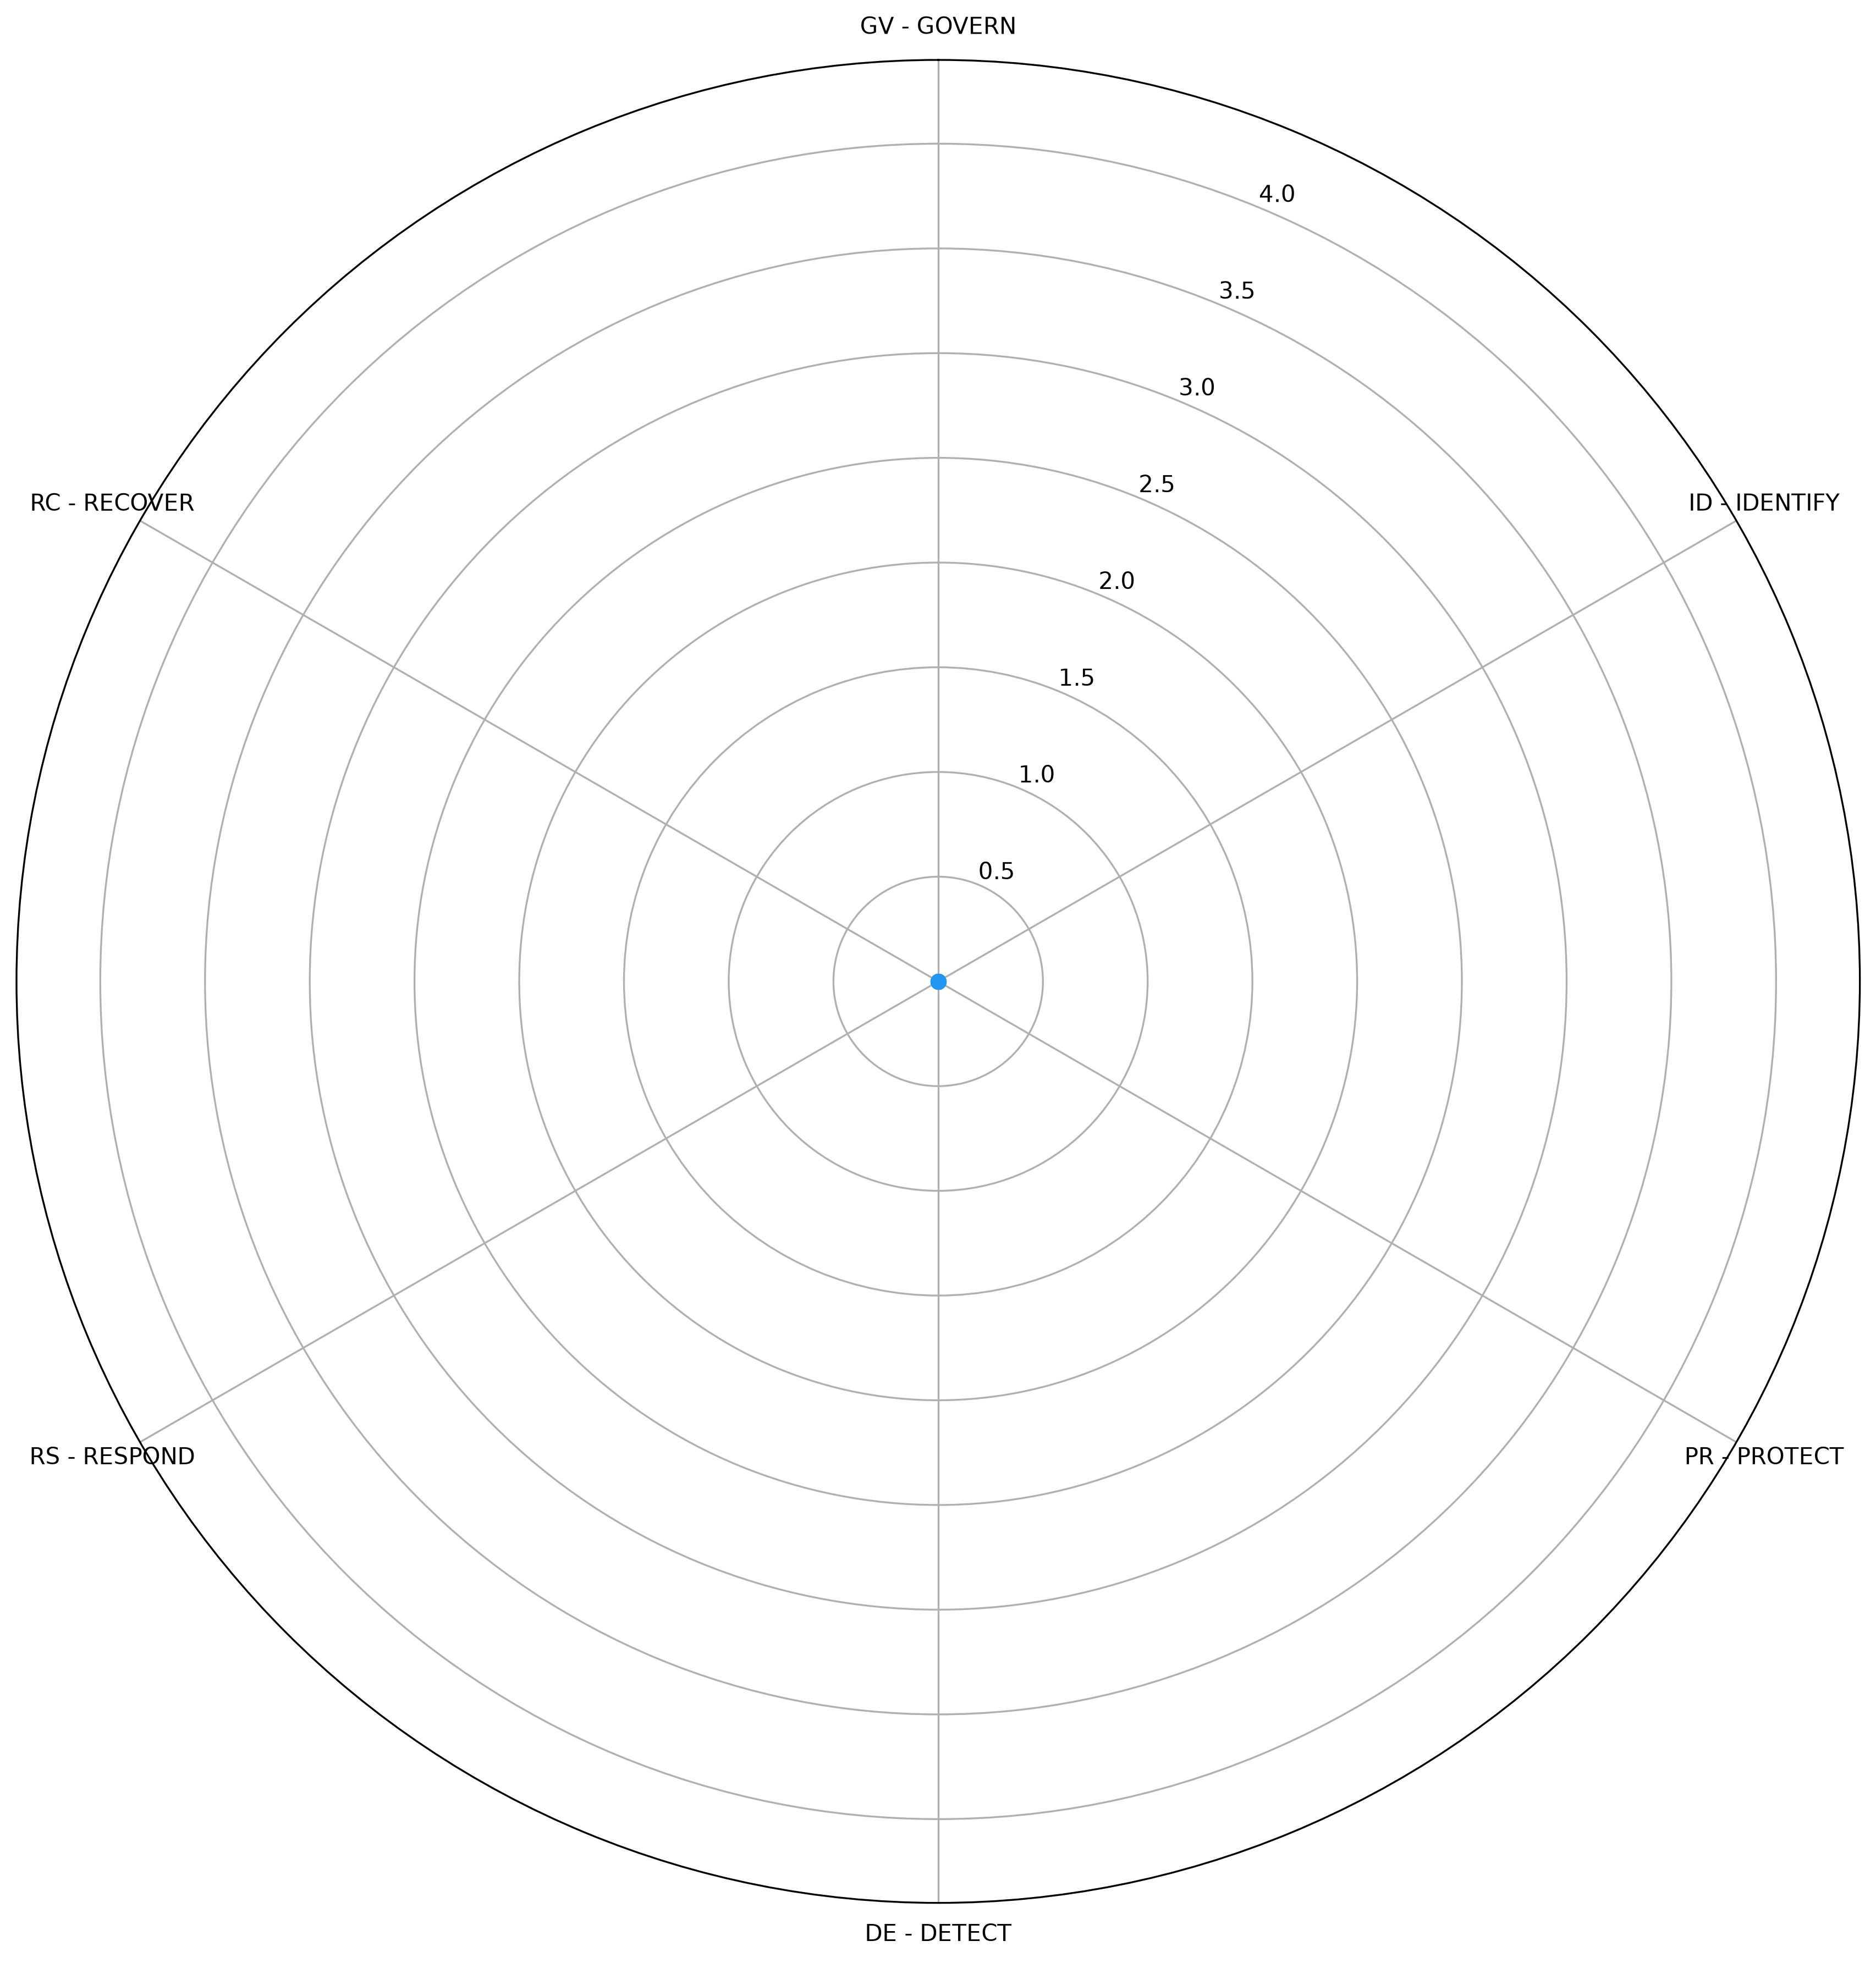

Auditor notes

Category | Drifts identified | Comments
GV - GOVERN | 30 | <comments>
ID - IDENTIFY | 19 | <comments>
PR - PROTECT | 21 | <comments>
DE - DETECT | 8 | <comments>
RS - RESPOND | 11 | <comments>
RC - RECOVER | 8 | <comments>

Security controls

Overview
Identified security controls: 16

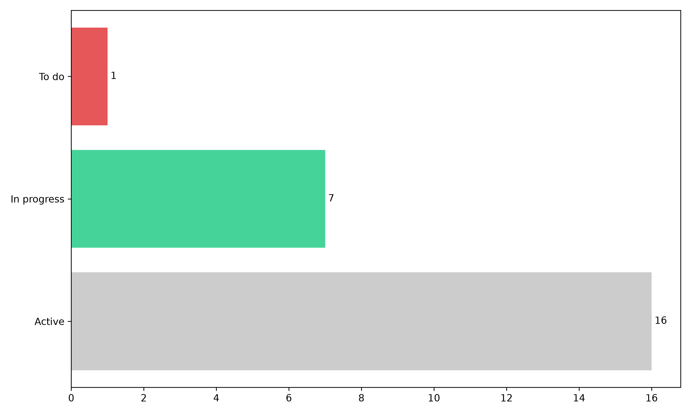
<comments>

Main priorities (P1)
The table below lists the security controls that have not been implemented yet and prioritized by the auditor:

Control | Description | Category | Status | Requirements covered

Auditor observations
<comments>


Full action plan
Control | Description | Priority | Category | Status | ETA | Requirements covered
Alerts are raised and investigated | Alerts are raised and investigated  Area: Monitoring / IR  HIPAA: 164.308(a)(1)(ii)(D); 164.308(a)(6)(ii)  NIST CSF 2.0: DE.AE-02, DE.AE-06  NIST SP 800-53 r5: AU-6, SI-4  ISO 27001:2022: A.8.16  PCI DSS 4.0.1: 10.4.1  Risks: R03, R04  Evidence: identity_detections.csv; IR1 Tasks 2-3  Test: TC-05, TC-06, TC-07  Test result (2026-11-03): PASS (TC-05 after CA-10) | - | Technical | Active | - | 2
Security risks are identified, scored and treated | Security risks are identified, scored and treated  Area: GRC  HIPAA: 164.308(a)(1)(ii)(A)-(B)  NIST CSF 2.0: ID.RA-05, ID.RA-06  NIST SP 800-53 r5: RA-3, PM-9  ISO 27001:2022: Clause 6.1.2, 6.1.3  PCI DSS 4.0.1: 12.3.1  Risks: R01-R05  Evidence: Risk register R01-R05 (Risk Management 1)  Test: Register review  Test result (2026-11-03): PASS | - | Process | Active | - | 2
Vendor access is sponsored, time-boxed and removed at expiry | Vendor access is sponsored, time-boxed and removed at expiry  Area: Third-party access  HIPAA: 164.308(b)(1); 164.314(a)  NIST CSF 2.0: GV.SC-07, PR.AA-05  NIST SP 800-53 r5: AC-2(2), PS-7  ISO 27001:2022: A.5.19, A.5.20  PCI DSS 4.0.1: 8.2.7  Risks: R05  Evidence: Service/vendor identity register; TC-08  Test: TC-08  Test result (2026-11-03): PASS | - | Process | In progress | - | 2
ePHI and credentials are encrypted in transit (TLS 1.2+) | ePHI and credentials are encrypted in transit (TLS 1.2+)  Area: Data protection  HIPAA: 164.312(e)(1), (e)(2)(ii)  NIST CSF 2.0: PR.DS-02  NIST SP 800-53 r5: SC-8, SC-8(1)  ISO 27001:2022: A.8.24  PCI DSS 4.0.1: 4.2.1  Risks: R03  Evidence: Compliance E-ENC-01  Test: Audit ENC-01 tests 1-4  Test result (2026-11-03): PASS (Azure); EXCEPTION (IdP) | - | Technical | In progress | - | 1
Security-relevant identity events are logged | Security-relevant identity events are logged  Area: Monitoring  HIPAA: 164.312(b)  NIST CSF 2.0: DE.CM-03, PR.PS-04  NIST SP 800-53 r5: AU-2, AU-3, AU-12  ISO 27001:2022: A.8.15  PCI DSS 4.0.1: 10.2.1  Risks: R03, R04  Evidence: keycloak_login_events.csv; Wazuh (IR lab)  Test: W5 detect run  Test result (2026-11-03): PASS | - | Technical | Active | - | 2
Security logs are kept 12 months | Security logs are kept 12 months  Area: Monitoring / retention  HIPAA: 164.316(b)(2) (policy); 164.312(b)  NIST CSF 2.0: PR.PS-04  NIST SP 800-53 r5: AU-11  ISO 27001:2022: A.8.15  PCI DSS 4.0.1: 10.5.1  Risks: R03  Evidence: Compliance E-LOG-01  Test: Audit LOG-01 test 3  Test result (2026-11-03): FAIL | - | Technical | To do | - | 1
Terminated users are disabled and all access removed promptly | Terminated users are disabled and all access removed promptly  Area: IAM / JML  HIPAA: 164.308(a)(3)(ii)(C)  NIST CSF 2.0: PR.AA-01, PR.AA-05  NIST SP 800-53 r5: AC-2, PS-4  ISO 27001:2022: A.5.18, A.6.5  PCI DSS 4.0.1: 8.2.5  Risks: R02  Evidence: JML evidence (TERM-2026-0301); TC-04; TC-09  Test: TC-04; TC-09  Test result (2026-11-03): PASS (after CA-09) | - | Technical | Active | - | 2
Access is reviewed periodically and findings are remediated | Access is reviewed periodically and findings are remediated  Area: IAM / GRC  HIPAA: 164.308(a)(4)(ii)(C); 164.308(a)(1)(ii)(D)  NIST CSF 2.0: PR.AA-05, ID.IM-01  NIST SP 800-53 r5: AC-2(j)  ISO 27001:2022: A.5.18  PCI DSS 4.0.1: 7.2.4, 7.2.5.1  Risks: R01, R02  Evidence: access_review_*.csv; TC-09  Test: TC-09  Test result (2026-11-03): PASS | - | Process | In progress | - | 2
Control gaps are tracked to verified remediation | Control gaps are tracked to verified remediation  Area: GRC  HIPAA: 164.308(a)(8)  NIST CSF 2.0: ID.IM-01, GV.OV-03  NIST SP 800-53 r5: CA-5, CA-7  ISO 27001:2022: Clause 10.2  PCI DSS 4.0.1: 12.4.2  Risks: R01-R05  Evidence: Corrective action tracker; exception register  Test: TC-10  Test result (2026-11-03): PASS | - | Process | Active | - | 2
Incidents are handled with a tested playbook | Incidents are handled with a tested playbook  Area: Incident response  HIPAA: 164.308(a)(6)(i)-(ii)  NIST CSF 2.0: RS.MA-01, RS.AN-03  NIST SP 800-53 r5: IR-4, IR-5, IR-8  ISO 27001:2022: A.5.24-A.5.28  PCI DSS 4.0.1: 12.10.1  Risks: R03, R04  Evidence: IR1 Tasks 1-6; CAN-IR-PB-02  Test: IR1 Task 6 (34 checks)  Test result (2026-11-03): PASS | - | Process | Active | - | 2
Role changes remove old access before new access is granted | Role changes remove old access before new access is granted  Area: IAM / JML  HIPAA: 164.308(a)(4)(ii)(C)  NIST CSF 2.0: PR.AA-05  NIST SP 800-53 r5: AC-2, PS-5  ISO 27001:2022: A.5.18  PCI DSS 4.0.1: 7.2.4  Risks: R01  Evidence: JML evidence (CHG-2026-0201); TC-03  Test: TC-03  Test result (2026-11-03): PASS | - | Technical | Active | - | 1
Each application admits only approved job roles | Each application admits only approved job roles  Area: IAM / application access  HIPAA: 164.312(a)(1)  NIST CSF 2.0: PR.AA-05  NIST SP 800-53 r5: AC-3  ISO 27001:2022: A.8.3  PCI DSS 4.0.1: 7.2.1  Risks: R01  Evidence: EV-13 app-gate verify; TC-02  Test: TC-02  Test result (2026-11-03): PASS | - | Technical | Active | - | 1
Users receive only the access their job requires (RBAC, least privilege) | Users receive only the access their job requires (RBAC, least privilege)  Area: IAM / RBAC  HIPAA: 164.308(a)(4)(ii)(B); 164.312(a)(1)  NIST CSF 2.0: PR.AA-05  NIST SP 800-53 r5: AC-2, AC-3, AC-6  ISO 27001:2022: A.5.15, A.5.18  PCI DSS 4.0.1: 7.2.1, 7.2.2  Risks: R01  Evidence: EV-13 access reviews; TC-01  Test: TC-01; audit AC-01 tests 1-2  Test result (2026-11-03): PASS | - | Technical | Active | - | 1
Privileged access is approved, limited and monitored | Privileged access is approved, limited and monitored  Area: IAM / PAM  HIPAA: 164.308(a)(4)(ii)(B)  NIST CSF 2.0: PR.AA-05  NIST SP 800-53 r5: AC-2(7), AC-6(5), AC-6(9)  ISO 27001:2022: A.8.2  PCI DSS 4.0.1: 7.2.2, 8.2.2  Risks: R04  Evidence: Privileged access matrix; TC-07  Test: TC-07  Test result (2026-11-03): PASS | - | Technical | In progress | - | 1
Lockout after repeated failures; strong password standard | Lockout after repeated failures; strong password standard  Area: Authentication  HIPAA: 164.308(a)(5)(ii)(D)  NIST CSF 2.0: PR.AA-03  NIST SP 800-53 r5: AC-7, IA-5(1)  ISO 27001:2022: A.5.17, A.8.5  PCI DSS 4.0.1: 8.3.4, 8.3.6, 8.3.7  Risks: R03  Evidence: EV-13 lockout + password tests  Test: W5 verify; TC-05  Test result (2026-11-03): PASS | - | Technical | Active | - | 1
Privileged and cardholder-data users pass MFA | Privileged and cardholder-data users pass MFA  Area: Authentication  HIPAA: 164.312(d)  NIST CSF 2.0: PR.AA-03  NIST SP 800-53 r5: IA-2(1), IA-2(2)  ISO 27001:2022: A.8.5  PCI DSS 4.0.1: 8.4.1, 8.4.2  Risks: R03  Evidence: EV-13 verify (MFA_REQUIRED)  Test: W5 verify; TC-03  Test result (2026-11-03): PASS | - | Technical | In progress | - | 1

Appendix

- Details of the requirements and attached evidences
- The remediation plan (controls list)
- Auditor background and approach

