  - PROJECT EVIDENCE & IMPLEMENTATION RECORD

Care Access Navigator
  - CISO Assistant v4.1.5 (now v4.2.1) | End-to-End IAM & GRC Demonstration
Healthcare workforce termination risk: R02 - Incomplete Leaver Deprovisioning
Prepared: 03 November 2026 | Updated: 04 November 2026 (v1.1) | Environment: Local self-hosted demonstration

PROJECT OUTCOME A complete, traceable GRC case from documented termination test to risk evaluation, existing control, supporting evidence, HIPAA-aligned audit, compliance finding, planned remediation, and reporting. Automated Keycloak deprovisioning has not yet been deployed or validated.

GRC aspect | Recorded state
Current risk | 4 - High (CISO Assistant imported matrix)
Target residual risk | 2 - Low (CISO Assistant imported matrix; future scenario)
Treatment | Mitigate
HIPAA termination requirement | Partially compliant (re-assessed 04 Nov); audit status In progress
Finding | CAN-FIND-001; High severity, In progress
Automation | CAN-CTRL-JML-002; in progress: scripted leaver step verified 03 Nov (AT-02 to AT-04); AT-01 Entra-triggered disable still open

Interpretation: the assessment and recordkeeping workflow is demonstrated. This is a capstone simulation with synthetic identities and a mock EHR, not a certification of HIPAA compliance or proof of a remediated access-control gap.

Update 4 November 2026 (v1.1)
This update records what changed after the 3 November report. Everything below it in this document is the original 3 November record, with status lines corrected where they were out of date.

What was verified
The scripted Keycloak leaver step (can_iam.py leaver) was tested end to end on 3 November (evidence EV-14). TC-04 passed: the test leaver was disabled, every session was logged out and the old password was refused. TC-09 passed after corrective action CA-09 removed an IdP-mapped billing role that had been left on the disabled Keycloak copy of Jeevan Smith. Against the CAN-CTRL-JML-002 acceptance tests this covers AT-02 (session revocation), AT-03 (access denied) and AT-04 (audit logging); AT-05 is partly covered by the access-review flag DISABLED_BUT_HAS_ACCESS.

What did not change
AT-01 is not done. An Entra ID termination still does not disable the Keycloak copy automatically; for federated users the script only reports that Entra must also be blocked. So CAN-CTRL-JML-002 is In progress (not Active), CAN-FIND-001 is In progress (not resolved), the termination requirement stays Partially compliant, and R02 current risk stays 4 - High with 2 - Low as the target. The register value residual 5 (Moderate) in risks.csv is that target, not the current state.

Platform and scope
CISO Assistant was moved from the Windows laptop to the Mac and upgraded to v4.2.1. The database copy had been taken while the application was running and was damaged; it was recovered with SQLite .recover, every GRC record in this report survived, and the user account was rebuilt with its original ID.
CISO Assistant is now the project's GRC system of record. On 4 November it was loaded with risks R01-R05, the 16 catalog controls, 41 evidence items, 25 HIPAA (NIST SP 800-66 Rev. 2) requirement results (14 compliant, 10 partially compliant, 1 non-compliant), a NIST CSF 2.0 mapping of 15 subcategories, exceptions EX-01 to EX-08 and corrective actions CA-01 to CA-18. Record IDs in this report are unchanged; the risk assessment and the HIPAA audit were renamed (version 2.0) for the wider scope. Exports are in Care_Access_Navigator/07_GRC (files named CAN_DOC_CISO_*).

1 Executive summary
Care Access Navigator (CAN) is a healthcare IAM/GRC capstone built around Microsoft Entra ID as the workforce identity source, Keycloak as an identity broker and authorization layer, and a mock EHR application. The focus of this report is one documented leaver event, Jeevan Smith (TERM-2026-0301), executed on 19 October 2026 UTC.
The Entra ID workforce account was disabled and sessions revoked; the Billing application role was removed. A read-only check at 18:25 UTC nevertheless showed the federated Keycloak account still enabled. An administrator subsequently disabled that Keycloak account, verified it was disabled, and confirmed Entra rejected sign-in. At the 18:25 snapshot there were zero active Keycloak sessions for this identity. No unauthorized EHR access was observed.
CISO Assistant was used to turn this operational observation into a tracked governance response: R02 risk scenario, manual JML control, evidence, HIPAA workforce termination requirement assessment, and a confirmed finding linked to a planned automation control.

Decision and recommendation
Continue operating and verifying the manual Entra-plus-Keycloak leaver procedure while implementing an automated or reconciliation-based disable-and-session-revocation mechanism. Retest with new synthetic users and log the results before changing the planned control to Active or representing target residual risk as achieved.

What is verified versus what is projected?
Item | State | Interpretation
Jeevan termination evidence | Observed | Actual October 19 lab test, including the temporary Keycloak gap
Current R02 risk | Recorded | Probability 3, impact 5; CISO category 4 - High
JML manual control | Recorded/tested | Existing procedure applied, including manual Keycloak disable
HIPAA audit result | Recorded | Partially compliant for one selected requirement; not full-audit compliance
Finding | Recorded | CAN-FIND-001 High; Confirmed on 03 Nov, In progress from 04 Nov; requirement link visible
Automated remediation | Partly verified | Scripted Keycloak leaver step verified 03 Nov (TC-04, TC-09); Entra-triggered automation not implemented

2 Scope, architecture, and assumptions

Scope of this case study
- In scope: a synthetic healthcare workforce identity, the Entra ID -> Keycloak federation, the Mock EHR application, termination administration, evidence and GRC tracking.
- Out of scope: production ePHI, real patient records, enterprise-wide HIPAA certification, every control in the imported framework, and production integration of the two systems.
- Platform: CISO Assistant Community Edition v4.1.5 running locally through Docker Desktop/WSL 2 on Windows. The final instance, record states, and exports are controlled by the user. Update 04 Nov 2026: moved to macOS (Docker Desktop) and upgraded to v4.2.1.

Simplified IAM flow
Layer | System | Role in demonstration
Workforce source | Microsoft Entra ID | Identity lifecycle, app assignment, sign-in restrictions and session revocation
Identity broker | Keycloak (OIDC, realm care-access-navigator) | Federated user copy, realm roles, sessions and application authentication
Protected service | Mock EHR / other simulated CAN apps | Illustrative protected healthcare workflow and ePHI access-risk context
GRC system | CISO Assistant | Assess R02, link controls/evidence, record audit findings and remediation

Design distinction Entra disablement stops new upstream sign-ins, but an independently enabled Keycloak account and potentially surviving downstream sessions require explicit controls. The evidence showed no active Keycloak session for Jeevan at the snapshot, not a proven unauthorized login.

3 Evidence chronology: Jeevan Smith
UTC time | 19 Oct 2026 | Action / observation | Assessment interpretation
18:13 | Entra account disabled | Blocks Entra sign-in for the terminated employee
18:15 | Entra sign-in sessions revoked | Invalidates Entra-side sessions/tokens per the test procedure
18:17 | Billing enterprise-app role removed | Removes application assignment at source
18:25 | Keycloak account still enabled; billing role; zero active sessions | Confirmed automation gap; not proof of unauthorized application use
~18:28 | Keycloak federated account manually disabled and rechecked | Manual recovery completed; control remains dependent on operator action
After source disablement | Entra login test rejected | Confirms source-side sign-in block

Primary evidence: Care_Access_Navigator_JML_Lifecycle_Evidence.pdf, especially pages 10-15 (termination actions, read-only account state, post-fix recheck, audit log, and findings). Supporting artifacts are cited by the source PDF as JML-LOG.csv, JML-15-entra-audit-log.txt and an evidence hash index. Only the PDF attachment is known to have been uploaded into CISO Assistant during this walkthrough.

4 CISO Assistant record inventory
Object | ID / title | Recorded purpose
Domain | Care Access Navigator - IAM & GRC (CAN-GRC-001) | Scope for GRC records
Assessment perimeter | Mock EHR - Workforce Access Governance (CAN-EHR-001) | Suggested scope; creation was not independently confirmed
Asset | Mock EHR Application (CAN-AST-001) | Application at risk; creation was guided but not independently evidenced
Risk assessment | CAN-RA-001 - Healthcare IAM - Workforce Termination Risk Assessment (v2.0: Healthcare IAM Risk Assessment (R01-R05)) | Container for R02 using an imported 5x5 matrix
Risk scenario | R02 - Incomplete Leaver Deprovisioning | Termination control gap; do not duplicate
Applied control - existing | CAN-CTRL-JML-001 - Workforce Termination and Access Revocation | Manual JML procedure
Evidence | CAN-EVD-JML-001 / Jeevan Smith - Leaver Access Revocation Evidence | JML PDF attachment; evidence reference may be application-generated
Applied control - planned | CAN-CTRL-JML-002 - Automated Keycloak Leaver Deprovisioning | Proposed technical remediation
Audit | CAN-AUD-HIPAA-001 - Healthcare IAM - HIPAA Workforce Termination Compliance Assessment (v2.0: Healthcare IAM - HIPAA Security Rule Access Controls Audit) | NIST SP 800-66 Rev. 2 framework used for HIPAA-aligned audit
Requirement assessment | 5. Establish Termination Procedures | HIPAA 45 CFR 164.308(a)(3)(ii)(C)
Finding | CAN-FIND-001 - Keycloak Account Deprovisioning Gap | Confirmed High-severity process/automation gap

Record names and IDs reflect the walkthrough. User-reported final checks are noted as such; screenshots independently show the HIPAA assessment outcome, finding metadata and the planned control description.

5 Completed workflow: from test to GRC response
Phase | Action performed in CISO Assistant | Outcome
Foundation | Set up local instance; created CAN domain and supporting scope | Reusable local GRC environment
Risk assessment | Imported 5x5 matrix; created CAN-RA-001 and R02 | Tracked current and target risk
Existing control | Created CAN-CTRL-JML-001; linked to R02 Current risk | Manual safeguard associated with R02
Evidence | Uploaded JML PDF; linked to control and HIPAA requirement | Auditable support for observations
Planned control | Created CAN-CTRL-JML-002; linked under R02 Extra controls | Targeted remediation scope
HIPAA audit | Imported NIST SP 800-66 Rev. 2; created CAN-AUD-HIPAA-001 | Requirement-by-requirement compliance review
Requirement assessment | Assessed Establish Termination Procedures; 3/3 questions answered | In progress; Partially compliant
Finding | Created CAN-FIND-001 and linked it to requirement assessment | Recorded confirmed High finding
Remediation | Associated planned control and added validation plan | Work can be tracked to eventual testing/closure
Quality control | User reviewed six relationships in Step 22 | Reported as correct; locally visible results remain source of truth

Important distinctions in data entry
- Existing controls belong under R02 -> Current risk. Additional or extra planned controls belong under R02 -> Residual risk.
- The Finding record is separate from the risk scenario. It identifies an audit-related gap and is linked to a planned applied control.
- The Requirement assessment should retain its observation and evidence, while the Finding can carry owner, priority, due date and remediation status.
- Controls planned or not yet tested must not be marked Active. Findings should remain open/Confirmed until remediation is evidenced and reviewed.

6 Risk scoring and treatment

Same likelihood/impact, different matrix classifications
Risk point | Likelihood x impact | CAN rubric | CISO Assistant display
Original R02 / conservative current | 3 x 5 = 15 | Critical (15-25) | 4 - High (imported ISO 27005 5x5 matrix)
Planned target after new controls | 1 x 5 = 5 | Moderate (5-9) | 2 - Low (imported matrix)

The original CAN rubric has bands Low 1-4, Moderate 5-9, High 10-14 and Critical 15-25. The imported CISO Assistant matrix uses different rating categories and thresholds. Both presentations should be documented without treating category numbers 4 and 2 as raw risk products.

Why Current Risk remains High
The evidence supports a real deprovisioning timing gap even though the manual Keycloak disable eventually succeeded. The current probability 3 and impact 5 were entered as a conservative assessment. The level calculated by CISO Assistant is High. The decision is Mitigate, consistent with the previously selected Moderate tolerance.

Why the target Low is not yet achieved
Residual probability 1 and impact 5 refer to the expected state once automated disablement, session revocation and reconciliation work reliably. CAN-CTRL-JML-002 is a planned control; implementation and validation were expressly pending. No claim of achieved risk reduction is appropriate.

Additional business-priority measure (not the matrix score)
The earlier Risk Evaluation rubric also assigns R02 a 4.15 / 5 weighted business-impact priority score (Financial 3, Operational 4, Compliance 5, Reputation 4; weights 20%, 25%, 35%, 20%). This is distinct from likelihood x impact and should never replace the 5x5 risk assessment.

7 Control catalogue, evidence, and improvement
Control | State / function | Related evidence
CAN-CTRL-JML-001 | Existing: Entra disablement, Entra session revocation, app-role removal, manual Keycloak disablement and verification | Jeevan Smith JML PDF; October 19 source/audit extracts
CAN-CTRL-JML-002 | In progress (was Planned): automatic/scheduled downstream disablement, Keycloak session termination, reconciliation, alerting, access verification | EV-14 end-to-end results and test report (TC-04 PASS; TC-09 PASS after CA-09) for AT-02 to AT-04; AT-01 evidence still required

Acceptance testing for CAN-CTRL-JML-002
Test | Expected outcome | Evidence to retain
AT-01 Account lifecycle | Disabled Entra synthetic leaver triggers Keycloak disablement within approved SLA | Entra and Keycloak before/after states, timestamps
AT-02 Session revocation | Existing Keycloak sessions invalidated and not usable | Session inventory and denied session replay
AT-03 Mock EHR access | New sign-in and protected resource access fail for terminated account | Denied login and mock app access test
AT-04 Auditability | Events recorded with actor, account, time and outcome | Admin, audit and application logs
AT-05 Reconciliation/alerting | Remaining enabled leavers flagged within monitoring SLA | Report, generated alert and triage evidence

Closure gate All applicable tests must pass and be reviewed. Attach new evidence to CAN-CTRL-JML-002 and CAN-FIND-001. Only then consider changing control status to Active and reassessing actual current risk; the target residual score must not be used as a shortcut.

8 HIPAA-aligned compliance assessment
Audit CAN-AUD-HIPAA-001 uses the imported NIST SP 800-66 Rev. 2 framework as implementation guidance related to the HIPAA Security Rule. The selected item is under 164.308(a)(3), Workforce Security: "5. Establish Termination Procedures," reflecting 45 CFR 164.308(a)(3)(ii)(C).
Attribute | Recorded state
Relevant requirement | 5. Establish Termination Procedures
Questions | 3/3 answered
Workflow status | In progress
Assessment result | Partially compliant
Linked applied control | CAN-CTRL-JML-001
Linked evidence | Jeevan Smith JML lifecycle PDF
Linked finding | CAN-FIND-001
Audit scope | Imported framework contains 152 associated requirements; only the focused case-study requirement was assessed in this workflow. Update 04 Nov 2026: 25 access-related requirements now assessed (14 compliant, 10 partially compliant, 1 non-compliant).

Assessment question coverage
The three displayed questions addressed (1) separate voluntary/involuntary termination procedures, (2) a standard offboarding checklist, and (3) notifying other organizations where their accounts require deactivation. They were all answered. Exact persisted Yes/No/N/A choices were not independently verified from the final screen, so this report does not assert any specific combination.

Compliance observation summary
The manual leaver process is evidenced and Entra access was removed. However, the Keycloak federated user remained enabled until a separate manual action, creating a control-dependence and timing gap. A standardized reusable checklist and automated downstream disablement/reconciliation should be evidenced before upgrading the result. The partial result applies only to this requirement, not to the whole HIPAA Security Rule.

9 Finding and remediation management
Finding field | Value / comment
ID / title | CAN-FIND-001 - Keycloak Account Deprovisioning Gap
Severity / status | High / In progress (scripted step verified 03 Nov; AT-01 open)
Requirement association | 5. Establish Termination Procedures (confirmed in screenshot)
Finding observation | Keycloak enabled at 18:25 after Entra disablement, manually disabled at ~18:28
Impact statement | Potential stale access risk; no observed unauthorized EHR access
Planned remediation | CAN-CTRL-JML-002 automated Keycloak leaver deprovisioning
Accountability | A finding owner was assigned in the local app; personal email omitted from this shareable report
Due date | Not observed in provided screenshot; set a genuine commitment when available
Closure state | Open for remediation; not resolved or closed

The finding-to-requirement link is evidenced by the CISO Assistant Finding preview screen. The finding-to-planned-control connection was requested and the user reported that the Step 22 final check passed. This document should not be mistaken for an independently fetched database audit of every association.

10 Step 23 - exact export runbook
This is the final user-side task. The document itself is produced here; exports below must be generated from the local CISO Assistant application because the assistant cannot access https://localhost:8443.

A. Export risk and action plan from CAN-RA-001
- Open Risk -> Risk Assessments -> CAN-RA-001.
- Click Export on the risk assessment overview (in v4.1.5 this opens a grouped export dialog).
- Choose Risk Report - PDF; save it as CAN-RA-001_Risk_Report.pdf.
- Choose Risk Scenarios Workbook - XLSX; save it as CAN-RA-001_Risk_Scenarios.xlsx.
- Choose Action Plan status-grouped report - PDF; save it as CAN-RA-001_Action_Plan.pdf.
- Optional: open Action Plan and Analytics on the same assessment and capture the To Do / Active status view.

B. Export compliance evidence from CAN-AUD-HIPAA-001
- Open Compliance -> Audits -> CAN-AUD-HIPAA-001.
- Click Export on the audit overview.
- Choose Audit Posture - PDF; save it as CAN-AUD-HIPAA-001_Audit_Posture.pdf.
- Choose Requirements Workbook - XLSX; save it as CAN-AUD-HIPAA-001_Requirements.xlsx.
- Choose Bundle with Evidences - ZIP; save it as CAN-AUD-HIPAA-001_Evidence_Bundle.zip.
- Optional: use Action Plan -> Export PDF or XLSX to demonstrate control coverage.

C. Capture the six proof screenshots
Image ID | Capture in local CISO Assistant
S01 | R02 Current risk: Probability 3; Impact 5; Current level 4 - High; Treatment Mitigate
S02 | R02 Residual risk: Extra control CAN-CTRL-JML-002; Probability 1; Impact 5; target level 2 - Low
S03 | R02 Existing controls: CAN-CTRL-JML-001
S04 | HIPAA requirement: Establish Termination Procedures; In progress, Partially compliant, 3/3 questions
S05 | Linked Jeevan Smith JML evidence / attachment preview
S06 | Finding CAN-FIND-001 with linked requirement, status Confirmed and remediation association

D. Suggested report package folders
CAN_CISO_Assistant_Final_Demo/ -> 01_Risk/ | 02_Compliance/ | 03_Evidence/ | 04_Screenshots/ | 05_Documentation/
Privacy check before sharing Only synthetic identities and lab data should appear. Review exported screenshots, tenant names, email addresses, access tokens, security identifiers, hostnames, and log content; redact sensitive details before external distribution. Do not upload real ePHI.

11 Final demo storyline and presenter notes
Demo moment | On-screen action | Suggested talking point
1 - Business context | Open CAN domain and asset scope | A workforce termination creates an access-governance obligation.
2 - Observed evidence | Open JML PDF summary / evidence record | Entra blocked sign-in, but the Keycloak federated account remained enabled until manual disablement.
3 - Risk | Open R02 current/residual ratings | Current 4-High; mitigation planned to reach target 2-Low. Ratings use the imported matrix.
4 - Control mapping | Show Existing and Extra controls | Distinguish the working manual safeguard from unimplemented automation.
5 - Compliance | Show 5. Establish Termination Procedures | Partial compliance based on specific observations and supporting evidence.
6 - Finding | Open CAN-FIND-001 | Confirmed high-severity issue, linked to the audit requirement and planned corrective control.
7 - Reporting | Open action plan, export dialog and analytics | Demonstrates prioritization, traceability and reporting without claiming the technical remediation is finished.

One-minute executive conclusion
"Our IAM termination test identified a temporary synchronization gap between Entra ID and Keycloak. We documented the factual evidence, assessed R02 as High current risk, linked the existing manual JML control, recorded a partially compliant termination-procedures assessment, and opened a confirmed finding with a planned technical remediation. CISO Assistant provides the governance trail and reporting. The next engineering milestone is to automate downstream disablement, validate session termination and access denial, and reassess the risk using new evidence."

12 Outstanding work, scope of completion, and limitations
Item | State as of this report | What closes it
GRC data entry / traceability | User reported final six checks passed | Local exports/screen captures provide an independent archival record
CISO report exports | Exported 04 Nov 2026 to Care_Access_Navigator/07_GRC (CAN_DOC_CISO_*) | Done; re-export after each change in CISO Assistant
Automated Keycloak offboarding | Scripted step verified (TC-04); Entra-triggered automation not implemented | Deploy secure integration or reconciliation and pass AT-01 (and full AT-05) with a synthetic Entra leaver
Current R02 exposure | High in imported matrix | Re-test controls and reassess after implementation
Audit result | Partially compliant for selected requirement | Expand evidence, remediation and review before changing result
Additional HIPAA requirements | 25 access-related requirements assessed 04 Nov | Remaining 127 requirements are outside the capstone scope
Finding remediation date | Not confirmed in screenshots | Assign an achievable target date to owner and monitor

Data assurance and limitations
- The supplied PDFs and screenshots document an educational simulation, not an external assurance opinion.
- A successfully disabled account does not by itself establish universal downstream session revocation, nor that every EHR route was tested.
- A 2 - Low target residual category is a model projection only, not a verified current state.
- CISO Assistant does not replace implementation and effectiveness testing of technical access controls.
- A single partially compliant HIPAA-related requirement must not be used to claim overall HIPAA compliance.
- Some metadata, such as a perimeter creation and remediation ETA, was suggested during setup but not independently verified by screenshots.

13 Supporting materials and references
User-provided project evidence:
- Care_Access_Navigator_JML_Lifecycle_Evidence.pdf (15 pages; 19 October 2026 run and extracts).
- Care_Access_Navigator_RiskMgmt_1_Criterion_1_Risk_Management_Fundamentals.pdf.
- Care_Access_Navigator_RiskMgmt_1_Criterion_2_Risk_Assessment_Techniques.pdf.
- Care_Access_Navigator_RiskMgmt_1_Criterion_3_Risk_Evaluation_Methods.pdf.
- Care_Access_Navigator_RiskMgmt_1_Criterion_4_Risk_Mitigation_Planning.pdf.
- Care_Access_Navigator_RiskMgmt_1Criterion_5_Risk_Communication.pdf.
- Care_Access_Navigator_RiskMgmt_Criterion_6_Risk_Management_Implementation.pdf.
Platform references (version-specific code/documentation):
- https://github.com/intuitem/ciso-assistant-community/tree/v4.1.5/product-docs/features
- https://github.com/intuitem/ciso-assistant-community/blob/v4.1.5/product-docs/features/action-plans.md
- https://github.com/intuitem/ciso-assistant-community/blob/v4.1.5/product-docs/concepts/applied-controls.md
- https://github.com/intuitem/ciso-assistant-community/blob/v4.1.5/product-docs/concepts/findings-assessments.md
CISO application outputs (to be added from local instance): CAN-RA-001 Risk Report PDF; Action Plan PDF; risk scenario XLSX; CAN-AUD-HIPAA-001 Audit Posture PDF; requirements XLSX; evidence ZIP; screenshots S01-S06.

Appendix A Screenshots already supplied
These images are from the conversation screenshots. They substantiate selected individual states; local exported PDFs and six final screenshots remain the official archival deliverables for Step 23.
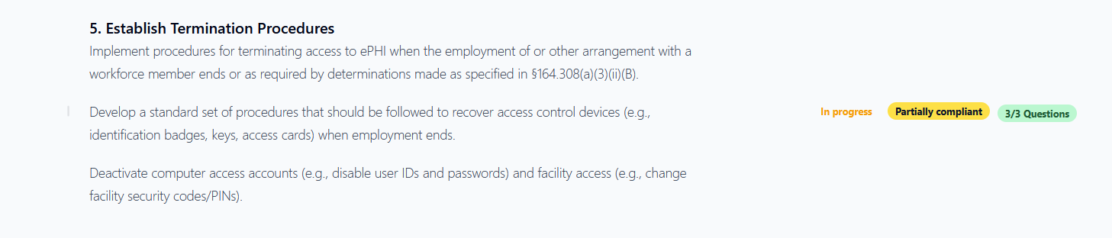
A1. HIPAA requirement - In progress, Partially compliant, 3/3 questions.
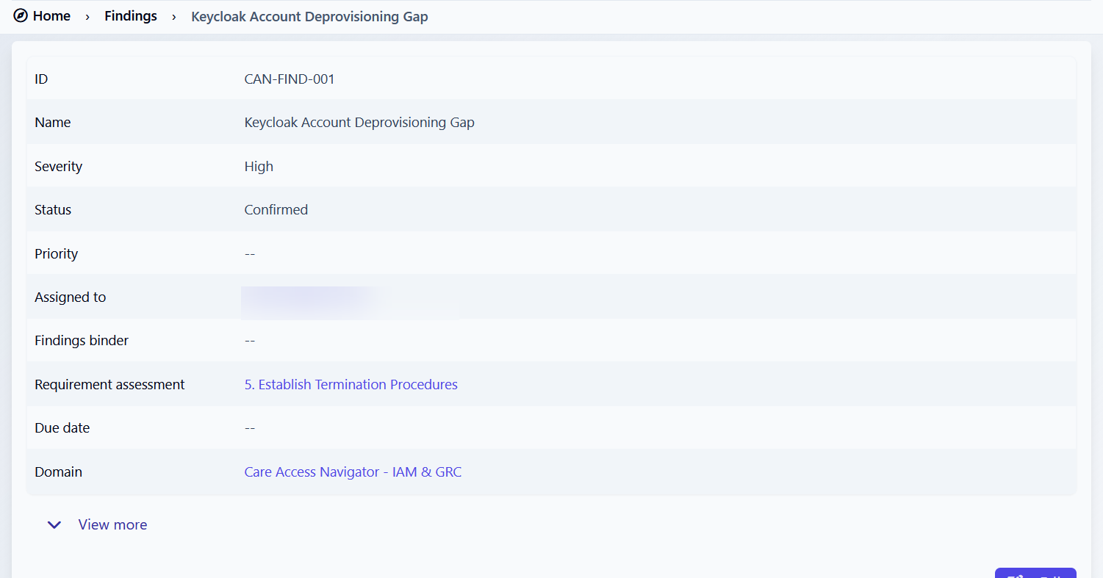
A2. Finding CAN-FIND-001 - High, Confirmed; requirement association verified. Assigned-user email blurred for shareability.

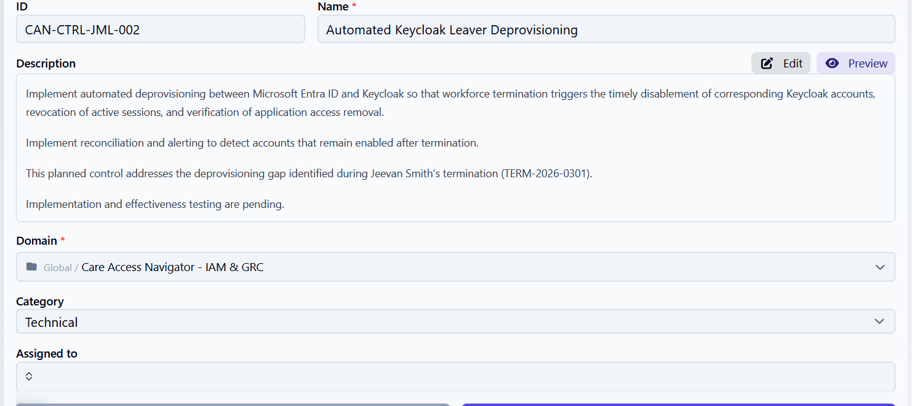
A3. Planned technical applied control CAN-CTRL-JML-002; implementation and testing explicitly pending.
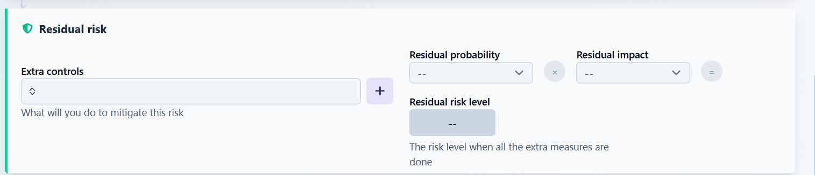
A4. Residual risk editing screen, including Extra controls and target scoring fields (before values were saved).

