Audit: Healthcare IAM - HIPAA Security Rule Access Controls Audit
Version:

NIST SP-800-66 rev2 (HIPAA)
Profile(s) :

09/11/2026

Auditors:
akchrao@gmail.com


Summary

Assessment scope:

Description:
This audit evaluates workforce identity and access management controls within the Care Access Navigator healthcare IAM and GRC capstone project, using NIST SP 800-66 Rev. 2 as guidance for the HIPAA Security Rule.
The assessment focuses on workforce termination procedures, account deprovisioning, access revocation, and verification across Microsoft Entra ID, Keycloak, and the Mock EHR application.
It uses the documented termination of Jeevan Smith (TERM-2026-0301) to evaluate the existing manual JML control (CAN-CTRL-JML-001), identify the Keycloak deprovisioning gap, and track the planned automated remediation (CAN-CTRL-JML-002).
Supporting evidence includes JML lifecycle records, access revocation verification, and the related risk scenario R02. The audit will document control effectiveness, compliance gaps, corrective actions, and outstanding risks.
This is a simulated, HIPAA-aligned assessment for educational purposes and does not certify regulatory compliance.

Observations:

Number of requirements: 152
17 | 7 | 1 | 0 | 127
Compliant | Partially compliant | Non-compliant | Not applicable | Not assessed

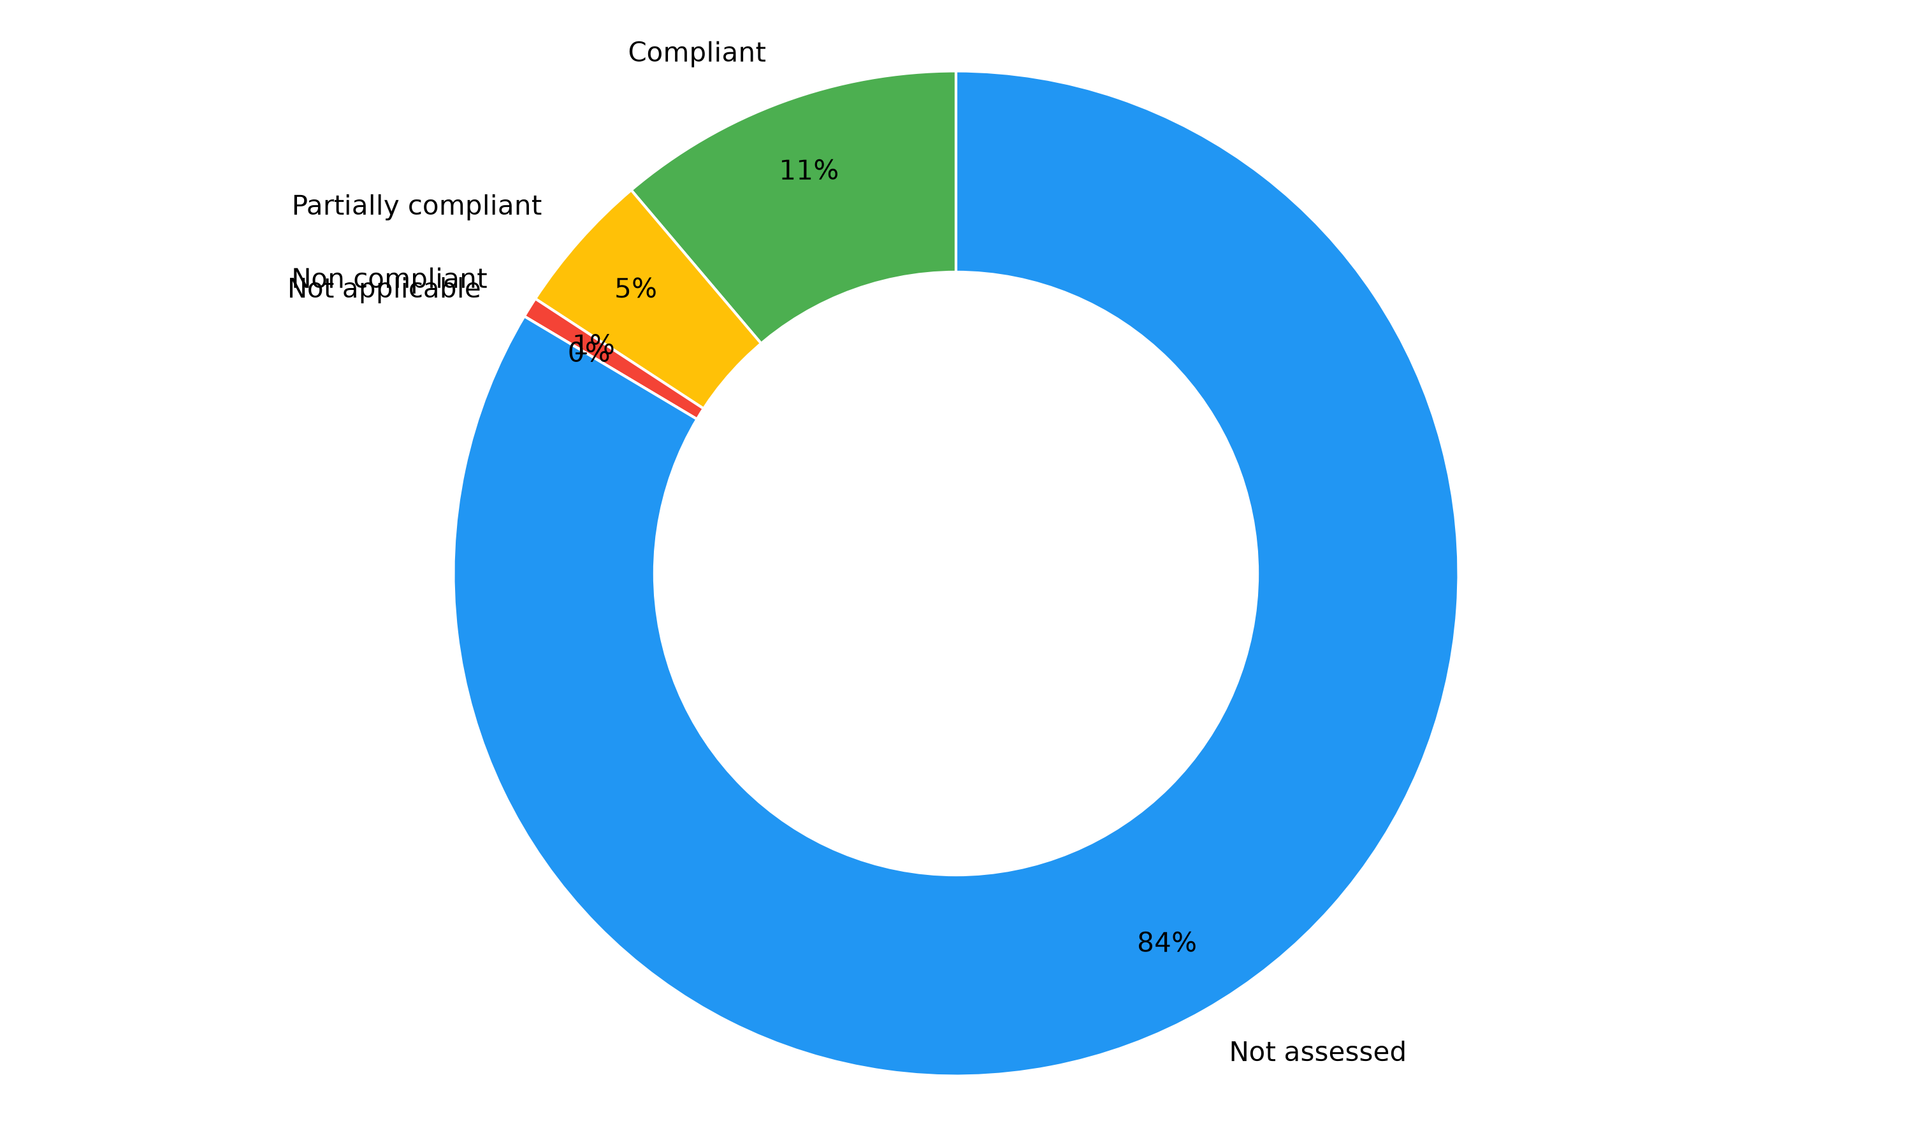

<Comments>


Audited scopes

Overview
The percentage indicates the completion of each section based on the items marked as compliant or non-applicable.

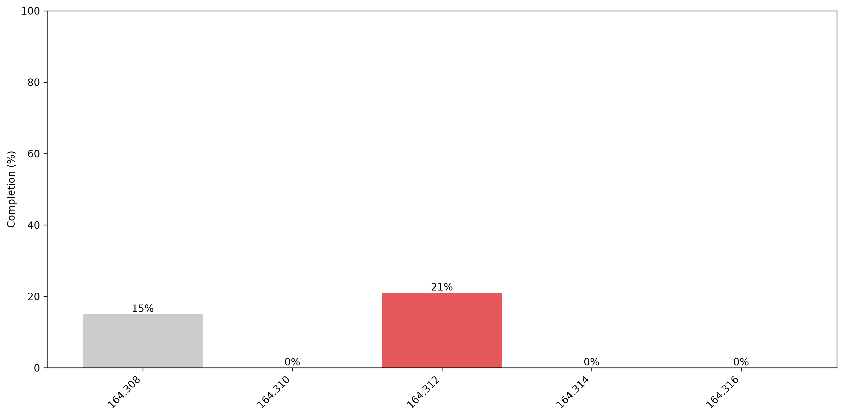
<comments>

Additionally, the following chart illustrates the maturity assessed by the auditor in each section:
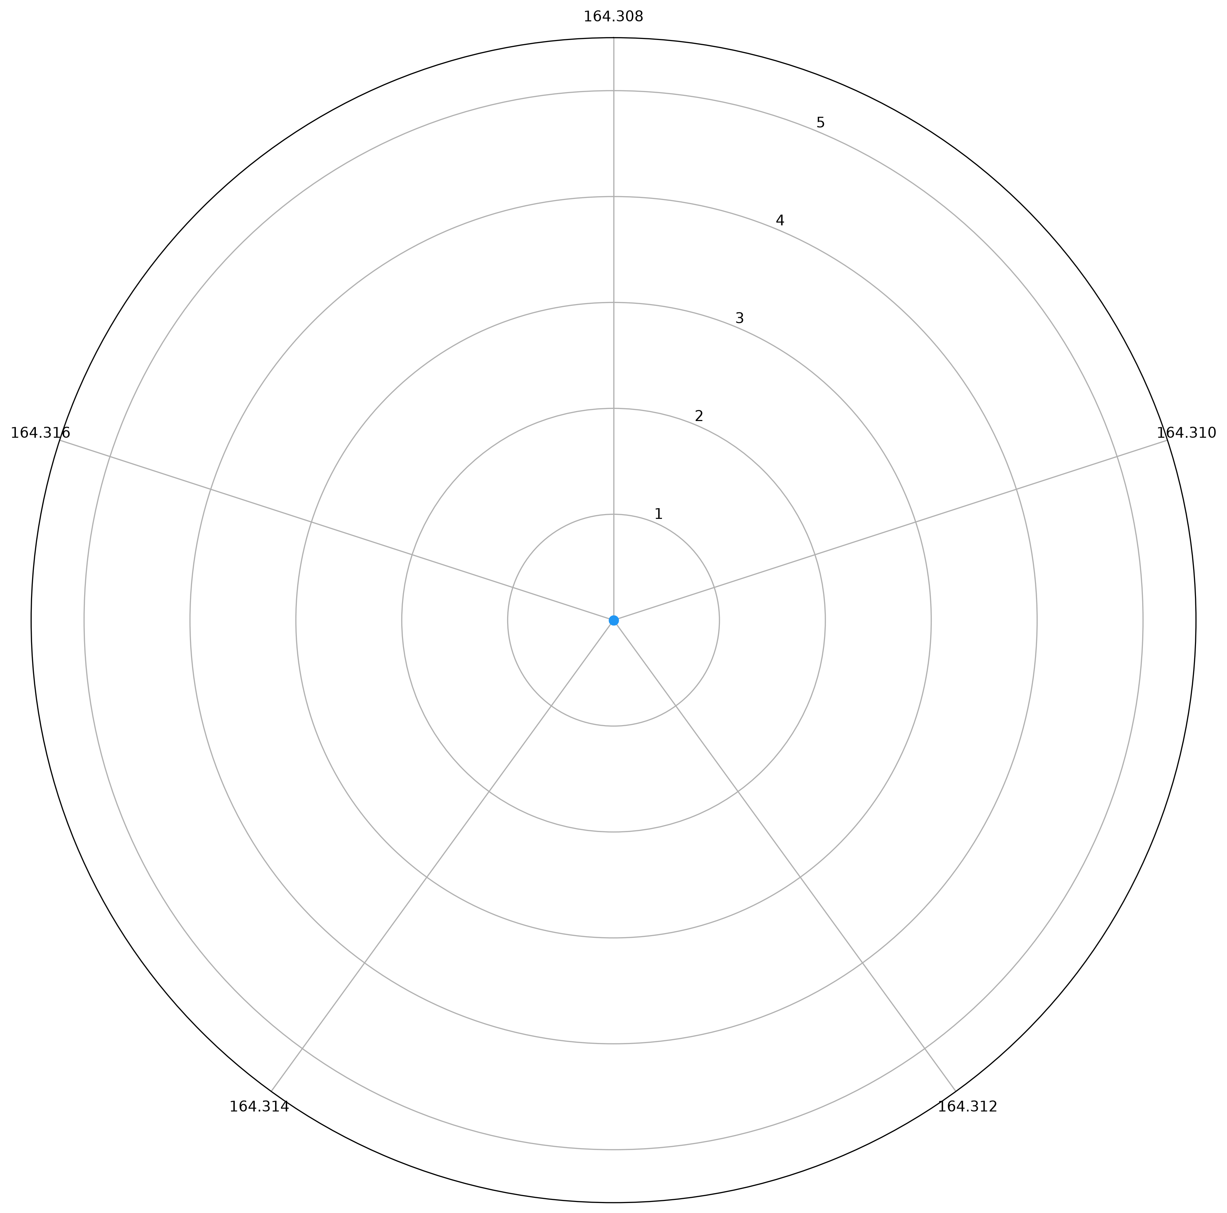

Auditor notes

Category | Drifts identified | Comments
164.308 | 57 | <comments>
164.310 | 24 | <comments>
164.312 | 27 | <comments>
164.314 | 18 | <comments>
164.316 | 9 | <comments>

Security controls

Overview
Identified security controls: 18

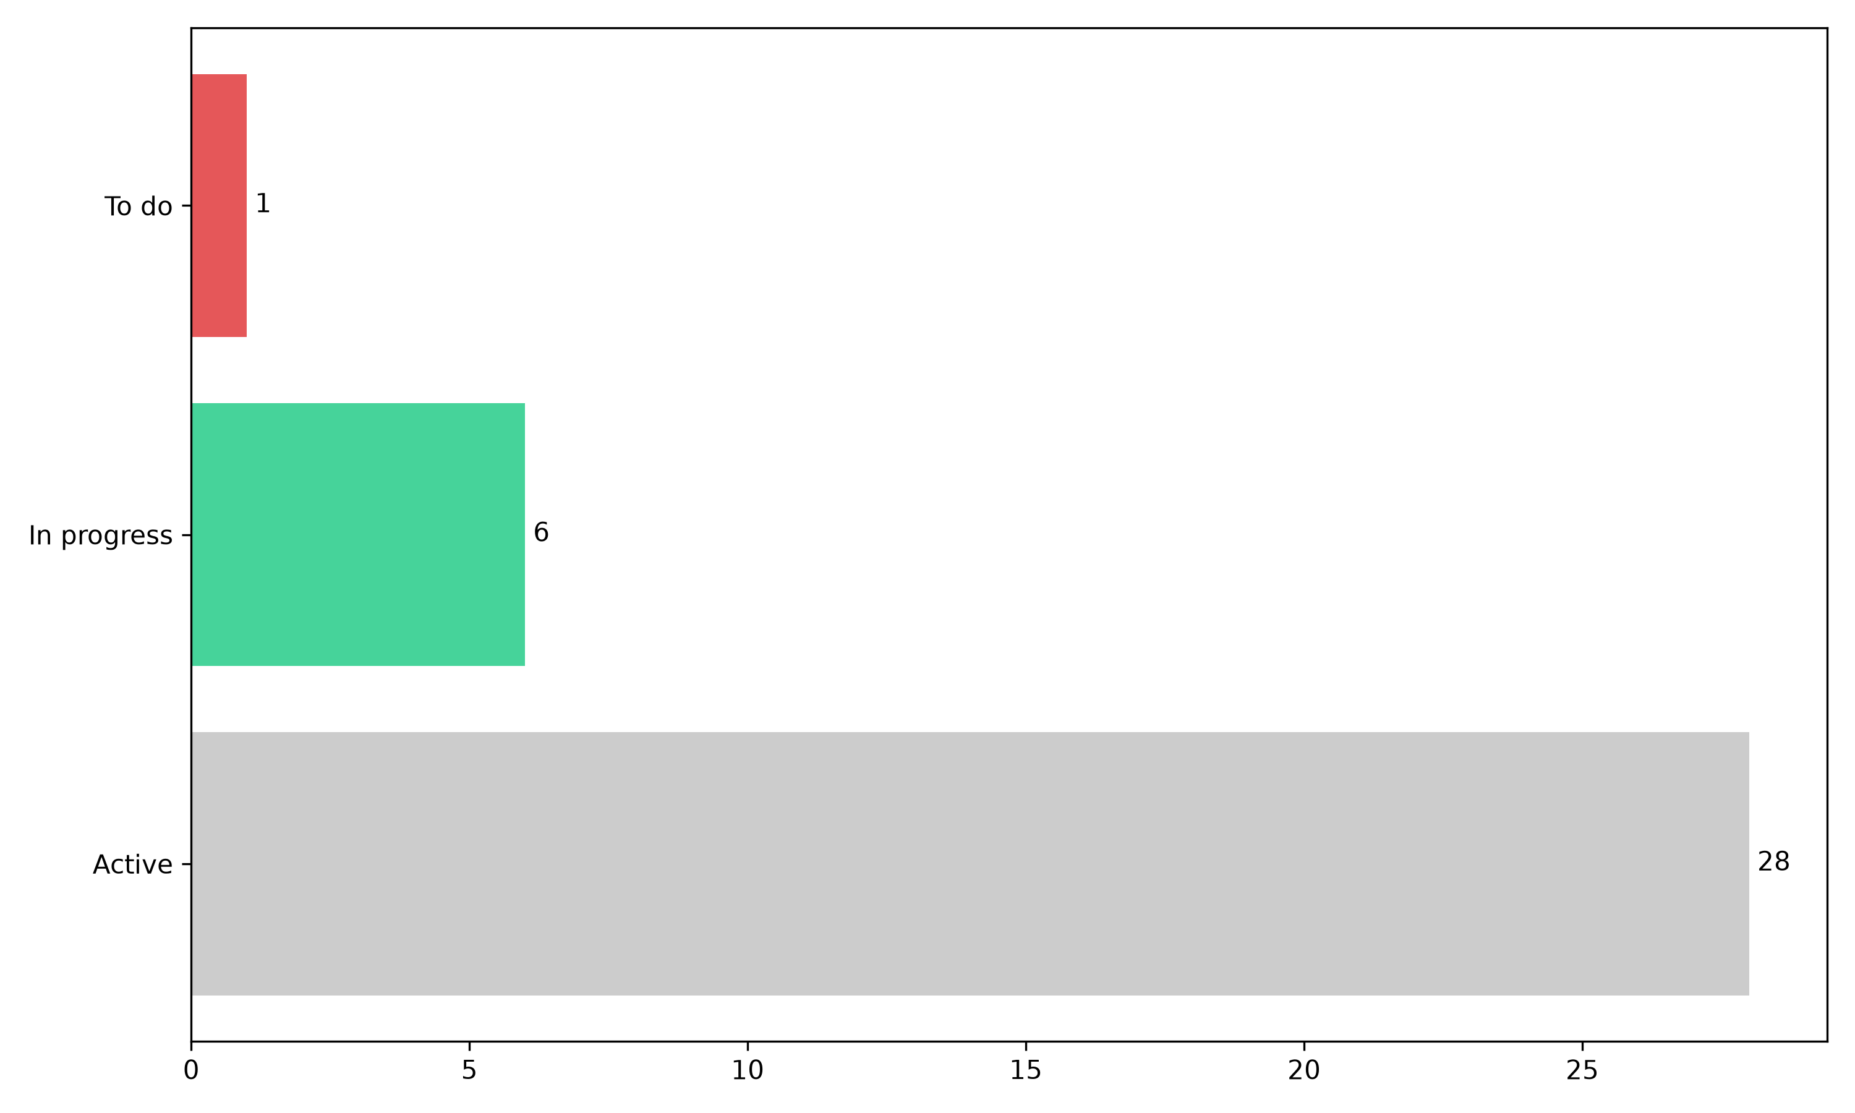
<comments>

Main priorities (P1)
The table below lists the security controls that have not been implemented yet and prioritized by the auditor:

Control | Description | Category | Status | Requirements covered

Auditor observations
<comments>


Full action plan
Control | Description | Priority | Category | Status | ETA | Requirements covered
Security-relevant identity events are logged | Security-relevant identity events are logged  Area: Monitoring  HIPAA: 164.312(b)  NIST CSF 2.0: DE.CM-03, PR.PS-04  NIST SP 800-53 r5: AU-2, AU-3, AU-12  ISO 27001:2022: A.8.15  PCI DSS 4.0.1: 10.2.1  Risks: R03, R04  Evidence: keycloak_login_events.csv; Wazuh (IR lab)  Test: W5 detect run  Test result (2026-11-03): PASS | - | Technical | Active | - | 2
ePHI and credentials are encrypted in transit (TLS 1.2+) | ePHI and credentials are encrypted in transit (TLS 1.2+)  Area: Data protection  HIPAA: 164.312(e)(1), (e)(2)(ii)  NIST CSF 2.0: PR.DS-02  NIST SP 800-53 r5: SC-8, SC-8(1)  ISO 27001:2022: A.8.24  PCI DSS 4.0.1: 4.2.1  Risks: R03  Evidence: Compliance E-ENC-01  Test: Audit ENC-01 tests 1-4  Test result (2026-11-03): PASS (Azure); EXCEPTION (IdP) | - | Technical | In progress | - | 1
Security logs are kept 12 months | Security logs are kept 12 months  Area: Monitoring / retention  HIPAA: 164.316(b)(2) (policy); 164.312(b)  NIST CSF 2.0: PR.PS-04  NIST SP 800-53 r5: AU-11  ISO 27001:2022: A.8.15  PCI DSS 4.0.1: 10.5.1  Risks: R03  Evidence: Compliance E-LOG-01  Test: Audit LOG-01 test 3  Test result (2026-11-03): FAIL | - | Technical | To do | - | 1
Lockout after repeated failures; strong password standard | Lockout after repeated failures; strong password standard  Area: Authentication  HIPAA: 164.308(a)(5)(ii)(D)  NIST CSF 2.0: PR.AA-03  NIST SP 800-53 r5: AC-7, IA-5(1)  ISO 27001:2022: A.5.17, A.8.5  PCI DSS 4.0.1: 8.3.4, 8.3.6, 8.3.7  Risks: R03  Evidence: EV-13 lockout + password tests  Test: W5 verify; TC-05  Test result (2026-11-03): PASS | - | Technical | Active | - | 3
Privileged and cardholder-data users pass MFA | Privileged and cardholder-data users pass MFA  Area: Authentication  HIPAA: 164.312(d)  NIST CSF 2.0: PR.AA-03  NIST SP 800-53 r5: IA-2(1), IA-2(2)  ISO 27001:2022: A.8.5  PCI DSS 4.0.1: 8.4.1, 8.4.2  Risks: R03  Evidence: EV-13 verify (MFA_REQUIRED)  Test: W5 verify; TC-03  Test result (2026-11-03): PASS | - | Technical | In progress | - | 1
Security risks are identified, scored and treated | Security risks are identified, scored and treated  Area: GRC  HIPAA: 164.308(a)(1)(ii)(A)-(B)  NIST CSF 2.0: ID.RA-05, ID.RA-06  NIST SP 800-53 r5: RA-3, PM-9  ISO 27001:2022: Clause 6.1.2, 6.1.3  PCI DSS 4.0.1: 12.3.1  Risks: R01-R05  Evidence: Risk register R01-R05 (Risk Management 1)  Test: Register review  Test result (2026-11-03): PASS | - | Process | Active | - | 2
Privileged access is approved, limited and monitored | Privileged access is approved, limited and monitored  Area: IAM / PAM  HIPAA: 164.308(a)(4)(ii)(B)  NIST CSF 2.0: PR.AA-05  NIST SP 800-53 r5: AC-2(7), AC-6(5), AC-6(9)  ISO 27001:2022: A.8.2  PCI DSS 4.0.1: 7.2.2, 8.2.2  Risks: R04  Evidence: Privileged access matrix; TC-07  Test: TC-07  Test result (2026-11-03): PASS | - | Technical | In progress | - | 2
Users receive only the access their job requires (RBAC, least privilege) | Users receive only the access their job requires (RBAC, least privilege)  Area: IAM / RBAC  HIPAA: 164.308(a)(4)(ii)(B); 164.312(a)(1)  NIST CSF 2.0: PR.AA-05  NIST SP 800-53 r5: AC-2, AC-3, AC-6  ISO 27001:2022: A.5.15, A.5.18  PCI DSS 4.0.1: 7.2.1, 7.2.2  Risks: R01  Evidence: EV-13 access reviews; TC-01  Test: TC-01; audit AC-01 tests 1-2  Test result (2026-11-03): PASS | - | Technical | Active | - | 5
Terminated users are disabled and all access removed promptly | Terminated users are disabled and all access removed promptly  Area: IAM / JML  HIPAA: 164.308(a)(3)(ii)(C)  NIST CSF 2.0: PR.AA-01, PR.AA-05  NIST SP 800-53 r5: AC-2, PS-4  ISO 27001:2022: A.5.18, A.6.5  PCI DSS 4.0.1: 8.2.5  Risks: R02  Evidence: JML evidence (TERM-2026-0301); TC-04; TC-09  Test: TC-04; TC-09  Test result (2026-11-03): PASS (after CA-09) | - | Technical | Active | - | 2
Automated Keycloak Leaver Deprovisioning | Implement automated deprovisioning between Microsoft Entra ID and Keycloak so that workforce termination triggers the timely disablement of corresponding Keycloak accounts, revocation of active sessions, and verification of application access removal.  Implement reconciliation and alerting to detect accounts that remain enabled after termination.  This planned control addresses the deprovisioning gap identified during Jeevan Smith's termination (TERM-2026-0301).  Implementation and effectiveness testing are pending.  Remediation Validation Plan – R02  Objective: Verify that terminating a workforce member in Microsoft Entra ID automatically revokes their Keycloak access and prevents access to the Mock EHR application.  Test 1 – Account deprovisioning: Disable a synthetic employee account in Entra ID. Verify that the corresponding Keycloak account is automatically disabled within the organization's defined termination SLA.  Test 2 – Session revocation: Confirm that active Keycloak sessions are terminated or invalidated and that the terminated employee cannot reuse an existing application session.  Test 3 – Access verification: Attempt to authenticate and access the Mock EHR using the terminated test account. Verify that access is denied.  Test 4 – Audit logging: Confirm that termination, account disablement, session revocation, and verification activities are logged with timestamps.  Test 5 – Monitoring: Confirm that reconciliation or alerting identifies accounts that remain enabled after termination.  Acceptance criteria: All five tests must pass, with supporting screenshots and log evidence. Any failure requires corrective action and retesting.  Related finding: CAN-FIND-001  Related risk: R02  Status: Planned – Implementation and validation pending. | P4 | Technical | In progress | - | 1
Workforce Termination and Access Revocation | This control manages employee termination and access revocation across Microsoft Entra ID and Keycloak.  It includes disabling terminated employee accounts, revoking sessions, removing application roles, manually disabling federated Keycloak accounts, and verifying access removal.  Jeevan Smith's termination (TERM-2026-0301) demonstrated successful manual deprovisioning. However, automatic Keycloak account deactivation is not yet implemented, creating a residual IAM security risk. | - | Process | Active | - | 1
Alerts are raised and investigated | Alerts are raised and investigated  Area: Monitoring / IR  HIPAA: 164.308(a)(1)(ii)(D); 164.308(a)(6)(ii)  NIST CSF 2.0: DE.AE-02, DE.AE-06  NIST SP 800-53 r5: AU-6, SI-4  ISO 27001:2022: A.8.16  PCI DSS 4.0.1: 10.4.1  Risks: R03, R04  Evidence: identity_detections.csv; IR1 Tasks 2-3  Test: TC-05, TC-06, TC-07  Test result (2026-11-03): PASS (TC-05 after CA-10) | - | Technical | Active | - | 4
Access is reviewed periodically and findings are remediated | Access is reviewed periodically and findings are remediated  Area: IAM / GRC  HIPAA: 164.308(a)(4)(ii)(C); 164.308(a)(1)(ii)(D)  NIST CSF 2.0: PR.AA-05, ID.IM-01  NIST SP 800-53 r5: AC-2(j)  ISO 27001:2022: A.5.18  PCI DSS 4.0.1: 7.2.4, 7.2.5.1  Risks: R01, R02  Evidence: access_review_*.csv; TC-09; AR-2026-Q4 signed 2026-11-09  Test: TC-09; AR-2026-Q4 sign-off  Test result (2026-11-03): PASS | - | Process | Active | - | 3
Vendor access is sponsored, time-boxed and removed at expiry | Vendor access is sponsored, time-boxed and removed at expiry  Area: Third-party access  HIPAA: 164.308(b)(1); 164.314(a)  NIST CSF 2.0: GV.SC-07, PR.AA-05  NIST SP 800-53 r5: AC-2(2), PS-7  ISO 27001:2022: A.5.19, A.5.20  PCI DSS 4.0.1: 8.2.7  Risks: R05  Evidence: Service/vendor identity register; TC-08  Test: TC-08  Test result (2026-11-03): PASS | - | Process | In progress | - | 1
Control gaps are tracked to verified remediation | Control gaps are tracked to verified remediation  Area: GRC  HIPAA: 164.308(a)(8)  NIST CSF 2.0: ID.IM-01, GV.OV-03  NIST SP 800-53 r5: CA-5, CA-7  ISO 27001:2022: Clause 10.2  PCI DSS 4.0.1: 12.4.2  Risks: R01-R05  Evidence: Corrective action tracker; exception register  Test: TC-10  Test result (2026-11-03): PASS | - | Process | Active | - | 2
Incidents are handled with a tested playbook | Incidents are handled with a tested playbook  Area: Incident response  HIPAA: 164.308(a)(6)(i)-(ii)  NIST CSF 2.0: RS.MA-01, RS.AN-03  NIST SP 800-53 r5: IR-4, IR-5, IR-8  ISO 27001:2022: A.5.24-A.5.28  PCI DSS 4.0.1: 12.10.1  Risks: R03, R04  Evidence: IR1 Tasks 1-6; CAN-IR-PB-02  Test: IR1 Task 6 (34 checks)  Test result (2026-11-03): PASS | - | Process | Active | - | 2
Role changes remove old access before new access is granted | Role changes remove old access before new access is granted  Area: IAM / JML  HIPAA: 164.308(a)(4)(ii)(C)  NIST CSF 2.0: PR.AA-05  NIST SP 800-53 r5: AC-2, PS-5  ISO 27001:2022: A.5.18  PCI DSS 4.0.1: 7.2.4  Risks: R01  Evidence: JML evidence (CHG-2026-0201); TC-03  Test: TC-03  Test result (2026-11-03): PASS | - | Technical | Active | - | 1
Each application admits only approved job roles | Each application admits only approved job roles  Area: IAM / application access  HIPAA: 164.312(a)(1)  NIST CSF 2.0: PR.AA-05  NIST SP 800-53 r5: AC-3  ISO 27001:2022: A.8.3  PCI DSS 4.0.1: 7.2.1  Risks: R01  Evidence: EV-13 app-gate verify; TC-02  Test: TC-02  Test result (2026-11-03): PASS | - | Technical | Active | - | 1

Appendix

- Details of the requirements and attached evidences
- The remediation plan (controls list)
- Auditor background and approach

