PRACTICAL NO. 01
Aim :-
  - Write a Java program to demonstrate a Generic Class.
Code :-
package prac1;
public class prac1a<T> {
private T value;
public prac1a(T value) {
this.value = value;
}
public void displayValue() {
if (value instanceof Integer) {
System.out.println("Value of Integer: " + value);
} else if (value instanceof String) {
System.out.println("Value of String: " + value);
} else {
System.out.println("Value: " + value);
}
}
public static void main(String[] args) {
prac1a<Integer> intInstance = new prac1a<>(33);
intInstance.displayValue();
prac1a<String> strInstance = new prac1a<>("TABISH KHAN");
strInstance.displayValue();
}
}

Output :-
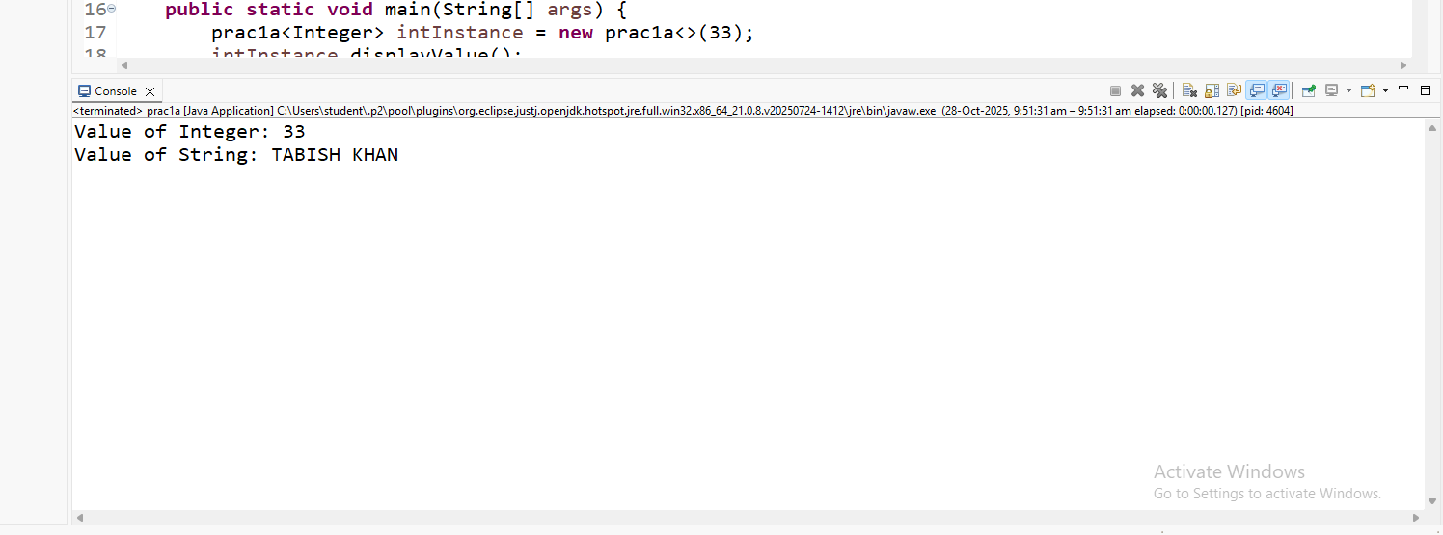

Aim :-
1.2 Write a program to demonstrate Generic Methods.
Code :-
package prac1;
public class prac1b {
void display() {
System.out.println("GENERIC METHOD EXAMPLE");
}
public <T> void printName(T name) {
System.out.println("Name: " + name);
}
public <U> void printRollNo(U rollNo) {
System.out.println("Roll No: " + rollNo);
}
public <V> void printAge(V age) {
System.out.println("Age: " + age);
}
public static void main(String[] args) {
prac1b obj = new prac1b();
obj.display();
obj.printName("TABISH KHAN");
obj.printRollNo(33);
obj.printAge(22);
}
}

Output :-
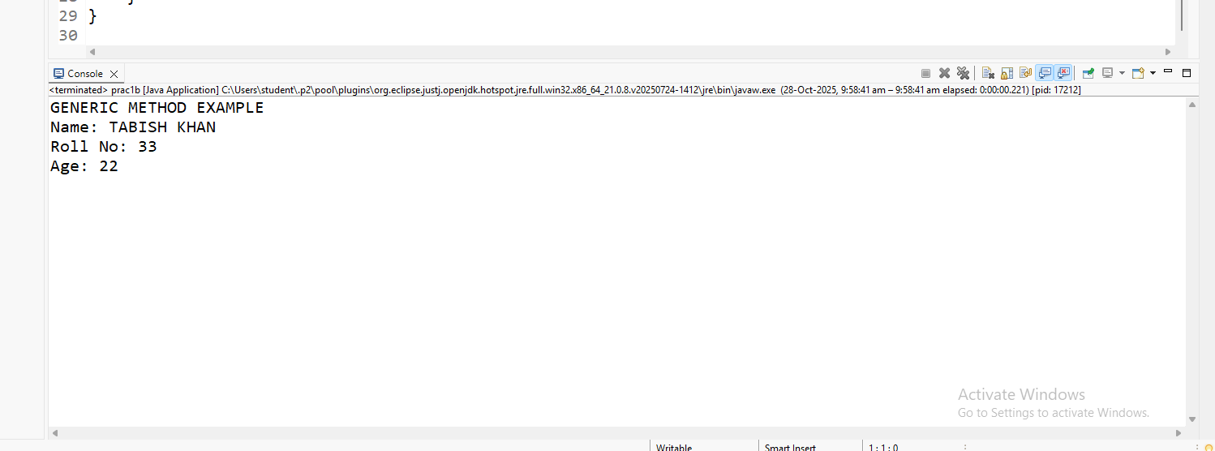

Aim :-
1.3 Write a program to demonstrate Wild Cards in Java Generics.
Code :-
import java.util.*;
public class prac1c {
private static double sum(List<? extends Number> list) {
double sum = 0.0;
for (Number i : list) {
sum = sum + i.doubleValue();
}
return sum;
}
public static void show(List<? super Integer> list) {
list.forEach(x -> {
System.out.println(x + " ");
});
}
public static void main(String[] args) {
System.out.println("Roll no: 25MCA-33");
System.out.println("Name: Khan Tabish");
System.out.println("\nUpper bounded:");
List<Integer> list1 = Arrays.asList(4, 2, 7, 5, 1, 9);
System.out.println("List 1 Sum: " + sum(list1));
List<Double> list2 = Arrays.asList(4.7, 2.4, 7.3, 5.4, 1.5, 9.2);
System.out.println("List 2 Sum: " + sum(list2));
System.out.println("\nLower bounded:");
System.out.println("Only classes with Integer superclass will be accepted");

List<Integer> list3 = Arrays.asList(4, 2, 7, 5, 1, 9);
show(list3);
}
}

Output :-
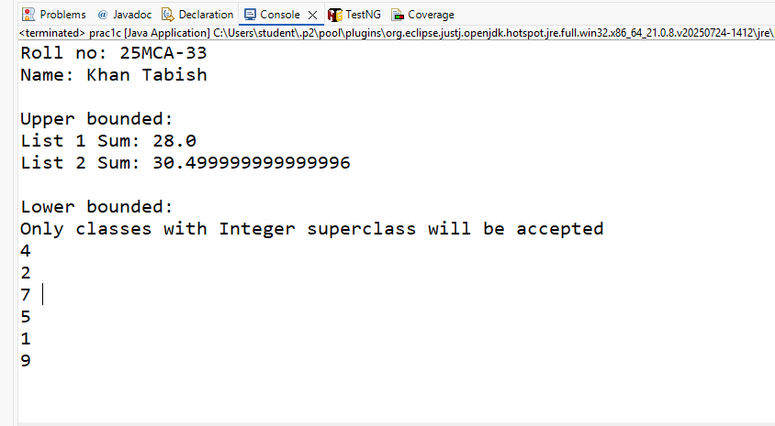

PRACTICAL NO. 02
Aim :-
2.1 Write a Java program to create List containing list of items of type String and use for-each loop to print the items of the list.
Code :-
package prac2;
import java.util.ArrayList;
public class prac2a {
public static void main(String[] args) {
ArrayList<String>list = new ArrayList<String>();
list.add("MATHS");
list.add("ADBMS");
list.add("JAVA");
list.add("PYTHON");
System.out.println("NAME:TABISH KHAN");
System.out.println("ROLL-NO:25MCA-33");
System.out.println(list);
System.out.println("Traversing list THrough for Each loop");
for(String subject:list)
System.out.println(subject);
}
}

Output :-
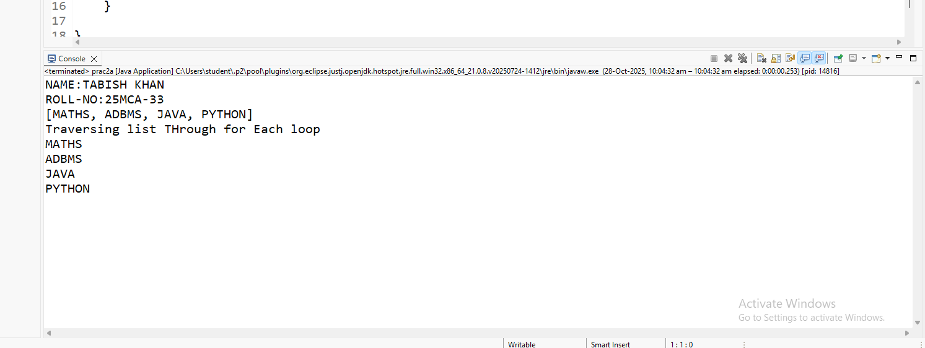

Aim :-
2.2 Write a Java program to create List containing list of items and use ListIterator interface to print items present in the list. Also print the list in reverse / backward direction.
Code :-
package prac2;
import java.util.*;
public class prac2b {
public static void main(String[] args) {
System.out.println("ROLLNO:25MCA-33");
System.out.println("NAME:TABISH KHAN");
List<String> pro = new ArrayList<>();
pro.add("p1");
pro.add("p2");
pro.add("p3");
pro.add("p4");
pro.add("p5");
ListIterator<String> fi = pro.listIterator();
System.out.println("Forward iteration:");
while (fi.hasNext()) {
System.out.println(fi.next());
}
ListIterator<String> bi = pro.listIterator(pro.size());
System.out.println("\nBackward iteration:");
while (bi.hasPrevious()) {
System.out.println(bi.previous());
}
}
}
Output :-
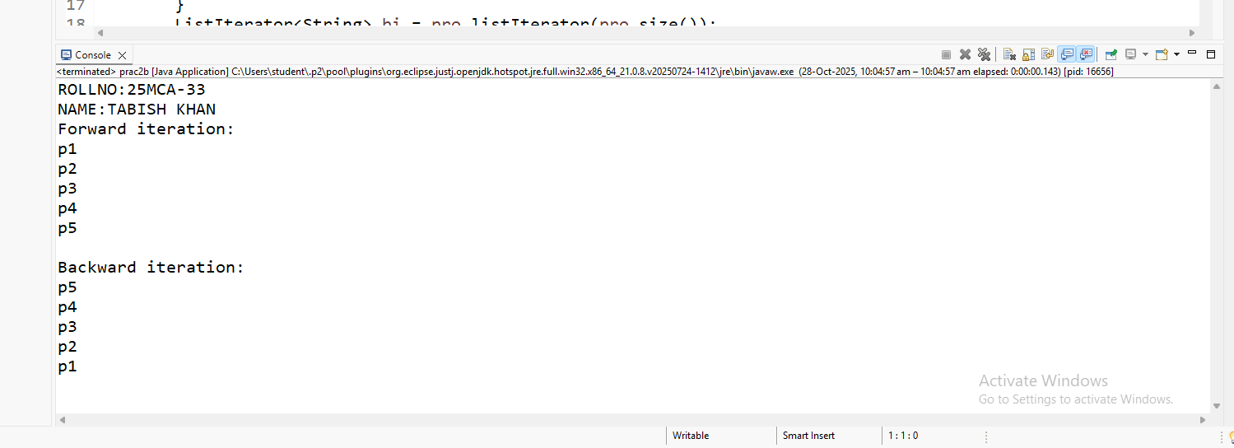

PRACTICAL NO. 3
Aim :-
3.1 Write a Java program to create a Set containing list of items of type String and print the items in the list using Iterator interface. Also print the list in reverse / backward direction.
Code :-
package prac3;
import java.util.*;
public class prac3a {
public static void main(String[] args) {
System.out.println("ROLLNO:25MCA-33");
System.out.println("NAME:TABISH KHAN");
LinkedList<String> proList = new LinkedList<>();
proList.add("ANKIT");
proList.add("SANKET");
proList.add("AYUSH");
proList.add("AMIT");
proList.add("BHUVAN");
ListIterator<String> fi = proList.listIterator();
System.out.println("Forward iteration listIterator :");
while (fi.hasNext()) {
System.out.println(fi.next());
}
ListIterator<String> bi = proList.listIterator(proList.size());
System.out.println("\nBackward iteration listIterator:");
while (bi.hasPrevious()) {
System.out.println(bi.previous());
}
}
}
Output :-
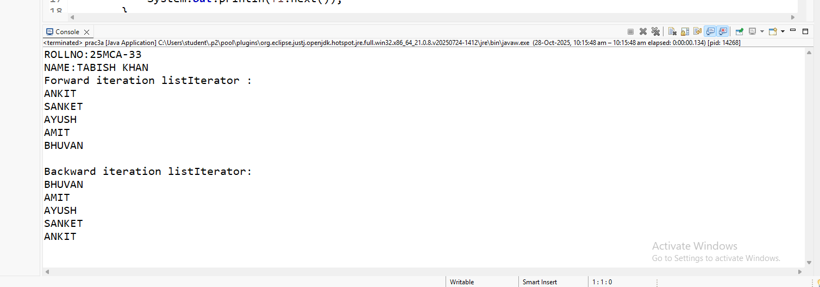

Aim :-
3.2 Write a Java program using Set interface containing list of items and perform the following operations:
- Add items in the set.
- Insert items of one set in to other set.
- Remove items from the set
- Search the specified item in the set
Code :-
package prac3;
import java.util.*;
public class prac3b {
public static void main(String[] args) {
System.out.println("ROLLNO:25MCA-33");
System.out.println("NAME:TABISH KHAN");
Set<String> set1 = new HashSet<>();
set1.add("ANKIT");
set1.add("SANKET");
set1.add("AYUSH");
set1.add("AMIT");
set1.add("BHUVAN");
System.out.println("Set after adding elements: " + set1);
Set<String> set2 = new HashSet<>();
set2.add("RAVI");
set2.add("MANOJ");
set2.add("VIKRAM");
set1.addAll(set2);
System.out.println("Set1 after adding all elements of Set2: " + set1);
set1.remove("AMIT");
System.out.println("Set1 after removing 'AMIT': " + set1);
boolean isPresent = set1.contains("AYUSH");
System.out.println("Is AYUSH present in set1: " + isPresent);
}
}
Output :-
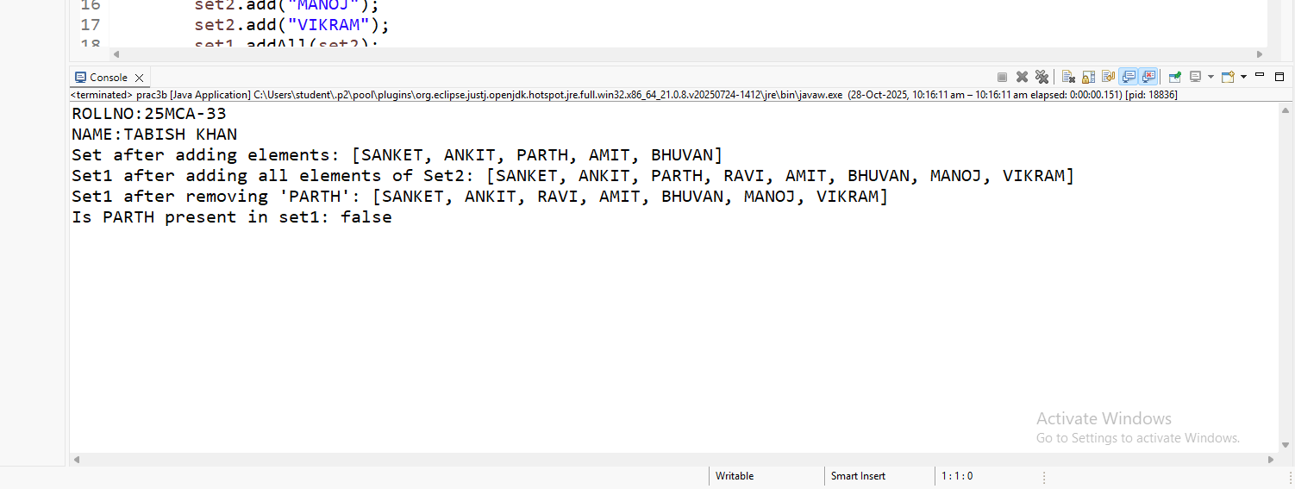

PRACTICAL NO. 4
Aim :- Write a Java program using Map interface containing list of items having keys and associated values and perform the following operations:
- Add items in the map.
- Remove items from the map
- Search specific key from the map
- Get value of the specified key
- Insert map elements of one map in to other map.
- Print all keys and values of the map.
Code:-
package prac4;
import java.util.*;
public class prac4a {
public static void main(String[] args) {
System.out.println("ROLL NO:25MCA-33");
System.out.println("NAME:TABISH KHAN");
Map<Integer,String>map1=new HashMap<>();
map1.put(1,"Aniket");
map1.put(2,"Suresh");
map1.put(3,"Tabish");
System.out.println("map1: "+map1);
Map<Integer,String>map2=new HashMap<>();
map2.put(4,"Amit");
map2.put(5,"Bhuvan");
map2.put(6,"Max");
System.out.println("map2: "+map2);
map1.putAll(map2);
System.out.println("map1 after adding map2 in map1: "+map1);

map1.remove(5);
System.out.println("map1 after removing :"+map1);
boolean isPresent=map1.containsKey(1);
System.out.println("is apple present: "+ isPresent);
String value=map1.get(2);
System.out.println("Value for key 2 is:"+ value);
for(Map.Entry<Integer,String>entry:map1.entrySet())
{
System.out.println("key: "+entry.getKey()+" values: "+entry.getValue());
}
}
}
Output :-
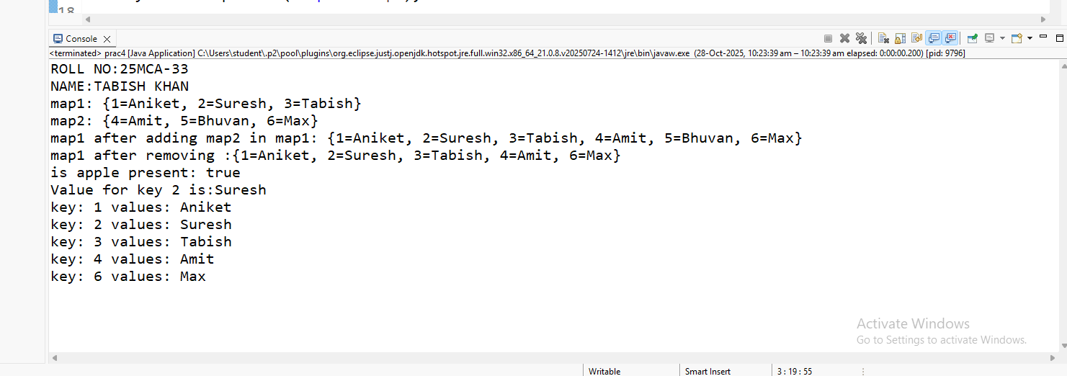

PRACTICAL NO. 5
Aim :-
5.1 Write a program using Lambda Expression to print “Hello World”.
Code :-
package prac5;
public class prac5a {
public static void main(String[] args) {
Runnable helloworld =()->System.out.println("Hello World");
Runnable Name =()->System.out.println("Tabish Khan");
Runnable Rollno =()->System.out.println("25MCA-33");
helloworld.run();
Name.run();
Rollno.run();
}
}

Output :-
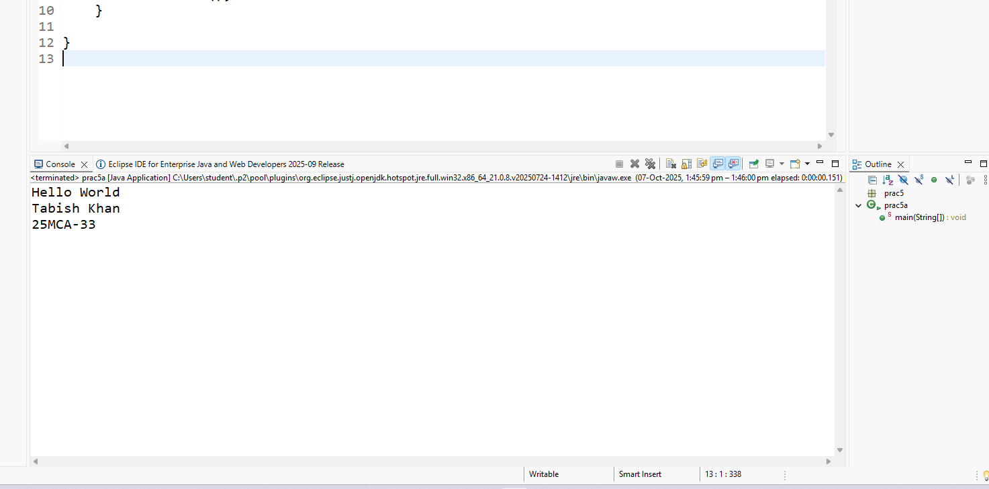

Aim :-
5.2 Write a program using Lambda Expression to print names with single parameters.
Code :-
package prac5;
import java.util.*;
public class prac5b {
public static void main(String[] args) {
System.out.println("Rollno:25MCA-33");
System.out.println("Name: Khan Tabish Mujeeb");
List<String>names=Arrays.asList("Tabish","Ahsan","Majid");
names.forEach(name->System.out.println("Hello "+name+"!"));
}
}

Output :-
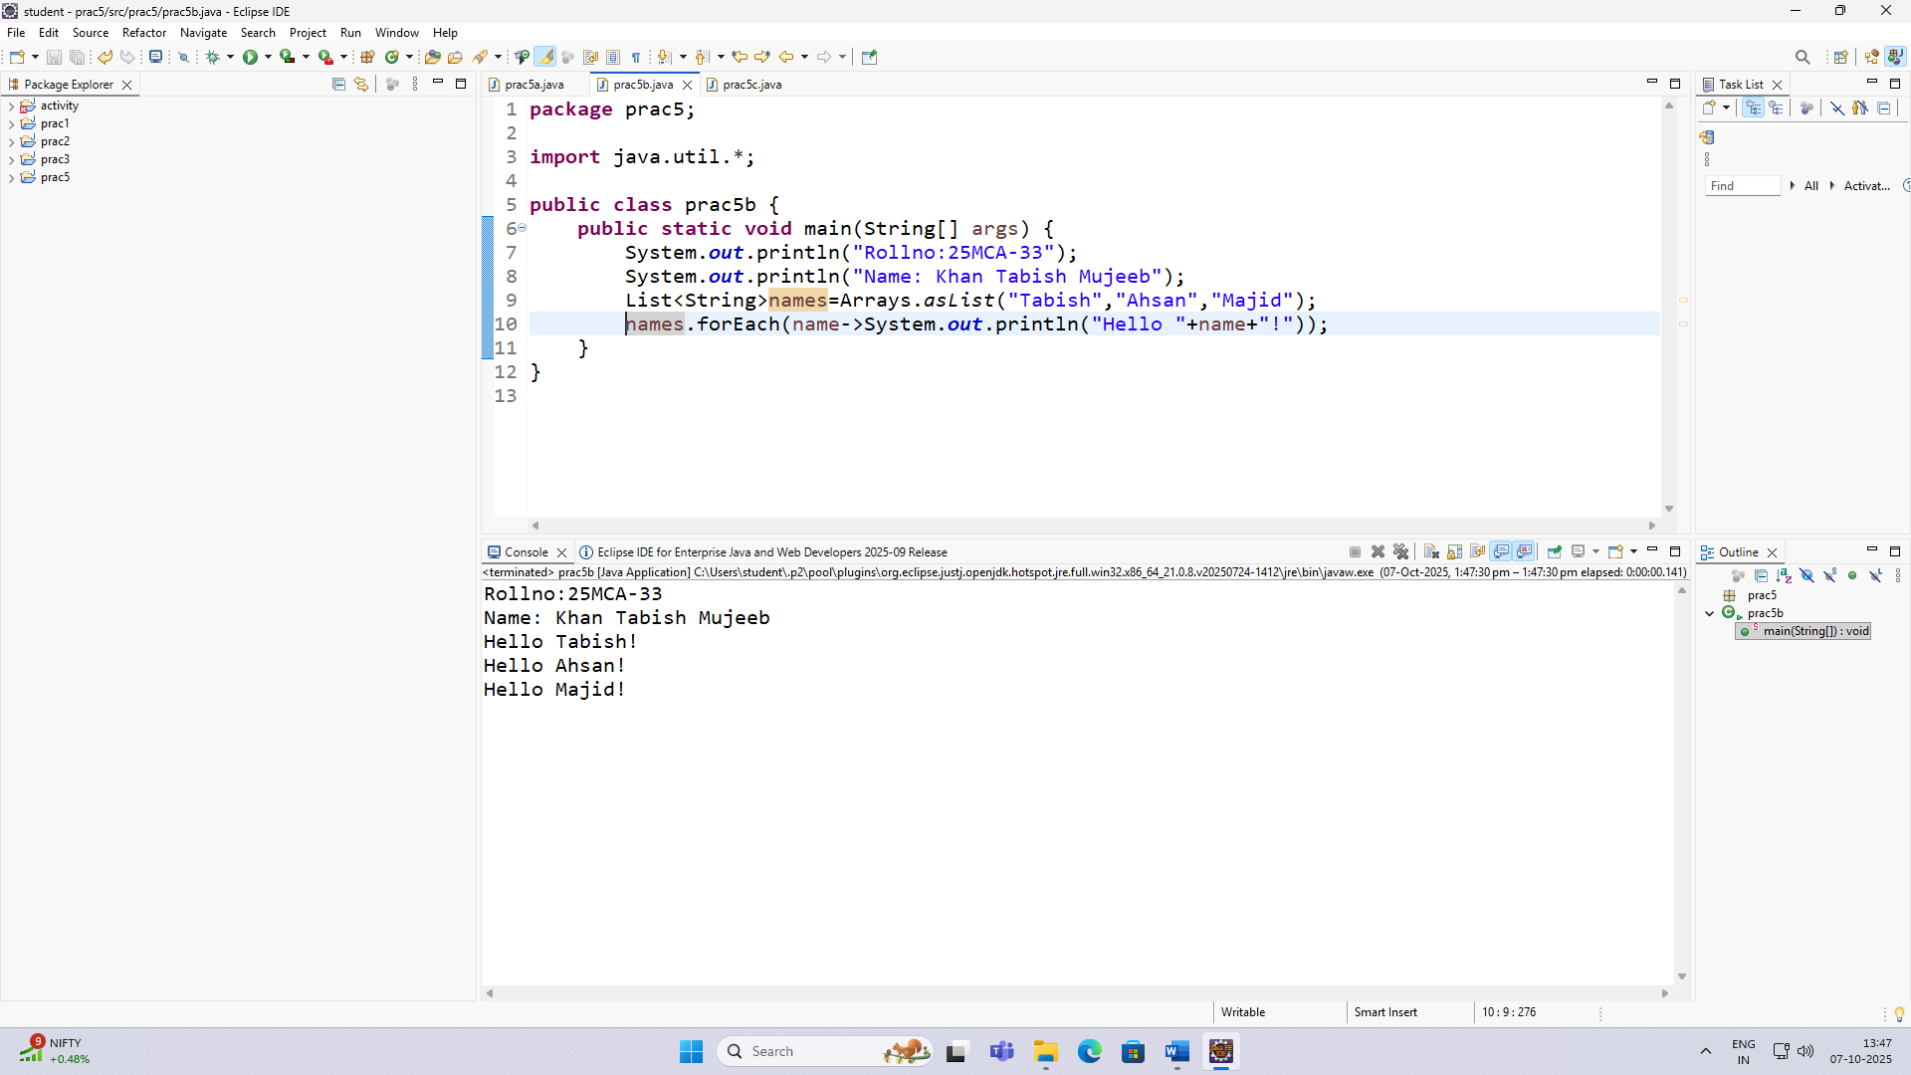

Aim :-
5.3 Write a program using Lambda Expression with multiple parameters to add two
numbers.
package prac5;
interface A{
int add(int i,int j);
}
public class prac5c {
public static void main(String[] args) {
A num=(i,j)->i+j;
int result = num.add(15,56);
System.out.println("Rollno:25MCA-33");
System.out.println("Name: Khan Tabish Mujeeb");
System.out.println("Addition of number "+result);
}
}

Output :-
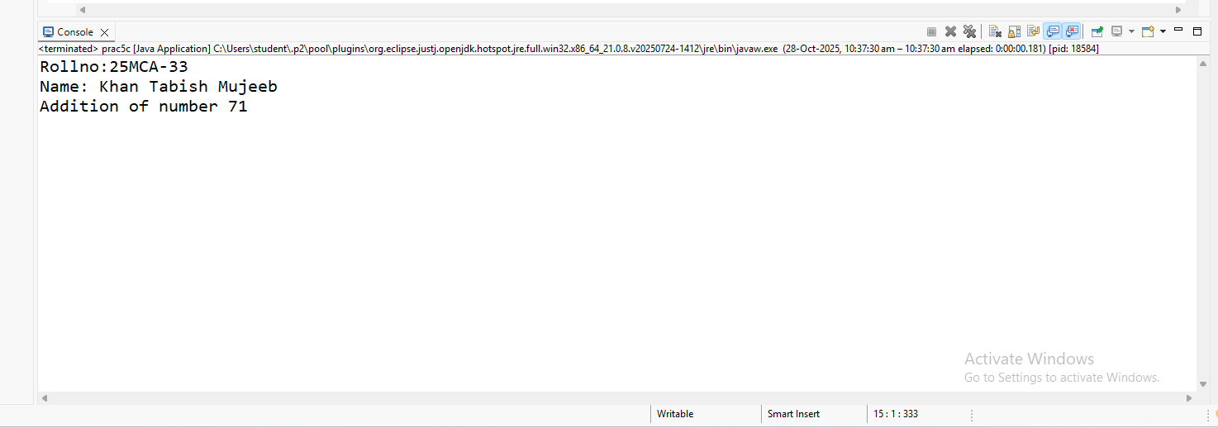

Aim :-
5.4 Write a program using Lambda Expression to calculate the following :
- 1.Convert Fahrenheit to Celsius.
- 2.Convert Kilometers to Miles.
Code :-
package prac5;
interface Converter{
double convert(double input);
}
public class pracE {
public static void main(String[] args) {
System.out.println("ROLLNO:25MCA-33");
System.out.println("NAME:TABISH KHAN");
Converter a=f->(f-32)*5/9;
double celcius=a.convert(100);
System.out.println("100 Degree fahrenite is "+celcius+" Degree celcius");
Converter b=km->km/1.609344;
double miles=b.convert(90);
System.out.println("90 kilometer is:"+miles+" miles");
}
}
Output :- 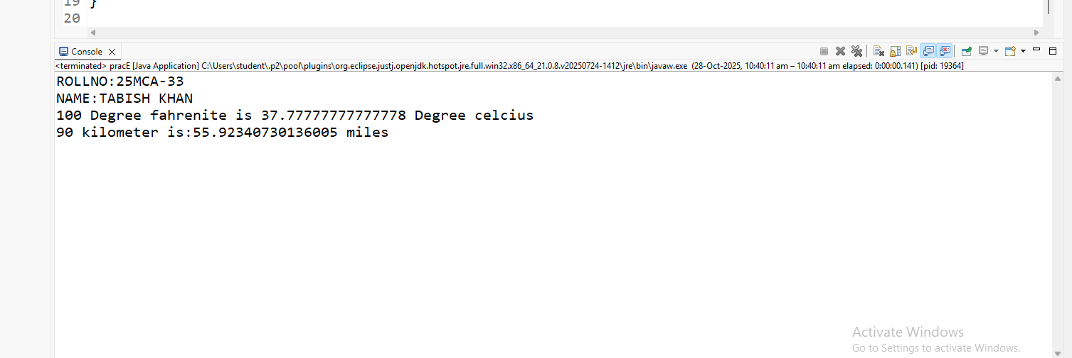
Aim :-
5.5 Write a program using Lambda Expression with or without return keyword.
Code :-
package prac5;
interface Calculator{
int calculate(int i,int j);
}
public class prac5e {
public static void main(String[] args) {
System.out.println("ROLLNO:25MCA-33");
System.out.println("NAME:TABISH KHAN");
Calculator add=(i,j)->i+j;
Calculator subtract=(i,j)->{
return i=j;
};
int sum=add.calculate(10,8);
int diffrence=subtract.calculate(78,45);
System.out.println("Without return keyword addition:" +sum);
System.out.println("with return keyword diffrence:"+diffrence);
}

}

Output :-
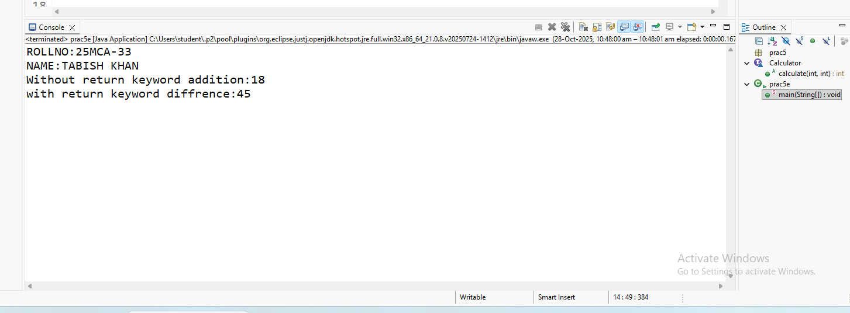

Aim :-
5.6 Write a program using Lambda Expression to concatenate two Strings:
Code :-
package prac5;
public interface Concatentor{
String concatenate(String s1, String s2);
}
public class prac5f{
public static void main(String[] args) {
String str = "Khan";
String str1 = " Tabish";
Concatentor s = (s1, s2) -> s1 + s2;
String res = s.concatenate(str, str1);
System.out.println("The concatenation string is " + res);
}
}

Output :-
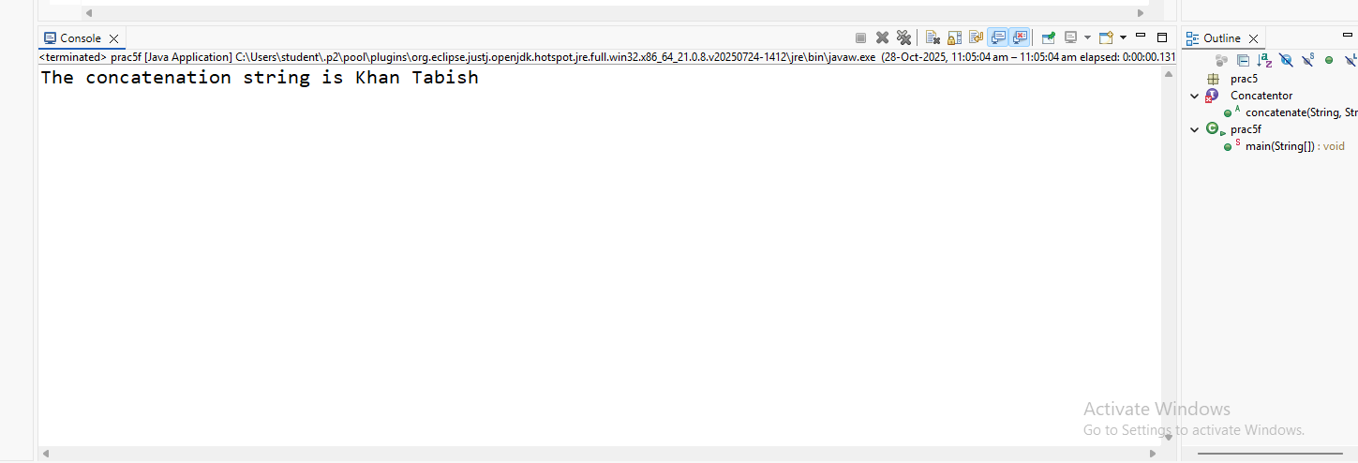

PRACTICAL NO. 6
Aim :-
6.2 Write a JSP page to display the Registration form
Code :-
registration.jsp
<%@ page language="java" contentType="text/html; charset=UTF-8" pageEncoding="UTF-8"%>
<!DOCTYPE html>
<html>
<head>
<meta charset="UTF-8">
<title>Complete Registration Form</title>
<style>
body {
font-family: Arial, sans-serif;
background-color: #e9f0f5;
display: flex;
justify-content: center;
align-items: center;
height: 100vh;
}
.container {
width: 600px;
background-color: white;
padding: 30px;
border-radius: 10px;
box-shadow: 0 0 15px rgba(0,0,0,0.2);
}
h2 {
text-align: center;
color: #333;
}
form {
display: grid;
grid-template-columns: 1fr 1fr;
grid-gap: 15px;
}
label {
font-weight: bold;
}
input, select, textarea {
width: 100%;
padding: 8px;
border: 1px solid #ccc;
border-radius: 5px;
}
.full-width {
grid-column: span 2;
}
.buttons {
grid-column: span 2;
text-align: center;
}
input[type="submit"], input[type="reset"] {
width: 120px;
background-color: #007bff;
color: white;
border: none;
cursor: pointer;
padding: 10px;
border-radius: 5px;
margin: 10px;
}
input[type="submit"]:hover, input[type="reset"]:hover {
background-color: #0056b3;
}
</style>
</head>
<body>
<div class="container">
<h2>Registration Form</h2>
<form action="registerUser.jsp" method="post">
<label for="fullname">Full Name:</label>
<input type="text" id="fullname" name="fullname" required>
<label for="username">Username:</label>
<input type="text" id="username" name="username" required>
<label for="password">Password:</label>
<input type="password" id="password" name="password" required>
<label for="confirm">Confirm Password:</label>
<input type="password" id="confirm" name="confirm" required>
<label for="gender">Gender:</label>
<select id="gender" name="gender" required>
<option value="">-- Select --</option>
<option>Male</option>
<option>Female</option>
<option>Other</option>
</select>
<label for="dob">Date of Birth:</label>
<input type="date" id="dob" name="dob">
<label for="email">Email:</label>
<input type="email" id="email" name="email" required>
<label for="phone">Phone:</label>
<input type="text" id="phone" name="phone" required>
<label for="country">Country:</label>
<select id="country" name="country">
<option>India</option>
<option>United States</option>
<option>United Kingdom</option>
<option>Canada</option>
<option>Australia</option>
<option>Other</option>
</select>
<label for="state">State:</label>
<input type="text" id="state" name="state">
<label>Hobbies:</label>
<div>
<input type="checkbox" name="hobby" value="Reading"> Reading
<input type="checkbox" name="hobby" value="Traveling"> Traveling
<input type="checkbox" name="hobby" value="Music"> Music
<input type="checkbox" name="hobby" value="Sports"> Sports
</div>
<label for="address" class="full-width">Address:</label>
<textarea id="address" name="address" rows="3" class="full-width"></textarea>
<div class="buttons">
<input type="submit" value="Register">
<input type="reset" value="Reset">
</div>
</form>
</div>
</body>
</html>

registerUser.jsp
<%@ page import="java.sql.*,java.util.*" %>
<%@ page contentType="text/html;charset=UTF-8" language="java" %>
<!DOCTYPE html>
<html>
<head>
<title>Registration Result</title>
<style>
body {
font-family: Arial, sans-serif;
background-color: #e9f0f5;
display: flex;
justify-content: center;
align-items: center;
height: 100vh;
}
.message-box {
background: white;
padding: 30px;
border-radius: 10px;
box-shadow: 0 0 15px rgba(0,0,0,0.2);
width: 450px;
text-align: center;
}
h2 { color: #007bff; }
p { font-size: 16px; }
a {
display: inline-block;
margin-top: 15px;
padding: 10px 15px;
background-color: #007bff;
color: white;
text-decoration: none;
border-radius: 5px;
}
a:hover { background-color: #0056b3; }
</style>
</head>
<body>
<div class="message-box">
<%
request.setCharacterEncoding("UTF-8");
String fullname = request.getParameter("fullname");
String username = request.getParameter("username");
String password = request.getParameter("password");
String confirm = request.getParameter("confirm");
String gender = request.getParameter("gender");
String dob = request.getParameter("dob");
String email = request.getParameter("email");
String phone = request.getParameter("phone");
String country = request.getParameter("country");
String state = request.getParameter("state");
String[] hobbies = request.getParameterValues("hobby");
String address = request.getParameter("address");
if (password == null) password = "";
if (confirm == null) confirm = "";
String hobbyList = "";
if (hobbies != null && hobbies.length > 0) {
hobbyList = String.join(", ", hobbies);
}
if (!password.equals(confirm)) {
out.println("<h2 style='color:red;'>Password and Confirm Password do not match!</h2>");
} else {
Connection conn = null;
PreparedStatement ps = null;
try {
Class.forName("com.mysql.cj.jdbc.Driver");
String url = "jdbc:mysql://localhost:3306/penta?useSSL=false&serverTimezone=UTC";
String dbUser = "root"; // your MySQL username
String dbPass = "gnims"; // your MySQL password
conn = DriverManager.getConnection(url, dbUser, dbPass);
String sql = "INSERT INTO users (fullname, username, password, gender, dob, email, phone, country, state, hobbies, address) " +
"VALUES (?, ?, ?, ?, ?, ?, ?, ?, ?, ?, ?)";

ps = conn.prepareStatement(sql);
ps.setString(1, fullname);
ps.setString(2, username);
ps.setString(3, password);
ps.setString(4, gender);
if (dob != null && !dob.isEmpty()) {
ps.setDate(5, java.sql.Date.valueOf(dob));
} else {
ps.setNull(5, java.sql.Types.DATE);
}
ps.setString(6, email);
ps.setString(7, phone);
ps.setString(8, country);
ps.setString(9, state);
ps.setString(10, hobbyList);
ps.setString(11, address);
int rows = ps.executeUpdate();
if (rows > 0) {
out.println("<h2>Registration Successful!</h2>");
out.println("<p>Welcome, " + fullname + ".</p>");
} else {
out.println("<h2 style='color:red;'>Registration Failed.</h2>");
}
} catch (ClassNotFoundException e) {
out.println("<h2 style='color:red;'>MySQL JDBC Driver not found! Please add it to Tomcat/lib.</h2>");
} catch (SQLException e) {
out.println("<h2 style='color:red;'>Database Error: " + e.getMessage() + "</h2>");
} catch (Exception e) {
out.println("<h2 style='color:red;'>Unexpected Error: " + e.getMessage() + "</h2>");
} finally {
try { if (ps != null) ps.close(); } catch (SQLException ignored) {}
try { if (conn != null) conn.close(); } catch (SQLException ignored) {}
}
}
%>
<a href="registration.jsp">Go Back</a>
</div>
</body>
</html>
Sql query:-
CREATE TABLE users (
id INT AUTO_INCREMENT PRIMARY KEY,
fullname VARCHAR(100) NOT NULL,
username VARCHAR(50) NOT NULL UNIQUE,
password VARCHAR(255) NOT NULL,
gender VARCHAR(10),
dob DATE,
email VARCHAR(100) UNIQUE,
phone VARCHAR(20),
country VARCHAR(50),
state VARCHAR(50),
hobbies VARCHAR(255),
address TEXT,
created_at TIMESTAMP DEFAULT CURRENT_TIMESTAMP
);
Output :-
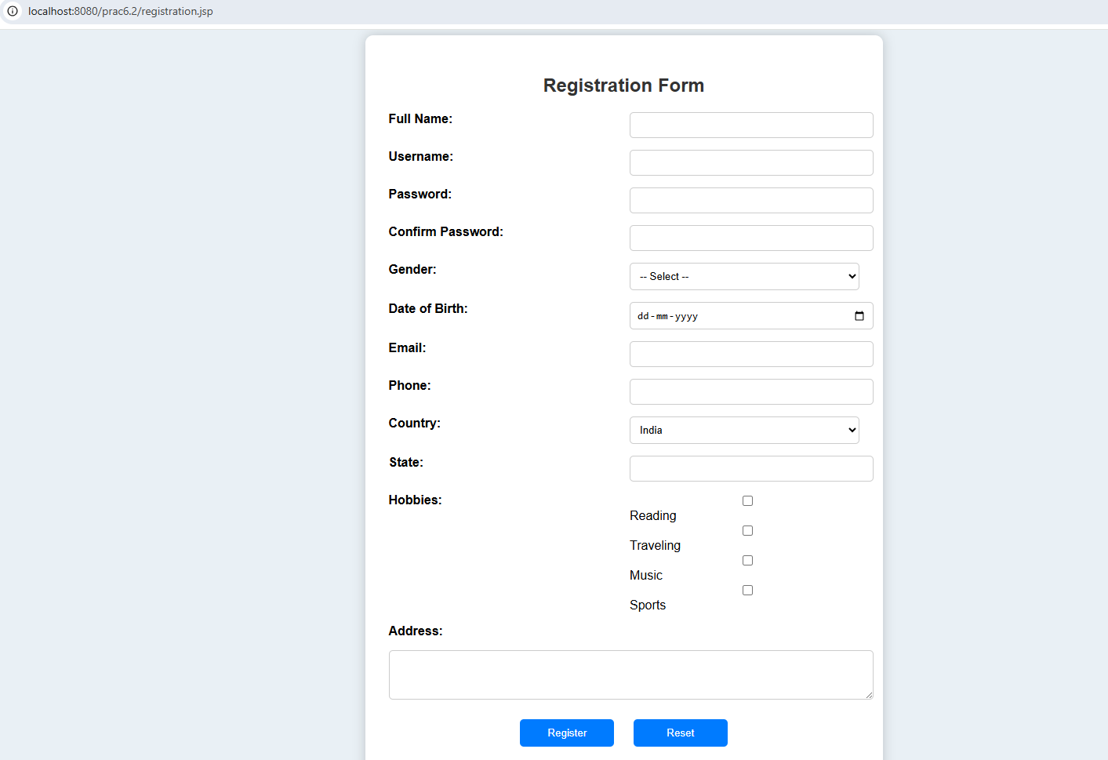
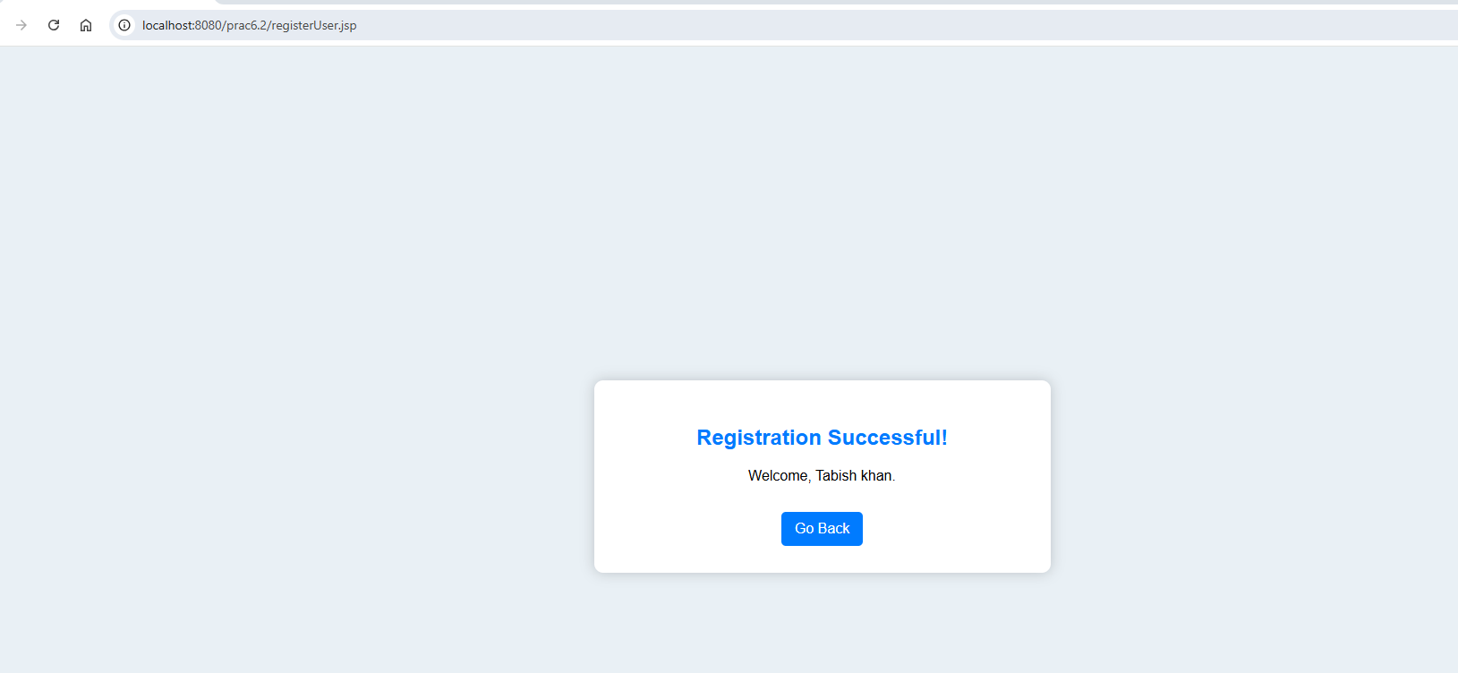
DATABASE :-

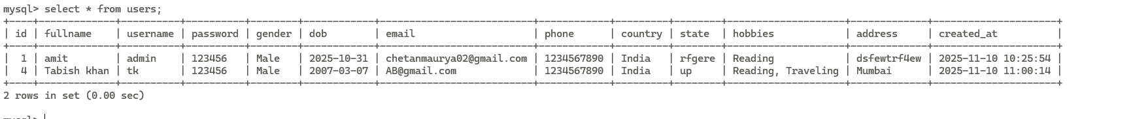
Aim :-
6.3 Write a JSP program to add, delete and display the records from StudentMaster (RollNo, Name, Semester, Course) table.
Code :-
Studentmaster.jsp
<%@ page import="java.sql.*" %>
<html>
<head>
<title>Student Master</title>
<link href="https://fonts.googleapis.com/css2?family=Baloo+2:wght@600&display=swap" rel="stylesheet">
<style>
body {
font-family: 'Baloo 2', cursive;
margin: 30px;
background: url('https://images.pexels.com/photos/691668/pexels-photo-691668.jpeg') no-repeat center center fixed;
background-size: cover;
color: #222;
}
h2, h3 {
color: #ff3030;
text-shadow: 3px 3px yellow;
font-size: 40px;
}
table {
border-collapse: collapse;
width: 75%;
margin-top: 20px;
background: rgba(255,255,255,0.85);
border-radius: 15px;
overflow: hidden;
box-shadow: 0px 0px 15px 4px rgba(0,0,0,0.4);
}
th {
background-color: #ff0000;
color: white;
font-size: 20px;
padding: 12px;
border-bottom: 4px solid black;
}
td {
border: 2px solid #000;
padding: 10px;
font-size: 18px;
}
input[type=text] {
width: 200px;
padding: 8px;
border: 3px solid #000;
border-radius: 10px;
font-size: 16px;
background: #fff8d6;
}
input[type=submit] {
padding: 10px 20px;
font-size: 18px;
border-radius: 12px;
cursor: pointer;
font-weight: bold;
border: 3px solid #000;
transition: 0.2s;
background: #ffcd00;
}
input[type=submit]:hover {
background: #ffe066;
transform: scale(1.1);
}
input[value="Delete"] {
background: #ff1e1e;
color: white;
}
input[value="Delete"]:hover {
background: #ff5252;
}
input[value="Edit"] {
background: #1e90ff;
color: white;
}
input[value="Edit"]:hover {
background: #65b5ff;
}
input[value="Update"] {
background: #ffa500;
color: black;
}
.msg {
margin-top: 15px;
font-weight: bold;
background: yellow;
width: fit-content;
padding: 10px 20px;
border: 3px solid black;
border-radius: 10px;
font-size: 22px;
}
</style>
</head>
<body>
<h2>Student Master</h2>
<%
String url = "jdbc:mysql://localhost:3306/penta";
String user = "root";
String pass = "gnims";
Connection con = null;
PreparedStatement ps = null;
ResultSet rs = null;
String message = "";
String editRoll = "";
String editName = "";
String editSem = "";
String editCourse = "";
boolean isEdit = false;
try {
Class.forName("com.mysql.cj.jdbc.Driver");
con = DriverManager.getConnection(url, user, pass);
String action = request.getParameter("action");
if ("Add".equals(action)) {
int roll = Integer.parseInt(request.getParameter("rollno"));
String name = request.getParameter("name");
int sem = Integer.parseInt(request.getParameter("semester"));
String course = request.getParameter("course");
ps = con.prepareStatement("INSERT INTO studentmaster VALUES (?, ?, ?, ?)");
ps.setInt(1, roll);
ps.setString(2, name);
ps.setInt(3, sem);
ps.setString(4, course);
ps.executeUpdate();
message = "Student Added Successfully!";
} else if ("Delete".equals(action)) {
int roll = Integer.parseInt(request.getParameter("rollno"));
ps = con.prepareStatement("DELETE FROM studentmaster WHERE rollno=?");
ps.setInt(1, roll);
int rows = ps.executeUpdate();
if (rows > 0)
message = "Student Deleted Successfully!";
else
message = "No student found with Roll No " + roll;
} else if ("Edit".equals(action)) {
int roll = Integer.parseInt(request.getParameter("rollno"));
ps = con.prepareStatement("SELECT * FROM studentmaster WHERE rollno=?");
ps.setInt(1, roll);
rs = ps.executeQuery();
if (rs.next()) {
editRoll = rs.getString("rollno");
editName = rs.getString("name");
editSem = rs.getString("semester");
editCourse = rs.getString("course");
isEdit = true;
}
} else if ("Update".equals(action)) {
int roll = Integer.parseInt(request.getParameter("rollno"));
String name = request.getParameter("name");
int sem = Integer.parseInt(request.getParameter("semester"));
String course = request.getParameter("course");
ps = con.prepareStatement("UPDATE studentmaster SET name=?, semester=?, course=? WHERE rollno=?");
ps.setString(1, name);
ps.setInt(2, sem);
ps.setString(3, course);
ps.setInt(4, roll);
ps.executeUpdate();
message = "Student Updated Successfully!";
}
} catch (Exception e) {
message = "Error: " + e.getMessage();
}
%>
<form method="post" action="studentmaster.jsp">
<table>
<tr>
<td>Roll No:</td>
<td><input type="text" name="rollno" value="<%= isEdit ? editRoll : "" %>" <%= isEdit ? "readonly" : "" %> required></td>
</tr>
<tr>
<td>Name:</td>
<td><input type="text" name="name" value="<%= isEdit ? editName : "" %>" required></td>
</tr>
<tr>
<td>Semester:</td>
<td><input type="text" name="semester" value="<%= isEdit ? editSem : "" %>" required></td>
</tr>
<tr>
<td>Course:</td>
<td><input type="text" name="course" value="<%= isEdit ? editCourse : "" %>" required></td>
</tr>
</table>
<br>
<% if (isEdit) { %>
<input type="submit" name="action" value="Update">
<% } else { %>
<input type="submit" name="action" value="Add">
<% } %>
</form>
<div class="msg"><%= message %></div>
<h3>All Student Records</h3>
<table>
<tr>
<th>Roll No</th>
<th>Name</th>
<th>Semester</th>
<th>Course</th>
<th>Action</th>
</tr>
<%
try {
Statement st = con.createStatement();
rs = st.executeQuery("SELECT * FROM studentmaster ORDER BY rollno");
while (rs.next()) {
%>
<tr>
<td><%= rs.getInt("rollno") %></td>
<td><%= rs.getString("name") %></td>
<td><%= rs.getInt("semester") %></td>
<td><%= rs.getString("course") %></td>
<td>
<form method="post" action="studentmaster.jsp" style="display:inline;">
<input type="hidden" name="rollno" value="<%= rs.getInt("rollno") %>">
<input type="submit" name="action" value="Edit">
</form>
<form method="post" action="studentmaster.jsp" style="display:inline;">
<input type="hidden" name="rollno" value="<%= rs.getInt("rollno") %>">
<input type="submit" name="action" value="Delete">
</form>
</td>
</tr>
<%
}
} catch (Exception e) {
out.println("<tr><td colspan='5'>Error: " + e.getMessage() + "</td></tr>");
} finally {
if (rs != null) rs.close();
if (ps != null) ps.close();
if (con != null) con.close();
}
%>
</table>
</body>
</html>
Sql queries:-
CREATE TABLE studentmaster (
rollno INT PRIMARY KEY,
name VARCHAR(100) NOT NULL,
semester INT NOT NULL,
course VARCHAR(100) NOT NULL
);

Output :-
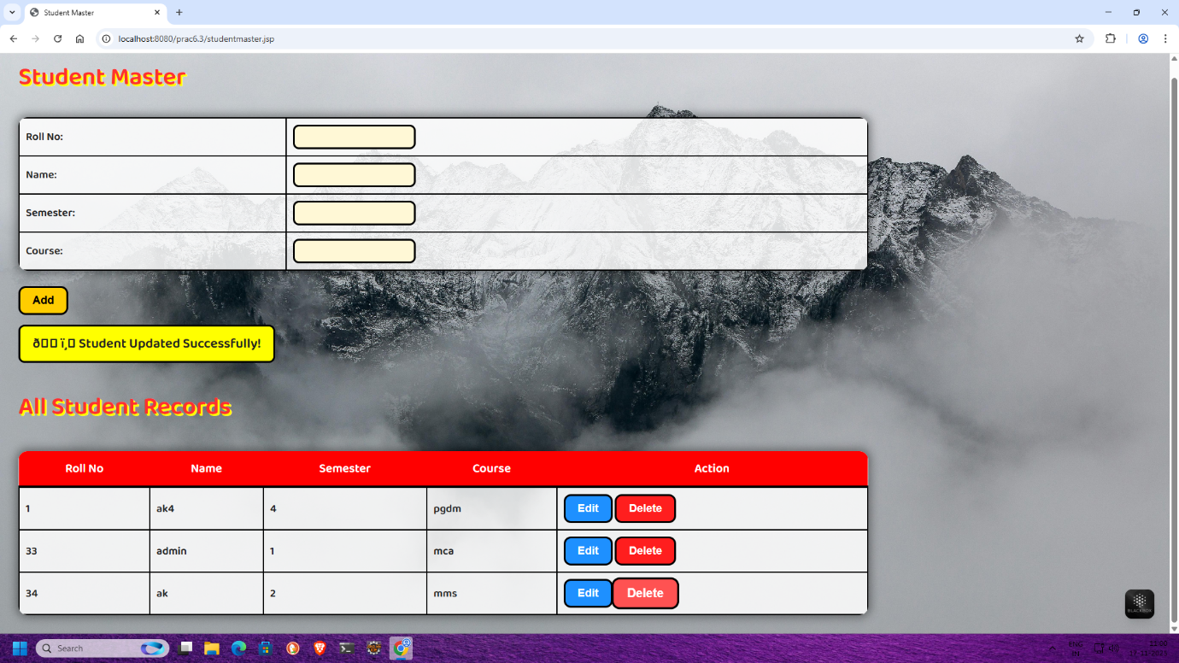
DATABASE:-
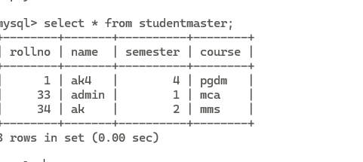

Aim :-
6.4 Design Loan calculator using JSP which accepts Period of Time (in years) and Principal Loan Amount. Display the payment amount for each loan and then list the loan balance and interest paid for each payment over the term of the loan for the following time period and interest rate:
a)1 to 7 year at 5.35%
b)8 to 15 year at 5.5%
c)16 to 30 year at 5.75%

Code :-
Index.jsp
<%@ page language="java" contentType="text/html; charset=UTF-8" pageEncoding="UTF-8"%>
<!DOCTYPE html>
<html>
<head>
<title>Loan Calculator</title>
<style>
body { font-family: Arial; background: #f4f4f4; text-align: center; padding: 50px; }
form { background: white; display: inline-block; padding: 20px; border-radius: 8px; }
input { margin: 10px; padding: 8px; }
button { padding: 10px 20px; background-color: #4CAF50; color: white; border: none; border-radius: 4px; }
</style>
</head>
<body>
<h2>Loan Calculator</h2>
<form action="calculate.jsp" method="post">
<label>Principal Loan Amount:</label><br>
<input type="number" name="principal" step="0.01" required><br>

<label>Period of Time (in years):</label><br>
<input type="number" name="years" required><br>

<button type="submit">Calculate</button>
</form>
</body>
</html>

Calculate.jsp
<%@ page import="java.text.DecimalFormat" %>
<%@ page contentType="text/html;charset=UTF-8" language="java" %>
<!DOCTYPE html>
<html>
<head>
<title>Loan Calculation Result</title>
<style>
body { font-family: Arial; background: #f9f9f9; text-align: center; padding: 40px; }
table { margin: auto; border-collapse: collapse; width: 80%; }
th, td { border: 1px solid #ccc; padding: 10px; text-align: right; }
th { background-color: #f2f2f2; }
</style>
</head>
<body>
<%
double principal = Double.parseDouble(request.getParameter("principal"));
int years = Integer.parseInt(request.getParameter("years"));
double annualRate = 0.0;
if (years >= 1 && years <= 7) {
annualRate = 5.35;
} else if (years >= 8 && years <= 15) {
annualRate = 5.5;
} else if (years >= 16 && years <= 30) {
annualRate = 5.75;
} else {
out.println("<h3>Invalid time period. Please enter between 1 and 30 years.</h3>");
return;
}
double monthlyRate = annualRate / 100 / 12;
int months = years * 12;
double monthlyPayment = principal * monthlyRate / (1 - Math.pow(1 + monthlyRate, -months));
DecimalFormat df = new DecimalFormat("#,##0.00");
out.println("<h2>Loan Calculation Result</h2>");
out.println("<p><b>Principal:</b> $" + df.format(principal) + "</p>");
out.println("<p><b>Years:</b> " + years + "</p>");
out.println("<p><b>Annual Interest Rate:</b> " + annualRate + "%</p>");
out.println("<p><b>Monthly Payment:</b> $" + df.format(monthlyPayment) + "</p>");
%>
<table>
<tr>
<th>Payment No.</th>
<th>Interest Paid</th>
<th>Principal Paid</th>
<th>Remaining Balance</th>
</tr>
<%
double balance = principal;
for (int i = 1; i <= months; i++) {
double interest = balance * monthlyRate;
double principalPaid = monthlyPayment - interest;
balance -= principalPaid;
if (balance < 0) balance = 0;
out.println("<tr>");
out.println("<td>" + i + "</td>");
out.println("<td>$" + df.format(interest) + "</td>");
out.println("<td>$" + df.format(principalPaid) + "</td>");
out.println("<td>$" + df.format(balance) + "</td>");
out.println("</tr>");
}
%>
</table>
<p><a href="index.jsp">Back to Calculator</a></p>
</body>
</html>
Output :-
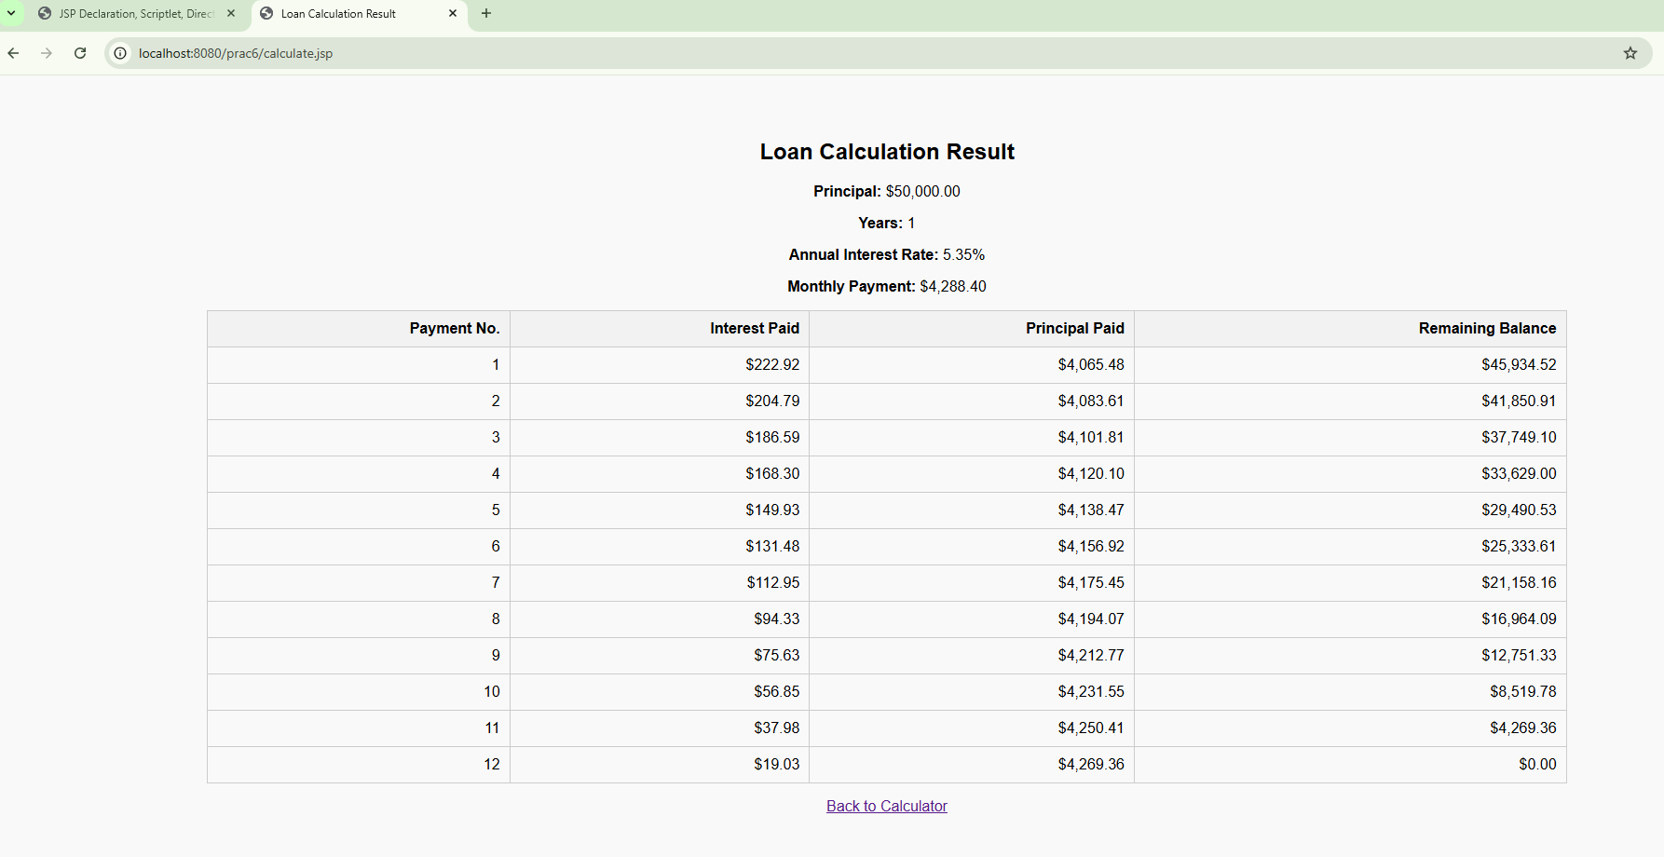

Aim :-
6.5 Write a program using JSP that displays a webpage consisting an Application form for change of Study Center which can be filled by any student who wants to change his/ her study center. Make necessary assumptions

Code :-
<%@ page contentType="text/html; charset=UTF-8" language="java" %> <!DOCTYPE html>
<html>
<head>
<title>Change Study Center Application</title>
</head>
<body>
<%
String studentName = request.getParameter("studentName");
String currentCenter = request.getParameter("currentCenter");
String newCenter = request.getParameter("newCenter");
%>
<h1>Change Study Center Application</h1>
<form method="post">
Student Name: <input type="text" name="studentName" value="<%= (studentName != null ? studentName : "") %>" required><br><br>
Current Study Center: <input type="text" name="currentCenter" value="<%= (currentCenter != null ? currentCenter : "") %>" required><br><br>
New Study Center: <input type="text" name="newCenter" value="<%= (newCenter != null ? newCenter : "") %>" required><br><br>
<input type="submit" value="Submit">
</form>
<%
if (studentName != null && currentCenter != null && newCenter != null) { %>
<hr>
<h2>Application Submitted</h2>
<p>Thank you for submitting your study center change application.</p> <p><b>Student Name:</b> <%= studentName %></p> <p><b>Current Center:</b> <%= currentCenter %></p> <p><b>New Center:</b> <%= newCenter %></p>
<%
}
%>
</body>
</html>
Output :-
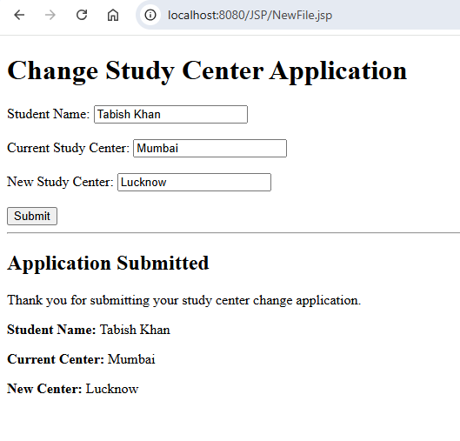

Aim :-
6.6 Write a JSP program that demonstrates the use of JSP declaration, scriptlet, directives, expression, header and footer.

Code :-
Main.jsp
<%@ page language="java" contentType="text/html; charset=ISO-8859-1"
pageEncoding="ISO-8859-1"%>
<!DOCTYPE html>
<html>
<head>
<meta charset="ISO-8859-1">
<title>JSP Declaration, Scriptlet, Directive, Expression, Header, and Footer Example</title>
</head>
<body>
<%@ include file="header.jsp" %>
<center>
<h2>JSP Declaration, Scriptlet, Directive, Expression Example</h2>
<%-- JSP Declaration: declaring variables and methods --%>
<%!
int data = 100;
double circle(int r) {
return 3.14 * r * r;
}
int rectangle(int l, int b) {
return l * b;
}
int perimeter(int x, int y) {
int peri = 2 * (x + y);
return peri;
}
double triangle(double base, double height) {
return 0.5 * base * height;
}
int square(int side) {
return side * side;
}
%>
<%-- JSP Expression: display results dynamically --%>
<p><b>Value of variable:</b> <%= data %></p>
<p><b>Area of Circle (r=15):</b> <%= circle(15) %></p>
<p><b>Area of Rectangle (l=67, b=25):</b> <%= rectangle(67,25) %></p>
<p><b>Perimeter of Rectangle (l=52, b=21):</b> <%= perimeter(52,21) %></p>
<p><b>Area of Triangle (base=10, height=6):</b> <%= triangle(10,6) %></p>
<p><b>Area of Square (side=10):</b> <%= square(10) %></p>
<p><i>Thanks for visiting my page!</i></p>
</center>
<%@ include file="footer.jsp" %>
</body>
</html>

Header.jsp
<%@ page language="java" contentType="text/html; charset=ISO-8859-1"
pageEncoding="ISO-8859-1"%>
<!DOCTYPE html>
<html>
<head>
<meta charset="ISO-8859-1">
<title>Header Section</title>
<%!
int pageCount = 0;
void addCount() { pageCount++; }
%>
<% addCount(); %>
</head>
<body style="background-color:#f0f8ff;">
<center>
<h2>The Include Directive Example</h2>
<p><b>This site has been visited <%= pageCount %> time(s).</b></p>
<hr>
</center>
</body>
</html>

Footer.jsp
<%@ page language="java" contentType="text/html; charset=ISO-8859-1"
pageEncoding="ISO-8859-1"%>
<!DOCTYPE html>
<html>
<head>
<meta charset="ISO-8859-1">
<title>Footer Section</title>
</head>
<body>
<hr>
<center>
<b>Tabish Khan</b><br>
<b>25MCA-33</b><br>
<b>&copy; 2025 JSP Example Page</b>
</center>
</body>
</html>

Output :-
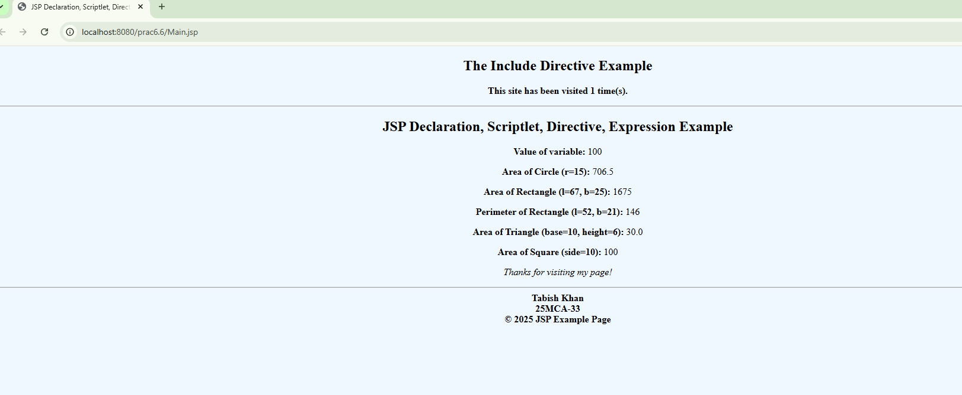

PRACTICAL NO. 7
Aim :- Assignment based Spring Framework

- Write a program to print “Hello World” using spring framework.
- Write a program to demonstrate dependency injection via setter method.
- Write a program to demonstrate dependency injection via Constructor.
- Write a program to demonstrate Autowiring.

Code :-
Prac7Application.java
package com.example.demo;
import org.springframework.boot.CommandLineRunner;
import org.springframework.boot.SpringApplication;
import org.springframework.boot.autoconfigure.SpringBootApplication;
import org.springframework.context.annotation.Bean;
import org.springframework.context.annotation.ComponentScan;
import org.springframework.stereotype.Controller;
import org.springframework.ui.Model;
import org.springframework.web.bind.annotation.GetMapping;
import org.springframework.web.bind.annotation.RestController;
@SpringBootApplication
@ComponentScan(basePackages = "com.example.demo")
public class Prac7Application{
public static void main(String[] args) {
SpringApplication.run(Prac7Application.class, args);
}
@Bean
public CommandLineRunner demo(Car car) {
return args -> {
car.setModel("Honda");
Driver dr=new Driver();
dr.setName("Tabish");
car.setDriver(dr);
car.start();
};
}
}
@RestController
class HelloController {
private final Car car;
public HelloController(Car car) {
this.car = car;
}
@GetMapping("/hello")
public String hello() {
car.start();
return car.getModel();
}
}

Car.java
package com.example.demo;
import org.springframework.beans.factory.annotation.Autowired;
import org.springframework.stereotype.Component;
@Component
public class Car {
private String model;
private Driver driver;
public String getModel() {
return model;
}
public void setModel(String model) {
this.model = model;
}
public Driver getDriver() {
return driver;
}
@Autowired
public void setDriver(Driver driver) {
this.driver = driver;
}
public void start() {
System.out.println("Car model: " + model);
System.out.println("Driver: " + driver.getName());
System.out.println("Car is starting...");
}
}

Driver.java
package com.example.demo;
import org.springframework.stereotype.Component;
@Component
public class Driver {
private String name;
public String getName() {
return name;
}
public void setName(String name) {
this.name = name;
}
}

Output :-

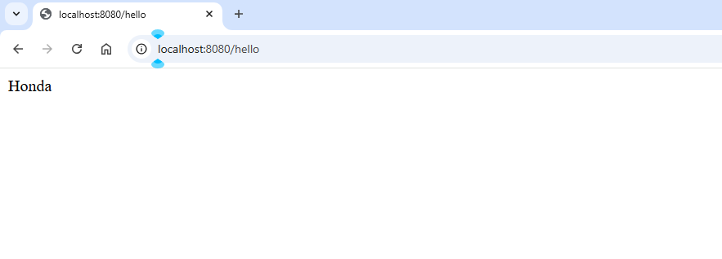

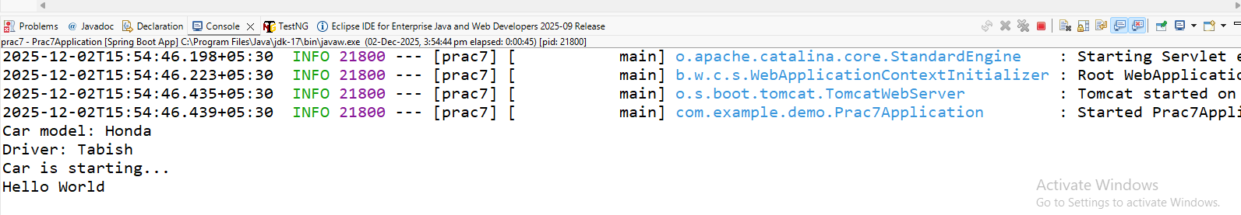

PRACTICAL NO. 8
Aim :- Assignment based Aspect Oriented Programming

- Write a program to demonstrate Spring AOP – before advice.
- Write a program to demonstrate Spring AOP – after advice.
- Write a program to demonstrate Spring AOP – around advice.
- Write a program to demonstrate Spring AOP – after returning advice.
- Write a program to demonstrate Spring AOP – after throwing advice.
- Write a program to demonstrate Spring AOP – pointcuts.

Pom.xml
<project xmlns="http://maven.apache.org/POM/4.0.0"
xmlns:xsi="http://www.w3.org/2001/XMLSchema-instance" xsi:schemaLocation="http://maven.apache.org/POM/4.0.0http://maven.apache.org/xsd/maven-4.0.0.xsd">
<modelVersion>4.0.0</modelVersion>
<groupId>com.example</groupId>
<artifactId>prac-8</artifactId>
<version>1.0</version>
<name>Prac-8</name>
<parent>
<groupId>org.springframework.boot</groupId>
<artifactId>spring-boot-starter-parent</artifactId>
<version>3.2.0</version>
</parent>
<dependencies>
<!-- Spring Boot AOP -->
<dependency>
<groupId>org.springframework.boot</groupId>
<artifactId>spring-boot-starter-aop</artifactId>
</dependency>
<!-- Optional: Spring Web (if needed) -->
<dependency>
<groupId>org.springframework.boot</groupId>
<artifactId>spring-boot-starter-web</artifactId>
</dependency>
</dependencies>
</project>
Prac8Application.java
package com.example.demo;
import org.springframework.beans.factory.annotation.Autowired;
import org.springframework.boot.CommandLineRunner;
import org.springframework.boot.SpringApplication;
import org.springframework.boot.autoconfigure.SpringBootApplication;
import com.example.demo.service.MyService;
@SpringBootApplication
public class Prac8Application implements CommandLineRunner {
@Autowired
private MyService service;
public static void main(String[] args) {
SpringApplication.run(Prac8Application.class, args);
}
@Override
public void run(String... args) throws Exception {
System.out.println("=== Calling doSomething() ===");
service.doSomething();
System.out.println("---------------------------");
System.out.println("=== Calling getData() ===");
service.getData();
System.out.println("---------------------------");
System.out.println("=== Calling throwError() ===");
try {
service.throwError();
} catch (Exception e) {
System.out.println("Caught Exception in main: " + e.getMessage());
}
}
}

Myservice.java
package com.example.demo.service;
import org.springframework.stereotype.Service;
@Service
public class MyService {
public void doSomething() {
System.out.println("Executing doSomething()...");
}
public String getData() {
System.out.println("Executing getData()...");
return "Hello from AOP";
}
public void throwError() {
System.out.println("Executing throwError()...");
throw new RuntimeException("An error occurred!");
}
}
LoggingAspect.java
package com.example.demo.aspect;
import org.aspectj.lang.ProceedingJoinPoint;
import org.aspectj.lang.annotation.*;
import org.springframework.stereotype.Component;
@Aspect
@Component
public class LoggingAspect {
// POINTCUT
@Pointcut("execution(* com.example.demo.service.MyService.*(..))")
public void allMethods() {}
// BEFORE ADVICE
@Before("allMethods()")
public void beforeAdvice() {
System.out.println("Before Advice: Method is about to execute");
}
// AFTER ADVICE
@After("allMethods()")
public void afterAdvice() {
System.out.println("After Advice: Method execution finished");
}
// AROUND ADVICE
@Around("execution(* com.example.demo.service.MyService.doSomething(..))")
public Object aroundAdvice(ProceedingJoinPoint pjp) throws Throwable {
System.out.println("Around Advice: Before method...");
Object result = pjp.proceed();
System.out.println("Around Advice: After method...");
return result;
}
// AFTER RETURNING
@AfterReturning(
pointcut = "execution(* com.example.demo.service.MyService.getData(..))",
returning = "value")
public void afterReturningAdvice(Object value) {
System.out.println("After Returning Advice: Method returned = " + value);
}
// AFTER THROWING
@AfterThrowing(
pointcut = "execution(* com.example.demo.service.MyService.throwError(..))",
throwing = "ex")
public void afterThrowingAdvice(Exception ex) {
System.out.println("After Throwing Advice: Exception = " + ex.getMessage());
}
}
Output :-
Before output
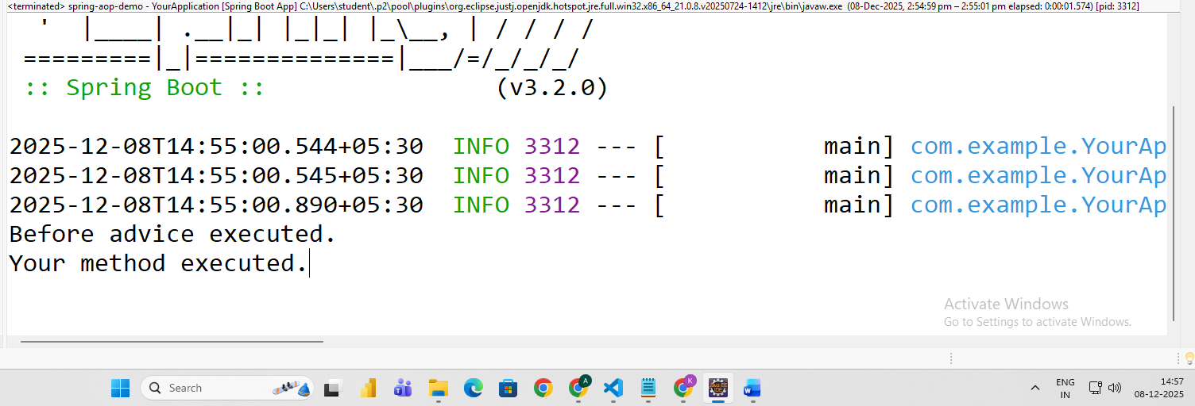

After output
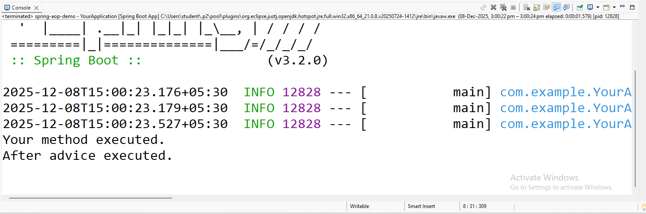
Around Advice output
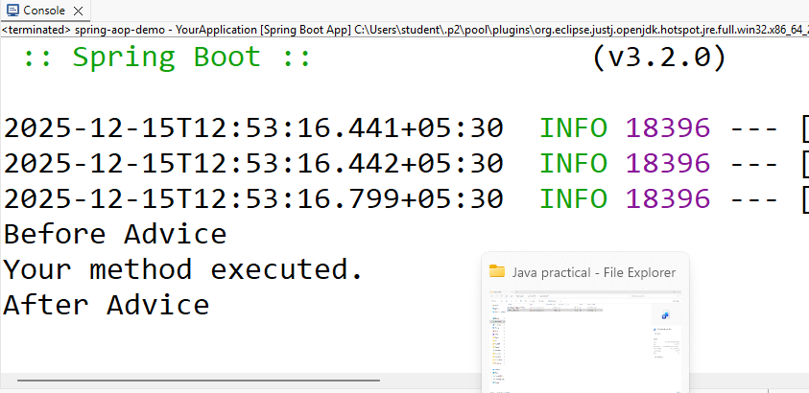
After Returning Advice Output:
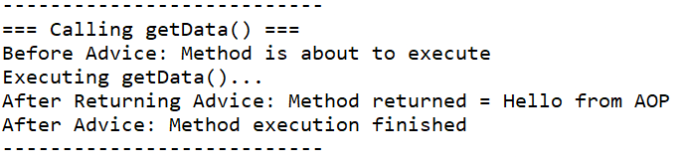
After throwing advice Output:
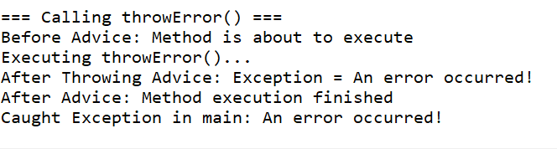
Pointcuts Output:
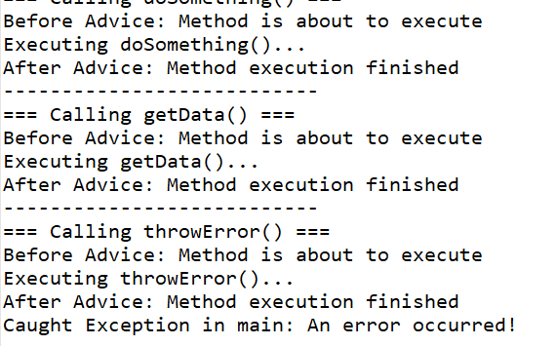

PRACTICAL NO. 10
Aim :- Assignment based Spring Boot and RESTful Web Services

10.A:-Write a program to create a simple Spring Boot application that prints a message.
Code :-
project1\project1\src\main\java\com\tabish\project1\Project1Application.java
Project1Application.java
package com.tabish.project1;
import org.springframework.boot.SpringApplication;
import org.springframework.boot.autoconfigure.SpringBootApplication;
@SpringBootApplication
public class Project1Application {
public static void main(String[] args) {
SpringApplication.run(Project1Application.class, args);
}
}
project1\project1\src\main\java\com\tabish\project1\controller\Testcontroller.java
Testcontroller.java
package com.tabish.project1.controller;
import org.springframework.stereotype.Controller;
import org.springframework.web.bind.annotation.GetMapping;
@Controller
public class Testcontroller {
@GetMapping("/greet")
public String greet() {
return "hello";
}
}
project1\project1\src\main\resources\templates\hello.html
Hello.html
<!DOCTYPE html>
<html xmlns:th="http://www.thymeleaf.org">
<html>
<head>
<title>Mario Theme - Color Choose</title>
<style>
/* 🎨 CHANGE COLORS HERE */
:root {
--bg-color: #4ec0ca; /* sky blue */
--text-color: #703c3c; /* main text color */
--shadow-color: #000000; /* text shadow */
--box-bg: #1fb878; /* question-block yellow */
--box-border: #a13737; /* black border */
}
body {
margin: 0;
padding: 0;
background: var(--bg-color);
font-family: 'Press Start 2P', sans-serif;
text-align: center;
color: var(--text-color);
}
@import url('https://fonts.googleapis.com/css2?family=Press+Start+2P&display=swap');
h1 {
margin-top: 150px;
font-size: 40px;
text-shadow: 4px 4px 0 var(--shadow-color);
}

.mario-box {
margin: 40px auto;
padding: 20px;
width: 300px;
background: var(--box-bg);
border: 4px solid var(--box-border);
border-radius: 10px;
box-shadow: 4px 4px 0 var(--box-border);
color: black;
}
</style>
</head>
<body>
<h1>🎨 🎨</h1>
<div class="mario-box">
<p>Hello world</p>
</div>
</body>
</html>

Output :-
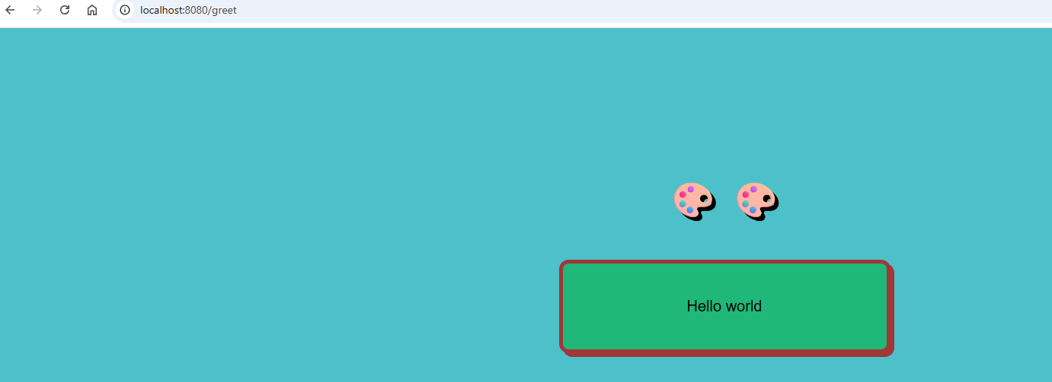

AIM:-
10. B:- Write a program to demonstrate RESTful Web Services with spring boot.
C:-Write a program to demonstrate Database Connection with spring boot.
Code :-

project1\src\main\resources\application.properties
spring.application.name=project1
spring.datasource.url=jdbc:mysql://localhost:3306/spring
spring.datasource.username=root
spring.datasource.password=gnims
spring.jpa.hibernate.ddl-auto=update
spring.jpa.show-sql=true

project1\src\main\java\com\tabish\project1\repository\studentrepository.java
package com.tabish.project1.repository;
import org.springframework.data.jpa.repository.JpaRepository;
import org.springframework.stereotype.Repository;
import com.tabish.project1.entity.*;;
@Repository
public interface studentrepository extends JpaRepository< Student , Integer>{
}

project1\src\main\java\com\tabish\project1\entity\Student.java
package com.tabish.project1.entity;
import jakarta.persistence.Entity;
import jakarta.persistence.GeneratedValue;
import jakarta.persistence.GenerationType;
import jakarta.persistence.Id;
@Entity
public class Student {
@Id
@GeneratedValue(strategy=GenerationType.IDENTITY)
private int id;
private String name;
private String city;
public Student(String city, int id, String name) {
this.city = city;
this.id = id;
this.name = name;
}
public int getId() {
return id;
}
public void setId(int id) {
this.id = id;
}
public String getName() {
return name;
}
public void setName(String name) {
this.name = name;
}
public String getCity() {
return city;
}
public void setCity(String city) {
this.city = city;
}
}

project1\src\main\java\com\tabish\project1\controller\Studentcontroller.java
package com.tabish.project1.controller;
import org.springframework.beans.factory.annotation.Autowired;
import org.springframework.web.bind.annotation.*;
import com.tabish.project1.entity.Student;
import com.tabish.project1.service.StudentService;
import java.util.List;
@RestController
@RequestMapping("/students/api")
public class Studentcontroller {
@Autowired
private StudentService studentService;
@PostMapping("/add")
public Student addStudent(@RequestBody Student student) {
return studentService.add(student);
}
@GetMapping("/all")
public List<Student> getAllStudents() {
return studentService.getAll();
}
}

project1\src\main\java\com\tabish\project1\service\StudentService.java
package com.tabish.project1.service;
import java.util.List;
import org.springframework.beans.factory.annotation.Autowired;
import org.springframework.stereotype.Service;
import com.tabish.project1.entity.Student;
import com.tabish.project1.repository.studentrepository;
@Service
public class StudentService {
@Autowired
private studentrepository repo;
public Student add(Student student) {
return repo.save(student);
}
public List<Student> getAll(){
return repo.findAll();
}
}

project1\pom.xml
<?xml version="1.0" encoding="UTF-8"?>
<project xmlns="http://maven.apache.org/POM/4.0.0" xmlns:xsi="http://www.w3.org/2001/XMLSchema-instance"
xsi:schemaLocation="http://maven.apache.org/POM/4.0.0 https://maven.apache.org/xsd/maven-4.0.0.xsd">
<modelVersion>4.0.0</modelVersion>
<parent>
<groupId>org.springframework.boot</groupId>
<artifactId>spring-boot-starter-parent</artifactId>
<version>3.5.7</version>
<relativePath/> <!-- lookup parent from repository -->
</parent>
<groupId>com.tabish</groupId>
<artifactId>project1</artifactId>
<version>0.0.1-SNAPSHOT</version>
<name>project1</name>
<description>Demo project for Spring Boot</description>
<url/>
<licenses>
<license/>
</licenses>
<developers>
<developer/>
</developers>
<scm>
<connection/>
<developerConnection/>
<tag/>
<url/>
</scm>
<properties>
<java.version>17</java.version>
</properties>
<dependencies>
<dependency>
<groupId>org.springframework.boot</groupId>
<artifactId>spring-boot-starter-data-jpa</artifactId>
</dependency>
<dependency>
<groupId>org.springframework.boot</groupId>
<artifactId>spring-boot-starter-thymeleaf</artifactId>
</dependency>
<dependency>
<groupId>org.springframework.boot</groupId>
<artifactId>spring-boot-starter-web</artifactId>
</dependency>
<dependency>
<groupId>org.springframework.boot</groupId>
<artifactId>spring-boot-devtools</artifactId>
<scope>runtime</scope>
<optional>true</optional>
</dependency>
<dependency>
<groupId>com.mysql</groupId>
<artifactId>mysql-connector-j</artifactId>
<scope>runtime</scope>
</dependency>
<dependency>
<groupId>org.springframework.boot</groupId>
<artifactId>spring-boot-starter-test</artifactId>
<scope>test</scope>
</dependency>
</dependencies>
<build>
<plugins>
<plugin>
<groupId>org.springframework.boot</groupId>
<artifactId>spring-boot-maven-plugin</artifactId>
</plugin>
</plugins>
</build>
</project>

Step:-
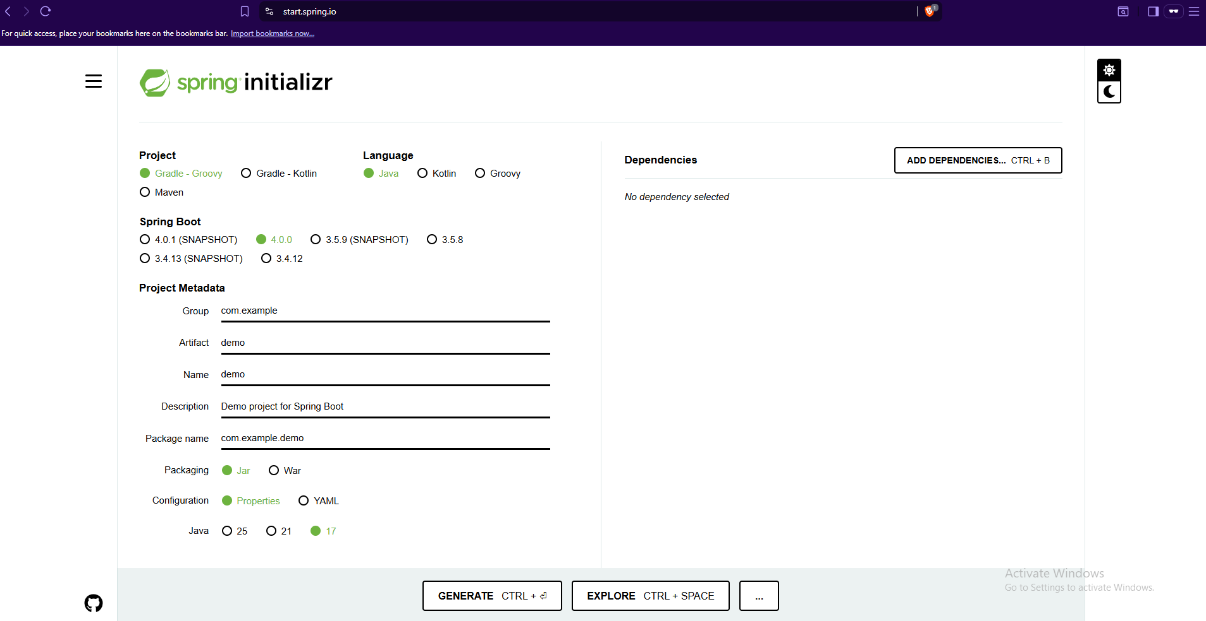

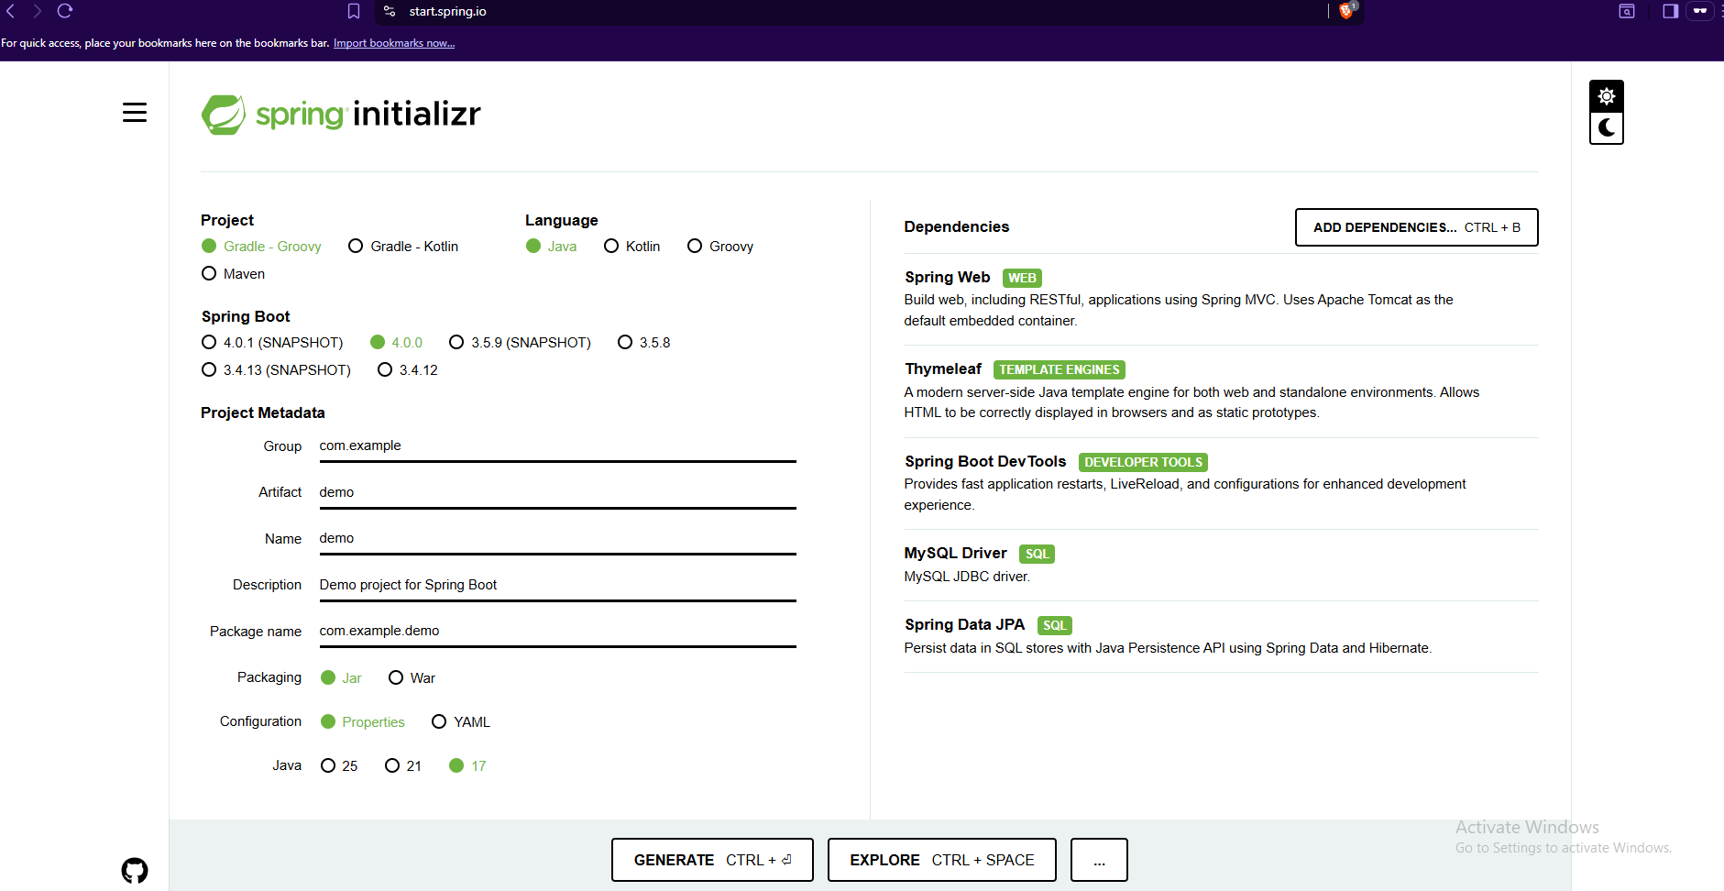

Output :-
