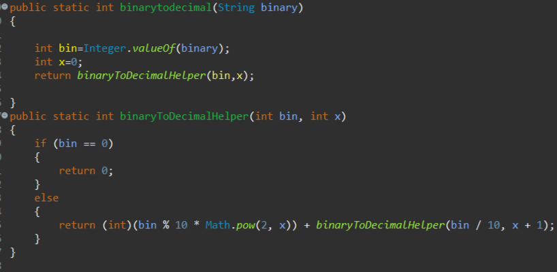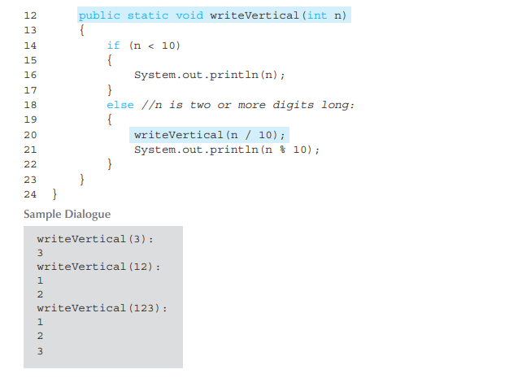
-------------------------------------------------------------------------------------------------------------------------
Bu kod, verilen bir n sayısına kadar olan sayıların karelerinin toplamını hesaplar. Yani, squares(n) fonksiyonu, 1^2 + 2^2 + 3^2 + ... + n^2 ifadesinin sonucunu döndürür.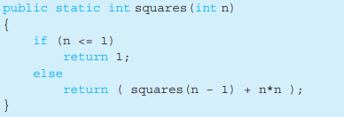

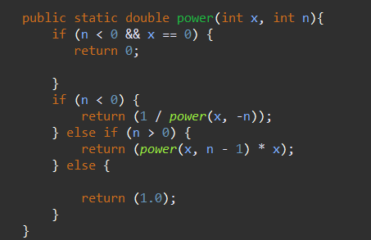

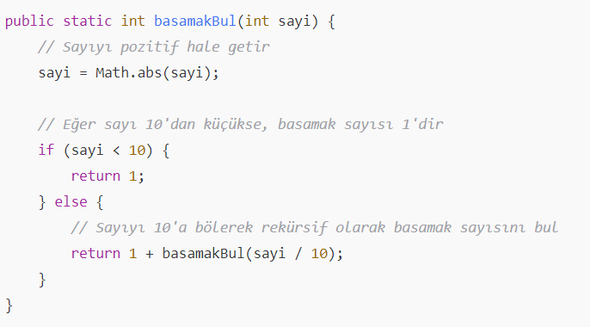

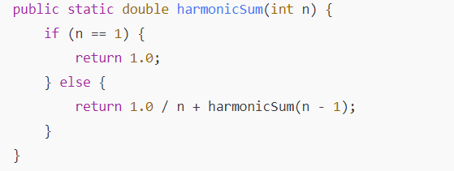
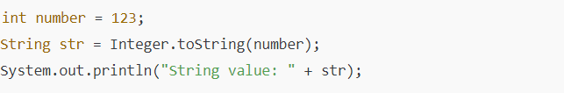

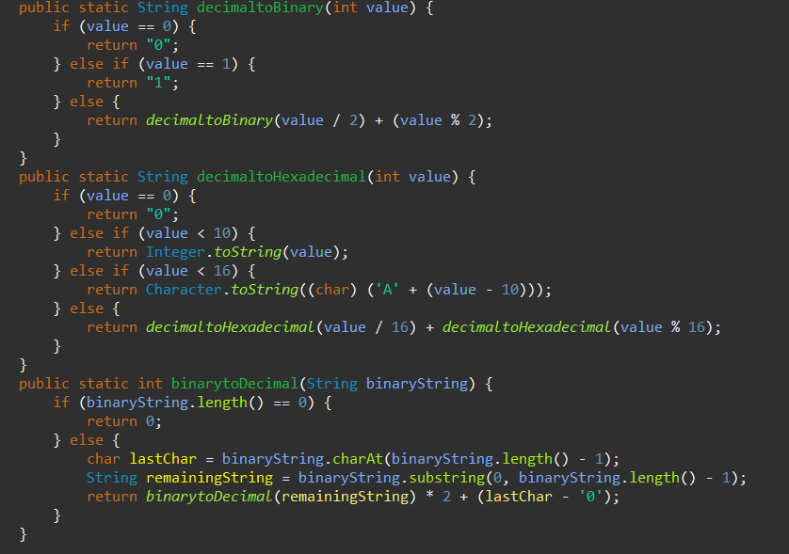

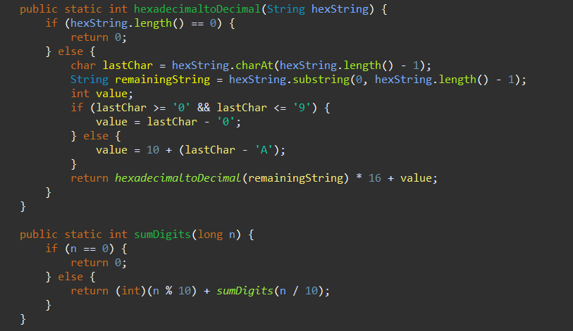
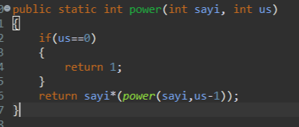
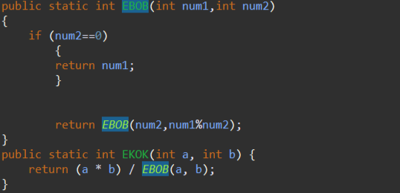
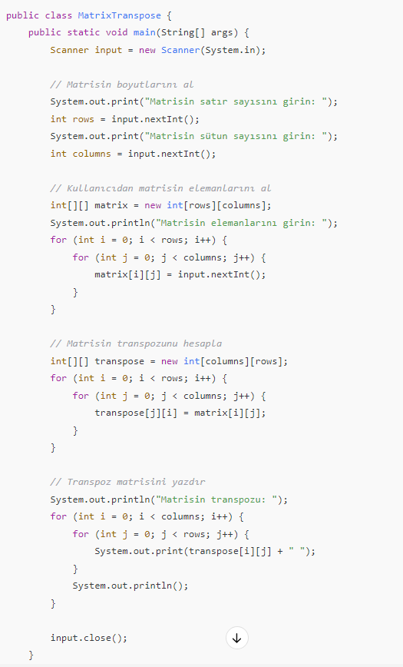

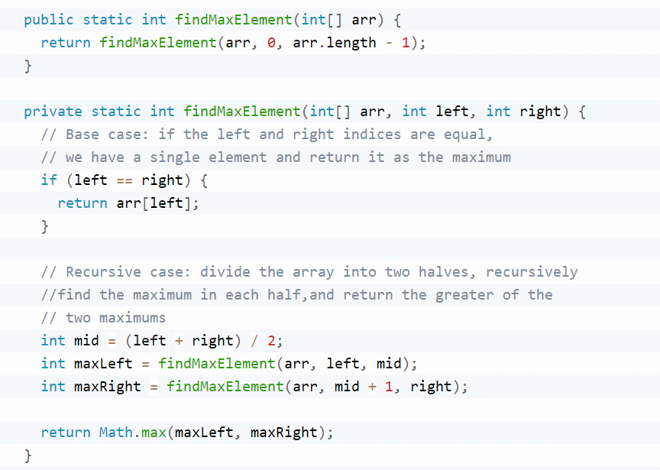
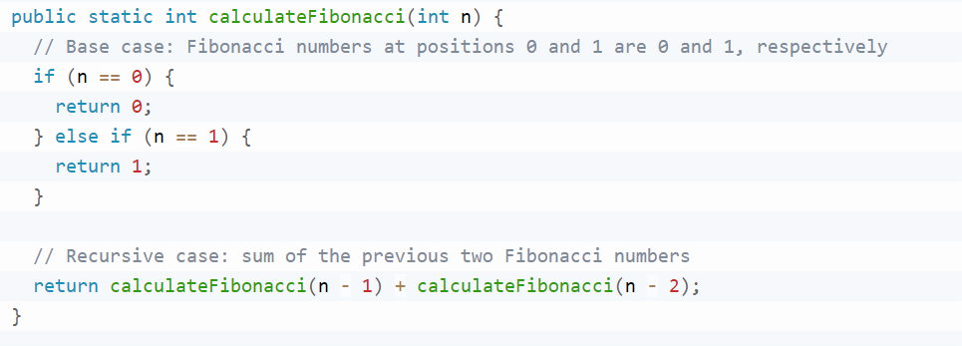
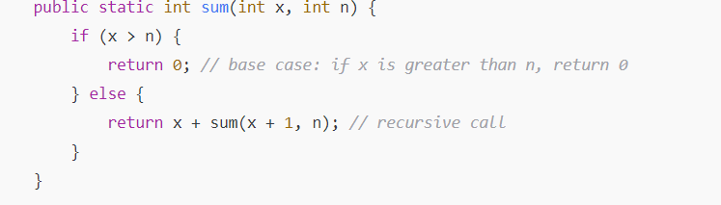
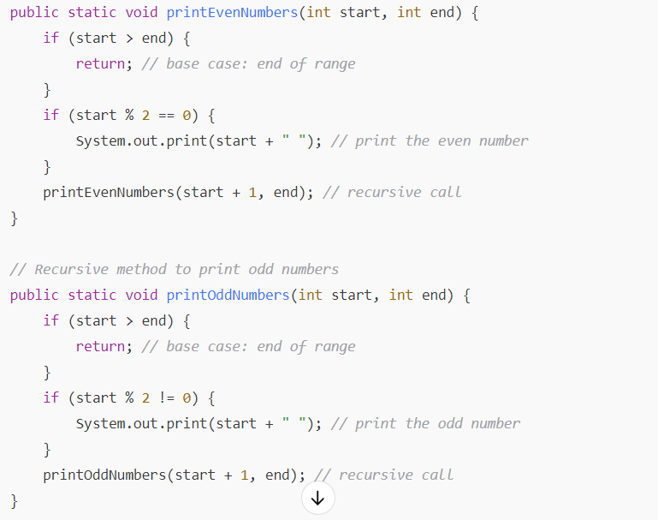

Countways’in fibonacciyle tek farkı n==0 return 0; fibonaccide
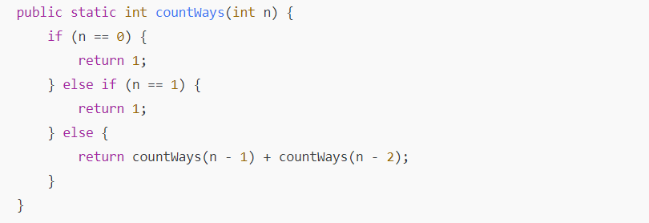

public class VolkanCoffeeService {

public int[] getSampleSales() {
int[] sales = {100, 120, 130, 140, 150, 160, 170};
return sales;
}

public String targetCheck(int sales, int day, int dailyTarget) {
if (sales >= dailyTarget) {
return "Goal ACHIEVED";
} else {
return "Goal NOT ACHIEVED";
}
}

public String checkSpecialDiscount(int daySales) {
if (daySales >= 200) {
return "Congratulations! 10% discount tomorrow!";
} else {
return "No discount tomorrow...";
}
}

public int calculateTotal(int[] sales) {
int total = 0;
for (int i = 0; i < sales.length; i++) {
total += sales[i];
}
return total;
}

public double calculateAverage(int[] sales) {
int total = calculateTotal(sales);
return (double) total / sales.length;
}

public int findMaxDay(int[] sales) {
int maxDay = 0;
for (int i = 1; i < sales.length; i++) {
if (sales[i] > sales[maxDay]) {
maxDay = i;
}
}
return maxDay;
}

public String checkWeeklyTarget(int totalSales, int weeklyTarget) {
if (totalSales >= weeklyTarget) {
return "Congratulations! Goal met!";
} else {
return "Try harder next week...";
}
}

public double[] calculateDailyRevenue(int[] sales, double basePrice) {
double[] dailyRevenue = new double[sales.length];
for (int i = 0; i < sales.length; i++) {
if (i > 0 && sales[i - 1] >= 200) {
dailyRevenue[i] = sales[i] * basePrice * 0.9;
} else {
dailyRevenue[i] = sales[i] * basePrice;
}
}
return dailyRevenue;
}

public double calculateTotalRevenue(double[] dailyRevenues) {
double totalRevenue = 0.0;
for (int i = 0; i < dailyRevenues.length; i++) {
totalRevenue += dailyRevenues[i];
}
return totalRevenue;
}
}

