1.Mark the following (T-F) questions using T For True anf F For False into the given table above
Q1-1 In a System with only one instance of each resource type,
the presence of a cycle in the wait for graph sufficient to detect a deadlock.
Q1-2 There are solutions to synchronization problems that can be implemented using mutexes,
but cannot implemented using semaphores.
Q1-3 The convoy effect is a result of using SJF scheduling algorithm.
Q1-4 FCFS is a non-preemptive scheduling algorithm
Q1-5 In multithreaded programing each thread has its own registers, stack and code segment.
Q1-6 A very large quantum (q) value in RR scheduling is equivalent to FIFO.

Answer 1-1. True
In a system with one instance of each resource type, deadlock can be detected by the presence of a cycle in the graph.
Answer 1-2. True.
There are solution to synchronization problems that can be implemented using mutexes but not semaphores as mutex provides us specific use-case procedures that cannot be implemented using semaphores such as priority inversion safety and deletion safety.
Answer 1-3. False.
The convoy effect is a result of using FCFS scheduling algorithm not SJF scheduling algorithm. It is a effect in which our system slows due to few large processes.
Answer 1-4. True
FCFS is a non-preemptive scheduling algorithm because in FCFS when a process is allocated to the CPU, it does not release the CPU until it finishes executing.
Answer 1-5. False
In multithreaded programming each thread has its own registers and stack but they share the same code segment.
Answer 1-6 True
If the value of q(quantum) is very large in round robin, then scheduling happens according to FCFS scheduling algorithm.

2.
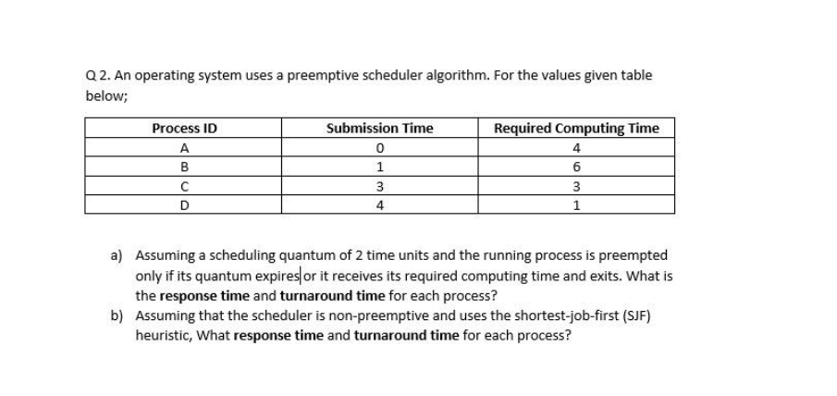

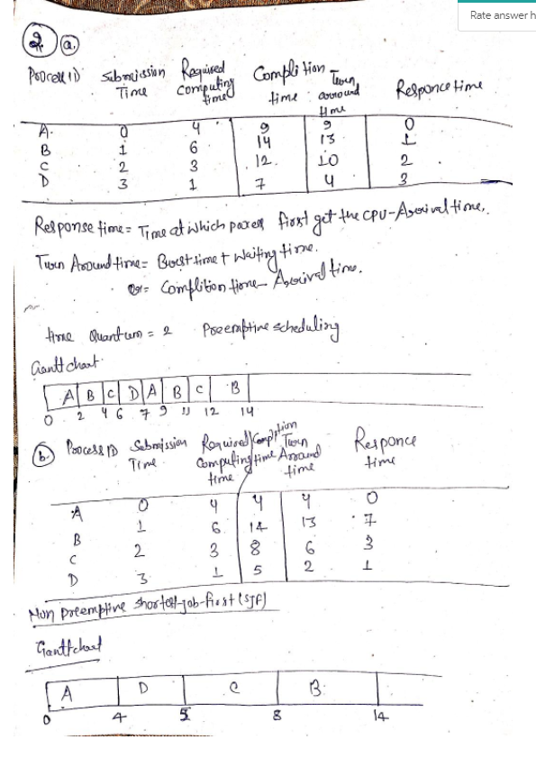

3.
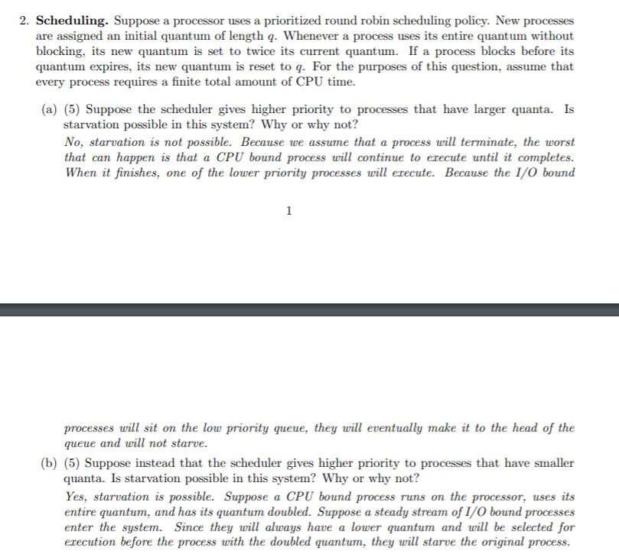

4. 4.Considering the following C code.
a. Draw the process tree showing the up to date variable values
b. What would be a possible output?
c. How many lines are printed on the screen(Assume that fork does not fail)
#include <stdio.h>
#include <stdlib.h>
#include <unistd>
int main(void)
{
int a,b;
a=1;
b=a+1;
while(a<4){
if(fork())
b++;
else
a++;
a+=1;
}
printf("%d $d\n" ,a,b);
return(0);
}

a) 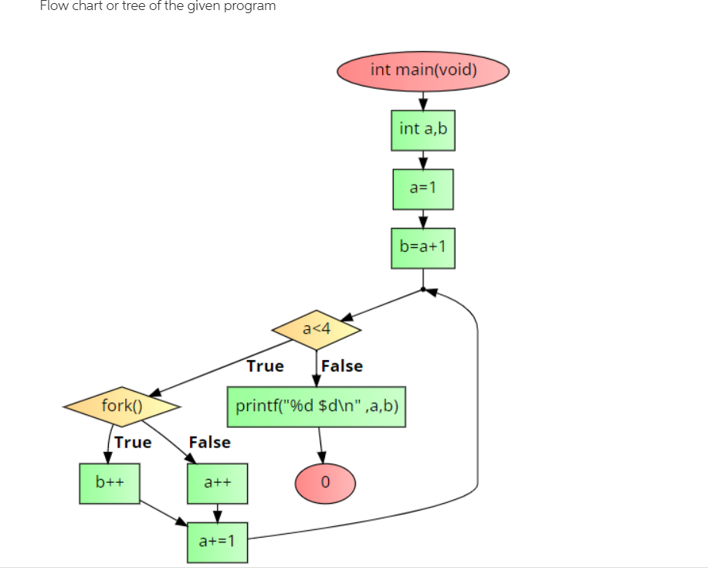

b)c) 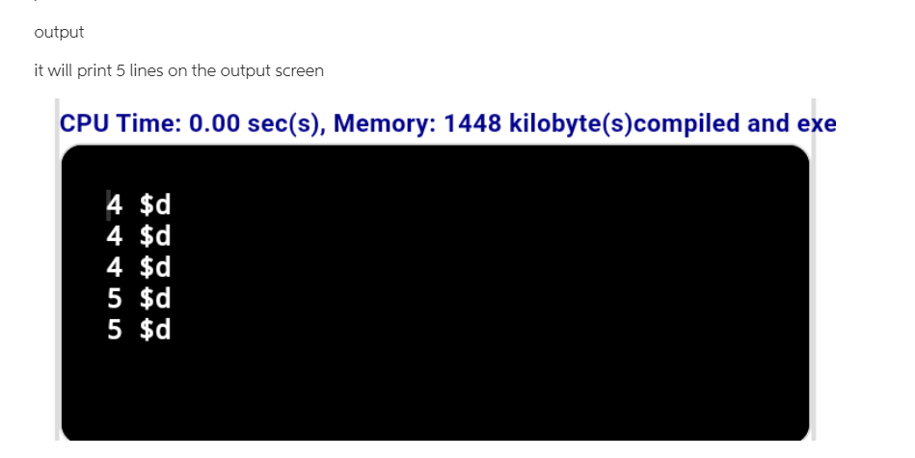

5.
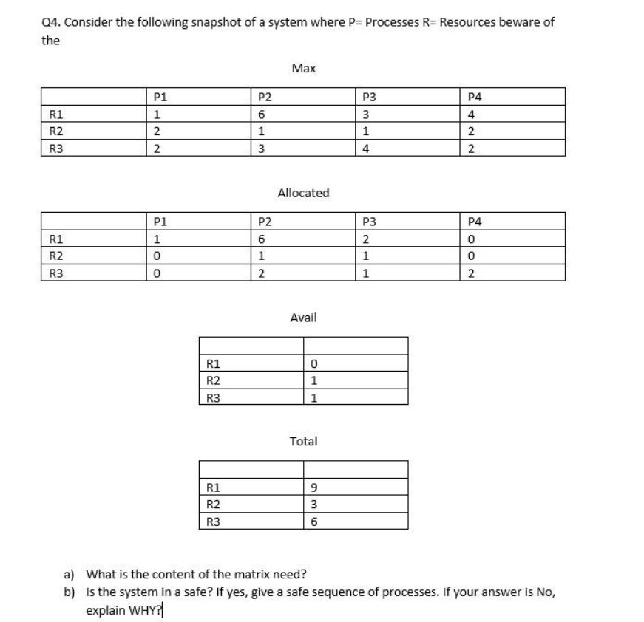
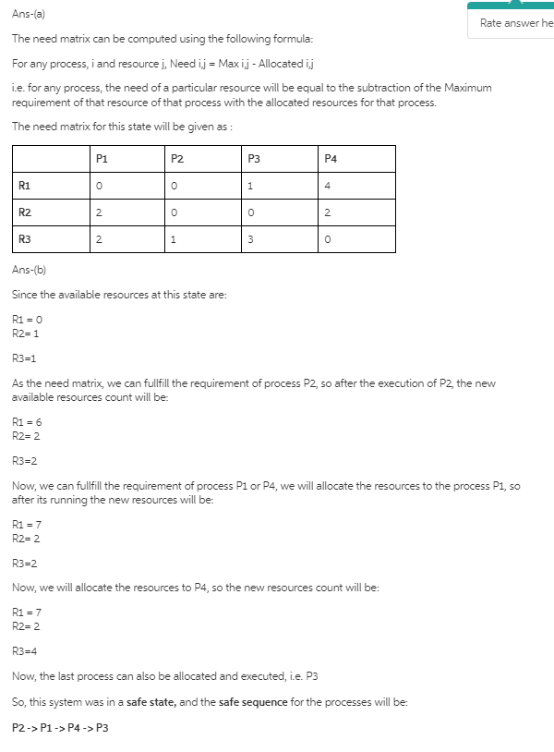

6.
Estimate the Effective Access Time (EAT) when hit ratio α=90% ε=10ns for TLB search and 250ns for memory access.

Answer Given that, hit ratio(α) = 90% = 0.9, TLB search time () = 10 ns and memory access (m) = 250 ns.
Effective Access time(EAT) = α x ( + m ) + ( 1 - α ) x ( + m + m ) = 0.9 x (10 + 250) + ( 1 - 0.9 ) x ( 10 + 250 + 250 ) ns = 0.9 x 260 + 0.1 x 510 ns = 234 + 51 ns = 285 ns.

7.
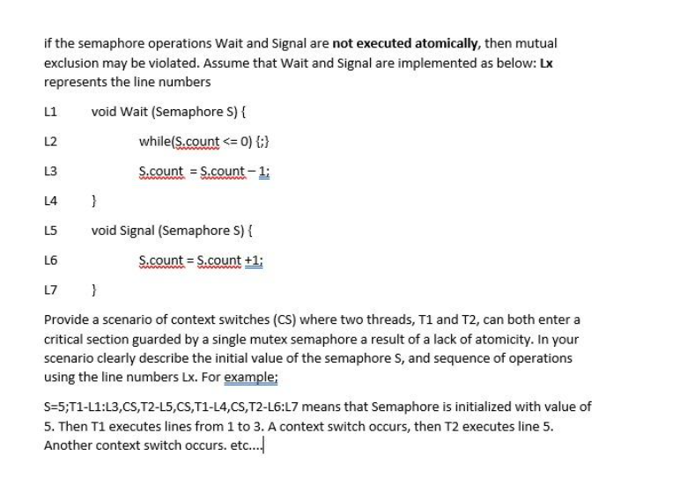
Consider the following execution of two threads T1 and T2:
- Initially, the semaphore S is initialized to a value of 1.
- T1 starts and calls the Wait(S) function (L1). It then executes L2 and finds that S.count > 0.
- Next, a context switch (CS) occurs, and control is transferred to thread T2.
- Thread T2 calls the Wait(S) function (L1). It then executes L2 and finds that S.count > 0.
- Next, T2 executes lines L3 and L4 and sets S.count = 0. T2 then enters the critical section.
- At this point, again a context switch (CS) occurs, and control is transferred back to T1.
- T1 executes the lines L3 and L4, and sets S.count = 0 - 1 = -1. T1 then enters the critical section.
Thus, both T1 and T2 enter the critical section in the following scenario:
S = 1;T1-L1:L2,CS,T2-L1:L4,CS,T1:L3-L4
You can comment below the answer in case of any doubts, and I will be happy to help.
Please give a thumbs up if the answer could be of help!
All the best!

8.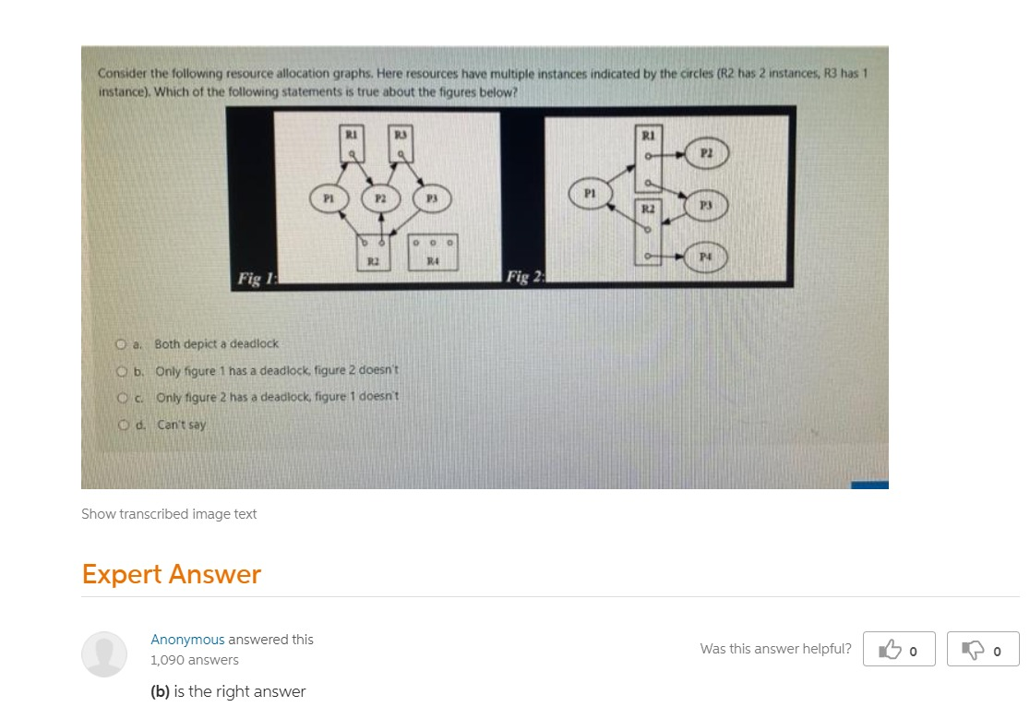

9
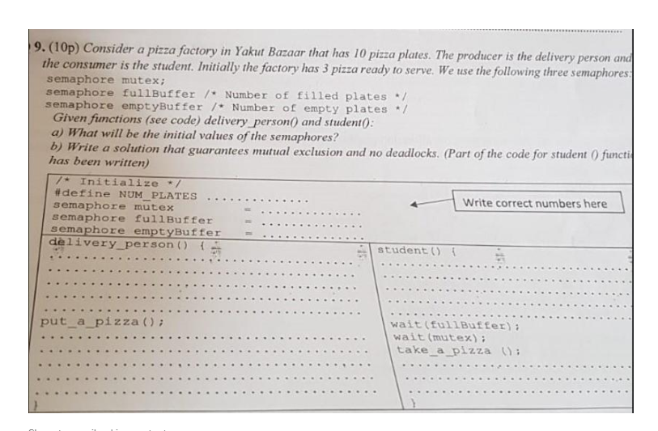

#define NUM_PLATES 10
semaphore mutex = 1;
semaphore fullBuffer = 3;
semaphore emptyBuffer = 7;

student () {
wait (fullBuffer); // wait till there is at least 1 full plate (out of 10) & decrement it
wait (mutex); // get exclusive access to pizza data structure since need to grab one
take_a_pizza ();
post (mutex); // done grabbing pizza, unlock so others can access the pizza data structure
post (EmptyBuffer); // increase the number of empty plates by 1
}

delivery_person () {
wait (emptyBuffer); // wait till there is at least 1 empty plate (out of 10) & decrement it
wait (mutex); // get exclusive access to pizza data structure so I can add a pizza to it
put_a_pizza ();
post (mutex); // done updating pizza list, allow others to access
post (fullBuffer); // increment full plates by 1
}

2021 Online Final Sorulari

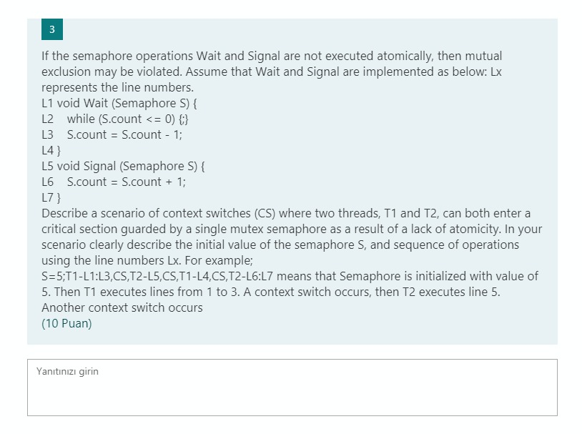

Consider the following execution of two threads T1 and T2:
- Initially, the semaphore S is initialized to a value of 1.
- T1 starts and calls the Wait(S) function (L1). It then executes L2 and finds that S.count > 0.
- Next, a context switch (CS) occurs, and control is transferred to thread T2.
- Thread T2 calls the Wait(S) function (L1). It then executes L2 and finds that S.count > 0.
- Next, T2 executes lines L3 and L4 and sets S.count = 0. T2 then enters the critical section.
- At this point, again a context switch (CS) occurs, and control is transferred back to T1.
- T1 executes the lines L3 and L4, and sets S.count = 0 - 1 = -1. T1 then enters the critical section.
Thus, both T1 and T2 enter the critical section in the following scenario:
S = 1;T1-L1:L2,CS,T2-L1:L4,CS,T1:L3-L4

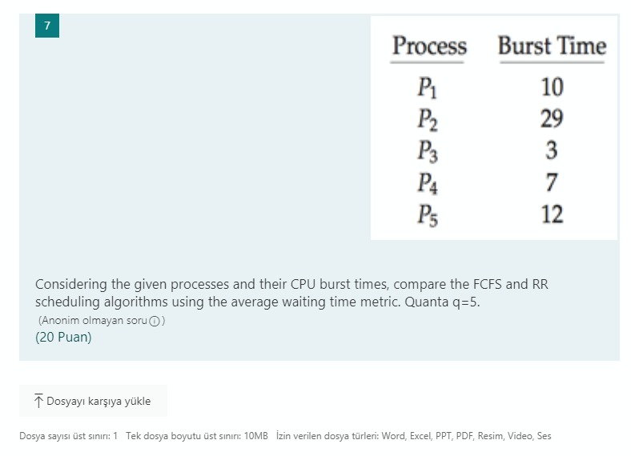

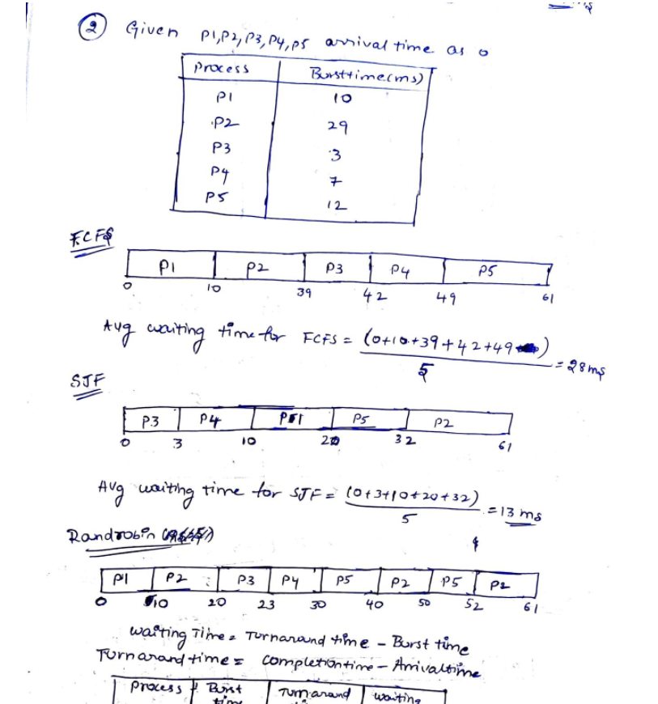

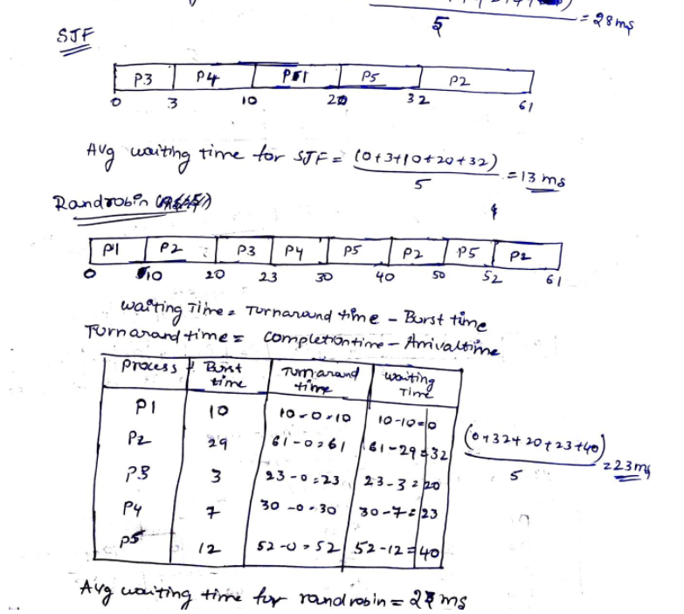

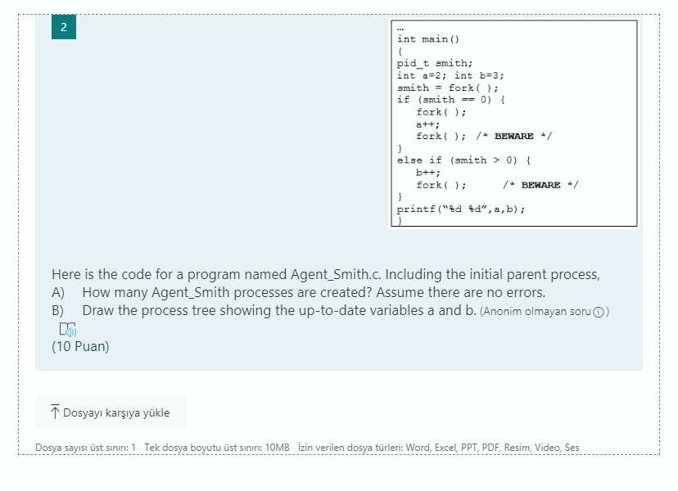

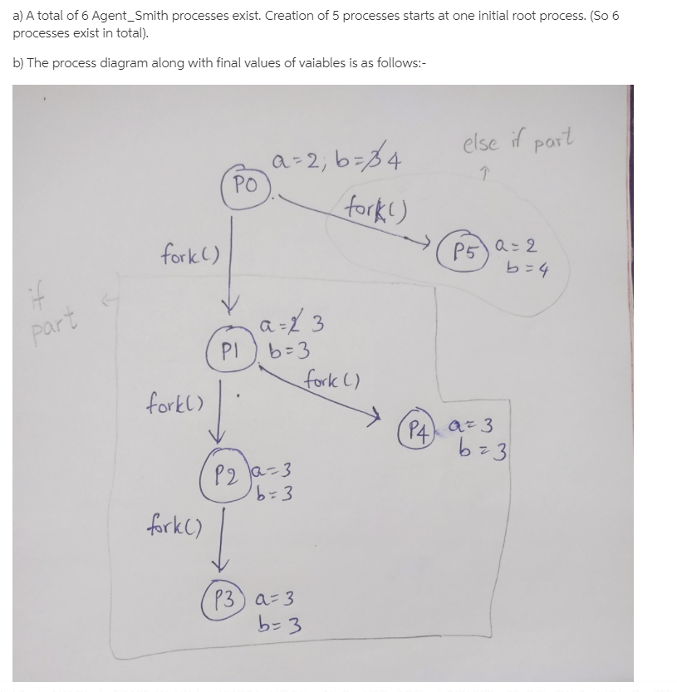

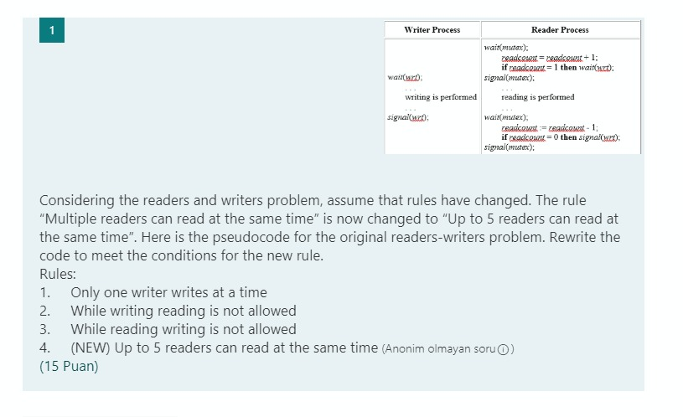

wait(mutex);
readcount=readcount +1;
if readcount = 1
{
then wait(wrt);
}
if readcount<=5
{
singal(mutex);
....reading is performed....
}
if mutex=1
{
wait(mutex)
}
readcount=readcount-1;
if readcount=0
{
signal(wrt);
}
signal(mutex);

