Exercise 2

Name: TECSON, AKEHIDE T. Date: ___________________

Requirements:

Storage: 50 GB

2 logical partitions: Disk 0: 30GB

Disk 1: 20GB

Memory: 4GB

OS: Ubuntu 22.10 64bit

User accounts: (Create two user accounts) The first account is for you with your complete details and the 2nd account is for a guest user.

Install Ubuntu OS (guide on another file) and answer/complete the following questions:

1. What is the purpose of the Ubuntu installer's "Try Ubuntu" option?-

* **Try Ubuntu** will run live image of Ubuntu system, this will not actually installing Ubuntu—thus changes you made here not gonna be saved and will be gone after shutdown.

1. How can you partition a hard disk during the Ubuntu OS installation process?-

* To create the Ubuntu partition, select the hard drive free space in the hard disk partition table menu and press the + button. In the partition pop-up window, enter the partition size in MB, the partition type as Primary, and the partition location at the start of this space.

1. How can you install additional software packages after Ubuntu OS installation?-

* To install Additional or Missing Drivers on your Ubuntu 18.04 LTS dekstop, Open Gnome Search Box search for Software & update. Click on “Additional Drivers” Tab and follow the specific instructions provided on the screen.

4. Screenshot of the login screen with the two user accounts

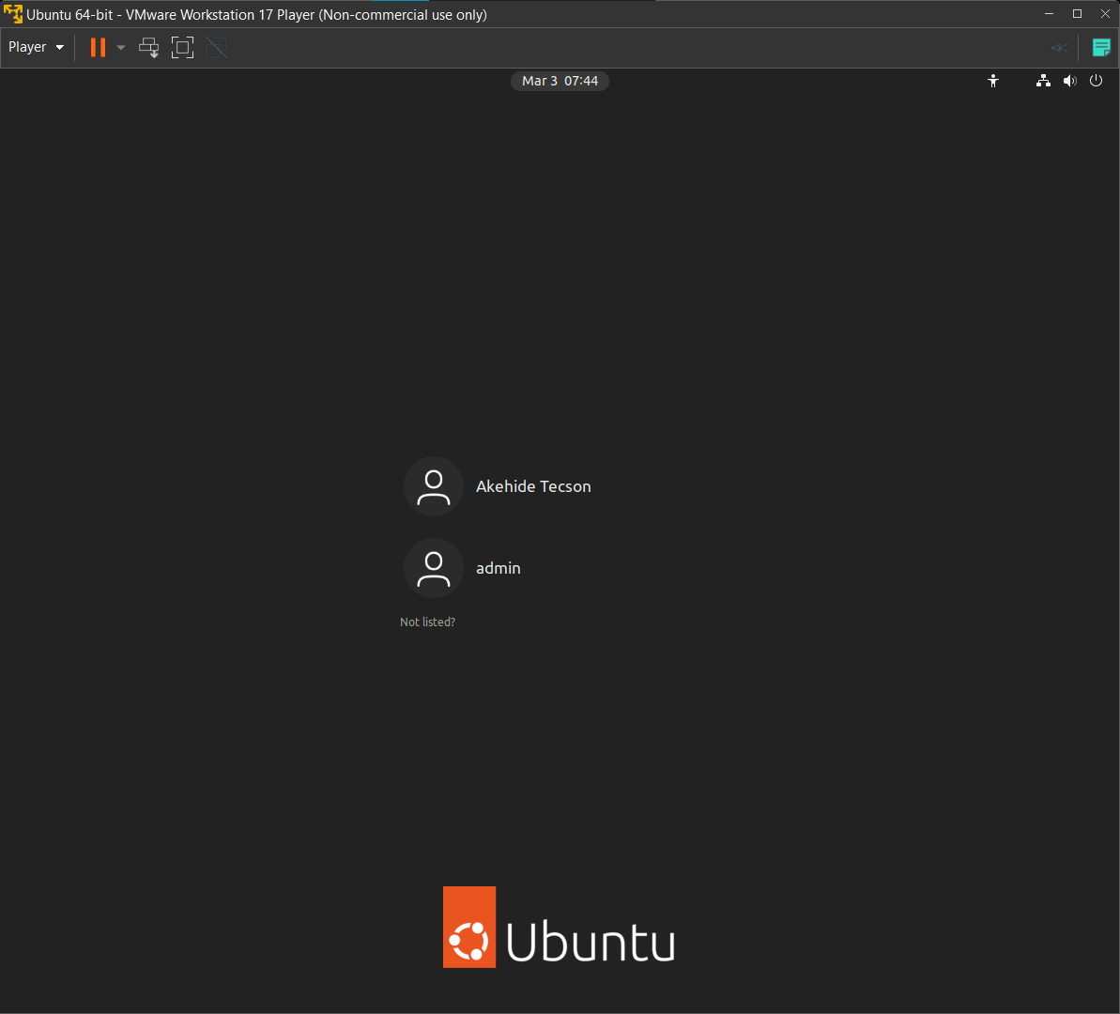

1. Screenshot of the logical drives

