Figure 1: Flowchart of patient inclusion.

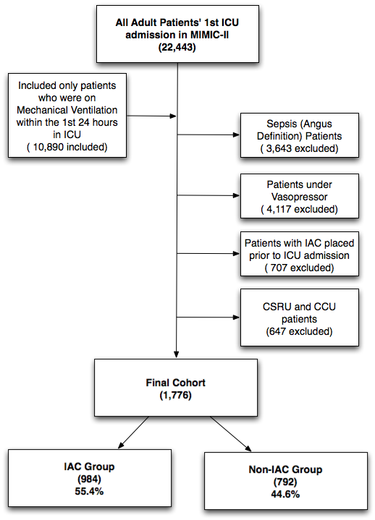

Figure 2: Propensity score distribution plot comparing the IAC and non-IAC groups before and after matching.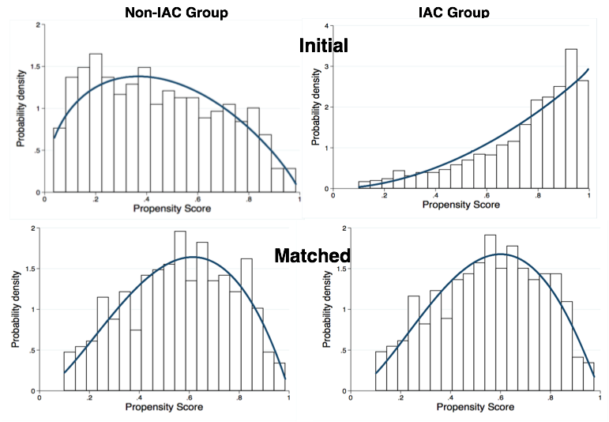

Figure 3. Sensitivity analyses using various propensity score models and matching caliper levels. The findings from sensitivity studies were consistent with the original study design. As shown in (a), the Odds Ratio for IAC placement and 28-day mortality are around 1.0. In addition, as shown in (b), the p values for all the analyses were statistically insignificant (p>0.05).

