Difference between static and non-static methods, variables And explain their memory architecture as well?

Ans: A static method is a method that belongs to a class, but it does not belong to an instance of that class and this method can be called without the instance or object of that class.

Every method in java defaults to a non-static method without static keyword preceding it . Non-static methods can access any static method and static variable, without creating an instance of the object.

What is typecasting? Suppose there is a data which is of type double then how can you show that double in int data type?

Ans: Type casting is when you assign a value of one primitive data type to another type. The easiest way to convert a double to int in Java is by type casting but it works only when your requirement is just to get rid of anything after the decimal point. Since double is bigger data type than int, it needs to be down-casted as shown below:

int value = (int) 6.14; // 6

int score = (int) 6.99; // 6

What is Polymorphism? What are the advantages?

Ans: Polymorphism is the ability of a programming language to present the same interface for several different underlying data types. Polymorphism is the ability of different objects to respond in a unique way to the same message.

Advantages of Polymorphism

Polymorphism offers the following advantages −

* It helps the programmer to reuse the codes, i.e., classes once written, tested and implemented can be reused as required. Saves a lot of time.
* Single variable can be used to store multiple data types.
* Easy to debug the codes.

What is the alternate of polymorphism?

Ans: The alternative to using polymorphism in Java is to use instanceof and type casts.

What is constructor chaining in java?

Ans: Constructor chaining is the process of calling one constructor from another constructor with respect to current object within same class, It can be done using this() keyword for constructors in same class. From base class: by using super() keyword to call constructor from the base class.

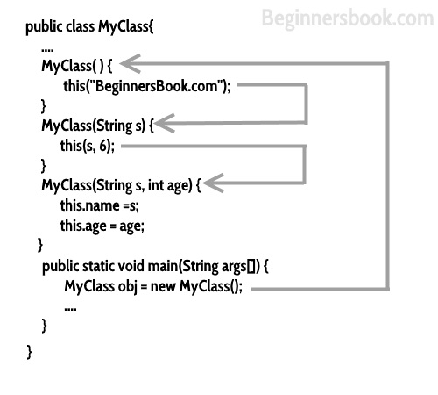

What is constructor ? what are advantages of a constructor ? Explain constructor with the help of inheritance?

Ans: A constructor is a block of code that's called when an instance of an object is created in Java. In many ways, a constructor is similar to a method, but a few differences exist: A constructor doesn't have a return type. The name of the constructor must be the same as the name of the class.

If you create a new Object of MyClass it will automatically call the constructor - you can initialize all members within it, and be sure that this object´s members are all initialized. Generally: A constructor is always called once when you create a new Object of this class, and you can´t call it manually.

In Java, constructor of base class with no argument gets automatically called in derived class constructor. But, if we want to call parameterized constructor of base class, then we can call it using super(). The point to note is base class constructor call must be the first line in derived class constructor. For example, in the following program, super(_x) is first line derived class constructor.

What is super keyword?

Ans: The super keyword refers to superclass (parent) objects. It is used to call superclass methods, and to access the superclass constructor. The most common use of the super keyword is to eliminate the confusion between superclasses and subclasses that have methods with the same name.

Super’ keyword is used to access superclass properties, but what when you are not allowed to use super then how can you access the property of superclass, if yes then how?

Don’t know

Why java compiler needs main method static only?

Java main() method is always static, so that compiler can call it without the creation of an object or before the creation of an object of the class. In any Java program, the main() method is the starting point from where compiler starts program execution. So, the compiler needs to call the main() method.

What do you understand by anonymous word? And what is the impact of anonymous array and object in java? Explain memory structure with or without anonymous?

In simple words, the anonymous inner class is a class without names and only one object is created. Anonymous class is useful when we have to create an instance of the object with overloading methods of a class or interface without creating a subclass of class. An array without name is known as anonymous array in java. As the array do not have any name so it can be used only once. anonymous int array : new int[] { 1, 2, 3, 4};

Why java requires inner class? What do you understand by static inner classes in java? And where will you use a static and non-static class?

Inner classes are a security mechanism in Java. We know a class cannot be associated with the access modifier private, but if we have the class as a member of other class, then the inner class can be made private. And this is also used to access the private members of a class.

<https://www.tutorialspoint.com/Why-do-we-need-inner-classes-in-Java>

A nested class is a member of its enclosing class. Non-static nested classes (inner classes) have access to other members of the enclosing class,

What are different ways to create an object in java?

Java new Operator

Java Class.newInstance() method

Java newInstance() method of constructor

Java Object.clone() method

Java Object Serialization and Deserialization

So basically, an object is created from a class. In Java, the new keyword is used to create new objects. Anytime an object gets created, it is stored in the heap space. The stack memory only comprises its reference and local primitive variables. Objects here are accessible globally across the application. Other threads cannot access stack memory objects.

JVM is compiler in java to run your program, explain steps from writing your code to execute on the machine?

First, the source ‘.java’ file is passed through the compiler, which then encodes the source code into a machine independent encoding, known as Bytecode. The content of each class contained in the source file is stored in a separate ‘.class’ file. While converting the source code into the bytecode

What is heap memory allocation in java? Explain the difference between stack and heap memory allocation in java?

Heap space in Java is used for dynamic memory allocation for Java objects and JRE classes at the runtime. Stack always stored blocks in LIFO order whereas heap memory used dynamic allocation for allocating and deallocating memory blocks.

How JVM knows about your program and what is the cycle of code execution in java?

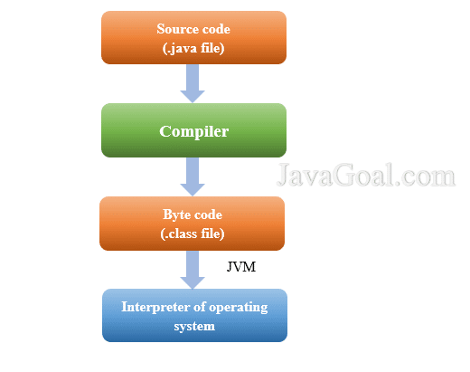

Difference between public, private and protected modifiers and explain why do you need all these modifiers in your code?

The private access modifier is the most restrictive access level. Class and interfaces cannot be private. Members that are declared private can be accessed outside the class.

The public access modifier can be associated with class, method, constructor, interface, etc. public can be accessed from any other class. Therefore, fields, methods, blocks declared inside a public class can be accessed from any class.

The protected access modifier can be associated with variables, methods, and constructors, which are declared protected in a superclass can be accessed only by the subclasses in other package or any class within the package of the protected members' class.

The default access modifier does not have keyword a variable or method declared without any access control modifier is available to any other class in the same package.

What will be the result If java set the main method to private?

Yes, we can declare the main method as private in Java. It compiles successfully without any errors but at the runtime, it says that the main method is not public

The interface is about 100% abstraction, what do you understand by 100% abstraction and how can you achieve 100% abstraction in java? Write the same program from both interface and abstract class, now as you can write the same code with abstract class then why do you need an interface in java?

Abstraction is a process of hiding the implementation details from the user, only the functionality will be provided to the user. In other words, the user will have the information on what the object does instead of how it does it.

What is multilevel inheritance in java? And does java support multiple inheritances, explain your thoughts?

Multiple Inheritance is a feature of object oriented concept, where a class can inherit properties of more than one parent class. The problem occurs when there exist methods with same signature in both the super classes and subclass. Java doesn't allow multiple inheritance to avoid the ambiguity caused by it.

Java is object-oriented language, explain both object and oriented word?

Object-oriented programming is a programming pattern where everything is represented as an object. Object Oriented programming is a programming style which is associated with the concepts like class, object, Inheritance, Encapsulation, Abstraction, Polymorphism.

What do you understand by the break and continue keyword in an iteration?

The break statement is used to terminate the loop immediately. The continue statement is used to skip the current iteration of the loop.

Write all possible syntax of for loop?

easy answer

What is the difference between while and for loop? And explain the cases where which one suits better?

The 'for' loop used only when we already knew the number of iterations. The 'while' loop used only when the number of iteration are not exactly known

Scope is that area of the program where the variable is visible to a program and can be used (accessible). i.e. the scope of variable determines its accessibility for other parts of program.Java allows declaring variables within any block. Local variables must be initialized before use, as they don't have a default value and the compiler won't let us use an uninitialized value.

What is an interpreter in java? And the difference between compilation and interpretation in java?

Interpreter in Java is a computer program that converts high-level program statement into Assembly Level Language. It is designed to read the input source program and then translate the source program instruction by instruction. The difference between an interpreted and a compiled language lies in the result of the process of interpreting or compiling. An interpreter produces a result from a program, while a compiler produces a program written in assembly language.

What do you get by mean of return type in java? And suppose you have to return int data but return type of method is double, explain will it work or not?

A return statement causes the program control to transfer back to the caller of a method. There will be error.

What is object chaining in java?

This technique is useful when you want to call a series of methods on an object. It reduces the amount of code required to achieve that and allows you to have a single returned value after the chain of methods.

Write a singleton class in java? And where, why you will prefer singleton in any case?

class must ensure that only single instance should be created and single object can be used by all other classes.

Early Instantiation: creation of instance at load time.

Lazy Instantiation: creation of instance when required.

Difference between parameters and arguments in java?

When a function is called, the values that are passed during the call are called as arguments. The values which are defined at the time of the function prototype or definition of the function are called as parameters

Whether java is procedural language or functional language explain it?

java is both procudural and functional.A procedural language is a computer programming language that follows, in order, a set of commands. Functional programming languages are specially designed to handle symbolic computation and list processing applications.

What are the parameters that make java different from other language give some practical examples where java suits better than any other language?

The main difference between Java and any other programming language is the unique way in which Java code is executed. Unlike compiled languages such as C++, Java is compiled into bytecode which can run on any device with the Java Virtual Machine (JVM).

Let's consider java is not having error handling mechanism then write a function where you need to handle ArrayIndexOutOfBoundException yourself.

Need to study More on this.

Why exception handling is introduced in java? List down all the causes behind this?

The core advantage of exception handling is to maintain the normal flow of the application. An exception normally disrupts the normal flow of the application that is why we use exception handling. There can be several reasons that can cause a program to throw exception. For example: Opening a non-existing file in your program, Network connection problem, bad input data provided by user etc.

Difference between try, catch and finally?

The try block will execute a sensitive code which can throw exceptions

The catch block is only executed if an exception is thrown in the try block.

The finally block is executed always after the try(-catch) block, if an exception is thrown or not.

In your example you haven't shown the third possible construct:

try {

// try to execute this statements...

}

catch( SpecificException e ) {

// if a specific exception was thrown, handle it here

}

// ... more catches for specific exceptions can come here

catch( Exception e ) {

// if a more general exception was thrown, handle it here

}

finally {

// here you can clean things up afterwards

}

Try to relate every oop concept from your surrounding.

Object-oriented programming has four basic concepts: encapsulation, abstraction, inheritance and polymorphism.

What is Garbage Collection?

Java garbage collection is the process by which Java programs perform automatic memory management. Java programs compile to bytecode that can be run on a Java Virtual Machine, or JVM for short. ... The garbage collector finds these unused objects and deletes them to free up memory.

IOC container?

The Spring IoC container is at the core of the Spring Framework. The container will create the objects, wire them together, configure them. The Spring container uses dependency injection (DI) to manage the components that make up an application.

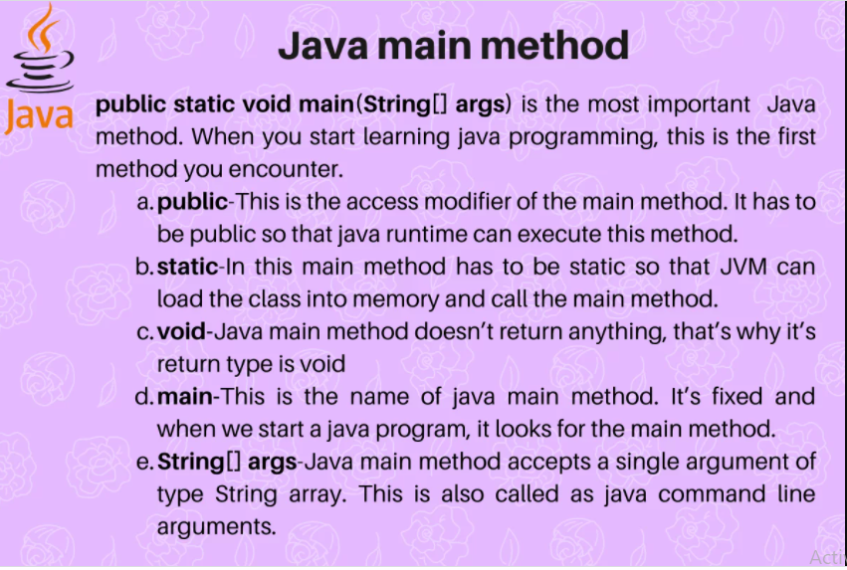

Bean life cycle is managed by the spring container. When we run the program then, first of all, the spring container gets started. After that, the container creates the instance of a bean as per the request and then dependencies are injected. And finally, the bean is destroyed when the spring container is closed.

difference between c# and java?

Java is a class-based Object Oriented language whereas C# is Object-Oriented, functional, strong typing, component-oriented.

What the difference between Cookies and Local Storage?

Cookies and local storage serve different purposes. Cookies are primarily for reading server-side, local storage can only be read by the client-side.

What is stream?

Ans: A stream is a sequence of objects that supports various methods which can be pipelined to produce the desired result.

Extra-

In Java, the Stream is used to process collections of objects. A stream is a sequence of objects that supports various methods which can be pipelined to produce the desired result.

what is parant tag in xml of spring?

When you use XML-based configuration metadata, you indicate a child bean definition by using the parent attribute, specifying the parent bean as the value of this attribute.

What is Data Pipeline Archritecture?

A data pipeline achritecture is a set of actions that take raw data from different sources and move the data to a destination for storage and analysis.

API

What is an API Endpoint?

An API endpoint is basically a fancy word for a URL of a server or service.

What is an API (Application Programming Interface)?

APIs just allow applications to communicate with one another.

An API is not a database. It is an access point to an app that can access a database.