**List dir test (working)**

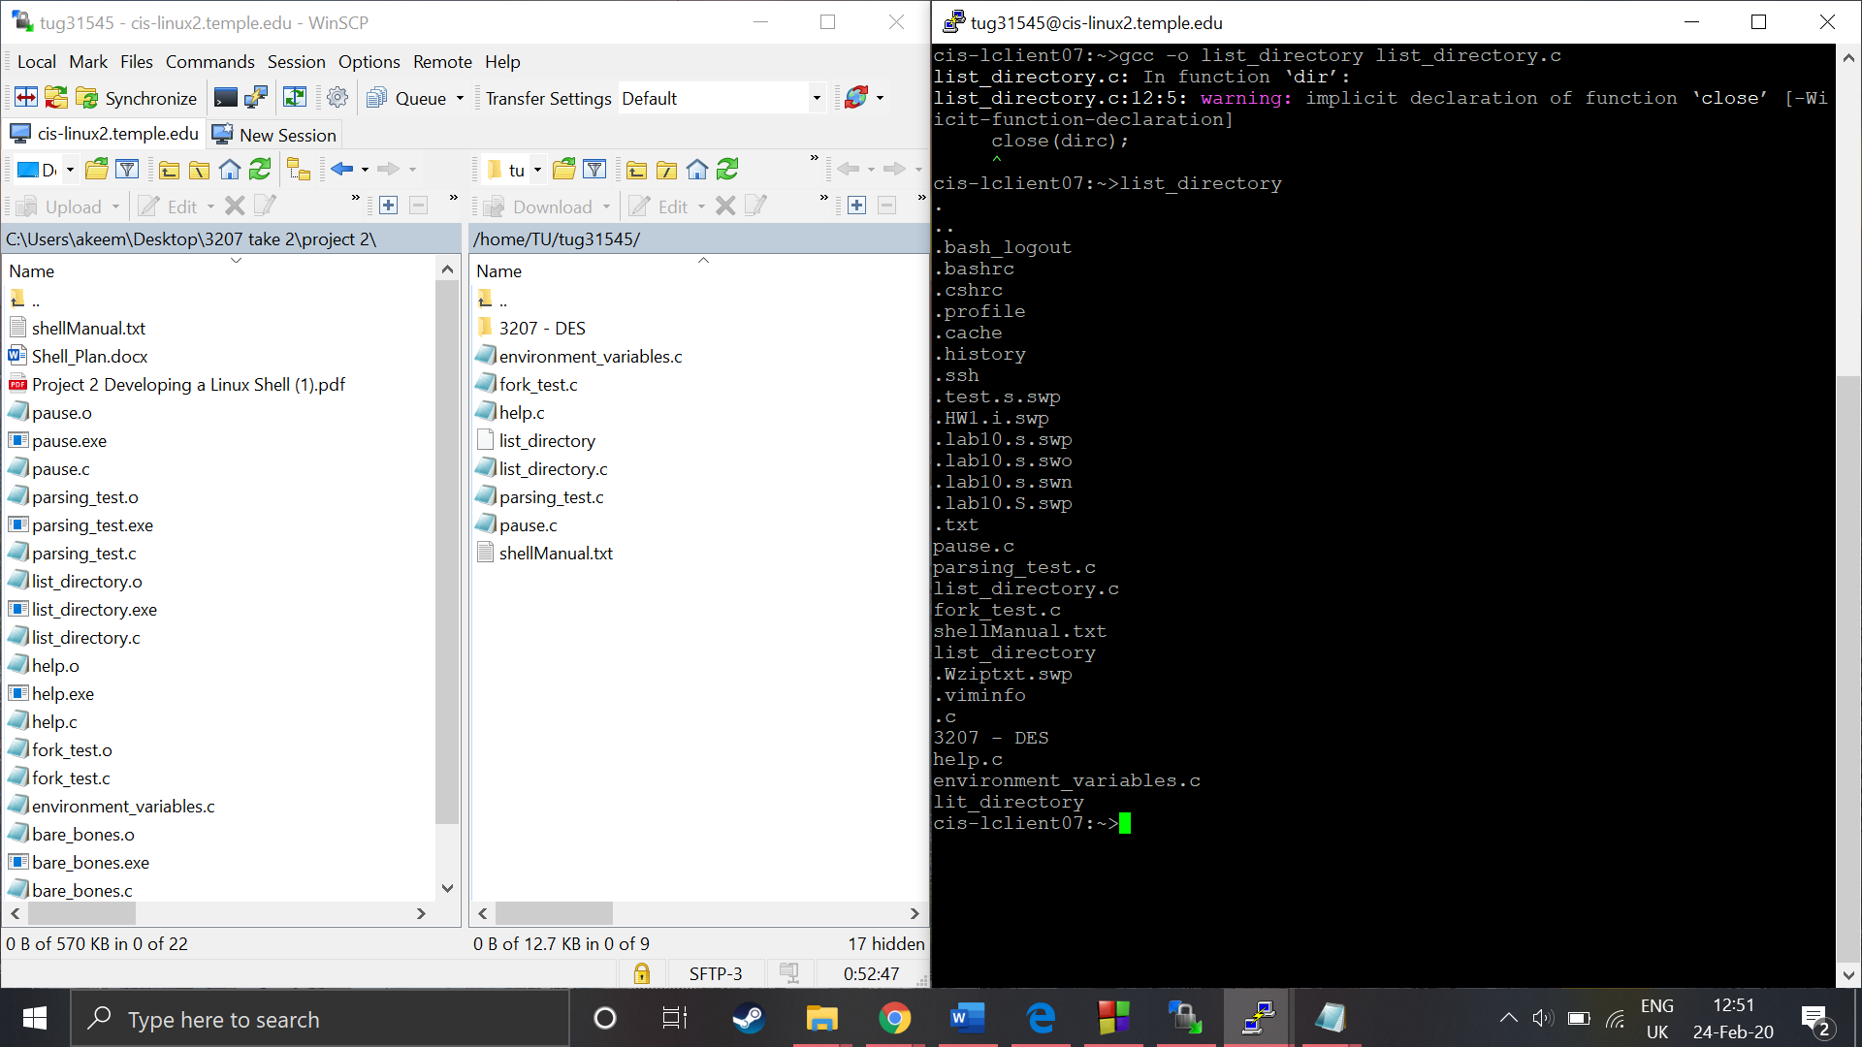

Basic fork: fork working but needs to be able to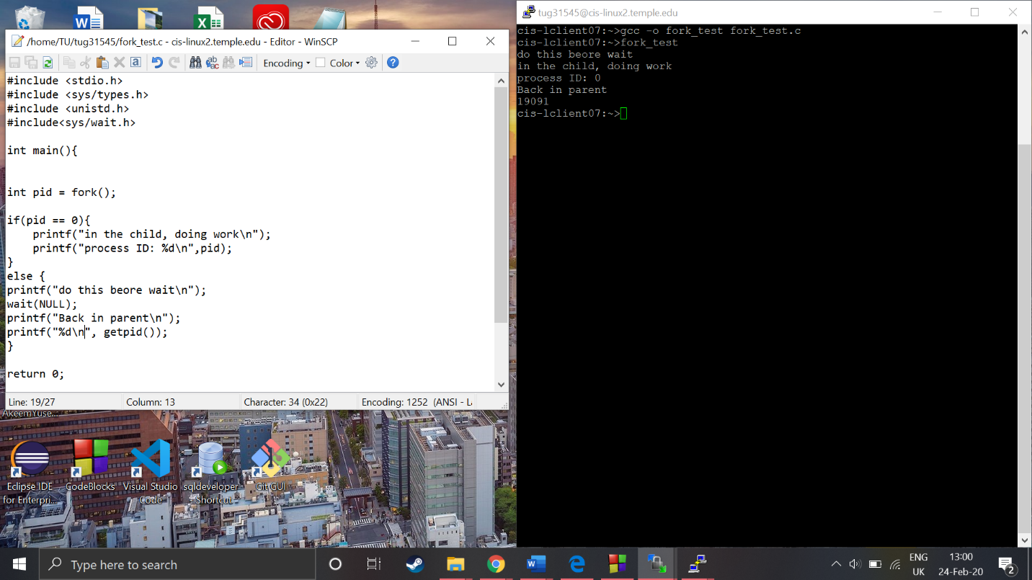 exec

**Parsing test**

My parser gets the basics idea but doesn’t really do the job correct as in this example a is a program & b is an input file, I don’t want it to overwrite nor do I want c to append. Im thinking arr[0] will be a program call and so I should base my redirection of that

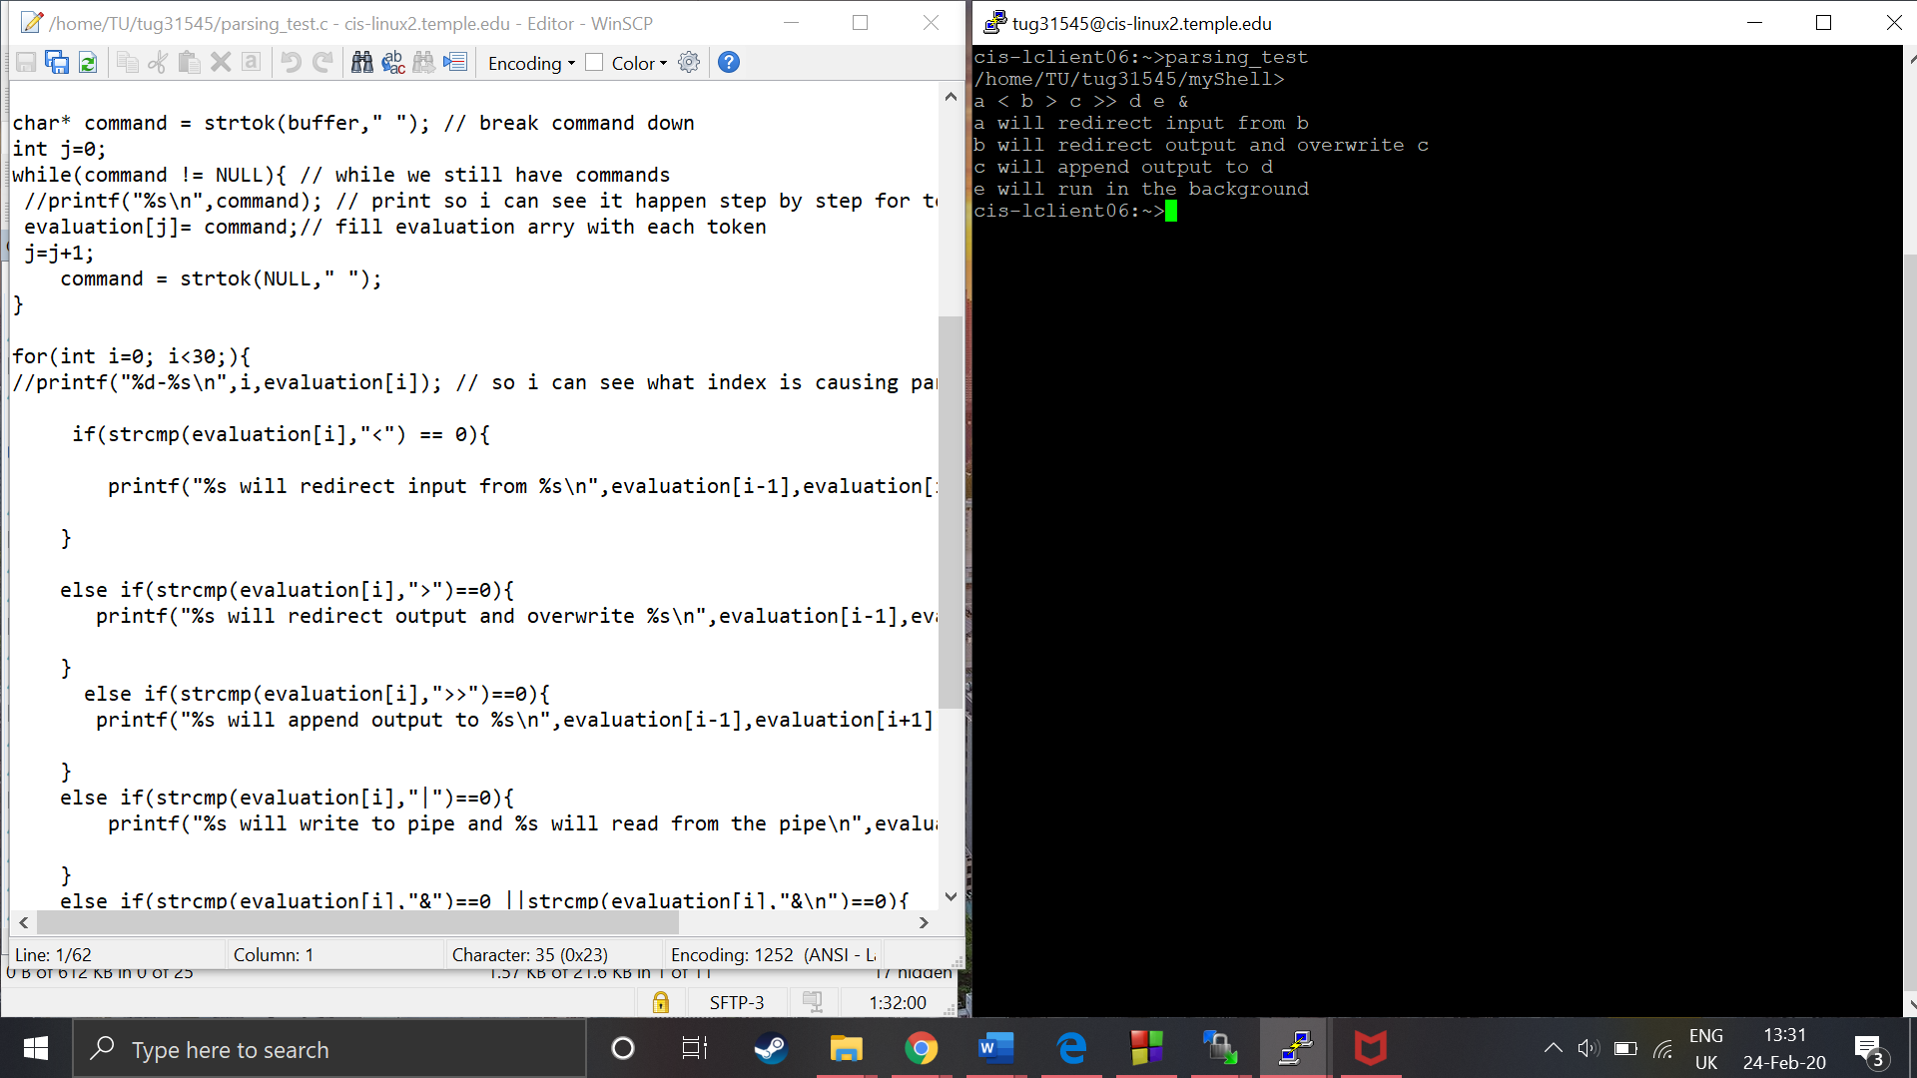

clearScreen

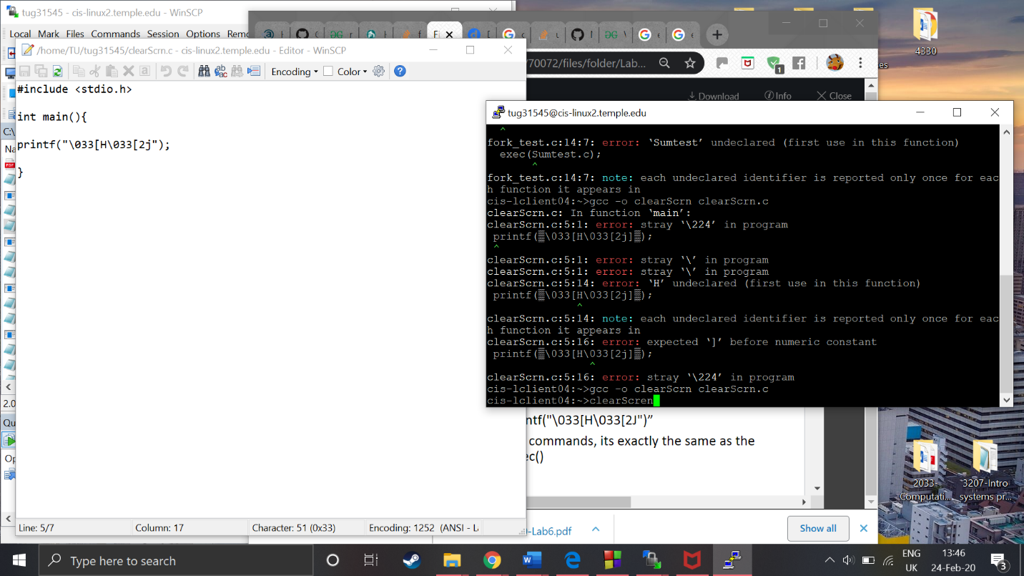before:

After: doesn’t work at the moment it bugs out and goes back to the top of the screen but doesn’t clear

Help: (working)

