# Development Environment hands on lab

## Overview

In this lab, you will set up an Azure trial subscription, an Office365 trial subscription, and an Azure-based virtual machine for the development environment for subsequent labs in the DevCamp. To expedite the process, we’ve prepared Windows and Linux images that you will copy into your own environment, start the virtual machine and connect to it. You will then configure the components for Azure development.

## Objectives

In this hands-on lab, you will learn how to:

* Set up an Azure trial subscription
* Set up an Office365 trial subscription
* Create an Azure Virtual Machine for development
* Connect to the Azure Virtual Machine and configure it for development

## Prerequisites

The source for the starter app is located in the HOL\dotnet\modern-cloud-apps\src folder.

The finished project is located in the HOL\dotnet\modern-cloud-apps\end folder.

# Exercises

This hands-on-lab has the following exercises:

* Exercise 1: Create an Azure Trial Subscription
* Exercise 2: Create an Office 365 Trial Subscription
* Exercise 3: Create an Azure Virtual Machine for development
* Exercise 4: Configure your Virtual Machine for development

## Exercise 1: Create an Azure Trial Subscription

To complete the trial signup process, you will need a Microsoft ID. If you don’t have one you can use, sign up for a new one here: https://signup.live.com/

In your browser, go to <https://azure.microsoft.com/free/>

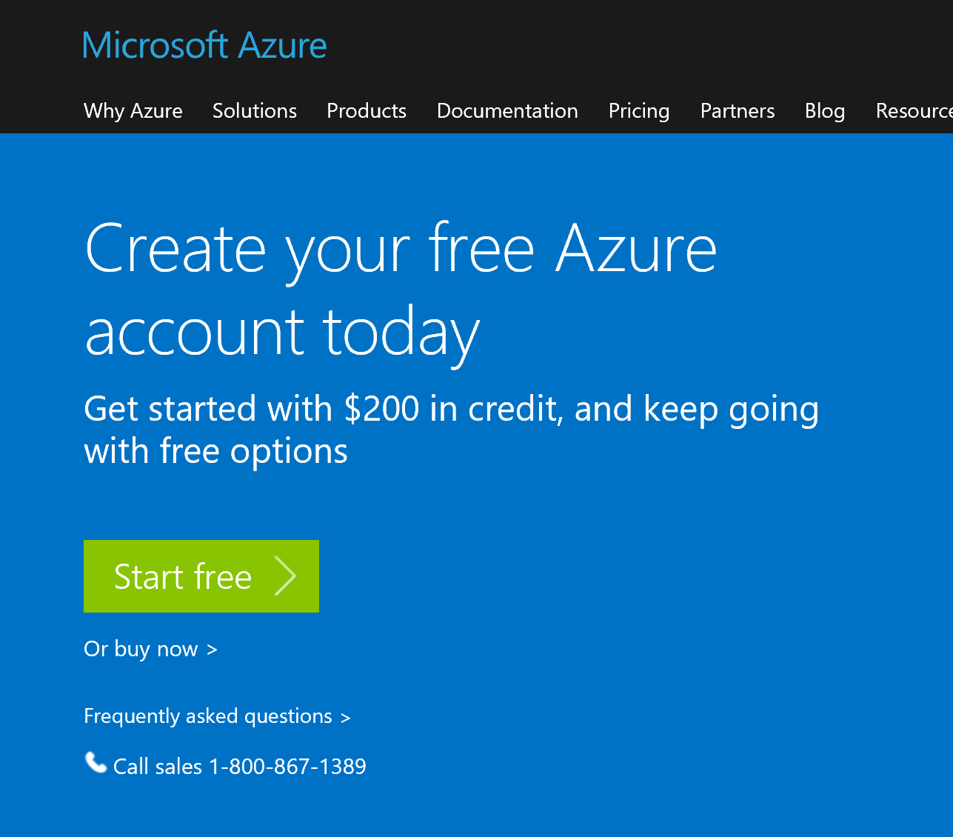

Click the “Start free button”, log in with your Microsoft ID and fill out the identification form.

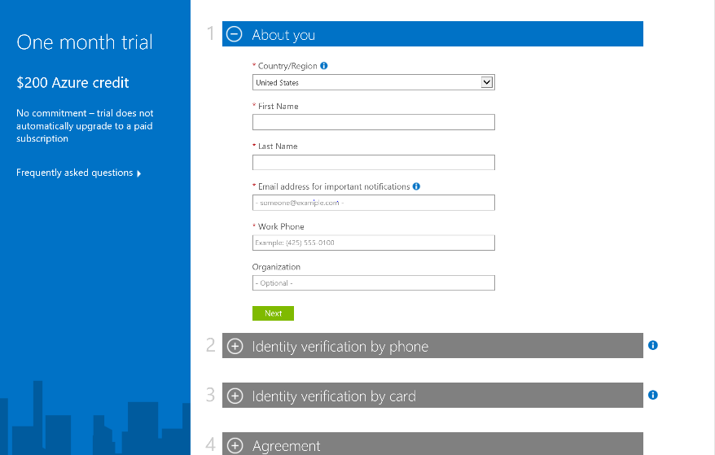

Complete the identity verification by phone, and by credit card. This information is collected only to verify your identity. You will not be charged unless you explicitly upgrade to a paid offer.

Next, complete the agreement and sign up.

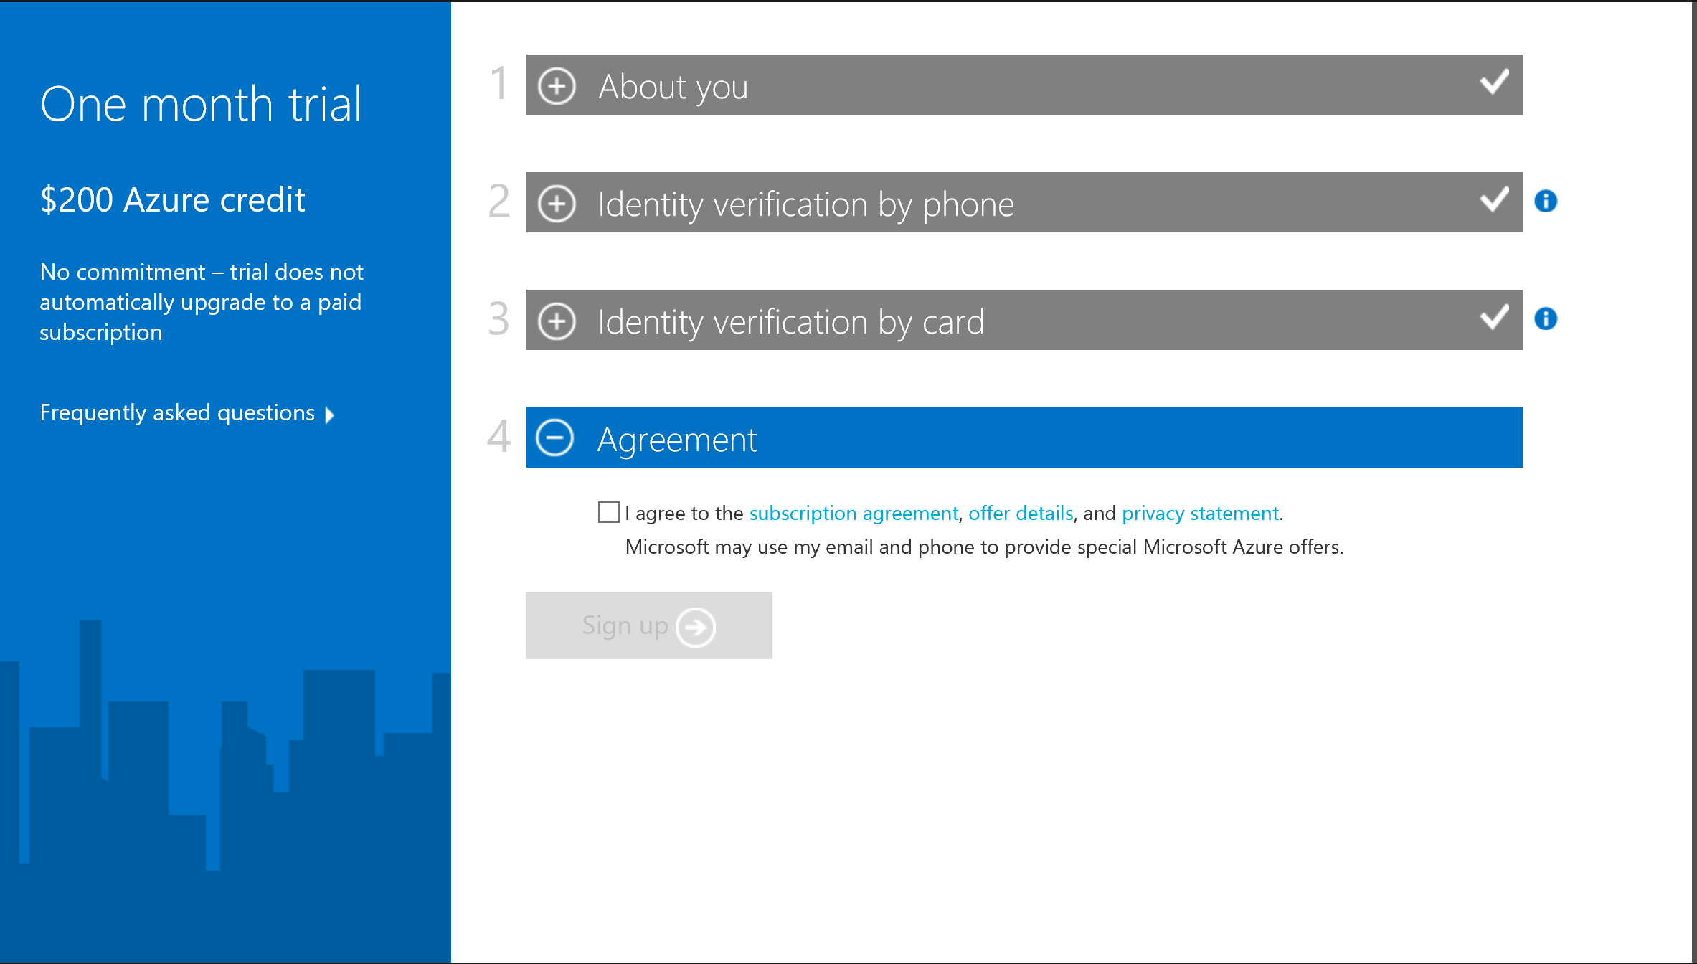

After a short delay, you should see:

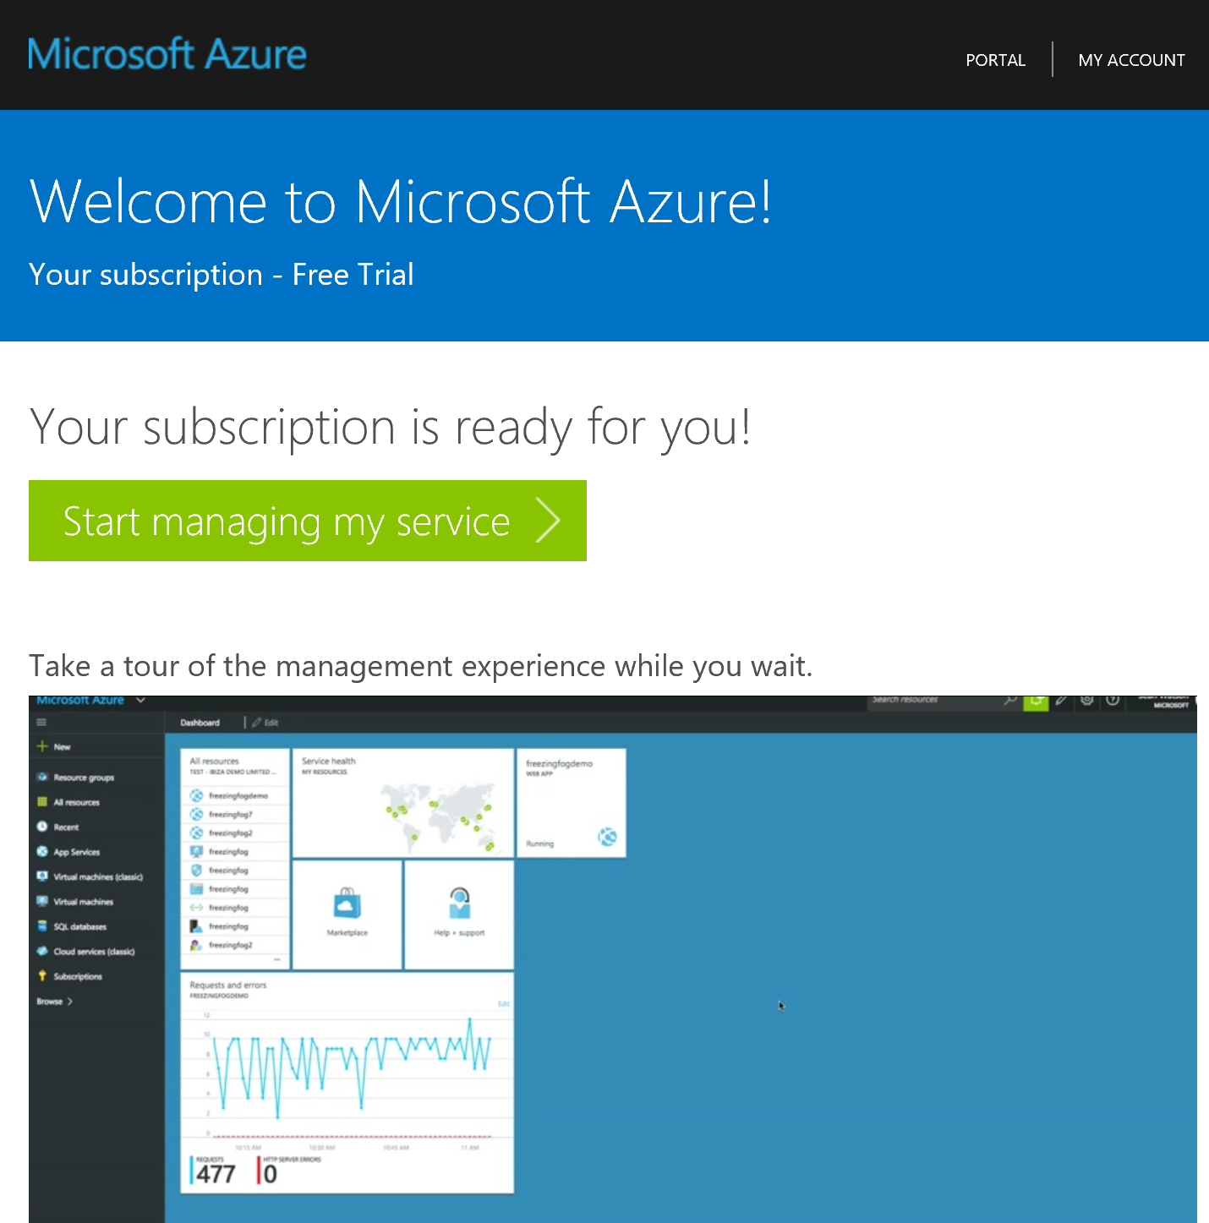

# Office 365 trial

In your browser, go to https://products.office.com/business/office-365-enterprise-e3-business-software

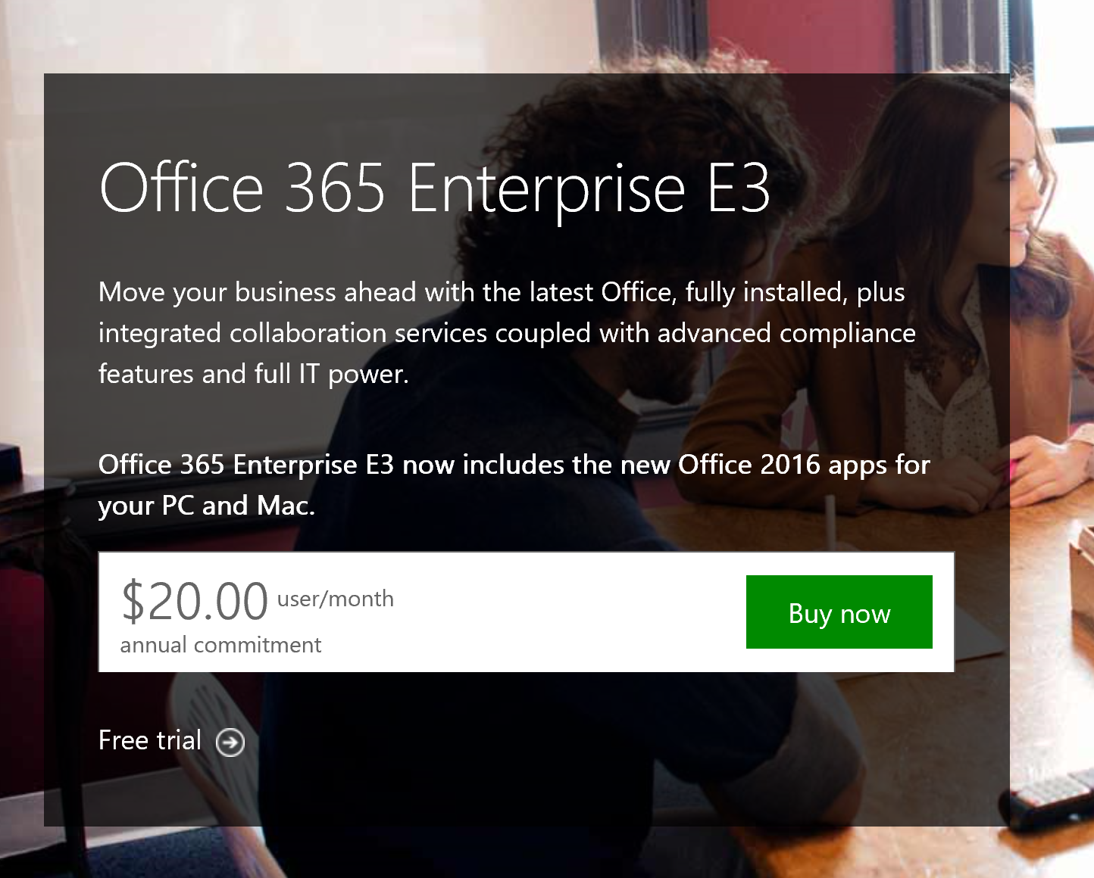

Click “Free Trial”. Fill out the identification form, and then choose your organization name and administrator login. Then, perform the phone verification process. Finally, make note of the sign-in page and user ID presented.

Go to the Office365 portal at <http://portal.office.com> and login with your new credentials. Click the admin tile at the bottom of the list of apps:

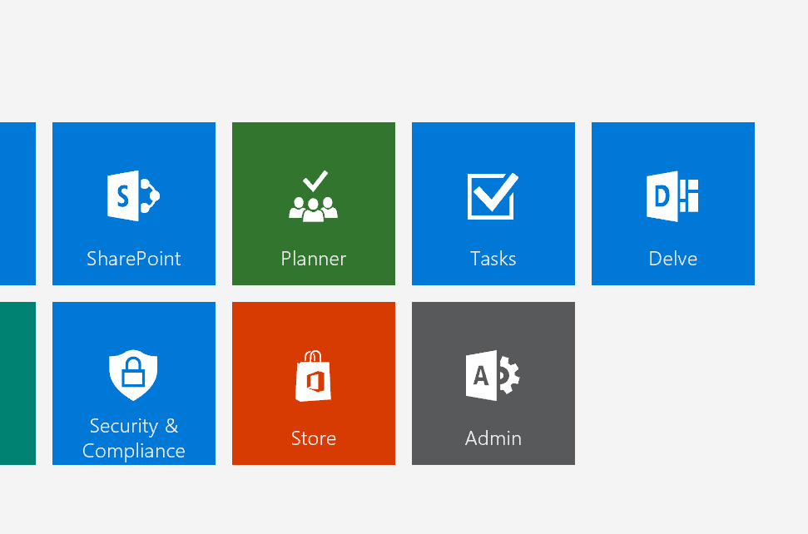

In the window that pops up, choose “Admin Centers” in the left portion, and choose “Azure AD”

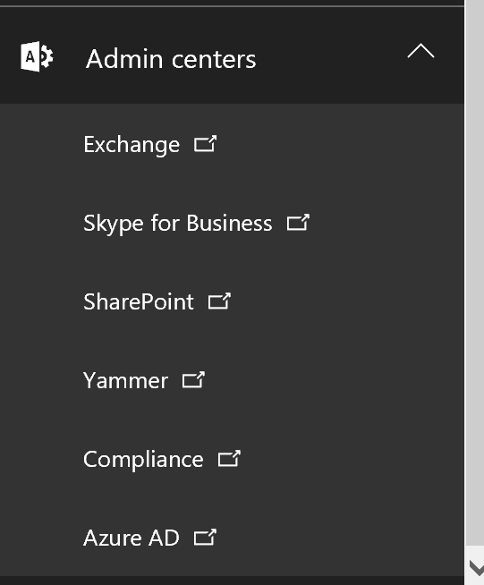

This will pop up another brower window, which will say:

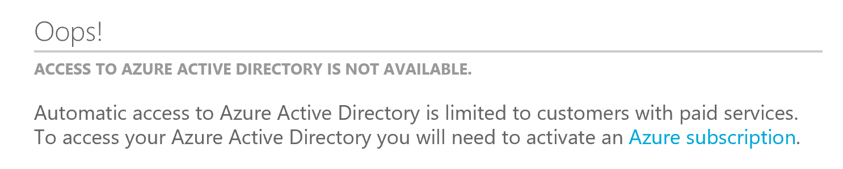

Click “Azure subscription” which will take you to the screen to set up the Azure trial:

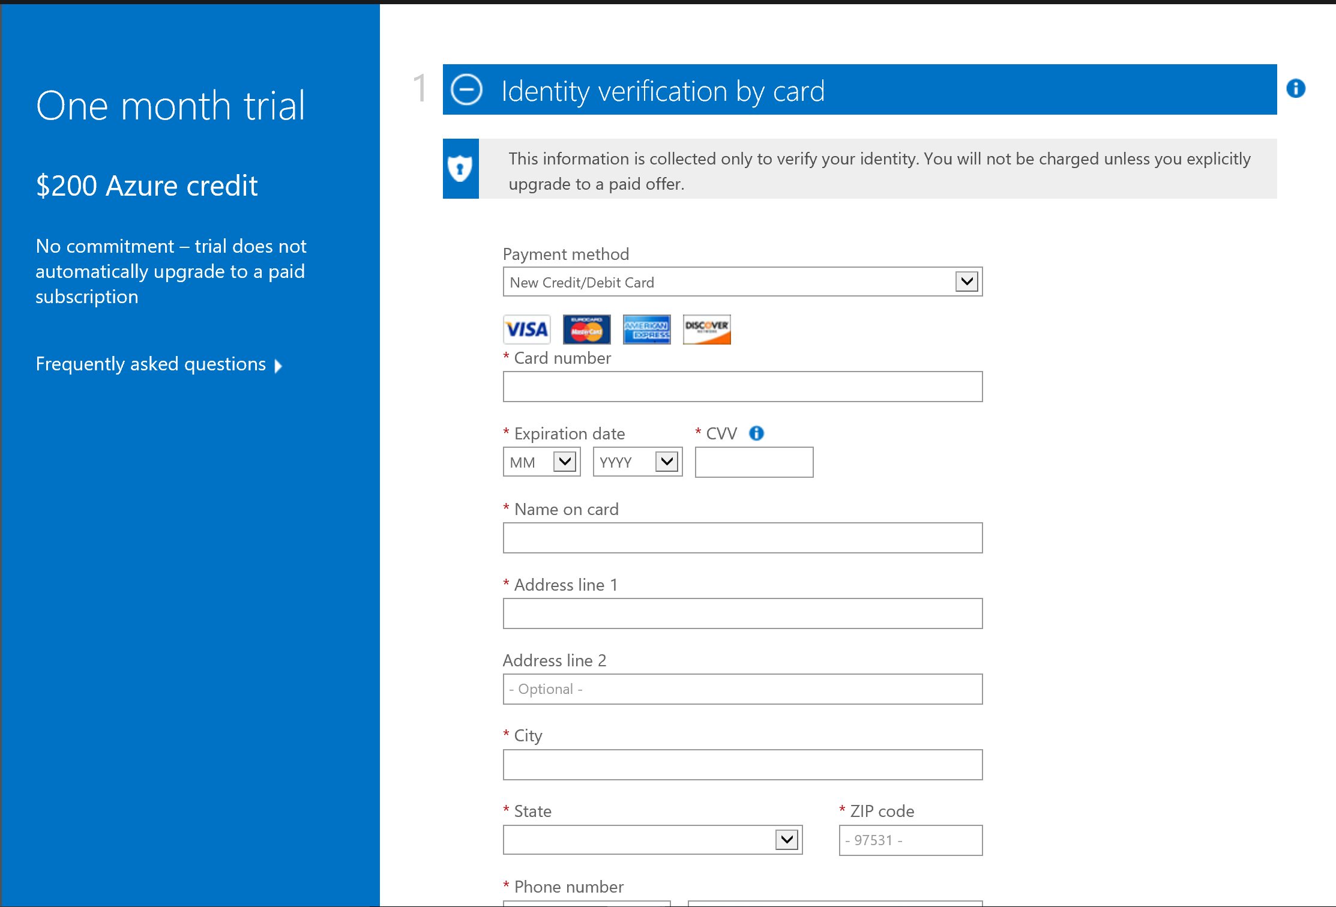

Fill out this form, and choose “next”, then click on the “Agreement”, and choose “sign up”.

# Summary

In this hands-on lab, you learned how to:

* Objective 1
* Objective 2
* Objective 3

Copyright 2016 Microsoft Corporation. All rights reserved. Except where otherwise noted, these materials are licensed under the terms of the MIT License. You may use them according to the license as is most appropriate for your project. The terms of this license can be found at https://opensource.org/licenses/MIT.