# Modern Apps hands on lab

## Overview

In this lab, you will work with an existing API to connect to the web application front end. This will allow you perform CRUD operations for outages. You will also configure some additional Azure features such as Redis CACHE, queues and blob storage.

## Objectives

In this hands-on lab, you will learn how to:

* Use Visual Studio to connect to an API
* Provision an Azure Web App to host the Web site
* Modify a view to add caching
* Modify code to add queuing and blob storage

## Prerequisites

The source for the starter app is located in the HOL\dotnet\modern-cloud-apps\src folder.

The finished project is located in the HOL\dotnet\modern-cloud-apps\end folder.

# Exercises

This hands-on-lab has the following exercises:

* Exercise 1: Configure the WebAPI
* Exercise 2: XXX
* Exercise 3: XXX

## Exercise 1: Configure the WebAPI

Deploy the webapi to your Azure subscription

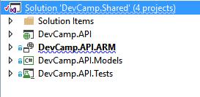

Test with Chrome/postman

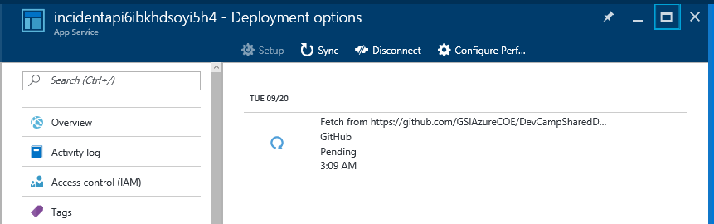

Step 2 – Connect the Web app project to the API

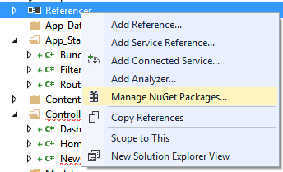

Add the following:

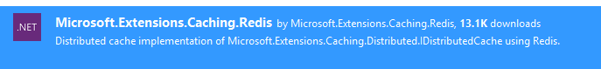

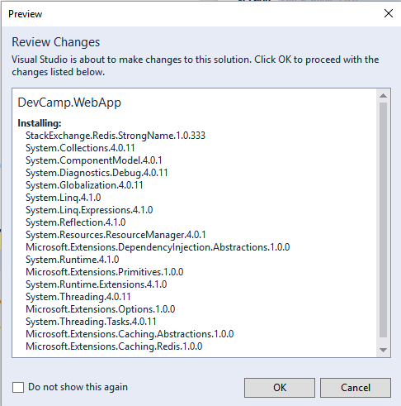

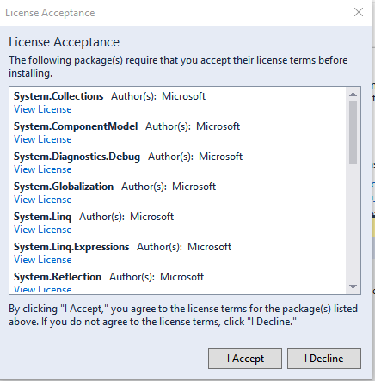



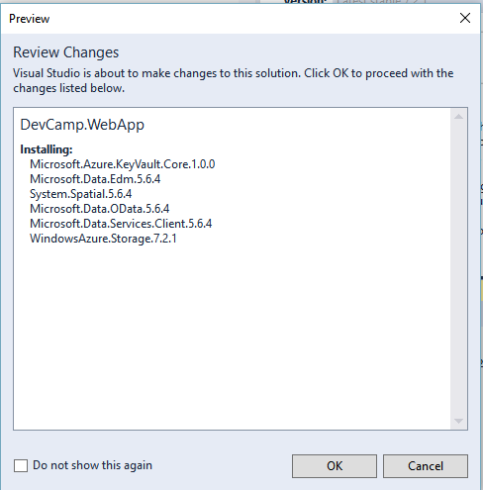

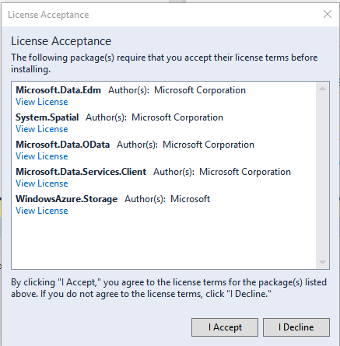

Add a reference to the Web API project URL

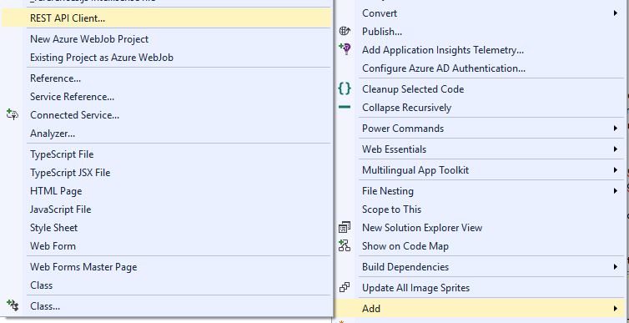

<http://incidentapi4w5agyt32vajs.azurewebsites.net/swagger/docs/v1>

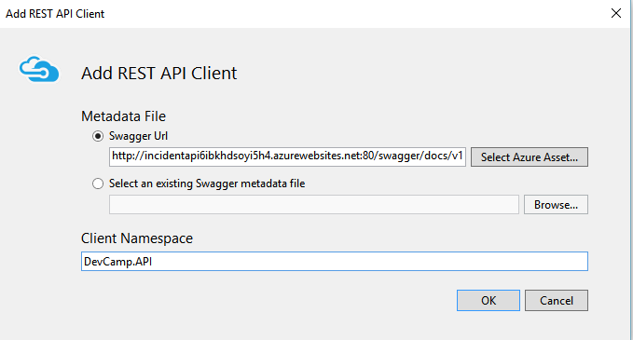

Update the web.config to point to your API URL

<add key="INCIDENT_API_URL" value="" />

Add the following to the Dashboard View:

<!--VIEW CODE-->

<div class="row">

    @if (Model.Count > 0)

        {

            foreach (var item in Model)

            {

            <div class="col-sm-3">

                <div class="panel panel-default">

                    <div class="panel-heading">Outage: @item.Id</div>

                    <table class="table">

                        <tr>

                            <th>Address</th>

                            <td>@item.Address</td>

                        </tr>B

                        <tr>

                            <th>Contact</th>

                            <td><a href="tel:14174444444">Jane Doe</a></td>

                        </tr>

                        <tr>

                            <th>Reported</th>

                            <td>@item.Created</td>

                        </tr>

                    </table>

                </div>

            </div>

        }

    }

    else

    {

        <div><h2>No incidents reported</h2></div>

    }

</div>

<!--VIEW CODE-->

# Summary

In this hands-on lab, you learned how to:

* Objective 1
* Objective 2
* Objective 3

Copyright 2016 Microsoft Corporation. All rights reserved. Except where otherwise noted, these materials are licensed under the terms of the MIT License. You may use them according to the license as is most appropriate for your project. The terms of this license can be found at https://opensource.org/licenses/MIT.