**UNIVERSITY OF BUEA**



**FACULTY OF ENGINEERING AND TECHNOLOGY**

**DERPARTMENT OF COMPUTER ENGINEERING**

**TASK 6: Database and Backend Implementation**

**COURSE CODE:** CEF 440

**COURSE TITLE:** INTERNET PROGRAMMING and MOBILE PROGRAMMING

**COURSE INSTUCTOR:** DR NKEMENI Valery

**BY GROUP 17**

**DATE: June 2025**

|  |  |  |
| --- | --- | --- |
| **SN** | **NAME** | **MATRICULE** |
| 1 | AKENJI FAITH SIRRI | FE22A142 |
| 2 | DYL PADARAN AMBE MUNJO | FE22A193 |
| 3 | KONGNYU DESCHANEL | FE22A234 |
| 4 | NDI BERTRAND | FE22A252 |
| 5 | NDOUKIE EBOKE BLANDINE | FE22A254 |

Table of Contents

**Database Design and Implementation** 4

**1. Data Elements Analysis** 4

**1.1 Theoretical Foundation of Data Element Identification** 4

**1.2 User Management Data Elements** 4

**1.3 Academic Domain-Specific Data Elements** 4

**1.4 Biometric and Location Data Elements** 6

**2. Conceptual Design** 8

**1.** **Users** 8

**2. Mobile App (Client-Side)** 9

**3. Backend Services** 9

**4. APIs & External Services** 10

**3. ER Diagram Theoretical Analysis** 10

**3.1 Relationship Cardinality Analysis** 11

**3.2 Entity Classification** 11

**3.3 Integrity Constraints** 12

**4. Database Implementation** 13

**4.1 Database Normalization** 13

**4.2 Transformation from Basic ER to EER Model** 15

**4.3 Hybrid Database Architecture** 17

**4.4 Database Schema Design Principles** 17

**4.5 Security Implementation Theory** 19

**5. Backend Implementation** 19

**5.1 API Design Architecture** 19

**5.2 Data Processing Algorithms** 20

**5.3 Real-Time Processing Requirements** 21

**6. Database-Backend Integration Theory** 21

**6.1 Connection Management Strategies** 21

**6.2 Data Synchronization Patterns** 22

**6.3 Performance Optimization Theory** 22

**7. Conclusion** 23

**Database Design and Implementation**

**1. Data Elements Analysis**

**1.1 Theoretical Foundation of Data Element Identification**

Data elements represent the fundamental building blocks of any database system. In the context of our mobile-based attendance management system, data elements are derived from the functional requirements specified in the SRS document. According to Elmasri and Navathe's database theory, data elements should be atomic, relevant, and directly support the system's business logic.

**1.2 User Management Data Elements**

The system requires comprehensive user management to support role-based access control (RBAC). The theoretical foundation for this approach stems from the principle of least privilege in information security. Each user entity must contain sufficient data to:

* **Identity Authentication**: Username and password fields support the authentication process, following standard security practices where passwords are stored as hashed values using algorithms like bcrypt or Argon2.
* **Role-Based Authorization**: The role field (Student, Educator, Administrator) implements the RBAC model, ensuring users can only access functionalities appropriate to their organizational position.
* **Audit Trail**: Registration date and status fields provide temporal tracking and account lifecycle management.

**1.3 Academic Domain-Specific Data Elements**

**Student Profile Data**

The student-specific data elements reflect the academic context of the system. The matriculation number serves as a unique business identifier separate from the technical primary key, following database normalization principles. This separation allows for system flexibility while maintaining academic record integrity.

|  |  |  |
| --- | --- | --- |
| **Data Element** | **Data Type** | **Description** |
| user_id | UUID / String | Unique identifier for each user |
| full_name | String | User’s official name |
| email | String | Used for authentication and communication |
| password_hash | String (Hashed) | Encrypted password for secure login |
| role | Enum (student, educator, admin) | Determines user access level |
| profile_picture | Image (Base64/URL) | Optional profile photo used for identification |

**Course Management Data**

Course data elements support the educational workflow defined in FR13. The course code serves as a natural key for academic identification, while the technical primary key ensures database efficiency. Credit hours and semester information support academic calendar integration and workload calculation.

|  |  |  |
| --- | --- | --- |
| **Data Element** | **Data Type** | **Description** |
| course_id | String | Unique course identifier |
| course_name | String | Full name of the course |
| course_code | String | Short course code (e.g., CEF 440) |
| lecturer_id | String | Links course to assigned lecturer |
| schedule | JSON / Object | Contains course days and time slots |

**Session Management Data**

Class session data elements enable temporal tracking of educational activities. The distinction between scheduled time and actual start time addresses the real-world scenario identified in the feasibility study (Section 6.1) where lectures often begin late. This dual-time approach ensures accurate attendance calculation based on actual class duration rather than scheduled duration.

|  |  |  |
| --- | --- | --- |
| **Data Element** | **Data Type** | **Description** |
| attendance_id | UUID / String | Unique ID for the attendance record |
| user_id | String | Links the record to a student |
| course_id | String | Links attendance to a course |
| date | Date | Date of the class session |
| check_in_time | Time | Actual check-in time |
| status | Enum (Present, Absent, Excused, Revoked) | Attendance status |
| recorded_by | String | Lecturer ID who validated the entry |

**1.4 Biometric and Location Data Elements**

**Facial Recognition Data**

The facial recognition data elements implement biometric authentication as specified in FR2. The face encoding field stores mathematical representations of facial features rather than actual images, addressing privacy concerns while enabling identification. The confidence threshold provides a tunable parameter for balancing security and usability.

|  |  |  |
| --- | --- | --- |
| **Data Element** | **Data Type** | **Description** |
| face_id | String / Hash | Encrypted representation of facial data |
| face_image | Image | Captured facial image during check-in |
| verification_status | Boolean | Indicates if the face matched a registered user |
| timestamp | DateTime | Time the face was scanned |

**Geofencing Data**

Geofencing data elements implement location-based verification (FR4). The latitude, longitude, and radius fields define circular geofences using the World Geodetic System (WGS84) coordinate system. This approach provides adequate accuracy for classroom-level location verification while maintaining computational efficiency.

|  |  |  |
| --- | --- | --- |
| **Data Element** | **Data Type** | **Description** |
| geofence_id | String | Unique ID for geofence area |
| name | String | Friendly name of location |
| center_latitude | Float | Latitude of geofence center |
| center_longitude | Float | Longitude of geofence center |
| altitude | float | Height of venue (geofence) above sea level |

**2. Conceptual Design** 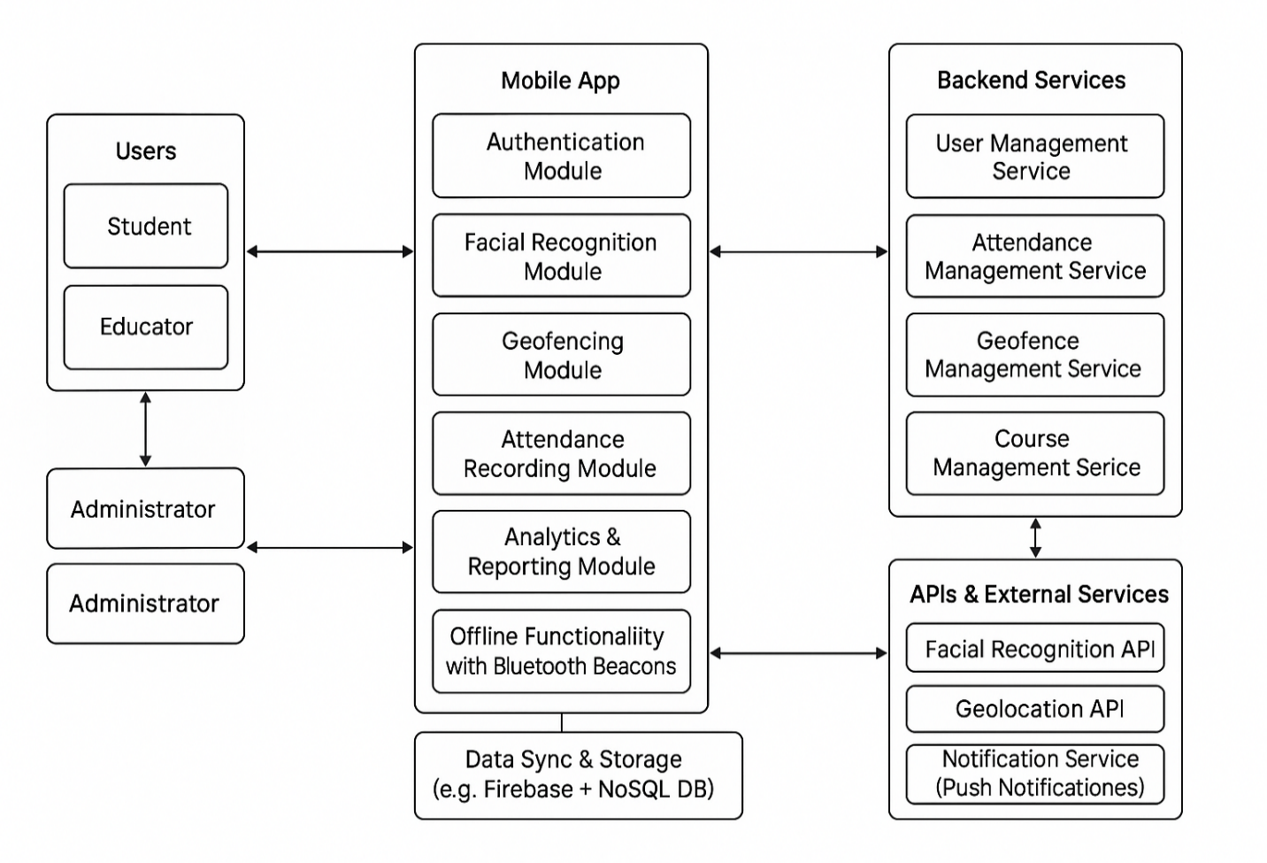

Figure 0‑1: System Conceptual Design

The conceptual design provides a high-level view of data relationships without implementation details. This abstraction level is crucial for stakeholder communication and system understanding.

**2.1 Data Flow Architecture**

The conceptual design implements a layered data flow architecture:

1. **Users**

This layer represents the primary system actors:

* **Students**: Use the mobile app to register their attendance. Their location and facial identity are verified during attendance.
* **Educators (Lecturers)**: Use the app to monitor attendance, initiate facial recognition, and manage classes.
* **Administrators**: Manage users, geofences, courses, and system configurations.

**2. Mobile App (Client-Side)**

The mobile application is the core interface through which all users interact with the system. It is composed of the following functional modules:

**Authentication Module:** Verifies user credentials for login and role-based access (student, lecturer, admin).

**Facial Recognition Module:** Activates the device's camera to capture student images.

**Geofencing Module:** Uses GPS to detect whether the student is within the predefined classroom boundary, works with the Geolocation API and syncs location data in real-time or offline.

**Attendance Recording Module:** Combines facial recognition and geofence verification results, records and timestamps successful check-ins/check-outs, supports manual overrides by lecturers.

**Analytics & Reporting Module:** Provides users with attendance statistics.

**Data Sync & Storage:** Ensures local data is synchronized with the backend when internet connectivity is restored.

**3. Backend Services**

These services provide the logic, processing, and data management needed for the app to function:

**User Management Service**: Enforces role-based permissions.

**Attendance Management Service:** Maintains attendance logs, supports validation, analytics, and manual overrides.

**Geofence Management Service:** Enables administrators to define and update geofenced locations and stores geofence metadata (coordinates, radius, classroom ID).

**Course Management Service:** Supports course creation, registration, and lecturer assignment, syncs course schedules with attendance tracking modules.

**4. APIs & External Services**

These are third-party tools and APIs that enhance the system's capabilities:

**Facial Recognition API:** Processes captured facial data and returns identity verification results.

**Geolocation API:** Converts raw GPS data into location coordinates for geofencing logic, enables real-time movement tracking and validation.

**Notification Service:** Sends push alerts for class start/end times, attendance confirmations, or missed check-ins.

**3. ER Diagram Theoretical Analysis**

The ERD serves as a blueprint for the database, illustrating the various entities (tables), their attributes (columns), and the relationships between them. This design is foundational for developing a system that effectively manages user information, course enrollment, attendance tracking, and communication.

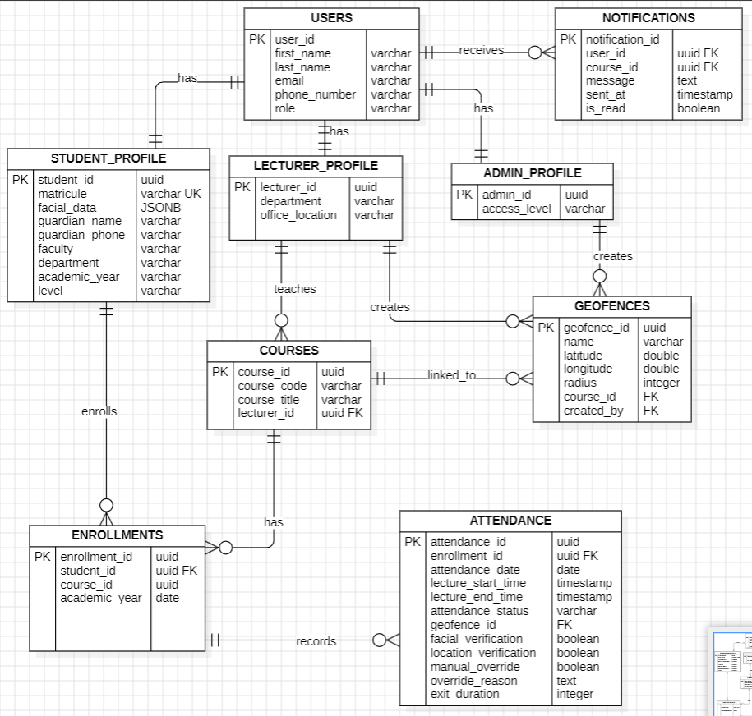

Figure 0‑2: ER Diagram

**3.1 Relationship Cardinality Analysis**

The ER diagram implements specific cardinality relationships based on business rules:

**One-to-Many Relationships**

* **Users to Student Profiles**: Each user can have at most one student profile, but the system allows for future expansion to support multiple roles per user
* **Courses to Class Sessions**: Each course can have multiple sessions across different time periods
* **Class Sessions to Attendance Records**: Each session generates multiple attendance records, one per enrolled student

**Many-to-Many Relationships**

* **Students to Courses**: Implemented through the Course Enrollments associative entity, supporting student registration in multiple courses and courses having multiple enrolled students
* **Educators to Courses**: Implemented through Course Assignments, allowing team teaching and multiple course assignments per educator

**3.2 Entity Classification**

* **Strong Entities**: Users, Courses, Geofences exist independently and have their own primary keys
* **Weak Entities**: Student Profiles, Educator Profiles depend on Users for existence
* **Associative Entities**: Course Enrollments, Attendance Records represent many-to-many relationships

**3.3 Integrity Constraints**

**Referential Integrity**

Foreign key relationships ensure data consistency across related tables. Cascading delete operations maintain referential integrity when primary entities are removed.

**Domain Constraints**

Enumerated types (ENUM) restrict field values to valid options, preventing data inconsistency. For example, attendance status is limited to 'present', 'absent', 'late', or 'excused'.

**Business Rule Constraints**

Unique constraints on business identifiers (matriculation numbers, course codes) prevent duplicate academic records while allowing technical primary keys for database optimization.

**4. Database Implementation**

Before the implementation of the database, it is important to enhance our ER diagram and to make sure normalization has been done.

# **4.1 Database Normalization**

### 4.1 Why We Normalize Databases

Database normalization is a systematic approach to organizing data that serves several critical purposes in the attendance management system:

### Eliminate Data Redundancy

**Problem**: Without normalization, the same data is stored in multiple places, leading to storage waste and maintenance challenges.

**Example**: In an unnormalized attendance system, course information (course name, instructor, credits) might be repeated in every attendance record, enrollment record, and grade record.

**Solution**: Store course information once in a dedicated courses table, referenced by other tables through foreign keys.

### Prevent Data Anomalies

Normalization prevents three types of destructive anomalies:

**Update Anomalies**

* **Problem**: When data is duplicated, updating one instance might leave others unchanged, creating inconsistencies
* **Example**: If a course name changes and it's stored in 100 attendance records, failure to update all instances results in inconsistent course names across the system
* **Impact**: Reports showing different names for the same course, confusion for users, and loss of data integrity

**Insert Anomalies**

* **Problem**: Unable to add certain data without having other unrelated data
* **Example**: Cannot add a new course to the system until at least one student enrolls and has an attendance record
* **Impact**: Prevents proactive course setup and planning

**Delete Anomalies**

* **Problem**: Deleting a record removes more information than intended
* **Example**: Removing the last attendance record for a course might delete all course information
* **Impact**: Unintentional loss of valuable academic data

### Ensure Data Integrity

* **Referential Integrity**: Foreign key relationships ensure related data remains consistent across tables
* **Domain Constraints**: Each attribute has a defined set of valid values, preventing invalid data entry
* **Business Rules**: Database constraints enforce organizational policies automatically

### Improve System Maintainability

* **Single Source of Truth**: Each piece of information exists in exactly one location
* **Simplified Updates**: Changes to course information, user details, or business rules require modification in only one place
* **Reduced Human Error**: Elimination of redundancy reduces opportunities for data entry mistakes

### 4.2 Transformation from Basic ER to EER Model

The Enhanced Entity-Relationship (EER) model extends the basic ER diagram by incorporating advanced modeling concepts that better represent the complexity of the attendance management system. This transformation addresses limitations in the basic ER model and provides a more comprehensive representation of the system's data requirements.

### 4.2.1 Significance of EER Model Implementation

**Enhanced Semantic Representation**

The EER model provides superior semantic clarity by explicitly representing:

* **Role-based Access Control**: Different user types have distinct database permissions and application functionalities
* **Inheritance Relationships**: Common attributes are inherited rather than duplicated, reducing redundancy
* **Constraint Specification**: Business rules are more precisely defined through specialization constraints

**Database Design Optimization**

The EER model directly influences physical database implementation through:

* **Table Inheritance Strategies**: Three implementation approaches are considered:
  1. **Single Table Inheritance**: All user types in one table with discriminator column
  2. **Class Table Inheritance**: Separate tables for each subclass with foreign key relationships
  3. **Concrete Table Inheritance**: Complete separate tables for each user type
* **Query Optimization**: Specialized queries can target specific user types without unnecessary joins
* **Maintenance Efficiency**: Schema modifications affect only relevant user types rather than all users

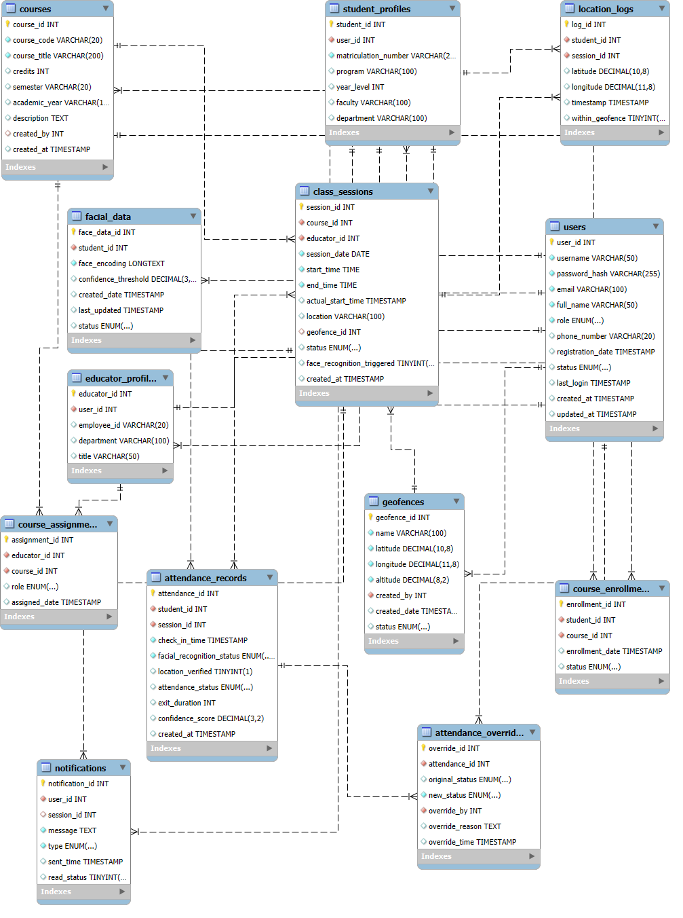

Figure 0‑1: Enhanced ER Diagram

**4.3 Hybrid Database Architecture**

We can now go ahead and implement our database. The implementation employs a polyglot persistence approach, utilizing both SQL and NoSQL databases for optimal performance and functionality:

**SQL Database Selection (MySQL)**

Relational databases excel at handling structured data with complex relationships. The attendance management system's academic data (courses, enrollments, grades) exhibits strong relational characteristics requiring ACID properties:

* **Atomicity**: Attendance recording operations must complete entirely or not at all
* **Consistency**: Academic records must maintain referential integrity
* **Isolation**: Concurrent attendance submissions must not interfere with each other
* **Durability**: Academic records must persist despite system failures

**4.4 Database Schema Design Principles**

**Logical Schema Design**

The logical schema translates the conceptual ER model into database-specific structures while maintaining platform independence. This involves:

* **Table Structure Definition**: Each entity becomes a table with appropriate column definitions
* **Relationship Implementation**: Foreign keys implement entity relationships
* **Constraint Definition**: Business rules become database constraints

An example of a table created is the attendance record table as shown below. Similar SQL commands were used to create all other tables of the database.

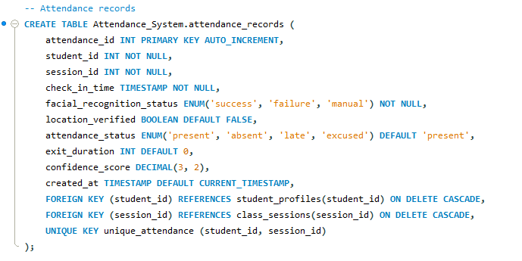

Figure 0‑2: Attendance Record Table creation



Figure 0‑3: All Database Tables

**Physical Schema Design**

Physical design optimizes database performance through:

* **Index Strategy**: Strategic indexing on frequently queried columns (username, course codes, session dates)
* **Partitioning**: Large tables (attendance records) can be partitioned by academic year or semester
* **Storage Optimization**: Appropriate data types minimize storage requirements while maintaining precision

**4.5 Security Implementation Theory**

**Data Encryption**

Sensitive data fields implement field-level encryption:

* **Password Security**: Bcrypt hashing with salt provides one-way encryption for authentication credentials
* **Biometric Data Protection**: Facial encodings are encrypted at rest using AES-256 encryption
* **Personal Information**: Student identification numbers and contact information require encryption for privacy compliance

**5. Backend Implementation**

**5.1 API Design Architecture**

The backend implements FASTAPI principles. FastAPI is a modern, high-performance web framework for building APIs with Python 3.7+ based on standard Python type hints. It is designed to create RESTful APIs quickly and efficiently, with a focus on performance, ease of use, and developer productivity.

* **Resource-Based URLs**: Each endpoint represents a specific resource (users, courses, attendance)
* **HTTP Method Semantics**: GET for retrieval, POST for creation, PUT for updates, DELETE for removal
* **Stateless Communication**: Each request contains all necessary information for processing
* **Standard Status Codes**: HTTP status codes communicate operation results consistently

**Microservices Considerations**

While the current implementation uses a monolithic architecture, the modular design supports future microservices migration:

* **Authentication Service**: User management and token generation
* **Attendance Service**: Facial recognition and location verification
* **Course Management Service**: Academic data and enrollment handling
* **Notification Service**: Communication and alert distribution

**5.2 Data Processing Algorithms**

**Facial Recognition Processing**

The system implements facial recognition using established computer vision algorithms:

* **Face Detection**: Haar cascades or deep learning models identify facial regions in images
* **Feature Extraction**: Algorithms like Local Binary Patterns (LBP) or Convolutional Neural Networks extract facial features
* **Face Matching**: Euclidean distance calculations compare extracted features with stored encodings
* **Confidence Scoring**: Statistical measures provide recognition reliability metrics

**Geofencing Calculations**

Location verification employs geographical computation:

* **Coordinate System**: GPS coordinates use the WGS84 datum for global compatibility
* **Distance Calculation**: Haversine formula calculates spherical distances between GPS points
* **Boundary Detection**: Circular geofences provide simple yet effective location verification
* **Accuracy Considerations**: GPS accuracy limitations (±3-5 meters) influence geofence radius selection

**5.3 Real-Time Processing Requirements**

**Synchronous Operations**

Critical operations require immediate processing:

* **Authentication**: Login requests need immediate response for user experience
* **Attendance Submission**: Real-time verification ensures timely feedback to users
* **Location Verification**: Immediate geofence checking prevents attendance fraud

**Asynchronous Processing**

Non-critical operations can be processed in background:

* **Facial Recognition**: Complex image processing can occur asynchronously with status updates
* **Notification Distribution**: Bulk notifications are queued for efficient delivery
* **Analytics Generation**: Attendance statistics and reports are computed during low-usage periods

**6. Database-Backend Integration Theory**

**6.1 Connection Management Strategies**

**Connection Pooling**

Database connection pooling optimizes resource utilization:

* **Pool Size Configuration**: Balance between resource consumption and request handling capacity
* **Connection Lifecycle**: Automatic connection creation, validation, and cleanup
* **Timeout Management**: Idle connection cleanup prevents resource exhaustion
* **Load Balancing**: Multiple database servers can share connection load

**Transaction Management**

Database transactions ensure data consistency:

* **Transaction Boundaries**: Clear definition of atomic operation units
* **Rollback Strategies**: Error handling that maintains database consistency
* **Isolation Levels**: Appropriate concurrency control for multi-user environments
* **Deadlock Prevention**: Query ordering and timeout strategies prevent system locks

**6.2 Data Synchronization Patterns**

**Online-First Approach**

Primary operations occur with immediate database interaction:

* **Real-Time Validation**: Attendance submissions are immediately verified against database rules
* **Immediate Feedback**: Users receive instant confirmation of successful operations
* **Consistency Guarantee**: Database state remains consistent across all user interactions

**Offline Capability**

Mobile environments require offline functionality:

* **Local Storage**: Critical data cached on mobile devices for offline access
* **Synchronization Queue**: Offline operations queued for later database update
* **Conflict Resolution**: Strategies for handling conflicting updates when reconnecting
* **Data Freshness**: Mechanisms to ensure cached data remains reasonably current

**6.3 Performance Optimization Theory**

**Query Optimization**

Database query performance directly affects user experience:

* **Index Strategy**: Strategic indexing on frequently filtered and joined columns
* **Query Plan Analysis**: Regular examination of execution plans for optimization opportunities
* **Batch Operations**: Grouping multiple database operations for efficiency
* **Result Caching**: Frequently accessed data cached to reduce database load

**Scalability Considerations**

System design must accommodate growth:

* **Horizontal Scaling**: Database sharding strategies for large user populations
* **Vertical Scaling**: Hardware improvements to handle increased load
* **Read Replicas**: Separate read-only database instances for query distribution
* **Data Archiving**: Historical data management to maintain performance with growing datasets

**7. Conclusion**

The database design and implementation for the mobile-based attendance management system represents a comprehensive solution addressing the functional and non-functional requirements specified in the SRS document. The theoretical framework underlying this implementation draws from established database design principles, security best practices, and mobile application development patterns.

The hybrid database approach leverages the strengths of both relational and document-oriented storage systems, providing optimal performance for different data types and access patterns. The careful consideration of academic environment requirements ensures the system can effectively serve educational institutions while maintaining compliance with privacy regulations and integration capabilities with existing systems.

The modular design approach facilitates future enhancements and scalability improvements, ensuring the system can evolve with changing technological requirements and institutional needs. The comprehensive theoretical foundation provides a solid basis for implementation decisions and ongoing system maintenance.

This detailed analysis demonstrates how database design theory translates into practical solutions for real-world applications, specifically addressing the unique requirements of educational attendance management in mobile environments. The integration of biometric authentication, location verification, and traditional database management principles creates a robust and secure system suitable for modern educational institutions.