**UNIVERSIDAD EAFIT**

Escuela de economía y finanzas

By: Nicolas Akerman

Curse: Advance Econometrics

Revision of:

*Mafia and Public Spending: Evidence on the Fiscal Multiplier from a Quasi-Experiment,*

Medellín, Colombia, June 6, 2021

*Abstract*

The fiscal multiplier is a central instrument of policy makers. Understanding its magnitude and effect in the economy is imperative to the correct implementation of fiscal policy. In this article we depict the Antonio Acconciaa, Giancarlo Corsetti and Saverio Simonelli 2014 article, *Mafia and Public Spending: Evidence on the Fiscal Multiplier from a Quasi-Experiment,* evaluating their results in order to understand how in times of high criminality a budget cut could impact economies output, and obtaining a fiscal multiplier estimate for Italy.

*Resumen*

El multiplicador fiscal es un instrumento central de los hacedores de política. Comprender su magnitud y efecto en la economía, es imperativo para la correcta implementación de la política fiscal. En este artículo revisamos el artículo de Antonio Acconciaa, Giancarlo Corsetti y Saverio Simonelli del 2014, *Mafia and Public Spending: Evidence on the Fiscal Multiplier from a Quasi-Experiment*, evaluando sus resultados para comprender cómo en tiempos de alta criminalidad un recorte presupuestario podría impactar la producción de una economía, obteniendo así una estimación del multiplicador fiscal para Italia.

**1. Introduction**

The fiscal multiplier is a central instrument of policy makers in an economy. This multiplier states that for every dollar spend by a government, the output of their economy increase x amount of dollars. In recent times, due to economic distress, fiscal spending has got special importance as a tool for economic stimulus, so understanding the magnitude of its effects has become crucial for any responsible and well implemented macroprudential policy. Said that, due to automatic stabilizers, understanding the actual magnitude of fiscal stimulus or a reduction in fiscal budget has become an intricate task to do.

In this article we study the Acconcia et al. (2014) model, in which they were able to use policies against mafia organizations as an instrument, to see how a reduction of public expenditure could impact on local economy of Italy province during the 90’s. Isolating it from taxes reaction, thanks to the fact that tax policy is decided at a national level. It’s important to understand that in this context of high criminality the economy would tend to underperform, rely on fiscal spending, and give signals to private agents of high uncertainty. This all can lead to an overreaction of the economy to a fiscal budget reduction, producing a fiscal multiplier that had almost 2 units of magnitude, far higher that what economic theory expects from a develop market.

In this article, the results of the authors mention above are tested by implementing econometric models similar to the authors original work, but relaxing assumptions such as strict exogeneity and spatial dependence. At the ended it was easy to conclude that their original work was correct and in times such as the ones described above, the output at a local level is incredible sensitive to an abrupt fiscal budget cut. The next sections of this article are as follows: 2. Literature Review; 3. Data; 4. Model; 4. Results and 5. Conclusions.

**2. Literature Review**

"The fiscal multipliers is a measure of the short-term impact of fiscal policy in the output" (Batini et al. 2014, P1). Said multiplier, is compose by two effects: an impact multiplier, which is the direct or short span effect of fiscal spending on the GDP; and a Multiplier in the horizon, which is the effect of fiscal spending over time (Batini et al., 2014, p3).

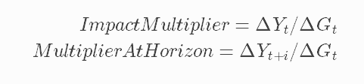

These concepts were first introduced by the father of Macroeconomics, John Maynard Keynes, in a paper dated to 1931 in which he intended to point the ratio of change between fiscal policy and the economic output. (Investopedia article on Fiscal Multiplier, 2021). Said that, it has been one of the most important ideas in economics for almost a century now, getting special relevant in the last year as economies have become more reliant on big government spending to get out of the economic crisis impose by exogenous shock such as the 2020 Covid 19 pandemic. As Boesler (2021) point out in his article on Bloomberg:

In 2020, when the pandemic hit and economies around the world went into lockdown, policymakers effectively short-circuited the business cycle without thinking twice. In the U.S. in particular, a blitz of public spending pulled the economy out of the deepest slump on record—faster than almost anyone expected—and put it on the verge of a boom. The result could be a tectonic transformation of economic theory and practice.

Although fiscal stimulus is of incredible importance for the correct function of economies, the importance of understanding and knowing the magnitude of fiscal multiplier is much greater than just an implementation of policy. Without it, countries are bound to set unachievable fiscal targets, and miscalculate the amount of adjustment necessary “to curb their debt ratio” (Batini et al., 2014, p3). In other words, is not possible to implement correct macroprudential policies, making an economy unstable, possibly making the stimulus more detrimental than beneficial.

Even though the prior is all true, a constant debate over “how fiscal policy affects the economy (that) is reflected in an ongoing debate over the size of the fiscal multiplier” (Whalen et al, 2015, p.1). Batini et al. (2014) affirms that:

Advanced economies DSGE simulations and SVAR models, developed since the early 1990s, suggest that first-year multipliers generally lie between 0 and 1 in “normal times.” This literature also finds that spending multipliers tend to be larger than revenue multipliers.4 Based on a survey of 41 such studies, Mineshima and others (2014) show that first-year multipliers amount on average to 0.75 for government spending and 0.25 for government revenues (p3).

As well as stating that the fiscal multiplier has a persistence of around 5 years in the same “normal times” and having an inverted u shape.

The issue with these models and calculations, permitting the discussion of its effectiveness and magnitude to persist, is how hard is to isolate the effect of the fiscal multipliers from the effects of simultaneous changes on taxes. This due to the fact that, “spending and taxes typically react automatically to the business cycle through so-called “automatic stabilizers.” They also respond to the cycle in a discretionary way; for instance, a countercyclical policy may raise tax rates and cut spending when the output gap increases.” (Batini et al., 2014, p3).

To approach this question, this article is based on the works of Antonio Acconciaa, Giancarlo Corsetti and Saverio Simonelli, in their 2014 article, *Mafia and Public Spending: Evidence on the Fiscal Multiplier from a Quasi-Experiment.* This paper differs from traditional fiscal multiplier studies for two main reasons, first it studies the multiplier at a regional level while typically it’s study at an aggregate level (Acconciaa et al., 2014, p2). Also, and maybe the biggest contribution of their work, thanks to the Italian law against mafia infiltration in city council, they are able to, instrument and isolate the effects of public spending over the output (Acconciaa et al., 2014, p3).

Before actually depicting these authors work and their implication, it’s important to understand the context in which it was develop. Italy was the first country to present Mafia criminal structures, which then got replicated over several countries in the world.

It was only at the beginning of the 1980s that these distinctive features were recognized by the Italian judicial system. Until then, Article 416 of the Penal Code (“associazione a delinquere”) punished in the same way all groups of three or more people involved in some type of criminal activity. Such a generic norm failed thus to distinguish between, say, small groups of bank-robbers and wide criminal networks exerting a ramified control over the territory. This changed in 1982 with Law 646/82, which introduced Article 416-bis (“associazione a delinquere di stampo mafioso”) aimed explicitly at mafia organizations, defined as those groups that “exploit the power of intimidation granted by the membership in the organization and the condition of subjugation and omert´a that descends from it to commit crimes, acquire the management or the control of economic activities, concessions, authorizations and public contracts, to realize unjust profits”. (Pinotti, 2011, p6)

With this the central government could treat crimes related with mafia and nexus from regional mandatories differently. This aloud the Italian government to institute a law in which, any link of a city council with Mafia organizations will implicate a dismantling of the city council, which then would be replace by three external commissioners appointed by the central government. (Acconciaa et al., 2014, p.3)

Also is important to point out that, the fight on war had several implications on the economic activity, Pinotti (2011) pointed this stating how: “violence and predatory activities destroy part of the physical and human capital stock… these phenomena increase the riskiness and uncertainty of the business environment, which in turn may hinder the accumulation process and lower the long-run growth rate of the economy”. Resulting in a GDP per capita decline of as much as 16%, at the same time as homicides increase relative sharply. All of this accompanied by persistent and increasing levels of corruptions. (Pinotti, 2011, P.14). This detriment becomes evident, as the five Italian regions with the greatest presences of crime where the poorest of the country (p2). Now, one could question which direction does the causality has, poor regions are more likely to have high rates of criminality. But if we go further on the works of Pinotti, in which he states:

(Apulia and Basilicata) In just a few years, between the end of the 1970s and the beginning of the 1980s, the growth rate of the two regions dropped from being the highest to become the lowest of the country. Historical and judicial evidence suggests that this period coincides with the outbreak of organized crime in Apulia and Basilicata, leading to the formation of the so-called fourth and fifth mafia. (P.8)

It is clear how a region with higher criminality rates become systematically poorer. This due to the facts mentions before, as well that this criminal organizations started to earn revenue by obtaining a monopoly over the investment realize by regional governments (Acconciaa et al. 2014 and Pinotti 2011), forcing private investment to systematically flee the zones of high criminality and being replace with public investment.

All the above becomes of extreme importance understanding the data and the model stated by Acconciaa et al. (2014). First, as public investment becomes a bigger part of the economy, a decrease on it, would imply a bigger reaction of the output than usual, in other words, the fiscal multiplier it’s going to be bigger. This couple with the fact that “a number of studies have shown that multipliers can exceed 1 in “abnormal” circumstances—in particular when the economy is in a severe downturn…. Fiscal multipliers are generally found to be larger in downturns than in expansions (Table 4).11 This is true both for fiscal consolidation and stimulus.” (Batini et al., 2014, p7), resulting in a much more sensible output to changes in the fiscal policy.

Now Acconciaa et al. (2014) observe the fiscal multiplier of Italy at province level by studying how the GDP reacted when a city council was dismissed for having links with Mafia organizations. With only one member of the city council having a link with a Mafia organization, the whole council would be dismissed and get replace by central government civil servants. This would implicate an immediate, unanticipated, and temporary cut of public investment project. In some cases, only 20% of the budget that the regional government had was spend. Now the advantage of this was that, although a big part of the budget was determine by local government, taxes where a jurisdiction of the central government (p3). Implying that, one could observe the effect of generating an important cut of fiscal spending, without worrying about automatic stabilizers camouflaging the actual effect.

To do the former, the authors implemented a panel data model, using the interventions over the city council due to mafia nexus as an instrument of public spending and measure the impact of it over the output:

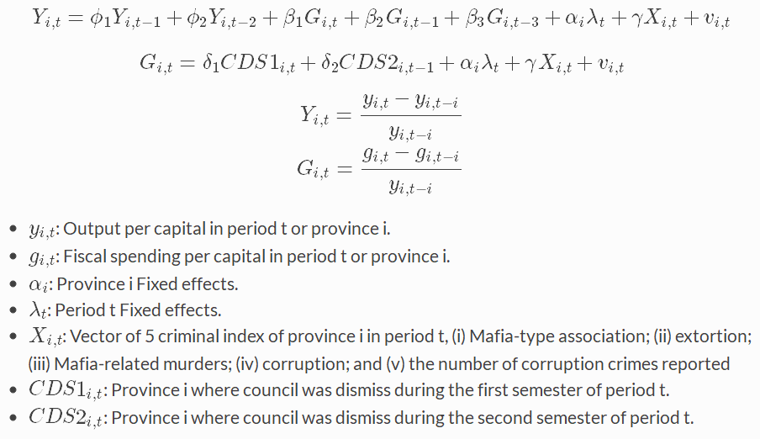

They were able to conclude that:

The contemporaneous output multiplier of spending contractions not compensated by monetary expansions, holding the tax burden constant is as high as 1.5. Furthermore, under the maintained assumption that lagged spending is exogenous to current output, the combined effects of past and current spending bring our multiplier estimate up to 1.9. We also find no significant spillovers of provincial spending into adjacent areas, suggesting that local economies may be quite "insular" from each other. (Acconciaa et al., 2014, p3; observe figure 1 of the appendix).

**3. Data**

The data use on the analysis presented is based on 95 Italian provinces (observe figure 2 and figure 3). These observations are taken on a time span of 10 years, between 1990-1999, resulting on 950 observations. This sample size has a cross section (n) large enough compared to the time span (t) to be able to base our models on asymptotic theory (Wooldridge, 2010). This can be depicted on the figure 4 and 5, where we can observe how the distribution of both the output and the government spending variations, respectively, have a (real close) normal distribution, as the asymptotic theory indicates a large enough sample should. Moreover, when we observe the rest of the variables of the model on figure 6, it can bee seen very clearly in the last row that all of them have an extremely statistically significant normal distribution (as well as all the descriptive statistics relevant to this set of data). This is helpful as it allows for traditional econometrical analysis to be implemented without needing to relaxed distributions assumptions.

Now, when the data is study in a more thorough manner, we can observe how the ideas stated in the section above might be right. In figure 8 and 9, we can observe the accumulate GDP change, as well as the number of city council dismissals (normalize by the total number of cities in a province, cd) over the time span that the data was gather (which one can easily relate with the incidence and size of Mafia in the local economy), seem to have a close linkage. At the same time, from these images we can see how this phenomenon is more apparent in the south of the country, making it hard to blindly accept the results from Acconcia et al. that there is no spatial causality between the provinces. This is ratified by the image 10, which represents Italian criminality by region.

When we go ahead and measure and realize the global Moran test, we can see that for most of the years in the sample there is a relevant positive spatial correlation in the sample (Figure 11 and Figure 12). Moreover, when we go ahead and analyze the local interdependence of the province GDP variations, we can see that although most of the sample is not significant, the areas that are significant, for most part, not only are very consistent, but also the ones where criminality tends to be the highest (Figure 13).

**4. Model**

Although this works is in great part based on the Acconsi et al. 2014 model, and we do a similar exercise to them, this article goes ahead in stating some more models relevant to the question of how the cut of fiscal resources at a local level could impact a province GDP. First, in line with what authors just mention did, we do state a similar model in which the fiscal spending is an endogenous variable, so we conduct a 2SLM. With this in mind and like Acconsi et al. (2014), we use the city council and the criminality measurements over the region and time span as instruments to estimate fiscal spending changes. But different to the model stated by the authors, we didn’t found any relevant effects of the time fixed effects over the model; which is quite normal in a sample with an small t. The estimation of the government spending was done through a pool panel data model.



On the second step of the estimation of the model, there is another divergence from the authors models and from the theory stated on the literature. The variables that measure the level of criminality, which are used as instrumental variables, where not consider on as regressors of the output, due to the fact that when we control for them, both using the government spending and not as a regressor, they were statistically insignificant. This could be related to many reasons, many of them explain by the time laps the variables are measure (Figure 14). First, as the policies study are dated up to the 1980’s, a great impact on the mafia organizations had already taken place, making the variability of this variables small, resulting in this not being a good explanatory variable to the changes in the economic activity. Second, as war on mafia take place, they might be a great increment on violence due to reorganization of this criminal structures and their facto power. The variables study here are proxy variables to the mafia incidence on a society, not the actual size of this organizations and as study before, war on this criminal organization differ from region to region making the proxy have mixed effects on the GDP. Third, some of these variables are difficult to measure, making their effect not being as reliable.

All of this makes our second equation have the form of:



4.1 Dynamic Panel Model

After stating this, they were several models implemented that could be divide into 2 types: panel and dynamic panel models; and spatial panels models. The first class is constituted of 4 models that assume that there is no spatial dependency between the provinces. We use first use a pool model, which assumes that there is no significant unobserved individual effect over the provinces, in a nutshell is your normal OLS model, that accounts for observation over province and on time as individual observations. The second model is a random effect model, in which although there is an individual effect of each province, as its name describe it, it is similar to a white noise error, in which is mean equals to 0. Meaning that, the coefficient estimator will still be unbiased, but to make the regression efficient you got to account for the variance of the individual effect. Then we relaxed the assumption that the mean of the individual effect is cero and pass to a fixed effect model, similar to the random effect, its name describes the nature of the individual effect, which is supposed to be constant through time. Now it’s pretty clear that with this type of model’s coefficients would be bias, due to the fact that the covariance of x and the individual effect is not 0:



To fixed this, we subtract the mean to the model and obtain an unbiased data generator process (assuming other assumptions in the models stand). Finally, to introduce the last model, we got to state an assumption that was implicit in all the models mentioned before. The assumption is that there is a strict exogeneity of the regressors, this means that the covariance of the regressors with the idiosyncratic error (the white noise error), both contemporaneous and lag, is equal to zero:



Now, this assumption is relaxed, and we only assume sequential exogeneity, which simply states that there a not null covariance between the independent variables and the dependent variables when they are contemporaneous. Which, in this case, tends to make sense, due to the structure of the model.



To deal with this we differentiate the model and state what is known as first difference panel data model.

* Pool:



* Random Effects:

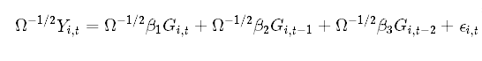



Where Ω comes from:



* Fixed Effects:





* First Difference:



4.2 Spatial Panel Models:

Now that the basic models are stated we pass to models that consider spatial lags. In order to do this, a symmetrical matrix W is implemented, which has the form:

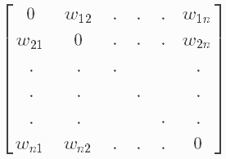

In it, wij has a value of 1 if two regions share a frontier and 0 otherwise. Also wii always have a value of 0. Now we state 6 models which we evaluate the random effects, fixed effects and first differences models explained above. We didn´t use the pool model accounting for the fact that, pooling and random effects, if estimated correctly, would have the same coefficients, but random effects are robust to an existing unobserved individual effect.

If we condense the form of the equation being study to:



We can wright express the spatial models as:

* Spatial lag Model SAR:



* SLX:



* Spatial Error Model- SEM:





* SAC (SARAR):



* Spatial Durbin model:



* Spatial Durbin Error Model:



**5. Results**

Table 1. Dynamic Panel Results

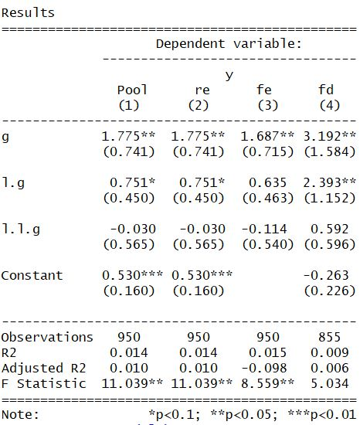

Obtaining the results of the first types of models stated (table 1), we can observe how the models that were based on the Acconcia et al. (2014) model throughs really similar results to the ones described by the authors, which could help sustain the theory they are well stated. In these, the fiscal multiplier has a great and significant effect the period where there is an abrupt cut of the fiscal budget, which rapidly diminish both in magnitude and significance. This can help support the idea that, in moments where the economy is underperforming for exogenous variables can produce a highly sensitivity of the economy to changes on the public spending. This is especially true in the context of the study because, criminal organizations disincentivizing private investment and having a monopoly of public contracts, which economic theory tell us that would produces efficiency losses by itself, makes the economy extremely reliable of public spending and investment. Without it, the economy has no way of replenishing the physical and human capital losses that naturally occurs in an economy every period. Another important factor that explains why these cuts are so sever, is the signals that it has on the agents of the economy. As a city council is dismissed for nexus with organize crimes, there is clear sign to the households and the investors that the local economy is going to be under a moment of uncertainty and economic distress, disincentivizing investors to take risk and households to consume. This explaining in great part why the reduction of public budget can have such an acute effect on the output.

Moreover, the first three models are statistically significant, while the one that is thought to be the most robust model (first difference, fd) isn´t. This could be due to the fact that, the variables being analyze are already variations over time, meaning that they itself have already been differentiated, making the second differentiation unnecessary. Moreover, when we analyze the Hausman test we can see that fixed effect (fe) and the random effect (re) are not statistically different. This probably occurs because, as we are using province specific variables as instrumental variables, it can make the biased due to the fact of the unobserved individual effect dissipate. Said that, all these models could still present endogeneity on its independent variables due to the fact of spatial lags.

When the effects of including spatial lags are observe, for the most part, the coefficients are not really supported by economic theory (observe table 2). In most cases, a change in public spending does not have an effect over the output, which is impossible, fiscal spending is a part of the GDP, if there is reduction in it, by definition, there must be a reduction of the GDP, in the only model that this is not true is in the SARAR fd model, but when a robust hypothesis test is done on this model lags, the error spatial lag is not significant, stating that this model isn’t the correct data generating process.

All mention before, can be the result of using instrumental variables that are link to the provinces, controlling for the spatial effects that can be presented by the different provinces. Leading to the conclusion that the Acconcia et al. (2014) first approach was correct, and the best model to explain the fiscal multiplier when using variation on the output and fiscal spending and using province specific variables as instruments, is a random effect model.

Table 2. Spatial Lag Models



**5. Conclusions**

The fiscal multiplier is a crucial element to understand in the moment of making correct macroprudential and economic stimulus policies in an economy. The issue with this, is that due to automatic stabilizers, product of taxes and public spending adjustments, depicting the exact magnitude of said multiplier can be extremely difficult. Acconcia et al. (2014) were able to study the effect of an acute and unannounced fiscal spending cut at a regional level, without changes in taxation, due to the war against mafia fought in Italy. In which a city council will be dismiss and replace by three government officials if any linkage with Mafia organizations was found.

Although they were able to depict the effects of an abrupt fiscal cut on the economy, their results may have been influence by over reliance of said economy in fiscal spending, due to a systematic replacement of private investment by public investment in the local economy; an underperformance of the economy which is associated with a bigger fiscal impact; as well as, the use of what could have been a strong signal of economic and social uncertainty to the different agents. Making that this fiscal cut had an overreaction on the output, resulting in a fiscal multiplier of almost 2, way higher that one should expect. Said that, after several implementation of different econometric models, it was concluded that the model stablish by the authors was correct. Meaning that in times of high economic distress, over reliance on public spending and high uncertainty, a cut on public spending has devasting effects on the output.

**Bibliography**

Acconciaa, A., Corsetti, G., & Simonelli, S. (2014). Mafia and public spending: Evidence on the fiscal multiplier from a quasi-experiment. *American Economic Review*, *104*(7), 2185-2209.

Batini, N., Eyraud, L., Forni, L., & Weber, A. (2014). *Fiscal multipliers: Size, determinants, and use in macroeconomic projections*. International Monetary Fund.

Boesler, M. (2021). *The Covid Trauma Has Changed Economics—Maybe Forever*. Bloomberg. https://www.bloomberg.com/tosv2.html?vid=&uuid=ce0752b0-c628-11eb-9598-216ec4f3fe12&url=L25ld3MvZmVhdHVyZXMvMjAyMS0wNi0wMS9zdGltdWx1cy1jaGVja3MtMjAyMS1pcy1nb3Zlcm5tZW50LWNhc2gtYXMtZWNvbm9taWMtcG9saWN5LWhlcmUtdG8tc3RheQ==

*Fiscal Multiplier Definition*. (2021). Investopedia. https://www.investopedia.com/terms/f/fiscal-multiplier.asp

Pinotti, P. (2011). The economic consequences of organized crime: Evidence from Southern Italy. *Bank of Italy*.

Whalen, Charles & Reichling, Felix. (2015). *The Fiscal Multiplier and Economic Policy Analysis in the United States. Contemporary Economic Policy.* 33. 735-746. 10.1111/coep.12104.

**Appendix**

Figure 1. Results from Acconciaa et al. model

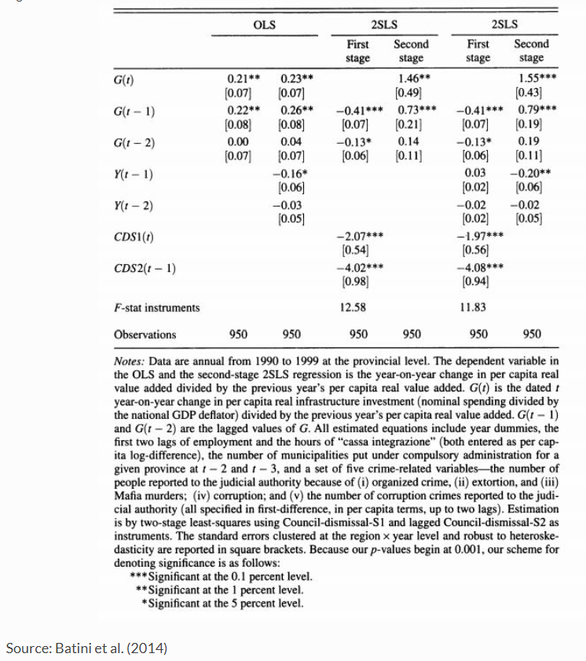

Source: Batini et al. (2014)

Figure 2. Provinces of sample

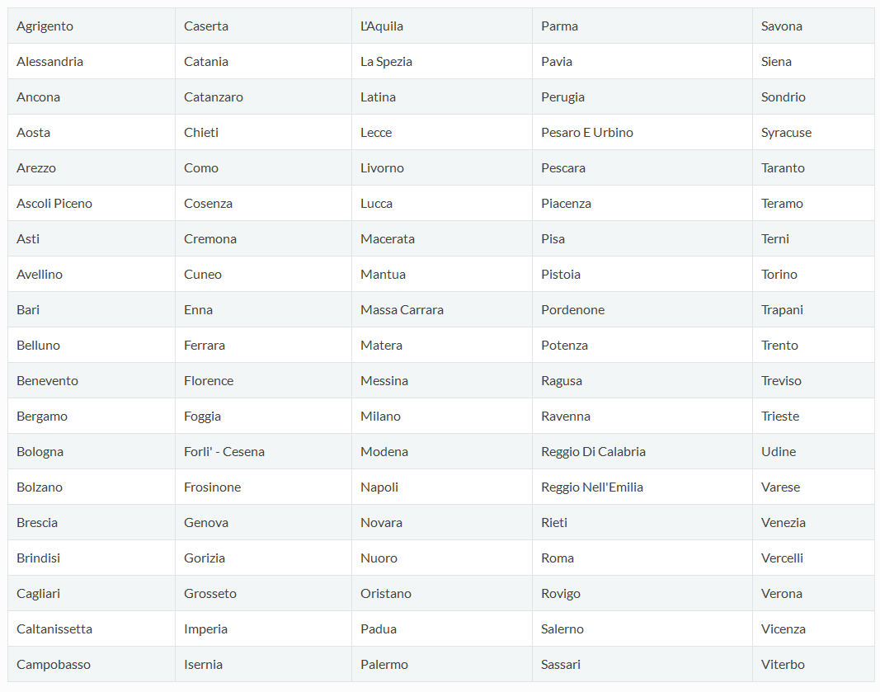

Figure 3. Regions of sample

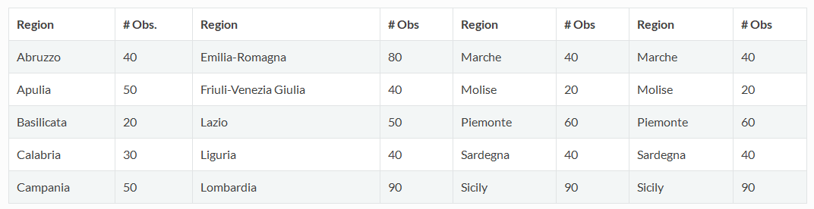

Figure 4. Distribution of Output Figure 5. Distribution of fiscal spending

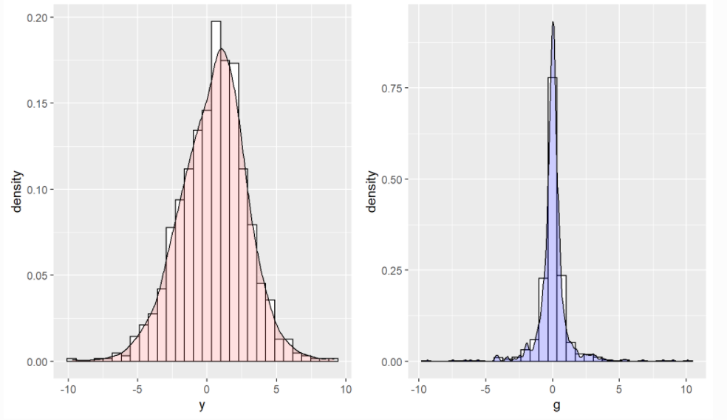

Figure 6. Descriptive statistics

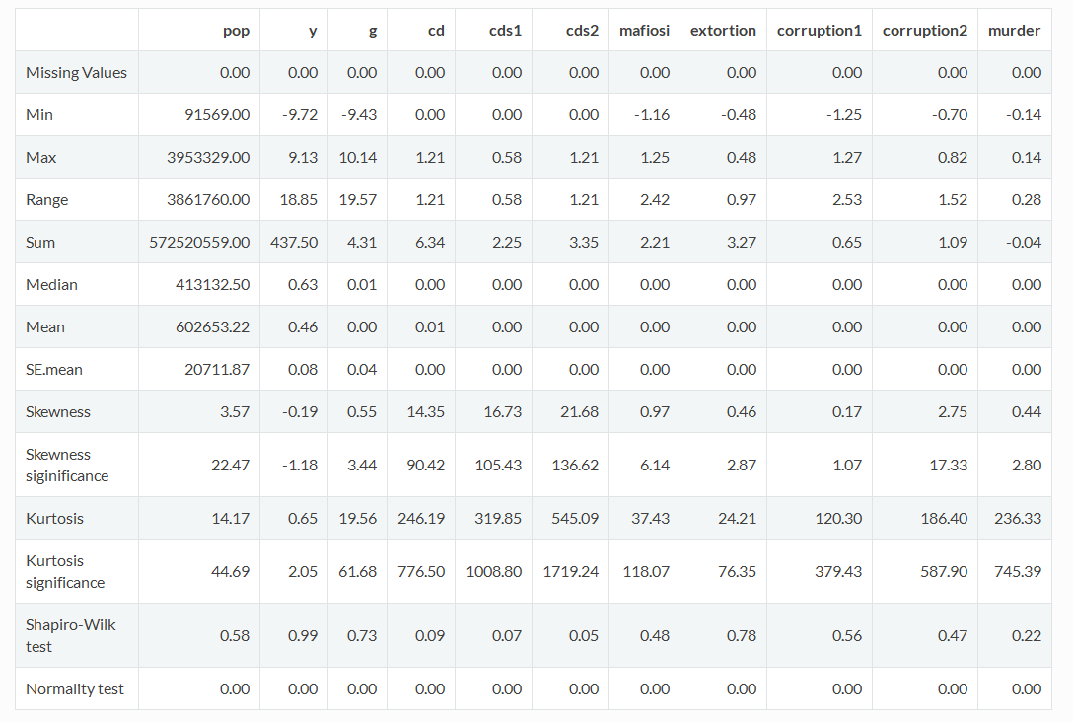

Figure 8. Obs per Region Figure 9. Total GDP variation Figure 10. Total council dismissals

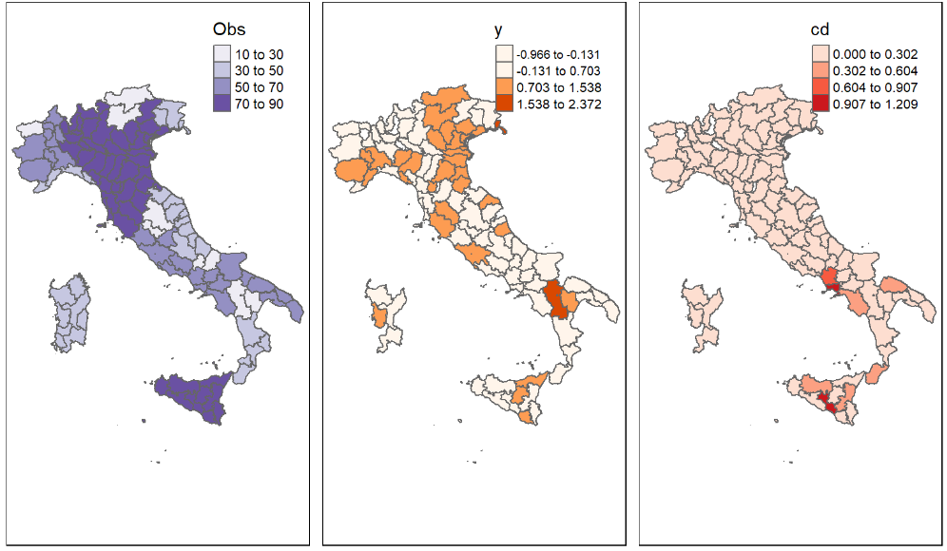

Figure 10. Criminality of Italy by regions

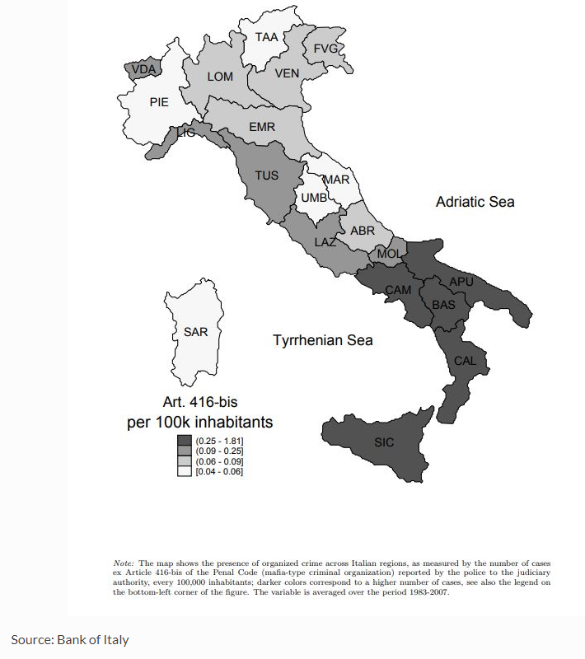

Source: bank of Italy

Figure 11. Moran test

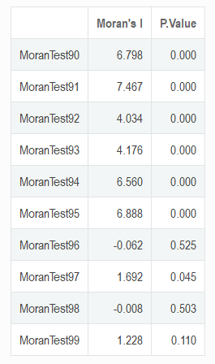

Figure 12. Moran Scatter Plot

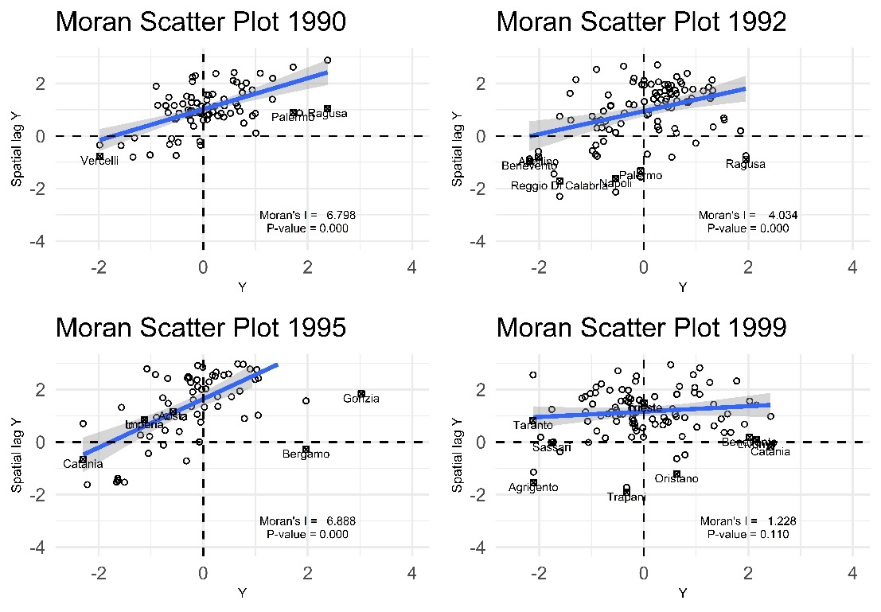

Figure 13. Local Moran test over the years

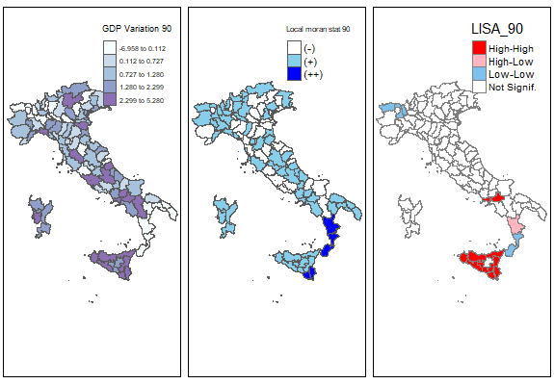

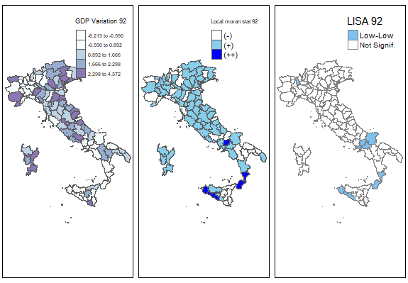

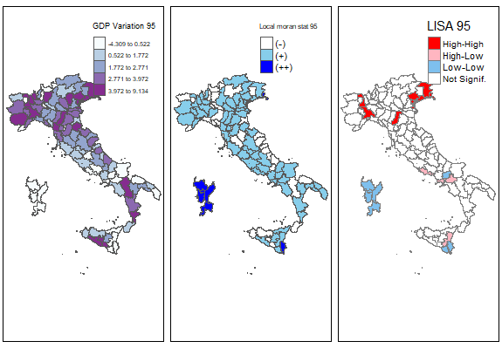

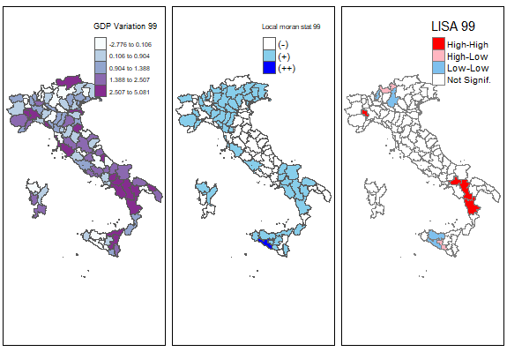

Figure 14. Instrumental Variables incide non GDP output

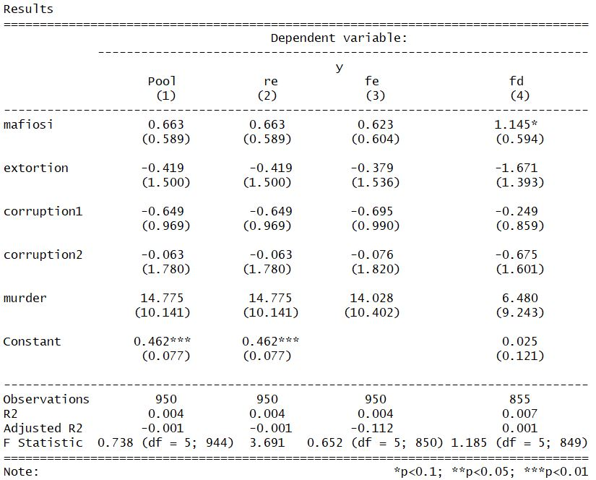

Figure 15. Hausman test

