Ilike信息管理系统
——资金流管理
上课班级：GJ02 学号：0940112166 姓名：梁文栩

子系统功能需求

系统功能描述
角色：系统管理员
功能描述：
  - 身份验证功能：
系统管理员只有通过身份认证登录系统后，才能修改相关系统信息
  - 银行帐号管理功能：
管理员登录后可以对帐号进行添加、删除、修改、查询操作
其用例图如1-1所示：
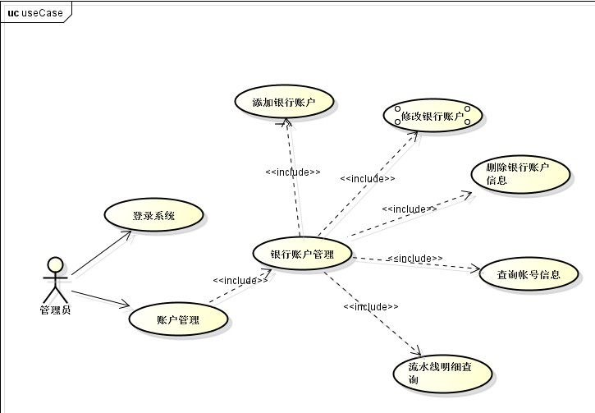
图1-1 帐号信息管理用例图

数据库设计

2.1 数据库关系表
（无）

2.2 各表结构
1. 管理员表admin_tb
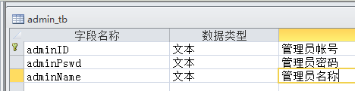
2. 账户信息表bankaccount_tb
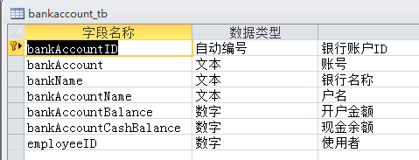

详细设计

3.1 类图设计
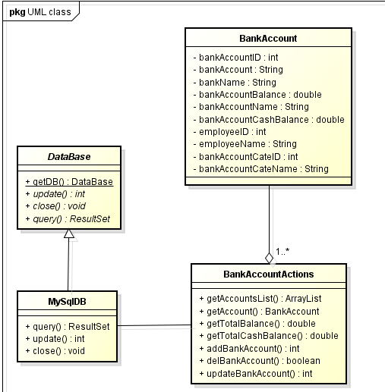

系统实现

4.1 公共模块实现
- 数据库连接，并进行数据库表的查询与修改
·使用Adapter设计思想，抽象类DataBase抽象了访问、修改、查询方法，实体类MySqlDB实现对MySql数据库的连接以及操作：
代码清单：
package org.myilike.Adapters.DB;
import java.sql.*;
import org.myilike.Moudles.Conf;
import org.myilike.Moudles.DB.MySqlDB;
import org.myilike.Moudles.DB.OdbcDB;
/**
*
* @author Akers
*/
public abstract class DataBase
{
public static DataBase getDB()
{
DataBase db = null;
Conf conf = new Conf();
if(conf.getDbType().equals("mysql"))
db = new MySqlDB(conf);
if(conf.getDbType().equals("odbc"))
db = new OdbcDB(conf);
return db;
}
//执行查询
public abstract ResultSet query(String sql);
//执行update delete操作
public abstract int update(String sql);
//注销数据库连接
public abstract void close();
}
package org.myilike.Moudles.DB;
import org.myilike.Adapters.DB.DataBase;
import java.sql.*;
import org.myilike.Moudles.Conf;
import org.myilike.utils.Convertors.StringConvertor;
/**
* @author Akers
*/
public class MySqlDB extends DataBase
{
private Connection con;
private Statement stmt;
private ResultSet rs;
private String charset;

public MySqlDB(){this(new Conf());}
public MySqlDB(Conf conf)
{
try
{
Class.forName(conf.getDriver());
con = DriverManager.getConnection(conf.getDBConnentStr(), conf.getDbUserName(), conf.getDbUserName());
stmt = con.createStatement();
charset = conf.getCharset();
}
catch (ClassNotFoundException e1) {
// TODO Auto-generated catch block
e1.printStackTrace();
}
catch (SQLException e) {
// TODO Auto-generated catch block
e.printStackTrace();
}
}
@Override
public ResultSet query(String sql)
{
//查询字符串重编码
sql = StringConvertor.getRecodeStr(sql, charset);
//设置数据库客户端字符编码
this.setNames(charset);
ResultSet rs = null;
try {
rs = stmt.executeQuery(sql);

} catch (SQLException e) {
// TODO Auto-generated catch block
e.printStackTrace();
}
//close();
return rs;
}
@Override
public int update(String sql){
//查询字符串重编码
sql = StringConvertor.getRecodeStr(sql, charset);
//设置数据库客户端字符编码
this.setNames(charset);
int n = 0;
try {
n = stmt.executeUpdate(sql);
} catch (SQLException e) {
// TODO Auto-generated catch block

}
//close();
return n;
}

/**
* 设置sql客户端字符集
* @param charSet
*/
public void setNames(String charSet)
{
try
{
stmt.executeQuery("set names '"+charSet+"';");
}
catch(SQLException e)
{
e.printStackTrace();
}
}
@Override
public void close()
{
try
{
if(rs!=null)
rs.close();
if(stmt!=null)
stmt.close();
if(con!=null)
con.close();
}
catch (SQLException e)
{
// TODO Auto-generated catch block
e.printStackTrace();
}
}
}

- 信息输出：
·服务器处理结果、反馈信息都统一一个页面输出
代码清单：
package org.myilike.Beans;
import java.io.Externalizable;
import java.io.IOException;
import java.io.ObjectInput;
import java.io.ObjectOutput;
import javax.servlet.ServletException;
import javax.servlet.http.HttpServletRequest;
import javax.servlet.http.HttpServletResponse;
/**
*
* @author Akers
*/
public class IlikeMessages implements Externalizable
{
private String msgType;
private String msgText;
private String callBackURL;
private String callBackName;
private int delayTime;
private HttpServletRequest request;
private HttpServletResponse respose;
//构造方法：
public IlikeMessages()
{this(null, null, "", "", "", "", 0);}
public IlikeMessages(HttpServletRequest req, HttpServletResponse resp)
{this(req, resp, "", "", "", "", 0);}
public IlikeMessages(String msgType, String msgText, String callBackURL, String callBackName, int delayTime)
{this(null, null, msgType, msgText, callBackURL, callBackName, delayTime);}
public IlikeMessages(HttpServletRequest req, HttpServletResponse resp, String msgType, String msgText, String callBackURL, String callBackName, int delayTime)
{
this.request = req;
this.respose = resp;
this.setMsgText(msgText);
this.setCallBackName(callBackName);
this.setDelayTime(delayTime);
this.setCallBackURL(callBackURL);
this.setMsgType(msgType);
}
//实现序列化方法
@Override//实现序列化数据读取
public void readExternal(ObjectInput in) throws IOException, ClassNotFoundException {
msgType = (String)in.readObject();
msgText = (String)in.readObject();
callBackURL = (String)in.readObject();
callBackName = (String)in.readObject();
delayTime = in.readInt();
}
@Override//实现序列化数据写入
public void writeExternal(ObjectOutput out) throws IOException {
out.writeObject(msgType);
out.writeObject(msgText);
out.writeObject(callBackURL);
out.writeObject(callBackName);
out.writeInt(delayTime);
}
//Actions：
//设置消息属性
public void setMessage(String msgType, String msgText, String callBackURL, String callBackName, int delayTime)
{
this.setMsgText(msgText);
this.setCallBackName(callBackName);
this.setDelayTime(delayTime);
this.setCallBackURL(callBackURL);
this.setMsgType(msgType);
}
//发送通用消息模板格式化的消息
public void sendMsg(HttpServletRequest req, HttpServletResponse resp, String msgType, String msgText, String callBackURL, String callBackName, int delayTime) throws ServletException, IOException
{
this.setMessage(msgType, msgText, callBackURL, callBackName, delayTime);
req.getSession().setAttribute("msg", this);
resp.setCharacterEncoding("utf-8");
resp.sendRedirect("msg.jsp");
}
public void sendMsg(String msgType, String msgText, String callBackURL, String callBackName, int delayTime) throws ServletException, IOException
{
this.setMessage(msgType, msgText, callBackURL, callBackName, delayTime);
this.request.getSession().setAttribute("msg", this);
this.respose.setCharacterEncoding("utf-8");
this.respose.sendRedirect("msg.jsp");
}
//发送非法访问消息：
public void illegalRequest(HttpServletRequest req, HttpServletResponse resp) throws ServletException, IOException
{
this.setMessage("sysMsg", "非法访问，可能是您未登录或者登录错误，请返回登录页面正常登录！！", "login.jsp", "登录页面", 3);
req.getSession().setAttribute("msg", this);
resp.setCharacterEncoding("utf-8");
resp.sendRedirect("msg.jsp");
}
public void illegalRequest() throws ServletException, IOException
{
this.setMessage("sysMsg", "非法访问，可能是您未登录或者登录错误，请返回登录页面正常登录！！", "login.jsp", "登录页面", 3);
this.request.getSession().setAttribute("msg", this);
this.respose.setCharacterEncoding("utf-8");
this.respose.sendRedirect("msg.jsp");
}
//getter and setters
public String getMsgType() {return msgType;}
public String getMsgText() {return msgText;}
public String getCallBackURL() {return callBackURL;}
public String getCallBackName() {return callBackName;}
public int getDelayTime() {return delayTime;}
public void setMsgType(String msgType) {this.msgType = msgType;}
public void setMsgText(String msgText) {this.msgText = msgText;}
public void setCallBackURL(String callBackURL) {this.callBackURL = callBackURL;}
public void setCallBackName(String callBackName) {this.callBackName = callBackName;}
public void setDelayTime(int delayTime) {this.delayTime = delayTime;}
}

4.2 系统各功能模块实现
4.2.1 注册功能（略）
1. 功能描述：
2. 运行界面：
3. 组件图：
4. 关键代码：
4.2.2 登录功能（略）
1. 功能描述：
2. 运行界面：
3. 组件图：
4. 关键代码：

4.2.3 银行账户管理
1. 功能描述：供应商左侧页面的“账户管理”菜单下的“银行账户管理”，则列出所有银行帐号的信息，并进入图4-1所示界面。
2. 运行界面：
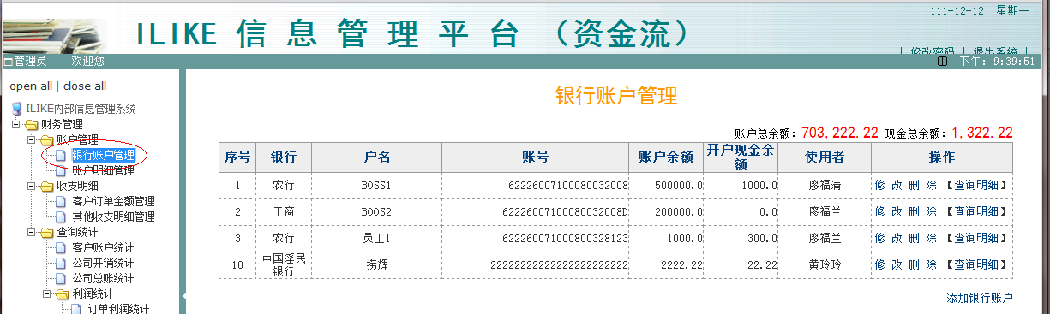
图4-1

3. 组件图：
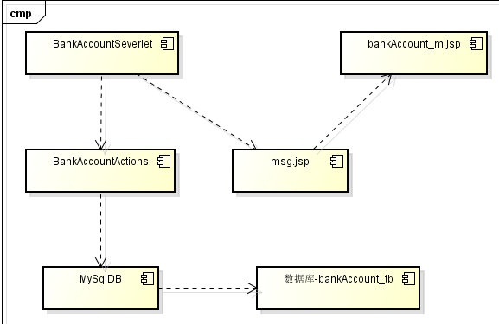
图4-1-2
4. 代码清单：
package org.myilike.Contortlors;
import com.sun.corba.se.impl.protocol.giopmsgheaders.Message;
import java.io.IOException;
import java.util.List;
import java.text.NumberFormat;
import javax.servlet.ServletException;
import javax.servlet.http.HttpServlet;
import javax.servlet.http.HttpServletRequest;
import javax.servlet.http.HttpServletResponse;
import org.myilike.Beans.*;
import org.myilike.Moudles.BankAccountActions;
/**
*
* @author Akers
*/
public class BankAccountsServlet extends HttpServlet
{
@Override
protected void doGet(HttpServletRequest req, HttpServletResponse resp) throws ServletException, IOException
{
this.doPost(req, resp);
}
@Override
protected void doPost(HttpServletRequest req, HttpServletResponse resp) throws ServletException, IOException
{
//判断是否正常访问
if(req.getSession().getAttribute("adminName") == null)
new IlikeMessages(req, resp).illegalRequest();
else if(req.getParameter("m") == null)
this.listAccounts(req, resp);
//m=add参数，新增银行帐号，添加成功跳转到BankAccounts_m.jsp
else if(req.getParameter("m").equals("add"))
this.addBankAccount(req, resp);
//m=del参数，删除银行帐号，删除成功跳转到BankAccounts_m.jsp
else if(req.getParameter("m").equals("del"))
this.deleteAccount(req, resp);
//m=up参数，修改银行帐号，修改成功跳转到BankAccounts_m.jsp
else if(req.getParameter("m").equals("up"))
this.updateAccount(req, resp);
else if(req.getParameter("m").equals("edit"))
this.updateAccount(req, resp);
}
/* function addBankAccount
* @author Akers
* 添加一个银行帐号到数据库
*/
private void addBankAccount(HttpServletRequest req, HttpServletResponse resp) throws ServletException, IOException
{
BankAccount ba = new BankAccount();
BankAccountActions baa = new BankAccountActions();
req.setCharacterEncoding("gbk");
ba.setBankName(req.getParameter("bankName"));
ba.setBankAccount(req.getParameter("bankAccount"));
ba.setBankAccountName(req.getParameter("bankAccountName"));
ba.setBankAccountBalance(Double.parseDouble(req.getParameter("bankAccountBalance")));
ba.setBankAccountCashBalance(Double.parseDouble(req.getParameter("bankAccountCashBalance")));
ba.setEmployeeID(Integer.parseInt(req.getParameter("employeeID")));
int resCode = baa.addBankAccount(ba);
//String msg = "";
IlikeMessages msg = new IlikeMessages(req, resp);
if(resCode == 0)
msg.sendMsg("sucMsg", "创建银行帐号成功！！", "bankaccounts", "管理页面", 3);
// msg = "添加帐号成功！！点击确定返回管理页面...";
else
{
String errMsg = "";
switch(resCode)
{
case 101:
errMsg = "需创建的帐号已经存在，请先删除原有帐号再重新新建";
break;
case 102:
errMsg = "数据写入失败！可能是数据库服务器出现故障或系统正在维护，请稍后再试或联系系统管理员";
break;
case 200:
errMsg = "未知错误，请联系系统管理员";
break;
}
msg.sendMsg("errMsg", "添加银行帐号失败，错误信息："+errMsg, "bankaccounts", "管理页面", 3);
}
}
/* function listAccounts
* @author Akers
* 取得所有银行帐号列表
*/
private void listAccounts(HttpServletRequest req, HttpServletResponse resp) throws ServletException, IOException
{
BankAccountActions baa = new BankAccountActions();
String totalBalance = "";//格式化后的货币字符串
String totalCashBalance = "";//格式化后的货币字符串
List<BankAccount> bankAccounts = baa.getAccountsList();
//格式化数字输出：
NumberFormat formater = NumberFormat.getNumberInstance();
formater.setMaximumFractionDigits(2);//格式化小数为总是保留2位
formater.setMinimumFractionDigits(2);
totalBalance = formater.format(baa.getTotalBalance());
totalCashBalance = formater.format(baa.getTotalCashBalance());
req.getSession().setAttribute("accounts", bankAccounts);
req.getSession().setAttribute("totalBalance", totalBalance);
req.getSession().setAttribute("totalCashBalance", totalCashBalance);
resp.setCharacterEncoding("utf-8");
resp.sendRedirect("myilike/fms/bankaccount/bankAccounts_m.jsp");
}
/**
* 删除银行帐号
* @author Akers
* @param req
* @param resp
* @throws ServletException
* @throws IOException
*/
private void deleteAccount(HttpServletRequest req, HttpServletResponse resp) throws ServletException, IOException
{
resp.setCharacterEncoding("utf8");
req.setCharacterEncoding("utf8");
BankAccountActions baa = new BankAccountActions();
boolean flag = false;
flag = baa.delBankAccount(Integer.parseInt(req.getParameter("aid")));
//输出操作结果
IlikeMessages msg = new IlikeMessages(req, resp);
if(flag)//删除成功
msg.sendMsg("sucMsg", "银行帐号删除成功！！", "bankaccounts", "管理页面", 3);
else//删除失败
msg.sendMsg("errMsg", "银行帐号删除失败！！", "bankaccounts", "管理页面", 3);
}
/**
* 修改银行帐号
* @author Akers
* @param req
* @param resp
* @throws ServletException
* @throws IOException
*/
private void updateAccount(HttpServletRequest req, HttpServletResponse resp) throws ServletException, IOException
{
BankAccount ba = new BankAccount();
BankAccountActions baa = new BankAccountActions();
req.setCharacterEncoding("gbk");
ba.setBankName(req.getParameter("bankName"));
ba.setBankAccount(req.getParameter("bankAccount"));
ba.setBankAccountName(req.getParameter("bankAccountName"));
ba.setBankAccountBalance(Double.parseDouble(req.getParameter("bankAccountBalance")));
ba.setBankAccountCashBalance(Double.parseDouble(req.getParameter("bankAccountCashBalance")));
ba.setEmployeeID(Integer.parseInt(req.getParameter("employeeID")));
ba.setBankAccountID(Integer.parseInt(req.getParameter("aid")));
int resCode = baa.updateBankAccount(ba);
//String msg = "";
IlikeMessages msg = new IlikeMessages(req,resp);
if(resCode == 0)
msg.setMessage("sucMsg", "修改银行帐号成功！！", "bankaccounts", "管理页面", 3);
// msg = "添加帐号成功！！点击确定返回管理页面...";
else
{
String errMsg = "";
switch(resCode)
{
case 101:
errMsg = "需修改的账户不存在";
break;
case 102:
errMsg = "数据写入失败！可能是数据库服务器出现故障或系统正在维护，请稍后再试或联系系统管理员";
break;
case 200:
errMsg = "未知错误，请联系系统管理员";
break;
}
msg.sendMsg("errMsg", "修改银行帐号失败，错误信息："+errMsg, "bankaccounts", "管理页面", 3);
}
}
}

4.2.4 修改银行帐号
1. 功能描述：在银行帐号管理页面，点击修改进入图4-2-1所示界面。
2. 运行界面：
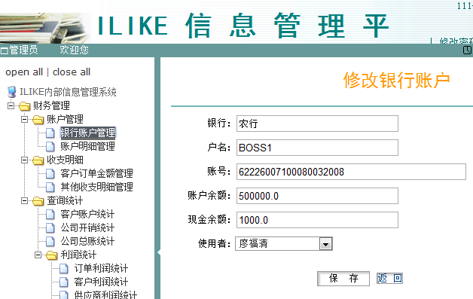
图4-2-1 主界面

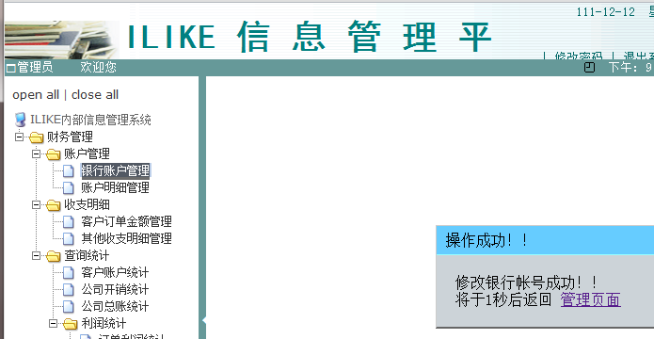图4-2-2 登录成功

输入信息不符合规范：
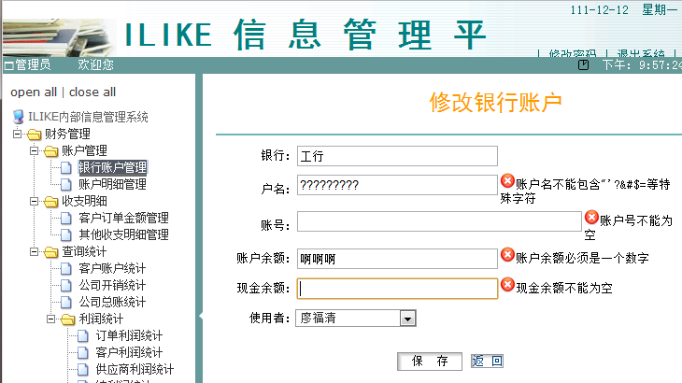
图4-2-3

3. 组件图：
见图4-1-2
4. 关键代码：
/**
* 根据帐号id获取帐号信息
* @param aid 帐号id
* @return BankAccount对象
*/
public BankAccount getAccount(int aid)
{
BankAccount ba = null;
String sql = "select ba.bankAccountID, ba.bankAccount, ba.bankName, "
+ "ba.bankAccountName, ba.bankAccountBalance, ba.bankAccountCashBalance, "
+ "ba.employeeID, ba.bankAccountCateID, bc.bankAccountCateName,"
+ "e.employeeName "
+ "from ((bankaccount_tb as ba "
+ "left join bankaccountcate_tb as bc on ba.bankAccountCateID=bc.bankAccountCateID) "
+ "left join employee_tb as e on ba.employeeID=e.employeeID) "
+ "where bankAccountID="+aid ;
ResultSet rs = db.query(sql);
try
{
if(rs.next())
{
ba = new BankAccount();
ba.setBankAccountID(rs.getInt("bankAccountID"));
ba.setBankAccount(rs.getString("bankAccount"));
ba.setBankAccountName(rs.getString("bankAccountName"));
ba.setBankAccountBalance(rs.getDouble("bankAccountBalance"));
ba.setBankAccountCashBalance(rs.getDouble("bankAccountCashBalance"));
ba.setBankAccountCateID(rs.getInt("bankAccountCateID"));
ba.setBankAccountCateName(rs.getString("bankAccountCateName"));
ba.setBankName(rs.getString("bankName"));
ba.setEmployeeID(rs.getInt("employeeID"));
ba.setEmployeeName(rs.getString("employeeName"));
}
rs.close();
}
catch (SQLException ex)
{
ex.printStackTrace();
}
return ba;
}
/**
* 修改银行帐号
* @param ba
* @return 返回0表示无错误，否则返回大于零的错误代码
* 错误代码列表：
* 101记录不存在
* 102数据库写入失败
* 200未知错误
*/
public int updateBankAccount(BankAccount ba)
{
if(new Double(ba.getBankAccountCateID()).isNaN())
{
ba.setBankAccountCateID(-1);
}

String sql = "SELECT * FROM bankaccount_tb WHERE bankAccountID=" + ba.getBankAccountID();
ResultSet rs = this.db.query(sql);
try
{
if(rs.next())
{
sql = "UPDATE bankaccount_tb SET "
+ "bankAccount='"+ba.getBankAccount()+"',"
+ "bankName='"+ba.getBankName()+"',"
+ "bankAccountName='"+ba.getBankAccountName()+"',"
+ "bankAccountBalance="+ba.getBankAccountBalance()+","
+ "bankAccountCashBalance="+ba.getBankAccountCashBalance()+","
+ "employeeID="+ba.getEmployeeID()+","
+ "bankAccountCateID="+ba.getBankAccountCateID()+""
+ " where bankAccountID="+ba.getBankAccountID()+";";
int n = this.db.update(sql);
if(n == 1)
return 0;
else
return 102;

}
else
{
rs.close();
return 101;//帐号不存在
}
}
catch (SQLException ex)
{
Logger.getLogger(BankAccountActions.class.getName()).log(Level.WARNING, null, ex);
return 200;//数据库异常
}
}

